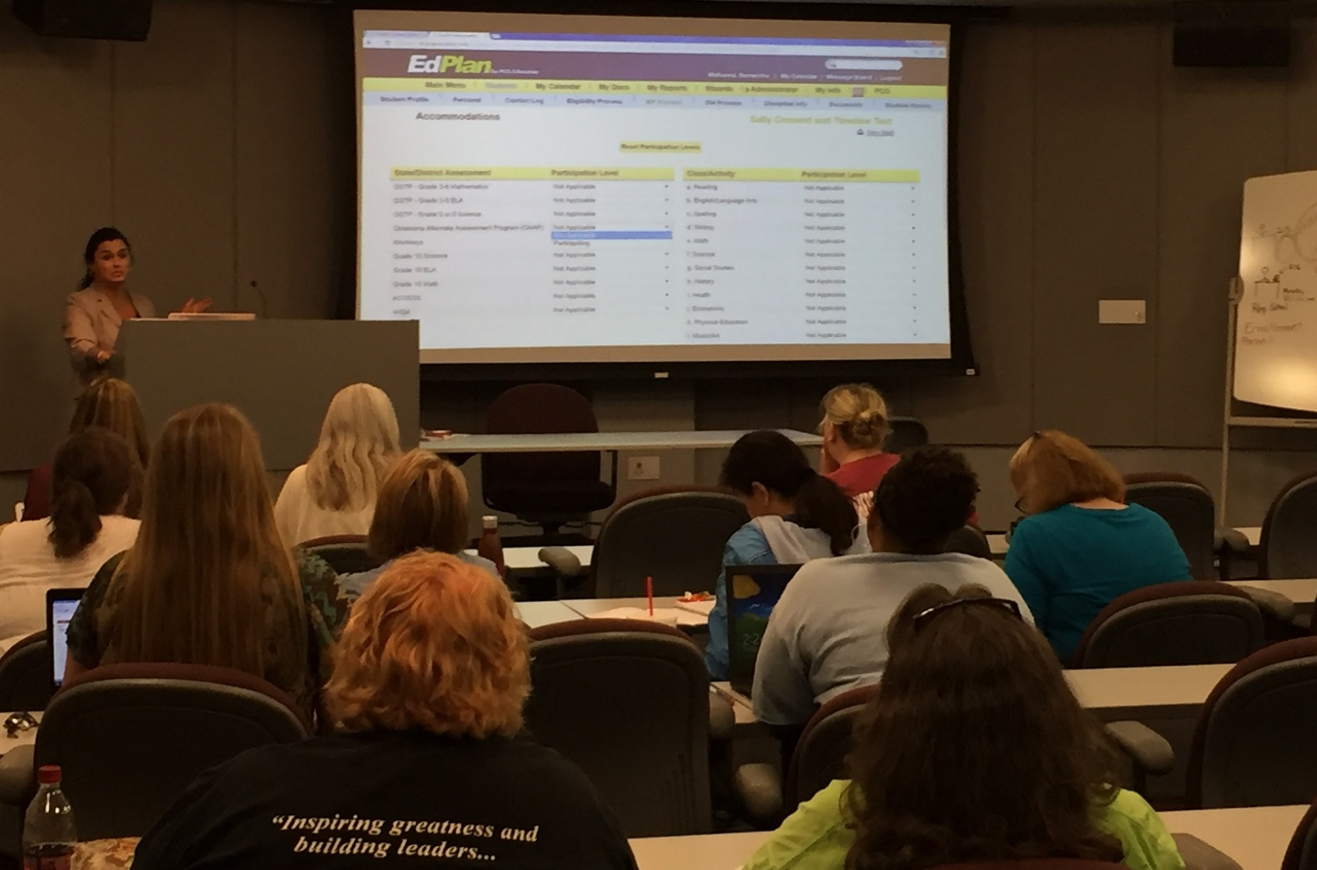 |  | - Oklahoma  - EDPlan™  - Newsletter
August 2017 |  | In this issue
District Calendar----------------------------------1
Grade Roll Up-------------------------------------1
Fall Training---------------------------------------1
New Features-------------------------------------2
Frequently Asked Questions -------------------2

Important DatesPPC
August 17-30 – EDPlan Fall Training
Webinars:
https://oksdeevents.webex.com/oksdeevents
Aug 4th 11:00-12:00 Edplan updates
Aug 23 7:30-8:30 am Edplan updates/IEP
Message Board

Click on “Send Message” at the top of the My Messages widget on your Main Menu page of OK EDPlan and send us a message. Be sure to include specific student information in all messages related to the system when applicable.
Resources

Video- Writing an IEP in OK EdPlan 11/14/16 https://vimeo.com/191535239
OK EdPlan Administrators Manual www.sde.ok.gov/sde/special-education

“Coming together is a beginning. Keeping together is progress. Working together is success.”

Henry Ford

This edition of the Oklahoma EDPlan™ newsletter reviews the District Calendar, Grade Roll Up, Fall Training, Frequently Asked Questions, and new features coming over the summer.

District Calendar
An important beginning-of-the-year task is to create the new district calendar. This includes editing the exact first and last days of the school year, adding ESY Schedule periods, and adding Report Periods. In order to edit your district calendar, click on the Calendar icon in the menu bar, click ‘Edit School Years,’ and add the appropriate Begin and End dates for this school year- make sure to click ‘Update the Database’ after doing this. Then, you can click ‘Edit’ under the appropriate column and row for ESY or Report Periods to add periods. To edit specific school days, add holidays and other days off, and add other special school days, return to the calendar by clicking the Calendar icon in the menu bar again, and double-click on individual school days to add the Day Type and Label.

Grade Roll Up
Students’ grade levels and schools that have been updated in your Student Management System and the WAVE file will automatically update in EDPlan after the WAVE data transfers over to EDPlan. If you encounter errors or questions about students rolling up to the next grade/school, please contact Support via the Message Board.

Fall Training
Fall training will be offered this month in OKC, Woodward, Lawton, Tulsa, Ardmore, and McAlester. Session dates and times offered vary slightly by location, and specific information about the schedule at each location can be found at the registration site: https://www.surveymonkey.com/r/OKAug2017 . Each individual attendee is required to register for training so that we can have a head count to prepare the appropriate amount of materials for each location and session. Training will cover a review of existing processes in EDPlan as well as an introduction to new features, updates, and enhancements. The deadline to register for training is Friday August 11 at 5pm Central Time.

New Features/Coming Soon:  EasyFax, EasyScan, Electronic Signature  We are excited to introduce the new optional features EasyFax, EasyScan, and Electronic Signature to Oklahoma EDPlan. Specifics on the functionality of these new features will be provided at Fall Training.  Frequently Asked Questions: Q: I’m trying to do my progress reports, and I get a message that there is no current IEP for that student. How can I complete my progress reports?  A: If the student does have a current IEP, then this error is most likely due to progress reporting periods not being set up correctly. Contact your district administrator, who will need to verify that progress reporting periods are set up and are correctly dated.  Q: How do I dismiss a student from a secondary disability?  A: Contact the Eligibility team for an eligibility meeting. Choose ‘Parent Contact’, ‘Notification of Meeting.’ Click the ‘Eligibility Process’. Select the ‘Evaluation’ tab and enter recent evaluation results. Checkmark ‘Include on Doc.’ Access the Eligibility Determination page and remove the secondary disability from the drop down box. Conduct the Eligibility Meeting. Present the draft eligibility to the team. Upon input, Click ‘Create Final’ and complete and Finalize the Written Notice.  Q: How do I dismiss a student from a related service?  A: Once you have searched and selected your student in OK EdPlan- click the ‘IEP Process’. Select the Services page and change the end date to show that services have stopped. The user will then need to click the Create Final page and choose either Subsequent IEP or IEP Addendum for the meeting purpose. Subsequent IEP would be Best Practice.  Q: I have a transfer student who shows a red stop sign, but I’ve accepted the transferred IEP. How do I get rid of the stop sign?  A: In the student history screen, 0ften the date of the transfer of records is after the date the IEP has been accepted. Ask your district administrator to update the date of transfer of records so that it matches the date the IEP was accepted.  Q: How do I convert a text file to excel?  A: Right click on the report name, and choose "save link as." You'll get a dialog box where you can save the report. Just remember where you save it! Then open Excel, and choose "File" and "Open," and then select your report. You'll see a Text Import Wizard, click Next, Next, and then Finish, and your report will open in Excel. If it's a report you want to keep in that format, click Save As, and that will save it as an Excel file. |  | Q: How can I print multiple documents for students at one time?  A: Click on ‘My Docs’. Select ‘Batch’ for the documents that you would like to mass print. Click ‘View Document Batch’ and the documents will be able to view. Select the printer icon to begin printing the documentation. This can be done for Progress Report, multiple IEP meetings in a week, Notification of Meeting, etc.  Q: Where can I look for issues/bugs being worked on by OKEdPlan?  A: PCG updates the Main Page as soon as something is reported as a bug. Before notifying the ‘Message Board’ please check to see if the issue has been reported. Once something has been fixed it will turn from red to green notifying the districts it has been completed.  Q: How do I turn the ‘T’ (transfer symbol) into a green check mark?  A: Once a student’s record has been transferred into your district someone will need to accept the IEP. Users will need to open each page of the IEP and save the information by clicking “update the database”. The begin date on the Create Draft/Final page should be the date the student enrolled in your district. The IEP will need to be finalized in your district even if it was current when you received the transfer. The State has added documentation for this process on the Main Page of OK EdPlan under Documents select the State tab and then choose Accepting an In-State IEP.  Terms to Remember  - Six months prior to the child’s 6th birthday a question mark will appear as a reminder the ECE data is required within 6 months  - Once the student has turned 6 years old and has an entrance date of greater than 180 the symbol will turn red to indicate the information is past due.  - Discontinue timeline when parent revokes consent for evaluations.  SIS – Student Information System ex. Powerschool, Wengage, Infinite Campus, etc.  Workspace – The Workspace is used for entering information into a student’s record in OK EdPlan. Editing and viewing information in the ‘Workspace’ is available based on user type permission.  Event – Final version of some items create an event in the system. Events are directly tied to timelines. Events can be viewed on each student by clicking the ‘Student History’ tab.  Student History – This screen will give a historical view of the student’s record to review dates and meeting types. If you want to know why something is out of compliance always check ‘Student History’ first.

