Run the Oklahoma Evaluation Score Export v2 Report (Organization Administrators have this privilege):
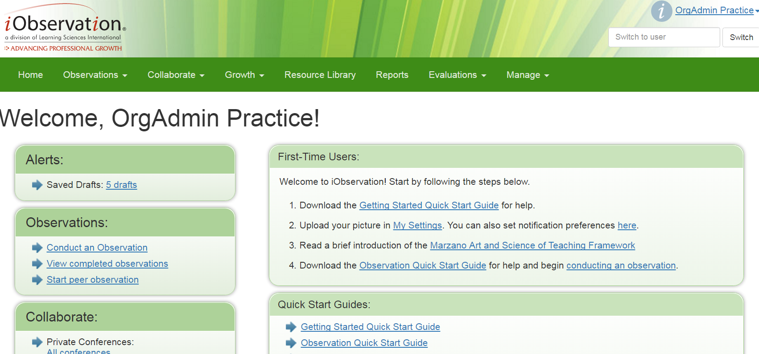

Scroll Down to the Oklahoma Evaluation Score Export V2 Report:
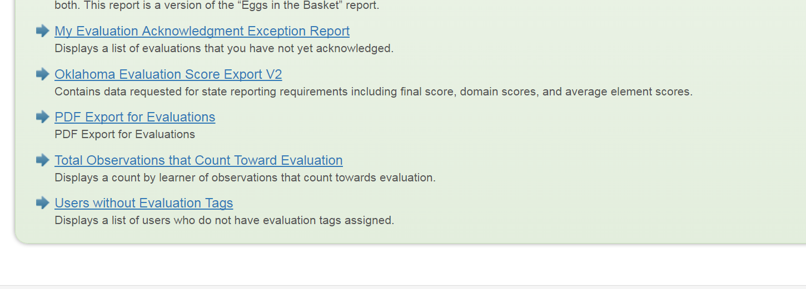

Enter your desired parameters to create your report:
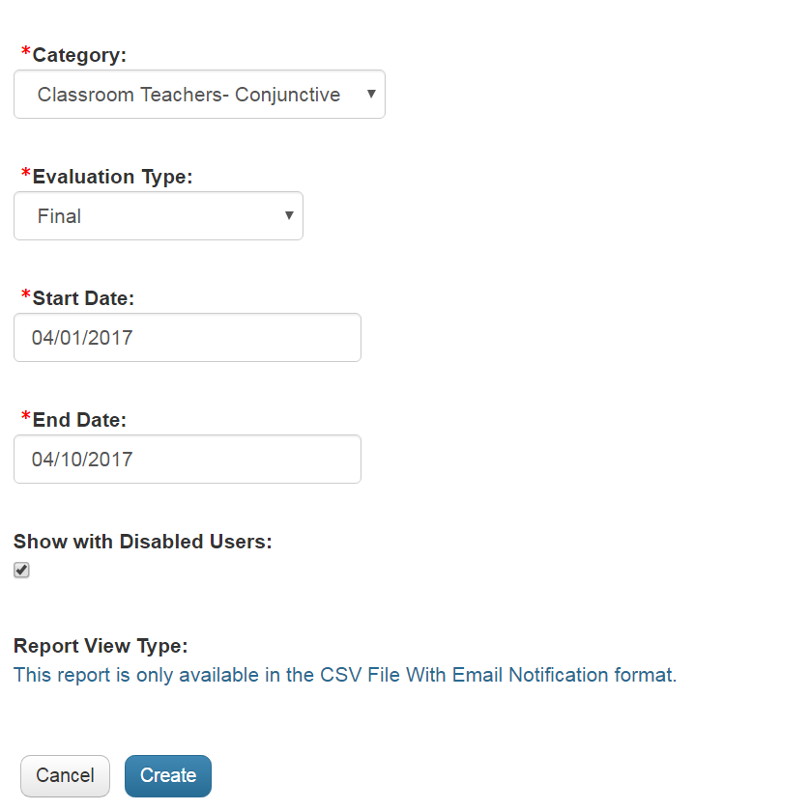

Open the report by clicking on the report date:
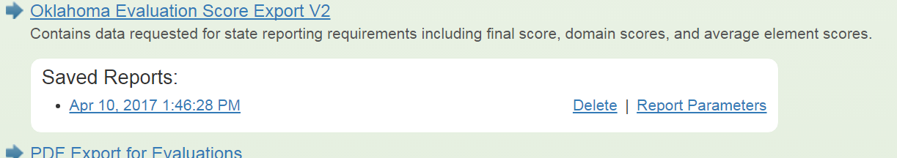

Sort the report by building, enter “True” in the Exempt column (column E) for any staff member that may not need to have information submitted, update the EvaluationType column (column J) with “Teacher,” “Leader,” or “Non-Classroom Professional”:
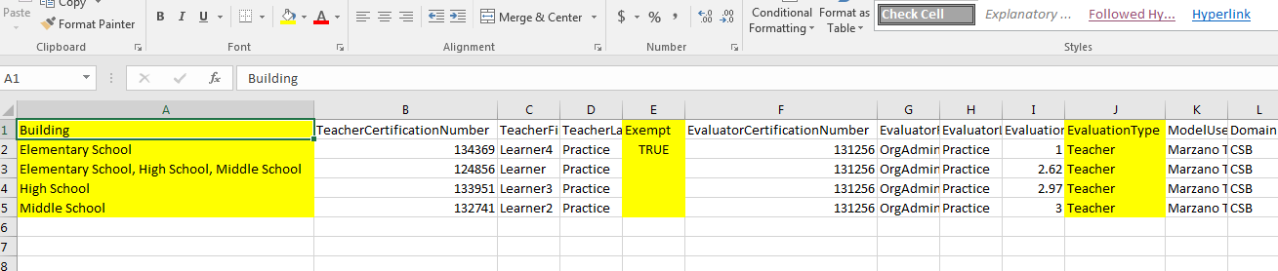

Cut and paste each separate site into a new tab or spreadsheet:
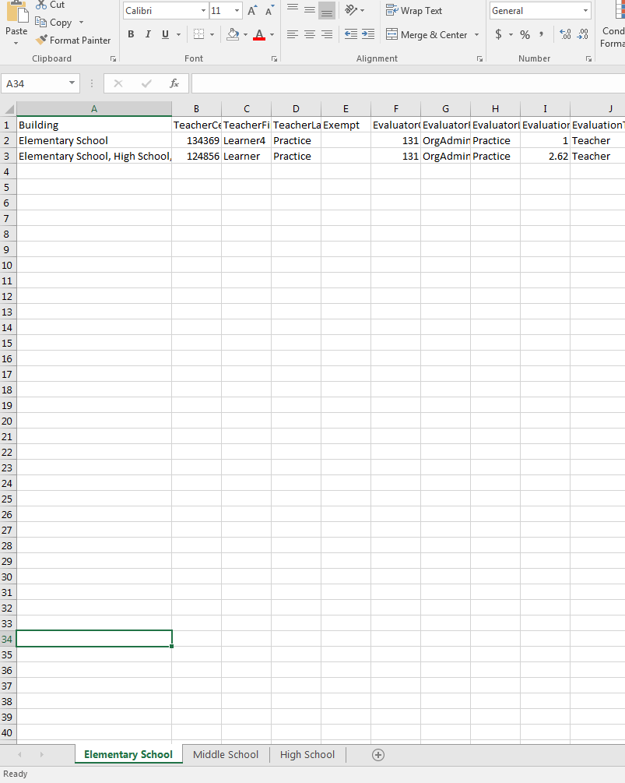
Run another report for the next evaluation category and repeat the above steps, adding the information to each appropriate site/building tab.

Once you have run the report for all evaluation categories, delete the Building column (column A) from each building tab or spreadsheet.

