Oklahoma: Preparing Principal Evaluation Data for Submission to the Wave
At the end of every school year, the Oklahoma Department of Education opens their web-based portal, known as the Wave, for districts to submit evaluation score data for their teachers and principals to the State. Their website (http://sde.ok.gov/sde/wave-system) contains guidance on submitting evaluation data files to the wave. To submit annual evaluation data to the Wave you will upload a separate evaluation score file for each of your campuses. Each of those files will contain both teacher and principal evaluation data.
Since your principal evaluation data are housed in a SearchSoft system, and your teacher data are not, you will need to add your principal data to your teacher data prior to uploading it to the Wave. This tutorial starts with the assumption that, using tools within your teacher evaluation system, you have already extracted a spreadsheet containing your teachers’ evaluation data.
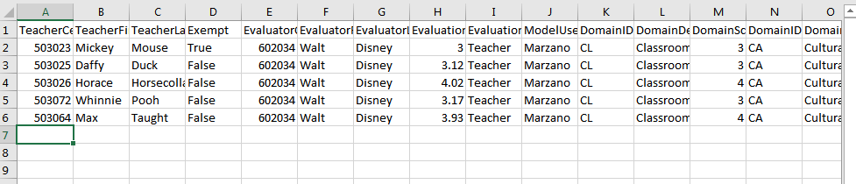
The next step is to extract your principals’ evaluation data from your SearchSoft/McREL Balanced Leadership Evaluation System. Click Data, then Reports.
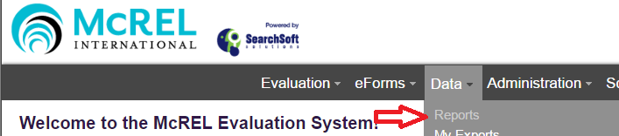

Then click the “Report” link for the TLE Qualitative Report.
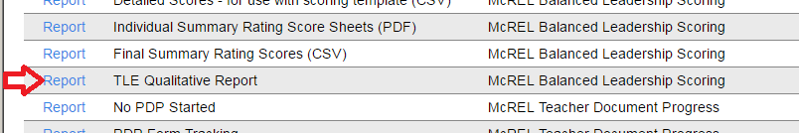

Then choose the School Year, Location(s), “District Employee ID” and click the “Create Report” button.
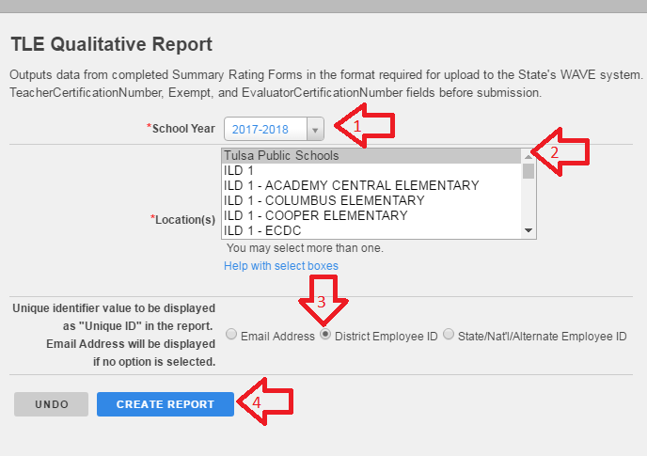
In the Location(s) field, clicking the name of your district is equivalent to clicking all your locations. Selecting the “District Employee ID” field will allow the “TeacherCertificationNumber” and “EvaluatorCertificationNumber” report fields to complete, provided this information exists in your evaluators’ and evaluees’ profiles. 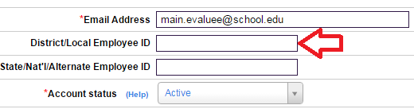
NOTE: You do not need to complete this field for your employees; you can simply hand-type these values into your spreadsheet if preferred.

After clicking “Create Report”, a download will begin.
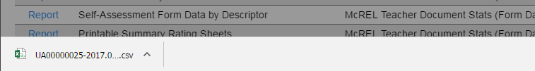
Follow your browser’s prompts to download and open the file. This file will be in CSV format. CSV files are not Excel files. But, on most PC systems, CSV files are configured to automatically open with Excel. If you are using a Mac, you may need to explicitly open the file in Excel so that you can manipulate it more easily.
When you open your file you will see your principals’ scores. If you do not see scores for a particular principal, it is because the principal does not have a completed Summary Rating Form for the selected school year. You may need to ask the evaluators and evaluees to visit their Pending Items pages to fulfill their respective signature requirements.
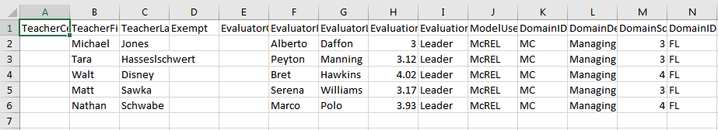
This year the WAVE will not accept any blank values. But, since the file requires data that are not stored in the SearchSoft system, you will need to enter the values of the evaluator’s and evaluee’s certification numbers (previously discussed as the “District/Local Employee ID” field) and exempt status by hand.
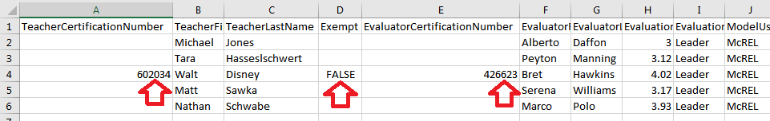
Once you have entered those values for all your principals, save the file to your computer for safe keeping.
Next you will open the teacher evaluation data file you created with your other evaluation system. You should have one file for each campus.
Then find the principals’ data that correspond to that campus, copy all the data from that/those row(s),
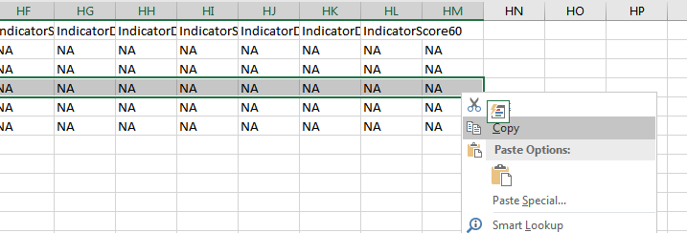
and paste the data into the teacher file.
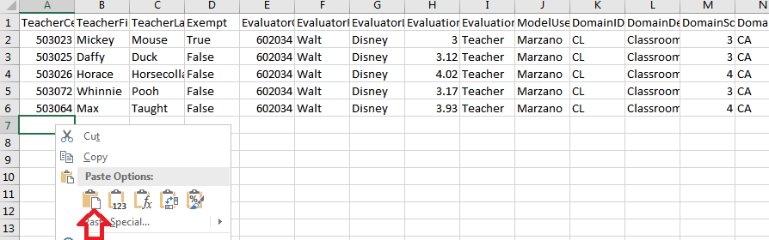
IMPORTANT: Do not select the entire data row in your principal data file via clicking the row number. Rather, using click and drag, highlight each of the data cells. This – clicking the row number to highlight it, rather than all the data cells – is the most common mistake users make in the copy/paste process. The second-most common mistake is failing to highlight all the data when copying. The right-most column this year is column HM.
When you are finished you will have a file that contains all the evaluation data for a single campus.
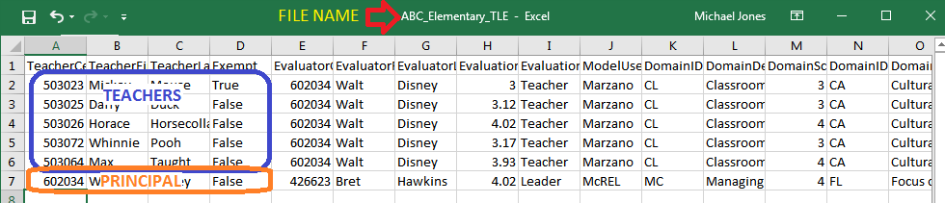
Save this file to your computer and upload it to the Wave, per the instructions provided by the Department of Education’s website. Repeat the copy, paste, save and upload steps for each of your campuses.

