Creating a Schoolwide/School Improvement Plan in GMS
- Log in to Single-Sign-On: https://sdeweb01.sde.ok.gov/SSO2/Signin.aspx
- Click on the “Grants Management and Expenditure Reporting” link
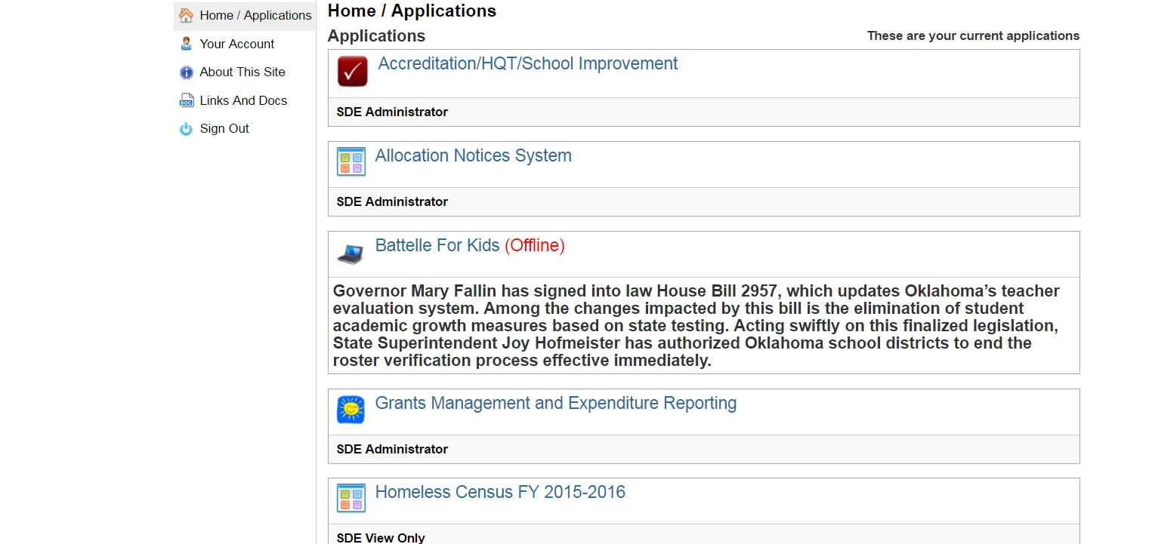

- Click “GMS Access/Select” link
- Scroll down to the “Available” section to view the “Consolidated Plan” section.

- Click the black to expand the section, and then click the blue “Create Site” button.
- Check the “Yes” box.
- This will reveal the option to create a new SW/SI Plan.
- Select site from the drop down menu and click the blue “Create New Project” button.
When a site has a SW/SI plan that was final approved in the previous fiscal year, there is the option to roll forward the existing approved SW/SI Plan. In this case, when given the option to select a site, choose the site from the “Roll Existing Project Forward” menu. If the site does NOT appear in this menu, they DO NOT have a SW/SI Plan that was previously final approved, and therefore, this option cannot be used.

Click the blue “Roll Existing Forward” button.

