**Oklahoma State Department of Education**

**Office of Federal Programs**

**Federal Programs Resource Toolkit**

2017-2018

## TABLE OF CONTENTS

|  |  |
| --- | --- |
| PLANS | 3 |
| PROFESSIONAL DEVELOPMENT ACTIVITIES PLAN GUIDELINES | 4-5 |
| ENGLISH LANGUAGE ACADEMIC PLAN | 6-7 |
| EDUCATIONAL ASSISTANCE PLAN GUIDELINES | 8 |
| **LETTERS** | 9 |
| PARENTS RIGHT-TO-KNOW LETTER | 10 |
| ENGLISH LANGUAGE LEARNER PARENTS RIGHT-TO-KNOW LETTER | 11 |
| PARENTS RIGHT TO DECLINE LANGUAGE INSTRUCTION EDUCATIONAL PROGRAM | 12 |
| PARENTS NOTIFICATION LETTER REGARDING TEACHER CERTIFICATION STATUS | 13 |
| **FORMS** | 14 |
| TITLE I SCHOOL-PARENT COMPACT | 15-18 |
| PARAPROFESSIONAL QUALIFICATIONS FORM | 19-21 |
| TIME DISTRIBUTION RECORDS | 22-26 |
| INVENTORY INSTRUCTIONS | 27 |
| RECRUITER CONTACT LOG FORM | 28 |
| PRIORITY FOR SERVICES FORM | 29-31 |
| ENGLISH LEARNER MONITORING FORM | 32 |
| **FEDERAL REQUIREMENTS** | 33 |
| FEDERAL PROGRAMS REQUIRED ADMINISTRATIVE POLICIES FOR LEAs | 34 |
| SINGLE AUDIT BASICS | 35-36 |

# *PLANS*

## *PROFESSIONAL DEVELOPMENT ACTIVITIES PLAN GUIDELINES*

*If the LEA is participating in a Federal Programs Consolidated Monitoring, complete the information in the chart below for planned professional development for the current school year.*

**Funding Source:**

Note what funding source(s) -state, local, and federal- paid for the professional development activity.

**Date:**

Date or date range that the professional development activity will take place.

**Planned Professional Development Activity Description:**

Include name of activity along with information such as registration fees, lodging, transportation, per diem, training products purchased, trainer fees, stipends etc.

**Total Number of Staff to be Trained:**

Include all staff members that participated in the professional development activity.

**Total Cost:**

Provide a total of the funds used to pay for the professional development activity.

|  |  |  |  |  |
| --- | --- | --- | --- | --- |
| **Funding Source**  (i.e. State, 511, 541, etc.) | **Date** | **Planned Professional Development Activity Description** | **Total Number of Staff to be Trained** | **Total Cost** |
|  |  |  |  |  |
|  |  |  |  |  |
|  |  |  |  |  |
|  |  |  |  |  |
|  |  |  |  |  |
|  |  |  |  |  |
|  |  |  |  |  |
|  |  |  |  |  |
|  |  |  |  |  |
|  |  |  |  |  |
|  |  |  |  |  |
|  |  |  |  |  |

**HIGH-QUALITY PROFESSIONAL DEVELOPMENT**

*Title IX, Part A, Section 9101(34)*

The term “high-quality professional development” means professional development that meets the criteria contained in the definition of professional development in Title IX, Section 9101(34) of ESEA. Professional development includes, but is not limited to, activities that:

• Improve and increase teachers’ knowledge of academic subjects and enable teachers to become highly qualified;

• Are an integral part of broad schoolwide and districtwide educational improvement plans;

• Give teachers and principals the knowledge and skills to help students meet challenging state academic standards;

• Improve classroom management skills;

• Are sustained, intensive, and classroom-focused and are not one-day or short-term workshops;

• Advance teacher understanding of effective instruction strategies that are based on scientifically based research; and

• Are developed with extensive participation of teachers, principals, parents, and administrators.

**SCIENTIFICALLY BASED RESEARCH**

*Title IX, Part A, Section 9101(37)*

*The term “scientifically based research”:*

*A. Means research that involves the application of rigorous, systematic, and objective procedures to obtain reliable and valid knowledge relevant to education activities and programs; and*

*B. Includes research that –*

*i. Employs systematic, empirical methods that draw on observation or experiment;*

*ii. Involves rigorous data analyses that are adequate to test the stated hypotheses and justify the general conclusions drawn;*

*iii. Relies on measurements of observational methods that provide reliable and valid data across evaluators and observers, across multiple measurements and observations, and across studies by the same or different investigators;*

*iv. Is evaluated using experimental or quasi-experimental designs in which individuals, entities, programs, or activities are assigned to different conditions and with appropriate controls to evaluate the effects of the condition of interest, with a preference for random-assignment experiments, or other designs to the extent that those designs contain within-condition or within-condition controls;*

*v. Ensures that experimental studies are presented in sufficient detail and clarity to allow for replication or, at a minimum, offer the opportunity to build systematically on their findings; and*

*vi. Has been accepted by a peer-reviewed journal or approved by a panel of independent experts through a comparable rigorous, objective, and scientific review. [Title IX, Part A, Section 9101(37)]*

## *ENGLISH LANGUAGE ACADEMIC PLAN (ELAP)*

Any student identified as English Learner (EL) through the state English Language Proficiency Assessments (ELPA), currently the WIDA spectrum of exams, must have a completed English Language Academic Plan (ELAP) on file and accessible to appropriate instructional personnel. The following sample document may be downloaded from the OSDE website.

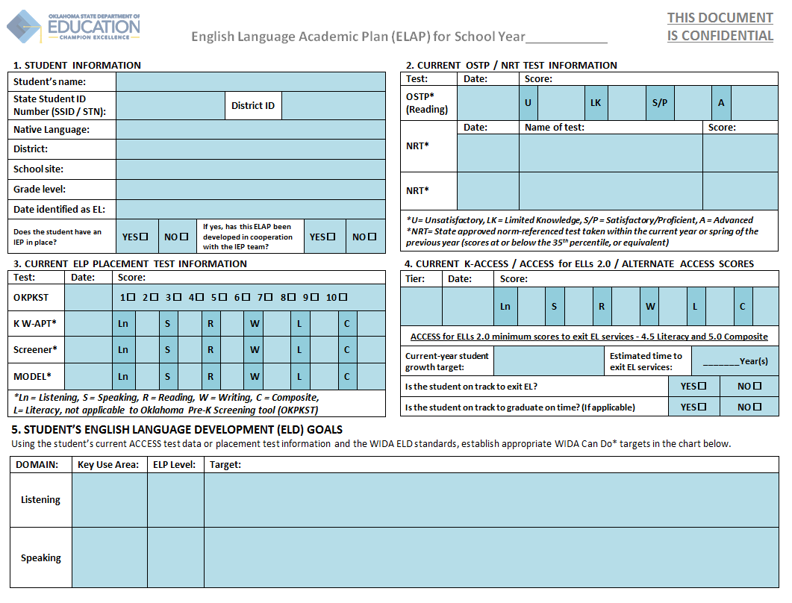

**SAMPLE**

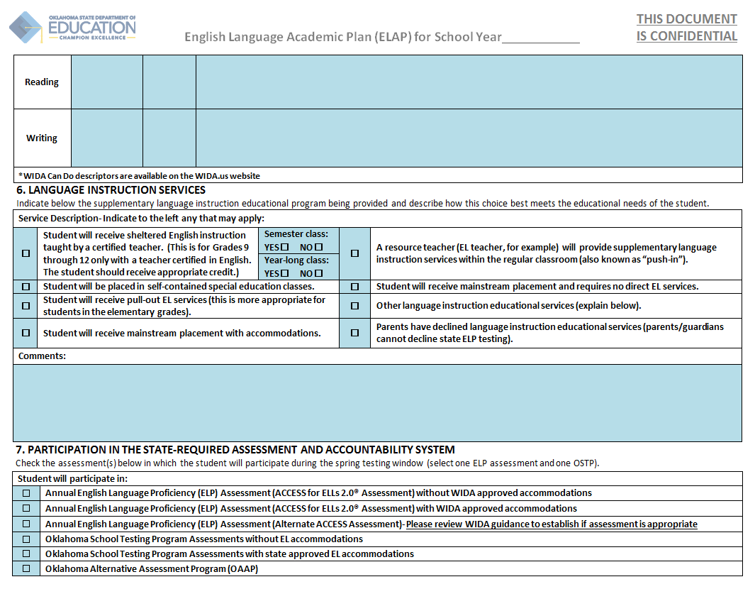

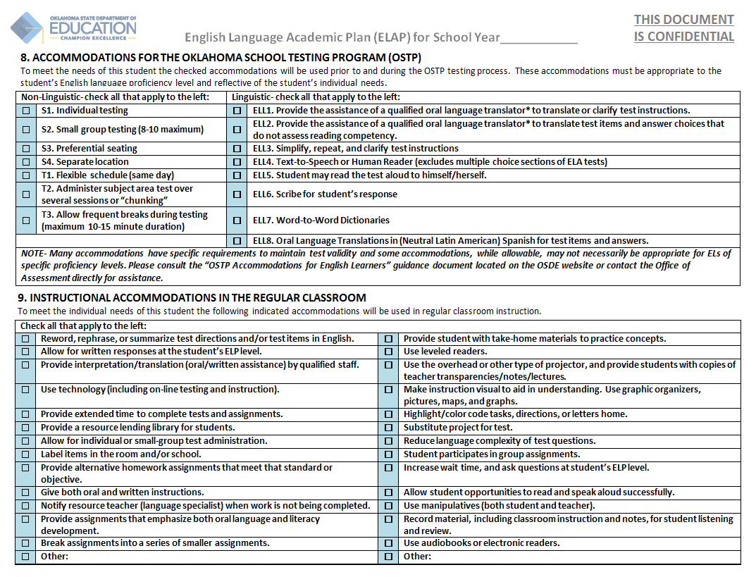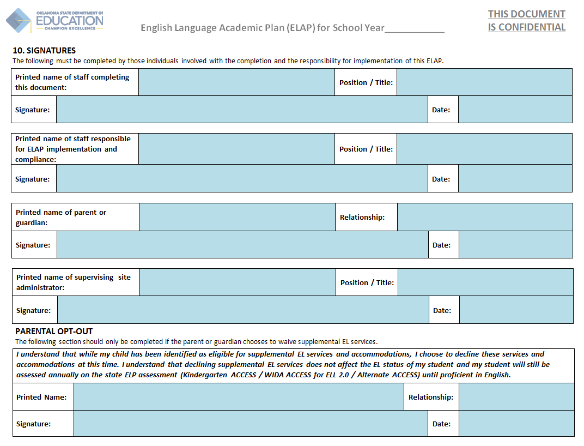

**SAMPLE**

## *EDUCATIONAL ASSISTANCE PLAN GUIDELINESS*

Tuition reimbursementis allowable from Title II Part A as a strategy to improve teacher and principal quality, and promote their professional growth.

Depending on the amount an employer provides to its employees, IRS requires the employer (LEA) to report employee’s (teacher/principal) income on the W-2 Form. (For more information see <http://www.irs.gov/publications/p970/ch11.html> )

Whether tuition reimbursement is taxable or not is between the teacher and the employer, and it depends on the amount received and if the employer has a written Educational Assistance Plan.

The *Educational Assistance Plan* is a written plan that stipulates tuition reimbursement to employees. Although the OSDE has no template that LEAs may use, there are components that must be covered in this plan. The *Educational Assistance Plan* must:

1. **Establish the eligibility requirements** for school personnel to receive tuition reimbursement from Title II A funds.

Eligibility criteria examples: be a certified teacher, teach a core academic subject (and give a definition of what is considered a core academic subject), work towards an advanced degree in a core academic subject, etc.

1. **Not be discriminatory in its eligibility requirements**

Indicate that the eligibility requirements are exclusively based on … (LEA created list), and they do not discriminate against …. (LEA created list).

1. **Not favor highly compensated employees.**

Describe how the plan meets this requirement, such as: tuition reimbursement is open to all certified teachers who meet the above eligibility requirements, regardless of … (LEA created list, including teacher remuneration).

1. **Indicate the amount that employees may receive during a school year.**

This will keep things equitable, and will not favor one teacher to receive all or the majority of the amount budgeted by the district for tuition reimbursement. Furthermore, please keep in mind that an LEA can never pay for an entire degree (even though a few classes are paid at a time).

1. **Be publicized to all employees who are eligible to participate.**

Make this plan part of the Faculty Handbook for example (to indicate that it is publicized and accessible to all employees, at any time). Then, you mention ways of disseminating this document.

# *LETTERS*

## *PARENTS RIGHT-TO-KNOW LETTER*

*\*This letter should be sent to parents/guardians at the beginning of each school year*

Date:

Dear Parents and Guardians:

In accordance with Parents Right-to-Know requirement under *Every Student Succeeds Act - ESSA, Section1112 (e)(1)(A)* this is a notification from_________________ Public Schools to every parent/guardian of a student in a Title I school that you have the right to request and receive in a timely manner:

1. information regarding the professional qualifications of your student’s classroom teachers. The information regarding the professional qualifications of your student’s classroom teachers shall include the following:

* If the teacher has met state qualification and licensing criteria for the grade level and subject areas taught;
* If the teacher is teaching under emergency or temporary status in which the state qualifications and licensing criteria are waived;
* The teachers baccalaureate degree major, graduate certification, and field of discipline; and
* Whether the student is provided services by paraprofessionals, and if so, their qualifications

*[ESSA, Section 1112(e)(1)(A)(i)-(ii)]*

1. information regarding any State or local educational agency policy regarding student participation in any assessments mandated by section 1111(b)(2) and by the State or local educational agency, which shall include a policy, procedure, or parental right to opt the child out of such assessment, where applicable.

*[ESSA, Section 1112(e)(2)(A)]*

1. upon request, parents of an English learner may:
   * have the child immediately removed from an English Learner (EL) program; *[ESSA 1112(e)(3)(A)(viii)(i)]*
   * decline the child’s enrollment in an EL program, or choose another program or method of instruction, if available; *[ESSA, Section 1112(e)(3)(A)(viii)(ii)]*
   * receive assistance in selecting among various programs and methods of instruction, if more than 1 program or method is offered by the eligible entity. *[ESSA 1112(e)(3)(A)(viii)(iii)]*
2. In addition to the above information you will be notified if your student has been taught for four or more consecutive weeks by a teacher who does not meet the applicable state certification for licensure requirements at the grade level and subject area in which the teacher has been assigned.

*[ESSA, Section 1112(e)(1)(B)(ii)]*

If you have questions or concerns, please feel free to contact the school principal at ______________________

Sincerely,

School Principal

## *ENGLISH LANGUAGE LEARNER PARENTS RIGHT-TO-KNOW LETTER*

*\*This letter should be sent to parents/guardians not later than 30 days after the beginning of the school year, or during the first 2 weeks of the child’s placement in a language instruction educational program*

Date:

Dear Mrs./Mr. :

In accordance with the Parents Right-to-Know requirement under *Every Student Succeeds Act - ESSA, Section1112 (e)(3)(A)* this is a notification from Public Schools to parents/guardians of identified for participation or participating in our district’s _________________________ English Learner (EL) program, that you have the right to request and receivein a timely manner to:

* + have the child immediately removed from this EL program; *[ESSA, Section 1112(e)(3)(A)(viii)(i)]*
  + decline the child’s enrollment in this EL program, or choose another program or method of instruction, if available; *[ESSA, Section 1112(e)(3)(A)(viii)(ii)]*
  + receive assistance in selecting among various programs and methods of instruction, if more than 1 program or method is offered by the district. *[ESSA, Section 1112(e)(3)(A)(viii)(iii)]*

Based onyour child’s English proficiency test scores, level of academic achievement, and teacher recommendation, we are pleased to inform you that your child will receive instruction in the district’s _________________________ program. In addition, the attached English Learner Academic Plan (ELAP) contains information regarding:

methods of instruction

English Language Development goals of the child

educational strengths and needs of the child

English Language instruction to meet age-appropriate academic achievement standards

accommodations for children with an individualized education program (IEP)

exit requirements for the program

The goal of this program is to help your child learn English and meet age-appropriate academic standards. If you wish to decline your child’s participation in this program, please complete the attached form and return it to the school.

Sincerely,

School Principal

## *PARENTS RIGHT TO DECLINE LANGUAGE INSTRUCTION EDUCATIONAL PROGRAM*

Date:

I, , the parent/guardian of

decline my child’s participation in the Language Instruction Educational Program offered by

Public Schools for the school year 2017-2018.

Although I chose to decline these services, I understand that my child will continue being identified as an English Learner, and will continue to be administered the English Language Proficiency Assessment.

Signature

## *PARENTS NOTIFICATION LETTER REGARDING TEACHER CERTIFICATION STATUS*

Date :

Dear Parents and Guardians:

The *Every Student Succeeds Act - ESSA, Section 1112(e)(1)(B)(ii)* requires all Title I schools to notify parents or guardians of a child who is a student in such school after a class has been taught for four consecutive weeks by a teacher who has not met state qualification and licensing requirements for the grade level and subject areas assigned to be taught.

The purpose of this letter is to notify you, as required by the federal law, that Mr./Ms._____________________ does not currently meet qualification and licensing requirements for the grade level and subject areas being taught to your child.

Nevertheless, given his/her professional experience, we believe that your child is receiving high-quality education in his/her class. (Any additional information or explanation may be inserted here.)

If you have any concerns regarding this information, you have the right, as a parent/guardian, to review the qualifications of your child’s teacher. Please contact name/title at number if you have any questions.

Sincerely,

School Principal

# *FORMS*

## *TITLE I SCHOOL-PARENT COMPACT*

*ESSA, Section 1116(d)*

Any school receiving Title I funds must have a School-Parent compact. A compact is a voluntary agreement between groups of people and is a component of the school-level parent involvement policy. It outlines how parents, school staff, and students will share the responsibility for improved student academic achievement.

School responsibilities:

* Provide high-quality curriculum and instruction;
* Provide a supportive and effective learning environment; and
* Enable children to meet the challenging academic state standards.

*ESSA, Section 1116(d)(1)*

Parent’s responsibilities:

* Volunteer in their child’s classroom;
* Participate, as appropriate, in decisions relating to the education of their children; and
* Monitor the positive use of extracurricular time.

*ESSA, Section 1116(d)(1)*

Communication between teachers and parents on an ongoing basis:

* Conduct parent-teacher conferences in elementary schools, at least annually, during which the compact should be discussed as the compact relates to the child’s achievement;
* Provide frequent progress reports to parents on their children’s progress; and
* Provide reasonable access to staff, opportunities to volunteer and participate in their child’s class, and observation of classroom activities.
* Ensuring regular two-way, meaningful communication between family members and school staff, and, to the extent practicable, in a language that family members can understand.

*ESSA, Section 1116(d)(2)(A)(B)(C)***ELEMENTARY LEVEL SCHOOL-PARENT COMPACT FORM**

*It is important that families and schools work together to help students achieve high academic standards. Through a process that included teachers, families, students, and community representatives, the following are agreed upon roles and responsibilities that we as partners will carry out and to support student success in school and in life.*

As a STAFF MEMBER, I will provide your child with every opportunity to learn and grow by:

* Maintaining a quiet and organized workplace;
* Having a high expectation of myself and my students;
* Giving instruction and assignments appropriate for the skill and development required by state and district standards;
* Monitoring student work on a daily basis to ensure success and progress; and
* Reporting regularly to parents with returned work, written notices, and conferences.

As a STUDENT, I will keep my focus on what is important in meeting my goal of learning by:

* Being in class on time, every day, with my homework in hand and prepared to work;
* Allowing the teacher to teach and everyone in class to learn;
* Completing my work on time and accurately;
* Keeping my hands, feet, objects, and comments to myself; and
* Respecting others and their property.

As a PARENT/GUARDIAN, I will support ____________’s (name of school) programs and activities that give my child the optimum opportunity for learning by:

* Expecting my child to complete daily homework assignments independently and discuss his/her results for improved learning, and check for a timely return to school;
* Accentuating the positive events at school and help my child resolve issues of concern and conflict;
* Supporting the discipline policy and reinforcing the highest expectations of the school staff;
* Reading to and listening to my child read daily as a way of building a lifelong interest and joy of reading;
* Seeing that my child gets adequate rest and is in school on time with a positive outlook;
* Attending conferences to discuss my child’s progress and attending events which showcase my child’s work and learning experiences; and
* Providing and maintaining accurate information on my child’s records for contact.

|  |  |  |  |
| --- | --- | --- | --- |
| Parent/Guardian: |  | Date: |  |
| Student: |  | Date: |  |
| Teacher: |  | Date: |  |
| Principal: |  | Date: |  |

**MIDDLE SCHOOL LEVEL SCHOOL-PARENT COMPACT FORM**

Our school philosophy as a school is that families, students and school staff should work in partnership to help each student reach his/her potential. **As partners we agree to the following:**

**As a student I will:**

* Believe that I can learn and will learn;
* Read for at least 30 minutes, five days a week;
* Come to class on time, ready to learn and with assignments completed;
* Set aside time every day to complete my homework;
* Know and follow the school and class rules;
* Follow the school's uniform dress code;
* Regularly talk to my parents and my teachers about my progress in school; and
* Respect my school, classmates, staff and family.

Student Signature ________________________________

**As a parent/guardian or family member I will:**

* Talk to my child regularly about the value of education;
* Monitor television viewing and make sure that my child reads every day;
* Make sure that my child attends school every day, on time, and with homework completed;
* Support the school's discipline and uniform dress code;
* Monitor my child's progress in school;
* Make every effort to attend school events such as parent-teacher conferences, Open House and Back-to-School Night;
* Ensure that my child receives adequate sleep, regular medical attention and proper nutrition;
* Participate in shared decision making with school staff and other families for the benefit of students; and
* Respect the school, staff, students and families.

Parent/guardian Signature _______________________________

**As a teacher I will:**

* Communicate high expectations for every student;
* Endeavor to motivate my students to learn;
* Teach and involve students in classes that are interesting and challenging;
* Participate in professional development opportunities that improve teaching and learning and support the formation of partnerships with families and the community;
* Enforce rules equitably and involve students in creating a warm and caring learning environment in the class;
* Communicate regularly with families about their child's progress in school;
* Provide assistance to families on what they can do to support their child's learning;
* Participate in shared decision making with other school staff and families for the benefit of students; and
* Respect the school, staff, students and families.

Teacher Signature _______________________________

Principal Signature ______________________________

**HIGH SCHOOL LEVEL SCHOOL-PARENT COMPACT FORM**

|  |  |  |  |  |
| --- | --- | --- | --- | --- |
| **Schools, families, and students benefit when they all take collective responsibility for quality education.** When a partnership exists and each partner fulfills his/her responsibilities, student learning improves. The term school community refers to teachers, students, families, other school staff and community members. The signatures below indicate our support of and commitment to the following responsibilities: | | | | |
| ***Administrative Responsibilities*** | ***Teacher Responsibilities*** | ***Family Responsibilities*** | | ***Student Responsibilities*** | |
| 1. Through collaborative decision making, create with the involvement of staff, families, students and the community, a compelling school vision and quality educational program with high standards that are widely understood and embraced by the school community. | 1.Through collaborative decision making with colleagues, families and students, create a school vision and quality educational program with high standards that are widely understood and embraced by the school community. | 1. Through collaborative decision making, participate with school staff and students in creating a compelling school vision and quality educational program with high standards that are widely understood and embraced by the school community. | | 1. Through collaborative decision making, participate with parents and school staff in creating a compelling school vision and quality educational program with high standards that are widely understood and embraced by the school community. | |
| 2. Provide instructional leadership to ensure appropriate instructional practices, high academic standards, student support, and the delivery of a quality core curriculum to all students. | 2. Endeavor to motivate my students to learn. Provide appropriate and varied classroom instruction that actively involves students, and maintain high standards within each subject. | 2. Communicate the value of education, and provide home support and monitoring of student academic work and progress in school. | | 2. Produce quality work that meets the high standards of each class. | |
| 3. Provide a safe, orderly and positive teaching/learning environment. | 3. Provide a safe, orderly, and caring classroom environment conducive to learning. | 3. Establish a schedule with my child for study time, television viewing, peer activities and out-of-school time. | | 3. Attend school regularly, on time, and with completed homework. Follow agreed schedule and home/school rules. | |
| 4. Provide appropriate professional development for staff, families and students to improve teaching and learning and to support collaborative partnerships with families and the community. | 4. Participate in professional development opportunities that improve teaching and learning and support the formation of partnerships with families and the community. | 4. Participate in training opportunities with staff that help to improve teaching and learning both at home and at school. | | 4. Participate in school activities with my parents and teachers that help to improve teaching and learning both at home and at school. | |
| 5. Maintain open two-way communication between the home and school. | 5. Establish two-way communication with families about student progress in school. | 5. Communicate regularly with the school. | | 5. Tell parents honestly what is happening at school and help to maintain two-way communication. | |
| 6. Respect the school, students, staff and families. | 6. Respect the school, students, staff and families. | 6. Respect the school, staff, students, and families. | | 6. Respect the school, staff, students, and families. | |
| Signatures | | | | | |
|  |  |  |  | | |
| Principal | Teacher | Parent/Guardian | Student | | |

Returned and filed at school this _________ day of ____________________, 20____.

## *PARAPROFESSIONAL QUALIFICATIONS FORM*

For the purposes of Title I, Part A, a paraprofessional is an employee of an LEA who provides instructional support in a program supported with Title I, Part A funds. Each LEA receiving assistance under Title I, Part A must ensure that all teachers and paraprofessionals working in a program supported with funds under this part meet applicable State certification and licensure requirements, including any requirements for certification obtained through alternative routes to certification. *[ESSA, Section 1111(2)(J)]*

The following paraprofessional duties are considered *instructional support*:

* To provide one-on-one tutoring *support* at a scheduled time when the student would otherwise not be receiving instruction from a teacher;
* To assist with classroom management, such as organizing instructional and other materials;
* To provide assistance in a computer laboratory;
* To conduct parental involvement activities;
* To provide support in a library or media center;
* To act as a translator; or
* To provide instructional services to students under the direct supervision of a state certified teacher.

When providing any instructional support services, the paraprofessional must be under the direct supervision of a highly qualified teacher.

In a schoolwide site all instructional support paraprofessionals must meet the Title I, Part A requirements. In a targeted assistance site only those instructional support paraprofessionals who are paid in whole or in part with Title I, Part A funds must meet the Title I, Part A requirements.

A paraprofessional must complete at least one of the following:

* Completed at least 2 years (48 credit hours) at an institution of higher education;
* Obtained an associate (or higher) degree; or
* Completed the Oklahoma General Education Test (OGET) or the ParaPro Test and achieved a passing score.

Ask the following questions in the flowcharts on the following page to determine if you must meet the paraprofessional qualification requirements.

Do you provide instructional support?

You are not required to meet ESSA paraprofessional requirements.

Do you work in a schoolwide site under Title I, Part A **OR** are you paid in whole or in part with Title I, Part A funds?

Do you have a high school diploma or a GED?

You are not required to meet the ESSA paraprofessional qualifications.

You have not met the ESSA requirements. You cannot be employed to work in a program supported by Title I funds.

Do you have an Associate Degree?

Have you completed two years (48 credit hours) of study at an institution of higher education?

Have you passed the Oklahoma General Education Test (OGET)?

Have you passed the ParaPro test with a score of 455 or better?

You have not met the ESSA requirements.

You have met the ESSA paraprofessional requirements.

You have met the ESSA paraprofessional requirements.

You have met the ESSA paraprofessional requirements.

You have met the ESSA paraprofessional requirements.

|  |  |  |  |  |  |  |  |  |  |  |
| --- | --- | --- | --- | --- | --- | --- | --- | --- | --- | --- |
| **PARAPROFESSIONAL QUALIFICATION FORM**  Certification of Qualified Instructional Support Paraprofessionals | | | | | | | | | |  |
|  |  |  |  |  | | | | |  | |
| District Name | Code |  |  | County Name | | | | | Code | |
|  | | | | | | | | | |  |
| Title I of the Elementary and Secondary Education Act (ESEA), as amended by the Every Student Succeeds Act (ESSA), is designed to help disadvantaged children reach high academic standards. Properly trained paraprofessionals can play important roles in improving student achievement in Title I schools where they can reinforce and augment a teacher's effort in the classroom. Instructional paraprofessionals must work directly under the supervision of a state certified teacher. | | | | | | | | | | |
|  | | | | | | | | | |  |
| Please list all paraprofessionals providing instructional support, the site code where each is providing support, grade level for support, and enter a check mark in the column for the qualification requirement the paraprofessional has met. | | | | | | | | | | |
|  | | | | | | | | | |  |
|  | | | | **Paraprofessional has met requirement with:** | | | | | **Has NOT met requirements** | **Works under the direct supervision of a highly qualified teacher** |
|  | | |  | **Associate Degree** | **48 Hours of College Credit** | **Oklahoma General Education Test (OGET)** | **Paraprofessional Test (ParaPro)** | **WorkKey** |
| **Name of Paraprofessional** | **Site Code** | **Grade Level** | **Federal Funding Project Code** |
| (*Example*) John R. Doe | 105 | K-5 | 511 |  | X |  |  |  |  | *Yes* |
|  |  |  |  |  |  |  |  |  |  |  |
|  |  |  |  |  |  |  |  |  |  |  |
|  |  |  |  |  |  |  |  |  |  |  |
|  |  |  |  |  |  |  |  |  |  |  |
|  |  |  |  |  |  |  |  |  |  |  |
|  |  |  |  |  |  |  |  |  |  |  |
|  |  |  |  |  |  |  |  |  |  |  |
|  |  |  |  |  |  |  |  |  |  |  |
|  |  |  |  |  |  |  |  |  |  |  |
|  |  |  |  |  |  |  |  |  |  |  |
|  |  |  |  |  |  |  |  |  |  |  |
|  |  |  |  |  |  |  |  |  |  |  |
|  |  |  |  |  |  |  |  |  |  |  |
|  |  |  |  |  |  |  |  |  |  |  |

## *TIME DISTRIBUTION RECORDS*

Employees that are paid with federal funds from single and/or multiple funding sources are required to document their time and effort by maintaining Time Distribution Records at the time that services are performed. Salaries for such employees will be paid monthly according to the time distribution among specific activities/funding sources, regardless of Title I targeted or schoolwide program status.

The total compensation for individual employees must adhere to the following Standards of Documentation:

1. Total compensation must be reasonable for the services rendered, based on records that accurately reflect the work performed and support payment amount, not exceeding 100% of paid activities.
2. Assignment follows a job description made in accordance with policies/laws that meet Federal statutes requirements.
3. Personnel expenses must be based on records that accurately reflect the work performed and be supported with verifiable documentation as stated below.
   1. Assurance that charges are accurate, allowable and properly allocated.
   2. All reports/payments are incorporated into the official records of the LEA.
   3. Include both federally funded and all other activities paid by the LEA on an integrated basis, but may also comprise of supplemental records as defined in the LEA’s written policy.
   4. Comply with the established accounting policies and practices of the LEA.
   5. Support the distribution of all salary/wages among specific activities or cost objectives regardless of work in any combination of Federal/non-Federal award or direct/indirect cost activity.
   6. Recognize that while budget estimates may be used for accounting purposes, they do not qualify as support for reimbursements of federal funds.

***Types of Time Distribution Records***

All Local Educational Agencies (LEAs) receiving federal funds under ANY federal program (Title I A, Migrant, Homeless, Neglected/Delinquent, Title VI, etc.) are responsible for ensuring that all staff members maintain accurate time distribution records. All documentation must be signed by the employee and supervisor evidencing first-hand knowledge of the work performed under the federal program. A description and samples of the documentation required, based on the type of position/duties and reporting periods are listed below.

***Permanent***– A permanent schedule is most often used for teachers or individuals who are being paid with federal funds and hold a fixed schedule every day of the week. For instance, a Title I teacher’s schedule could document that he/she is being paid 100% with federal funds and 100% of his/her day is dedicated to Title I programming. A teacher who was 50% Title I and 50% reading coach could also use this method if his/her schedule was consistent, day after day. Permanent schedules should be on file and updated throughout the school year. Teacher assignments in the Highly Qualified Teacher (HQT) system will suffice for the permanent schedule of a teacher paid with Title funds.

***Periodic***– District personnel who are funded from multiple funding sources and are on a fixed schedule (consistent duties every day-all year) must also document the amount of time allocated to each particular federal program and also maintain periodic certification documentation.

***Monthly***– District personnel who are funded from multiple funding sources and have an irregular schedule (duties change from day to day and/or during the year) must maintain a daily record within a monthly time distribution sheet. For example, an employee who is paid 25% from Title I funds to coordinate the district’s Title I program and 75% from the General Fund for other duties would keep a daily record of the time spent on Title I coordinator duties separate from the other duties. Monthly Time Distribution records must be signed by the employee and their supervisor. If the Monthly Time Distribution Records are maintained for PD activities, agendas and sign in sheets for each meeting must be kept on file & submitted with claims.

Periodic Time Distribution FORM

**District Name:** ___________________________ **County Code/Dist. #:** _____/________

|  |  |
| --- | --- |
| **Reporting Time Period:** | *E.g.: July 1 - December 31, 20XX* |
| **School Site Number:** |  |
| **Federal Program/Funding Source:** | *E.g.: Title I, Part A/ 511* |

This form is to be completed semi-annually for any employee who is paid with federal funds from a single cost objective.

|  |  |
| --- | --- |
| **Employee Name** | **Federally Funded Job Title:** |
|  |  |
|  |  |
|  |  |
|  |  |
|  |  |
|  |  |
|  |  |
|  |  |
|  |  |
|  |  |
|  |  |
|  |  |
|  |  |
|  |  |
|  |  |
|  |  |
|  |  |
|  |  |
|  |  |

*I certify that the employee(s) listed above worked 100% of their time on activities authorized by the federal program stated above.*

___________________________________ ___________________________________

Employee Signature / Date Supervisor Signature / Date

MONTHLY Time Distribution FORM

**District Name:** ___________________________ **County Code/Dist. #:** _____/________

|  |  |  |
| --- | --- | --- |
| **Employee’s Name:** |  | |
| **Federally Funded Job Title:** | *Instructional Coach* | □ Certified □ Non-Certified |
| **School Site Number:** |  | |
| **Reporting Time Period:** | *01/01-01/31/20XX* | |
| **Federal Program/Funding Source:** | *Title I, Part A* | *511* |

|  |  |  |  |
| --- | --- | --- | --- |
| **Date** | **Time In** | **Time Out** | **Federally funded activity** |
| *E.g.:01/01/20XX* | *3:00* | *4:00* | *After school PD* |
| 01/08/20XX | *3:00* | *4:00* | *After school PD* |
| 01/15/20XX | *3:00* | *4:00* | *After school PD* |
| 1/22/20XX | *3:00* | *4:00* | *After school PD* |
|  |  |  |  |
|  |  |  |  |
|  |  |  |  |
|  |  |  |  |
|  |  |  |  |
|  |  |  |  |
|  |  |  |  |
|  |  |  |  |
|  |  |  |  |
|  |  |  |  |
|  |  |  |  |
|  |  |  |  |
|  |  |  |  |
|  |  |  |  |
|  |  |  |  |
|  |  |  |  |
|  |  |  |  |
|  |  |  |  |
|  |  |  |  |
|  |  |  |  |
| *Total Time Worked* | | | *4 hours* |
| *Rate of Pay* | | |  |
| ***Total Payment*** | | | *$100* |

*I certify that the information provided above is correct.*

___________________________________ ___________________________________

Employee Signature / Date Supervisor Signature / Date

TUTORING MONTHLY Time Distribution FORM

**District Name:** ___________________________ **County Code/Dist. #:** _____/________

|  |  |  |
| --- | --- | --- |
| **Employee’s Name:** |  | |
| **Federally Funded Job Title:** | *Tutoring* | □ Certified □ Non-Certified |
| **School Site Name:** |  | |
| **Reporting Time Period:** | *01/01-01/31/20XX* | |
| **Federal Program/Funding Source:** | *Title I, Part A* | *511* |

|  |  |  |  |  |
| --- | --- | --- | --- | --- |
| **Date** | **Time In** | **Time Out** | **Federally funded activity** | **Total Time** |
| *E.g.:01/01/20XX* | *7:30* | *8:00* | *Before school Tutoring* | *30 min.* |
| 01/08/20XX | *3:00* | *4:00* | *After school Tutoring* | *1 hour* |
| 01/15/20XX | *7:30* | *7:50* | *Before school Tutoring* | *20 min.* |
|  |  |  |  |  |
|  |  |  |  |  |
|  |  |  |  |  |
|  |  |  |  |  |
|  |  |  |  |  |
|  |  |  |  |  |
|  |  |  |  |  |
|  |  |  |  |  |
|  |  |  |  |  |
|  |  |  |  |  |
|  |  |  |  |  |
|  |  |  |  |  |
|  |  |  |  |  |
|  |  |  |  |  |
|  |  |  |  |  |
|  |  |  |  |  |
|  |  |  |  |  |
|  |  |  |  |  |
|  |  |  |  |  |
|  |  |  |  |  |
|  |  |  |  |  |
| *Total Time Worked* | | |  | *1 hour/50 min.* |
| *Rate of Pay* | | |  | *$ 20* |
| ***Total Payment*** | | |  | *$ 36.67* |

*I certify that the information provided above is correct.*

___________________________________ ___________________________________

Employee Signature / Date Supervisor Signature / Date

**Tutoring Monthly Time Distribution Instructions**

**Instructions:** Complete the form to show how much time you spent each day on activities related to each program or funding source through which you receive payment. At the end of the month, total the number of hours for each program or calculate the percentage of time you have spent on each assignment. Then sign at the bottom of the sheet to certify that the total time is accurate. Finally, forward the time sheet to your supervisor for certification and processing along with any backup documentation.

**Top Section:**

Line 1: Use employee name as listed in School Personnel Records. If recently married, you may include both names.

Line 2: List specifically only the job represented by this timesheet.

Line 3: List specifically the school site where duties are performed.

Line 4: List the specific range (month, day and year) this timesheet covers.

Line 5: List the Federal program number that will pay for this duty.

**Middle Section:**

Step 1: List exact dates, starting and ending times and total time worked on each line.

Step 2: When duties are complete, total the time worked, insert the rate of pay and figure total

payment. Check for mathematical errors.

**Bottom Section:**

Step 1: Employee must sign and date the original timesheet and along with any additional backup

documentation, submit to the supervisor.

Step 2: Supervisor must sign and date the timesheet and submit the original timesheet along with

any backup documentation to the designated personnel. It is advised that the supervisor

keep a copy for their own records.

## *INVENTORY INSTRUCTIONS*

All materials, supplies, and equipment that are non-consumable and can remain in use over a period of one year must be inventoried.

All materials, supplies, and equipment (non-consumable items) purchased with federal funds, no matter what the value of the item, must be labeled.

Inventories must be kept by the district and must be annually reviewed and updated.

Store all materials, supplies, and equipment securely and appropriately.

In a Title I, Part A Targeted Assistance program reserve all materials, supplies, and equipment only for identified students.

All items must be kept on the federal program inventory for five years. After five years the district must use their policy for discarding.

The following information must be included on the inventory:

* Fund Source
* Description of Equipment
* Serial Number
* Acquisition Date
* Acquisition Cost
* Location of purchases

**FEDERAL PROGRAMS INVENTORY FORM**

|  |  |  |  |  |  |
| --- | --- | --- | --- | --- | --- |
| Fund Source | Description of Purchases | Serial Number | Acquisition Date | Acquisition Cost | Location of Purchases |
|  |  |  |  |  |  |
|  |  |  |  |  |  |
|  |  |  |  |  |  |
|  |  |  |  |  |  |
|  |  |  |  |  |  |
|  |  |  |  |  |  |
|  |  |  |  |  |  |
|  |  |  |  |  |  |
|  |  |  |  |  |  |
|  |  |  |  |  |  |
|  |  |  |  |  |  |

## *RECRUITER CONTACT LOG FORM*

**MEP logo - B&WOklahoma Migrant Program Project/District: _____________________________**

Recruiter Contact Log **Recruiter Signature: _________________________**

|  |  |  |  |  |
| --- | --- | --- | --- | --- |
| **DATE / TIME** | **CONTACT** | **PERSON / AGENCY**  **CONTACTED** | **PURPOSE** | **NARRATIVE /**  **COMMENT** |
| From:_________  To:___________ | □ Face to Face  □ School  □ Home  □ Agency  □ Phone  □ Other:____________ |  | □ COE Completion  □ Home School Liaison  □ Social Service □ Referral/Assistance  □ Active ID&R  □ Other:_________________ |  |
| From:_________  To:___________ | □ Face to Face  □ School  □ Home  □ Agency  □ Phone  □ Other:____________ |  | □ COE Completion  □ Home School Liaison  □ Social Service □ Referral/Assistance  □ Active ID&R  □ Other:_________________ |  |
| From:_________  To:___________ | □ Face to Face  □ School  □ Home  □ Agency  □ Phone  □ Other:____________ |  | □ COE Completion  □ Home School Liaison  □ Social Service □ Referral/Assistance  □ Active ID&R  □ Other:_________________ |  |

## *PRIORITY FOR SERVICES FORM*

**Oklahoma Migrant Education Program (MEP)** - **Student Selection and Priority for Services (PFS)**

**(Using Data from the 2017-2018 Regular School Year)**

**Oklahoma Migrant Education Program (OMEP)** **Student Selection and Priority for Services (PFS)**

The Student Selection and PFS Form is intended to assist the local MEP in determining which migrant students meet the PFS criteria and should receive migrant services first. It also serves as a collection form for the Oklahoma Migrant Student Network Database, since at-risk information should be entered into the system whether or not a student is identified as a PFS student. This form must be completed and on file for each PFS migrant student. In addition, the PFS determination must be verified for accuracy with a signature from the district’s MEP administrator.

**Note: Any migrant student who has the appropriate number of boxes checked (as described in Tables A and B) is a PFS student.**

|  |  |
| --- | --- |
| STUDENT DEMOGRAPHICS | |
| Date: |  |
| School Year: |  |
| Student’s Name: |  |
| Migrant Student Identification Number: |  |
| State Student Identification Number (SSID): |  |
| Most Current Qualifying Arrival Date (QAD): |  |
| Current School Attending: |  |
| Current Grade Enrolled: |  |
| Priority for Services Student (Yes/No): |  |
| Recipient of MEP Services (Yes/No): |  |
| **MEP Administrator Signature**: |  |

**Table A. Interruption during the Regular School Year**

(#1-4: At least one item must have a check.)

|  |  |  |
| --- | --- | --- |
| Check the one that is most recent: | Interruptions Related to Migrant Issues—During Regular School Year | School Year in Which Interruption Occurred |
|  | 1. Qualifying Arrival Date (QAD) i.e. 9/1/15 (or start of regular school year) until end of regular school year |  |
|  | 2. Moved from one district to another due to migrant lifestyle |  |
|  | 3. Absent for two or more weeks and then returned due to migrant lifestyle |  |
|  | 4. Officially withdrawn and gone for at least two weeks and then re-enrolled due to migrant lifestyle |  |

**Table B. At Risk of Failing to Meet State Standards Criteria**

(#5-11: Only one item must have a check.) OR

(#12-18: At least two items must have a check if no checks are present in numbers 5-11.)

|  |  |  |
| --- | --- | --- |
| Check all  that apply | Criteria  (Reference boxes to the left) | Year in Which Criteria Occurred |
|  | 5. Scored unsatisfactory or basic on Reading Assessment |  |
|  | 6. Scored unsatisfactory or basic on Mathematics Assessment |  |
|  | 7. Scored unsatisfactory or basic on Writing Assessment |  |
|  | 8. Scored unsatisfactory or basic on Science Assessment |  |
|  | 9. Scored unsatisfactory or basic on Social Studies Assessment |  |
|  | 10. Scored below proficient on State assessments from other States |  |
|  | 11. Scored below 50th percentile on norm-referenced test (reading and/or math) |  |
| **To be identified as a Priority for Services migrant student, there must be an interruption of services during the regular school year, and the student must meet one or more of the at-risk criteria. State assessment data must be considered first. If there are results for a migrant student, they must be used. If State assessment data is not available, at least two of the at-risk criteria (#12 – 18) must be met to be considered as priority for services. If a student is proficient on the State assessments, the student is NOT considered a priority for services student even though he or she may meet the other at-risk criteria. | | |
|  | *12. Is below grade level on any K-3 reading diagnostic assessment* |  |
|  | *13. Classified as non-English or limited English proficient on LAS, IPT,*  *LPT, ACCESS for ELLs, or English Proficiency Assessment (ELPA)* |  |
|  | *14. Is behind in accruing credits toward graduation requirements* |  |
|  | *15. Placed in a class that is not age appropriate* |  |
|  | *16. Has grades indicating below-average performance in math and/or*  *language arts at the elementary level* |  |
|  | *17. Has grades indicating below-average performance in math, language arts, sciences, or social studies at the middle or high school levels* |  |
|  | *18. Repeated a grade level or course* |  |

**Student name** ________________________ **School** ___________________ **Date** _______________

## *ENGLISH LEARNER MONITORING FORM*

|  |  |  |  |  |
| --- | --- | --- | --- | --- |
| **Student Name**: **ID#** **Grade**:  **District name: School Name: School Year:** | | | | |
| 1st year after scoring proficient on wida access for ells 2.0  2nd year after scoring proficient on wida access for ells 2.0 | | 3rd year after scoring proficient on wida access for ells 2.0  4th year after scoring proficient on wida access for ells 2.0 | | |
| **1ST SEMESTER** | | | | |
| **Proficiencies in the Regular Classroom** | | | **1st SEMESTER** | |
| **Oral Proficiency** | Student is making progress in oral language development. | | Yes | No |
| **Reading Proficiency** | Student is making progress in reading skills  Student is making progress in reading comprehension | | Yes  Yes | No  No |
| **Writing Proficiency** | Student is making progress in written grammar  Student is making progress in spelling  Student is making progress in written expression | | Yes  Yes  Yes | No  No  No |
| **Team Recommendation:** Continue Monitoring Status  Other Program/Interventions (specify):  **Team Comments:**   |  | | --- | | *English Language Development (ELD) Monitor Name* *ELD Monitor‘s Signature Date*  *Regular/English Teacher Name Regular/English Teacher’s Signature Date*  *Administrator Name Administrator’s Signature Date* | | | | | |
| **2nd SEMESTER** | | | | |
| **Proficiencies in the Regular Classroom** | | | **2nd SEMESTER** | |
| **Oral Proficiency** | Student is making progress in oral language development. | | Yes | No |
| **Reading Proficiency** | Student is making progress in reading skills  Student is making progress in reading comprehension | | Yes  Yes | No  No |
| **Writing Proficiency** | Student is making progress in written grammar  Student is making progress in spelling  Student is making progress in written expression | | Yes  Yes  Yes | No  No  No |
| **Team Recommendation:** Continue Monitoring Status  Other Program/Interventions (specify):  **Team Comments:**   |  | | --- | | *English Language Development (ELD) Monitor Name* *ELD Monitor Signature Date*  *Regular/English Teacher Name Regular/English Teacher Signature Date*  *Administrator Name Administrator Signature Date* | | | | | |

# *FEDERAL REQUIREMENTS*

## *FEDERAL PROGRAMS REQUIRED ADMINISTRATIVE POLICIES*

***FOR***

***LOCAL EDUCATIONAL AGENCIES (LEAs)***

Components of all the required administrative policies for LEAs can be found in the Federal Register - Code of Federal Regulations, Office of Management and Budget (OMB) and in the Every Student Succeeds Act (ESSA). Please follow the links below to identify the required components and develop LEA policies and procedures.

[*http://sde.ok.gov/sde/sites/ok.gov.sde/files/documents/files/FedProgCode%20of%20Federal%20Regulations%20FED%20REGISTER%5B1%5D.pdf*](http://sde.ok.gov/sde/sites/ok.gov.sde/files/documents/files/FedProgCode%20of%20Federal%20Regulations%20FED%20REGISTER%5B1%5D.pdf)

[*https://www2.ed.gov/documents/essa-act-of-1965.pdf*](https://www2.ed.gov/documents/essa-act-of-1965.pdf)

**LEA ADMINISTRATIVE POLICIES:**

1. Comparability Procedures *ESSA, Sec. 1118(c)(1)(A)*
2. **Federal Programs** Complaint Policy *34CFR Part 299, Subpart F*
3. Financial Management Procedures *OMB 200.302*
4. Fiscal Internal Control Policy *OMB 200.303*
5. Procurement Policy (must include Vendor Selection process) *OMB 200.318 and OMB 200.320*
6. Conflict of Interest Policy *OMB 200.112*
7. Compensation Policy *OMB 200.430*
8. Travel Policy (travel/dependent care costs reimbursement, etc.) *OMB 200.432 and OMB 200.474*

## *SINGLE AUDIT BASICS*

**Background**

Each year, the Federal Government provides over $400 billion–one-sixth of the Federal budget–in grants to non-Federal entities (States, local and tribal governments, colleges and universities, and other non-profit organizations). Audits are a primary tool used by the Federal government to ensure that these funds are expended properly.

**Basic Requirements**

All non-Federal entities that expend $500,000 or more of Federal awards in a year are required to obtain an

annual audit in accordance with the Single Audit Act Amendments of 1996, Office of Management and Budget (OMB) Circular A-133, "Audits of States, Local Governments and Non-Profit Organizations," the OMB Circular A-133 Compliance Supplement and *Government Auditing Standards*. Entities expending less than $500,000 in a year are exempt from Federal audit requirements, but must make records available for review or audit by Federal agencies or pass-through entities (non-Federal entities from whom they receive Federal funds), if requested.

**What is a Single Audit?**

Most non-Federal entities annually prepare financial statements and have them audited. A single audit combines the annual financial statement audit with additional audit coverage of Federal funds. The single audit is intended to meet the basic audit needs of both the non-Federal entity and Federal awarding agencies. Any additional auditing by the Federal government shall build upon work performed by other auditors.

**Your Primary Responsibilities**

In addition to your responsibility to administer Federal awards in compliance with Federal requirements, you have a key role to play in the single audit process:

* *Identifying Federal awards received and expended.* You are required to account for Federal funds received

and expended by individual award. This information is usually provided in grant award documents. Check with the awarding agency if you have any questions.

* *Preparing financial statements and a Schedule of Expenditures of Federal Awards (SEFA).* Most non-Federal entities prepare annual financial statements for their own purposes and are familiar with the process. Your auditor can usually answer any questions on financial statement preparation. OMB Circular A-133 sets forth the minimum content requirements for the SEFA. Questions on the preparation of the SEFA can be addressed to your auditor, Federal awarding agency, or pass-through entity.
* *Obtaining the audit and ensuring it is completed*. OMB Circular A-133 requires that Federal administrative rules be followed in procuring audit services, which can be found on OMB's website. Factors to consider in evaluating proposals for audit services include responsiveness to the request for proposal, availability of staff with professional qualifications and relevant experience, results of quality reviews and price. The Mid-America Intergovernmental Audit Forum (**www.auditforum.org**) has published a pamphlet, *Choosing an External Auditor*, to assist non-Federal entities in the procurement of audit services. The Government Accountability Office’s website (**www.gao.gov**) also contains a pamphlet, *How to Avoid a Substandard Audit: Suggestions for Procuring an Audit*. *Government Auditing Standards*, the standards auditors must follow in conducting the audit, are also available at this site.

*Submitting the audit reporting package and Data Collection Form (form SF-SAC) to the Federal Audit Clearinghouse (FAC) and pass-through entities* The reporting package includes your financial statements and SEFA, the auditor's reports, including a schedule of findings and questioned costs, and, if applicable, your corrective action plan and a summary schedule of prior audit findings.

You and your auditor jointly prepare form SF-SAC. You are encouraged to prepare the SF-SAC using the online option at the FAC website (**harvester.census.gov/fac**). Blank forms can be downloaded from the FAC's website and hard copies are also available on request. It is your responsibility to submit the SF-SAC together with the appropriate number (per the SF-SAC instructions) of reporting packages to the FAC within 30 days of the receipt of the auditor's reports, but no later than 9 months after the end of your fiscal year. The FAC distributes the reporting package to Federal agencies and maintains an archival copy. Information from the form SF-SAC is captured by the FAC in an electronic database, which is publicly accessible via its website.

For more information concerning submissions to the FAC, contact the FAC at govs.fac@census.gov or tollfree at 1-888-222-9907. If you are a subrecipient receiving Federal funds from a pass-through entity, you are also required to submit either a copy of the reporting package, or a notification that the audit was completed, to each pass-through entity that provides you with Federal funding. Contact your pass-through entity (ies) for questions concerning submissions to them.

* *Taking corrective action on audit findings.* You are required to prepare a corrective action plan that addresses each audit finding. The affected Federal awarding agency(ies) or pass-through entity(ies) should contact you on the acceptability of your plan or alternative actions it expects you to take. You are responsible for taking those actions.

Contact the affected Federal awarding agency or passthrough entity if you have any questions. Failure to meet the single audit requirements could result in your entity having to repay grant monies and/or losing access to future Federal funding.

**Additional Information and Where to Get Help**

* *OMB Source Documents*

Single audit requirements are set forth in OMB Circular A-133 and the OMB Circular A-133 Compliance Supplement, which are on OMB's website (**www.omb.gov/grants**).

* *Federal Agency Contact for General Assistance.* A Federal agency has been designated to answer your questions and provide help when needed with your single audit. This designation is generally based upon which Federal agency provides you with the most direct Federal funding. (Circular A-133 (paragraph 400) provides specific guidance for determining which Federal agency is designated to assist you.) The single audit contacts are listed in Appendix III of the OMB Circular A-133 Compliance Supplement.
* *Highlights of the Single Audit Process.* The Grants Management Committee of the Chief Financial Officers Council produced a pamphlet, *Highlights of the Single Audit Process*, to acquaint officials of Federal awarding agencies and non-Federal entities with the single audit process. It is available on the FAC website (harvester.census.gov/fac).