How to manually complete the TLE Qualitative Template.

- Download the template from the TLE Qualitative application in The Wave.
  - Go to the Oklahoma State Department of Education Website http://sde.ok.gov/sde/
  - Click on the Single Sign On Tile.
  - Log into Single Sign On.
  - Scroll down to find the Wave.
  - Hover over the “Reporting” tab and select “State Reporting Certification”.
  - Scroll down and find the “TLE Qualitative Report”
  - As a superintendent select your desired site that you want to complete this for. Note: As a principal this will be pre-selected for you.
  - You will then be navigate to the On Screen Data Entry screen. To the right of the “Import” button click on the “Download Template” hyperlink.

- At this point you should have the template open. Enter data in the following fields.
  - Teacher Certification Number – This is the professional certification number on file from the Oklahoma Educator Credentialing System.
  - Teacher First Name – the first name of the person being evaluated. This can be a principal as well as a teacher, nurse, dean, etc.
  - Teacher Last Name - the last name of the person being evaluated. This can be a principal as well as a teacher, nurse, dean, etc.
  - Exempt – this is dropdown. If “True” then do not enter any more information for that record. If “False” then you will need to continue to fill out information for that record.
  - Evaluator Certification Number - This is the professional certification number on file from the Oklahoma Educator Credentialing System.
  - Evaluator First Name - the first name of the person conducting the evaluation. This can be a principal as well as a teacher, nurse, dean, etc.
  - Evaluator Last Name - the last name of the person being evaluated. This can be a principal as well as a teacher, nurse, dean, etc.
  - Evaluation Score – this is the overall evaluation score.

- Select Evaluation Type for individual Educator/Administrator. This field is a dropdown field.
  - “Teacher” is for a classroom educator.
  - “Leader” would be appropriate for your principal, dean, or maybe even superintendent.
  - “Non-Classroom” professional would be appropriate for administrators such as nurse, librarian, counselor, etc.

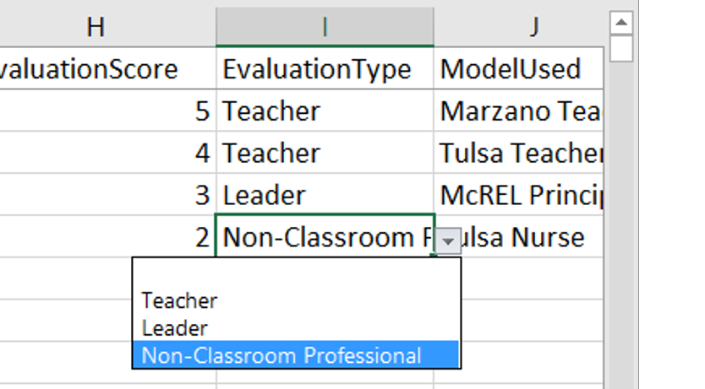

- Select the Model Used. Select one of the values from the dropdown list. From the model selected the template will auto-populate the Domain IDs, Domain Descriptions, Domain Indicator IDs, and the Domain Indicators Descriptions. The scores are left empty for you to enter.
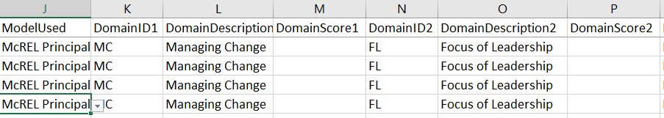

- Enter scores for Domains and Indicators.
  - Domains scores aren’t set to have any specific parameters, so any value entered will work for the template, but it is encouraged that any value entered should be as accurate as possible according the indicators scores supplied.
  - Indicators scores do have parameters set around them. You can either use the drop downs to input your values or you can type them in. Acceptable Values are “NA”, “Not Evaluated”, 1, 2, 3, 4, or 5. Note: You cannot enter decimals for indicator scores but you can for domain scores.
