New APR Data Management Spreadsheet
Instructions, Centers, Activities, and Staffing remain the SAME.
Participation & Outcomes now has new features:
- You can sort the data. Each column will have a little drop down arrow at the top that allows you to choose your sort options.
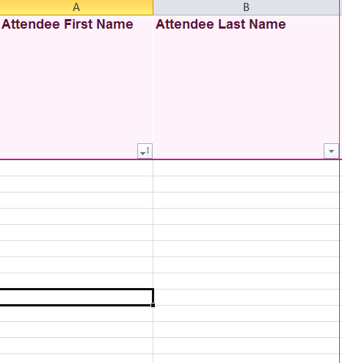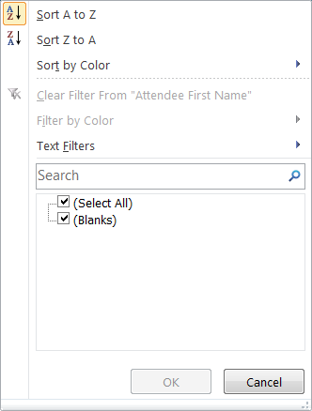
- You can insert and delete rows. If you highlight a row and right click you will now have the option to insert and delete rows.
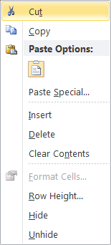

- If you are pasting data into the spreadsheet you must paste the values only. If you do not choose this option the spreadsheet will lock and you will not be able to sort the data or insert/delete rows.
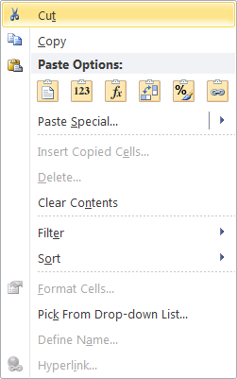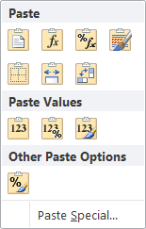
- You will enter in the same information as you have been previously. Nothing about the data collection process has changed.

- Finally, make sure that you are submitting your data cumulatively. You will want to have all your Summer, Fall, and Spring data on the same spreadsheet.

