The Oklahoma TLE Report tool will allow you to export the data that you need from Perform in a format that is ready to upload to the state's WAVE system.
Step 1: Access the new reporting tool
1) Navigate to HR Tools
2) Click on Reports at the top of the page
3) Select the Oklahoma TLE Report option under the Other Reports heading (see screenshot below)
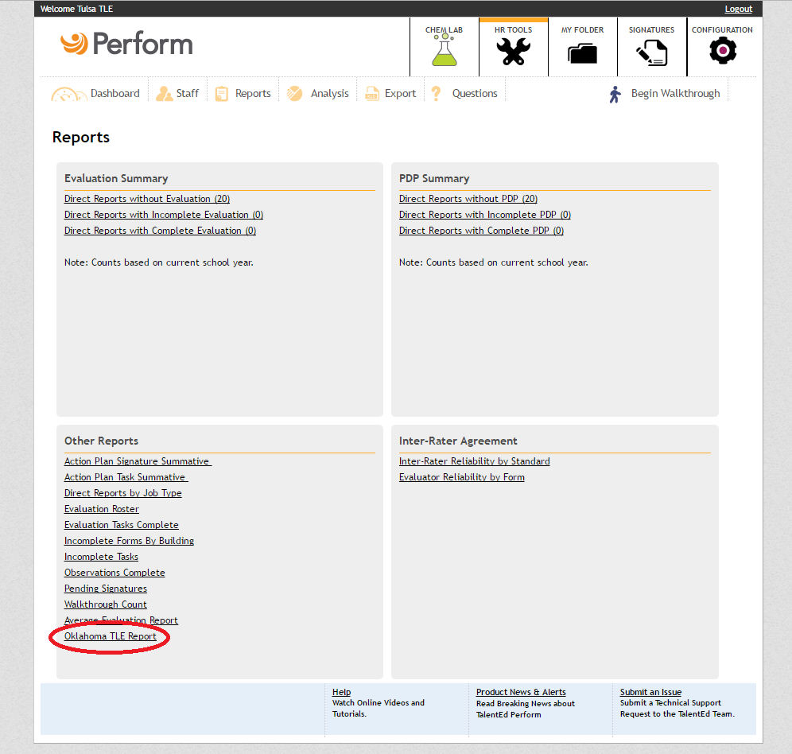

Step 2: Import staff certification numbers into Perform
1) At the bottom right of the Oklahoma TLE Report page, click the button named Import Certification Numbers
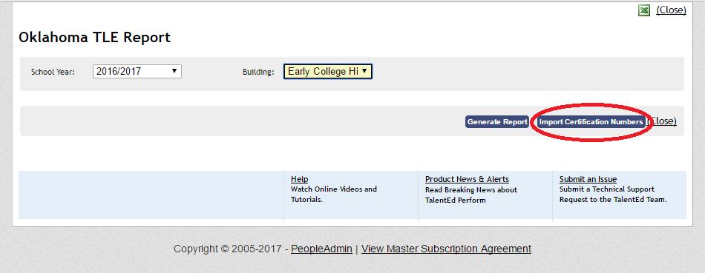
2) You will see instructions pop up that read as follows: "Import a CSV Comma, tab, or pipe delimited file. File supports two fields EmployeeID and Certification #
Do not include headers for columns"
3) If you need to generate a list of EmployeeID numbers for all staff in Perform here are two ways to do so:
A) Go to HR Tools > Click Reports > Run the Evaluation Roster report > Click the Excel icon at the top right or bottom right of the page > This will create an excel file with your staff's EmployeeID numbers
Alternatively
B) Go to HR Tools > Click Export > Click Legacy Data Export at the top right > Click Customizable Form Report > On the next page, select any form from the drop down and answer "No" to the popup > In the Add Field section, type DR and choose "DR Employee ID" > Click export to generate an excel file with your staff's EmployeeID numbers

4) Once, you have an excel file with your EmployeeID numbers from Perform, match the EmployeeID number to the staff member's corresponding certification number in the file. Save the Excel file as a .CSV and import it into Perform using the Import Certification Numbers tool on the Oklahoma TLE Reporting page
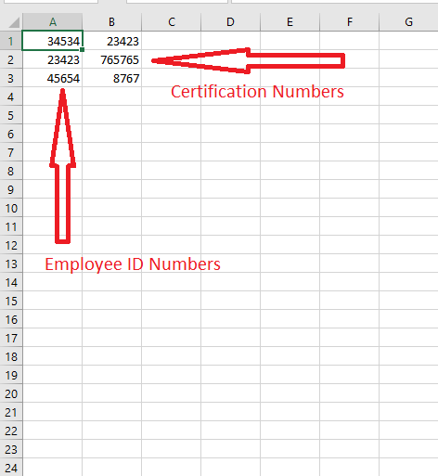
Step 3: Generate your reports for each building and upload the files to the state system
1) Select the correct school year and building. Click Generate Report to download an excel file with the data to your computer
2) Remove the "Location" and "Form Name" column from the excel file
3) Upload the downloaded excel files to the state WAVE system
4) Repeat the above steps for every building where staff where evaluated
Please Note: To utilize the Oklahoma TLE Report Tool you must be subscribed to the TLE forms and processes and have used them for the current evaluation year

