Data Systems



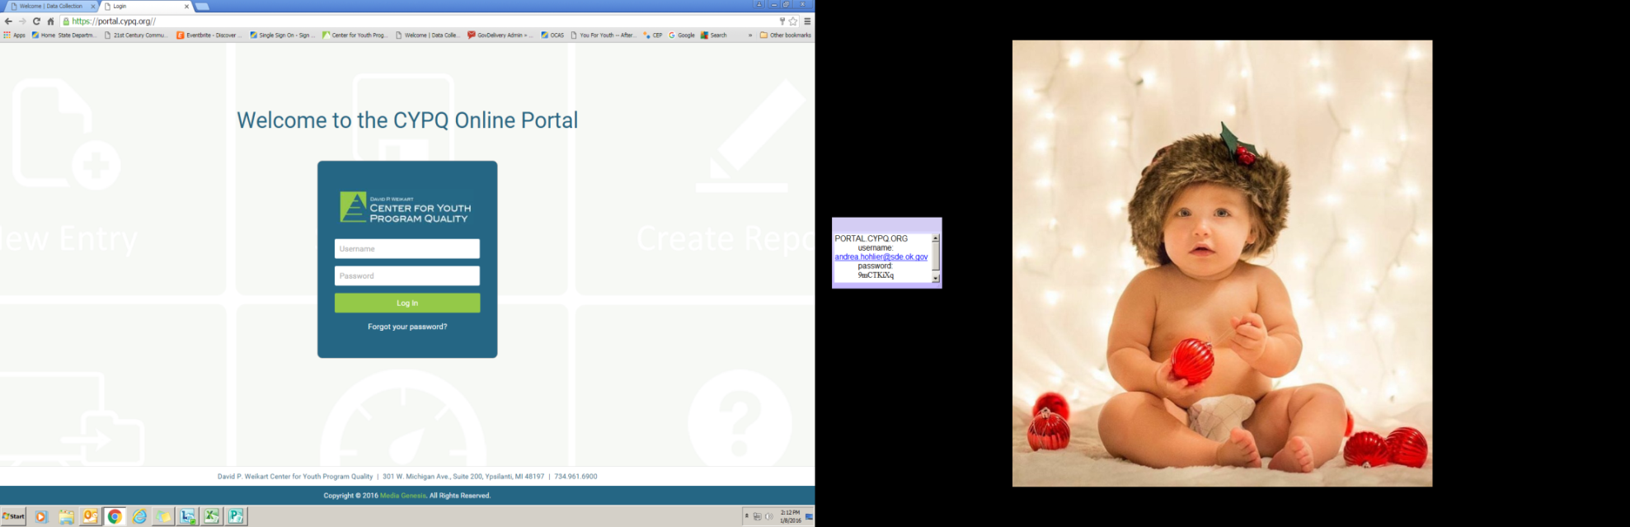

**Qualtrics**

(For program survey collection during the Spring term)

Survey links online:

[www.cypq.org/ok21cclc](http://www.cypq.org/ok21cclc)

Through this system, you will collect surveys from program:

• Leadership • Staff

• Families • Students

Data from site surveys will be provided to each site through the Leading Indicator Report for use in program improvement planning.

For assistance, email: OKdata@cpyq.org



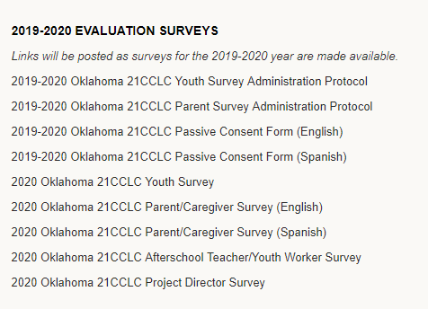

**Scores Reporter**

(For program quality assessment data)

Online:

<https://portal.cypq.org>

Through this system, you will:

• Enter self-assessment data • Enter improvement plan goals

• Access self and external assessment data by creating reports

Access credentials to Scores Reporter are including within the annual YPQ Box Set purchase for each program site.

For technical assistance, email: OKdata@cpyq.org

For assistance email: megan@cypq.org

**Data Management Spreadsheet**

(For federally required program data)

Online:

[www.cypq.org/ok21cclc](http://www.cypq.org/ok21cclc)

On the spreadsheet, you will enter information about:

• Your site/center • Staffing numbers

• Community partners • Program activities

• Family Participation • Student participation

• Student outcomes • Daily attendance (optional)

Spreadsheets are due at the end of each term. See YPQI Annual Calendar for data deadline dates.

The USDE requires specific program data to be reported for all 21st CCLC grantees. This data is used by the USDE to report to the United States Congress on the success of the program and to determine future funding.

**Grants Management System (GMS)**

(For all fiscal functions of the grant)

Online:<https://sdeweb01.sde.ok.gov/SSO2/Signin.aspx>

In this system, you will enter:

• Grant application • Budget amendments

• Budget • Close out/Annual Report

• Claims

For assistance contact: 21st CCLC office, 405-522-6225

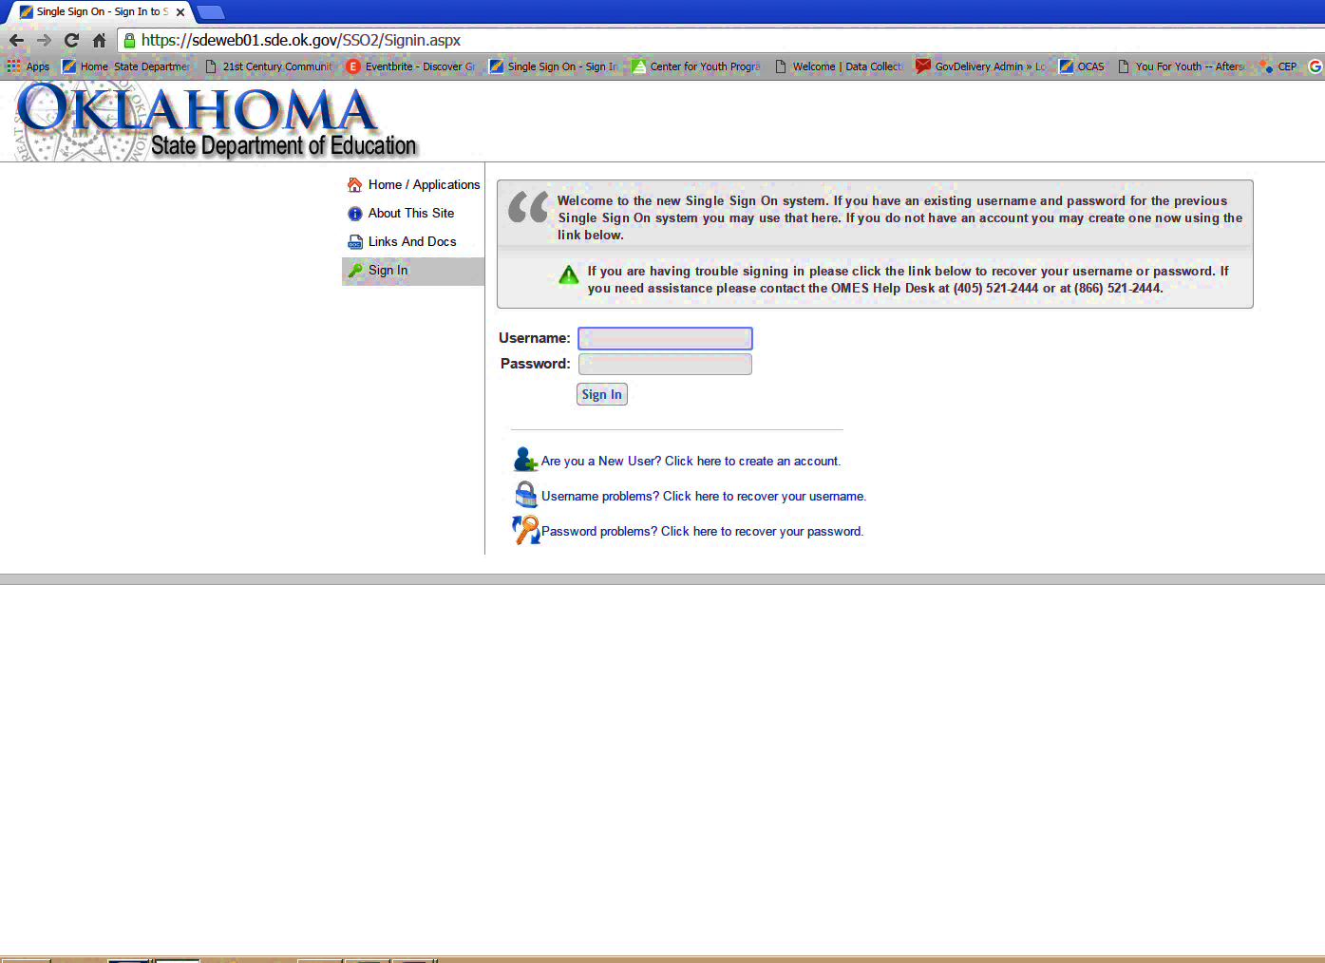



**The 21st CCLC program uses four unique systems to collect programmatic, assessment and financial data.**

**Data Management Spreadsheet**

http://www.cypq.org/

Enter:

Center overviewok21cclc

* On this spreadsheet, you will e
* Community partners;
* Program activities;
* Staffing; and
* Student participation and
* Student outcomes.

Spreadsheets will be due at the end of each term (Fall, Spring and Summer).

For assistance contact: leanner@cypq.org

**21st CCLC APR System**

https://21apr.thetactilegroup.com

In this on-line system, you will enter:

* Center Overview
* Community Partners
* Program activities

For assistance contact Sonia.johnson@sde.ok.gov