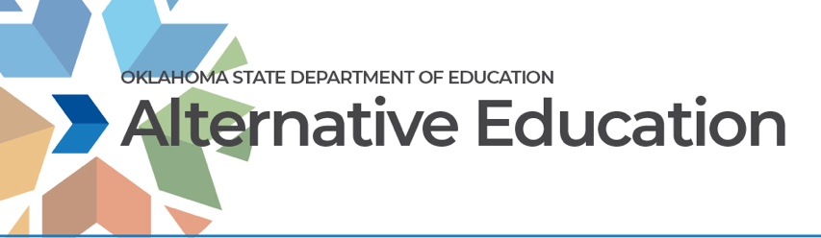Alternative Education Advisory Meeting
May 3, 2022- 10:00- 12:00
Oliver Hodge Bldg., Room #215
OSDE Alternative Education Team
- Brook Meiller, Deputy Superintendent of Student and School Support
- Elizabeth Suddath, Assistant Deputy Superintendent of Student and School Support
- Missy Corn, Co-Director of Alternative Education
- Leslie Frazier, Co-Director of Alternative Education
- Michelle Butler, Alternative Education Specialist

AGENDA
- Welcome …………………………………….……......................................SDE Alt. Ed. Team
- Introductions…………………………………………………………………….……SDE Alt. Ed. Team
- Evolution from Advisory Group to Consortium of Support………SDE Alt. Ed. Team
  - Future of this group
  - Topics for Conversation/Planning:
    - Professional Development
    - Curriculum Ideas
    - Regional Networking
    - Advocacy & Communications
    - Your Ideas
- MTSS (Elizabeth Suddath)
- NAEA Conference
- Data Updates:……………………………………………………………………………………………SDE Alt Ed Team
  - End of Year Data
  - Districtwide Student Needs Assessment
  - Implementation Plans FY23 changes
    - Budgets/Authorization to Pay Forms
- Updates from the Field……………………………………………………………………………..SDE Alt. Ed Team
  - Missy Corn
  - Leslie Frazier
  - Michelle Butler
- Reflections/Announcements/ Next meeting date
- Adjournment

Alternative Education Consortium Meeting
When: May 3, 2022 10:00 AM Central Time (US and Canada)

Register in advance for this meeting:
https://zoom.us/meeting/register/tJArcuGvqTotGNIEIRbgxhGF5tJyculDYLyi

