TITLE I SCHOOLWIDE PROGRAM
ANNUAL REVIEW
(For Schools Operating a Schoolwide School Program)
Documents related to the Annual Program Review should be filed at the school site and results shared with all stakeholders.


Overview of Annual Review Requirements
A copy of the Annual Program Review and a revised Schoolwide Plan need not be submitted to the Oklahoma State Department of Education unless requested for monitoring purposes.

Title I regulations require that all schoolwide sites have a written, comprehensive and current site plan. Sites should conduct an annual review of the schoolwide program to evaluate its effectiveness. The purpose of this review is to evaluate all components and to make revisions for the upcoming school year. The annual review can also serve other purposes such as:

- Inform internal program management and help school leaders make informed decisions to improve the quality of their program;
- Answer stakeholder questions and help them better understand how effectively the school is meeting its stated goals;
- Increase understanding of specific strategies and help the school determine the usefulness of the activities it has undertaken to increase student achievement; and
- Promote interest in and support of a program or activity by illustrating certain strategies, their outcomes in terms of improving student achievement, and increasing support for their use.

Just as the Schoolwide Plan should be considered a living document, the annual review should be thought of as a continuous cycle always affecting future progress of the schoolwide program. A review of the strategies and action steps originally proposed in the plan, an analysis of data, and input from various stakeholders should inform revision of the original Schoolwide Plan and reflect a revitalization of the school’s commitment ensuring all students have equal opportunity to achieve at high levels.

This toolkit is designed to be a guide during the annual program review process. Though there is no required format for the annual program review, the Designing Schoolwide Programs Non-Regulatory Guidance outlines specific requirements and suggested steps for review, which were used to create this document. A school wishing to format the annual review differently, should consult the guidance to ensure all requirements are met.

This Annual Program Review Toolkit includes a template for writing the annual review as well as several resources such as Annual Data Review Action Steps, Document Checklist, Action Plan Templates and Guiding Questions for the 10 Required Components of a Schoolwide Plan.

Documents gathered during the Annual Program Review and the revised Schoolwide Plan should be kept on file at the school site and be made available to all stakeholders. Results from the Annual Program Review must be shared with parents and staff on an annual basis and be made available upon request.

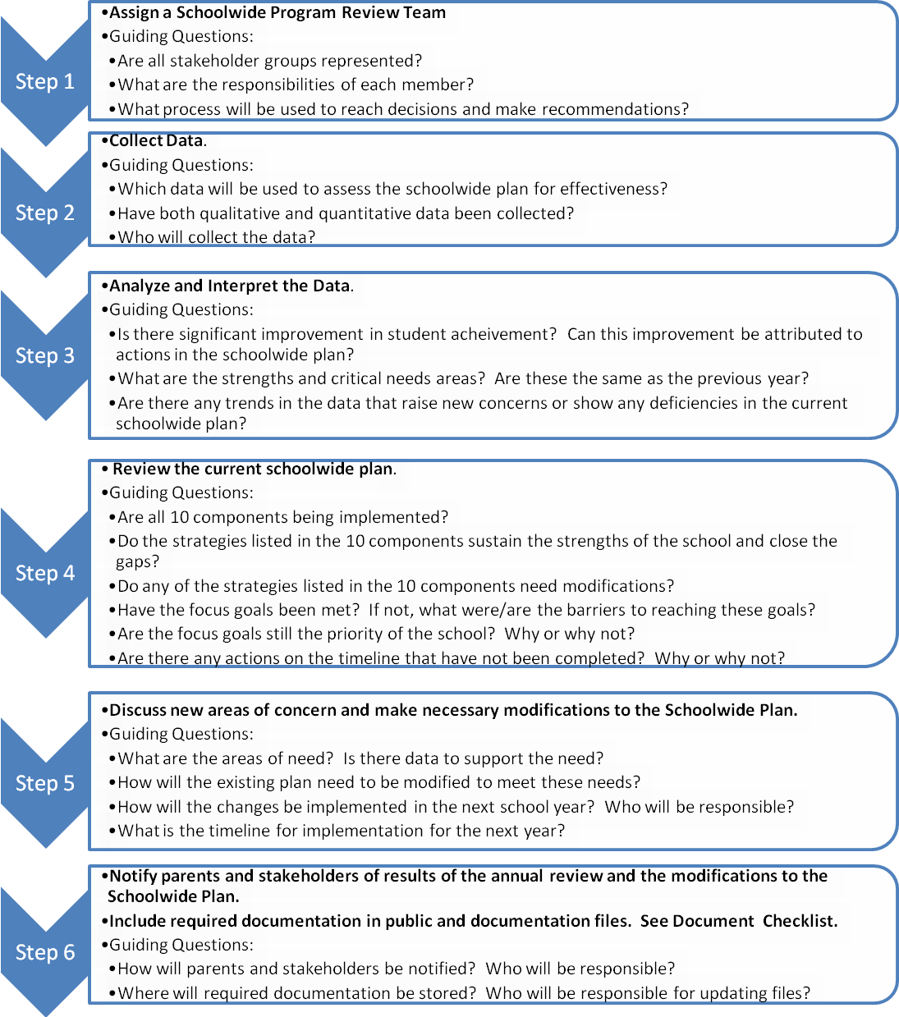

Step I – Assign a Schoolwide Program Review Team
Title I regulations require that a school operating a schoolwide program annually evaluate the implementation of, and results achieved by, the schoolwide program. The school must revise its plan as necessary based on the results of the evaluation to ensure the continuous improvement of student achievement.

Section A – Schoolwide Program Review Team
Name | Title | Stakeholder Group
Section B - Overview
Briefly describe how review team members were selected and which tasks were outlined for the team to accomplish.

Section C - Documentation
Record and file the following documentation concerning the schoolwide program review team:
- Attendance Records, Agenda and Minutes of all program review meetings.

Step II – Data Collection

Section A – Types of Data
Student Achievement Data  (OCCT, Benchmarks, District Assessments, Report Cards) | Perception Data  (Staff/Student/Parent Surveys, Self Assessments, Meeting Minutes) | Demographic Data  (Attendance, Truancy, Ethnicity, Low-Income, Special Education)
Section B - Overview
Briefly describe the data collection process.

Section C - Documentation
Record and file the following documentation concerning the schoolwide program review team:
- Copies of Data Used in the Annual Review
- Agenda, Minutes, and Attendance Record for Data Review Meetings

Step II Addendum – Data Profile (Include last three (3) years of data)

1. Student Enrollment by Gender
Year | Total Enrollment | # Male | % Male | # Female | % Female

2. Student Enrollment by Ethnicity
Year | Total  Enrollment | %  Black | %  American  Indian | %  Hispanic | %  Asian/  Pacific  Islander | %  White | %  Other

3. Students Eligible for Free and Reduced Lunch Program
Year | Number | Percent of Population

4. Students Participating in Targeted Title I Programs
Year | Program Enrollment | Percent of Population

5. Student Attendance
Year | Average Daily  Attendance | Percent of Student Population | # Male | % Male | # Female | % Female

6. Student Tardy Rate
Year | Average Daily  Attendance | Percent of Student Population | # Male | % Male | # Female | % Female
7. Student Mobility Rate
Year | Full Academic Year (FAY) |  | Non Full Academic Year (NFAY)
Year | # Students | % Student  Population | # Students | % Student Population

8. Student Truancy Rate
Year | Average Daily Truancy | Percent of Student Population

9. Students Identified as English Language Learners (ELL)
Year | Program Enrollment | Percent of Student Population

10. Student Behavior
Year | Average Daily Referrals | Average Daily In-School Suspensions | Average Daily Out-of-School Suspensions

11. Highly Qualified Teachers (HQT) and Paraprofessionals
Number of Certified Teachers | Number of HQT | Number of Non HQT
Number of Paraprofessionals | Number of HQT Paraprofessionals | Number of Non HQT Paraprofessionals

12. Teaching Experience | Years of Experience
Number of Certified Teachers | 0-3 | 3-5 | 6-10 | 11-15 | 15-20 | 20+

13. Education
 | Degree Received
Number of Certified Teachers | Bachelor’s | Bachelor’s  + 15 | Master’s | Master’s  +15 | Doctorate | National  Board  Certification
Step III – Data Analysis

Section A – Process
Briefly describe the process used to analyze the collected data.

Section B – Summary of Analysis
Summarize the results of the data analysis specifically identifying the strengths, weaknesses and critical needs areas as shown in the data.

Section C – Success of the Schoolwide Program
Based on the data analysis, explain which schoolwide programs are succeeding and which are not.
Step IV – Review the Current Schoolwide Plan

Section A – Overview
Briefly describe the implementation of the Schoolwide Plan and the effects the plan had on teaching and learning, specifically addressing how the needs of particularly low-achieving students were met.

Section B – Focus Goals
Briefly describe the progress made toward reaching the focus goals identified in the Schoolwide Plan, specifically addressing barriers if goals have not been met.

Section C – Required Components
Explain to what extent all 10 required components were implemented as indicated in the plan.

Section D – Deficiencies
After reviewing the Schoolwide Plan, describe any deficiencies as shown by the data or the review of the focus goals and 10 required components.

Step V - Modifications

Section A – Area of Need
Using the information obtained in the data analysis and the review of the current Schoolwide Plan, summarize the identified areas of need.

Section B – Focus Goals
Briefly explain how the focus goals will be modified or changed to meet the identified area of need.

Section C – 10 Required Components
Briefly describe how each of the 10 Required Components has been implemented according to the current Schoolwide Plan, how each is evaluated for effect on student achievement and how each will be modified or changed to meet the needs identified in the Annual Program Review. Guiding Questions for the 10 Required Components are included in this toolkit.

Component 1: Schoolwide Reform Strategies
Implementation:
Evaluation:
Modification/Changes:

Component 2: Instruction by Highly Qualified Teachers
Implementation:
Evaluation:
Modification/Changes:

Component 3: Professional Development
Implementation:
Evaluation:
Modification/Changes:

Component 4: High Quality Teachers to High Need Schools
Implementation:
Evaluation:
Modification/Changes:

Component 5: Parental Involvement
Implementation:
Evaluation:
Modification/Changes:

Component 6: Transition Strategies
Implementation:
Evaluation:
Modification/Changes:

Component 7: Data Driven Decisions
Implementation:
Evaluation:
Modification/Changes:

Component 8: Effective and Timely Additional Assistance
Implementation:
Evaluation:
Modification/Changes:

Component 9: Coordination of Programs
Implementation:
Evaluation:
Modification/Changes:

Component 10: Needs Assessment
Implementation:
Evaluation:
Modification/Changes:

Section D – Documentation
□ Step V Addendum for Each Identified Focus Goal

Step V Addendum – Schoolwide Focus Goals
For each focus goal identified in Step V of the Annual Program Review, complete the following Schoolwide Focus Goal Action Plan. Make additional copies as needed.

Goal:

Briefly describe the reasoning for the identified goal.
Describe the measurable outcomes for the goal (i.e., In 2009-2010, the percentage of students scoring 70 or below on the quarterly math assessment will decrease by 10%)

Action Plan
Strategies and Action Steps | Resources Needed | Person(s) Responsible | Timeline | Evidence of Progress

Guiding Questions – 10 Required Components
Guiding questions are designed to guide the Annual Program Review team during the analysis of the implementation of the 10 Required Components. Analysis of these questions does not constitute a complete Annual Program Review, but provides an integral part of the whole assessment of the schoolwide program.

Component #1 – Needs Assessment
- What does the data tell you about specific programs?
- What does the data tell you about specific subgroups?
- Are there any recognizable trends in the longitudinal data?
- What students/subgroups are achieving at your school?
- What students/subgroups are not achieving at your school?
- According to the data, what strategies and activities appear to be succeeding? Not succeeding?
- What additional data needs to be collected this year? Next year?

Component #2 – Schoolwide Reform Strategies
- What Scientifically Based Research programs are currently being used at the school? Are they effective?
- How did the school increase the amount and quality of instructional time? Was it effective?
- What was done to strengthen the core academic program at the school?
- Is curriculum aligned with the Priority Academic Student Skills (PASS)?
- Have the schoolwide programs ensured that ALL students at the school have the opportunity to reach the State’s satisfactory and proficient levels of learning?
- How is technology being utilized in the classroom? Has it been effective in increasing engagement, motivation and achievement?

Component #3 – Instruction by Highly Qualified Teachers
- Are all teachers at the school highly qualified? All paraprofessionals?
- Are staff members being utilized in the best way possible to meet the needs of the students?
- How will the school site continue to ensure instruction by highly qualified teachers?

Component #4 – Professional Development
- Was the professional development plan implemented as planned? If not, why?
- Did the professional development received improve instruction in the classroom?
- Did the professional development received improve student achievement?
- Was the professional development adequately monitored and evaluated on an ongoing basis?
- How did the professional development plan align with the school improvement goals?
- What are the current professional development needs of the staff? Administrators?
- How will the newly identified needs be implemented in the updated plan?

Component #5 – Highly Qualified Teachers to High Need Schools
- How many teachers are employed at the school?
- How many teachers have less than 3 years experience?
- What was the teacher turnover rate this year?
- What is the expected turnover rate for next year?
- What is the school doing to support teachers and provide time for mentoring and collaboration?
- How is the school recruiting highly qualified teachers?
- Does the district have equitable distribution of teachers where low-income high-minority students are not taught at a higher rate than other students by unqualified, out-of-field or inexperienced teachers?

Component #6 – Parental Involvement
- What services were provided to parents as part of the schoolwide plan?
- What communication was sent to parents this year?
- What other types of communication can be utilized?
- How was attendance at parent involvement activities? How could this be increased?
- Do any revisions need to be made to the parent involvement policy and parent compact?
- Have the parents been surveyed regarding parent involvement, communication, and other activities? If not, how can data be gathered from the parents?

Component #7 – Transitions
- Which transition activities were effective?
- Were all stakeholders involved in transition activities? If not, how can they be more involved in the future?
- Are there any gaps in the current transition activities? How can these be closed?

Component #8 – Data Driven Decisions
- Which assessments/benchmarks are currently used by the school to monitor student achievement? Are they effective?
- Do these assessments inform instruction?
- Are the assessments used by all staff and administrators to make decisions?
- How can the school better utilize assessment data?

Component #9 – Effective and Timely Additional Assistance
- How were low performing students identified during the school year?
- What interventions are in place to assist these students?
- Did low-performing students receive assistance in a timely manner?
- How is progress monitored?

Component #10 – Coordination of Programs
- Do all resources (federal, state, local) support the schoolwide program?
- Do any activities or programs need to be modified to better support the schoolwide program?

Document Checklist
The document checklist is intended to be a guide schools can use to ensure required documentation is included in the Schoolwide Plan, the annual review and the public and site file.
Schoolwide Plan Documents:
- Local board of education meeting minutes reflecting Schoolwide Plan approval
- Meeting agenda and/or attendance records for Parent Informational Meeting
- Meeting agenda and/or attendance records for Faculty Informational Meeting
- Disaggregated test data for math and reading/language arts
- Student/Parent/Teacher surveys (if applicable)
- Additional student achievement data used in needs assessment
- Part IV Addendum – Data Profile
- Part V Addendum - Schoolwide Focus Goal Action Plan(s)
- Letter of notification to parents of students taught by Non-Highly Qualified Teachers
- Part VIII Addendum - Professional Development Plans for the Current and Implementation Year
- Sample copies of professional development agendas and/or attendance records
- Sample evaluation tool for monitoring the implementation of professional development activities
- Sample individual professional development plan created by staff
- Parent Involvement Policy
- Site Parent/School Compact
- Parent survey or other evaluation tool regarding parent involvement activities
- Examples of school/parent communication
- Notification to parents regarding student achievement reports and test scores
- Notification to parents of Annual Parent Informational Meeting
- Notification of Title I programs and opportunities
- Letters, flyers, mailings, etc. notifying parents of transition activities
- Attendance records of parent meetings about transition activities
- Evidence of vertical teaming among faculty (i.e., agendas, minutes, curriculum maps)

Annual Review Documentation:
- Modified versions of the above listed documents as necessary
- Written copy of the Annual Program Review
- Documentation of Annual Program Review meeting(s) Including agenda, minutes and attendance records
- Notification to parents and stakeholders of Annual Program Review meeting and results
- Documentation of Annual Parent Informational Meeting

Public File Documentation:
- General information about the school including history, demographics, teachers, curriculum, achievement scores, activities, parent organizations
- Information about Title I, Part A programs
- Written Schoolwide Plan and Annual Program Review
- Site Parent Involvement Policy with School/Parent Compact

Document File Documentation:
- Written copy of Schoolwide Plan
- Written copy of Annual Program Review
- Written copy of Site Parental Involvement Policy
- Written copy of site Parent Compact
- Documentation of Annual Parent Meeting
- Documentation of Parental Communications
  - Information about Title I, Part A programs
  - Information about student academic progress
  - Notification of Non-Highly Qualified Teacher

