Oklahoma Department of Education
Draft Outline: Recommendations for a New Accountability System
Prioritizing post-secondary success for all students
Marianne Perie
9-13-2016

Early Thoughts on a New Accountability System for Oklahoma
- Requirements
  - ESSA and HB 3218
    - Use multiple measures that include, but are not limited to
      - statewide assessments including the establishment of student performance bands
      - graduation rates for high schools
      - statewide academic measures for elementary and middle schools
      - English language proficiency for English language learners, and
      - at least one additional statewide measure of school quality or student success, including but not limited to
        - school climate
        - school safety
        - student engagement
        - educator engagement
        - advanced coursework and postsecondary readiness.
    - A report card shall be prepared each year for each school and include
      - the grade for the school
      - information regarding school improvement
      - an explanation of school performance as evaluated in accordance with the Elementary and Secondary Education Act of 2001 1965 (ESEA), as reauthorized and amended by P.L. No. 107-110 114-95, also known as the Every Student Succeeds Act (ESSA), and
      - indicators of return on investment
- Goals for OK as stated by Task Force
  - Focus on college and career readiness
  - Distinguish work prep from college prep and reward for both
- Indicators for OK prioritized by Task Force
  - Assessment
    - Include ELA and math only
    - Want to reward all levels of performance – consider index system
    - Add growth – perhaps value table
    - Examine achievement gaps and focus on change in gaps
  - High school indicators
    - Focus on post-secondary success
    - Graduation rate
    - AP classes/apprenticeship opportunities
- Discussion of design decisions with Task Force
  - Keep number of indicators in rating small
  - Compensatory where possible but transparency is needed
  - Easy to understand
  - Dashboard approach
  - Debate on composite rating – A-F rating desired by state but not schools

Recommendations for OK SDE
- Keep A-F rating but change the scale
  - Instead of percentage, give points for each component of the dashboard
  - 200 points total
    - A=175+
    - B=150-174
    - C=120-149
    - D=90-110
    - F<90 or lowest 5% in percent proficient or below 67% graduation rate
- Identify indicators, show separately, and combine into an index worth 200 points
  - Status (40 points; 20 ELA, 20 math)
  - Growth (50 points; 25 ELA, 25 math)
  - Achievement gap (50 points; 10 ELA gap, 15 change in ELA gap, 10 math gap, 15 change in math gap)
  - ELPA progress (30 points)
    - Make long-term goal that all students should achieve English proficiency within 5 years of entering school. For students currently in system:
      - Level 1 student has 5 years to exit
      - Level 2 student has 4 years to exit
      - Level 3 student has 3 years to exit
      - Level 4 student has 2 years to exit
- Determine current proficiency levels and set goals for each student to be proficient in five years
- Use interim benchmarks to measure progress
  - Attendance (3-8 only) (10 points)
    - Set long term goal for each school of 95% in five years
    - Determine current attendance rate, calculate difference from 95%, divide by 5 to determine the percent improvement expected each year
  - Graduation rate (HS only) (20 points)
    - Current statewide graduation rate is 85%
    - Those below 85% should achieve 85% in five years
    - Those at or above 85% should strive for 90% or 5% higher than where they are
    - Again, calculate simple difference and amount of growth necessary to reach goal in five years for intermediate goals.
  - Post-secondary success (HS only) (10 points)
    - AP classes/apprenticeship opportunities
    - Postsecondary plans
  - Other indicator (3-8 only)
    - PD opportunities (5 points)
    - Student engagement (10 points)
      - Community service
      - Extra-curricular activities
      - Positive survey results
    - Parent engagement (5 points)
- Set goals for each indicator
  - Give grade-letter cut scores for each indicator and the composite
  - Set high goals with intermediate benchmarks
  - Provide a grade for each indicator and an overall grade
- Disaggregate by student group
    - Minimum n= 30
    - Use all groups listed in ESSA (more than NCLB)
- Make design decisions in categorizing schools
  - Base comprehensive support schools on those who are F schools, lowest 5 percent on overall points, and/or graduation rate below 67%
  - Base targeted support schools on those with large achievement gaps (first year) and little change or increases in gaps (subsequent years)
  - Identify reward schools
    - A schools
    - Top 5% in points
    - Evidence of growth (accounting for ceiling affect)
    - No large achievement gaps
    - Graduation rate above 80%
- Determine rules for leaving targeted and comprehensive support identification
  - More than just no longer in bottom 5%
  - Must show continued progress on multiple indicators
  - Must have plan for continued success
Validate the accountability system
- Use 2016 data and run it through the various approaches to developing a report card.
  - See which schools get which grades for each indicator
  - Determine whether the overall school grades pass the “sniff test”
    - Do the schools labeled as reward schools make sense?
    - Do the schools labeled as comprehensive support truly need support?
    - Are the best schools being identified for targeted support?
  - Review lists with Task Force and smaller focus groups
    - Allow for time to change formulas
    - Based on 2017 data, what schools would be on each list?
  - Distribute publicly with no consequences
    - Need to offer support for schools who would be in comprehensive or focused support groups, but not in a punitive fashion
  - What changes are recommended for 2018-2019 when ratings go into effect?

Sample Accountability reports
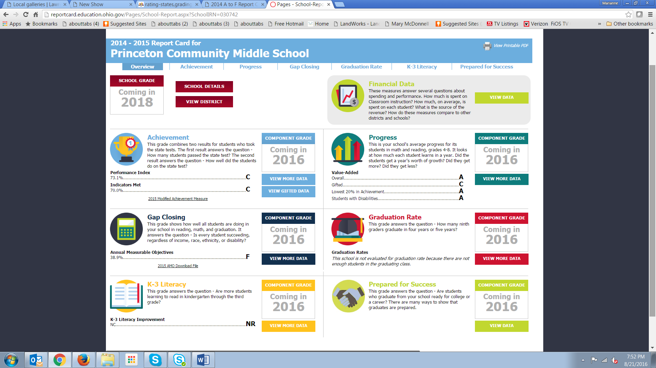

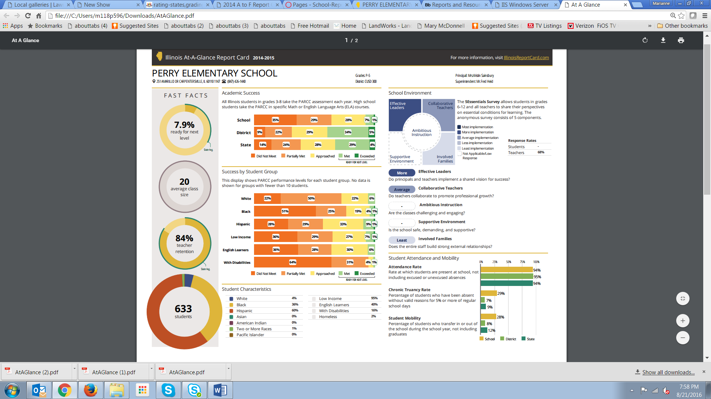

Questions for Task Force on September 19, 2016
- How do you feel about keeping A-F system if we change the calculation to include different variables and change the weights? Other options: stars, colors (e.g., California has blue, green, yellow, orange, red)
- What are you reactions to the indicator list?
  - Is anything missing that should be there or anything there that should not be?
  - The emphasis in high school is more on academics and postsecondary success. Should there be more “school climate” indicators?
  - Does anything change for high school if we use ACT/SAT rather than a state-developed test?
  - For the status measure, there are arguments that mean should be used instead of percent reaching performance level. What are your feelings about reporting status measures versus including them in accountability system? Which should appear where?
  - How do you want to adjust for schools with no ELLs?
- What are your reactions to the weights given to each indicator? Do you have recommended adjustments?
- What are your recommendations for interventions in identified schools?
- What rules should we use for schools to exit identified “support” status?
- What are your reactions to the example reports provided? What aspects do you like? Dislike?

