How to add Principal role for Grants Management

Superintendent:

Log in to SSO: https://sdeweb01.sde.ok.gov/SSO2/Signin.aspx

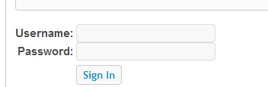

Click “Manage Users” in the left column

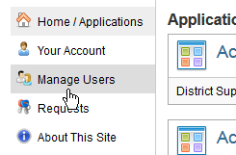

Search for and select the Principal’s account – If the Principal does not already have an account, you will need to create one using the “Create A New User” button at the top right of the “Manage Users” screen
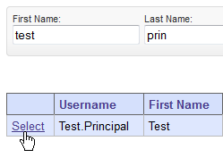

Please make sure that your principal is associated with their specific site or sites. To associate a principal with a site, click on the “Edit Sites” button on their SSO account profile.

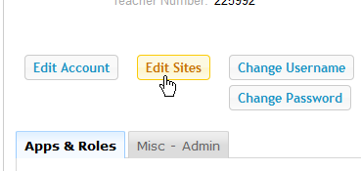

Once the site has been added, on the right side of the screen, Click “Manage roles for this user”
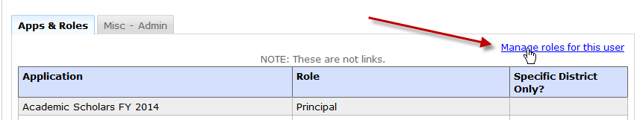

On the right side, again, click “Add a Role”

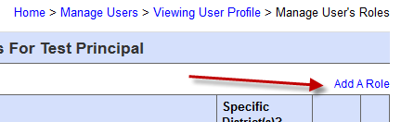

In the drop-down menu, select “Grants Management and Expenditure Reporting”

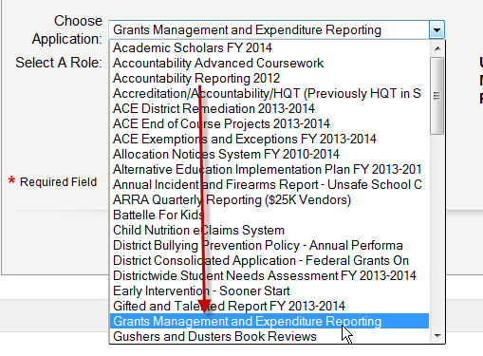

Select the “Principal” role and click “Submit” – If the principal already has another role, that’s ok. He or she will still need the “Principal” role.

