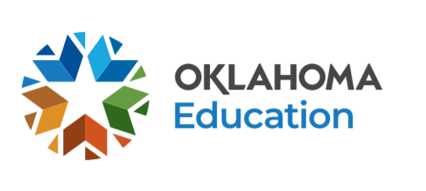
Oklahoma English Language Proficiency Office Calendar

Professional Development Opportunities
Event | Available
Introduction to the Components of the WIDA ELD Standards Framework 2020 | Available in September
Connecting Oklahoma Academic Standards to WIDA’s ELD Standards | Available in September
A Deep Dive into Language Features | Available in September
Model Content Lessons Modified for ELs Using WIDA’s Language Expectations | Available in September
English Learner Policy and Process Series: Part 1: | Webinar; Slide Deck
Improving Outcomes for English Learners | To access this series, visit osdeconnect.ok.gov, sign up or sign in, click the green "Add" button, and search for the series title.
CEOE ESL Certification Examination Prep Course | To access this series, visit osdeconnect.ok.gov, sign up or sign in, click the green "Add" button, and search for the series title.
Teachers of English Learners | To access this series, visit osdeconnect.ok.gov, sign up or sign in, click the green "Add" button, and search for the series title.

WIDA Facilitated Webinars (Registration Required)
Event | Available
WIDA Screener for Kindergarten webinar | Webinar: August 17, 2021  Time: 9-11am CT  Registration
WIDA Screener Online webinar | Webinar: August 19, 2021  Time: 9-11am CT  Registration
Planning with the WIDA ELD Standards Framework | Available in the Spring
ACCESS for ELLs Online Test Administrator Training webinar | Webinar: November 2, 2021  Time: 9-10:30am CT  Webinar: November 9, 2021  Time: 9-10:30am CT
ACCESS for ELLS Test Coordinator Training Webinar | Webinar: November 10, 2021  Time: 9-10:30am CT
Kindergarten ACCESS for ELLs Test Administrator Training webinar | Webinar: November 3, 2021  Time: 9-10:30am C
Alternate ACCESS for ELLs Test Administrator Training webinar | Webinar: September 11, 2021  Time: 9-10:30am CT
Teacher Leaders: Planning with the WIDA ELD Standards Framework | Available first week in February
Considerations when Educating Bilingual Learners w/Identified Learning Disabilities | 9/13 - 12/24  Online Meeting 11/15 at 9:00am

Key WIDA ACCESS Dates
Event | Start Date | End Date
Pre-Reporting Data Validation – LEAs in AMS | Tue 7/6/21 | Mon 7/26/21
Reports and Data Files Available in AMS - Online | Mon 8/11/21 | Mon 8/11/21
ELP Data Verification Window | Mon 8/18/21 | Wed 9/1/21
Reports Available in Districts - Printed | Thu 8/26/21 | Thu 8/26/21
ELP Band Exit Process Window | Mon 9/6/21 | Fri 9/24/21
Final Updated Data Posted in AMS | Wed 9/29/21 | Wed 9/29/21
WIDA Pre-Code | December | December
2021-2022 WIDA Testing Window | Mon 1/10/22 | Fri 3/25/22
Additional Test Material Ordering Window in WIDA AMS | Fri 1/7/22 | Fri 3/18/22

