Oklahoma State Department of Education
Office of Federal Programs

Comprehensive Needs Assessment
Table of Contents
I. School Information 3
II. Student Data Collection 4
III. Collaborative Leadership – Effective Leaders 5
IV. Stakeholder Engagement 6
V. Needs-Driven, Content-Specific Approach 7

School Information
Date: Click or tap to enter a date.
School District: Click here to enter text.
School Name: Click here to enter text.
School Address: Click here to enter text.
Principal Name: Click here to enter text.
Principal Phone: Click here to enter text.
Principal Email: Click here to enter text.
Superintendent Name: Click here to enter text.
Superintendent Phone: Click here to enter text.
Superintendent Email: Click here to enter text.
School Status Information: Choose an item.
School Overall Letter Grade: Choose an item.
Academic Achievement Score: Click here to enter text.
Academic Growth Score: Click here to enter text.
Chronic Absenteeism Score: Click here to enter text.

Student Data Collection
To complete this section you must completely fill out the CNA Student Data Collection file located on the OSDE Title I, Part A webpage.
There are 14 tabs that must be completed:
- Student Achievement Results
- Student Demographic Data
- Other Data Assessments
- Student Attendance
- Chronic Absenteeism
- Staff Attendance
- Student Discipline
- Graduation Rate
- Postsecondary Opportunity Rate
- Professional Development
- Counseling & Mental Health
- Culture & Climate
- Operations & Management
- Stakeholder Surveys
You can use the < and > buttons in the bottom-left corner to navigate through the tabs.
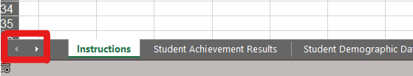
Additionally, you can right-click the arrows to view a list of all the tabs.
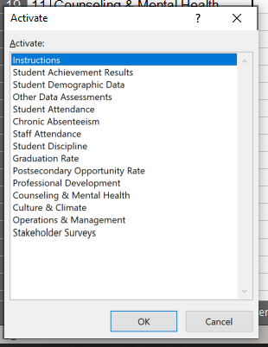

Collaborative Leadership – Effective Leaders
Describe how the planning team members are selected and recruited, and how the planning team communicates with the staff, parents, and the community about the Needs Assessment results.
Enter your narrative description here, addressing the topic above.
Describe team’s understanding of the CNA elements assessed and the data accompanying each element (e.g. ELA student performance level, staff attendance, stakeholders’ perception about school, etc.)
Enter your narrative description here, addressing the topic above.
Describe team’s understanding of the implementation level of each element assessed (e.g. Data indicates a growth trend in Math student performance, but the Reading Level is stagnant.)
Enter your narrative description here, addressing the topic above.
What are the priorities to be addressed? Has the team reached consensus regarding how these priorities are going to be addressed? Describe the results of this assessment, indicating if it is a high, medium, or low priority. (e.g. Data indicates that focusing on Reading is a high priority. The team has reached consensus to hire a full-time Reading Specialist. Elaborate more here.)
Enter your narrative description here, addressing the topic above.
What are the Professional Development (PD) priorities to be addressed? Has the team reached consensus regarding how these PD priorities are going to be addressed? Describe the results of this assessment.
Enter your narrative description here, addressing the topic above.
Determine the opportunity score of each element assessed:
- It is relatively easy to address.
- Accomplished with current budget/conditions.
- Requires changes in current budget/conditions.
Describe how the needs are going to be accomplished, the funds to be used, and the timeline of implementation (e.g. The CNA results indicate that improving student Reading levels in grades 1-3 is a high priority, which requires the need to hire a Reading Specialist a the Elementary School. Due to state and local budgetary restraints the school faced the past year, the school plans to support this full-time position from Title V, Part B – RLIS funds.).
Enter your narrative description here, addressing the topic above.

Stakeholder Engagement
Describe how the school involves parents and the community in the decision-making process, and how parents and the community support student learning.
Enter your narrative description here, addressing the topic above.
Describe how teachers communicate with parents on a regular basis, how often, what communication methods are used, and how the data is shared with students, parents, and the community.
Enter your narrative description here, addressing the topic above.
Describe how the school involves students, teachers, parents, and the community to support a safe and healthy school environment.
Enter your narrative description here, addressing the topic above.

Needs-Driven, Content-Specific Approach
Describe the High Priority needs indicated by the data analysis.
Enter your narrative description here, addressing the topic above.
Describe the root cause(s) of the High Priority problems. (You may use the “5 Whys” technique as a simple and effective tool for solving problems around the High Priority needs. By asking a sequence of “Why” questions - usually 5 are enough - you can peel away the layers of symptoms, which can lead to the root cause of a problem.)
Enter your narrative description here, addressing the topic above.
Establish and describe the priorities to be addressed in the upcoming school year. You may take the following steps:
- Make a list of all the elements analyzed in the CNA.
- Identify urgent needs vs. important needs.
- Address what carries the highest value to your school, the most urgent needs.
- Be flexible and adaptable, but stay focused on the tasks you are committed to complete.
- Know the cut-off point. Be realistic about what can be feasibly accomplished.
Enter your narrative description here, addressing the topic above.
Describe the following:
- How teachers are involved in analyzing the data and making data-driven instructional decisions.
- Teachers’ understanding of what data-driven instruction means for them in their day-to-day activities, both in and out of the classroom.
Enter your narrative description here, addressing the topic above.

