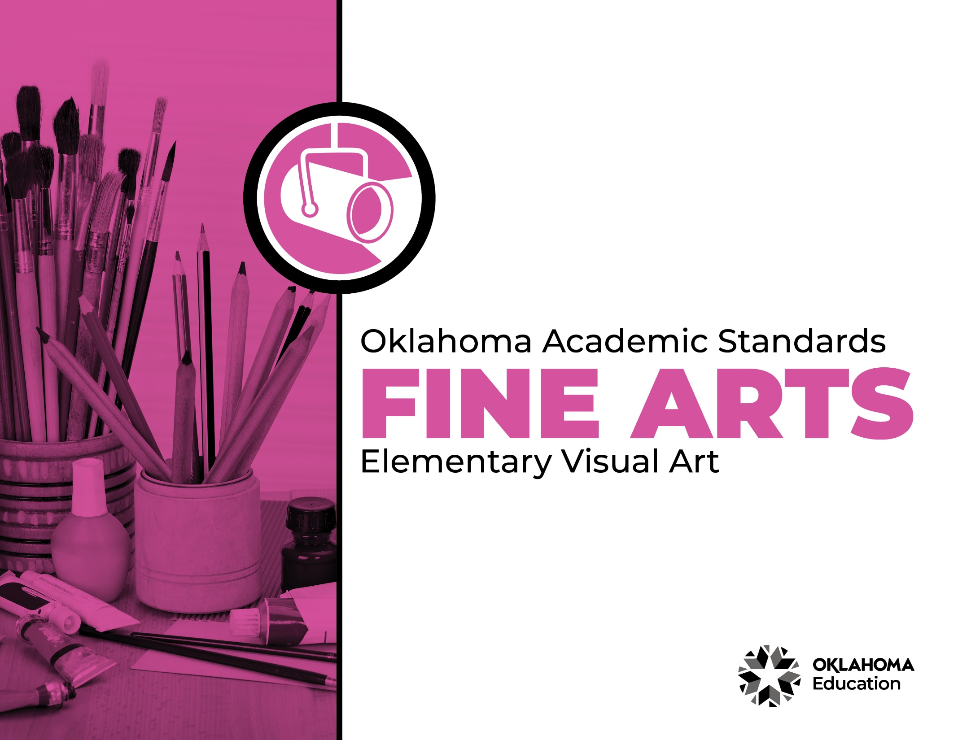
Table of Contents

Introduction & Standards Overview | 3
Visual Art Overview & Artistic Processes | 6
Visual Art Standards: PK-2nd Grade | 7
Visual Art Standards: 3rd Grade-5th Grade | 12
Visual Art Glossary | 16

Introduction
The Oklahoma Standards for Fine Arts encompass dance, drama/theatre, music, and visual art. The standards are the result of the contributions of hundreds of fine arts educators, arts administrators, and representatives of higher education, arts organizations, and community members. This document reflects a balanced synthesis of the work of all committee members of the Oklahoma standards for dance, drama/theatre, music, and visual art.

The standards specify what students should know and be able to do as learners in their discipline at the end of each grade level or course. Students have different levels of experience within a discipline so teachers can attend to both grade-level standards and meet the individual needs of students who may be performing at levels above or below grade level. The order of the standards at any grade level is not meant to imply a sequence of topics and should be considered flexible for the organization of any course.

The Oklahoma Standards for dance, drama/theatre, music, and visual art were informed by the National Coalition for Core Arts Standards (NCCAS), the Opportunity-to-Learn Standards for Dance, the Opportunity-to-Learn Standards for Music, the Opportunity-to-Learn Standards for Theatre Education, the Purposes, Principles, and Standards for School Art Programs, and other states’ standards documents.

Standards Overview
The Oklahoma Standards for Fine Arts are designed to support all Oklahoma students to develop and achieve artistic literacy and to promote access and equity in the arts. Study of the arts enrich the quality of life. Dance, drama/theatre, music, and visual art are used by and have shaped every culture and individual on earth. They provide a means for experiencing the world and give form to our innermost thoughts, feelings, and sensibilities. They also give students an opportunity to use metacognitive skills as they plan, monitor, revise, and assess their art work in dance, drama/theatre, music, or visual art.

A well-rounded education addresses the development of all the realms of human behavior—the physical, emotional, social, and intellectual. Neglecting any of the areas weakens all the rest; therefore, Oklahoma students must have access to arts education that includes dance, drama/theatre, music, and visual art. Schools that provide quality arts experiences, based on sequential skill development, supplemented with carefully selected arts resources, can help students cultivate a positive attitude towards themselves and toward learning—an attitude that carries over to their entire education and life. In short, access to arts education prepares students to be creative, persistent, and compassionate adults.

The standards are comprised of four artistic processes:
- Creating/Creative Process
- Performing/Production,
- Connecting/Cultural and Historical Perspectives, and
- Responding/Aesthetic Response and Critique Methodologies.

Each artistic process has a discipline-specific definition found in the discipline overview. The artistic processes branch into anchor standards in each discipline. The anchor standards designate specific learning targets at each grade or learning level.
In dance, drama/theatre, and visual art, there are elementary grade level standards through grade eight. At the secondary level in these disciplines, there are three proficiency levels: proficient, advanced, and accomplished. The proficiency levels may apply to high school students at any grade level and prepare students for a career or college life.
The elementary music standards extend through grade six. The ensemble and/or secondary music standards have five proficiency levels:
- Novice
- Intermediate
- Proficient
- Advanced
- Accomplished

Novice proficiency level is assigned to students who have started specialization and are developing artistic understanding and technique and may participate in performance opportunities as they are able. Intermediate proficiency level is for students who are continuing study in their art form, perhaps at the middle school level. Proficient, advanced, and accomplished may apply to students at any grade level. In a middle or high school class or ensemble, it is expected that the teacher will develop an understanding of their students’ proficiency levels and utilize the corresponding level from the standards for each student.

Reading the Oklahoma Academic Standards for Fine Arts
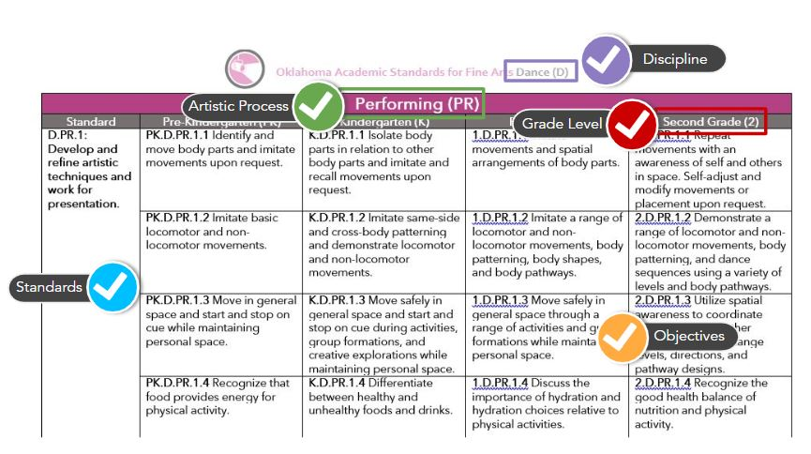
Visual Art Overview
Visual art is a significant expression of human culture. Art carries ideas from generation to generation, enhances cultural understandings, provides visual records of the past and gives form to contemporary ideas and events. Through visual art, we develop skills for perceiving, analyzing, appreciating, and responding to the visual environment.

Quality art programs help students develop skills to express themselves visually and understand the visual expression of others. As students work individually through an art project, there is constant decision-making and they learn to make adjustments to the work as it progresses. It is through the study of art that they learn about art products, artists, history, art materials, and art processes, which develop skills related college and career preparedness.

The visual art standards are designed to extend from pre-kindergarten through grade 12. The standards guide students through art skills in sequential order as they relate to the cognitive, psychomotor, and affective aspects of art. A total curriculum is balanced between the artistic processes: creative process, production, cultural and historical perspectives, and aesthetic response and critique methodologies. A glossary for teachers and administrators is provided in Appendix D: Visual Art Glossary. The glossary is not intended for student use; it contains educational terms for those reading the standards.

Visual Art Artistic Processes
The visual art standards emerge from the artistic processes of creative process, production, cultural and historical perspectives, and aesthetic response and critique methodologies. Each artistic process branches into multiple anchor standards. The anchor standards further divide into objectives, which describe student learning in visual art.

Creative Process
The creative process in art begins with learning the language of art and developing visual literacy to identify and/or communicate artistic concepts and techniques. Students learn art vocabulary, practice and refine techniques, make creative choices and practice individual expression in creating art.

Production
Art production demonstrates the learned techniques and expression of ideas. Students utilize a variety of ideas and different media, supplies, and tools in an appropriate and safe manner to create original artworks. They also demonstrate an appropriate skill level and revise and refine artworks to create finished works of art.

Cultural and Historical Perspectives
Visual art students learn about art in relation to history and culture. They connect artistic ideas and works with societal, cultural, and historical context to deepen understanding.

Aesthetic Response and Critique Methodologies
This reflective process includes art critique and assessment, preparation of the student’s artwork portfolio, and the exploration and study of visual art careers and pathways

Creative Process (CP)
Standard | Pre-Kindergarten (PK) | Kindergarten (K) | First Grade (1) | Second Grade (2)
VA.CP.1: Learn and use vocabulary and concepts related to visual arts. | PK.VA.CP.1.1 With guidance, show and describe personal artwork using introductory art vocabulary. | K.VA.CP.1.1 Talk about personal artwork using introductory art vocabulary, including describing creative choices (e.g., color or shape choices). | 1.VA.CP.1.1 Describe personal artwork while referencing introductory art vocabulary (e.g., various elements of art and principles of design). | 2.VA.CP.1.1 With support, discuss and explain multiple approaches to art or design problems while referencing various elements of art (e.g., line, color, form, shape, texture, value, and space) and principles of design (e.g., rhythm, balance, contrast, movement, center of interest, and repetition).
 | PK.VA.CP.1.2 Share observations of others’ artwork. | K.VA.CP.1.2 Describe others’ artwork using art vocabulary. | 1.VA.CP.1.2 Describe the content of works of art while referencing various elements of art and principles of design. | 2.VA.CP.1.2 Describe the visual qualities and content of works of art while referencing various elements of art and principles of design.
VA.CP.2: Practice and refine techniques and skills related to visual arts. | PK.VA.CP.2.1 Engage in self-directed creative play with art materials. | K.VA.CP.2.1 Engage in directed exploration and imaginative play with art materials. | 1.VA.CP.2.1 Engage collaboratively in exploration and imaginative play with materials. | 2.VA.CP.2.1 Experiment with various materials and tools to explore personal interests in a work of art or design.
 | PK.VA.CP.2.2 Identify common tools and materials in art making (e.g., scissors, rulers, etc.). | K.VA.CP.2.2 Practice the use of common tools and materials in art making (e.g., cutting lines, curves, etc.). | 1.VA.CP.2.2 Practice the use of common tools and materials in art making (e.g., cutting lines and curves, using a ruler to draw straight lines, using stencils, etc.). | 2.VA.CP.2.2 Practice the use of common tools and materials in art making (e.g., cutting lines and curves, measuring with a ruler, using stencils, etc.).
VA.CP.3: Make creative choices and practice individual expression in application of concepts, vocabulary, techniques, and skills. | PK.VA.CP.3.1 Describe choices involved in creating artwork through imaginative play. | K.VA.CP.3.1 Describe steps involved in creating personal artwork. | 1.VA.CP.3.1 Describe steps involved in creating artwork using art vocabulary (the elements of art and principles of design). | 2.VA.CP.3.1 Discuss and reflect with peers about choices made in creating artwork.
 | PK.VA.CP.3.2 Express feelings involved in creating personal work. | K.VA.CP.3.2 Explain emotions depicted in personal work. | 1.VA.CP.3.2 Use appropriate vocabulary (elements of art and principles of design) to express how art can portray emotions. | 2.VA.CP.3.2 Use appropriate vocabulary (elements of art and principles of design) to express how art can portray emotions.

Production (P)
Standard | Pre-Kindergarten (PK) | Kindergarten (K) | First Grade (1) | Second Grade (2)
VA.P.1: Utilize a variety of ideas and subject matter in creation of original works of visual art. | PK.VA.P.1.1 Practice creating works from selected ideas. | K.VA.P.1.1 Select specific ideas for creative exploration through original artworks. | 1.VA.P.1.1 Gather references from diverse sources and create works using various subject matter. | 2.VA.P.1.1 Gather references from diverse sources and create works using various subject matter utilizing a concept or theme.
VA.P.2: Use different media, supplies, and tools in an appropriate and safe manner in the creation of original visual artworks. | PK.VA.P.2.1 Practice creative exploration using a variety of art materials, supplies, and tools. | K.VA.P.2.1 Begin to create original works of art using a variety of art materials, supplies, and tools. | 1.VA.P.2.1 Explore the elements of art (e.g., line, color, form, shape, texture, value, and space) and principles of design (e.g., rhythm, balance, contrast, movement, center of interest, and repetition) using a variety of art materials, supplies, and tools in various media (materials). | 2.VA.P.2.1 Demonstrate use of the elements of art (shape, line, color, form, texture, space, and value) and principles of design (e.g., rhythm, balance, contrast, movement, center of interest, and repetition) using a variety of art materials, supplies, and tools in various media (materials).
 | PK.VA.P.2.2 Use supplies and tools in a safe and responsible manner to create original art. | K.VA.P.2.2 Use supplies and tools in a safe and responsible manner to create original art. | 1.VA.P.2.2 Use supplies and tools in a safe and responsible manner to create original art. | 2.VA.P.2.2 Use supplies and tools in a safe and responsible manner to create original art.
VA.P.3: Demonstrate appropriate skill level in the application of knowledge, techniques, skills, and concepts, through the creation of original visual artworks. | PK.VA.P.3.1 Engage in safe, creative exploration of art materials. | K.VA.P.3.1 Engage in creative art-making using a variety of art materials. | 1.VA.P.3.1 Engage in art-making, exploring knowledge of art vocabulary, materials, techniques, and skills. | 2.VA.P.3.1 Engage in art-making, applying knowledge of art vocabulary, materials, techniques, and skills.
VA.P.4: Revising and refining artworks to create finished works of art. | PK.VA.P.4.1 Follow teacher established criteria to decide when a piece of original artwork is complete. | K.VA.P.4.1 Follow teacher established criteria to decide when a piece of original artwork is complete. | 1.VA.P.4.1 Use observation and teacher established criteria to refine a piece of original artwork until its completion. | 2.VA.P.4.1 Use observation and teacher established criteria to refine a piece of original artwork until its completion.

Cultural and Historical Perspectives (CHP)
Standard | Pre-Kindergarten (PK) | Kindergarten (K) | First Grade (1) | Second Grade (2)
VA.CHP.1: Relate artistic ideas and works with societal, cultural and historical context to deepen understanding. | PK.VA.CHP.1.1 Recognize that people make art. | K.VA.CHP.1.1 Recognize that people make art. | 1.VA.CHP.1.1 Observe works of art from various times, places, and cultures. | 2.VA.CHP.1.1 Observe works of art from various times, places, and cultures.
 | PK.VA.CHP.1.2 View images of various works of art. | K.VA.CHP.1.2 View images of various works of art. | 1.VA.CHP.1.2 Explore the variety of reasons and materials used to create art. | 2.VA.CHP.1.2 Explore the variety of reasons and materials used to create art.

Aesthetic Response & Critique Methodologies (ARCM)
Standard | Pre-Kindergarten (PK) | Kindergarten (K) | First Grade (1) | Second Grade (2)
VA.ARCM.1: Perceive, analyze, interpret, and evaluate artistic work. | PK.VA.ARCM.1.1 Demonstrate respect for personal artwork and the artwork of others. | K.VA.ARCM.1.1 Demonstrate respect for personal artwork and the artwork of others. | 1.VA.ARCM.1.1 Demonstrate respect for personal artwork and the artwork of others. | 2.VA.ARCM.1.1 Demonstrate respect for personal artwork and the artwork of others.
 | PK.VA.ARCM.1.2 With guidance, explore connections between visual art and other domains of learning. | K.VA.ARCM.1.2 Explore connections between visual art and other domains of learning. | 1.VA.ARCM.1.2 Identify connections between visual art and other domains of learning. | 2.VA.ARCM.1.2 Identify connections between visual art and other domains of learning.
 | PK.VA.ARCM.1.3 With guidance, identify choices made in personal works of art. | K.VA.ARCM.1.3 Identify choices made in personal works of art. | 1.VA.ARCM.1.3 Describe choices made in personal works of art. | 2.VA.ARCM.1.3 Describe choices made in personal works of art.
 | PK.VA.ARCM.1.4 With guidance, explore potential art related careers. | K.VA.ARCM.1.4 With guidance, explore potential art related careers. | 1.VA.ARCM.1.4 Explore potential art related careers. | 2.VA.ARCM.1.4 Explore potential art related careers.
 |  |  | 1.VA.ARCM.1.5 Select and collect personal works of art. | 2.VA.ARCM.1.5 Select and collect personal works of art.

Creative Process (CP)
Standard | Third Grade (3) | Fourth Grade (4) | Fifth Grade (5)
VA.CP.1: Learn and use vocabulary and concepts related to visual arts. | 3.VA.CP.1.1 Discuss and explain an imaginative idea using elements of art and principles of design. | 4.VA.CP.1.1 Discuss and compare imaginative ideas using elements of art and principles of design. | 5.VA.CP.1.1 Discuss approaches and combine concepts to generate innovative ideas for creating art using elements of art and principles of design.
 | 3.VA.CP.1.2 Gain knowledge of available resources, tools, and technologies to investigate personal ideas through the art-making process. | 4.VA.CP.1.2 Apply knowledge of available resources, tools, and technologies to investigate personal ideas through the art-making process. | 5.VA.CP.1.2 Plan and demonstrate diverse methods of artistic investigation to choose an approach for beginning a work of art.
VA.CP.2: Practice and refine techniques and skills related to visual arts. | 3.VA.CP.2.1 Explore and invent a variety of art-making techniques and approaches. | 4.VA.CP.2.1 Explore and invent a variety of art-making techniques and approaches. | 5.VA.CP.2.1 Experiment and demonstrate developing skills in multiple art-making techniques, methods, and approaches through practice.
 | 3.VA.CP.2.2 Demonstrate an understanding of the safe and proficient use of materials, tools, and equipment in a manner that prevents danger to oneself and others. | 4.VA.CP.2.2 Demonstrate an understanding of the safe and proficient use of materials, tools, and equipment in a manner that prevents danger to oneself and others. | 5.VA.CP.2.2 Demonstrate proper and safe handling through care, storage, and use of materials, tools, and equipment.
VA.CP.3: Make creative choices and practice individual expression in application of concepts, language, techniques, and skills. | 3.VA.CP.3.1 Elaborate and revise artwork on the basis of insights gained through reflection and/or discussion. | 4.VA.CP.3.1 Elaborate and revise artwork on the basis of insights gained through reflection and/or discussion. | 5.VA.CP.3.1 Elaborate and revise artwork on the basis of insights gained through reflection and/or discussion.

Production (P)
Standard | Third Grade (3) | Fourth Grade (4) | Fifth Grade (5)
VA.P.1: Utilize a variety of ideas and subject matter in creation of original works of visual art. | 3.VA.P.1.1 Investigate and discuss diverse resources in creating works of art using a variety of subject matter utilizing a concept or theme. | 4.VA.P.1.1 Investigate and apply diverse resources and media (materials) for creating themed works of art. | 5.VA.P.1.1 Apply diverse media (materials), including available technology, for creating themed works of art.
 | 3.VA.P.1.2 Individually or collaboratively create works which represent places or objects that are part of everyday life. | 4.VA.P.1.2 Individually or collaboratively create works which represent places or objects that are part of everyday life. | 5.VA.P.1.2 Design, redesign, or visually document places or everyday objects.
VA.P.2: Use different media, supplies, and tools in an appropriate and safe manner in the creation of original visual artworks. | 3.VA.P.2.1 Demonstrate an understanding of the importance of the elements of art in the development of artwork. | 4.VA.P.2.1 Collaboratively discuss the elements of art and their relationship to the principles of design. | 5.VA.P.2.1 Demonstrate an understanding of the importance of the elements of art and their relationship to the principles of design in the creation of artwork.
 | 3.VA.P.2.2 Use supplies and tools in a safe and responsible manner to create original art. | 4.VA.P.2.2 Use supplies and tools in a safe and responsible manner to create original art. | 5.VA.P.2.2 Use supplies and tools in a safe and responsible manner to create original art.
VA.P.3: Demonstrate appropriate skill level in the application of knowledge, techniques, skills, and concepts, through the creation of original visual artworks. | 3.VA.P.3.1 Engage in art-making, applying knowledge of art-related vocabulary, materials, techniques, skills, and tools/technology. | 4.VA.P.3.1 Explore and experiment with materials and techniques to expand personal interests and skills. | 5.VA.P.3.1 Experiment and invent multiple art making techniques and approaches through practice.
VA.P.4: Revising and refining artworks to create finished works of art. | 3.VA.P.4.1 Demonstrate thoughtfulness and care in the process of refining original artwork. | 4.VA.P.4.1 Demonstrate thoughtfulness and care in the process of revising and refining original artwork. | 5.VA.P.4.1 Discuss processes of personal artistic choices during creating and revising original works of art.
Cultural and Historical Perspectives (CHP)
Standard | Third Grade (3) | Fourth Grade (4) | Fifth Grade (5)
CHP.1: Relate artistic ideas and works with societal, cultural and historical context to deepen understanding. | 3.VA.CHP.1.1 Compare and contrast works of art from various times, places, and cultures. | 4.VA.CHP.1.1 Compare and contrast works of art from various times, places, and cultures. | 5.VA.CHP.1.1 Analyze how art reflects changing times, traditions, resources, and cultural uses.
 | 3.VA.CHP.1.2 Explore ways that people have created artwork using accessible resources. | 4.VA.CHP.1.2 Explore ways that people have created artwork using accessible resources. | 5.VA.CHP.1.2 Explore how artists and cultures used media (materials) to express themselves.
 |  |  | 5.VA.CHP.1.3 Introduce global works of art to represent various cultures, societies, and historical periods.

Aesthetic Response & Critique Methodologies (ARCM)
Standard | Third Grade (3) | Fourth Grade (4) | Fifth Grade (5)
VA.ARCM.1: Perceive, analyze, interpret, and evaluate artistic work. | 3.VA.ARCM.1.1 Demonstrate care and respect for personal artwork and the artwork of others. | 4.VA.ARCM.1.1 Demonstrate care and respect for personal artwork and the artwork of others. | 5.VA.ARCM.1.1 Demonstrate care and respect for personal artwork and the artwork of others.
 | 3.VA.ARCM.1.2 Make connections between visual art and other domains of learning. | 4.VA.ARCM.1.2 Make connections between visual art and other domains of learning. | 5.VA.ARCM.1.2 Make connections between visual art and other domains of learning.
 | 3.VA.ARCM.1.3 Reflect on choices made in personal works of art. | 4.VA.ARCM.1.3 Critique personal art based on teacher established criteria. | 5.VA.ARCM.1.3 Critique personal art based on teacher established criteria.
 | 3.VA.ARCM.1.4 Explore potential art related careers. | 4.VA.ARCM.1.4 Explore potential art related careers. | 5.VA.ARCM.1.4 Explore potential art related careers.
 | 3.VA.ARCM.1.5 Select and collect personal works of art. | 4.VA.ARCM.1.5 Select and collect personal works of art. | 5.VA.ARCM.1.5 Select and collect personal works of art.

Visual Art Glossary

Appropriation Intentional borrowing, copying, and alteration of preexisting images and objects.

Balance The distribution of the visual weight of objects, colors, texture, and space. If the design was a scale, these elements should be balanced to make a design feel stable. In symmetrical balance, the elements used on one side of the design are similar to those on the other side; in asymmetrical balance, the sides are different but still look balanced. In radial balance, the elements are arranged around a central point and may be similar.

Color The quality of an object or substance with respect to the light reflected by the object. Color has three main characteristics:
Hue - The specific name of a color (red, green, blue, etc.)
Value - The degree of lightness or darkness of a color.
Intensity - The degree of brightness or dullness of a color

Color can also be characterized by the following:
- White is pure light; black is the absence of light.
- Primary colors are the only true colors (red, blue, and yellow). All other colors are mixes of primary colors.
- Secondary colors are two primary colors mixed together (green, orange, violet).
- Intermediate colors (sometimes called tertiary colors) are made by mixing a primary and secondary color together. Examples of intermediate colors include yellow-green, blue-green, and blue-violet.
- Complementary colors are located directly across from each other on the color wheel (an arrangement of colors along a circular diagram to show how they are related to one another). Complementary pairs contrast because they share no common colors. For example, red and green are complements, because green is made of blue and yellow.

- When complementary colors are mixed together, they neutralize one another.
- Warm colors are colors in the spectrum that suggest warmness, including red, yellow, and orange. Warm colors advance when used with cool colors.
- Cool colors are colors of the spectrum that suggest coolness, including blue, green and violet. Cool colors recede when used with warm colors.
- Analogous colors are colors that contain a common hue, which are found next to one another on the color wheel. An example of analogous colors include green-blue, blue, and blue-violet.

Contrast The difference between elements of art in a composition, such that each element is made stronger in relation to the other. When placed next to each other, contrasting elements command the viewer's attention. Contrast can be achieved by the juxtaposition of any of the elements of art.

Copyright Form of protection grounded in the U.S. Constitution and granted by law for original works of authorship fixed in a tangible medium of expression, covering both published and unpublished works.

Curate Select, organize, and exhibit works of art.

Elements of Art Line, shape, form, space, value, color, and texture.

Emphasis The part of the design that catches the viewer’s attention, also referred to as the center of interest or focal point. Usually the artist will make one area stand out by contrasting it with other areas. The area could be different in size, color, texture, shape, etc.

Fair Use The doctrine that brief excerpts of copyright material may, under certain circumstances, be quoted verbatim for purposes such as criticism, news reporting, teaching, and research, without the need for permission from or payment to the copyright holder.

Form Three-dimensional objects that can be measured by length, width, and depth (e.g., spheres, cylinders, cubes, pyramids, cuboids, etc.).

Line A mark with greater length than width. Lines can be horizontal, vertical, or diagonal; straight or curved; thick or thin.

Movement The path the viewer’s eye takes through the work of art. Such movement can be directed along lines, edges, shape, and color within the work of art.

Pattern The repeating of an object or symbol throughout the work of art.

Principles of Design Balance, emphasis, movement, pattern, repetition, rhythm, variety, unity, and contrast.

Proportion The relationship of one part of a whole to other parts.

Repetition Works with pattern to make the work of art seem active. The repetition of elements of art creates unity within the work of art.

Rhythm Created when one or more elements of art are used repeatedly to create a feeling of organized movement. Rhythm creates a mood like music or dancing. Unlike pattern, which demands consistency, rhythm relies on variety.

Shape A two-dimensional closed line. Shapes can be geometric (squares, circles, triangles, etc.) or organic (free-form or natural shapes). Shapes are flat and can be measured by length and width.

Space The area between, around, and within objects. The space around an object is negative space. The object itself is known as positive space. Space can also refer to the feeling of depth - also known as space-in-depth. Space-in-depth includes foreground, middle ground, and background space.

Texture The surface quality that can be seen and felt. Textures can be rough or smooth, soft or hard. Texture can be natural (real) and actually felt or visually implied by the artist and feels different than it appears.

Value The degree of lightness or darkness of a tone or color. Value is dependent upon the amount of light a surface reflects. Value can be created through the following techniques:
- Hatching - Technique that uses one set of hatching lines running parallel to the other sets.
- Cross-Hatching - Technique that uses one set of hatching lines over another set in a different direction so that the lines intersect.
- Stippling - Technique that uses a series of dots to create dark and light values.
- Tonal Shading - Technique that blends tones together creating a smooth effect.
- Shade - Dark value created by adding black.
- Tint - Light value created by adding white.

Variety The use of several elements of art to hold the viewer’s attention and to guide the viewer’s eye through and around the work.
Unity The feeling of harmony between all parts of the work of art, which creates a sense of completeness.

