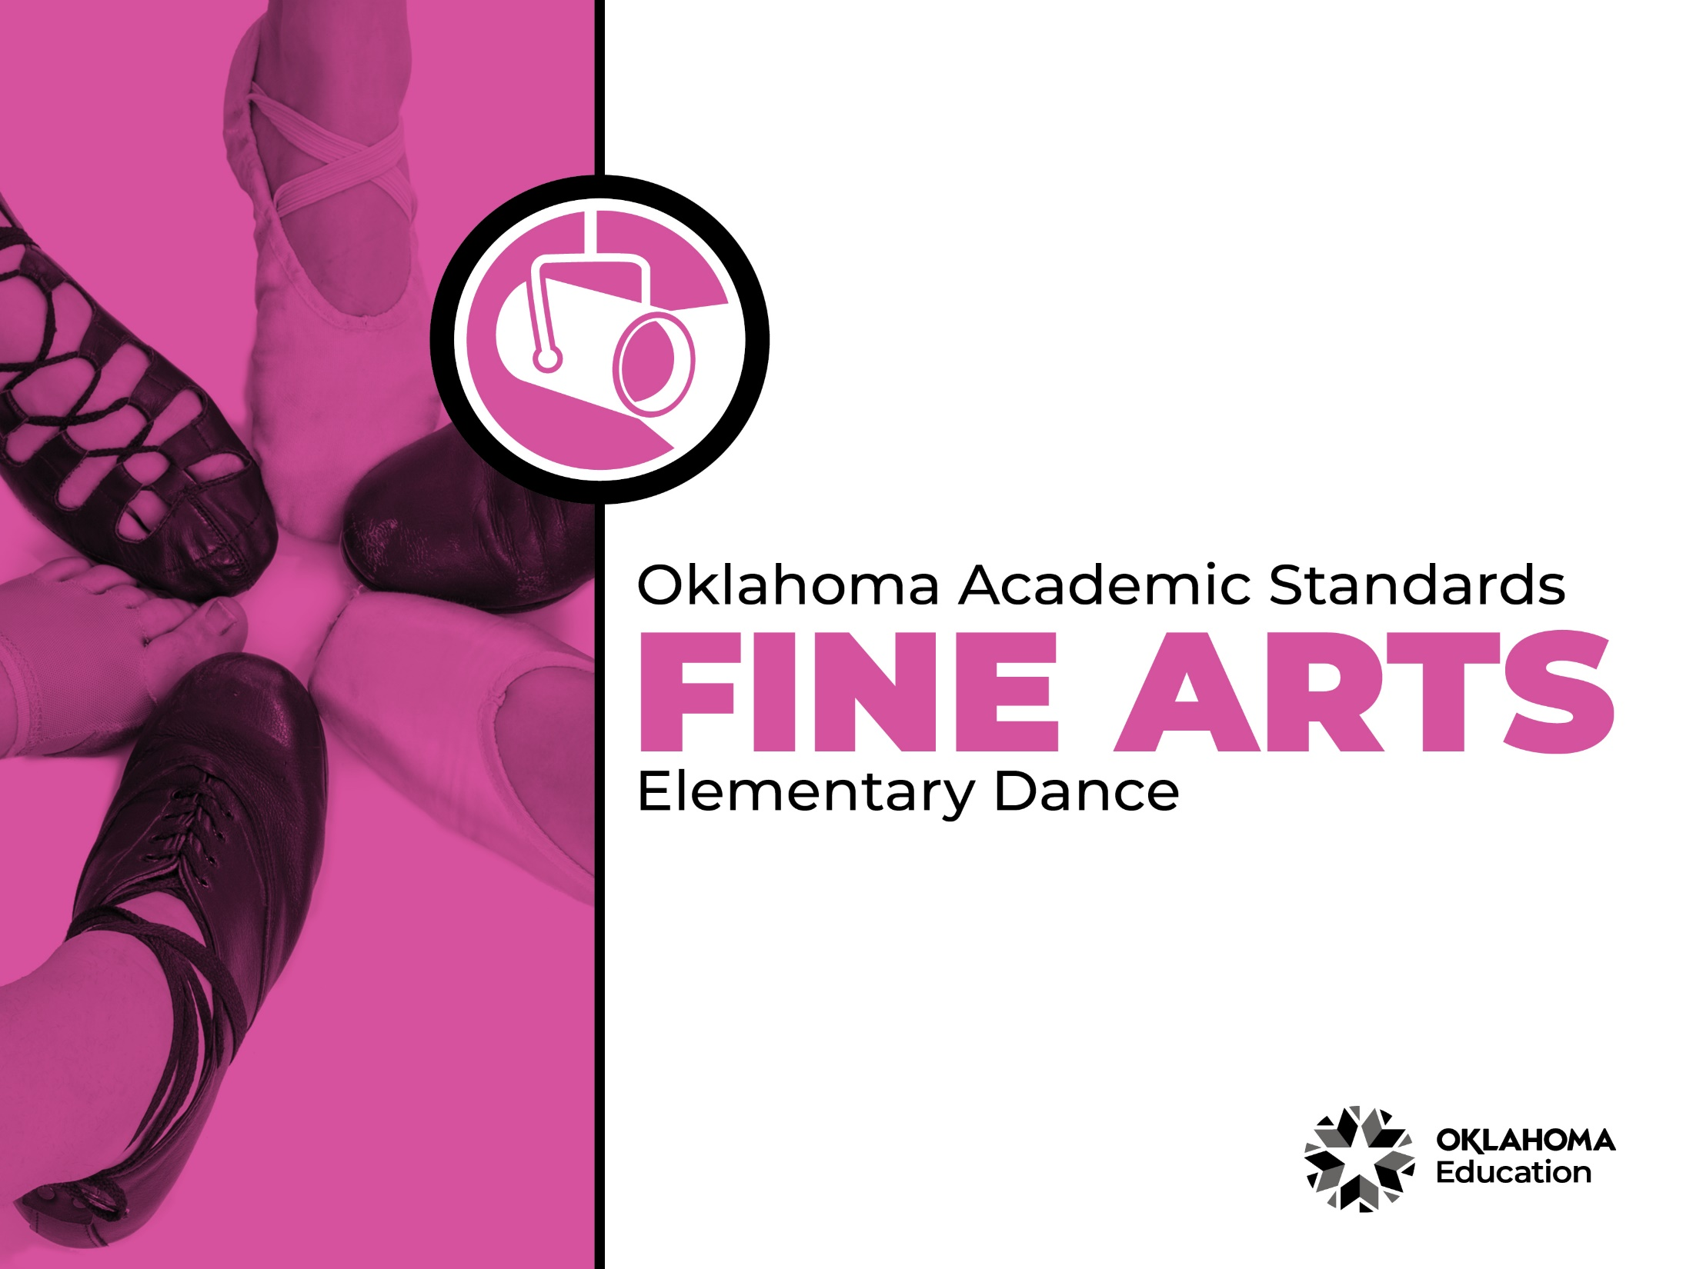

Table of Contents

Introduction & Standards Overview | 3
Dance Overview & Artistic Processes | 6
Dance Standards: PK-2nd Grade | 7
Dance Standards: 3rd Grade-5th Grade | 13
Dance Glossary | 18

Introduction
The Oklahoma Standards for Fine Arts encompass dance, drama/theatre, music, and visual art. The standards are the result of the contributions of hundreds of fine arts educators, arts administrators, and representatives of higher education, arts organizations, and community members. This document reflects a balanced synthesis of the work of all committee members of the Oklahoma standards for dance, drama/theatre, music, and visual art.

The standards specify what students should know and be able to do as learners in their discipline at the end of each grade level or course. Students have different levels of experience within a discipline so teachers can attend to both grade-level standards and meet the individual needs of students who may be performing at levels above or below grade level. The order of the standards at any grade level is not meant to imply a sequence of topics and should be considered flexible for the organization of any course.

The Oklahoma Standards for dance, drama/theatre, music, and visual art were informed by the National Coalition for Core Arts Standards (NCCAS), the Opportunity-to-Learn Standards for Dance, the Opportunity-to-Learn Standards for Music, the Opportunity-to-Learn Standards for Theatre Education, the Purposes, Principles, and Standards for School Art Programs, and other states’ standards documents.

Standards Overview
The Oklahoma Standards for Fine Arts are designed to support all Oklahoma students to develop and achieve artistic literacy and to promote access and equity in the arts. Study of the arts enrich the quality of life. Dance, drama/theatre, music, and visual art are used by and have shaped every culture and individual on earth. They provide a means for experiencing the world and give form to our innermost thoughts, feelings, and sensibilities. They also give students an opportunity to use metacognitive skills as they plan, monitor, revise, and assess their art work in dance, drama/theatre, music, or visual art.

A well-rounded education addresses the development of all the realms of human behavior—the physical, emotional, social, and intellectual. Neglecting any of the areas weakens all the rest; therefore, Oklahoma students must have access to arts education that includes dance, drama/theatre, music, and visual art. Schools that provide quality arts experiences, based on sequential skill development, supplemented with carefully selected arts resources, can help students cultivate a positive attitude towards themselves and toward learning—an attitude that carries over to their entire education and life. In short, access to arts education prepares students to be creative, persistent, and compassionate adults.

The standards are comprised of four artistic processes:
- Creating/Creative Process
- Performing/Production,
- Connecting/Cultural and Historical Perspectives, and
- Responding/Aesthetic Response and Critique Methodologies.

Each artistic process has a discipline-specific definition found in the discipline overview. The artistic processes branch into anchor standards in each discipline. The anchor standards designate specific learning targets at each grade or learning level.
In dance, drama/theatre, and visual art, there are elementary grade level standards through grade eight. At the secondary level in these disciplines, there are three proficiency levels: proficient, advanced, and accomplished. The proficiency levels may apply to high school students at any grade level and prepare students for a career or college life.
The elementary music standards extend through grade six. The ensemble and/or secondary music standards have five proficiency levels:
- Novice
- Intermediate
- Proficient
- Advanced
- Accomplished

Novice proficiency level is assigned to students who have started specialization and are developing artistic understanding and technique and may participate in performance opportunities as they are able. Intermediate proficiency level is for students who are continuing study in their art form, perhaps at the middle school level. Proficient, advanced, and accomplished may apply to students at any grade level. In a middle or high school class or ensemble, it is expected that the teacher will develop an understanding of their students’ proficiency levels and utilize the corresponding level from the standards for each student.

Reading the Oklahoma Academic Standards for Fine Arts
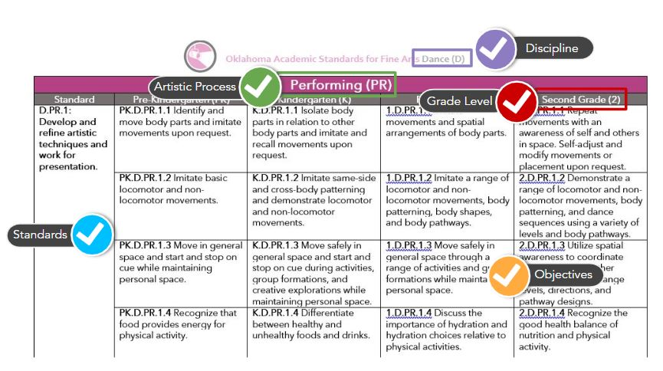
Dance Overview
Dance is essential to the well-rounded education of all students. Dance enables students to outwardly express and create through the medium of physical movement. The essence of dance is to feel, create, compose, interpret, perform, and respond. Dance is the physical expression of an idea developed through a process of research, inquiry, and movement discovery.
A dance education program provides for a student’s kinesthetic, spatial, emotional, social, intellectual, creative, and aesthetic development. Students are guided through experiences that are layered in a way that provides them with opportunities to experience and create different ways of doing and organizing movement sequences. These experiences are designed to enrich and broaden the students’ awareness of themselves and their world. All students should be provided access to quality dance education that supports college and career preparedness.
The standards are the impetus for Oklahoma dance educators to inspire their students to explore and discover their personal connection to the deep human tradition that is dance. The standards also prepare students for a life-long immersion in the socio-cultural-historical meanings and experience of dancing, as well as the embodied learning and enjoyment that performing, studying, and viewing dance can bring. A glossary for teachers and administrators is provided in Appendix A: Dance Glossary. The glossary is not intended for student use; it contains educational terms for those reading the standards.
Dance Artistic Processes
The dance standards emerge from the artistic processes of performing, creating, responding, and connecting. Each artistic process branches into multiple anchor standards. The anchor standards further divide into objectives, which describe student learning in dance.

Performing
Dance is an experiential discipline that enables students to outwardly express and create through the medium of physical movement. Students develop and refine artistic techniques and work for presentation. They also select, analyze, and interpret artistic work. Performing helps students convey meaning through dance.
Creating
Dance is an art form providing students the opportunity to create and compose. Students organize, develop, refine, and complete artistic ideas and work. Creating a dance or a portion of a dance gives students autonomy and self-efficacy in the classroom.
Responding
Dance students work to understand and evaluate how movement conveys meaning. This process begins with students perceiving and analyzing artistic work. Students then interpret and apply criteria to evaluate the artistic work.
Connecting
Students connect in dance by relating artistic ideas and work with personal meaning and external context. This is accomplished through synthesizing and relating knowledge and personal experiences to make art. Students also relate artistic works with societal, cultural, and historical context to deepen understanding.

Performing (PR)
Standard | Pre-Kindergarten (PK) | Kindergarten (K) | First Grade (1) | Second Grade (2)
D.PR.1: Develop and refine artistic techniques and work for presentation. | PK.D.PR.1.1 Identify and move body parts and imitate movements upon request. | K.D.PR.1.1 Isolate body parts in relation to other body parts and imitate and recall movements upon request. | 1.D.PR.1.1 Imitate movements and spatial arrangements of body parts. | 2.D.PR.1.1 Repeat movements with an awareness of self and others in space. Self-adjust and modify movements or placement upon request.
 | PK.D.PR.1.2 Imitate basic locomotor and non-locomotor movements. | K.D.PR.1.2 Imitate same-side and cross-body patterning and demonstrate locomotor and non-locomotor movements. | 1.D.PR.1.2 Imitate a range of locomotor and non-locomotor movements, body patterning, body shapes, and body pathways. | 2.D.PR.1.2 Demonstrate a range of locomotor and non-locomotor movements, body patterning, and dance sequences using a variety of levels and body pathways.
 | PK.D.PR.1.3 Move in general space and start and stop on cue while maintaining personal space. | K.D.PR.1.3 Move safely in general space and start and stop on cue during activities, group formations, and creative explorations while maintaining personal space. | 1.D.PR.1.3 Move safely in general space through a range of activities and group formations while maintaining personal space. | 2.D.PR.1.3 Utilize spatial awareness to coordinate with a partner or other dancers to safely change levels, directions, and pathway designs.
 | PK.D.PR.1.4 Recognize that food provides energy for physical activity. | K.D.PR.1.4 Differentiate between healthy and unhealthy foods and drinks. | 1.D.PR.1.4 Discuss the importance of hydration and hydration choices relative to physical activities. | 2.D.PR.1.4 Recognize the good health balance of nutrition and physical activity.
D.PR.2: Select, analyze, and interpret artistic work for presentation. | PK.D.PR.2.1 Imitate and follow directions for moving the body in general space (e.g., forward, backward, sideways, up, down, turning) and finding and returning to a place in space. | K.D.PR.2.1 Make still and moving body shapes that show lines (e.g., straight, bent, curved), changes levels, and vary in size (large/small). Join with others to make a circle formation and work with others to change its dimensions. | 1.D.PR.2.1 Present locomotor and non-locomotor movements that change body shapes, levels, and facings. Move in straight, curved, and zigzagged pathways. Find and return to place in space. Move with others to form straight lines and circles. | 2.D.PR.2.1 Present clear directionality, focus, and intent when performing locomotor and non-locomotor movements that change body shapes, facings, and pathways in space. Recognize symmetrical and asymmetrical body shapes and examine relationships between body parts. Differentiate between circling and turning as two separate ways of continuous directional change.
 | PK.D.PR.2.2 Imitate speed of dance as fast or slow. Move to varied rhythmic sounds at different tempi. | K.D.PR.2.2 Demonstrate tempo contrasts with movements that match the tempo of music or rhythmic accompaniment. | 1.D.PR.2.2 Relate quick, moderate, and slow movements to duration in time. Recognize steady beat and move to varying tempi of steady beat. | 2.D.PR.2.2 Identify the length of time a move or phrase takes (e.g., whether it is long or short). Identify and move on the downbeat and in varying meters. Match movement phrasing with musical phrasing.
 | PK.D.PR.2.3 Identify and apply different movement qualities (e.g., slow, smooth, wavy). | K.D.PR.2.3 Move with contrasting efforts (e.g., light/strong, quick/sustained, direct/indirect). | 1.D.PR.2.3 Identify and apply appropriate dynamics to demonstrate change in movement qualities (e.g., selecting specific adverbs and adjectives and apply them to movements). | 2.D.PR.2.3 Demonstrate movement qualities along with movement vocabulary (e.g., use adverbs and adjectives that apply to movement such as a bouncy leap, a floppy fall, a jolly jump, and joyful spin).
D.PR.3: Convey meaning through the presentation of artistic work. | PK.D.PR.3.1 Dance with others in a designated area or space. | K.D.PR.3.1 Dance for and with others in a designated space. | 1.D.PR.3.1 Dance for and with others in a space where audience and performers occupy different areas. | 2.D.PR.3.1 Understand the role of an audience member in a performance.
 | PK.D.PR.3.2 Use a simple prop as part of a dance. | K.D.PR.3.2 Select a prop to use as part of a dance. | 1.D.PR.3.2 Explore the use of simple props or scenery to enhance performance. | 2.D.PR.3.2 Use limited production elements (e.g., hand props, simple scenery, or media projections) to enhance performance.

Creating (CR)
Standard | Pre-Kindergarten (PK) | Kindergarten (K) | First Grade (1) | Second Grade (2)
D.CR.1: Generate and conceptualize artistic ideas and work. | PK.D.CR.1.1 Respond in movement to a variety of sensory stimuli (e.g., music/sound, visual, tactile). | K.D.CR.1.1 Respond in movement to a variety of stimuli (e.g., music/ sound, text, objects, images, symbols, observed dance). | 1.D.CR.1.1 Explore movement inspired by a variety of stimuli (e.g., music/sound, text, objects, images, symbols, observed dance, experiences) and identify the source. | 2.D.CR.1.1 Explore movement inspired by a variety of stimuli (e.g., music/sound, text, objects, images, symbols, observed dance, experiences) and suggest additional sources for movement ideas.
 | PK.D.CR.1.2 Explore basic locomotor and non-locomotor movements. | K.D.CR.1.2 Explore a different way to do several basic locomotor and non-locomotor movements. | 1.D.CR.1.2 Explore a variety of locomotor and non-locomotor movements by experimenting with and manipulating the elements of dance (e.g., Body, Space, Time, and Energy). | 2.D.CR.1.2 Combine a variety of movements to create a sequence while manipulating the elements of dance.
D.CR.2: Organize and develop artistic work. | PK.D.CR.2.1 Improvise dance that starts and stops on cue. | K.D.CR.2.1 Improvise dance that has a beginning, middle, and end. | 1.D.CR.2.1 Improvise a series of movements that have a beginning, middle, and end. Describe movement choices. | 2.D.CR.2.1 Organize a dance phrase with a beginning, a middle that has a main idea, and a clear end.
 | PK.D.CR.2.2 Engage in dance experiences moving alone or with a partner. | K.D.CR.2.2 Express an idea, feeling, or image, through improvised movement moving alone or with a partner. | 1.D.CR.2.2 Choose movements that express an idea or emotion or follow a musical phrase. | 2.D.CR.2.1 Choose movements that express a main idea or emotion or follow a musical phrase. Explain reasons for movement choices.
D.CR.3: Refine and complete artistic work. | PK.D.CR.3.1 Follow verbal cues for changing movement through guided improvisational experiences. | K.D.CR.3.1 Apply suggestions for changing movement through guided improvisational experiences. | 1.D.CR.3.1 Explore suggestions to change movement within short remembered sequences. | 2.D.CR.3.1 Explore suggestions and make choices to change movement from guided improvisation and/or short remembered sequences.
 | PK.D.CR.3.2 Identify parts of the body and draw a picture of a body shape or position. | K.D.CR.3.2 Depict a dance movement by drawing a picture or using a symbol. | 1.D.CR.3.2 Depict several different types of movements of a dance by drawing a picture or using a symbol (e.g., jump, turn, slide, bend, reach). | 2.D.CR.3.2 Depict the levels in a variety of dance movements by drawing a picture or using symbols (e.g., high, middle, low).

Responding (RE)
Standard | Pre-Kindergarten (PK) | Kindergarten (K) | First Grade (1) | Second Grade (2)
D.RE.1: Perceive and analyze artistic work. | PK.D.RE.1.1 Identify a learned movement in a dance. | K.D.RE.1.1 Identify a learned movement that repeats in a dance. | 1.D.RE.1.1 Identify a movement that repeats in a dance to make a pattern. | 2.D.RE.1.1 Identify a dance style within the pattern of a dance.
 | PK.D.RE.1.2 Demonstrate an observed or performed dance movement. | K.D.RE.1.2 Demonstrate or describe observed or performed dance movements. | 1.D.RE.1.2 Demonstrate and describe observed or performed dance movements from a specific genre or culture. | 2.D.RE.1.2 Demonstrate and describe movements in dances from different genres or cultures.
D.RE.2: Construct meaningful interpretations of artistic work. | PK.D.RE.2.1 Observe a shape or movement and describe it. | K.D.RE.2.1 Observe several shapes or movements and describe thoughts or feelings. | 1.D.RE.2.1 Observe several shapes or movements and use fundamental dance vocabulary to describe it. | 2.D.RE.2.1 Select context cues from movement to identify meaning and intent in a dance, using fundamental dance vocabulary.
D.RE.3: Apply criteria to evaluate artistic work. | PK.D.RE.3.1 Imitate a movement from a dance and explain how it feels to perform it. | K.D.RE.3.1 Select a movement observed in a dance. Demonstrate the movement and explain why it was selected. | 1.D.RE.3.1 Identify and demonstrate one movement in a dance that attracted attention. Describe the characteristics that make the movements interesting. | 2.D.RE.3.1 Observe or demonstrate dances from a specific genre or culture. Discuss characteristics of that genre or cultural dance.

Connecting (CN)
Standard | Pre-Kindergarten (PK) | Kindergarten (K) | First Grade (1) | Second Grade (2)
D.CN.1: Synthesize and relate knowledge and personal experiences to make art. | PK.D.CN.1.1 Recognize emotions expressed in dance movement that is watched or performed. | K.D.CN.1.1 Recognize and name an emotion that is experienced when watching, improvising, or performing dance. | 1.D.CN.1.1 Find an emotion expressed in a dance that relates to a familiar experience. Identify the movements that communicate this emotion. | 2.D.CN.1.1 Describe, create, and/or perform a dance that expresses personal meaning and explain how certain movements express this personal meaning.
 | PK.D.CN.1.2 Observe a dance work. Imitate a movement from the dance and ask a question about the dance. | K.D.CN.1.2 Observe illustrations from a story and discuss ideas for movement. | 1.D.CN.1.2 Observe a work of visual art. Describe and then express through movement something of interest about the artwork. | 2.D.CN.1.2 Respond to a dance work using an inquiry-based set of questions (e.g., See-Think-Wonder). Create movement using ideas from responses and explain how certain movements express a specific idea.
D.CN.2: Relate artistic ideas and works with societal, cultural and historical contexts to deepen understanding. | PK.D.CN.2.1 Imitate a dance movement experienced at home or elsewhere. | K.D.CN.2.1 Describe or demonstrate the movements in a dance that was watched or performed. | 1.D.CN.2.1 Watch and/or perform a dance from a different culture and discuss or demonstrate the types of movement danced. | 2.D.CN.2.1 Observe a dance and relate the movement to the people or environment in which the dance was created and performed, including dances of Oklahoma American Indian tribes and communities.

Performing (PR)
Standard | Third Grade (3) | Fourth Grade (4) | Fifth Grade (5)
D.PR.1: Develop and refine artistic techniques and work for presentation. | 3.D.PR.1.1 Identify and demonstrate movements initiated by distal ends (fingers/toes). Apply constructive feedback from teacher. | 4.D.PR.1.1 Demonstrate movements by isolating distal and mid-limb initiations (elbows, knees). Learn the roles of initiations and body patterns. | 5.D.PR.1.1 Demonstrate movement from central initiation (torso), mid-limb and distal initiation. Explore and analyze the role of initiations and body patterns and self-check to improve dance skills.
 | 3.D.PR.1.2 Introduce an awareness of body alignment and core support while executing body shapes and movement characteristics in a dance sequence. | 4.D.PR.1.2 Integrate movement fundamentals (e.g., alignment, coordination, balance, core support, kinesthetic awareness) and effort qualities in a dance sequence. | 5.D.PR.1.2 Execute a series of dance phrases while integrating movement fundamentals (e.g., alignment, coordination, balance, core support, kinesthetic awareness, clarity of movement).
 | 3.D.PR.1.3 Move safely in a variety of spatial relationships and formations with other dancers, sharing and maintaining personal space while exploring levels, directions, and pathway designs. | 4.D.PR.1.3 Coordinate phrases and timing with other dancers while changing levels, directions, and pathway designs. Reflect on feedback from others to inform personal dance performance goals. | 5.D.PR.1.3 Collaborate with peer ensemble members to repeat sequences, synchronize actions, and refine spatial relationships to improve performance quality. Apply feedback from others to establish personal performance goals.
 | 3.D.PR.1.4 Identifies foods that are beneficial for before and after physical activity. | 4.D.PR.1.4 Explore the relationship between safe body-use, healthy nutrition, and execution of technique. | 5.D.PR.1.4 Discuss how these practices, along with healthy eating habits, promote strength, flexibility, endurance, and injury prevention.
D.PR.2: Select, analyze, and interpret artistic work for presentation. | 3.D.PR.2.1 Present three-dimensional shapes with positive and negative space. Perform movement sequences in and through space with intentionality and focus. | 4.D.PR.2.1 Make static and dynamic shapes with positive and negative space. Perform elevated shapes (jump shapes) with soft landings and movement sequences alone and with others, establishing relationships with other dancers through performance focus. | 5.D.PR.2.1 Integrate static and dynamic shapes and varied pathways into dance sequences. Use performance focus to maintain relationships with other dancers and understand the difference between internal and external focus.
 | 3.D.PR.2.2 Fulfill specified duration of time with improvised locomotor and non-locomotor movements. Differentiate between “in time” and “out of time” to music. Perform movements that are the same or of a different tempi to accompaniment. | 4.D.PR.2.2 Accompany other dancers using a variety of percussive instruments and sounds. Respond in movement to even and uneven rhythms. Recognize and respond to tempi changes as they occur in dance and music. | 5.D.PR.2.2 Dance to a variety of rhythms generated from internal and external sources. Perform movement phrases that show the ability to respond to changes in time.
 | 3.D.PR.2.3 Change use of energy and dynamics by modifying movements and applying specific characteristics to heighten the effect of their intent. | 4.D.PR.2.3 Analyze movements and phrases for use of energy and dynamic changes. Refine the phrases by incorporating a range of contrasting movement characteristics. | 5.D.PR.2.3 Explore muscular tension and release as it relates to the body and space using effort qualities.
D.PR.3: Convey meaning through the presentation of artistic work. | 3.D.PR.3.1 Identify the main areas of a performance space using production terminology (i.e., stage directions). | 4.D.PR.3.1 Consider how to establish a formal performance space from an informal setting. | 5.D.PR.3.1 Demonstrate the ability to adapt dance to alternative performance venues by modifying spacing and movement to the performance space.
 | 3.D.PR.3.2 Explore simple production elements (e.g., costumes, props, music, scenery, lighting, media) for a dance performed for an audience in a designated performance space. | 4.D.PR.3.2 Identify, explore, and experiment with a variety of production elements to heighten the artistic intent and audience experience. | 5.D.PR.3.2 Identify, explore,  and select production elements that heighten and intensify the artistic intent of a dance and are adaptable for various performance spaces.

Creating (CR)
Standard | Third Grade (3) | Fourth Grade (4) | Fifth Grade (5)
D.CR.1: Generate and conceptualize artistic ideas and work. | 3.D.CR.1.1 Experiment with a variety of self-selected stimuli (e.g., music/sound, text, objects, images, notation, observed dance, experiences) for movement. | 4.D.CR.1.1 Generate ideas for choreography inspired by a variety of stimuli (e.g., music/ sound, text, objects, images, notation, observed dance, experiences). | 5.D.CR.1.1 Build content for choreography using several stimuli (e.g., music/sound, text, objects, images, notation, observed dance, experiences, literary forms, natural phenomena, current news, social events).
 | 3.D.CR.1.2 Explore manipulations of the elements of dance as tools to find a solution to a movement problem. | 4.D.CR.1.2 Develop a solution to a movement problem using the elements of dance. | 5.D.CR.1.2 Solve multiple movement problems to create choreographic content.
D.CR.2: Organize and develop artistic work. | 3.D.CR.2.1 Identify and experiment with choreographic devices to create simple movement patterns and dance structures (e.g., AB, ABA, theme and development). | 4.D.CR.2.1 Manipulate or modify choreographic devices to expand movement possibilities and create a variety of movement patterns and structures. Discuss movement choices. | 5.D.CR.2.1 Manipulate or modify a variety of choreographic devices to expand choreographic possibilities and develop a main idea. Explain reasons for movement choices.
 | 3.D.CR.2.2 Develop a dance phrase that expresses and communicates an idea or feeling. Discuss the effect of the movement choices. | 4.D.CR.2.2 Develop a dance study that expresses and communicates a main idea. Discuss the reasons and effectiveness of the movement choices. | 5.D.CR.2.2 Develop a dance study by selecting a specific movement vocabulary to communicate a main idea. Discuss how the dance communicates nonverbally.
CR.3: Refine and complete artistic work. | 3.CR.3.1 Revise movement choices in response to feedback to improve a short dance study. Describe the differences the changes made in the movements. | 4.CR.3.1 Revise movement based on peer feedback and self-reflection to improve communication of artistic intent in a short dance study. Explain choices made in the process. | 5.CR.3.1 Explore through movement the feedback from others to expand choreographic possibilities for a short dance study that communicates artistic intent. Explain and defend the movement choices and refinements.
 | 3.CR.3.2 Depict directions or spatial pathways in a dance phrase by drawing a picture map or using a symbol. | 4.CR.3.2 Depict the relationships between two or more dancers in a dance phrase by drawing a picture or using symbols (e.g., next to, above, below, behind, in front of). | 5.CR.3.2 Record changes in a dance sequence through writing, symbols, or a form of media technology.

Responding (RE)
Standard | Third Grade (3) | Fourth Grade (4) | Fifth Grade (5)
D.RE.1: Perceive and analyze artistic work. | 3.D.RE.1.1 Identify a movement pattern that creates a theme in a dance work. | 4.D.RE.1.1 Identify patterns of movement in dance works that create a style or theme. | 5.D.RE.1.1 Identify meaning or artistic intent conveyed through patterns of movement in a dance work.
 | 3.D.RE.1.2 Demonstrate and explain how one dance genre is different from another or how one cultural movement practice is different from another. | 4.D.RE.1.2 Demonstrate and explain how dance styles differ within a genre or within a cultural movement practice. | 5.D.RE.1.2 Demonstrate and explain the stylistic similarities and differences within a genre or within a cultural movement practice, using basic dance terminology.
D.RE.2: Construct meaningful interpretations of artistic work. | 3.D.RE.2.1 Select specific context cues from movement. Use dance vocabulary to explain how they relate to the main idea of the dance. | 4.D.RE.2.1 Relate movements, ideas, and context to decipher meaning in a dance, using dance vocabulary. | 5.D.RE.2.1 Interpret meaning or artistic intent from the patterns of movement in a dance work. Explain how the movements communicate the main idea of the dance using dance vocabulary.
D.RE.3: Apply criteria to evaluate artistic work. | 3.D.RE.3.1 Identify dance movements from different genres, styles, or cultures. Using dance vocabulary, describe ways in which they are alike and different. | 4.D.RE.3.1 Discuss the characteristics of a famous choreographic work. Using dance vocabulary, compare those characteristics to dances observed or performed in a specific genre, style, or cultural movement practice. | 5.D.RE.3.1 Define the aspects of a choreographic work that make a dance meaningful. Use dance vocabulary to discuss the elements of dance, genres, styles, or cultural movement practices used to illustrate the artist's intent.

Connecting (CN)
Standard | Third Grade (3) | Fourth Grade (4) | Fifth Grade (5)
D.CN.1: Synthesize and relate knowledge and personal experiences to make art. | 3.D.CN.1.1 Compare the relationships expressed in a dance to relationships with others. Explain how they are the same or different. | 4.D.CN.1.1 Relate the main idea or content in a dance to other experiences. Explain how the main idea of a dance is similar to or different from one’s own experiences, relationships, ideas, or perspectives. | 5.D.CN.1.1 Compare two dances with contrasting themes. Discuss feelings and ideas evoked by each. Describe how the themes and movements relate to points of view, relationships, and experiences.
 | 3.D.CN.1.2 Observe a dance that communicates a perspective about a topic or event. Identify and explore key aspects through movement. Share findings through oral, written, or movement forms. Discuss how the findings deepen understanding of the topic/event. | 4.D.CN.1.2 Develop and research a question related to a topic of study in school by selecting main ideas and choreographing movements that communicate the information. Discuss what was learned from creating the dance and describe how the topic might be communicated using another form of expression. | 5.D.CN.1.2 Select and research a choreographer and his or her work. Choreograph a dance that communicates the learned information and includes the genre and clarity of the choreographer’s style. Explain the genre, style, and meaning of the dance.
D.CN.2: Relate artistic ideas and works with societal, cultural and historical contexts to deepen understanding. | 3.D.CN.2.1 Find a relationship between a movement in a dance and the culture, society, or community from which the dance is derived. Explain what the movements communicate about the key aspects of the culture, society, or community. | 4.D.CN.2.1 Select and describe movements in a specific genre or style and explain how the movements relate to the culture, society, historical period, or community from which the dance originated, including those of Oklahoma Native American tribes and communities. | 5.D.CN.2.1 Describe how the movement characteristics and qualities of a dance in a specific genre or style communicate the ideas and perspectives of the culture, historical period, or community from which the genre or style originated, including those of Oklahoma Native American tribes and communities.

Dance Glossary

Body Shapes Movements and static shapes that are curved, straight, open, closed, symmetrical, asymmetrical, etc.

Body-mind Principles Concepts explored and/or employed to support mind-body connections (e.g., breathe, awareness of the environment, grounding, movement initiation, use of imagery, intention, inner-outer, stability-mobility).

Body Pathways Pathway in dance is synonymous to line in visual art: a point that moves through space that can vary in width, length, curvature and direction. In dance, a body part of the entire body can move in a variety of pathways.

Choreography (Literally, ‘dance writing.’) The creation and composition of dances by arranging or inventing steps, movements and patterns of movement.

Contrasting Efforts-To compare or oppose two things so as to show their differences. In dance, two contrasting efforts might be different in energy, space (size, direction, level), design (open/close, symmetrical/asymmetrical) timing (fast/slow, even/uneven).

Cross-body patterning Movements that cross the body midline.

Cross-lateral movement A body pattern that crosses the vertical mid-line of the body; movement that goes right to left or left to right; a body pattern of connecting body parts along a diagonal pathway through the body's core to the extremities.

Dance Study A short dance that is comprised of several dance phrases based on an artistic idea.
Distal, mid-limb, and central initiations Movement initiated by body parts situated away from the point of attachment to the body (e.g., fingers, toes), in the middle area of attachment to the body

(e.g., elbows, knees), and next to or nearest the point of attachment to the body (e.g., torso).

Dynamic The qualities or characteristics of movement which lend expression and style; also called “efforts,” or “energy” (e.g., lyrical, sustained, quick, light, or strong).

Elements of Dance The key components of movement; movement of the body using space, time, and energy; often referred to as the elements of movement.

Energy The dynamic quality, force, attach, weight, and flow of movement.

General Space Spatial orientation that is not focused towards one area of a studio or stage.

Genre A broad category of music that may include many different forms, styles and expressions (e.g., Baroque, Romantic, Minimalist, Broadway, Jazz, New Age).

Improvise To simultaneously invent and perform movement.

Locomotor/Non-locomotor Movement Movements that travel through space or carry weight from one location to another or a movement that a person performs while remaining stationary.

Meter In music, the number and length of beats in a measure (e.g., 2/4 equals two quarter notes in a measure and 6/8 equals six eighth notes in a measure).

Movement Phrase A brief sequence of related movements that have a sense of continuity and artistic or rhythmic completion.

Movement Qualities Expressive components of movement, also called efforts.

Musical Phrasing The way a dancer shapes a series of movements within a larger piece using dynamics (e.g., amplitude, attack, movement qualities), especially but not exclusively in coordination with music.

Notation System A symbol system for components of movement (e.g., Labanotation, Beauchamp-Feuillet Notation, Eshkol-Wachman, Benesh Notation, etc.).

Performance Etiquette Performance values and expected behaviors when rehearsing or performing (e.g., no talking while the dance is in progress, no chewing gum, neat and appropriate appearance, dancers do not call out to audience members who are friends, etc.).

Personal Space The area of space directly surrounding one’s body extending as far as a person can reach; also called the kinesphere.

Production Elements Aspects of performance that produce theatrical effects (e.g., costumes, make-up, sound, lighting, props).

Proprioception Internal sensations and awareness of body position and movement.

Rhythm The patterning or structuring of time through movement or sound.

Spatial Pathways The line through space along which a person moves.

Static Standing or fixed in one place; stationary.

Style Dance that has specific movement characteristics, qualities, or principles that give it distinctive identity (e.g., Graham technique is a style of Modern Dance; rhythm tap is a style of Percussive Dance; Macedonian folk dance is a style of International Folk dance; Congolese dance is a style of African Dance).

Tempo/tempi The pace or speed of a pulse or beat underlying music or movement (plural: tempi or tempo).

