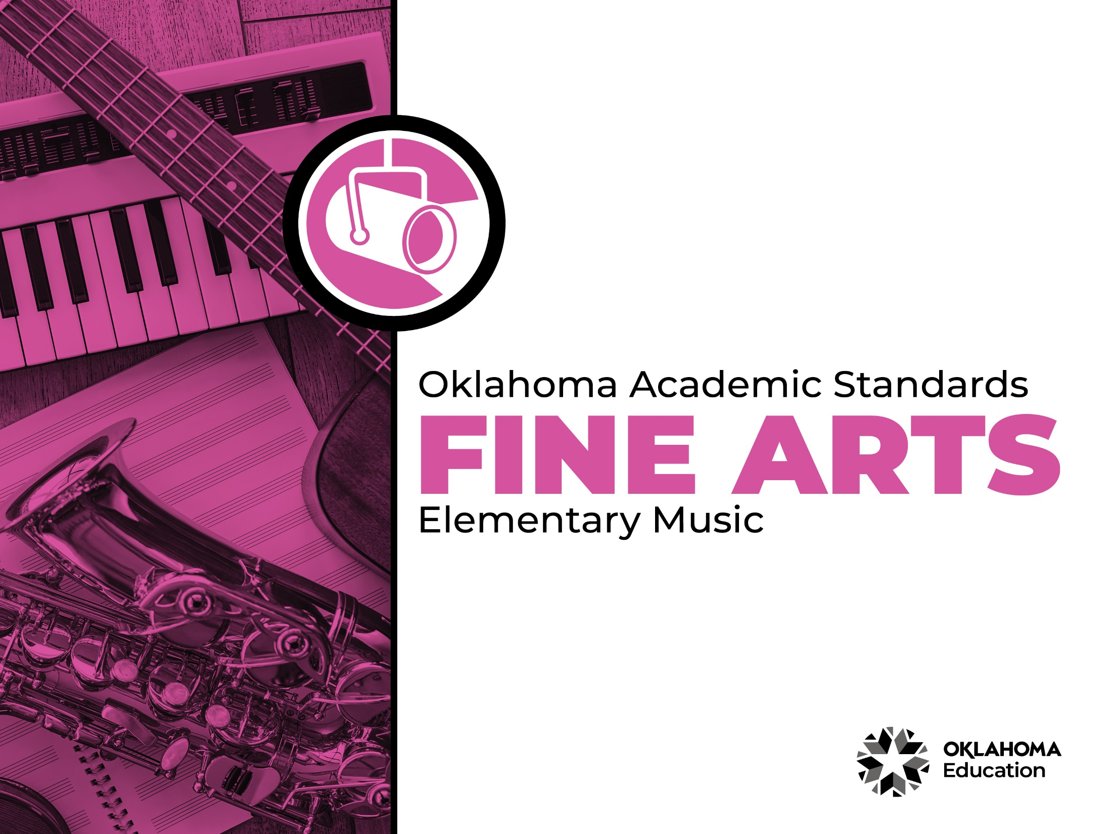

Table of Contents

Introduction & Standards Overview | 3
Music Overview & Artistic Processes | 6
Music Standards: PK-2nd Grade | 7
Music Standards: 3rd Grade-5th Grade | 12
Music Glossary | 18

Introduction
The Oklahoma Standards for Fine Arts encompass dance, drama/theatre, music, and visual art. The standards are the result of the contributions of hundreds of fine arts educators, arts administrators, and representatives of higher education, arts organizations, and community members. This document reflects a balanced synthesis of the work of all committee members of the Oklahoma standards for dance, drama/theatre, music, and visual art.

The standards specify what students should know and be able to do as learners in their discipline at the end of each grade level or course. Students have different levels of experience within a discipline so teachers can attend to both grade-level standards and meet the individual needs of students who may be performing at levels above or below grade level. The order of the standards at any grade level is not meant to imply a sequence of topics and should be considered flexible for the organization of any course.

The Oklahoma Standards for dance, drama/theatre, music, and visual art were informed by the National Coalition for Core Arts Standards (NCCAS), the Opportunity-to-Learn Standards for Dance, the Opportunity-to-Learn Standards for Music, the Opportunity-to-Learn Standards for Theatre Education, the Purposes, Principles, and Standards for School Art Programs, and other states’ standards documents.

Standards Overview
The Oklahoma Standards for Fine Arts are designed to support all Oklahoma students to develop and achieve artistic literacy and to promote access and equity in the arts. Study of the arts enrich the quality of life. Dance, drama/theatre, music, and visual art are used by and have shaped every culture and individual on earth. They provide a means for experiencing the world and give form to our innermost thoughts, feelings, and sensibilities. They also give students an opportunity to use metacognitive skills as they plan, monitor, revise, and assess their art work in dance, drama/theatre, music, or visual art.

A well-rounded education addresses the development of all the realms of human behavior—the physical, emotional, social, and intellectual. Neglecting any of the areas weakens all the rest; therefore, Oklahoma students must have access to arts education that includes dance, drama/theatre, music, and visual art. Schools that provide quality arts experiences, based on sequential skill development, supplemented with carefully selected arts resources, can help students cultivate a positive attitude towards themselves and toward learning—an attitude that carries over to their entire education and life. In short, access to arts education prepares students to be creative, persistent, and compassionate adults.

The standards are comprised of four artistic processes:
- Creating/Creative Process
- Performing/Production,
- Connecting/Cultural and Historical Perspectives, and
- Responding/Aesthetic Response and Critique Methodologies.

Each artistic process has a discipline-specific definition found in the discipline overview. The artistic processes branch into anchor standards in each discipline. The anchor standards designate specific learning targets at each grade or learning level.
In dance, drama/theatre, and visual art, there are elementary grade level standards through grade eight. At the secondary level in these disciplines, there are three proficiency levels: proficient, advanced, and accomplished. The proficiency levels may apply to high school students at any grade level and prepare students for a career or college life.

The elementary music standards extend through grade six. The ensemble and/or secondary music standards have five proficiency levels:
- Novice
- Intermediate
- Proficient
- Advanced
- Accomplished

Novice proficiency level is assigned to students who have started specialization and are developing artistic understanding and technique and may participate in performance opportunities as they are able. Intermediate proficiency level is for students who are continuing study in their art form, perhaps at the middle school level. Proficient, advanced, and accomplished may apply to students at any grade level. In a middle or high school class or ensemble, it is expected that the teacher will develop an understanding of their students’ proficiency levels and utilize the corresponding level from the standards for each student.

Reading the Oklahoma Academic Standards for Fine Arts
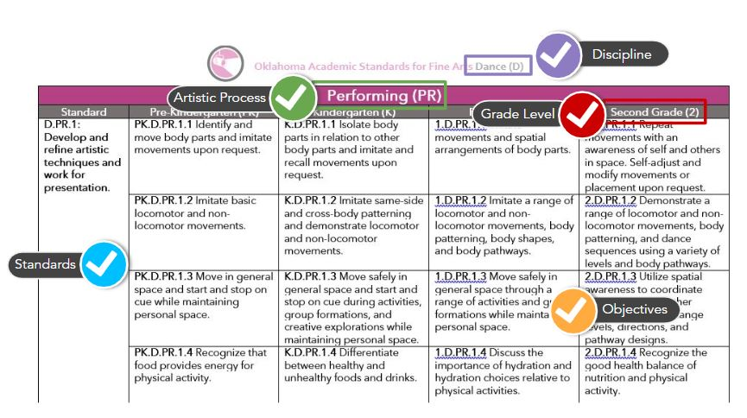

Music Overview
Every human culture has used music to educate, communicate, celebrate, and live. When we come together for graduations, weddings, parties, sports events, and worship, music is part of the occasion. Music permeates our media world through video games, advertising, movies, and television shows. Students today have earbuds or headphones within reach at all times. They have discovered that music helps us cope with our everyday lives. It makes us feel less alone and guides us as we process complex emotions. Music heals.

A comprehensive public school music program that provides every PK-12 student a solid and permanent relationship with music can result in a lifelong interest and involvement in music. Students can explore, understand music, and have an outlet in creativity and self-expression by taking classes in general music, vocal music, instrumental music, orchestra, modern band, mariachi, piano, guitar, music theory, hip hop, and music appreciation.

The Oklahoma standards for music are divided into two grade spans: Elementary Standards (Pre-K-6th) and Ensemble and/or Secondary Standards (upper elementary, middle, and high school). The Ensemble and/or Secondary Standards encompass five proficiency levels and apply to ensembles such as choir, band, orchestra, and secondary music classes such as 8th grade general music, music theory, etc. A glossary for teachers and administrators is provided in Appendix C: Music Glossary. The glossary is not intended for student use; it contains educational terms for those reading the standards.

Music Artistic Processes
The music standards emerge from the artistic processes of creating, performing, responding, and connecting. Each artistic process branches into multiple anchor standards. The anchor standards further divide into objectives, which describe student learning in music.

Creating
Music is a creative art that provides students the opportunity to create, compose, and improvise. Students learn notation, organize, develop, refine, and complete musical ideas. Creating a simple musical idea or a composition gives students autonomy and self-efficacy in the music classroom.

Performing
Music offers students an opportunity to realize artistic ideas and work through interpretation and presentation. Students analyze music, refine technical skills, develop and express personal interpretations, and use self-reflection or peer feedback to refine the performance. Students may also select music based on their interest, knowledge, skill, and context.
Responding
Students develop their understanding of how music conveys meaning by evaluating works and performances. Students choose music appropriate for specific purposes and interpret works to reflect the creators’/performers’ expressive intent.

Connecting
Students connect in music by relating artistic ideas and work with personal meaning and external context. This is accomplished through synthesizing and relating knowledge and personal experiences in making/understanding music. Students also relate artistic works with societal, cultural, and historical context to deepen understanding.

Creating (CR)
Standard | Pre-Kindergarten (PK) | Kindergarten (K) | First Grade (1) | Second Grade (2)
M.CR.1: Generate musical ideas through reading, notating, and/or interpreting music. | PK.M.CR.1.1 Explore the elements of music, including:  A. Beat/Meter (steady beat)  B. Pitch (high/low)  C. Tempo (fast/slow)  D. Dynamics (loud/quiet) | K.M.CR.1.1 Explore the elements of music, including:  A. Beat/Meter (steady beat, strong/weak beats, long/short sounds)  B. Pitch (high/low)  C. Tempo (fast/slow)  D. Dynamics (loud/quiet)  E. Melody (up/down)  F. Harmony (sing in unison, accompanied using pitched and unpitched instruments)  G. Form (same/different)  H. Tone Color (four voices: whisper, talk, shout/calling, sing, as well as the sounds around us: sounds from nature, machines, and environment) | 1.M.CR.1.1 Explore the elements of music, including:  A. Beat/Meter (steady beat, strong/weak beats, long/short sounds, 2/4 and 4/4 meters)  B. Pitch (high/low)  C. Tempo (fast/slow)  D. Dynamics (forte/piano)  E. Melody (upward/downward, steps/skips, and repeats)  F. Harmony (sing in unison, accompanied using pitched and unpitched instruments)  G. Form (introduction, call/response, Question/Answer, verse/refrain, and AB)  H. Tone Color (classroom percussion and instrument families of the orchestra) | 2.M.CR.1.1 Explore the elements of music, including:  A. Beat/Meter (2/4 and 4/4 meter and rhythm patterns in songs and ostinati)  B. Pitch (high/middle/low)  C. Tempo (largo, andante, allegro, and presto)  D. Dynamics (fortissimo/pianissimo and crescendo/decrescendo)  E. Melody (steps/skips/leaps)  F. Harmony (sing accompanied, using ostinati, chordal accompaniment, and body percussion)  G. Form (coda and ABA)  H. Tone Color (classroom percussion instruments, identify instrument families of the orchestra, as well as some individual instruments, and the timbre of a solo verses an ensemble)
 | PK.M.CR.1.2 Explore melodic and rhythmic answers using voice and classroom instruments. | K.M.CR.1.2 Explore melodic and rhythmic answers using voice and classroom instruments. | 1.M.CR.1.2 Improvise melodic and rhythmic answers with or without a system syllables, numbers or basic notation using voice, classroom instruments, or technology to demonstrate basic notation. | 2.M.CR.1.2 Improvise melodic and rhythmic answers with or without a system syllables, numbers or basic notation using voice, classroom instruments, or technology to demonstrate basic notation.
 | PK.M.CR.1.3 Explore movement (non-locomotor and locomotor) appropriate for the musical elements heard in various listening examples. | K.M.CR.1.3 Improvise movement (non-locomotor and locomotor) appropriate for the musical elements heard in various listening examples. | 1.M.CR.1.3 Improvise movement (non-locomotor and locomotor) appropriate for the musical elements heard in various listening examples. | 2.M.CR.1.3 Improvise movement (non-locomotor and locomotor) appropriate for the musical elements heard in various listening examples.
 | PK.M.CR.1.4 With guidance, explore rhythmic and melodic notation through icons and pictures. | K.M.CR.1.4 Explore rhythmic and melodic notation through icons and pictures. | 1.CR.1.4 Identify a system of syllables, numbers, or letters to demonstrate basic notation:  Rhythmic (quarter note, quarter rest, paired eighth notes)  Melodic (sol mi la) | 2.CR.1.4 Identify a system of syllables, numbers, or letters to demonstrate basic notation on a staff:  Rhythmic (half note, half rest, and beamed sixteenth)  Melodic (sol mi la do re)

Performing (PR)
Standard | Pre-Kindergarten (PK) | Kindergarten (K) | First Grade (1) | Second Grade (2)
M.PR.1: Present or demonstrate an existing work, formally or informally, with appropriate expressive and technical skills. | PK.M.PR.1.1 Participate in music through singing (individually and in groups, as well as accompanied and unaccompanied) and playing instruments. | K.M.PR.1.1 Participate in music through singing (individually and in groups, as well as accompanied and unaccompanied) and playing instruments. | 1.M.PR.1.1 Participate in music through singing (individually and in groups, as well as accompanied and unaccompanied) and playing traditional and/or non-traditional instruments (i.e., found sounds). | 2.M.PR.1.1 Participate in music through singing (individually and in groups, as well as accompanied and unaccompanied) and playing traditional and/or non-traditional instruments (i.e., found sounds).
 | PK.M.PR.1.2 Experience matching pitches, approaches singing in tune, and use appropriate tone and expression. | K.M.PR.1.2 Experience matching pitches, approaches singing in tune, and use appropriate tone and expression. | 1.M.PR.1.2 Match pitches, sing in tune, and use appropriate tone and expression. | 2.M.PR.1.2 Match pitches, sing in tune (C, D, F, or G-pentatone), and use appropriate tone and expression.
 | PK.M.PR.1.3 Experience steady beat using instruments or body percussion to accompany songs and rhythm activities. | K.M.PR.1.3 Explore steady beat using instruments or body percussion to accompany songs and rhythm activities. | 1.M.PR.1.3 Play steady beat and simple ostinati using instruments or body percussion to accompany songs and rhythm activities. | 2.M.PR.1.3 Perform simple ostinati using instruments or body percussion to accompany songs and rhythm activities.
 |  | K.M.PR.1.4 Recognize simple patterns on pitched or unpitched traditional or non-traditional instruments. | 1.M.PR.1.4 Perform simple patterns with voice or on pitched or unpitched traditional or non-traditional instruments. | 2.M.PR.1.4 Perform simple patterns with voice or on pitched or unpitched traditional or non-traditional instruments.

Responding (RE)
Standard | Pre-Kindergarten (PK) | Kindergarten (K) | First Grade (1) | Second Grade (2)
M.RE.1: Respond to music while demonstrating respect for others’ music preferences and music performances. | PK.M.RE.1.1 Respond to the beat or rhythm in music by using non-locomotor or locomotor movement, body percussion, and playing classroom instruments. | K.M.RE.1.1 Respond to the beat or rhythm in music by using non-locomotor or locomotor movement, body percussion, and playing classroom instruments. | 1.M.RE.1.1 Respond to the beat or rhythm in music by using non-locomotor or locomotor movement, body percussion, and playing classroom instruments. | 2.M.RE.1.1 Respond to the beat or rhythm in music by using non-locomotor or locomotor movement, body percussion, and playing classroom instruments.
 | PK.M.RE.1.2 Recognize and practice appropriate audience and performer behavior appropriate for the context and style of music performed. | K.M.RE.1.2 Recognize and practice appropriate audience and performer behavior appropriate for the context and style of music performed. | 1.M.RE.1.2 Recognize and practice appropriate audience and performer behavior appropriate for the context and style of music performed. | 2.M.RE.1.2 Recognize and practice appropriate audience and performer behavior appropriate for the context and style of music performed.
 | PK.M.RE.1.3 With guidance, respond, using directional movements or manipulatives, to the melodic contour of familiar songs. | K.M.RE.1.3 Respond, using directional movements or manipulatives, to the melodic contour of familiar and unfamiliar songs. | 1.M.RE.1.3 Respond, using directional movements or manipulatives, to the melodic contour of familiar and unfamiliar songs. | 2.M.RE.1.3 Respond, using directional movements or manipulatives, to the melodic contour of familiar and unfamiliar songs.
 |  |  | 1.M.RE.1.4 Recognize basic elements of familiar and unfamiliar songs. | 2.M.RE.1.4 Recognize basic elements of familiar and unfamiliar songs.
 |  |  | 1.M.RE.1.5 Discuss likes and dislikes of music in different styles. | 2.M.RE.1.5 Discuss likes and dislikes of music in different styles.

Connecting (CN)
Standard | Pre-Kindergarten (PK) | Kindergarten (K) | First Grade (1) | Second Grade (2)
M.CN.1: Recognize the development of music from a social, cultural, and historical context. | PK.M.CN.1.1 Sing and perform songs, chants, rhymes, singing games, and dances from a variety of cultures. | K.M.CN.1.1 Sing and perform songs, chants, rhymes, singing games, and dances from a variety of cultures. | 1.M.CN.1.1 Sing and perform songs, chants, rhymes, singing games, and dances from a variety of cultures. | 2.M.CN.1.1 Sing and perform songs, chants, rhymes, singing games, and dances from a variety of cultures.
 |  |  | 1.M.CN.1.2 Recognize American music, including work songs, holiday songs, and patriotic music. | 2.M.CN.1.2 Recognize American music, including work songs, holiday songs, and patriotic music.
 |  |  | 1.M.CN.1.3 Identify music and instruments from different cultures. | 2.M.CN.1.3 Identify music and instruments from different cultures.

Creating (CR)
Standard | Third Grade (3) | Fourth Grade (4) | Fifth Grade (5) | Sixth Grade (6)
M.CR.1: Generate musical ideas through reading, notating, and/or interpreting music. | 3.M.CR.1.1 Explore the elements of music, including:  A. Beat/Meter (meter in 2/4, 3/4, and 4/4)  B. Pitch (high/middle/low)  C. Tempo (largo, andante, allegro, and presto)  D. Dynamics (mezzo forte/mezzo piano)  E. Melody (steps/skips/leaps and melodic contour)  F. Harmony (rhythmic and melodic ostinati, canons/rounds, major/minor, and partner songs)  G. Form (rondo and D.C. al fine)  H. Tone Color (classroom percussion instruments, identify instrument families of the orchestra, as well as some individual instruments, and timbre of solo versus an ensemble) | 4.M.CR.1.1 Explore the elements of music, including:  A. Beat/Meter (meter in 2/4, 3/4, 4/4, and syncopation)  B. Pitch (high/middle/low)  C. Tempo (accelerando and ritardando)  D. Dynamics (mezzo forte/mezzo piano)  E. Melody (octave leap and melodic contour)  F. Harmony (layered ostinati, both rhythmic and melodic, canons/rounds, and partner songs)  G. Form (interlude and first/second ending)  H. Tone Color (classroom percussion instruments, identify instruments and instrument families of the orchestra, timbre of solo versus ensemble, as well as soprano, alto, tenor and bass) | 5.M.CR.1.1 Define and use correct terminology to identify and discuss the elements of music, including:  A. Beat/Meter (meter in 2/4, 3/4, 4/4, 6/8, and syncopation)  B. Pitch (high/middle/low)  C. Tempo (accelerando and ritardando)  D. Dynamics (mezzo forte/mezzo piano)  E. Melody (diatonic scale)  F. Harmony (descant and chordal changes (e.g., tonic, dominant and subdominant)  G. Form (D.S. al Coda)  H. Tone Color (duet, trio, quartet) | 6.M.CR.1.1 Define and use correct terminology to identify and discuss the elements of music, including:  A. Beat/Meter (mixed meter)  B. Pitch (high/middle/low)  C. Tempo (accelerando and ritardando)  D. Dynamics (mezzo forte/mezzo piano)  E. Melody (diatonic scale)  F. Harmony (major/minor chords)  G. Form (theme and variations)  H. Tone Color (duet, trio, quartet)
 | 3.M.CR.1.2 Improvise melodic and rhythmic answers with or without a system syllables, numbers, or basic notation using voice, classroom instruments, or technology to demonstrate basic notation. | 4.M.CR.1.2 Improvise melodic and rhythmic answers with or without a system syllables, numbers or basic notation using voice, classroom instruments, or technology to demonstrate basic notation. | 5.M.CR.1.2 Improvise melodic and rhythmic answers with or without a system of syllables, numbers or basic notation using voice, classroom instruments, or technology to demonstrate basic notation. | 6.M.CR.1.2 Improvise melodic and rhythmic answers with or without a system syllables, numbers or basic notation using voice, classroom instruments, or technology to demonstrate basic notation.
 | 3.M.CR.1.3 Improvise movement (non-locomotor and locomotor) appropriate for the musical elements heard in various listening examples. | 4.M.CR.1.3 Improvise movement (non-locomotor and locomotor) appropriate for the musical elements heard in various listening examples with and without partners or groups. | 5.M.CR.1.3 Improvise movement (non-locomotor and locomotor) appropriate for the musical elements heard in various listening examples with and without partners or groups. | 6.M.CR.1.3 Improvise movement (non-locomotor and locomotor) appropriate for the musical elements heard in various listening examples with and without partners or groups.
 | 3.M.CR.1.4 Identify a system of syllables, numbers, or letters to demonstrate basic notation on a staff:  Rhythmic (dotted half note, whole note, and whole rest)  Melodic (Pentatonic Scale) | 4.M.CR.1.4 Identify a system of syllables, numbers, or letters to demonstrate basic notation on a staff:  Rhythmic (syncopation and single eighth note and rest)  Melodic (high do, low la, low sol, and treble clef) | 5.M.CR.1.4 Identify a system of syllables, numbers, or letters to demonstrate basic notation on a staff:  Rhythmic (combination of sixteenth and eighth notes and dotted rhythms)  Melodic (diatonic scale and treble clef) | 6.M.CR.1.4 Identify a system of syllables, numbers, or letters to demonstrate basic notation on a staff:  Rhythmic (triplets)  Melodic (bass clef, grand staff, and minor scale)
 |  | 4.M.CR.1.5 Experiment with variations in and demonstrate understanding of tempo, timbre or tone color, dynamics, and phrasing for expressive purposes. | 5.M.CR.1.5 Experiment with variations in and demonstrate understanding of tempo, timbre or tone color, dynamics, and phrasing for expressive purposes. | 6.M.CR.1.5 Experiment with variations in and demonstrate understanding of tempo, timbre or tone color, dynamics, and phrasing for expressive purposes.

Performing (PR)
Standard | Third Grade (3) | Fourth Grade (4) | Fifth Grade (5) | Sixth Grade (6)
M.PR.1: Present or demonstrate an existing work, formally or informally, with appropriate expressive and technical skills. | 3.M.PR.1.1 Participate in music through singing (individually and in groups, as well as accompanied and unaccompanied) and playing traditional and/or non-traditional instruments (i.e., found sounds). | 4.M.PR.1.1 Participate in music through singing (individually and in groups, as well as accompanied and unaccompanied) and playing traditional and/or non-traditional instruments (i.e., found sounds). | 5.PR.1.1 Participate in music through singing (individually and in groups, as well as accompanied and unaccompanied) and playing traditional and/or non-traditional instruments (i.e., found sounds). | 6.M.PR.1.1 Participate in music through singing (individually and in groups, as well as accompanied and unaccompanied) and playing traditional and/or non-traditional instruments (i.e., found sounds).
 | 3.M.PR.1.2 Match pitches, sing in tune (C, D, F, or G-pentatone), and use appropriate tone and expression. | 4.M.PR.1.2 Match pitches, sing in tune (C, D, F, or G-pentatone), and use appropriate tone and expression. | 5.M.PR.1.2 Match pitches, sing in tune (C, D, F, or G-pentatone), and use appropriate tone and expression. | 6.M.PR.1.2 Demonstrate the ability to match pitch and read music from basic notation in treble or bass clef (e.g., folk songs and patriotic songs).
 | 3.M.PR.1.3 Perform simple ostinati using instruments or body percussion to accompany songs and rhythm activities. | 4.M.PR.1.3 Perform simple ostinati using instruments or body percussion to accompany songs and rhythm activities. | 5.M.PR.1.3 Perform ostinati using instruments or body percussion to accompany songs and rhythm activities. | 6.M.PR.1.3 Perform created ostinati using instruments or body percussion to accompany songs and rhythm activities.
 | 3.M.PR.1.4 Perform simple patterns with voice or on pitched or unpitched traditional or non-traditional instruments. | 4.M.PR.1.4 Perform simple patterns or melodies in group ensembles with voice or on pitched or unpitched traditional or non-traditional instruments. | 5.M.PR.1.4 Perform simple patterns or melodies in group ensembles with voice or on pitched or unpitched traditional or non-traditional instruments. | 6.M.PR.1.4 Perform and create simple melodies and accompaniments in solo or group ensembles through singing and playing traditional or non-traditional instruments, demonstrating knowledge of tonal and rhythmic elements.
 | 3.M.PR.1.5 Sing two-part rounds, partner songs, and ostinatos. | 4.M.PR.1.5 Sing two-part rounds, partner songs, and ostinatos. | 5.M.PR.1.5 Sing two-part rounds, partner songs, and ostinatos. | 6.M.PR.1.5 Sing two- or three-part rounds, partner songs, and ostinatos.
 | 3.M.PR.1.6 Sing with an acceptable tone quality throughout his/her singing ranges or play an instrument with an acceptable tone quality throughout an appropriate range. | 4.M.PR.1.6 Sing with an acceptable tone quality throughout his/her singing ranges or play an instrument with an acceptable tone quality throughout an appropriate range. | 5.M.PR.1.6 Sing with an acceptable tone quality throughout his/her singing ranges or play an instrument with an acceptable tone quality throughout an appropriate range. | 6.M.PR.1.6 Sing with an acceptable tone quality throughout his/her singing ranges or play an instrument with an acceptable tone quality throughout an appropriate range.

Responding (RE)
Standard | Third Grade (3) | Fourth Grade (4) | Fifth Grade (5) | Sixth Grade (6)
M.RE.1: Respond to music while demonstrating respect for others’ music preferences and music performances. | 3.M.RE.1.1 Respond to the beat or rhythm in music by using non-locomotor or locomotor movement, body percussion, and playing classroom instruments. | 4.M.RE.1.1 Respond to the beat or rhythm in music by using non-locomotor or locomotor movement, body percussion, and playing classroom instruments. | 5.M.RE.1.1 Respond to the beat or rhythm in music by using non-locomotor or locomotor movement, body percussion, and playing classroom instruments. | 6.M.RE.1.1 Respond to the beat or rhythm in music by using non-locomotor or locomotor movement, body percussion, and playing classroom instruments.
 | 3.M.RE.1.2 Recognize and practice appropriate audience and performer behavior appropriate for the context and style of music performed. | 4.M.RE.1.2 Recognize and practice appropriate audience and performer behavior appropriate for the context and style of music performed and demonstrate respect for music performed by others. | 5.M.RE.1.2 Recognize and practice appropriate audience and performer behavior appropriate for the context and style of music performed and demonstrate respect for music performed by others. | 6.M.RE.1.2 Recognize and practice appropriate audience and performer behavior appropriate for the context and style of music performed and demonstrate respect for music performed by others.
 | 3.M.RE.1.3 Respond to basic features (dynamics, tempo, form, etc.) of familiar and unfamiliar songs. | 4.M.RE.1.3 Respond to basic features (dynamics, tempo, form, etc.) of familiar and unfamiliar songs. | 5.M.RE.1.3 Respond to basic features (dynamics, tempo, form, etc.) of familiar and unfamiliar songs. | 6.M.RE.1.3 Respond to basic features (dynamics, tempo, form, etc.) of familiar and unfamiliar songs.
 | 3.M.RE.1.4 Recognize basic elements of familiar and unfamiliar songs. | 4.M.RE.1.4 Recognize basic elements of familiar and unfamiliar songs. | 5.M.RE.1.4 Label basic elements of familiar and unfamiliar songs. | 6.M.RE.1.4 Label basic elements of familiar and unfamiliar songs.
 | 3.M.RE.1.5 Compare students’ likes and dislikes of music of different styles, while using appropriate terms to explain opinions. | 4.M.RE.1.5 Compare students’ likes and dislikes of music of different styles, while using appropriate terms to explain opinions. | 5.M.RE.1.5 Compare students’ likes and dislikes of music of different styles and identify criteria for evaluating a musical composition or a music performance. | 6.M.RE.1.5 Compare and contrast different music styles and identify criteria for evaluating a musical composition or a music performance.

Connecting (CN)
Standard | Third Grade (3) | Fourth Grade (4) | Fifth Grade (5) | Sixth Grade (6)
M.CN.1: Recognize the development of music from a social, cultural, and historical context. | 3.M.CN.1.1 Sing and perform songs, chants, rhymes, singing games, and dances from a variety of cultures. | 4.M.CN.1.1 Sing and perform songs, chants, rhymes, singing games, and dances from a variety of cultures. | 5.M.CN.1.1 Sing and perform songs, chants, rhymes, singing games, and dances from a variety of cultures. | 6.M.CN.1.1 Sing and perform songs, chants, rhymes, singing games, and dances from a variety of cultures.
 | 3.M.CN.1.2 Recognize American music, including work songs, holiday songs, and patriotic music. | 4.M.CN.1.2 Recognize American music, including work songs, holiday songs, and patriotic music. | 5.M.CN.1.2 Recognize, describe, and listen to music from a variety of styles, periods, and cultures. | 6.M.CN.1.2 Recognize, describe, and listen to music from a variety of styles, periods, and cultures.
 | 3.M.CN.1.3 Identify music and instruments from different cultures. | 4.M.CN.1.3 Identify music and instruments from different cultures. | 5.M.CN.1.3 Identify music and instruments from different cultures. | 6.M.CN.1.3 Identify and differentiate the use of musical elements and instruments from other parts of the world, and compare them to the use of musical elements in American music.
 |  | 4.M.CN.1.4 Introduce the various roles musicians have in various musical settings and cultures. | 5.M.CN.1.4 Identify and describe the various roles musicians have in various musical settings and cultures. | 6.M.CN.1.4 Explore and research the various roles and careers musicians have in various musical settings and cultures.
 |  | 4.M.CN.1.5 Introduce uses of music in everyday life (e.g., film, television, background music, commercials, and video games). | 5.M.CN.1.5 Identify uses of music in everyday life (e.g., film, television, background music, commercials, and video games). | 6.M.CN.1.5 Explore and research uses of music in everyday life (e.g., film, television, background music, commercials, and video games).

Music Glossary

Accompaniment Vocal or instrumental parts that accompany a melody.

Arrangement Setting or adaptation of an existing musical composition.

Beat Underlying steady pulse present in most music.

Body Percussion Use of the human body as an instrument to create percussive/rhythmic sounds such as stomping, patsching (patting thighs), clapping, clicking, snapping.

Composition Original piece of music that can be repeated, typically developed over time, and preserved either in notation or in a sound recording.

Compositional Devices Musical ideas used to manipulate music (e.g., ostinato, imitation, sequence, augmentation, diminution, inversion, drone, Alberti Bass, etc.)

Culture Values and beliefs of a particular group of people, from a specific place or time, expressed through characteristics such as tradition, social structure, religion, art, and food.

Dynamics Level or range of loudness of a sound or sounds.

Form Element of music describing the overall organization of a piece of music, such as AB, ABA, rondo, theme and variations, and strophic form.

Found Sounds Objects that can be used as instruments, such as pencils, desks, books, buckets, etc.

Genre Category of music characterized by a distinctive style, form, and/or content, such as jazz, march, cantata, hip hop, etc.

Harmony Chordal structure of a music composition in which the simultaneous sounding of pitches produces chords and their successive use produces chord progressions.

Improvisation Music created and performed spontaneously or “in-the-moment,” often within a framework determined by the musical style.

Intonation Singing or playing the correct pitch in tune.

Locomotor/Non-locomotor Movement Movements that travel through space or carry weight from one location to another or a movement that a person performs while remaining stationary.

Melody Linear succession of sounds (pitches) and silences moving through time; the horizontal structure of music.

Musical Structure Totality of a musical work.

Notation Visual representation of musical sounds.

Ostinato A rhythmic or melodic figure that is repeated.

Pentatone The 1st, 2nd, 3rd, 5th, and 6th tones of a scale (do re mi so la)

Phrasing Performance of a musical phrase that uses expressive qualities such as dynamics, tempo, articulation, and timbre to convey a thought, mood, or feeling.

Pitch Identification of a tone or note with respect to highness or lowness (i.e., frequency).

Round A song imitated at the same pitch by a second (or third) group of musicians who begin at a designated time during the song.

Partner Song Two different songs sung at the same time to create harmony.

Rhythm Duration or length of sounds and silences that occur in music; organization of sounds and silences in time.

Style Label for a type of music possessing distinguishing characteristics and often performance practices associated with its historical period, cultural context, and/or genre.

Tempo Rate or speed of the beat in a musical work or performance.

Tone Color/Timbre Tone color or tone quality that distinguishes one sound source, instrument, or voice from another.

