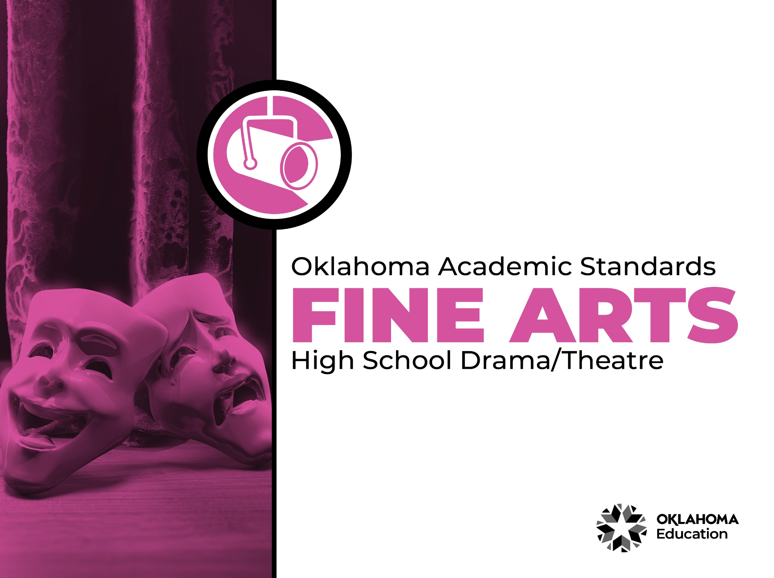

Table of Contents

Introduction & Standards Overview | 3
Drama/Theatre Overview & Artistic Processes | 6
Drama/Theatre Standards: High School | 7
Drama/Theatre Glossary | 15

Introduction
The Oklahoma Standards for Fine Arts encompass dance, drama/theatre, music, and visual art. The standards are the result of the contributions of hundreds of fine arts educators, arts administrators, and representatives of higher education, arts organizations, and community members. This document reflects a balanced synthesis of the work of all committee members of the Oklahoma standards for dance, drama/theatre, music, and visual art.

The standards specify what students should know and be able to do as learners in their discipline at the end of each grade level or course. Students have different levels of experience within a discipline so teachers can attend to both grade-level standards and meet the individual needs of students who may be performing at levels above or below grade level. The order of the standards at any grade level is not meant to imply a sequence of topics and should be considered flexible for the organization of any course.

The Oklahoma Standards for dance, drama/theatre, music, and visual art were informed by the National Coalition for Core Arts Standards (NCCAS), the Opportunity-to-Learn Standards for Dance, the Opportunity-to-Learn Standards for Music, the Opportunity-to-Learn Standards for Theatre Education, the Purposes, Principles, and Standards for School Art Programs, and other states’ standards documents.

Standards Overview
The Oklahoma Standards for Fine Arts are designed to support all Oklahoma students to develop and achieve artistic literacy and to promote access and equity in the arts. Study of the arts enrich the quality of life. Dance, drama/theatre, music, and visual art are used by and have shaped every culture and individual on earth. They provide a means for experiencing the world and give form to our innermost thoughts, feelings, and sensibilities. They also give students an opportunity to use metacognitive skills as they plan, monitor, revise, and assess their art work in dance, drama/theatre, music, or visual art.

A well-rounded education addresses the development of all the realms of human behavior—the physical, emotional, social, and intellectual. Neglecting any of the areas weakens all the rest; therefore, Oklahoma students must have access to arts education that includes dance, drama/theatre, music, and visual art. Schools that provide quality arts experiences, based on sequential skill development, supplemented with carefully selected arts resources, can help students cultivate a positive attitude towards themselves and toward learning—an attitude that carries over to their entire education and life. In short, access to arts education prepares students to be creative, persistent, and compassionate adults.

The standards are comprised of four artistic processes:
- Creating/Creative Process
- Performing/Production,
- Connecting/Cultural and Historical Perspectives, and
- Responding/Aesthetic Response and Critique Methodologies.

Each artistic process has a discipline-specific definition found in the discipline overview. The artistic processes branch into anchor standards in each discipline. The anchor standards designate specific learning targets at each grade or learning level.
In dance, drama/theatre, and visual art, there are elementary grade level standards through grade eight. At the secondary level in these disciplines, there are three proficiency levels: proficient, advanced, and accomplished. The proficiency levels may apply to high school students at any grade level and prepare students for a career or college life.

The elementary music standards extend through grade six. The ensemble and/or secondary music standards have five proficiency levels:
- Novice
- Intermediate
- Proficient
- Advanced
- Accomplished

Novice proficiency level is assigned to students who have started specialization and are developing artistic understanding and technique and may participate in performance opportunities as they are able. Intermediate proficiency level is for students who are continuing study in their art form, perhaps at the middle school level. Proficient, advanced, and accomplished may apply to students at any grade level. In a middle or high school class or ensemble, it is expected that the teacher will develop an understanding of their students’ proficiency levels and utilize the corresponding level from the standards for each student.

Reading the Oklahoma Academic Standards for Fine Arts
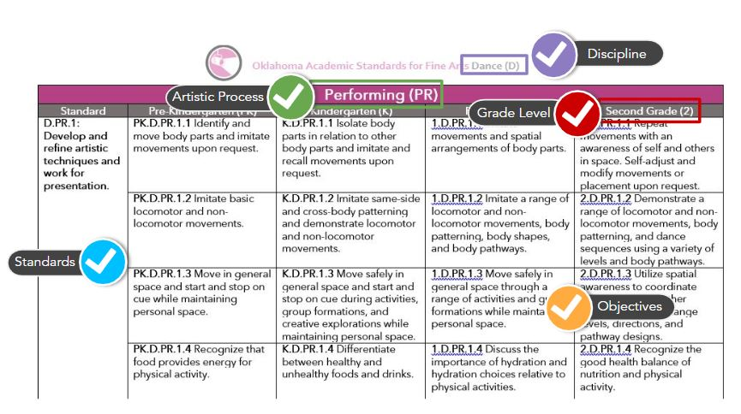

Drama/Theatre Overview
Drama and theatre are essential to the well-rounded education of all students because they lay the foundation for a critical understanding of human culture. Drama and theatre are uniquely qualified for this purpose. Drama and theatre do not exist within a vacuum, but rather comment on our world, history, philosophy, science, and understanding of our fellow human beings. Therefore, drama and theatre are a unique vehicle for transporting us to an infinite variety of integrated knowledge, understanding, and cross-curricular engagement. Drama and theatre reach out and connect to countless positive educational outcomes and support college and career preparedness.

“The terms drama and theatre are used throughout the document to represent two ends of a continuum in theatre education. Drama is any informal dramatic element that is designed not for presentation but rather for the experience or educational value. Theatre is a more formal study of the discipline which culminates in dramatic interpretation by actors and technicians on a stage before an audience.”
American Alliance for Theatre & Education

The drama/theatre standards are intended to inspire educators to integrate drama/theatre into other academic programming as well as to allow the subject to stand on its own as a component of a well-rounded education. The standards prepare students for a life-long immersion in drama/theatre, as well as the learning and enjoyment that creating, performing, and viewing drama/theatre can bring. A glossary for teachers and administrators is provided in Appendix B: Drama/Theatre Glossary. The glossary is not intended for student use; it contains educational terms for those reading the standards.

Drama/Theatre Artistic Processes
The drama/theatre standards emerge from the artistic processes of creating, presenting, responding, and connecting. Each artistic process branches into multiple anchor standards. The anchor standards further divide into objectives, which describe student learning in drama/theatre.

Creating
Drama/theatre gives students a chance to create and interact with others through the art form. Students are able to generate, organize, develop, and rehearse artistic ideas that may culminate in an organized activity within the classroom or a performance for peers or an audience.

Performing
Drama/theatre experiences require students to interpret and share artistic work. They are able to analyze and select work for presentation. As they work towards performance, they develop and refine techniques and convey meaning through the presentation.
Responding
In drama/theatre, students work to understand and evaluate how the arts convey meaning. This process begins with students perceiving and analyzing artistic work. Students then interpret the work and use criteria to evaluate performance.

Connecting
Students connect in drama/theatre by relating artistic ideas or work with personal meaning and external context. This is accomplished by synthesizing and relating knowledge and personal experiences to art. Students also relate artistic works with societal, cultural, and historical context to deepen understanding.

Creating (CR)
High School
Standard | Proficient (I) | Advanced (II) | Accomplished (III)
DT.CR.1: Generate and conceptualize artistic ideas and work. | I.CR.1.1 Conceptualize a unified piece of drama/theatre by investigating the collaborative nature of the actor, director, playwright, and designers and explore their interdependent roles in a drama/theatre work. | II.CR.1.1 Conceptualize a unified piece of theatre by exploring performance and technical choices to develop a drama/theatre work that is believable, authentic, and relevant. | III.CR.1.1 Conceptualize a unified piece of theatre by synthesizing knowledge from a variety of dramatic forms, drama/theatre conventions, and technologies.
 | I.CR.1.2 Imagine technical elements for a unified drama/theatre concept by exploring the impact of technology on design choices in a drama/theatre work. | II.CR.1.2 Imagine technical elements for a unified drama/theatre concept by understanding/applying technology and conducting research to inform the design of sets, costumes, sound, and lighting in a drama/theatre work. | III.CR.1.2 Imagine technical elements for a unified drama/theatre concept by developing and implementing a major design element (e.g., sets, costumes, sound, etc.) for a production.
 | I.CR.1.3 Develop a character authentic to the work through application of vocal techniques, employing movement techniques, and engaging in character analysis. | II.CR.1.3 Develop a character authentic to the work through application of vocal techniques, employing movement techniques, and demonstrating knowledge of motivation through the recall of emotional experience, blocking, and observations of the external world. | III.CR.1.3 Develop a character authentic to the work by: applying fundamental vocal techniques such as knowledge of dialects and accents, the International Phonetic Alphabet, increased range and control, intonation, and connotation; applying fundamental movement techniques and show increased poise and flexibility; and connecting and defending internal and external work to fully realize the character.
DT.CR.2: Organize, develop, and rehearse artistic ideas and work. | I.CR.2.1 Evolve a unified drama/theatre work by refining a dramatic concept to demonstrate a critical understanding of historical and cultural influences of original ideas. | II.CR.2.1 Evolve a unified drama/theatre work by generating ideas from research and script analysis to devise a performance that is believable, authentic, and relevant in a drama/theatre work. | III.CR.2.1 Evolve a unified drama/theatre work by generating ideas from research and script analysis and applying meaningful cultural, literary, and historical influences to acting choices, technical choices, or directorial concepts.
 | I.CR.2.2 Demonstrate collaborative and interdisciplinary skills by investigating the collaborative nature of the actor, director, playwrights, and designers and exploring their interdependent roles in a drama/theatre work. | II.CR.2.2 Demonstrate collaborative and interdisciplinary skills by cooperating as a creative team to make interpretive choices for a drama/theatre work. | III.CR.2.2 Demonstrate collaborative and interdisciplinary skills by working to develop theatrical production concepts, discover artistic solutions, and make interpretive choices in a drama/theatre work.
DT.CR.3: Revise, refine, and complete artistic work. | I.CR.3.1 Practice and revise a unified devised or scripted drama/theatre work using varied theatrical styles (e.g., realism, mime, vaudeville, etc.). | II.CR.3.1 Use the rehearsal process to analyze the dramatic concept and technical design elements of devised or scripted drama/theatre work. | III.CR.3.1 Refine, transform, and demonstrate the unifying concept in a devised or scripted drama/theatre work using the rehearsal process.
 | I.CR.3.2 Explore the connection to a character through physical, vocal, and psychological choices to develop a performance that is believable, authentic, and relevant to a drama/theatre work. | II.CR.3.2 Explore the connection to a character through mind/body/voice and use research and script analysis to revise dramatic choices and create a vivid character. | III.CR.3.2 Explore the connection to a character through mind/body/voice to create a vivid character and apply appropriate acting techniques and styles in performances of characters from a variety of dramatic genres and historical periods.
 | I.CR.3.3 Collaborate with peers to create a technical design using simple technology for a devised or scripted drama/theatre work. | II.CR.3.3 Revise and improve technical design choices to create an emotional impact and support the story of a devised or scripted drama or theatre work. | III.CR.3.3 Integrate, refine, and apply technical and design elements to enhance the unified concept and create an emotional impact or convey meaning in a devised or scripted drama/theatre work.
 | I.CR.3.4 Select a scene from literature, original, or scripted material, and contribute to the development of a scene as a member of an ensemble. | II.CR.3.4 Interpret drama using scripted material, literature, original material, and use improvisation to create extended theatrical pieces as a solo actor or as a member of an ensemble. | III.CR.3.4 Interpret drama using scripted material by independently writing a one-act play with correct form and structure that includes full character development, believable dialogue, and logical plot outcomes.

Performing (PR)
Standard | Proficient (I) | Advanced (II) | Accomplished (III)
DT.PR.1: Select, analyze, and interpret artistic work for presentation. | I.DT.PR.1.1 Explore various performance and design elements that will contribute to the most supportable and convincing drama/theatre work. | II.DT.PR.1.1 Develop and select performance and design elements that will contribute to the most supportable and convincing drama/theatre work. | III.DT.PR.1.1 Demonstrate the ability to utilize the fundamental conventions and the following styles: Non-realism, commedia dell arte, Shakespeare, absurdism, mask work, improvisation, environmental drama, and other theatre arts styles.
 | I.DT.PR.1.2 Understand that there are multiple choices for each character and select the most supportable choices for the moment. | II.DT.PR.1.2 Research and apply the development of acting skills for character creation and performance including historical movements, personal experience, and cultural influences utilizing various acting methods and techniques (e.g. Stanislavski, Uta Hagen, sense memory, emotional recall). | III.DT.PR.1.2 Demonstrate multiple choices for each character by applying a variety of research acting techniques as an approach to character choices in a drama theatre work.
DT.PR.2: Develop and refine artistic techniques and work for presentation. | I.DT.PR.2.1 Develop experience through practice and a personalization of acting techniques to expand skills in a rehearsal or drama/theatre performance. | II.DT.PR.2.1 Develop proficiency through practice and implement the voice, body, observation, and imagination to expand skills in a rehearsal or drama/theatre performance. | III.DT.PR.2.1 Develop expertise through practice, use and justify a collection of acting exercises from reliable resources, and implement the voice, body, observation, and imagination to expand skills in a rehearsal or drama/theatre performance.
 | I.DT.PR.2.2 Integrate design elements that create an emotional impact or convey meaning by researching technical elements to increase the impact of a design, introduce technical knowledge of safety procedures, and participating as a member of a technical crew and management team for a production. | II.DT.PR.2.2 Integrate design elements that create an emotional impact or convey meaning by researching technical elements to increase the impact of a design, applying technical knowledge of safety procedures, and participating as a member of a technical crew and management team for a production. | III.DT.PR.2.2 Integrate design elements that create an emotional impact or convey meaning by developing a plan for the coordination of all technical aspects of a theatrical production from a technical leadership perspective.
DT.PR.3: Convey meaning through the presentation of an artistic work. | I.DT.PR.3.1 Present a drama/theatre work with a defined purpose or intent through selection and use of performance spaces, drama and theatre conventions, and production elements appropriate to an audience. | II.DT.PR.3.1 Present a drama/theatre work using creative processes that shape the production for a specific audience. | III.DT.PR.3.1 Present a drama/theatre work for a specific audience that employs research and analysis grounded in the creative perspectives of the playwright, director, designer, and dramaturgy.

Responding (RE)
Standard | Proficient (I) | Advanced (II) | Accomplished (III)
DT.RE.1: Perceive and analyze artistic work. | I.DT.RE.1.1 Identify choices in a drama/theatre work to understand and explain personal reactions as a participant in a drama/theatre event. | II.RE.1.1 Identify choices in a drama/theatre work and demonstrate the ability to receive and act upon coaching, feedback, and constructive criticism. | III.RE.1.1 Identify choices in a drama/theatre work to understand multiple interpretations of a drama/theatre event and demonstrate the ability to receive and act upon coaching and feedback.
 | I.DT.RE.1.2 Analyze and evaluate theatrical works by viewing performances or attending live performances of extended length and complexity, demonstrating an understanding of the protocols of audience appropriate to the style of the performance. | II.RE.1.2 Analyze and critique a recorded or live performance work by connecting it to art forms, history, culture, and other disciplines using supporting evidence and criteria. | III.RE.1.2 Compare and debate the connection between a recorded or live performance and contemporary issues that may affect audiences.
DT.RE.2: Interpret intent and meaning in artistic work. | I.DT.RE.2.1 Use personal experience and background knowledge to create or interpret a drama/theatre work by identifying and comparing artistic choices developed from personal experiences, textual evidence, and appropriate criteria in a drama/theatre work. | II.RE.2.1 Use personal experience and background knowledge to create or interpret a drama/theatre work by analyzing artistic choices developed from personal experience, textual evidence, and appropriate criteria to reinforce artistic choices when participating in or observing a drama/theatre work. | III.RE.2.1 Use personal experience and background knowledge to create or interpret a drama/theatre work by analyzing artistic choices developed from personal experience, textual evidence, and appropriate criteria to reinforce artistic choices when participating in or observing a drama/theatre work.
 | I.DT.RE.2.2 Interpret how culture influences a performance by identifying and comparing cultural perspectives and contexts that may influence the interpretation of a drama/theatre work. | II.RE.2.2 Interpret how culture influences a performance by applying cultural perspectives and contexts that may influence the interpretation of a drama/theatre work. | III.RE.2.2 Interpret how culture influences a performance by demonstrating and articulating understandings of culture contexts to interpret a drama/theatre work.
 | I.DT.RE.2.3 Identify personal aesthetics by researching the concept of a personal aesthetic, recognizing and sharing artistic/aesthetic preferences and choices, and forming a personal aesthetic when contributing to or observing drama/theatre works. | II.DT.RE.2.3 Identify personal aesthetics by justifying a personal aesthetic when contributing to or observing drama/theatre works. | III.DT.RE.2.3 Identify personal aesthetics by debating and distinguishing multiple aesthetics when contributing to or observing drama/theatre works.
 | I.DT.RE.2.4 Evaluate and critique elements of drama, dramatic techniques, and theatrical conventions using guidelines for evaluating a theatrical production. | II.DT.RE.2.4 Critique various aspects of theatre using appropriate supporting evidence, analyze why artistic choices are made in drama/theatre work, and develop and utilize meaningful, structured criteria for assessing the work of an actor. | III.DT.RE.2.4 Use critical analysis to make an informed decision about the quality of a theatrical production.
DT.RE.3: Apply criteria to evaluate artistic work. | I.DT.RE.3.1 Develop and apply group-generated criteria to evaluate and assess one’s own work and the work of others. | II.DT.RE.3.1 Citing evidence, develop and apply group-generated criteria to evaluate and assess one’s own work and the work of others and receive/act upon coaching feedback and constructive criticism. | III.DT.RE.3.1 Synthesize evidence and appropriate criteria to revise personal work and interpret the work of others when participating in or observing a drama/theatre work.
 | I.DT.RE.3.2 Evaluate the effectiveness of technical and production elements in conveying the theme of the drama/theatre work while respecting others’ interpretations. | II.DT.RE.3.2 Citing evidence, evaluate the effectiveness of technical and production elements in conveying the theme of the drama/theatre work while respecting others’ interpretations. | III.DT.RE.3.2 Analyze and evaluate varied aesthetic interpretations of technical and production elements for the same drama/theatre work.
 | I.DT.RE.3.3 Establish an active relationship between audience and performer by observing and discussing how characters’ circumstances impact audience members’ perspectives and reactions in a drama/theatre work. | II.DT.RE.3.3 Establish an active relationship between audience and performer and evaluate audience responses based on personal experiences to critique a drama/theatre work. | III.DT.RE.3.3 Establish an active relationship between audience and performer by evaluating/synthesizing evidence from audience responses to revise personal work and interpret the work of others.
 | I.DT.RE.3.4 Develop respect for theatre, its practitioners, and conventions such as copyright law. | II.DT.RE.3.4 Develop respect by creating a personal code of theatre etiquette and ethics and respecting theatre practitioners and conventions such as copyright law. | III.DT.RE.3.4 Develop respect by creating a personal code of theatre etiquette and ethics, demonstrating awareness of professional ethics as a cast or crew member, and respecting theatre practitioners and conventions such as copyright law.

Connecting (CN)
Standard | Proficient (I) | Advanced (II) | Accomplished (III)
DT.CN.1: Synthesize and relate knowledge and personal experiences to art. | I.DT.CN.1.1 Choose and interpret a drama/theatre work to reflect or question personal beliefs. | II.DT.CN.1.1 Develop a drama/theatre work that identifies and investigates culture, global, and historic belief systems. | III.DT.CN.1.1 Explore the relationship between theatre and other non-arts disciplines to synthesize concepts and skills and develop a drama/theatre work.
 | I.DT.CN.1.2 Identify and analyze theatrical works from a variety of historical periods, cultures and playwrights. | II.DT.CN.1.2 Demonstrate a basic understanding of theatre history through the study of playwrights, theatrical styles, genres and historical periods. | III.DT.CN.1.2 Synthesize and apply critical research on a historical time period to develop a drama/theatre work.
DT.CN.2: Relate artistic ideas and works with societal, cultural, and historical context to deepen understanding. | I.DT.CN.2.1 Explore how cultural, global, and historic belief systems affect/have affected creative choices in drama/theatre work. | II.DT.CN.2.1 Examine contemporary social, cultural, or global issues through different forms of drama/theatre work. | III.DT.CN.2.1 Collaborate on a drama/theatre work that examines a critical global issue using multiple personal, community, and cultural perspectives.
DT.CN.3: Research and relate artistic ideas/works and societal, cultural, and historical context to deepen understanding. | I.DT.CN.3.1 Use basic theatre research methods (dramaturgy) to better understand the social and cultural background of a drama/theatre work. | II.DT.CN.3.1 Research societal, historical, and cultural context for a performance and present an opinion about the drama/theatre design based on those contexts. | III.DT.CN.3.1 Synthesize and apply critical research on a historical time period to create a design for a modern drama/theatre space.
DT.CN.4: Examine how theatre connects to life experiences, careers, and other content. | I.DT.CN.4.1 Explore how theatre connects to life experiences, careers, and other content through exploration of various careers in the theatre arts (e.g., performance, design, production, administrative, education, marketing, etc.). | II.DT.CN.4.1 Explore how theatre connects to life experiences, careers, and other content and examine methods of pursuing various careers (including demonstrating audition etiquette and techniques) and theatre/theatre-based careers. | III.DT.CN.4.1 Explore how theatre connects to life experiences and explore careers through participation in various production roles and activities found in commercial, professional, amateur, and/or educational theatre.

Drama/Theatre Glossary

Aesthetics Unique to each individual, aesthetics refers to a set of principles concerned with the nature and appreciation of beauty.

Aristotle’s Six Elements of Drama Spectacle, Character, Fable (Plot), Diction, Melody, and Thought.

Artistic Criteria The criteria for judging the work of particular artists. These may include intent, focus, skill, form, representation, imagination, authenticity, engagement, pleasure, universal significance, context, criticism, and limitations of time, space, and finances.

Audience Etiquette The social norms appropriate to a group participating as spectators. These norms may vary greatly depending on the particular event; however, respect and consideration for other audience members is always the key. Behavior and voices should be appropriate to the venue and considerate of others ability to see and hear the event.

Character Analysis Evaluation of specific traits of a character.

Character Morgue A collection of reference works and files used by actors, directors and designers to develop particular aspects of a character. Character morgues often feature pictures, mementos and writing to demonstrate or explore aspects of a character.

Character Traits Observable embodied actions that illustrate a character’s personality, values, beliefs, and history.

Creative Drama A process-centered, non-exhibitional approach to drama intended to benefit the performers themselves; story drama and process drama are two types of creative drama.

Culture The customs, arts, social institutions, history and achievements of a particular nation, people, or other social group.

Dialect A particular form of a language which is peculiar to a specific region or social group.

Dramatic Play Make-believe where children naturally assign and accept roles, then act them out.

Documentary theatre Documentary Theatre is a theatre primarily of social and political change; it often seeks to present an entire picture and individual perspectives on issues while also trying to give emotional insights into a theme or issue.
Guided Drama Experience A leader guides participants during a process drama, story drama, or creative drama experience through side-coaching, narration, and prompting; the action of the drama does not stop in order for the leader to support the students; facilitator may guide participants in or out of role.

Focus Commitment by a participant (e.g., actor, technician, director) to remain in the scope of the project or to stay within the world of the play.

Improvise The spontaneous, intuitive, and immediate response of movement and speech; a distinction can be made between spontaneous improvisation, which is immediate and unrehearsed, and prepared improvisation, which is shaped and rehearsed.

International Phonetic Alphabet (IPA) An internationally recognized set of phonetic symbols developed in the late 19th century, based on the principle of strict one-to-one correspondence between sounds and symbols.

Locomotor/Non-locomotor Movement Movements that travel through space or carry weight from one location to another or a movement that a person performs while remaining stationary.

Musical theatre A form of theatre that combines spoken dialogue, music, songs, and dance.

Non-representational Materials Objects which can be transformed into specific props through the imagination.

Oklahoman Culture The customs, arts, social institutions, history, and achievements unique to Oklahoma; including, but not limited to, Will Rogers, Woody Guthrie, The Dust Bowl, and the 39 present day tribes that call Oklahoma home.

Pantomime The art of portraying a character or a story solely by means of body movement, realistic and symbolic gestures, and facial expressions. Pantomime (and mime) is not charades, but has been described as “the art of expressing feelings by attitudes and not a means of expressing words through gestures.”

Personal Aesthetics An individual’s criteria or set of principles which establishes criteria and nature of beauty.

Play Plan Describes the role and actions a child will engage in during the first few minutes of intentional make-believe play. This initial plan helps children act purposefully, the first step to becoming self-regulated learners.

Plot A narrative as revealed through the action and/or dialogue; traditionally, a plot has the elements of exposition, inciting incident, conflict, rising action, climax, and resolution or falling action.

Process Drama A non-linear, episodic, process-centered, improvised form of drama in which teacher and students are in-role exploring and reflecting on an issue, story, theme, problem, or idea in a non-exhibitional format that is intended to benefit the performers themselves.

Production Elements The areas of technical theatre are scenery, lighting, properties, costuming, and sound. All of these areas work together in a production to establish the place, time period, and mood of the production.

Puppetry A unique and ancient art form in which students create, personify, story-build, and perform using puppets.
Reader’s Theatre Reader’s Theatre is a creative oral reading of any type of literature - play, prose, or poetry. Students may assume multiple roles, as long as their characters appear in different scenes. Students should study of the entire play so that they are aware of relationships, issues, and of the contribution of each scene to the total effect of the play.

Staging Patterns of movement in a scene or play (e.g., stage crosses, entrances, exits, etc.) which help to convey meaning.

Staging Choices Choices made about the way to play the scene.

Story Drama Episodic, process-centered, improvised form of drama that uses existing literature as a starting point for drama exploration, the drama explores moments (before, after, or within) that may not exist in the story and is presented in a non-exhibitional format that is intended to benefit the performers themselves.

Story Enactment Using the literary plot line as the guiding force to create an informal play.

Style The use of a specific set of characteristic or distinctive techniques such as realism, expressionism, epic theatre, documentary theatre, or classical drama; style may also refer to the unique artistic choices of a particular playwright, director, or actor.

Supportable Choices Choices for which a student can supply facts, proof, or evidence.

Synergy A combined action between actors, actors and audience, etc.

Tableau A dramatic and theatrical technique in which actors freeze in poses (with an expression on their faces and energy in their bodies) to create a picture of one important moment in or associated with the dramatic activity or play. This requires deeper reading, research, thinking, and rehearsing (focus and commitment), as well as an exploration of the idea or text and experimentation with a variety of alternatives before choosing final poses.

Technical Elements The elements of spectacle such as sets, sound, costume, lights, music, props, and makeup used to create a unified and meaningful design for a theatrical production.

