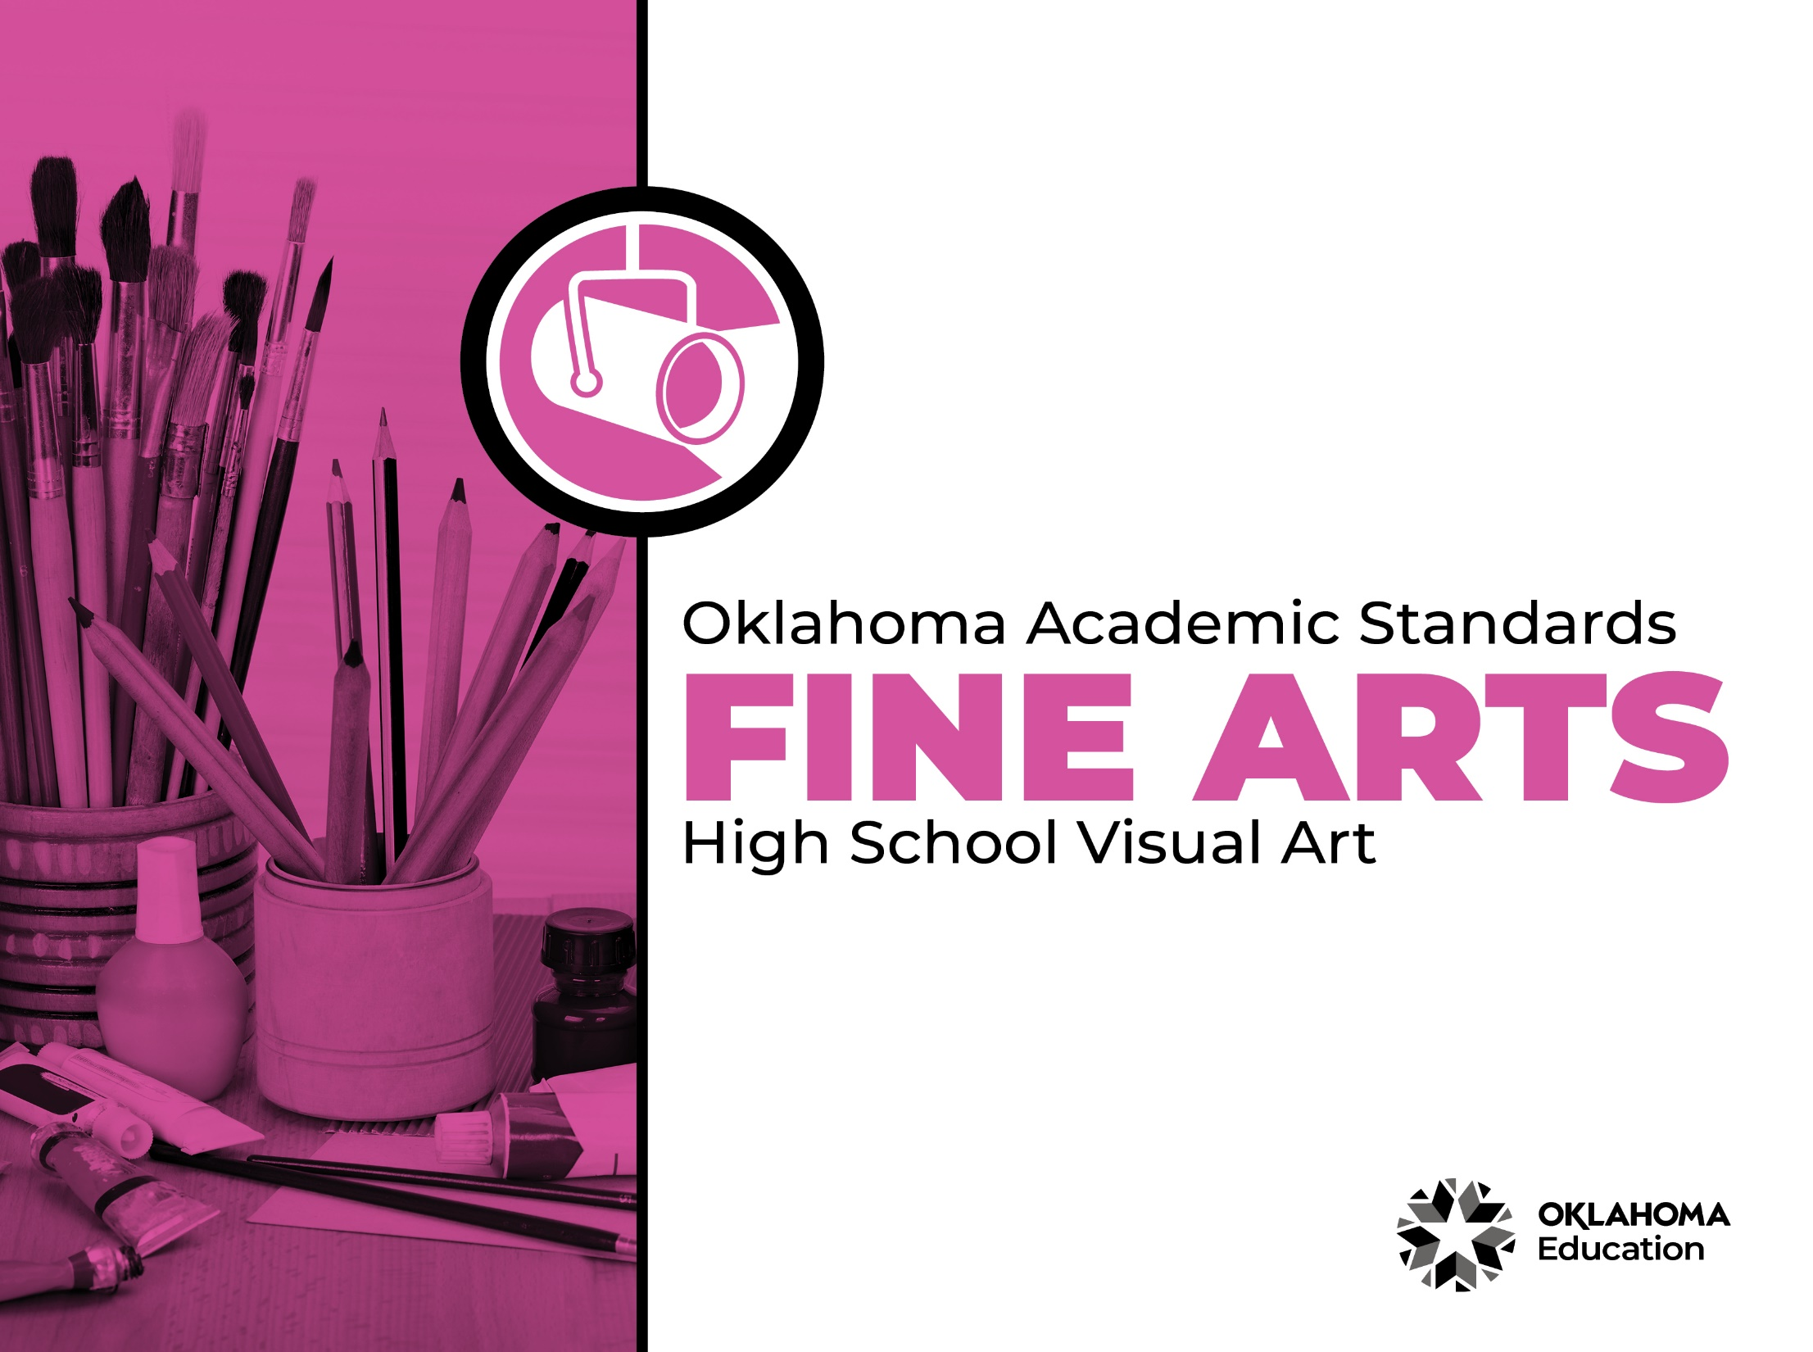
Table of Contents

Introduction & Standards Overview | 3
Visual Art Overview & Artistic Processes | 6
Visual Art Standards: High School | 7
Visual Art Glossary | 11

Introduction
The Oklahoma Standards for Fine Arts encompass dance, drama/theatre, music, and visual art. The standards are the result of the contributions of hundreds of fine arts educators, arts administrators, and representatives of higher education, arts organizations, and community members. This document reflects a balanced synthesis of the work of all committee members of the Oklahoma standards for dance, drama/theatre, music, and visual art.

The standards specify what students should know and be able to do as learners in their discipline at the end of each grade level or course. Students have different levels of experience within a discipline so teachers can attend to both grade-level standards and meet the individual needs of students who may be performing at levels above or below grade level. The order of the standards at any grade level is not meant to imply a sequence of topics and should be considered flexible for the organization of any course.

The Oklahoma Standards for dance, drama/theatre, music, and visual art were informed by the National Coalition for Core Arts Standards (NCCAS), the Opportunity-to-Learn Standards for Dance, the Opportunity-to-Learn Standards for Music, the Opportunity-to-Learn Standards for Theatre Education, the Purposes, Principles, and Standards for School Art Programs, and other states’ standards documents.

Standards Overview
The Oklahoma Standards for Fine Arts are designed to support all Oklahoma students to develop and achieve artistic literacy and to promote access and equity in the arts. Study of the arts enrich the quality of life. Dance, drama/theatre, music, and visual art are used by and have shaped every culture and individual on earth. They provide a means for experiencing the world and give form to our innermost thoughts, feelings, and sensibilities. They also give students an opportunity to use metacognitive skills as they plan, monitor, revise, and assess their art work in dance, drama/theatre, music, or visual art.

A well-rounded education addresses the development of all the realms of human behavior—the physical, emotional, social, and intellectual. Neglecting any of the areas weakens all the rest; therefore, Oklahoma students must have access to arts education that includes dance, drama/theatre, music, and visual art. Schools that provide quality arts experiences, based on sequential skill development, supplemented with carefully selected arts resources, can help students cultivate a positive attitude towards themselves and toward learning—an attitude that carries over to their entire education and life. In short, access to arts education prepares students to be creative, persistent, and compassionate adults.

The standards are comprised of four artistic processes:
- Creating/Creative Process
- Performing/Production,
- Connecting/Cultural and Historical Perspectives, and
- Responding/Aesthetic Response and Critique Methodologies.

Each artistic process has a discipline-specific definition found in the discipline overview. The artistic processes branch into anchor standards in each discipline. The anchor standards designate specific learning targets at each grade or learning level.
In dance, drama/theatre, and visual art, there are elementary grade level standards through grade eight. At the secondary level in these disciplines, there are three proficiency levels: proficient, advanced, and accomplished. The proficiency levels may apply to high school students at any grade level and prepare students for a career or college life.

The elementary music standards extend through grade six. The ensemble and/or secondary music standards have five proficiency levels:
- Novice
- Intermediate
- Proficient
- Advanced
- Accomplished

Novice proficiency level is assigned to students who have started specialization and are developing artistic understanding and technique and may participate in performance opportunities as they are able. Intermediate proficiency level is for students who are continuing study in their art form, perhaps at the middle school level. Proficient, advanced, and accomplished may apply to students at any grade level. In a middle or high school class or ensemble, it is expected that the teacher will develop an understanding of their students’ proficiency levels and utilize the corresponding level from the standards for each student.

Reading the Oklahoma Academic Standards for Fine Arts
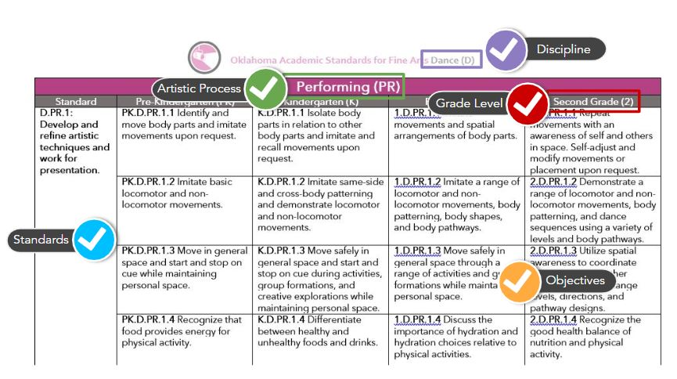

Visual Art Overview
Visual art is a significant expression of human culture. Art carries ideas from generation to generation, enhances cultural understandings, provides visual records of the past and gives form to contemporary ideas and events. Through visual art, we develop skills for perceiving, analyzing, appreciating, and responding to the visual environment.

Quality art programs help students develop skills to express themselves visually and understand the visual expression of others. As students work individually through an art project, there is constant decision-making and they learn to make adjustments to the work as it progresses. It is through the study of art that they learn about art products, artists, history, art materials, and art processes, which develop skills related college and career preparedness.

The visual art standards are designed to extend from pre-kindergarten through grade 12. The standards guide students through art skills in sequential order as they relate to the cognitive, psychomotor, and affective aspects of art. A total curriculum is balanced between the artistic processes: creative process, production, cultural and historical perspectives, and aesthetic response and critique methodologies. A glossary for teachers and administrators is provided in Appendix D: Visual Art Glossary. The glossary is not intended for student use; it contains educational terms for those reading the standards.

Visual Art Artistic Processes
The visual art standards emerge from the artistic processes of creative process, production, cultural and historical perspectives, and aesthetic response and critique methodologies. Each artistic process branches into multiple anchor standards. The anchor standards further divide into objectives, which describe student learning in visual art.

Creative Process
The creative process in art begins with learning the language of art and developing visual literacy to identify and/or communicate artistic concepts and techniques. Students learn art vocabulary, practice and refine techniques, make creative choices and practice individual expression in creating art.

Production
Art production demonstrates the learned techniques and expression of ideas. Students utilize a variety of ideas and different media, supplies, and tools in an appropriate and safe manner to create original artworks. They also demonstrate an appropriate skill level and revise and refine artworks to create finished works of art.

Cultural and Historical Perspectives
Visual art students learn about art in relation to history and culture. They connect artistic ideas and works with societal, cultural, and historical context to deepen understanding.

Aesthetic Response and Critique Methodologies
This reflective process includes art critique and assessment, preparation of the student’s artwork portfolio, and the exploration and study of visual art careers and pathways.

Creative Process (CP)
High School
Standard | Proficient (I) | Advanced (II) | Accomplished (III)
VA.CP.1: Learn and use vocabulary and concepts related to visual arts. | I.VA.CP.1.1 Use the elements of art (e.g., line, color, form, shape, texture, value, and space) and principles of design (e.g., rhythm, balance, contrast, movement, center of interest, and repetition) to develop multiple approaches to create art. | II.VA.CP.1.1 Use the elements of art and principles of design to create artwork for the development of a portfolio. | III.VA.CP.1.1 Visualize and hypothesize to generate art that could complete a portfolio.
 | I.VA.CP.1.2 Shape a personal artistic vision using a contemporary practice of art and design. | II.VA.CP.1.2 Choose from a range of materials and methods of traditional and contemporary artistic practices to plan personal works of art and design. | III.VA.CP.1.2 Follow or break established conventions, to plan the making of multiple works of art and design based on a theme, idea, or concept.
 |  | II.VA.CP.1.3 Reflect on artistic choices through written response. | III.VA.CP.1.3 Reflect on artistic choices through written response.
VA.CP.2: Practice and refine techniques and skills related to visual arts. | I.VA.CP.2.1 Experiment and practice skills and knowledge of various art forms. | II.VA.CP.2.1 Continue to experiment to demonstrate acquisition of skills and knowledge in a chosen art form. | III.VA.CP.2.1 Plan and make multiple works of art that explore a personally meaningful theme, idea, or concept.
 | I.VA.CP.2.2 Understand the legal consequence of appropriation, fair use, copyright, open source, social media, and creative commons as they apply to works of art and design. | II.VA.CP.2.2 Understand the legal consequence of appropriation, fair use, copyright, open source, social media, and creative commons as they apply to works of art and design. | III.VA.CP.2.2 Understand the legal consequence of using copyrighted materials in the creation and circulation of creative work.
VA.CP.3: Make creative choices and practice individual expression in application of concepts, language, techniques, and skills. | I.VA.CP.3.1 Apply relevant criteria from cultural contexts to examine, reflect, and plan for works of art and design. | II.VA.CP.3.1 Reflect, revise, and refine works of art or design considering relevant traditional and contemporary criteria as well as personal artistic vision. | III.VA.CP.3.1 Engage in constructive critique with peers, then reflect, revise, and refine works of art and design consistent with personal artistic vision.

Production (P)
Standard | Proficient (I) | Advanced (II) | Accomplished (III)
VA.P.1: Utilize a variety of ideas and subject matter in creation of original works of visual art. | I.VA.P.1.1 Document process of developing ideas from early stages to fully elaborated ideas and originality. | II.VA.P.1.1 Utilize inquiry methods of observation, research, and experimentation to explore unfamiliar subjects through original art making. | III.VA.P.1.1 Synthesize knowledge of social, cultural, historical, and personal life with art-making approaches to create original, meaningful works of art or design.
VA.P.2: Use various media, supplies, and tools in an appropriate and safe manner in the creation of original visual artworks. | I.VA.P.2.1 Explain how traditional and non-traditional materials used in art making may impact human health and the environment. Demonstrate safe handling of materials, tools, and equipment. | II.VA.P.2.1 Demonstrate awareness of ethical implications and social responsibility in making and distributing creative work. Demonstrate safe handling of materials, tools, and equipment. | III.VA.P.2.1 Demonstrate understanding of the importance of balancing freedom and responsibility in the use of images, materials, tools, and equipment in the creation and circulation of creative work. Demonstrate safe handling of materials, tools, and equipment.
VA.P.3: Demonstrate appropriate skill level in the application of knowledge, techniques, skills, and concepts, through the creation of original visual artworks. | I.VA.P.3.1 Use multiple approaches to begin creative endeavors. | II.VA.P.3.1 Through experimentation, practice, and persistence demonstrate acquisition of skills and knowledge in a chosen art form. | III.VA.P.3.1 Experiment, plan, and make a series of works of art and design that explores a personally meaningful theme, idea, or concept.
VA.P.4: Revise and refine artworks to create finished works of art. | I.VA.P.4.1 Apply relevant criteria from traditional and contemporary contexts to examine, reflect on and plan revisions for works of art and design in progress. | II.VA.P.4.1 Engage in constructive critique with peers, then reflect on, revise, and refine works of art and design in response to personal artistic vision. | III.VA.P.4.1 Reflect on, revise, and refine works of art or design considering relevant traditional and contemporary criteria as well as personal artistic vision.
Cultural and Historical Perspectives (CHP)
Standard | Proficient (I) | Advanced (II) | Accomplished (III)
VA.CHP.1: Relate artistic ideas and works with societal, cultural and historical context to deepen understanding. | I.VA.CHP.1.1 Describe how knowledge of cultures, traditions, and history may influence personal responses to art. | II.VA.CHP.1.1 Analyze works of art in a variety of societal, cultural, and historical contexts and make connections to uses of art in contemporary and local contexts. | III.VA.CHP.1.1 Evaluate the impact of an artist or a group of artists on the beliefs, values, and behaviors of a society.
 | II.VA.CHP.1.2 Describe how an artist or culture uses media (materials) to identify social, cultural, or political beliefs and actions. | II.VA.CHP.1.2 Analyze, explain, and justify why artists or cultures use specific media (materials) to record their social, cultural, and political history. | III.VA.CHP.1.2 Utilize contextual and visual knowledge of historical and contemporary art making to defend why media (materials) are used by an artist or culture.
 | I.VA.CHP.1.3 Describe basic ideas underlying major art movements and their historical periods and attribute works of art to specific artists, cultures, and movements. | II.VA.CHP.1.3 Analyze issues related to chronological art history and the development of an art movement. | III.VA.CHP.1.3 Research the context of and defend positions related to historical or contemporary movements in art and their social impact.

Aesthetic Response & Critique Methodologies (ARCM)
Standard | Proficient (I) | Advanced (II) | Accomplished (III)
VA.ARCM.1: Perceive, analyze, interpret, and evaluate artistic work. | I.VA.ARCM.1.1 Develop a personal artistic style in a portfolio or body of personal artwork, including an artist statement. | II.VA.ARCM.1.1 Continue to develop a personal artistic style in a portfolio or body of personal artwork, including an artist statement. | III.VA.ARCM.1.1 Refine a personal artistic style in a portfolio or body of personal artwork, including an artist statement.
 | I.VA.ARCM.1.2 Understand how knowledge gained in other subjects can lead to the creative resolution of design challenges in the visual arts. | II.VA.ARCM.1.2 Understand how knowledge gained in other subjects can lead to the creative resolution of design challenges in the visual arts. | III.VA.ARCM.1.2 Understand how knowledge gained in other subjects can lead to the creative resolution of design challenges in the visual arts.
 | I.VA.ARCM.1.3 Critique personal artwork based on a thoughtful inquiry. | II.VA.ARCM.1.3 Discuss and critique personal and peer created artwork using correct terminology. | III.VA.ARCM.1.3 Construct persuasive and reasonable arguments, individually, or collaboratively to defend or critique works of art.
 | I.VA.ARCM.1.4 Reflect on personal critiques to improve current or future work. | II.VA.ARCM.1.4 Incorporate peer critique to improve current or future work. | III.VA.ARCM.1.4 Demonstrate continual refinement of artwork based on formative critique.
 | I.VA.ARCM.1.5 Document and preserve personal works of art. | II.VA.ARCM.1.5 Select and prepare finished artwork for presentation. | III.VA.ARCM.1.5 Curate and showcase work for a specific purpose.
 | I.VA.ARCM.1.6 Discuss and explore necessary preparations for entering careers, college programs, exhibits, competitions, and pathways in the visual arts. | II.VA.ARCM.1.6 Discuss and explore necessary preparations for entering careers, college programs, exhibits, competitions, and pathways in the visual arts. | III.VA.ARCM.1.6 Prepare and submit personal work for evaluation in competitions, exhibits, college evaluation, or advanced assessment credit.

Visual Art Glossary

Appropriation Intentional borrowing, copying, and alteration of preexisting images and objects.

Balance The distribution of the visual weight of objects, colors, texture, and space. If the design was a scale, these elements should be balanced to make a design feel stable. In symmetrical balance, the elements used on one side of the design are similar to those on the other side; in asymmetrical balance, the sides are different but still look balanced. In radial balance, the elements are arranged around a central point and may be similar.

Color The quality of an object or substance with respect to the light reflected by the object. Color has three main characteristics:

Hue - The specific name of a color (red, green, blue, etc.)
Value - The degree of lightness or darkness of a color.
Intensity - The degree of brightness or dullness of a color

Color can also be characterized by the following:
- White is pure light; black is the absence of light.
- Primary colors are the only true colors (red, blue, and yellow). All other colors are mixes of primary colors.
- Secondary colors are two primary colors mixed together (green, orange, violet).
- Intermediate colors (sometimes called tertiary colors) are made by mixing a primary and secondary color together. Examples of intermediate colors include yellow-green, blue-green, and blue-violet.
- Complementary colors are located directly across from each other on the color wheel (an arrangement of colors along a circular diagram to show how they are related to one another). Complementary pairs contrast because they share no common colors. For example, red and green are complements, because green is made of blue and yellow. When complementary colors are mixed together, they neutralize one another.
- Warm colors are colors in the spectrum that suggest warmness, including red, yellow, and orange. Warm colors advance when used with cool colors.
- Cool colors are colors of the spectrum that suggest coolness, including blue, green and violet. Cool colors recede when used with warm colors.
- Analogous colors are colors that contain a common hue, which are found next to one another on the color wheel. An example of analogous colors include green-blue, blue, and blue-violet.

Contrast The difference between elements of art in a composition, such that each element is made stronger in relation to the other. When placed next to each other, contrasting elements command the viewer's attention. Contrast can be achieved by the juxtaposition of any of the elements of art.

Copyright Form of protection grounded in the U.S. Constitution and granted by law for original works of authorship fixed in a tangible medium of expression, covering both published and unpublished works.

Curate Select, organize, and exhibit works of art.

Elements of Art Line, shape, form, space, value, color, and texture.

Emphasis The part of the design that catches the viewer’s attention, also referred to as the center of interest or focal point. Usually the artist will make one area stand out by contrasting it with other areas. The area could be different in size, color, texture, shape, etc.

Fair Use The doctrine that brief excerpts of copyright material may, under certain circumstances, be quoted verbatim for purposes such as criticism, news reporting, teaching, and research, without the need for permission from or payment to the copyright holder.

Form Three-dimensional objects that can be measured by length, width, and depth (e.g., spheres, cylinders, cubes, pyramids, cuboids, etc.).

Line A mark with greater length than width. Lines can be horizontal, vertical, or diagonal; straight or curved; thick or thin.

Movement The path the viewer’s eye takes through the work of art. Such movement can be directed along lines, edges, shape, and color within the work of art.

Pattern The repeating of an object or symbol throughout the work of art.

Principles of Design Balance, emphasis, movement, pattern, repetition, rhythm, variety, unity, and contrast.

Proportion The relationship of one part of a whole to other parts.

Repetition Works with pattern to make the work of art seem active. The repetition of elements of art creates unity within the work of art.

Rhythm Created when one or more elements of art are used repeatedly to create a feeling of organized movement. Rhythm creates a mood like music or dancing. Unlike pattern, which demands consistency, rhythm relies on variety.

Shape A two-dimensional closed line. Shapes can be geometric (squares, circles, triangles, etc.) or organic (free-form or natural shapes). Shapes are flat and can be measured by length and width.

Space The area between, around, and within objects. The space around an object is negative space. The object itself is known as positive space. Space can also refer to the feeling of depth - also known as space-in-depth. Space-in-depth includes foreground, middle ground, and background space.

Texture The surface quality that can be seen and felt. Textures can be rough or smooth, soft or hard. Texture can be natural (real) and actually felt or visually implied by the artist and feels different than it appears.

Value The degree of lightness or darkness of a tone or color. Value is dependent upon the amount of light a surface reflects. Value can be created through the following techniques:
- Hatching - Technique that uses one set of hatching lines running parallel to the other sets.
- Cross-Hatching - Technique that uses one set of hatching lines over another set in a different direction so that the lines intersect.
- Stippling - Technique that uses a series of dots to create dark and light values.
- Tonal Shading - Technique that blends tones together creating a smooth effect.
- Shade - Dark value created by adding black.
- Tint - Light value created by adding white.

Variety The use of several elements of art to hold the viewer’s attention and to guide the viewer’s eye through and around the work.
Unity The feeling of harmony between all parts of the work of art, which creates a sense of completeness.

