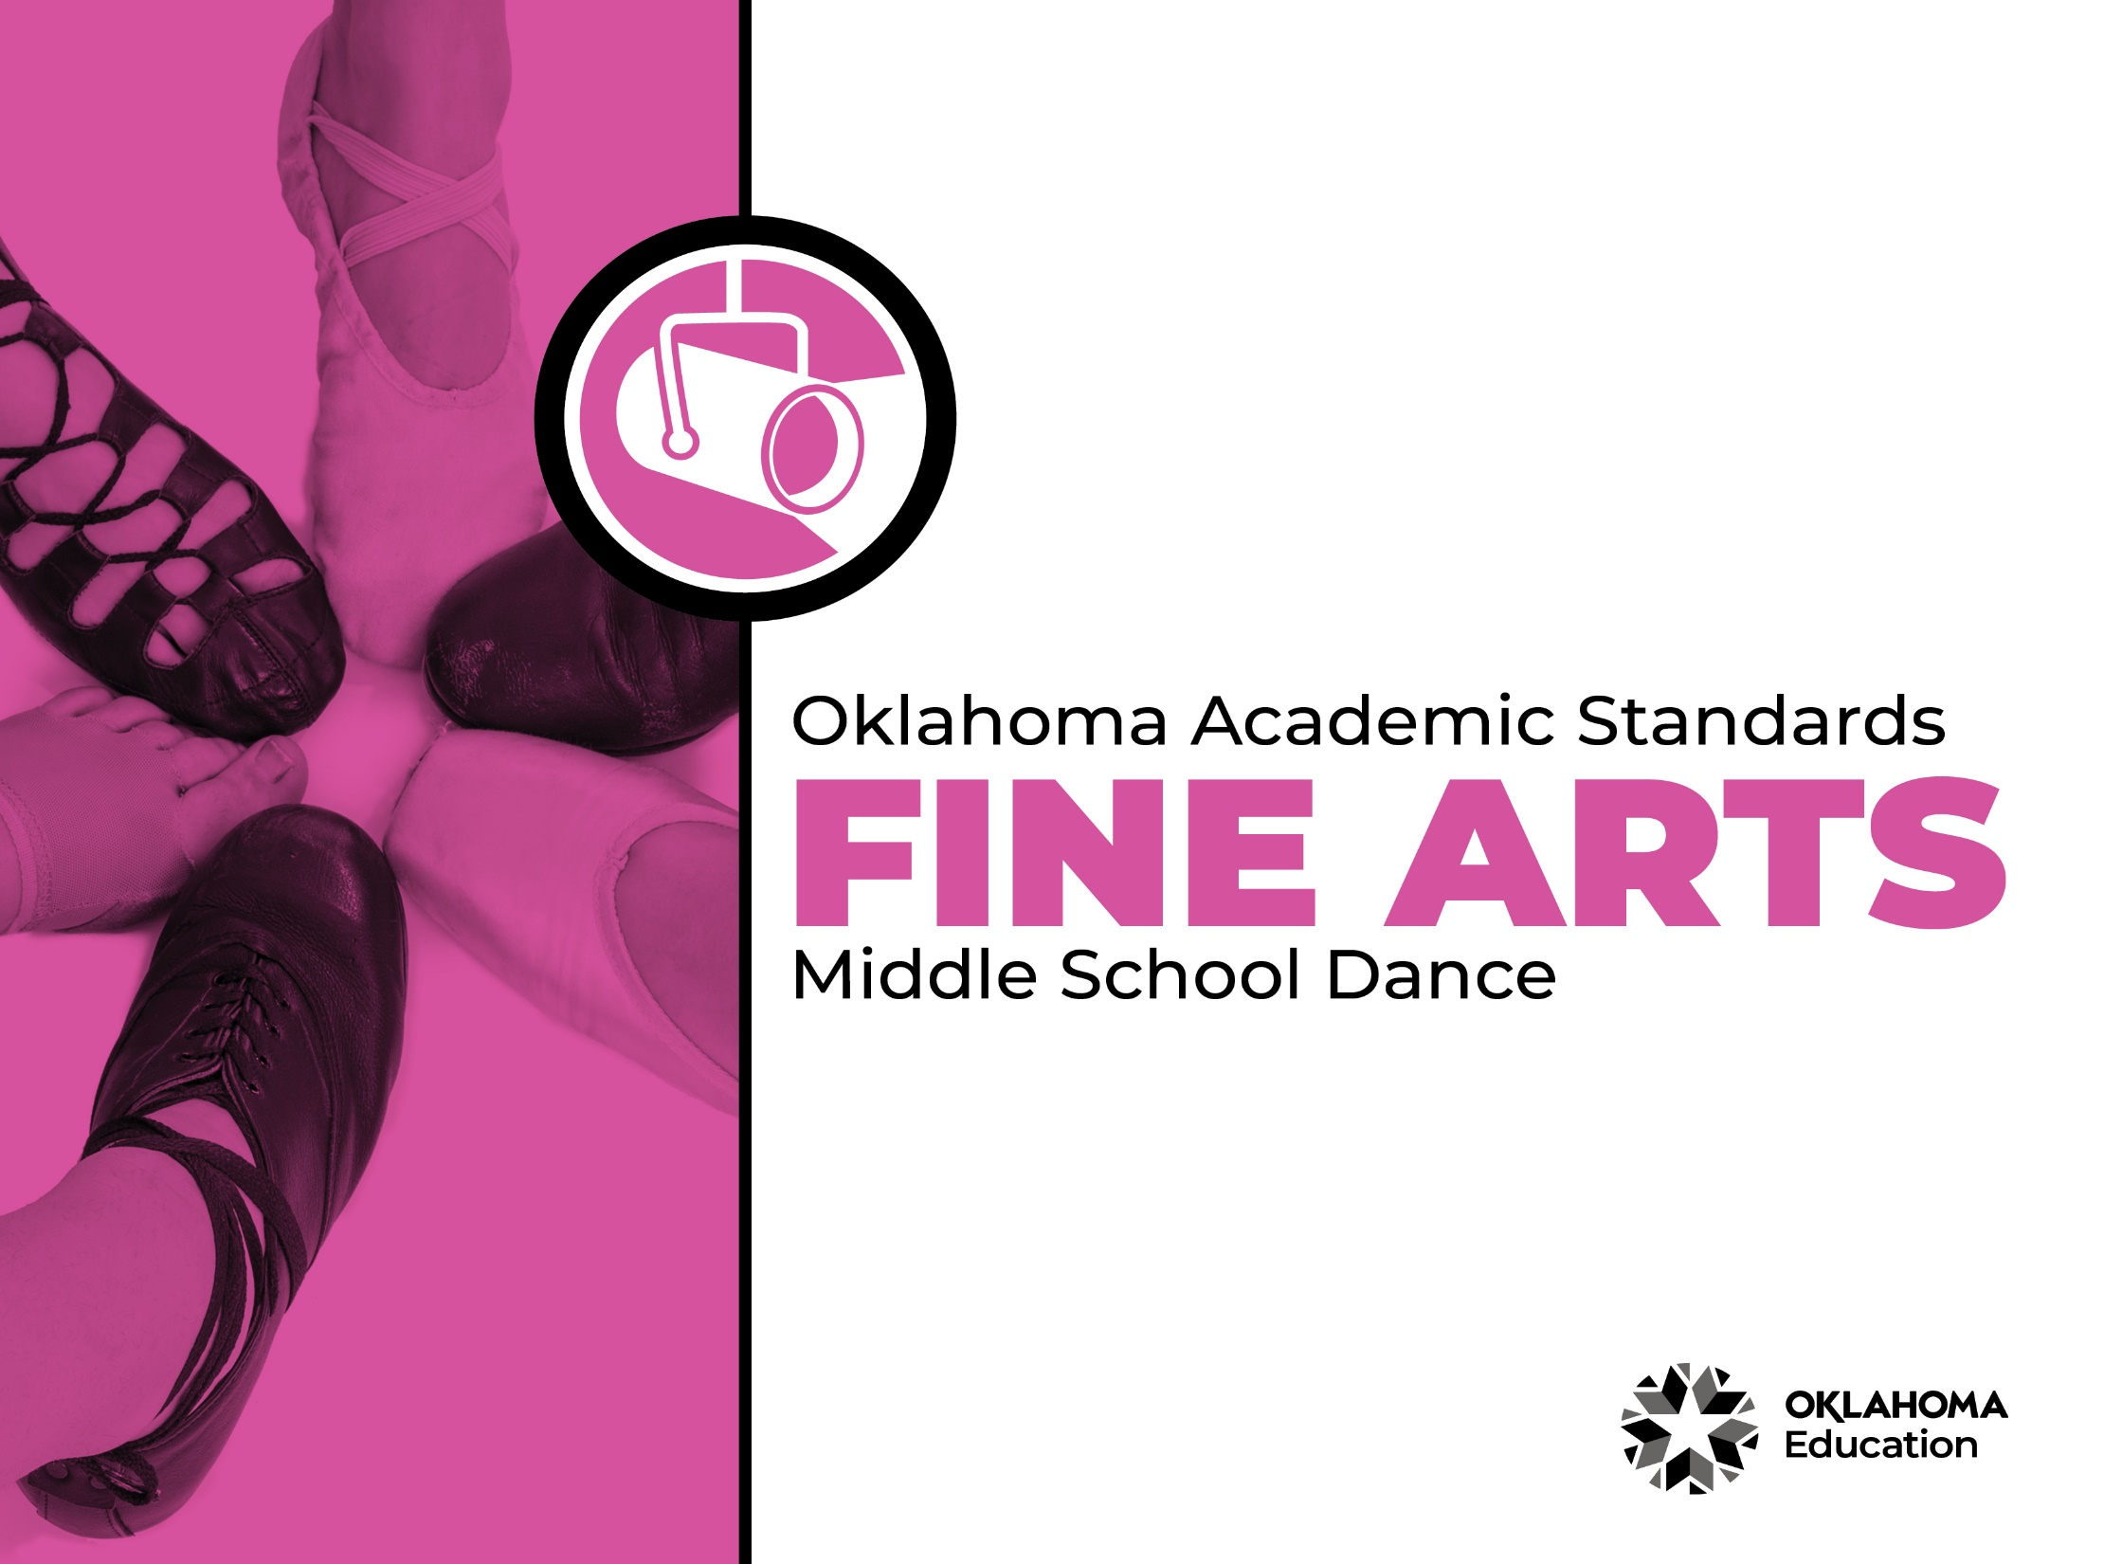
Table of Contents

Introduction & Standards Overview | 3
Dance Overview & Artistic Processes | 6
Dance Standards: 6th Grade-8th Grade | 7
Dance Glossary | 13

Introduction
The Oklahoma Standards for Fine Arts encompass dance, drama/theatre, music, and visual art. The standards are the result of the contributions of hundreds of fine arts educators, arts administrators, and representatives of higher education, arts organizations, and community members. This document reflects a balanced synthesis of the work of all committee members of the Oklahoma standards for dance, drama/theatre, music, and visual art.

The standards specify what students should know and be able to do as learners in their discipline at the end of each grade level or course. Students have different levels of experience within a discipline so teachers can attend to both grade-level standards and meet the individual needs of students who may be performing at levels above or below grade level. The order of the standards at any grade level is not meant to imply a sequence of topics and should be considered flexible for the organization of any course.

The Oklahoma Standards for dance, drama/theatre, music, and visual art were informed by the National Coalition for Core Arts Standards (NCCAS), the Opportunity-to-Learn Standards for Dance, the Opportunity-to-Learn Standards for Music, the Opportunity-to-Learn Standards for Theatre Education, the Purposes, Principles, and Standards for School Art Programs, and other states’ standards documents.

Standards Overview
The Oklahoma Standards for Fine Arts are designed to support all Oklahoma students to develop and achieve artistic literacy and to promote access and equity in the arts. Study of the arts enrich the quality of life. Dance, drama/theatre, music, and visual art are used by and have shaped every culture and individual on earth. They provide a means for experiencing the world and give form to our innermost thoughts, feelings, and sensibilities. They also give students an opportunity to use metacognitive skills as they plan, monitor, revise, and assess their art work in dance, drama/theatre, music, or visual art.

A well-rounded education addresses the development of all the realms of human behavior—the physical, emotional, social, and intellectual. Neglecting any of the areas weakens all the rest; therefore, Oklahoma students must have access to arts education that includes dance, drama/theatre, music, and visual art. Schools that provide quality arts experiences, based on sequential skill development, supplemented with carefully selected arts resources, can help students cultivate a positive attitude towards themselves and toward learning—an attitude that carries over to their entire education and life. In short, access to arts education prepares students to be creative, persistent, and compassionate adults.

The standards are comprised of four artistic processes:
- Creating/Creative Process
- Performing/Production,
- Connecting/Cultural and Historical Perspectives, and
- Responding/Aesthetic Response and Critique Methodologies.

Each artistic process has a discipline-specific definition found in the discipline overview. The artistic processes branch into anchor standards in each discipline. The anchor standards designate specific learning targets at each grade or learning level.
In dance, drama/theatre, and visual art, there are elementary grade level standards through grade eight. At the secondary level in these disciplines, there are three proficiency levels: proficient, advanced, and accomplished. The proficiency levels may apply to high school students at any grade level and prepare students for a career or college life.
The elementary music standards extend through grade six. The ensemble and/or secondary music standards have five proficiency levels:
- Novice
- Intermediate
- Proficient
- Advanced
- Accomplished

Novice proficiency level is assigned to students who have started specialization and are developing artistic understanding and technique and may participate in performance opportunities as they are able. Intermediate proficiency level is for students who are continuing study in their art form, perhaps at the middle school level. Proficient, advanced, and accomplished may apply to students at any grade level. In a middle or high school class or ensemble, it is expected that the teacher will develop an understanding of their students’ proficiency levels and utilize the corresponding level from the standards for each student.

Reading the Oklahoma Academic Standards for Fine Arts
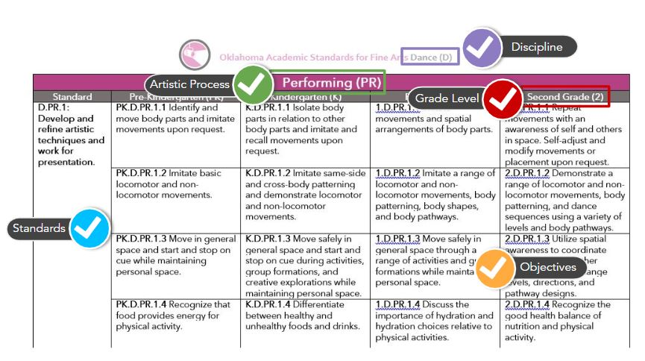
Dance Overview
Dance is essential to the well-rounded education of all students. Dance enables students to outwardly express and create through the medium of physical movement. The essence of dance is to feel, create, compose, interpret, perform, and respond. Dance is the physical expression of an idea developed through a process of research, inquiry, and movement discovery.
A dance education program provides for a student’s kinesthetic, spatial, emotional, social, intellectual, creative, and aesthetic development. Students are guided through experiences that are layered in a way that provides them with opportunities to experience and create different ways of doing and organizing movement sequences. These experiences are designed to enrich and broaden the students’ awareness of themselves and their world. All students should be provided access to quality dance education that supports college and career preparedness.
The standards are the impetus for Oklahoma dance educators to inspire their students to explore and discover their personal connection to the deep human tradition that is dance. The standards also prepare students for a life-long immersion in the socio-cultural-historical meanings and experience of dancing, as well as the embodied learning and enjoyment that performing, studying, and viewing dance can bring. A glossary for teachers and administrators is provided in Appendix A: Dance Glossary. The glossary is not intended for student use; it contains educational terms for those reading the standards.
Dance Artistic Processes
The dance standards emerge from the artistic processes of performing, creating, responding, and connecting. Each artistic process branches into multiple anchor standards. The anchor standards further divide into objectives, which describe student learning in dance.

Performing
Dance is an experiential discipline that enables students to outwardly express and create through the medium of physical movement. Students develop and refine artistic techniques and work for presentation. They also select, analyze, and interpret artistic work. Performing helps students convey meaning through dance.
Creating
Dance is an art form providing students the opportunity to create and compose. Students organize, develop, refine, and complete artistic ideas and work. Creating a dance or a portion of a dance gives students autonomy and self-efficacy in the classroom.
Responding
Dance students work to understand and evaluate how movement conveys meaning. This process begins with students perceiving and analyzing artistic work. Students then interpret and apply criteria to evaluate the artistic work.
Connecting
Students connect in dance by relating artistic ideas and work with personal meaning and external context. This is accomplished through synthesizing and relating knowledge and personal experiences to make art. Students also relate artistic works with societal, cultural, and historical context to deepen understanding.
Performing (PR)
Standard | Sixth Grade (6) | Seventh Grade (7) | Eighth Grade (8)
D.PR.1: Develop and refine artistic techniques and work for presentation. | 6.D.PR.1.1 Identify body pathways (central, transverse, and peripheral) to clarify movement intention. | 7.D.PR.1.1 Identify and explore the fundamental movement patterns of total body connectivity including body half, cross lateral, upper/lower, core/distal. | 8.D.PR.1.1 Identify and explore the progression of simultaneous, sequential, successive movement.
 | 6.D.PR.1.2 Embody technical dance skills (e.g., alignment, coordination, balance, core support, kinesthetic awareness, clarity of movement) to execute changes of direction, levels, facings, pathways, elevations and landings, extensions of limbs, and movement transitions. | 7.D.PR.1.2 Apply strategies to accommodate physical maturational development to technical dance skills (e.g., functional alignment, coordination, balance, core support, kinesthetic awareness, clarity of movement, weight shifts, flexibility/ range of motion). | 8.D.PR.1.2 Embody technical dance skills (e.g., functional alignment, coordination, balance, core support, clarity of movement, weight shifts, flexibility/ range of motion) to replicate, recall, and execute spatial designs and musical or rhythmical dance phrases.
 | 6.D.PR.1.3 Collaborate as an ensemble to refine dances by executing complex patterns, sequences, and formations, testing options, and finding good results. Document self-improvements over time. | 7.D.PR.1.3 Collaborate with peers to practice and refine dances. Develop group performance expectations through observation and analyses (e.g., view live or recorded professional dancers and collaboratively develop group performance expectations based on information gained from observations). | 8.D.PR.1.2 Collaborate with peers to discover strategies for achieving performance accuracy, clarity, and expressiveness. Articulate personal performance goals and practice to reach goals. Document personal improvement over time (e.g., journaling, portfolio, timeline).
 | 6.D.PR.1.4 Apply basic anatomical knowledge, proprioceptive feedback, spatial awareness, and nutrition to promote safe and healthy strategies when warming up and dancing. | 7.D.PR.1.4 Utilize healthy practices and sound nutrition in dance activities and everyday life. Discuss benefits of practices and how choices enhance performance. | 8.D.PR.1.3 Evaluate personal healthy practices in dance activities and everyday life, including nutrition and injury prevention. Discuss choices made, the effects experienced, and methods for improvement.
D.PR.2: Select, analyze, and interpret artistic work for presentation. | 6.D.PR.2.1 Refine partner and ensemble skills in the ability to judge distance and spatial design. Establish diverse pathways, levels, and patterns in space. Maintain focus with partner or group in near and far space. | 7.D.PR.2.1 Expand movement vocabulary of floor and spatial pattern designs using locomotor and non-locomotor movements. Incorporate and modify differently designed shapes and movements for interest and contrast. | 8.D.PR.2.1 Design body shapes in relation to other dancers, objects, and/or environment. Use appropriate performance focus in direct and indirect pathways.
 | 6.D.PR.2.2 Use combinations of sudden and sustained timing as it relates to both the metered time and the dynamics of a phrase or dance work. Accurately use accented and unaccented beats. | 7.D.PR.2.2 Use timing accents and variations within a phrase to add interest kinesthetically, rhythmically, and visually. | 8.D.PR.2.2 Analyze and select metric, kinetic, and breath phrasing and apply them appropriately to dance phrases. Perform dance phrases of different lengths that use various timings within the same section. Use different tempi in different body parts at the same time.
 | 6.D.PR.2.3 Explore dynamic expression as it relates to energy relationships in a variety of dance genres or styles. Distinguish between bound and free-flowing movements and apply them to technique exercises and dance phrases. | 7.D.PR.2.3 Compare and contrast dynamic qualities from a variety of dance genres or styles. Discuss specific qualities using adjectives and adverbs to describe them. Determine what dancers must do to perform them clearly. | 8.D.PR.2.3 Direct dynamic energy in such a way that movement is layered with multiple components and incorporate it into technique exercises and dance performance.
D.PR.3: Convey meaning through the presentation of artistic work. | 6.D.PR.3.1 Use performance etiquette and performance practices during class, rehearsal, and performance. Accept notes from the choreographer, make corrections as needed, and apply to future performances. | 7.D.PR.3.1 Use performance etiquette and performance practices during class, rehearsal, and performance. Maintain a journal documenting these actions. Accept notes from the choreographer and apply corrections to future performances. | 8.D.PR.3.1 Demonstrate character-based skills (e.g. commitment, dependability, responsibility, cooperation) when preparing for performances. Use performance etiquette and performance practices during class, rehearsal, and performance, document actions, and create a plan for ongoing improvements. Accept notes from the choreographer and apply corrections to future performances.
 | 6.D.PR.3.2 Compare and contrast a variety of possible production elements that would intensify and heighten the artistic intent of the work. Select choices and use production terminology to explain reasons for the decisions made. | 7.D.PR.3.2 Explore possibilities of producing dance in a variety of venues or for different audiences. Use production terminology to explain how the production elements would be handled in different situations to enhance artistic intent. | 8.D.PR.3.2 Collaborate to design and execute production elements that would intensify and heighten the artistic intent of a dance performed on a stage, in a different venue, or for different audiences. Use production terminology to explain reasons for choices.

Creating (CR)
Standard | Sixth Grade (6) | Seventh Grade (7) | Eighth Grade (8)
D.CR.1: Generate and conceptualize artistic ideas and work. | 6.D.CR.1.1 Explore similar or contrasting ideas to develop choreography using a variety of stimuli (e.g., music, observed dance, literary forms, notation, natural phenomena, personal experience/ recall, current news, social events). | 7.D.CR.1.1 Compare a variety of stimuli (e.g., music, observed dance, literary forms, notation, natural phenomena, personal experience/ recall, current news, social events) and make selections to expand movement vocabulary and artistic expression. | 8.D.CR.1.1 Implement movement from a variety of stimuli (e.g., music, observed dance, literary forms, notation, natural phenomena, personal experience/recall, current news, social events) to develop dance content for an original dance study or dance.
 | 6.D.CR.1.2 Explore various movement vocabularies to transfer ideas into choreography. | 7.D.CR.1.2 Explore various movement vocabularies to express an artistic intent in choreography. Explain and discuss the choices made using genre-specific dance terminology. | 8.D.CR.1.2 Identify and select personal preferences to create an original dance study or dance. Use genre-specific dance terminology to articulate and justify choices made in movement development to communicate intent.
D.CR.2: Organize and develop artistic work. | 6.D.CR.2.1 Explore choreographic devices and dance structures to develop a dance study that supports an artistic intent. Explain the goal or purpose of the dance. | 7.D.CR.2.1 Use a variety of choreographic devices and dance structures to develop a dance study with a clear artistic intent. Articulate reasons for movement and structural choices. | 8.D.CR.2.1 Collaborate to select and apply a variety of choreographic devices and dance structures to choreograph an original dance study or dance with a clear artistic intent. Articulate the group process for making movement and structural choices.
 | 6.D.CR.2.2 Develop artistic intention to choreograph a dance study that communicates personal or cultural meaning. Based on the intention, evaluate why some movements are more or less effective than others. | 7.D.CR.2.1 Develop artistic intention to choreograph a dance study that communicates personal or cultural meaning. Articulate how the artistic intention serves to communicate the meaning of the dance. | 8.D.CR.2.2 Define and apply artistic intention to choreograph a dance that communicates personal or cultural meaning. Discuss how the intention clarifies or intensifies the meaning of the dance.
D.CR.3: Refine and complete artistic work. | 6.D.CR.3.1 Revise dance compositions using collaboratively developed artistic criteria. Explain reasons for revisions and how choices made relate to artistic intent. | 7.D.CR.3.1 Evaluate possible revisions of dance compositions and, if necessary, consider revisions of artistic criteria based on self-reflection and the feedback from others. Explain reasons for choices and how they clarify artistic intent. | 8.D.CR.3.1 Revise choreography collaboratively or independently based on artistic criteria, self-reflection, and the feedback from others. Articulate the reasons for choices and revisions and explain how they clarify and enhance the artistic intent.
 | 6.CR.3.2 Explore or invent a system to record a dance sequence through writing, symbols, or a form of media technology. | 7.CR.3.2 Investigate a recognized system to document a dance sequence by using words, symbols, or media technologies. | 8.CR.3.2 Experiment with aspects of a recognized system to document a section of a dance by using words, symbols, or media technologies.

Responding (RE)
Standard | Sixth Grade (6) | Seventh Grade (7) | Eighth Grade (8)
D.RE.1: Perceive and analyze artistic work. | 6.D.RE.1.1 Describe recurring patterns of movement and their relationships in dance. | 7.D.RE.1.1 Compare, contrast, and discuss patterns of movement and their relationships in dance. | 8.D.RE.1.1 Describe and discuss patterns of movement and their relationships in dance in context of artistic intent.
 | 6.D.RE.1.2 Explain how the elements of dance are used in a variety of dance genres, styles, or cultural movement practices. Use genre-specific dance terminology. | 7.D.RE.1.2 Compare and contrast how the elements of dance are used in a variety of genres, styles, or cultural movement practices. Use genre-specific dance terminology. | 8.D.RE.1.2 Explain how the elements of dance are used in a variety of genres, styles, or cultural movement practices to communicate intent. Use genre-specific dance terminology.
D.RE.2: Construct meaningful interpretations of artistic work. | 6.D.RE.2.1 Explain how the artistic expression of a dance is achieved through the use of body, dance technique, dance structure, and context. Use genre-specific dance terminology. | 7.D.RE.2.1 Compare the meaning of different dances. Explain how the artistic expression of each dance is achieved through the elements of dance, use of body, dance technique, and context, using genre-specific dance terminology. | 8.D.RE.2.1 Select a dance and explain how artistic expression is achieved through relationships among the elements of dance, use of body, dance technique and context. Cite evidence in the dance to support your interpretation, using genre-specific dance terminology.
D.RE.3: Apply criteria to evaluate artistic work. | 6.D.RE.3.1 Discuss the characteristics and artistic intent of a dance from a genre, style, or cultural movement practice and develop artistic criteria to critique the dance, using genre-specific dance terminology. | 7.D.RE.3.1 Compare artistic intent, content, and context from different dances to examine the qualities of genre, style, or cultural movement practice. Based on the comparison, develop artistic criteria, using genre-specific dance terminology. | 8.D.RE.3.1 Use artistic criteria to determine what makes an effective performance. Consider content, context, genre, style, or cultural movement practice to comprehend artistic expression. Use genre-specific dance terminology.

Connecting (CN)
Standard | Sixth Grade (6) | Seventh Grade (7) | Eighth Grade (8)
D.CN.1: Synthesize and relate knowledge and personal experiences to make art. | 6.D.CN.1.1 Observe the movement characteristics or qualities in a specific dance genre. Describe differences and similarities to one’s attitudes and movement preferences. | 7.D.CN.1.1 Compare and contrast the movement characteristics or qualities found in a variety of dance genres. Discuss how the movement characteristics or qualities differ from one’s own movement preferences and perspectives. | 8.D.CN.1.1 Relate connections found between different dances and discuss the relevance of the connections to the development of one’s personal perspectives.
 | 6.D.CN.1.2 Choose a topic, concept, or content from another subject of interest and research how other art forms have expressed the topic. Create and explain a dance study that expresses the idea. | 7.D.CN.1.2 Conduct research using a variety of resources to find information about a social issue. Use the information to create a dance study that expresses a specific point of view on the topic. Discuss whether the experience of creating and sharing the dance reinforces personal views or offers new knowledge and perspectives. | 8.D.CN.1.2 Research the historical development of a dance genre or style. Use knowledge gained from the research to create a dance study that evokes the essence of the style or genre. Share the dance study and research with peers.
D.CN.2: Relate artistic ideas and works with societal, cultural and historical contexts to deepen understanding. | 6.D.CN.2.1 Interpret and demonstrate how the movement and qualities of a dance communicate its cultural, historical, and/or community purpose or meaning, including those of Oklahoma Native American tribes and communities. | 7.D.CN.2.1 Compare, contrast, and discuss dances performed by people in various localities or communities, including the contributions of Oklahoma Native American tribes and communities. Formulate possible reasons why similarities and differences developed in relation to the ideas and perspectives important to each social group. | 8.D.CN.2.1 Analyze and discuss how dances from a variety of cultures, societies, historical periods, or communities reveal the ideas and perspectives of the people, including  those of Oklahoma Native American tribes and communities.

Dance Glossary

Body Shapes Movements and static shapes that are curved, straight, open, closed, symmetrical, asymmetrical, etc.

Body-mind Principles Concepts explored and/or employed to support mind-body connections (e.g., breathe, awareness of the environment, grounding, movement initiation, use of imagery, intention, inner-outer, stability-mobility).

Body Pathways Pathway in dance is synonymous to line in visual art: a point that moves through space that can vary in width, length, curvature and direction. In dance, a body part of the entire body can move in a variety of pathways.

Choreography (Literally, ‘dance writing.’) The creation and composition of dances by arranging or inventing steps, movements and patterns of movement.

Contrasting Efforts-To compare or oppose two things so as to show their differences. In dance, two contrasting efforts might be different in energy, space (size, direction, level), design (open/close, symmetrical/asymmetrical) timing (fast/slow, even/uneven).

Cross-body patterning Movements that cross the body midline.

Cross-lateral movement A body pattern that crosses the vertical mid-line of the body; movement that goes right to left or left to right; a body pattern of connecting body parts along a diagonal pathway through the body's core to the extremities.

Dance Study A short dance that is comprised of several dance phrases based on an artistic idea.
Distal, mid-limb, and central initiations Movement initiated by body parts situated away from the point of attachment to the body (e.g., fingers, toes), in the middle area of attachment to the body

(e.g., elbows, knees), and next to or nearest the point of attachment to the body (e.g., torso).

Dynamic The qualities or characteristics of movement which lend expression and style; also called “efforts,” or “energy” (e.g., lyrical, sustained, quick, light, or strong).

Elements of Dance The key components of movement; movement of the body using space, time, and energy; often referred to as the elements of movement.

Energy The dynamic quality, force, attach, weight, and flow of movement.

General Space Spatial orientation that is not focused towards one area of a studio or stage.

Genre A broad category of music that may include many different forms, styles and expressions (e.g., Baroque, Romantic, Minimalist, Broadway, Jazz, New Age).

Improvise To simultaneously invent and perform movement.

Locomotor/Non-locomotor Movement Movements that travel through space or carry weight from one location to another or a movement that a person performs while remaining stationary.

Meter In music, the number and length of beats in a measure (e.g., 2/4 equals two quarter notes in a measure and 6/8 equals six eighth notes in a measure).

Movement Phrase A brief sequence of related movements that have a sense of continuity and artistic or rhythmic completion.

Movement Qualities Expressive components of movement, also called efforts.

Musical Phrasing The way a dancer shapes a series of movements within a larger piece using dynamics (e.g., amplitude, attack, movement qualities), especially but not exclusively in coordination with music.

Notation System A symbol system for components of movement (e.g., Labanotation, Beauchamp-Feuillet Notation, Eshkol-Wachman, Benesh Notation, etc.).

Performance Etiquette Performance values and expected behaviors when rehearsing or performing (e.g., no talking while the dance is in progress, no chewing gum, neat and appropriate appearance, dancers do not call out to audience members who are friends, etc.).

Personal Space The area of space directly surrounding one’s body extending as far as a person can reach; also called the kinesphere.

Production Elements Aspects of performance that produce theatrical effects (e.g., costumes, make-up, sound, lighting, props).

Proprioception Internal sensations and awareness of body position and movement.

Rhythm The patterning or structuring of time through movement or sound.

Spatial Pathways The line through space along which a person moves.

Static Standing or fixed in one place; stationary.

Style Dance that has specific movement characteristics, qualities, or principles that give it distinctive identity (e.g., Graham technique is a style of Modern Dance; rhythm tap is a style of Percussive Dance; Macedonian folk dance is a style of International Folk dance; Congolese dance is a style of African Dance).

Tempo/tempi The pace or speed of a pulse or beat underlying music or movement (plural: tempi or tempo).

