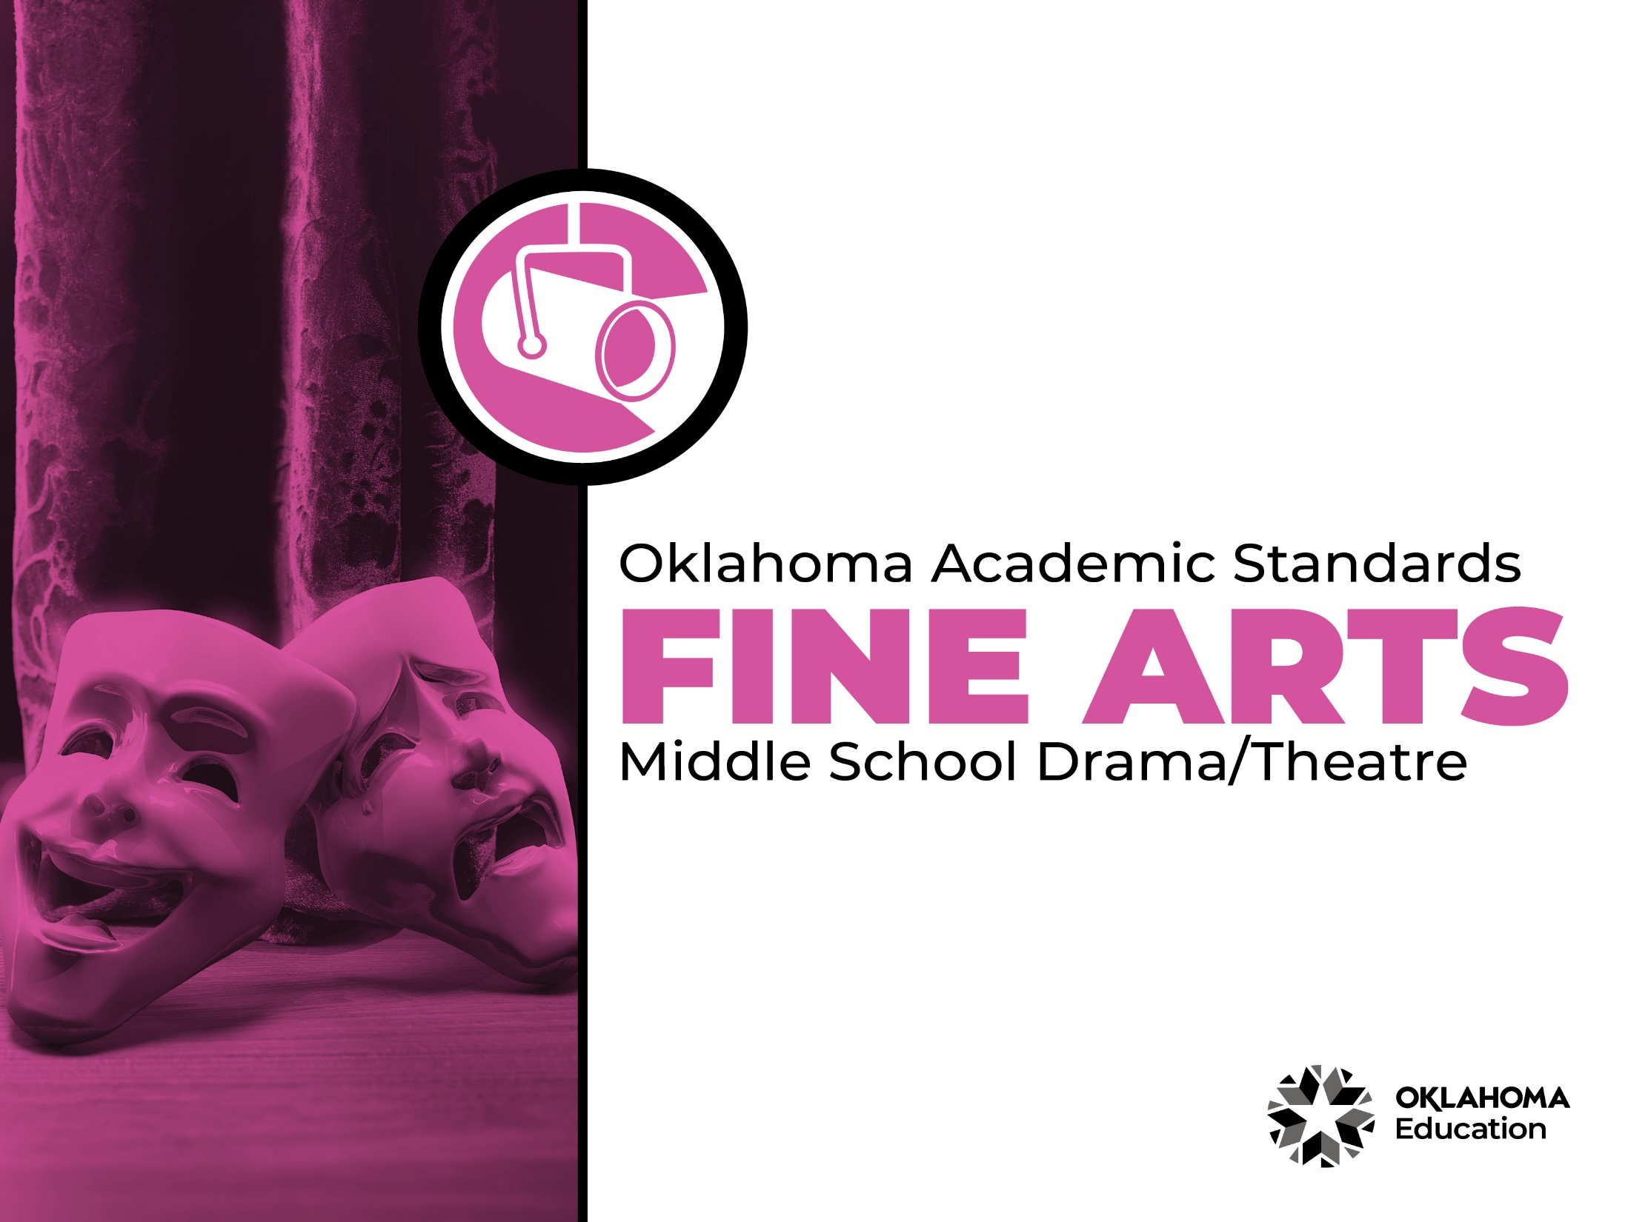

Table of Contents

Introduction & Standards Overview | 3
Drama/Theatre Overview & Artistic Processes | 6
Drama/Theatre Standards: 6th Grade-8th Grade | 7
Drama/Theatre Glossary | 13

Introduction
The Oklahoma Standards for Fine Arts encompass dance, drama/theatre, music, and visual art. The standards are the result of the contributions of hundreds of fine arts educators, arts administrators, and representatives of higher education, arts organizations, and community members. This document reflects a balanced synthesis of the work of all committee members of the Oklahoma standards for dance, drama/theatre, music, and visual art.

The standards specify what students should know and be able to do as learners in their discipline at the end of each grade level or course. Students have different levels of experience within a discipline so teachers can attend to both grade-level standards and meet the individual needs of students who may be performing at levels above or below grade level. The order of the standards at any grade level is not meant to imply a sequence of topics and should be considered flexible for the organization of any course.

The Oklahoma Standards for dance, drama/theatre, music, and visual art were informed by the National Coalition for Core Arts Standards (NCCAS), the Opportunity-to-Learn Standards for Dance, the Opportunity-to-Learn Standards for Music, the Opportunity-to-Learn Standards for Theatre Education, the Purposes, Principles, and Standards for School Art Programs, and other states’ standards documents.

Standards Overview
The Oklahoma Standards for Fine Arts are designed to support all Oklahoma students to develop and achieve artistic literacy and to promote access and equity in the arts. Study of the arts enrich the quality of life. Dance, drama/theatre, music, and visual art are used by and have shaped every culture and individual on earth. They provide a means for experiencing the world and give form to our innermost thoughts, feelings, and sensibilities. They also give students an opportunity to use metacognitive skills as they plan, monitor, revise, and assess their art work in dance, drama/theatre, music, or visual art.

A well-rounded education addresses the development of all the realms of human behavior—the physical, emotional, social, and intellectual. Neglecting any of the areas weakens all the rest; therefore, Oklahoma students must have access to arts education that includes dance, drama/theatre, music, and visual art. Schools that provide quality arts experiences, based on sequential skill development, supplemented with carefully selected arts resources, can help students cultivate a positive attitude towards themselves and toward learning—an attitude that carries over to their entire education and life. In short, access to arts education prepares students to be creative, persistent, and compassionate adults.

The standards are comprised of four artistic processes:
- Creating/Creative Process
- Performing/Production,
- Connecting/Cultural and Historical Perspectives, and
- Responding/Aesthetic Response and Critique Methodologies.

Each artistic process has a discipline-specific definition found in the discipline overview. The artistic processes branch into anchor standards in each discipline. The anchor standards designate specific learning targets at each grade or learning level.
In dance, drama/theatre, and visual art, there are elementary grade level standards through grade eight. At the secondary level in these disciplines, there are three proficiency levels: proficient, advanced, and accomplished. The proficiency levels may apply to high school students at any grade level and prepare students for a career or college life.

The elementary music standards extend through grade six. The ensemble and/or secondary music standards have five proficiency levels:
- Novice
- Intermediate
- Proficient
- Advanced
- Accomplished

Novice proficiency level is assigned to students who have started specialization and are developing artistic understanding and technique and may participate in performance opportunities as they are able. Intermediate proficiency level is for students who are continuing study in their art form, perhaps at the middle school level. Proficient, advanced, and accomplished may apply to students at any grade level. In a middle or high school class or ensemble, it is expected that the teacher will develop an understanding of their students’ proficiency levels and utilize the corresponding level from the standards for each student.

Reading the Oklahoma Academic Standards for Fine Arts
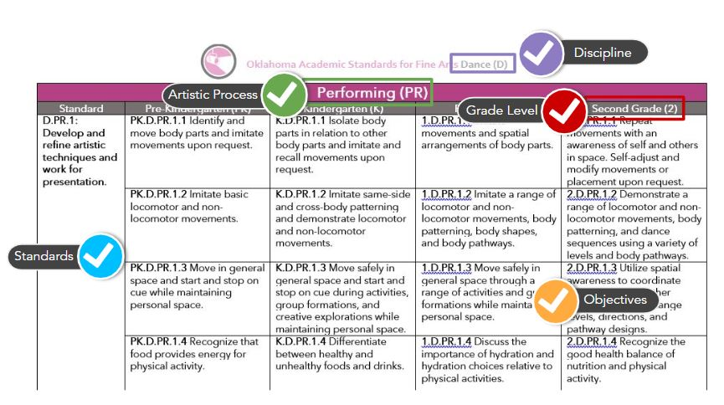

Drama/Theatre Overview
Drama and theatre are essential to the well-rounded education of all students because they lay the foundation for a critical understanding of human culture. Drama and theatre are uniquely qualified for this purpose. Drama and theatre do not exist within a vacuum, but rather comment on our world, history, philosophy, science, and understanding of our fellow human beings. Therefore, drama and theatre are a unique vehicle for transporting us to an infinite variety of integrated knowledge, understanding, and cross-curricular engagement. Drama and theatre reach out and connect to countless positive educational outcomes and support college and career preparedness.

“The terms drama and theatre are used throughout the document to represent two ends of a continuum in theatre education. Drama is any informal dramatic element that is designed not for presentation but rather for the experience or educational value. Theatre is a more formal study of the discipline which culminates in dramatic interpretation by actors and technicians on a stage before an audience.”
American Alliance for Theatre & Education

The drama/theatre standards are intended to inspire educators to integrate drama/theatre into other academic programming as well as to allow the subject to stand on its own as a component of a well-rounded education. The standards prepare students for a life-long immersion in drama/theatre, as well as the learning and enjoyment that creating, performing, and viewing drama/theatre can bring. A glossary for teachers and administrators is provided in Appendix B: Drama/Theatre Glossary. The glossary is not intended for student use; it contains educational terms for those reading the standards.

Drama/Theatre Artistic Processes
The drama/theatre standards emerge from the artistic processes of creating, presenting, responding, and connecting. Each artistic process branches into multiple anchor standards. The anchor standards further divide into objectives, which describe student learning in drama/theatre.

Creating
Drama/theatre gives students a chance to create and interact with others through the art form. Students are able to generate, organize, develop, and rehearse artistic ideas that may culminate in an organized activity within the classroom or a performance for peers or an audience.

Performing
Drama/theatre experiences require students to interpret and share artistic work. They are able to analyze and select work for presentation. As they work towards performance, they develop and refine techniques and convey meaning through the presentation.
Responding
In drama/theatre, students work to understand and evaluate how the arts convey meaning. This process begins with students perceiving and analyzing artistic work. Students then interpret the work and use criteria to evaluate performance.

Connecting
Students connect in drama/theatre by relating artistic ideas or work with personal meaning and external context. This is accomplished by synthesizing and relating knowledge and personal experiences to art. Students also relate artistic works with societal, cultural, and historical context to deepen understanding.

Creating (CR)
Standard | Sixth Grade (6) | Seventh Grade (7) | Eighth Grade (8)
DT.CR.1: Generate and conceptualize artistic ideas and work. | 6.DT.CR.1.1 Conceptualize a unified piece of drama/theatre by articulating creative ideas in playwriting, improvisation, oral and written form, staging, and design. | 7.DT.CR.1.1 Conceptualize a unified piece of drama/theatre by experimenting with possible solutions to playwriting, improvisation, staging, performance, and design. | 8.DT.CR.1.1 Conceptualize a unified piece of drama/theatre by elaborating upon creative ideas and devising possible solutions to playwriting, improvisation, staging, performance, and design.
 | 6.DT.CR.1.2 Conceptualize and craft production elements for a unified drama/theatre concept by using theatre vocabulary to describe the most appropriate and meaningful staging choices. | 7.DT.CR.1.2 Conceptualize and craft production elements for a unified drama/theatre concept by using theatre vocabulary when describing areas of the stage to create meaningful blocking and present solutions to design challenges. | 8.DT.CR.1.2 Conceptualize and craft production elements for a unified drama/theatre concept by analyzing design elements (e.g., set, lights, costumes, props, sound, make up, special effects, media, and marketing/publicity) for an improvised or scripted work.
 | 6.DT.CR.1.3 Develop characters authentic to the drama/theatre work by: developing physical and vocal character traits; exploring characters’ inner thoughts and their impact on character traits, relationships, and story development; and formulating dialogue and actions. | 7.DT.CR.1.3 Develop characters authentic to the drama/theatre work by: demonstrating physical and vocal character traits; engaging in character analysis to determine how characters’ inner thoughts impact character back-story, character traits, relationships, and story development; and formulating or interpreting dialogue and actions. | 8.DT.CR.1.3 Develop characters authentic to the drama/theatre work by: demonstrating physical and vocal character traits; engaging in character analysis; and formulating or interpreting dialogue and actions.
DT.CR.2: Organize, develop, and rehearse artistic ideas and work. | 6.DT.CR.2.1 Imagine and refine ideas and artistic choices through exploration and critical analysis in an original or scripted drama/theatre work. | 7.DT.CR.2.1 Imagine, develop, and refine artistic choices through research and the application of Aristotle’s six elements of drama during the dramatic writing process. | 8.DT.CR.2.1 Through critical analysis, refine artistic choices through research and the application of Aristotle’s six elements of drama during the dramatic writing process.
 | 6.DT.CR.2.2 Demonstrate collaborative skills by working effectively and respectfully with a diverse team to incorporate a variety of artistic ideas in an original or scripted drama/theatre work. | 7.DT.CR.2.2 Demonstrate collaborative skills by assuming roles, identifying responsibilities, and being receptive of a variety of artistic ideas in an original or scripted drama/theatre work. | 8.DT.CR.2.2 Demonstrate collaborative skills by working effectively with a diverse team and modeling actor etiquette in an original or scripted drama/theatre work.
DT.CR.3: Revise, refine, and complete artistic work. | 6.DT.CR.3.1 Examine choices (performance, design, production) that contribute to a unified drama/theatre work. | 7.DT.CR.3.1 Prepare choices (performance, design, production, marketing/publicity) that contribute to a unified drama/theatre work. | 8.DT.CR.3.1 Prepare, refine, and justify choices (performance, design, production, marketing/publicity) that contribute to a unified drama/theatre work.
 | 6.DT.CR.3.2 Develop characters through imagination, research, observation, physical movement, gesture, sound, word choice, dialogue, rate, pitch, volume, etc. | 7.DT.CR.3.2 Develop and identify effective physical and vocal traits of characters through the use of acting techniques (character analysis - character morgue, Stanislavski, Strasberg, Meisner, Hagen, etc.). | 8.DT.CR.3.2 Refine effective physical, vocal, and physiological traits of characters through the use of acting techniques (character analysis - character morgue, Stanislavski, Strasberg, Meisner, Hagen, etc.).
 | 6.DT.CR.3.3 Integrate design elements that create an emotional impact or convey meaning by working creatively and collaboratively to conceptualize and create settings, costumes, and props for drama/theatre experiences. | 7.DT.CR.3.3 Integrate design elements that have an emotional impact or convey meaning by considering multiple planned technical design elements to communicate mood, period, culture, and locale. | 8.DT.CR.3.3 Conceptualize, design, and implement solutions to technical/production challenges in a drama/theatre experience.

Performing (PR)
Standard | Sixth Grade (6) | Seventh Grade (7) | Eighth Grade (8)
DT.PR.1: Select, analyze, and interpret artistic work for presentation. | 6.DT.PR.1.1 Demonstrate that there are multiple design and performance choices for every drama/theatre work and select the most supportable choice for the moment. | 7.DT.PR.1.1 Develop performance and design choices (e.g., dramatic structure/plot, characters, setting, theme, design elements, props, sound, etc.) that will contribute to the most supportable and convincing drama/theatre work. | 8.DT.PR.1.1 Develop and select performance and design elements that will contribute to the most supportable and convincing drama/theatre work.
 | 6.DT.PR.1.2 Experiment with meaningful, effective, and appropriate physical and vocal traits of characters in improvised, original, or scripted drama/theatre work and select the most supportable choices. | 7.DT.PR.1.2 Evaluate and apply meaningful, effective, and appropriate physical and vocal traits of characters in improvised, original, or scripted drama/theatre work and select the most supportable choices. | 8.DT.PR.1.2 Evaluate and apply meaningful, effective, and appropriate physical and vocal traits of characters and react and respond appropriately in character with awareness of verbal and non-verbal cues in improvised, original, or scripted drama/theatre work.
DT.PR.2: Develop and refine artistic techniques and work for presentation. | 6.DT.PR.2.1 Develop expertise by participating in a variety of dramatic and theatre forms (e.g., pantomime, tableau, puppetry, story enactment, reader’s theatre, musical theatre, documentary theatre, etc.). | 7.DT.PR.2.1 Assume roles in a variety of dramatic and theatrical forms and develop expertise through a personalization of techniques. | 8.DT.PR.2.1 Assume roles in a variety of dramatic and theatrical forms to refine the approaches and requirements demanded by each style and form and develop expertise through a personalization of techniques.
 | 6.DT.PR.2.2 Incorporate available technology and technical elements (e.g., music, sound effects, images, text, etc.) to convey or enhance meaning in a drama/theatre work. | 7.DT.PR.2.2 Assess the effectiveness of design/production elements at creating emotional impact and conveying meaning in a drama/theatre work. | 8.DT.PR.2.2 Through script analysis, determine the design/production elements necessary for a drama/theatre work.
DT.PR.3: Convey meaning through the presentation of an artistic work. | 6.DT.PR.3.1 Present a rehearsed original or scripted drama/theatre work for a classroom or community audience and engage in shared reflection. | 7.DT.PR.3.1 Analyze the elements of plot, character, thought/theme, diction, indirect music, spectacle, and design/production elements in preparation to present a rehearsed original or scripted drama/theatre work for a classroom or community audience. | 8.DT.PR.3.1 Analyze the elements of plot, character, thought/theme, diction, indirect music, and spectacle, and apply to performance and design/production elements to demonstrate the purpose and intent in a drama/theatre work; present a rehearsed original or scripted drama/theatre work for a classroom or community audience.

Responding (RE)
Standard | Sixth Grade (6) | Seventh Grade (7) | Eighth Grade (8)
DT.RE.1: Perceive and analyze artistic work. | 6.DT.RE.1.1 Model audience skills of observing attentively; analyze reactions to a read, live, or recorded performance; and develop criteria necessary to analyze a drama/theatre work. | 7.DT.RE.1.1 Employ a variety of self-evaluation processes (including journaling, rubrics, and aesthetic responses) to analyze choices made in drama/theatre work. | 8.DT.RE.1.1 Evaluate live, recorded, or read drama/theatre presentations using a created rubric.
DT.RE.2: Interpret intent and meaning in artistic work. | 6.DT.RE.2.1 Discuss related personal experiences relevant to plot events in a live or recorded performance. | 7.DT.RE.2.1 Identify the artistic choices made based on personal experiences relevant to plot events in a live or recorded performance. | 8.DT.RE.2.1 Identify the artistic choices made based on personal experiences relevant to plot events in a live or recorded performance and identify how the intended purpose of a drama/theatre work appeals to specific audiences.
 | 6.DT.RE.2.2 Discuss responses to character and production elements based on cultural perspectives when participating in, contributing to, or observing drama/theatre. | 7.DT.RE.2.2 Identify and explain responses to character and production elements based on cultural perspectives when participating in, contributing to, or observing drama/theatre. | 8.DT.RE.2.2 Analyze how culture influences a performance by identifying, researching, and explaining responses to character and production elements based on cultural perspectives when participating in, contributing to, or observing drama/theatre.
 | 6.DT.RE.2.3 Recognize and share artistic and aesthetic preferences when contributing to or observing drama/theatre works. | 7.DT.RE.2.3 Research the concept of a personal aesthetic and recognize and share artistic preferences when contributing to or observing drama/theatre works. | 8.DT.RE.2.3 Formulate a personal aesthetic and how to apply it to a drama/theatre work.
DT.RE.3: Apply criteria to evaluate artistic work. | 6.DT.RE.3.1 Collaboratively develop criteria to evaluate a variety of aspects of drama/theatre work. | 7.DT.RE.3.1 Determine the similarities and differences between criteria necessary for the evaluation of various genres and styles of theatre produced in a variety of historical periods and cultures. | 8.DT.RE.3.1 Respond to a drama/theatre work using supporting evidence, personal aesthetics, and artistic criteria.
 | 6.DT.RE.3.2 Evaluate the contributions and effectiveness of the technical/design/production elements in supporting environment, mood, and meaning in a drama/theatre work. | 7.DT.RE.3.2 Evaluate the contributions and effectiveness of the technical/design/production elements, while keeping in mind the limitations and/or possibilities inherent in the architecture, stage types, and staging, in a drama/theatre work. | 8.DT.RE.3.2 Observe and discuss how technical/design/production elements and choices impact audience members’ perspectives and reactions in a drama/theatre work.
 | 6.DT.RE.3.3 Interact with the audience in informal or formal response activities. | 7.DT.RE.3.3 Interact with the audience in informal or formal response activities and identify the moments in drama/theatre work that elicited an audience reaction. | 8.DT.RE.3.3 Define and discuss actor/audience relationship and synergy.

Connecting (CN)
Standard | Sixth Grade (6) | Seventh Grade (7) | Eighth Grade (8)
DT.CN.1: Synthesize and relate knowledge and personal experiences to art. | 6.DT.CN.1.1 Read plays/stories from a variety of cultures and historical periods and identify the characters, settings, plots, themes, and conflicts to understand how these connect to oneself, community, and world at large. | 7.DT.CN.1.1 Research and dramatize stories from Oklahoma culture or history and stories of other histories and cultures to discover similarities and differences. | 8.DT.CN.1.1 Identify common or shared social concerns and issues and choose or create a drama/theatre work that explores those connections.
DT.CN.2: Relate artistic ideas and works with societal, cultural, and historical context to deepen understanding. | 6.DT.CN.2.1 Analyze how drama/theatre works, plays, and characters relate to real life. | 7.DT.CN.2.1 Identify universal themes or common social issues and express them through a drama/theatre work. | 8.DT.CN.2.1 Identify common or shared social concerns and issues that make an appearance throughout history, and choose or create a drama/theatre work that realistically or metaphorically explores those connections.
 | 6.DT.CN.2.2 Create drama/theatre works that connect the history and culture of Oklahoma (including the stories and storytelling contributions of the thirty-nine present day tribes that call Oklahoma home) and other cultures. | 7.DT.CN.2.2 Evaluate the overall impact on drama/theatre as influenced by the history and culture of Oklahoma (including the stories and storytelling contributions of the thirty-nine present day tribes that call Oklahoma home) and other cultures. | 8.DT.CN.2.2 Use different forms of drama/theatre to explore the history and culture of Oklahoma (including the stories and storytelling contributions of the thirty-nine present day tribes that call Oklahoma home) and other cultures.
DT.CN.3: Research and relate artistic ideas/works and societal, cultural, and historical context to deepen understanding. | 6.DT.CN.3.1 Analyze commonalities and uniqueness between stories/plays set in different cultures/historical contexts in preparation for drama/theatre work. | 7.DT.CN.3.1 Research and discuss how the historical and cultural context influenced the perception of the work. | 8.DT.CN.3.1 Research the story elements of a drama/theatre work and compare them to another production of the same work.
 | 6.DT.CN.3.2 Research visual elements from a societal, historical, and cultural context to create a unified drama/ theatre design. | 7.DT.CN.3.2 Examine artifacts from a time period and geographic location to better understand performance and design choices in a drama/theatre work. | 8.DT.CN.3.2 Analyze the visual similarities and differences between Oklahoma history and culture and other histories and cultures to inform performance and design choices.

Drama/Theatre Glossary

Aesthetics Unique to each individual, aesthetics refers to a set of principles concerned with the nature and appreciation of beauty.

Aristotle’s Six Elements of Drama Spectacle, Character, Fable (Plot), Diction, Melody, and Thought.

Artistic Criteria The criteria for judging the work of particular artists. These may include intent, focus, skill, form, representation, imagination, authenticity, engagement, pleasure, universal significance, context, criticism, and limitations of time, space, and finances.

Audience Etiquette The social norms appropriate to a group participating as spectators. These norms may vary greatly depending on the particular event; however, respect and consideration for other audience members is always the key. Behavior and voices should be appropriate to the venue and considerate of others ability to see and hear the event.

Character Analysis Evaluation of specific traits of a character.

Character Morgue A collection of reference works and files used by actors, directors and designers to develop particular aspects of a character. Character morgues often feature pictures, mementos and writing to demonstrate or explore aspects of a character.

Character Traits Observable embodied actions that illustrate a character’s personality, values, beliefs, and history.

Creative Drama A process-centered, non-exhibitional approach to drama intended to benefit the performers themselves; story drama and process drama are two types of creative drama.

Culture The customs, arts, social institutions, history and achievements of a particular nation, people, or other social group.

Dialect A particular form of a language which is peculiar to a specific region or social group.

Dramatic Play Make-believe where children naturally assign and accept roles, then act them out.

Documentary theatre Documentary Theatre is a theatre primarily of social and political change; it often seeks to present an entire picture and individual perspectives on issues while also trying to give emotional insights into a theme or issue.
Guided Drama Experience A leader guides participants during a process drama, story drama, or creative drama experience through side-coaching, narration, and prompting; the action of the drama does not stop in order for the leader to support the students; facilitator may guide participants in or out of role.

Focus Commitment by a participant (e.g., actor, technician, director) to remain in the scope of the project or to stay within the world of the play.

Improvise The spontaneous, intuitive, and immediate response of movement and speech; a distinction can be made between spontaneous improvisation, which is immediate and unrehearsed, and prepared improvisation, which is shaped and rehearsed.

International Phonetic Alphabet (IPA) An internationally recognized set of phonetic symbols developed in the late 19th century, based on the principle of strict one-to-one correspondence between sounds and symbols.

Locomotor/Non-locomotor Movement Movements that travel through space or carry weight from one location to another or a movement that a person performs while remaining stationary.

Musical theatre A form of theatre that combines spoken dialogue, music, songs, and dance.

Non-representational Materials Objects which can be transformed into specific props through the imagination.

Oklahoman Culture The customs, arts, social institutions, history, and achievements unique to Oklahoma; including, but not limited to, Will Rogers, Woody Guthrie, The Dust Bowl, and the 39 present day tribes that call Oklahoma home.

Pantomime The art of portraying a character or a story solely by means of body movement, realistic and symbolic gestures, and facial expressions. Pantomime (and mime) is not charades, but has been described as “the art of expressing feelings by attitudes and not a means of expressing words through gestures.”

Personal Aesthetics An individual’s criteria or set of principles which establishes criteria and nature of beauty.

Play Plan Describes the role and actions a child will engage in during the first few minutes of intentional make-believe play. This initial plan helps children act purposefully, the first step to becoming self-regulated learners.

Plot A narrative as revealed through the action and/or dialogue; traditionally, a plot has the elements of exposition, inciting incident, conflict, rising action, climax, and resolution or falling action.

Process Drama A non-linear, episodic, process-centered, improvised form of drama in which teacher and students are in-role exploring and reflecting on an issue, story, theme, problem, or idea in a non-exhibitional format that is intended to benefit the performers themselves.

Production Elements The areas of technical theatre are scenery, lighting, properties, costuming, and sound. All of these areas work together in a production to establish the place, time period, and mood of the production.

Puppetry A unique and ancient art form in which students create, personify, story-build, and perform using puppets.
Reader’s Theatre Reader’s Theatre is a creative oral reading of any type of literature - play, prose, or poetry. Students may assume multiple roles, as long as their characters appear in different scenes. Students should study of the entire play so that they are aware of relationships, issues, and of the contribution of each scene to the total effect of the play.

Staging Patterns of movement in a scene or play (e.g., stage crosses, entrances, exits, etc.) which help to convey meaning.

Staging Choices Choices made about the way to play the scene.

Story Drama Episodic, process-centered, improvised form of drama that uses existing literature as a starting point for drama exploration, the drama explores moments (before, after, or within) that may not exist in the story and is presented in a non-exhibitional format that is intended to benefit the performers themselves.

Story Enactment Using the literary plot line as the guiding force to create an informal play.

Style The use of a specific set of characteristic or distinctive techniques such as realism, expressionism, epic theatre, documentary theatre, or classical drama; style may also refer to the unique artistic choices of a particular playwright, director, or actor.

Supportable Choices Choices for which a student can supply facts, proof, or evidence.

Synergy A combined action between actors, actors and audience, etc.

Tableau A dramatic and theatrical technique in which actors freeze in poses (with an expression on their faces and energy in their bodies) to create a picture of one important moment in or associated with the dramatic activity or play. This requires deeper reading, research, thinking, and rehearsing (focus and commitment), as well as an exploration of the idea or text and experimentation with a variety of alternatives before choosing final poses.

Technical Elements The elements of spectacle such as sets, sound, costume, lights, music, props, and makeup used to create a unified and meaningful design for a theatrical production.

