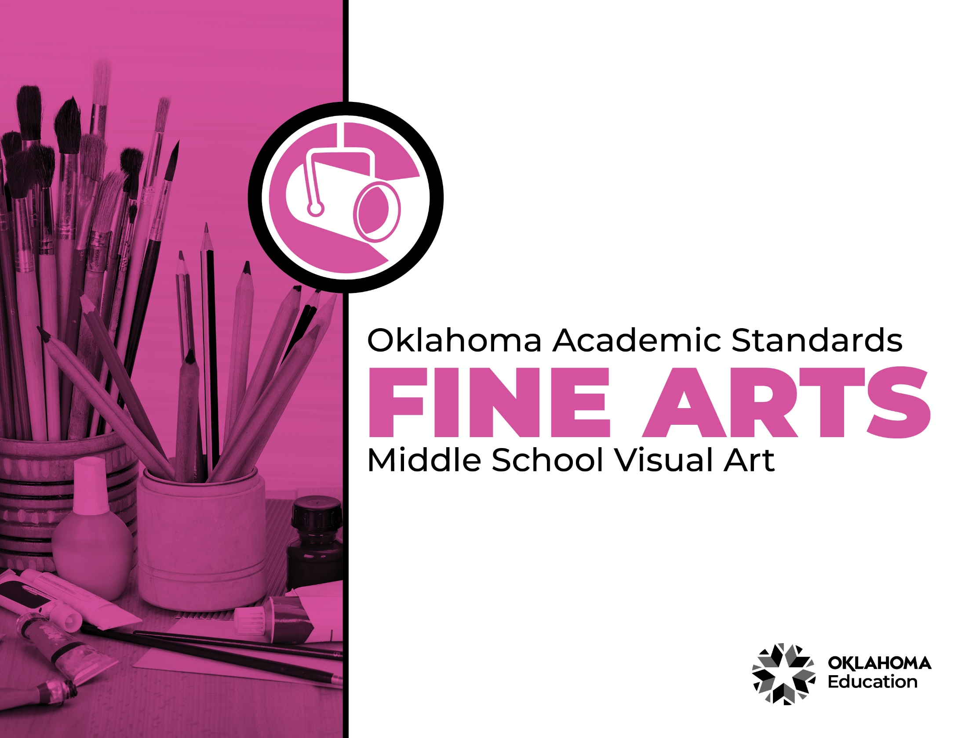

Table of Contents

Introduction & Standards Overview | 3
Visual Art Overview & Artistic Processes | 6
Visual Art Standards: 6th Grade-8th Grade | 7
Visual Art Glossary | 11

Introduction
The Oklahoma Standards for Fine Arts encompass dance, drama/theatre, music, and visual art. The standards are the result of the contributions of hundreds of fine arts educators, arts administrators, and representatives of higher education, arts organizations, and community members. This document reflects a balanced synthesis of the work of all committee members of the Oklahoma standards for dance, drama/theatre, music, and visual art.

The standards specify what students should know and be able to do as learners in their discipline at the end of each grade level or course. Students have different levels of experience within a discipline so teachers can attend to both grade-level standards and meet the individual needs of students who may be performing at levels above or below grade level. The order of the standards at any grade level is not meant to imply a sequence of topics and should be considered flexible for the organization of any course.

The Oklahoma Standards for dance, drama/theatre, music, and visual art were informed by the National Coalition for Core Arts Standards (NCCAS), the Opportunity-to-Learn Standards for Dance, the Opportunity-to-Learn Standards for Music, the Opportunity-to-Learn Standards for Theatre Education, the Purposes, Principles, and Standards for School Art Programs, and other states’ standards documents.

Standards Overview
The Oklahoma Standards for Fine Arts are designed to support all Oklahoma students to develop and achieve artistic literacy and to promote access and equity in the arts. Study of the arts enrich the quality of life. Dance, drama/theatre, music, and visual art are used by and have shaped every culture and individual on earth. They provide a means for experiencing the world and give form to our innermost thoughts, feelings, and sensibilities. They also give students an opportunity to use metacognitive skills as they plan, monitor, revise, and assess their art work in dance, drama/theatre, music, or visual art.

A well-rounded education addresses the development of all the realms of human behavior—the physical, emotional, social, and intellectual. Neglecting any of the areas weakens all the rest; therefore, Oklahoma students must have access to arts education that includes dance, drama/theatre, music, and visual art. Schools that provide quality arts experiences, based on sequential skill development, supplemented with carefully selected arts resources, can help students cultivate a positive attitude towards themselves and toward learning—an attitude that carries over to their entire education and life. In short, access to arts education prepares students to be creative, persistent, and compassionate adults.

The standards are comprised of four artistic processes:
- Creating/Creative Process
- Performing/Production,
- Connecting/Cultural and Historical Perspectives, and
- Responding/Aesthetic Response and Critique Methodologies.

Each artistic process has a discipline-specific definition found in the discipline overview. The artistic processes branch into anchor standards in each discipline. The anchor standards designate specific learning targets at each grade or learning level.
In dance, drama/theatre, and visual art, there are elementary grade level standards through grade eight. At the secondary level in these disciplines, there are three proficiency levels: proficient, advanced, and accomplished. The proficiency levels may apply to high school students at any grade level and prepare students for a career or college life.

The elementary music standards extend through grade six. The ensemble and/or secondary music standards have five proficiency levels:
- Novice
- Intermediate
- Proficient
- Advanced
- Accomplished

Novice proficiency level is assigned to students who have started specialization and are developing artistic understanding and technique and may participate in performance opportunities as they are able. Intermediate proficiency level is for students who are continuing study in their art form, perhaps at the middle school level. Proficient, advanced, and accomplished may apply to students at any grade level. In a middle or high school class or ensemble, it is expected that the teacher will develop an understanding of their students’ proficiency levels and utilize the corresponding level from the standards for each student.

Reading the Oklahoma Academic Standards for Fine Arts
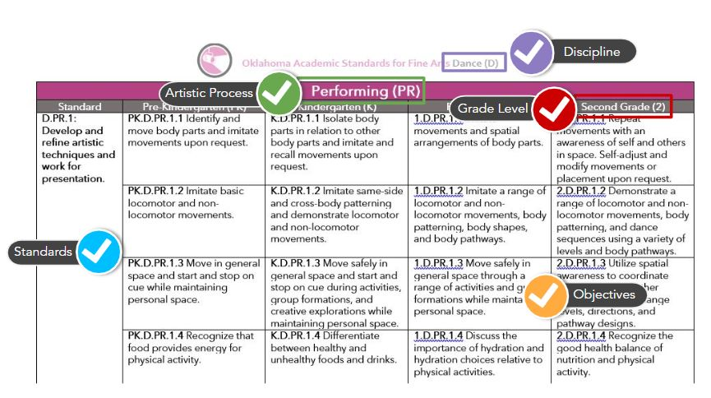

Visual Art Overview
Visual art is a significant expression of human culture. Art carries ideas from generation to generation, enhances cultural understandings, provides visual records of the past and gives form to contemporary ideas and events. Through visual art, we develop skills for perceiving, analyzing, appreciating, and responding to the visual environment.

Quality art programs help students develop skills to express themselves visually and understand the visual expression of others. As students work individually through an art project, there is constant decision-making and they learn to make adjustments to the work as it progresses. It is through the study of art that they learn about art products, artists, history, art materials, and art processes, which develop skills related college and career preparedness.

The visual art standards are designed to extend from pre-kindergarten through grade 12. The standards guide students through art skills in sequential order as they relate to the cognitive, psychomotor, and affective aspects of art. A total curriculum is balanced between the artistic processes: creative process, production, cultural and historical perspectives, and aesthetic response and critique methodologies. A glossary for teachers and administrators is provided in Appendix D: Visual Art Glossary. The glossary is not intended for student use; it contains educational terms for those reading the standards.

Visual Art Artistic Processes
The visual art standards emerge from the artistic processes of creative process, production, cultural and historical perspectives, and aesthetic response and critique methodologies. Each artistic process branches into multiple anchor standards. The anchor standards further divide into objectives, which describe student learning in visual art.

Creative Process
The creative process in art begins with learning the language of art and developing visual literacy to identify and/or communicate artistic concepts and techniques. Students learn art vocabulary, practice and refine techniques, make creative choices and practice individual expression in creating art.

Production
Art production demonstrates the learned techniques and expression of ideas. Students utilize a variety of ideas and different media, supplies, and tools in an appropriate and safe manner to create original artworks. They also demonstrate an appropriate skill level and revise and refine artworks to create finished works of art.

Cultural and Historical Perspectives
Visual art students learn about art in relation to history and culture. They connect artistic ideas and works with societal, cultural, and historical context to deepen understanding.

Aesthetic Response and Critique Methodologies
This reflective process includes art critique and assessment, preparation of the student’s artwork portfolio, and the exploration and study of visual art careers and pathways.
Creative Process (CP)
Standard | Sixth Grade (6) | Seventh Grade (7) | Eighth Grade (8)
VA.CP.1: Learn and use vocabulary and concepts related to visual arts. | 6.VA.CP.1.1 Brainstorm approaches and combine concepts to generate innovative ideas for creating art. | 7.VA.CP.1.1 Apply knowledge of elements of art (e.g., line, color, form, shape, texture, value, and space) and principles of design (e.g., rhythm, balance, contrast, movement, center of interest, and repetition) to the early stages of the creative process. | 8.VA.CP.1.1 Apply knowledge of elements of art and principles of design throughout the creative process and completion of works of art.
 | 6.VA.CP.1.2 Research and demonstrate diverse methods for approaching the beginning of an artwork. | 7.VA.CP.1.2 Develop criteria to guide making a work of art or design to communicate an identified goal. | 8.VA.CP.1.2 Develop criteria to guide making a work of art or design and evaluate progress to meet the identified criteria.
VA.CP.2: Practice and refine techniques and skills related to visual arts. | 6.VA.CP.2.1 Experiment and practice skills in multiple art-making techniques, methods, and approaches. | 7.VA.CP.2.1 Demonstrate willingness to experiment, innovate, and take risks to pursue ideas, forms, and meanings that emerge in the art making process. | 8.VA.CP.2.1 Experiment, innovate, and take risks using developed skills to pursue ideas, forms, and meanings that emerge throughout the art making process.
 | 6.VA.CP.2.2 Demonstrate care and safe handling through the storage and use of materials, tools, and equipment. | 7.VA.CP.2.2 Demonstrate care and safe handling through the storage and use of materials, tools, and equipment. | 8.VA.CP.2.2 Demonstrate care and safe handling through the storage and use of materials, tools, and equipment.
 | 6.VA.CP.2.3 Explore practices, issues, and ethics of appropriation, fair use, and copyright as they apply to creating works of art and design. | 7.VA.CP.2.3 Develop awareness of practices, issues, and ethics of appropriation, fair use, and copyright as they apply to creating works of art and design. | 8.VA.CP.2.3 Demonstrate awareness of practices, issues, and ethics of appropriation, fair use, and copyright as they apply to creating works of art and design.
VA.CP.3: Make creative choices and practice individual expression in application of concepts, language, techniques, and skills. | 6.VA.CP.3.1 Explore relevant criteria to examine, reflect, and plan revisions for a work of art or design in progress. | 7.VA.CP.3.1 Develop relevant criteria to examine, reflect and plan revisions for a work of art or design in progress. | 8.VA.CP.3.1 Apply personal criteria to examine, reflect and plan revisions for a work of art or design in progress.

Production (P)
Standard | Sixth Grade (6) | Seventh Grade (7) | Eighth Grade (8)
VA.P.1: Utilize a variety of ideas and subject matter in creation of original works of visual art. | 6.VA.P.1.1 Explore and develop art making techniques and approaches. | 7.VA.P.1.1 Experiment and develop skills in multiple art making techniques and approaches through practice. | 8.VA.P.1.1 Demonstrate persistence in developing personal skills with various materials, methods, and available technology.
 | 6.VA.P.1.2 Design, redesign, or visually document places or everyday objects. | 7.VA.P.1.2 Design, redesign, or visually re-interpret places or objects of personal significance. | 8.VA.P.1.2 Design, redesign, or visually re-interpret places or objects of personal significance with justification.
VA.P.2: Use different media, supplies, and tools in an appropriate and safe manner in the creation of original visual artworks. | 6.VA.P.2.1 Show consistent use of the elements of art and principles of design in the creative process. | 7.VA.P.2.1 Show consistent use of the elements of art and principles of design in the creative process. | 8.VA.P.2.1 Identify the use of the elements of art and principles of design in the work of others.
VA.P.3: Demonstrate appropriate skill level in the application of knowledge, techniques, skills, and concepts, through the creation of original visual artworks. | 6.VA.P.3.1 Understand risk-taking and demonstrate openness in trying new ideas, materials, and methods. | 7.VA.P.3.1 Demonstrate an openness to artistic challenges while developing skills with new ideas, materials, methods, and approaches. | 8.VA.P.3.1 Demonstrate willingness to experiment, innovate, and take risks to pursue ideas, forms, and meanings that emerge in the process of art making or design.
VA.P.4: Revise and refine artworks to create finished works of art. | 6.VA.P.4.1 Reflect on whether one’s artwork conveys the intended meaning and revise accordingly. | 7.VA.P.4.1 Reflect on and explain important information about personal artwork in an artist statement or another format. | 8.VA.P.4.1 Examine and reflect on relevant criteria to plan and implement revisions on a work of art or design in progress.
Cultural and Historical Perspectives (CHP)
Standard | Sixth Grade (6) | Seventh Grade (7) | Eighth Grade (8)
VA.CHP.1: Relate artistic ideas and works with societal, cultural and historical context to deepen understanding. | 6.VA.CHP.1.1 Analyze how art reflects changing times, traditions, resources, and cultural uses. | 7.VA.CHP.1.1 Explore different ways art is used to represent, establish, reinforce, and reflect cultural identity. | 8.VA.CHP.1.1 Distinguish different ways art is used to represent, establish, reinforce, and reflect cultural identity.
 | 6.VA.CHP.1.2 Explore how artists and cultures used media (materials) to express themselves. | 7.VA.CHP.1.2 Explore connections between art production and imagery relative to social and political climates. | 8.VA.CHP.1.2 Identify connections between art production and imagery relative to social and political climates.
 | 6.VA.CHP.1.3 Place works of art from a global perspective on a timeline to represent specific movements, historical periods, and cultures. | 7.VA.CHP.1.3 Explore works of art and artists in relation to specific movements, historical periods, and cultures. | 8.VA.CHP.1.3 Identify works of art and artists in relation to specific movements, historical periods, and cultures.

Aesthetic Response & Critique Methodologies (ARCM)
Standard | Sixth Grade (6) | Seventh Grade (7) | Eighth Grade (8)
ARCM.1: Perceive, analyze, interpret, and evaluate artistic work. | 6.ARCM.1.1 Identify concepts that would reflect respect for personal artwork and the artwork of others. | 7.ARCM.1.1 Demonstrate respect for personal artwork and the artwork of others. | 8.ARCM.1.1 Consistently apply respect for personal artwork and the artwork of others.
 | 6.ARCM.1.2 Make connections between visual art and other domains of learning. | 7.ARCM.1.2 Make connections between visual art and other domains of learning. | 8.ARCM.1.2 Make connections between visual art and other domains of learning.
 | 6.ARCM.1.3 Critique personal art based on teacher established criteria. | 7.ARCM.1.3 Analyze and reflect upon personal artwork based on formative and summative evaluations. | 8.ARCM.1.3 Develop statements to reflect upon personal artwork based on formative and summative evaluations.
 | 6.ARCM.1.4 Preserve and collect personal works of art. | 7.ARCM.1.4 Preserve and collect personal works of art, organizing based on teacher identified criteria. | 8.ARCM.1.4 Preserve and collect personal works of art, organizing based on student identified criteria to show concepts and student growth.
 | 6.ARCM.1.5 Explore art skills that contribute to success in other areas of study. | 7.ARCM.1.5 Identify skills developed through the arts that contribute to success in visual arts and non-arts careers. | 8.ARCM.1.5 Analyze abilities developed in the arts needed to be successful in a variety of visual arts and non-arts careers.

Visual Art Glossary

Appropriation Intentional borrowing, copying, and alteration of preexisting images and objects.

Balance The distribution of the visual weight of objects, colors, texture, and space. If the design was a scale, these elements should be balanced to make a design feel stable. In symmetrical balance, the elements used on one side of the design are similar to those on the other side; in asymmetrical balance, the sides are different but still look balanced. In radial balance, the elements are arranged around a central point and may be similar.

Color The quality of an object or substance with respect to the light reflected by the object. Color has three main characteristics:

Hue - The specific name of a color (red, green, blue, etc.)
Value - The degree of lightness or darkness of a color.
Intensity - The degree of brightness or dullness of a color

Color can also be characterized by the following:
- White is pure light; black is the absence of light.
- Primary colors are the only true colors (red, blue, and yellow). All other colors are mixes of primary colors.
- Secondary colors are two primary colors mixed together (green, orange, violet).
- Intermediate colors (sometimes called tertiary colors) are made by mixing a primary and secondary color together. Examples of intermediate colors include yellow-green, blue-green, and blue-violet.
- Complementary colors are located directly across from each other on the color wheel (an arrangement of colors along a circular diagram to show how they are related to one another). Complementary pairs contrast because they share no common colors. For example, red and green are complements, because green is made of blue and yellow. When complementary colors are mixed together, they neutralize one another.
- Warm colors are colors in the spectrum that suggest warmness, including red, yellow, and orange. Warm colors advance when used with cool colors.
- Cool colors are colors of the spectrum that suggest coolness, including blue, green and violet. Cool colors recede when used with warm colors.
- Analogous colors are colors that contain a common hue, which are found next to one another on the color wheel. An example of analogous colors include green-blue, blue, and blue-violet.

Contrast The difference between elements of art in a composition, such that each element is made stronger in relation to the other. When placed next to each other, contrasting elements command the viewer's attention. Contrast can be achieved by the juxtaposition of any of the elements of art.

Copyright Form of protection grounded in the U.S. Constitution and granted by law for original works of authorship fixed in a tangible medium of expression, covering both published and unpublished works.

Curate Select, organize, and exhibit works of art.

Elements of Art Line, shape, form, space, value, color, and texture.

Emphasis The part of the design that catches the viewer’s attention, also referred to as the center of interest or focal point. Usually the artist will make one area stand out by contrasting it with other areas. The area could be different in size, color, texture, shape, etc.

Fair Use The doctrine that brief excerpts of copyright material may, under certain circumstances, be quoted verbatim for purposes such as criticism, news reporting, teaching, and research, without the need for permission from or payment to the copyright holder.

Form Three-dimensional objects that can be measured by length, width, and depth (e.g., spheres, cylinders, cubes, pyramids, cuboids, etc.).

Line A mark with greater length than width. Lines can be horizontal, vertical, or diagonal; straight or curved; thick or thin.

Movement The path the viewer’s eye takes through the work of art. Such movement can be directed along lines, edges, shape, and color within the work of art.

Pattern The repeating of an object or symbol throughout the work of art.

Principles of Design Balance, emphasis, movement, pattern, repetition, rhythm, variety, unity, and contrast.

Proportion The relationship of one part of a whole to other parts.

Repetition Works with pattern to make the work of art seem active. The repetition of elements of art creates unity within the work of art.

Rhythm Created when one or more elements of art are used repeatedly to create a feeling of organized movement. Rhythm creates a mood like music or dancing. Unlike pattern, which demands consistency, rhythm relies on variety.

Shape A two-dimensional closed line. Shapes can be geometric (squares, circles, triangles, etc.) or organic (free-form or natural shapes). Shapes are flat and can be measured by length and width.

Space The area between, around, and within objects. The space around an object is negative space. The object itself is known as positive space. Space can also refer to the feeling of depth - also known as space-in-depth. Space-in-depth includes foreground, middle ground, and background space.

Texture The surface quality that can be seen and felt. Textures can be rough or smooth, soft or hard. Texture can be natural (real) and actually felt or visually implied by the artist and feels different than it appears.

Value The degree of lightness or darkness of a tone or color. Value is dependent upon the amount of light a surface reflects. Value can be created through the following techniques:
- Hatching - Technique that uses one set of hatching lines running parallel to the other sets.
- Cross-Hatching - Technique that uses one set of hatching lines over another set in a different direction so that the lines intersect.
- Stippling - Technique that uses a series of dots to create dark and light values.
- Tonal Shading - Technique that blends tones together creating a smooth effect.
- Shade - Dark value created by adding black.
- Tint - Light value created by adding white.

Variety The use of several elements of art to hold the viewer’s attention and to guide the viewer’s eye through and around the work.
Unity The feeling of harmony between all parts of the work of art, which creates a sense of completene

