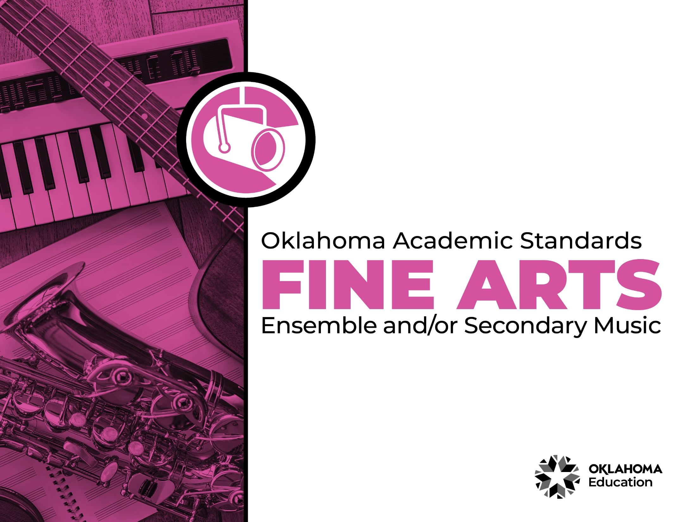

Table of Contents

Introduction & Standards Overview | 3
Music Overview & Artistic Processes | 6
Music Standards: Ensemble and/or Secondary Music | 7
Music Glossary | 13

Introduction
The Oklahoma Standards for Fine Arts encompass dance, drama/theatre, music, and visual art. The standards are the result of the contributions of hundreds of fine arts educators, arts administrators, and representatives of higher education, arts organizations, and community members. This document reflects a balanced synthesis of the work of all committee members of the Oklahoma standards for dance, drama/theatre, music, and visual art.

The standards specify what students should know and be able to do as learners in their discipline at the end of each grade level or course. Students have different levels of experience within a discipline so teachers can attend to both grade-level standards and meet the individual needs of students who may be performing at levels above or below grade level. The order of the standards at any grade level is not meant to imply a sequence of topics and should be considered flexible for the organization of any course.

The Oklahoma Standards for dance, drama/theatre, music, and visual art were informed by the National Coalition for Core Arts Standards (NCCAS), the Opportunity-to-Learn Standards for Dance, the Opportunity-to-Learn Standards for Music, the Opportunity-to-Learn Standards for Theatre Education, the Purposes, Principles, and Standards for School Art Programs, and other states’ standards documents.

Standards Overview
The Oklahoma Standards for Fine Arts are designed to support all Oklahoma students to develop and achieve artistic literacy and to promote access and equity in the arts. Study of the arts enrich the quality of life. Dance, drama/theatre, music, and visual art are used by and have shaped every culture and individual on earth. They provide a means for experiencing the world and give form to our innermost thoughts, feelings, and sensibilities. They also give students an opportunity to use metacognitive skills as they plan, monitor, revise, and assess their art work in dance, drama/theatre, music, or visual art.

A well-rounded education addresses the development of all the realms of human behavior—the physical, emotional, social, and intellectual. Neglecting any of the areas weakens all the rest; therefore, Oklahoma students must have access to arts education that includes dance, drama/theatre, music, and visual art. Schools that provide quality arts experiences, based on sequential skill development, supplemented with carefully selected arts resources, can help students cultivate a positive attitude towards themselves and toward learning—an attitude that carries over to their entire education and life. In short, access to arts education prepares students to be creative, persistent, and compassionate adults.

The standards are comprised of four artistic processes:
- Creating/Creative Process
- Performing/Production,
- Connecting/Cultural and Historical Perspectives, and
- Responding/Aesthetic Response and Critique Methodologies.

Each artistic process has a discipline-specific definition found in the discipline overview. The artistic processes branch into anchor standards in each discipline. The anchor standards designate specific learning targets at each grade or learning level.
In dance, drama/theatre, and visual art, there are elementary grade level standards through grade eight. At the secondary level in these disciplines, there are three proficiency levels: proficient, advanced, and accomplished. The proficiency levels may apply to high school students at any grade level and prepare students for a career or college life.

The elementary music standards extend through grade six. The ensemble and/or secondary music standards have five proficiency levels:
- Novice
- Intermediate
- Proficient
- Advanced
- Accomplished

Novice proficiency level is assigned to students who have started specialization and are developing artistic understanding and technique and may participate in performance opportunities as they are able. Intermediate proficiency level is for students who are continuing study in their art form, perhaps at the middle school level. Proficient, advanced, and accomplished may apply to students at any grade level. In a middle or high school class or ensemble, it is expected that the teacher will develop an understanding of their students’ proficiency levels and utilize the corresponding level from the standards for each student.

Reading the Oklahoma Academic Standards for Fine Arts
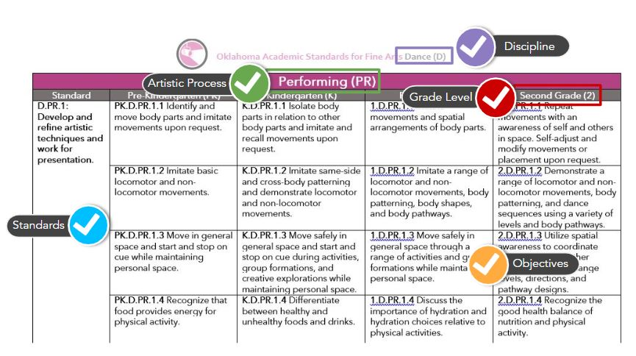

Music Overview
Every human culture has used music to educate, communicate, celebrate, and live. When we come together for graduations, weddings, parties, sports events, and worship, music is part of the occasion. Music permeates our media world through video games, advertising, movies, and television shows. Students today have earbuds or headphones within reach at all times. They have discovered that music helps us cope with our everyday lives. It makes us feel less alone and guides us as we process complex emotions. Music heals.

A comprehensive public school music program that provides every PK-12 student a solid and permanent relationship with music can result in a lifelong interest and involvement in music. Students can explore, understand music, and have an outlet in creativity and self-expression by taking classes in general music, vocal music, instrumental music, orchestra, modern band, mariachi, piano, guitar, music theory, hip hop, and music appreciation.

The Oklahoma standards for music are divided into two grade spans: Elementary Standards (Pre-K-6th) and Ensemble and/or Secondary Standards (upper elementary, middle, and high school). The Ensemble and/or Secondary Standards encompass five proficiency levels and apply to ensembles such as choir, band, orchestra, and secondary music classes such as 8th grade general music, music theory, etc. A glossary for teachers and administrators is provided in Appendix C: Music Glossary. The glossary is not intended for student use; it contains educational terms for those reading the standards.

Music Artistic Processes
The music standards emerge from the artistic processes of creating, performing, responding, and connecting. Each artistic process branches into multiple anchor standards. The anchor standards further divide into objectives, which describe student learning in music.

Creating
Music is a creative art that provides students the opportunity to create, compose, and improvise. Students learn notation, organize, develop, refine, and complete musical ideas. Creating a simple musical idea or a composition gives students autonomy and self-efficacy in the music classroom.

Performing
Music offers students an opportunity to realize artistic ideas and work through interpretation and presentation. Students analyze music, refine technical skills, develop and express personal interpretations, and use self-reflection or peer feedback to refine the performance. Students may also select music based on their interest, knowledge, skill, and context.
Responding
Students develop their understanding of how music conveys meaning by evaluating works and performances. Students choose music appropriate for specific purposes and interpret works to reflect the creators’/performers’ expressive intent.

Connecting
Students connect in music by relating artistic ideas and work with personal meaning and external context. This is accomplished through synthesizing and relating knowledge and personal experiences in making/understanding music. Students also relate artistic works with societal, cultural, and historical context to deepen understanding.

Creating (CR)
Ensemble and/or Secondary Music
Standard | Novice (N) | Intermediate (I) | Proficient (P) | Advanced (AD) | Accomplished (AC)
M.CR.1: Generate musical ideas for various purposes and contexts. | N.M.CR.1 Discover and experiment with melodic and rhythmic ideas or motives that reflect characteristics of music or texts. | I.M.CR.1 Discover and experiment with short melodic and rhythmic passages based on characteristics of music or texts studied. | P.M.CR.1 Compose and/or improvise ideas for melodies, rhythmic passages, and arrangements for specific purposes that reflect characteristic(s) of music studied. | AD.M.CR.1 Compose and improvise ideas for arrangements, sections, and short compositions for specific purposes that reflect characteristic(s) of music from a variety of cultures or historical periods studied. | AC.M.CR.1 Compose and improvise musical ideas for a variety of purposes and contexts.
M.CR.2: Select and develop musical ideas for defined purposes and contexts. | N.M.CR.2 Develop melodic and rhythmic ideas or motives that incorporate the characteristics of music or texts studied. | I.M.CR.2 With guidance, select and develop melodic and rhythmic passages that incorporate the characteristics of music or texts studied while preserving them through notation and/or audio recording. | P.M.CR.2 Select and develop melodic and rhythmic passages and arrangements that incorporate the characteristics of music or texts studied while preserving them through notation and/or audio recording. | AD.M.CR.2 Select and develop extended melodic and rhythmic compositions that demonstrate the characteristics of music from a variety of cultures and genres while preserving them through notation and/or audio recording. | AC.M.CR.2 Select and develop composed and improvised ideas to construct musical works organized for a variety of purposes and contexts while preserving them through notation and/or audio recording.
M.CR.3: Evaluate and refine selected musical ideas to create musical work that meets appropriate criteria. | N.M.CR.3 Evaluate and refine compositions and improvisations based on knowledge, skill, and teacher-provided criteria. | I.M.CR.3 Evaluate and refine compositions and improvisations based on knowledge, skill, and teacher-student developed criteria. | P.M.CR.3 Evaluate and refine melodies, rhythmic passages, arrangements, and improvisations based on established criteria. | AD.M.CR.3 Evaluate and refine arrangements, sections, short compositions, and improvisations based on personally-developed criteria. | AC.M.CR.3 Evaluate and refine varied musical works based on appropriate, context-specific criteria.
M.CR.4: Share creative musical work that conveys intent, demonstrates craftsmanship, and exhibits originality. | N.M.CR.4 Share personally-developed melodic and rhythmic ideas or motives – individually or as an ensemble – that demonstrate characteristics of music or texts studied. | I.M.CR.4 Share personally-developed melodies and rhythmic passages – individually or as an ensemble – that demonstrate characteristics of music or texts studied. | P.M.CR.4 Share personally-developed melodies, rhythmic passages, and arrangements – individually or as an ensemble – that address identified purposes. | AD.M.CR.4 Share personally-developed arrangements, sections, and short compositions – individually or as an ensemble – that address identified purposes. | AC.M.CR.4 Share varied, personally-developed musical works – individually or as an ensemble – that address identified purposes and contexts.

Performing (P)
Standard | Novice (N) | Intermediate (I) | Proficient (P) | Advanced (AD) | Accomplished (AC)
M.PR.1: Select varied musical works to present based on interest, knowledge, technical skill, and context. | N.M.PR.1 Select varied repertoire with guidance based on interest, music reading skills (where appropriate), the structure of the music, context, and the technical skill of the individual or ensemble. | I.M.PR.1 Select varied repertoire with limited guidance based on interest, music reading skills (where appropriate), the structure of the music, context, and the technical skill of the individual or ensemble. | P.M.PR.1 Explain the criteria used to select a varied repertoire based on an understanding of theoretical and structural characteristics of the music, the technical skill of the individual or ensemble, and the purpose or context of the performance. | AD.M.PR.1 Develop and apply criteria to select a varied repertoire based on an understanding of theoretical and structural characteristics and expressive challenges in the music, the technical skill of the individual or ensemble, and the purpose and context of the performance. | AC.M.PR.1 Develop and apply criteria to select varied programs based on an understanding of theoretical and structural characteristics and expressive challenges in the music, the technical skill of the individual or ensemble, and the purpose and context of the performance.
M.PR.2: Analyze varied musical works and their implications for performance. | N.M.PR.2 Identify elements of musical works that inform prepared or improvised performances. | I.M.PR.2 Describe how the setting and formal characteristics of musical works inform prepared or improvised performances. | P.M.PR.2 Analyze how compositional devices of musical works inform prepared or improvised performances. | AD.M.PR.2 Document and demonstrate how compositional devices impact and inform prepared and improvised performances using appropriate music literacy skills. | AC.M.PR.2 Examine, evaluate, and critique how compositional devices impact and inform prepared and improvised performances using appropriate music literacy skills.
M.PR.3: Develop and express personal interpretations that consider creators’ intent. | N.M.PR.3 Identify expressive qualities in a varied repertoire of music that can be demonstrated through prepared and improvised performances. | I.M.PR.3 Apply expressive qualities in a varied repertoire of music through prepared and improvised performances. | P.M.PR.3 Utilize context(s) to inform interpretation in a varied repertoire of music through prepared and improvised performances. | AD.M.PR.3 Utilize style, genre, technical skill and context(s) of a varied repertoire of music to influence prepared and improvised performances. | AC.M.PR.3 Utilize style, genre, technical skill and context(s) of a varied repertoire of music to Inform prepared and improvised performances that connect with the audience.
M.PR.4: Use self-reflection and peer feedback to refine individual and ensemble performances of varied music repertoire. | N.M.PR.4 Use self-reflection and peer feedback to refine individual and ensemble performances of a varied repertoire of music. | I.M.PR.4 Develop strategies and evaluate success using feedback from ensemble peers and other sources to address technical challenges in a varied repertoire of music. | P.M.PR.4 Develop strategies and evaluate success using feedback from ensemble peers and other sources to address challenges in a varied repertoire of music. | AD.M.PR.4 Develop and apply appropriate rehearsal strategies to refine performance(s), while addressing individual and ensemble challenges in a varied repertoire of music. | AC.M.PR.4 Develop, apply, and refine appropriate rehearsal strategies to address individual and ensemble challenges in a varied repertoire of music.
M.PR.5: Perform expressively, with appropriate interpretation and technical accuracy. | N.M.PR.5 Demonstrate attention to technical accuracy and expressive qualities in prepared and improvised performances of a varied repertoire of music. | I.M.PR.5 Demonstrate attention to technical accuracy and expressive qualities in prepared and improvised performances of a varied repertoire of music representing diverse cultures and styles. | P.M.PR.5 Demonstrate attention to technical accuracy and expressive qualities in prepared and improvised performances of a varied repertoire of music representing diverse cultures, styles, and genres. | AD.M.PR.5 Demonstrate developing fluency of the technical demands and expressive qualities of the music in prepared and improvised performances of a varied repertoire representing diverse cultures, styles, genres, and historical periods. | AC.M.PR.5 Demonstrate fluency and command of the technical demands and expressive qualities of the music through prepared and improvised performances of a varied repertoire representing diverse cultures, styles, genres, and historical periods in multiple types of ensembles.

Responding (RE)
Standard | Novice (N) | Intermediate (I) | Proficient (P) | Advanced (AD) | Accomplished (AC)
M.RE.1: Choose music appropriate for a specific purpose or context. | N.M.RE.1 Identify reasons for selecting music based on characteristics found in the music, connections to personal interest, and purpose or context. | I.M.RE.1 Discuss reasons for selecting music, citing characteristics found in the music and connections to personal interest, purpose, and context. | P.M.RE.1 Apply criteria to select music for specified purposes, supporting choices by citing characteristics found in the music and connections to personal interest, purpose, and context. | AD.M.RE.1 Develop personal criteria to select music for a variety of purposes, justifying choices citing knowledge of the music and the specified purpose and context. | AC.M.RE.1 Use research and personally-developed criteria to justify choices made when selecting music, citing knowledge of the music, and individual and ensemble purpose and context.
M.RE.2: Analyze how the structure and context of varied musical works inform the response. | N.M.RE.2 Identify how knowledge of context and the use of repetition, similarities, and contrasts affect musical response. | I.M.RE.2 Describe how understanding context and the way the elements of music are manipulated affect musical response. | P.M.RE.2 Explain how the analysis of passages and understanding the way the elements of music are manipulated affect musical response. | AD.M.RE.2 Explain how the analysis of musical structures and contexts affect musical response. | AC.M.RE.2 Analyze and evaluate the musical structures, contexts, and performance decisions for a musical work.
M.RE.3: Support the reasons for an interpretation of musical works that reflect creators’/ performers’ expressive intent. | N.M.RE.3 Identify interpretations of the expressive intent and meaning of musical works, referring to the elements of music, contexts, and (when appropriate) the setting of the text. | I.M.RE.3 Identify and support the reasons for the interpretations of the expressive intent and meaning of musical works, citing as evidence the treatment of the elements of music, contexts, and (when appropriate) the setting of the text. | P.M.RE.3 Explain and support the reasons for interpretations of expressive intent and meaning of musical works, citing as evidence the treatment of the elements of music, contexts, (when appropriate) the setting of the text. | AD.M.RE.3 Explain and support, using research, the reasons for interpretations of the expressive intent and meaning of musical works citing as evidence the treatment of the elements of music, contexts, and (when appropriate) the setting of the text. | AC.M.RE.3 Justify interpretations of the expressive intent and meaning of musical works by comparing and synthesizing varied researched sources that can include reference to other art forms.
M.RE.4: Evaluate musical works and performances based on analysis, interpretation, and established criteria. | N.M.RE.4 Identify and describe the effect of personal interest, experience, analysis, and context on the perceived value of a musical work or performance. | I.M.RE.4 Explain the influence of experiences, analysis, and context on the perceived value of a musical work or performance. | P.M.RE.4 Evaluate works and performances based on personally- or collaboratively- developed criteria, including analysis of the structure and context. | AD.M.RE.4 Evaluate works and performances based on research as well as personally- and collaboratively-developed criteria, including analysis and interpretation of the structure and context. | AC.M.RE.4 Evaluate music, programs of music, and performances based on standardized criteria, personal decision-making, research, and understanding of contexts.

Connecting (CN)
Standard | Novice (N) | Intermediate (I) | Proficient (P) | Advanced (AD) | Accomplished (AC)
M.CN.1: Synthesize and relate knowledge and personal experiences in making/understanding music. | N.M.CN.1 Describe how current personal interests or concerns impact music making/musical understanding. | I.M.CN.1 Generate a collection of personal ideas reflecting current interests and concerns that could be investigated in music making/musical understanding. | P.M.CN.1 Reflect and critique musical experiences and the effects that personal interests and concerns have on the outcome for both performer(s) and the audience. | AD.M.CN.1 Analyze the effect of personal interests and concerns on musical experiences and their impact and value on both the performers and the audience. | AC.M.CN.1 Synthesize knowledge related to the effects of personal interests and concerns with musical experiences to create meaningful works of art.
M.CN.2: Relate artistic ideas and works with societal, cultural, and historical context to deepen personal understanding. | N.M.CN.2 Generate ideas about how music reflects changing times, traditions, resources, and cultural uses. | I.M.CN.2 Identify different ways music is used to represent, establish, reinforce, and reflect group identity. | P.M.CN.2 Describe how knowledge of culture, traditions, and history influences personal responses to music. | AD.M.CN.2 Compare and contrast uses of music in a variety of societal, cultural, and historical contexts while making connections to uses of music in contemporary and local contexts. | AC.M.CN.2 Analyze and evaluate the impact of a musician or a group of musicians on the beliefs, values, and behaviors of a society.

Music Glossary

Accompaniment Vocal or instrumental parts that accompany a melody.

Arrangement Setting or adaptation of an existing musical composition.

Beat Underlying steady pulse present in most music.

Body Percussion Use of the human body as an instrument to create percussive/rhythmic sounds such as stomping, patsching (patting thighs), clapping, clicking, snapping.

Composition Original piece of music that can be repeated, typically developed over time, and preserved either in notation or in a sound recording.

Compositional Devices Musical ideas used to manipulate music (e.g., ostinato, imitation, sequence, augmentation, diminution, inversion, drone, Alberti Bass, etc.)

Culture Values and beliefs of a particular group of people, from a specific place or time, expressed through characteristics such as tradition, social structure, religion, art, and food.

Dynamics Level or range of loudness of a sound or sounds.

Form Element of music describing the overall organization of a piece of music, such as AB, ABA, rondo, theme and variations, and strophic form.

Found Sounds Objects that can be used as instruments, such as pencils, desks, books, buckets, etc.

Genre Category of music characterized by a distinctive style, form, and/or content, such as jazz, march, cantata, hip hop, etc.

Harmony Chordal structure of a music composition in which the simultaneous sounding of pitches produces chords and their successive use produces chord progressions.

Improvisation Music created and performed spontaneously or “in-the-moment,” often within a framework determined by the musical style.

Intonation Singing or playing the correct pitch in tune.

Locomotor/Non-locomotor Movement Movements that travel through space or carry weight from one location to another or a movement that a person performs while remaining stationary.

Melody Linear succession of sounds (pitches) and silences moving through time; the horizontal structure of music.

Musical Structure Totality of a musical work.

Notation Visual representation of musical sounds.

Ostinato A rhythmic or melodic figure that is repeated.

Pentatone The 1st, 2nd, 3rd, 5th, and 6th tones of a scale (do re mi so la)

Phrasing Performance of a musical phrase that uses expressive qualities such as dynamics, tempo, articulation, and timbre to convey a thought, mood, or feeling.

Pitch Identification of a tone or note with respect to highness or lowness (i.e., frequency).

Round A song imitated at the same pitch by a second (or third) group of musicians who begin at a designated time during the song.

Partner Song Two different songs sung at the same time to create harmony.

Rhythm Duration or length of sounds and silences that occur in music; organization of sounds and silences in time.

Style Label for a type of music possessing distinguishing characteristics and often performance practices associated with its historical period, cultural context, and/or genre.

Tempo Rate or speed of the beat in a musical work or performance.

Tone Color/Timbre Tone color or tone quality that distinguishes one sound source, instrument, or voice from another.

