Understanding your Discipline Data Import Template

Below is a legend (key) that explains what each of the headers in the Discipline Data Import Template are, as well as how to properly enter the information. Once the discipline information has been entered into the template, the template is then uploaded into EdPlan by uploading the document to the Data Test student in your district. If there is no Data Test student in your district, they have been inactivated and will need to be reactivated.
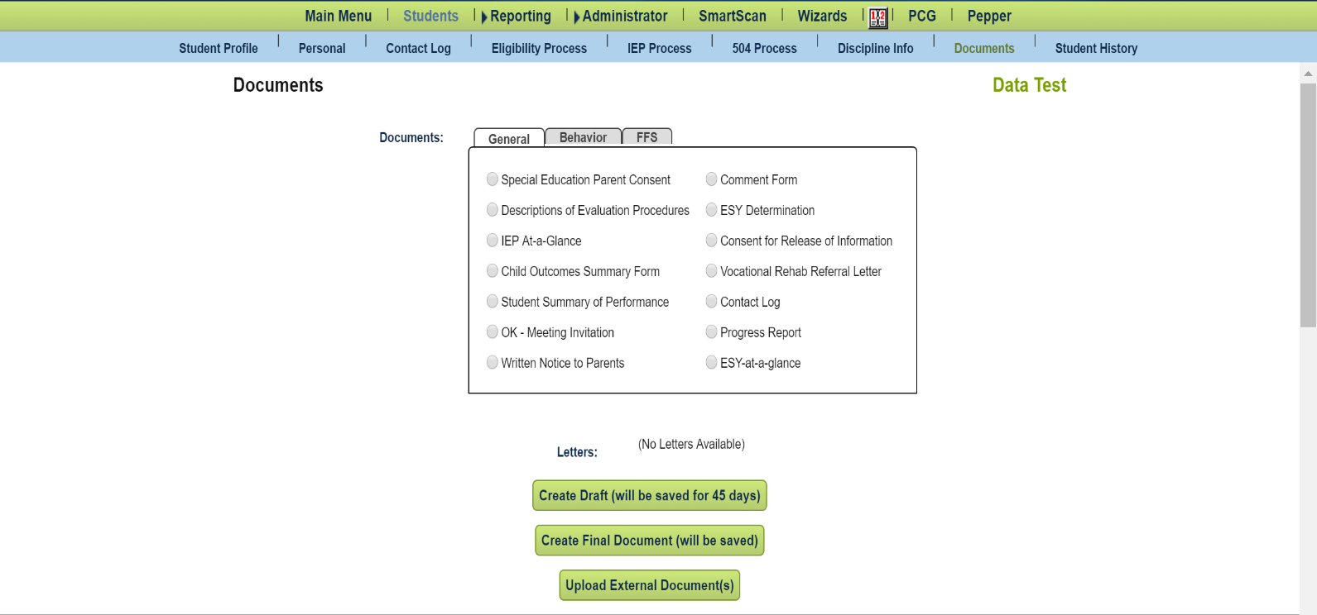

Once this data is uploaded, it is extremely difficult to alter or correct the uploaded data. Corrections will have to be made for students on an individual basis. The district will be held responsible for all reported data.
District Code: A district’s 2 digit county code plus the district’s 4 digit site code. An example of this would read as follows: 88I005. Please enter your own District Code in this field.
Student Code: The student’s local State ID number as it appears in SIS (Student Information System).
State Code: This refers to the child’s State Testing Number (STN). Please enter the STN of the child that is receiving discipline in this field.

Last Name: The last name of the child. This should be entered with proper capitalization (capitalized first letter, with lowercase letters following), and no spaces after the name. An example of this is as follows:
Barnes
Please enter the last name of the child receiving discipline in this field.
First Name: The first name of the child. This should be entered with proper capitalization (capitalized first letter, with lowercase letters following), and no spaces after the name. An example of this is as follows:
Jonathan
Please enter the first name of the child receiving discipline in this field.
Discipline Types: The code that is used to classify the type of discipline event that took place is entered here. There are 4 discipline type codes:
- ISS: In-School Suspension
- OSS: Out-of-School Suspension
- EXP: Expulsion
- HOD: Hearing Officer Determination
Please enter the code that corresponds to the discipline event that took place (e.g., EXP).

Offense Types: The code that is used to classify the type of offense that was committed is entered here. There are 4 offense type codes:
- D: Drugs
- SBI: Serious Bodily Injury
- W: Weapons
- DR: Other

Please enter the code that corresponds to the offense that was committed (e.g., DR).

Number of Days: This is the number of school days that the discipline event spanned over. Please enter a numerical value (e.g., 6, not ‘Six’) in this field. The number should not have any spaces before or after it.

Begin Date: The date that the discipline event began. Please enter this date in mm/dd/yyyy format (e.g., 02/23/2018).

End Date: The date that the discipline event ended. Please enter this date in mm/dd/yyyy format (e.g., 02/26/2018).

Parent Notification: Displays whether or not the listed parent of the child has been notified of the discipline. If yes, type Yes with a capital Y and no spaces afterwards (i.e., do not type ‘Y’, or ‘yes’, type Yes. If no, type No with a capital N (i.e., do not type, ‘N’ or ‘no’, type No).

Person: Displays the school official that entered the discipline event. Please type this person’s title or name with proper capitalization and no spaces after their title (e.g., Principal, Bobby Johnson, etc.).
Notes: Additional notes about the discipline event can be added in this cell.

