Understanding your Discipline Services Import Template

Below is a legend (key) that explains what each of the headers in the Discipline Data Import Template are, as well as how to properly enter the information. Once the discipline service information has been entered into the template, the template is then uploaded into EdPlan by uploading the document to the Data Test student in your district. If there is no Data Test student in your district, they have been inactivated and will need to be reactivated.
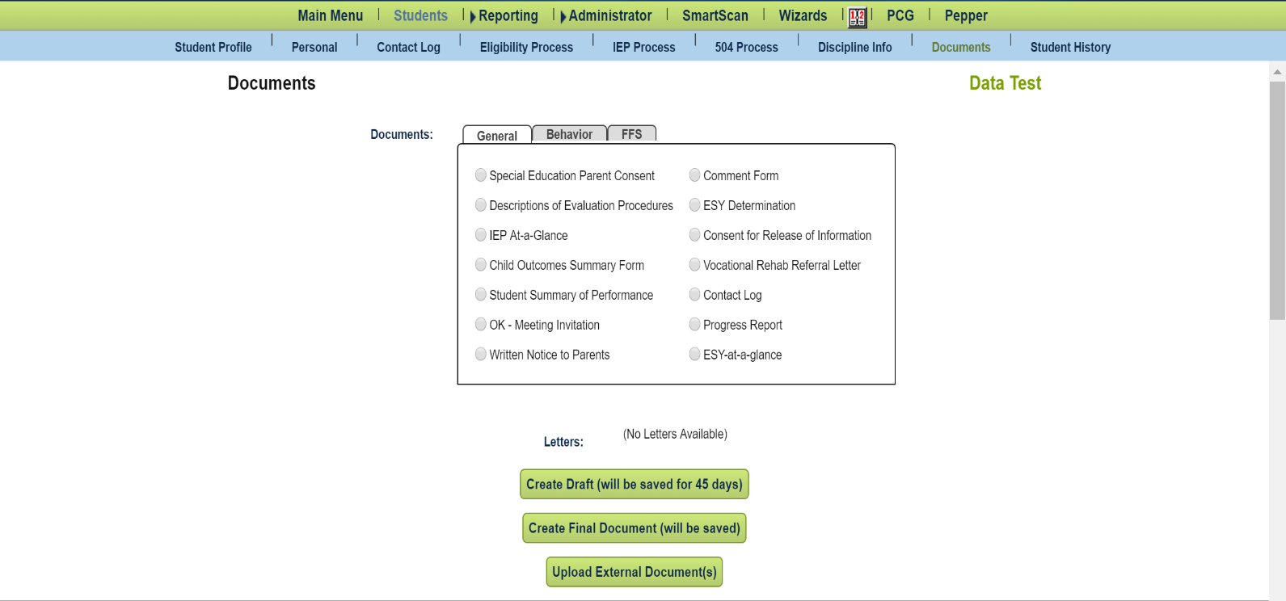

Once this data is uploaded, it is extremely difficult to alter or correct the uploaded data. Corrections will have to be made for students on an individual basis. The district will be held responsible for all reported data.
State Code: This refers to the child’s State Testing Number (STN). Please enter the STN of the child that is receiving discipline in this field.
Student Code: The student’s local identification code as it appears in your SIS (Student Information System). This code could be numeric or alphanumeric (combination of letters and numbers).
Last Name: The last name of the child. This should be entered with proper capitalization (capitalized first letter, with lowercase letters following), and no spaces before or after the name. An example of this is as follows:
Barnes
Please enter the last name of the child receiving discipline in this field.
First Name: The first name of the child. This should be entered with proper capitalization (capitalized first letter, with lowercase letters following), and no spaces before or after the name. An example of this is as follows:
Jonathan
Please enter the first name of the child receiving discipline in this field.
Date of Birth: The child’s birthday. Please enter this date in mm/dd/yyyy format (e.g., 02/26/2018).
Custom (Discipline Services Provided): Displays whether or not services were provided over the course of the discipline event. If yes, type Yes with a capital Y and no spaces afterwards (i.e., do not type ‘Y’, or ‘yes’, type Yes). If no, type No with a capital N and no spaces afterwards (i.e., do not type, ‘N’ or ‘no’, type No).
Custom (Discipline Services Provided Text): If services were not provided, please enter the individual dates in mm/dd/yyyy format (e.g., 02/26/2018; 02/27/2018; 02/28/2018).

