Understanding your Discipline Services Import Template

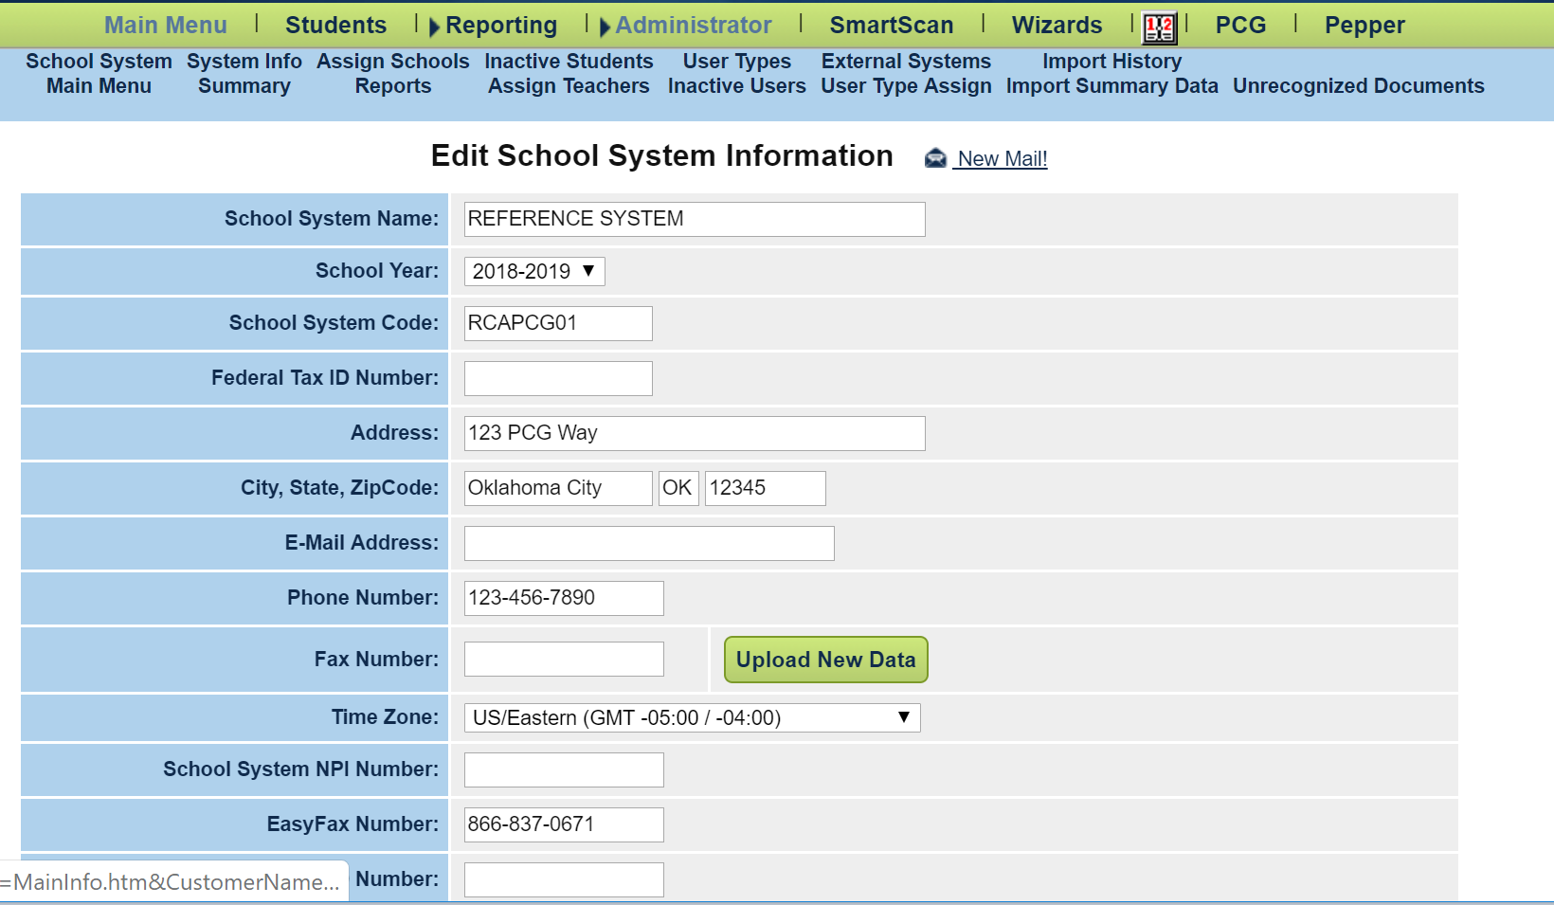
Below is a legend (key) that explains what each of the headers in the Discipline Services Import Template are, as well as how to properly enter the information. Once the discipline information has been entered into the template, the template is then uploaded into EdPlan by uploading the document through the Administrator tab and using the Upload New Data button.

After clicking the Upload New Data Button, click the Choose File button, and select the discipline file from your computer to upload the file to EdPlan. Leave the box unchecked to upload the data, and be sure to insert your email to receive a notification about the status of the discipline upload. If you choose to upload multiple discipline service files, be sure to only update dates that services were not provided. If services were provided for each discipline event, then there is no need to add other dates.
Leave unchecked!
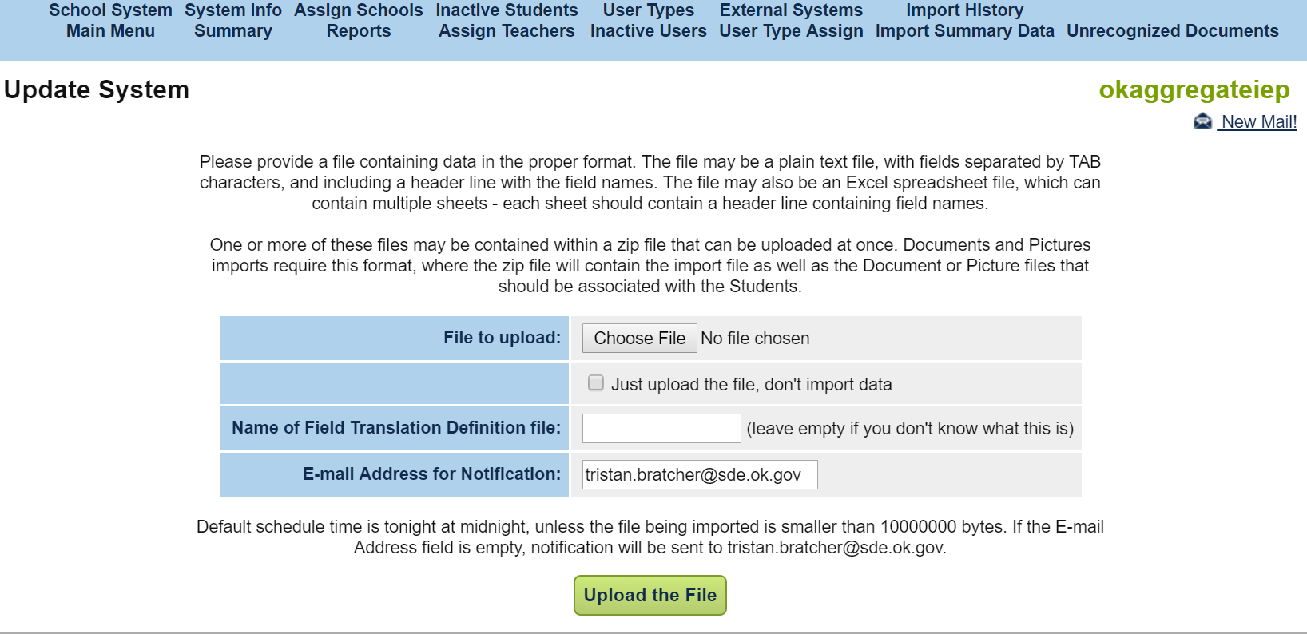

Once this data is uploaded, it is extremely difficult to alter or correct the uploaded data. Corrections will have to be made for students on an individual basis. The district will be held responsible for all reported data.
State Code: This refers to the child’s State Testing Number (STN). Please enter the STN of the child that is receiving discipline in this field.
Student Code: The student’s local identification code as it appears in your SIS (Student Information System). This code could be numeric or alphanumeric (combination of letters and numbers).
Last Name: The last name of the child. This should be entered with proper capitalization (capitalized first letter, with lowercase letters following), and no spaces before or after the name. An example of this is as follows:
Barnes
Please enter the last name of the child receiving discipline in this field.
First Name: The first name of the child. This should be entered with proper capitalization (capitalized first letter, with lowercase letters following), and no spaces before or after the name. An example of this is as follows:
Jonathan
Please enter the first name of the child receiving discipline in this field.
Date of Birth: The child’s birthday. Please enter this date in mm/dd/yyyy format (e.g., 02/26/2018).
Custom (Discipline Services Provided): Displays whether or not services were provided over the course of the discipline event. If yes, type Yes with a capital Y and no spaces afterwards (i.e., do not type ‘Y’, or ‘yes’, type Yes). If no, type No with a capital N and no spaces afterwards (i.e., do not type, ‘N’ or ‘no’, type No).
Custom (Discipline Services Provided Text): If services were not provided, please enter the individual dates in mm/dd/yyyy format (e.g., 02/26/2018; 02/27/2018; 02/28/2018).

