OKLAHOMA Charter School Training

Oklahoma State Department of Education
Accreditation Division

December 10 & 11, 2020

Charter School Training
Oklahoma State Department of Education

Tentative Agenda December 10 & 11, 2020

Thursday

1:00-1:30 Office of Accreditation Ryan Pieper, Executive Director
Leslie Janis, Regional Accreditation Officer

1:30-2:00 Office of School Personnel Records Heather Young, Director

2:00 -2:30 Office of Assessment & Accountability Maria Harris, Deputy Superintendent

2:30-3:00 Office of Curriculum & Instruction Levi Patrick, Asst. Deputy Superintendent

3:00-3:30 Office of Child Nutrition Kendra Merveldt, Director of Training

3:30-4:00 Office of Accreditation Leslie Janis, Regional Accreditation Officer

Friday

9:00-9:30 Office of Federal Programs Kimberley Murphy, Program Specialist

9:30-10:00 Special Education Services Todd Loftin, Deputy Superintendent

10:00-10:30 Office of Financial Accounting Kathy Black, Executive Director

10:30-11:00 Office of State Aid Renee McWaters, Executive Director

11:00-12:00 SDE Legal Services Brad Clark, General Counsel

Charter School Training
Oklahoma State Department of Education

Contact Information December 10 & 11, 2020
Department Contacts

Accreditation Standards . . . . . . . . . . . . . . . . . . . . . . . . . . . . . . . . . . . . . . . . . . . . . . . . . . . 405-521-3311
Ryan Pieper, Executive Director

Assessments & Accountability . . . . . . . . . . . . . . . . . . . . . . . . . . . . . . . . . . . . . . . . . . . . . .405-521-3341
Maria Harris, Deputy Superintendent

Child Nutrition . . . . . . . . . . . . . . . . . . . . . . . . . . . . . . . . . . . . . . . . . . . . . . . . . . . . . . . . . . 405-521-3327
Jennifer Weber, Executive Director

Curriculum & Instruction . . . . . . . . . . . . . . . . . . . . . . . . . . . . . . . . . . . . . . . . . . . . . . . . . . . 405-521-4287
Tiffany Neill, Deputy Superintendent

Federal Programs . . . . . . . . . . . . . . . . . . . . . . . . . . . . . . . . . . . . . . . . . . . . . . . . . . . . . . . 405-521-2517
Gloria Bayouth, Executive Director

Financial Accounting (OCAS) . . . . . . . . . . . . . . . . . . . . . . . . . . . . . . . . . . . . . . . . . . . . . . 405-521-2517
Kathy Black, Executive Director

School Support & Improvement . . . . . . . . . . . . . . . . . . . . . . . . . . . . . . . . . . . . . . . . . . . . . .405-522-0140
Brook Meiller, Deputy Superintendent

School Personnel Records . . . . . . . . . . . . . . . . . . . . . . . . . . . . . . . . . . . . . . . . . . . . . . . . 405-521-3369
Heather Butler, Director

Special Education . . . . . . . . . . . . . . . . . . . . . . . . . . . . . . . . . . . . . . . . . . . . . . . . . . . . . . . 405-521-3351
Todd Loftin, Deputy Superintendent

State Aid . . . . . . . . . . . . . . . . . . . . . . . . . . . . . . . . . . . . . . . . . . . . . . . . . . . . . . . . . . . . . . 405-521-3460
Renee McWaters, Executive Director

Data Information Systems . . . . . . . . . . . . . . . . . . . . . . . . . . . . . . . . . . . . . . . . . . . . . . . . . 405-522-3517
Erik Friend, Executive Director

Technology Service Contacts

Office of Management and Enterprise Services (OMES Help Desk): 405-521-2444

Helpful Website

http://sde.ok.gov/sde/

Charter School Training
Oklahoma State Department of Education

Rules & Statutes December 10 & 11, 2020
Health, Safety, Civil Rights, and Insurance
Laws and Rules Applicable to Charter Schools

70 O.S. § 3-136 requires charter schools to comply with "all federal regulations and state and local rules and statutes relating to health, safety, civil rights and insurance."

Civil Rights Laws

Age Discrimination in Employment Act (ADEA) 29 U.S.C. § 621
Americans with Disabilities Act 42 U.S.C. § 12101
Civil Rights Act of 1963 and Amendments of 1974 42 U.S.C. § 2000C-2
Discrimination Based on Religion 42 U.S.C. § 2000e
Family Educational Rights and Privacy Act of 1974 (FERPA) 20 U.S.C. § 1232(g)
Family Medical Leave Act (FMLA) 29 C.F.R. Part 825
Individuals with Disabilities Education Act (IDEA) Public Law 105-17
Pregnancy Discrimination Act 42 U.S.C. § 2000e(k), 70 O.S. § 6-104
Records of Disabled Students 34 C.F.R. §§ 300.562-573
Rehabilitation Act of 1973 (Sec. 504) 29 U.S.C. § 701
Sex Discrimination: Athletic Programs Title IX
Sex Discrimination: Equal Pay 29 U.S.C. § 206(d)(1)
Sexual Harassment 25 O.S. § 1301, Title IX, Title VII

Health Laws

Administration of Medication 70 O.S. § 1-116.2
AIDS Prevention Education 70 O.S. § 11-103.3
Asbestos Hazardous Emergency Response Act 15 U.S.C. § 2641, 40 C.F.R.§ 763
Confidentiality of AIDS Infected Student Multidisciplinary Team 63 O.S. § 1-502.2
Drug-Free Schools Act 20 U.S.C. § 7101
Family and Medical Leave Act Public Law 103-3
Foods of Minimal Nutritional Value 70 O.S. § 5-147
Healthy and Fit Advisory Committees 70 O.S. § 24-100a
Information About Meningococcal Meningitis 70 O.S. § 1210.195
List of Immunization Tests Required 70 O.S. § 1210.191
Oklahoma Hazardous Communication Standard 40 O.S. §§ 401-424
Policy Regarding Asthma Medication 70 O.S. § 1-116.3
Prohibition Against Smoking – Exemptions 63 O.S. § 1-1523, 20 U.S.C.§ 6081
Recess and Physical Education 70 O.S. § 11-103.9
Smoking in Public Places Act 63 O.S. §§ 1-1521-1527
Sports-Related Head Injuries 70 O.S. § 24-155
Chase Morris Sudden Cardiac Arrest Prevention Act 70 O.S. § 24-156
Students Under the Influence of Prohibited Substances Reporting-Written Policy 70 O.S. § 24-138
Vision Screening 70 O.S. § 1210.284

Health Rules

AIDS Prevention Education OAC 210:15-17-1,2
Health Services OAC 210:35-3-107

Safety Laws

Automated External Defibrillators in Schools Act 70 O.S. § 1210.200
Bus or Commercial Motor Vehicle – Railroad Crossing 47 O.S. § 11-702, 49 C.F.R.§ 390.5
Conviction of Sex Offense or Felony 70 O.S. § 6-101.48, 57 O.S.§ 589
CPR Training 70 O.S. § 1210.199
Driver Education 70 O.S. §§ 19-113 – 19-123
Felony Record Search Request – Statement Regarding Felony
Record Searches 70 O.S. §§ 5-142, 5-142.1
Fire Drills 63 O.S. § 176
Lockdown Drills 70 O.S. § 5-148
Reports of Child Abuse 10 O.S. § 7103, 21 O.S.§ 826
Safe School Committee 70 O.S. § 100.5
Safe Workplace and Safety Training of Employees 40 O.S. § 403
Safety Belts for School Bus Drivers 70 O.S. § 24-121
Safety Goggles 70 O.S. § 24-117
School Bullying Prevention Act 70 O.S. § 24-100.3
School Protection Act 70 O.S. §§ 6-140 – 6-148
Separation of Victim and Offender 70 O.S. § 24-100.6
Teacher Training in Recognition/Reporting of Child Abuse and Neglect 70 O.S. § 6-194
Transportation Equipment – Inspection 70 O.S. § 9-101.1
Zone of Safety Around Schools 21 O.S. § 1125

Safety Rules

Athletic Coaches/Care and Prevention of Athletic Injuries OAC 210:20-37-2
Driver Education OAC 210:15-19-4 through OAC 15-19-12
Harassment, Intimidation, and Bullying OAC 210:10-1-20
Tornado Drills OAC 210:35-3-186
Transportation OAC 210:30-5-1, 30-5-2

Insurance Laws

Federal Unemployment Tax Act (FUTA) 26 U.S.C. § 3301
Employment Security Act 40 O.S. § 1-101
Local Treasurer – Surety Bond 70 O.S. § 5-115

Laws Applicable if the Charter Participates in Health and Insurance Programs

Health Insurance Plan Required by School District 70 O.S. § 5-117.5
Payment of Additional Salary in Lieu of Employee Insurance 70 O.S. § 5-140
Procedure for Payment (health insurance) 74 O.S. § 1310.1
State and Education Employees Group Insurance Act 74 O.S. §§ 1301-1323

Charter School Training
Oklahoma State Department of Education

Student Information Vendors December 10 & 11, 2020

List of Oklahoma Approved Student Information System (SIS) Vendors

Wen-Gage (Municipal Accounting Systems-MAS)
Infinite Campus
Classroll.com
eSchoolPlus—now owned by PowerSchool
InformationNow/STI/Chalkable—now owned by PowerSchool
School Insight/TeacherEase/Common Goals
Sunguard- Mizuni Agent
Tyler Technologies
PowerSchool

Charter School Training
Oklahoma State Department of Education

FAQ December 10 & 11, 2020

What are charter schools?

Charter schools are public schools that are allowed greater flexibility in exchange for greater accountability. They are considered public schools because they receive public funds, but are independently managed and operated under a “charter,” which a contract entered into between the school and its authorizing agency. The contract outlines the terms and conditions of the schools’ operations. Charter schools are not confined to district boundaries and regulations, but must report their performance gains and financial viability to their authorizer. If a school does not meet the requirements of its charter, it can be closed more easily than a traditional school district.

A charter school maintains its own board of governance in addition to being accountable to their sponsor (authorizer) that should advise and closely monitor charter school leadership. The Oklahoma Charter School Act lists seven (7) purposes for charter school

1. Improve student learning;
2. Increase learning opportunities for students;
3. Encourage the use of different and innovative teaching methods;
4. Provide additional academic choices for parents and students;
5. Require the measurement of student learning and create different and innovative forms of measuring student learning;
6. Establish new forms of accountability for schools; and
7. Create new professional opportunities for teachers and administrators including the opportunity to be responsible for the learning program at the school site.

Who can sponsor (authorize) a charter school?

The Oklahoma Charter School Act allows several avenues to charter sponsorship. These sponsors review applications for charter schools and then supervise the charter school if approved.

Possible sponsors (authorizers) are listed below:
- Any school district in the state
- Any technology center school district
- A higher education institution or community college, if the charter school is located within a county having a population of 500,000 or more.
- A federally recognized Indian Tribe, if the charter is located within former reservation or treaty area boundaries of the tribe on property held in a trust
- The State Board of Education when the applicant is the Office of Juvenile Affairs or when the applicant has twice been denied by a local school district pursuant to the requirements in the Oklahoma Charter Schools Act

What is a charter management organization?

Charter management organizations (CMOs) are organizations that contract with an individual school or schools to deliver management services. KIPP, Aspire, IDEA, Uplift, YES, Strive, BASIS, K12, and Connections are examples of CMOs. CMO’s are not required.

How to get started?

At a minimum, applications must include the following:
- Mission statement
- Description and background information of organizational structure and governance
- Financial plan for the first five (5) years of operation
- Description of treasurer or other officers or persons having primary responsibility for finances. Such person shall have demonstrated experience in school finance or the equivalent thereof
- Description of hiring policy
- Name(s) of the applicant(s) and the requested sponsor
- Description of the facility and location
- Description of the grades to be served
- Outline of criteria designed to measure instructional effectiveness
- Demonstration of support for the charter school from area residents or the school district which may include but is not limited to a survey of the school district residents or a petition signed by residents of the school district
- Documentation the applicants completed the charter school training set forth in subsection A
- A description of the minimum and maximum enrollment planned per year for each term of the charter contract
- The proposed calendar for the charter school and sample daily schedule
- Unless otherwise authorized by law or regulation, a description of the academic program aligned with state standards
- A description of the instructional design of the charter school, including the type of learning environment, class size and structure, curriculum overview and teaching methods
- The plan for using internal and external assessments to measure and report student progress on the performance framework developed by the applicant in accordance with subsection C of Section 3-135 of this title
- The plans for identifying and successfully serving students with disabilities, students who are English language learners and students who are academically behind
- A description of cocurricular or extracurricular programs and how they will be funded and delivered
- Plans and time lines for student recruitment and enrollment, including lottery procedures
- The student discipline policies for the charter school, including those for special education students
- An organizational chart that clearly presents the organizational structure of the charter school, including lines of authority and reporting between the governing board, staff, any related bodies such as advisory bodies or parent and teacher councils and any external organizations that will play a role in managing the school
- A clear description of the roles and responsibilities for the governing board, the leadership and management team for the charter school and any other entities shown in the organizational chart
- The leadership and teacher employment policies for the charter school
- Proposed governing bylaws
- Explanations of any partnerships or contractual partnerships central to the operations or mission of the charter school
- The plans for providing transportation, food service and all other significant operational or ancillary services
- Opportunities and expectations for parental involvement
- A detailed school start-up plan that identifies tasks, time lines and responsible individuals
- A description of the financial plan and policies for the charter school, including financial controls and audit requirements
- A description of the insurance coverage the charter school will obtain
- Start-up and five-year budgets with clearly stated assumptions
- Start-up and first-year cash-flow projections with clearly stated assumptions
- Evidence of anticipated fundraising contributions, if claimed in the application
- A sound facilities plan, including backup or contingency plans if appropriate
- A requirement that the charter school governing board meet at a minimum quarterly in the state and that for those charter schools outside of counties with a population of five hundred thousand (500,000) or more, that a majority of members are residents within the geographic boundary of the sponsoring entity
- A requirement that the charter school follow the requirements of the Oklahoma Open Meeting Act and Oklahoma Open Records Act.
Eligible sponsors have 90 days to respond to each application. If an application is rejected, applicants may within 30 days submit a revised application, which must be approved or rejected within 30 days. If it is rejected a second time, applicants may seek mediation or binding arbitration. However, applicants seeking sponsorship by a local board of education may appeal the denial of a revised application to the State Board of Education.

How are charter schools funded?

Oklahoma law provides that charter schools shall receive the state aid and state appropriated funding generated by their students through the State Aid funding formula, set by law. Up to 5 percent of a school's allocation may be retained by its sponsor for administrative costs. Charter schools may receive additional funding through public aid, grants, federal funding (such as Title I), and other revenue as well as private sources.

Who regulates charter school finances?

For a charter school to open its doors, it must have a contract with an eligible authorizer. Moreover, as a part of its oversight of the public school system in Oklahoma, the State Board of Education/State Department of Education also provides oversight of public charter schools.

To whom are charter schools accountable?

Charters are accountable to their sponsors (authorizers). Initial charter school contracts are for a term of 5 years and must include criteria by which effectiveness of the school will be measured. Sponsors must give written notice and explanation of their intent to deny requests for renewal at least 8 months prior to expiration of contracts. However, if a charter school fails to meet the standards outlined in its contract, its sponsor may give 90 days’ written notice of intent to terminate. Further, if a charter school ranks in the bottom 5% of all public schools in Oklahoma at time of renewal of its charter, the charter school is to be closed.

Charters are accountable to their boards. When charters are run well, their advisory or governance boards maintain high performance standards and take corrective action when needed. Every charter operation falls under their purview, from finances to teacher evaluation. Governing boards must follow the Open Meetings Act.

Charters are accountable to the SDE. Like any other public school, charters must go through an accreditation process which is run through the Office of Accreditation at the SDE. This is to ensure that charters are compliant with all federal and state laws. Additionally, charters are graded on the A-F Report Card.

How do charter schools choose their performance goals?

Charter schools and their authorizers must agree on student academic achievement goals before opening the school(s). These goals are written in the schools’ contract, or charter, in partnership with the authorizer.

Can a charter school change their performance or financial goals in their charter?

When a charter is created between a school and an authorizer, a time limit for renewal is specified, usually 3-5 years. During the renewal time, the school contract may be revised or renegotiated by either party. Additionally, authorizers may provide specific goals to struggling schools in an attempt to show satisfactory growth towards sustainable practices.

What assessments are used to evaluate the performance of charters?

In the charter contract, the schools and authorizer identify how the schools will assess student performance. Please contact your local school for specific assessment information.

How often are charter schools evaluated?

Charter schools must be evaluated at least annually and publish their reports with their authorizing organization. The charter school performance and financial goals are evaluated using the agreed goals established in the schools charter. Further, charter schools are graded on the A-F Report Card.

Who is responsible for evaluating a charter school?

The charter school authorizer organization, whether it be a district, state, or another entity handles evaluating the school's performance annually. Charters have a high level of accountability and as such, are subject to closure if they are not meeting the prescribed terms of the school and authorizer contract.

Can charter schools be evaluated by parents?

While there is no formal evaluation protocol for parent feedback, charter schools are open enrollment schools. Parents have the opportunity to share their opinions and history with the school and may withdraw their children if they are not satisfied with the school’s performance.

Are teachers evaluated at charter schools?

Charter schools are not required to adhere to the Teacher and Leader Effectiveness standards set by the state of Oklahoma which allows them to choose the evaluation system that best fits their needs. If a charter does not meet performance standards, they may be closed by their sponsors.

Who can attend charter schools?

Charter schools cannot "limit admission based on ethnicity, national origin, gender, income level, disabling condition, English proficiency, measures of achievement, aptitude, or athletic ability" and must be as free and open as a traditional public school. They may enroll students whose legal residence is within the boundaries of the school district in which the school is located or who have transferred to the school. Preference shall be given to resident students. If capacity is insufficient to enroll all interested eligible students, then charter schools must select students through a lottery.

Do charters school students have to take the state standardized tests?

Charter schools are required to comply with the Oklahoma state testing program.

***Note: This information is intended to be general in nature, and is not to supply legal advice. Those interested in applying for a charter school or in reviewing a submitted charter school application, should retain independent legal advice.

PLANNING & TIMELINES

When choosing your Charter School Board, it is a good idea to include people with finance & legal backgrounds as money will be very tight & they can be an invaluable resource during these early & lean planning months. A lawyer on your board can help with the submission & contracting phase of this process, while a finance person can assist with line item budgeting.

File paperwork for your 501c3 federal tax exemption and hire a treasurer and encumbrance clerk. These must be different people and it is always best to find someone with experience in School Finance preferably from the state of Oklahoma.

In law, only the following organizations can sponsor a charter school:
Public School Districts, Public Universities (Oklahoma or Tulsa County), Career Techs (Oklahoma or Tulsa County), Native American Tribes, SDE, and the Statewide Virtual Board.

Write & Rewrite your application, covering all mandated topics (38 in all), including a budget with expected startup costs & income for no less than 3 years. Keep in mind, a sponsor will likely identify parts of the application they want changed & may impose additional requirements above what the law states. You will turn this in to your prospective sponsor/authorizer for final approval.

The prospective sponsor has 90 days to respond to the application. If they accept this the first time-consider yourself fortunate! If they deny the application, they must state in writing why they denied it. You then have 30 days to appeal to the sponsor. The sponsor then has another 30 days to respond to the appeal. If denied a second time, the applicant has 30 days to appeal to the Oklahoma State Board of Education & their decision is final.

After the sponsor accepts the application, the charter school enters into contract with the sponsor.

Once you go into contract with your sponsor, you will notify the State Dept. of Education to request a District/Site code so that you will have access to all reporting. You will do this by emailing the following three items to the Office of Accreditation. 1) Letter on school letterhead requesting a new district & site code for your new school. Include the names of leadership team, address, phone number and grades taught 2) Copy of your approved application 3) signed contract 4) board minutes showing approval to open a charter school

As soon as you have been issued this district/site code, you’ll NEED to get superintendent log in rights to Single Sign On.

You’ll also want to contact the Office of Federal Programs to request a New School packet to receive Federal Funds. This MUST be done 120 days before the start of school in order to meet Federal Guideline

*There are services providers that you can contract that will help guide you through the process. Decide if you want to take advantage of these experts. Two that we work with are:

Steve Huff Charter School Consultant & OPSRC-Oklahoma Public School Resource Center-they
Have some fantastic resources on their website under the
Charter Resources tab.

Glossary of Abbreviations and Acronyms

ADA, ADM…………………………………….………....... Average Daily Attendance, Membership
AMO…………………………………………………………...………..Annual Measurable Objective
ASR…………………………………………….…...…………………..…....Annual Statistical Report
AVID…………………………………...………...Advancement via Individual Determination (Grant)
CCLC………………………………………………………21st Century Community Learning Centers
CDAP…………………………………………………………Comprehensive District Academic Plan
CFR ........................................................................................................... Code of Federal Regulations
CNP ................................................................................................................ Child Nutrition Programs
CLEP ...........................................................................................Comprehensive Local Education Plan
DTC…………………………………………………………………………District Test Coordinators
ESEA.....................................................................................Elementary and Secondary Education Act
ESSA……………………………………………………………………...Every Student Succeeds Act
FBA…………………………………………………………...……….......Flexible Benefit Allowance
FFVP………………………………………………………………Fresh Fruit and Vegetable Program
FQSR……………………………………………………………….......First Quarter Statistical Report
GED ..................................................................................................General Educational Development
HB ......................................................................................................................................... House Bill
HR .............................................................................................................................. House Resolution
IDEA ..................................................................................Individuals with Disabilities Education Act
ILC……………………………………………………………………………...Inter-local Cooperative
LEA ...............................................................................................................Local Educational Agency
MEP……………………………………………………………………….Migrant Education Program
N & D………………………………………………………………………..Neglected and Delinquent
NSLP……………………………………………………...National School Lunch/Breakfast Programs
OAC ......................................................................................................Oklahoma Administrative Code
OCAS .............................................................................................Oklahoma Cost Accounting System
OECS ...................................................................................Oklahoma Educator Credentialing System
O.S. . .....................................................................................................................Oklahoma Legislation
OSTP ...............................................................................................Oklahoma School Testing Program
PEP………………………………………………………………………….Parent Education Program
P.L. .......................................................................................................................................Public Law
RAO…………………………………………………………………...Regional Accreditation Officers
RLIS…………………………………………………………………...Rural and Low-Income Schools
RSA ..................................................................................................................Reading Sufficiency Act
§ and §§ ..................................................................................................................................Section(s)
SB ..........................................................................................................................................Senate Bill
SBE ..................................................................................................................State Board of Education
SBP………………………………………………………………………….School Breakfast Program
SDE ........................................................................................................State Department of Education
SEA ................................................................................................................State Educational Agency
SES…………………………………………………………………………Special Education Services
SFA…………………………………………….…………………….....………School Food Authority
SFSP…………………………………………………………………...Summer Food Service Program
SIS…………………………………………………………………...........Student Information System
SRSA…………………………………………………………….…Small Rural Schools Achievement
SSO…………………………………………………………………………...……...…Single Sign-On
STEM………………………………………………..Science, Technology, Engineering, Mathematics
Supp .....................................................................................................................................Supplement
SWSP……………………………………………………………………….Schoolwide Schools Plan
TLE……………………………………………..…………………...Teacher and Leader Effectiveness
Federal Programs
Title I A .....................................…. Improving Basic Programs Operated by Local Educational Agencies
Title I A .....................................…. …………………………………………………………...Foster Care
Title I A .....................................……... Recognition & Awards Program: Distinguished Schools Awards
Title I C.................................................................................................... Education of Migratory Children
Title I D…….....……Prevention and Intervention Programs for Children and Youth Who are Neglected,
Delinquent, or At-Risk- Subpart 1 State Agency Programs and Subpart 2 Local Agency Programs
Title II ...Preparing, Training & Recruiting High-Quality Teachers & Principals & Other School Leaders
Title III A .........English Language Acquisition, Language Enhancement, & Academic Achievement Act
Title IV A……………………………………………………Oklahoma Champions of Excellence Grants
Title IV A…………………………………………….Student Support and Academic Enrichment Grants
Title IV B. . . . . . . . . . . . . . . . . . . . . . . . . . . . . . . . . . . . . . . . . 21st Century Community Learning Centers
Title V B …………. ……………………………………………………………Rural Education Initiative
Title IX A…… .. McKinney-Vento Homeless Education Assistance Act-.Homeless Children & Youths

Notification of Intent
For New School Start Up

Please check one of the following: Charter School Private School

District/School Name: ___________________________________________________________

Contact Person: ________________________________________________________________

Telephone: ____________________ Email Address: __________________________________

County: _______________________ Mailing Address: ________________________________

City: ______________________________ State: ________ Zip: ___________

Opening Year: ______________________ Expected 1st year enrollment: ____________

Initial Grade(s) Served: _______________ Final Grade(s) Served: _____________

Please check all statements that apply:

New School seeking Accreditation Existing School seeking Accreditation

The Governing Board has been formed A Charter Sponsor has been chosen

A Charter Sponsor approved the application The Charter School/Sponsor have a
signed contract

Charter School Sponsor: _________________________________________________________

Signature of School Authorized Representative: ______________________________________

Date: ______________ (Submission to OSDE) Date: ______________ (Received by OSDE)

To receive Federal Funds, Notification to Open MUST be turned in to SDE Accreditation Office prior to 120 days before opening date. IF Notification to Open is turned in later than 120 days before the opening date, NO Federal Funds will be dispersed for the 1st operational year.

Please submit this form to:
Office of Accreditation
Oklahoma State Department of Education
2500 N. Lincoln Blvd., Suite 210
Oklahoma City, OK 73105
Telephone (405) 521-3335
Fax: (405) 522-1519| Email: leslie.janis@sde.ok.gov

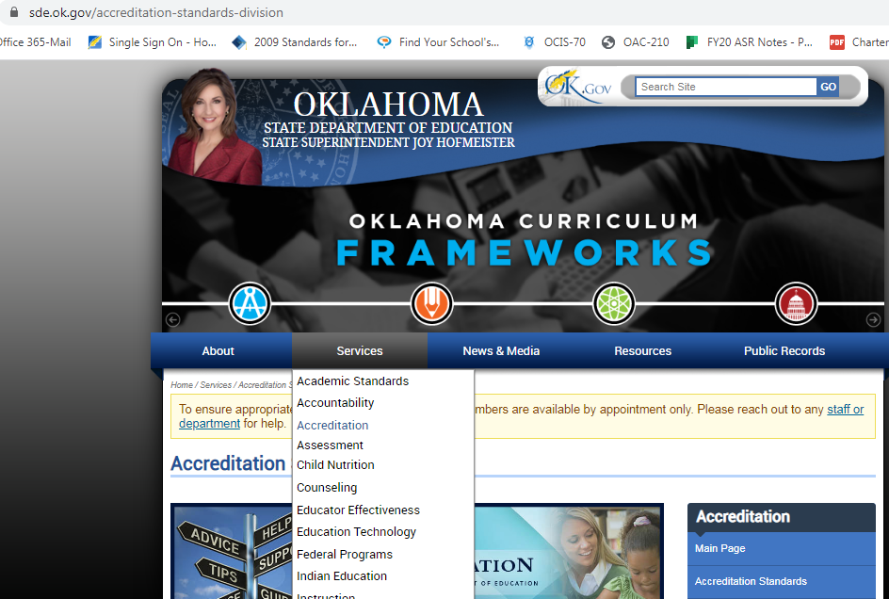

OKLAHOMA STATE DEPARTMENT OF ACCREDITATION
CHARTER SCHOOL DISTRICT CHECKLIST
FULL YEAR 2020-2021

_____ 1. All mandated reports are submitted to the State Department of Education in a timely manner. 70 0.S.§3-104
Documentation: RAO will receive data from other OSDE departments (e.g. drop outs, bullying, Alt., Ed., Needs Assessment, fiscal, personnel, federal programs, RSA, TLE, Consolidated Rpt., etc.)

_____ 2. All necessary data is reported to the Office of Educational Quality and Accountability. 70 OS § 3-136 A(4)
Documentation: principal survey print-out

_____ 3. Oklahoma Cost Accounting System is used to report financial transactions. 70 0.S. § 3-136 A (6)
Documentation: print out of accounting/fiscal statement showing OCAS coding

_____ 4. The superintendent, treasurer and all encumbrance clerks are bonded. OAC 210:40-87-6
Documentation: copy of bonds

_____ 5. The district treasurers and all encumbrance clerks have received the minimum of 12 hours of training on charter school finance laws, accounting, ethics & duties and the minimum of 12 hours of continuing education every 3 years. 70 O.S. § 5-190
Documentation: certificates & documents showing hours with stamp/seal of SDE approval

_____ 6. The Oklahoma Open Meeting Act and the Oklahoma Open Records Act are in compliance with state laws 70 0.S. § 3-136 A (16)
Documentation: stamped copy of meetings sent to County Clerk, guest sign in sheets, procedures for posting agenda, board agendas, board minutes, etc.

_____ 7. The governing body of the charter school is in compliance with the conflict of interest requirements. 70 0.S. § 3-136 A (I7)
Documentation: board signed assurances, documented board training on conflicts of interest, board policies, etc.

_____ 8. The charter school is in compliance with the Employment Security Act. 40 O.S. § 1-101
Documentation: policy and/or documents showing compliance

_____ 9. The charter school is in compliance with the State and Education Employees Group Insurance Act. 74 O.S. § 1301
Documentation: policy and/or documents showing compliance

_____ 10. The charter school is in compliance with the requirements for a Health Insurance Plan. 70 O.S. § 5-117.5
Documentation: policy and/or documents showing compliance

_____ 11. The charter school is in compliance with the requirements for Procedure of Payment (health insurance). 74 O.S. § 1310.1
Documentation: policy and/or documents showing compliance

_____ 12. The charter school is in compliance with the requirements for Payment of Additional Salary in Lieu of Employee Insurance. 70 O.S. § 5-140
Documentation: policy and/or documents showing compliance

_____ 13. Felony record searches have been conducted on all new employees. 70 0.S. § 5-142
Documentation: list of new employees, copy of policy, contract with drug testing facility and assurance letter signed by superintendent verifying receipt of searches

_____ 14. Students are provided a free education without tuition or fees. 70 0.S. § 3-136 A (10)
Documentation: copy of enrollment application, handbook page, web page, enrollment policies, procedures, etc.

_____ 15. Children with disabilities are provided an education in compliance with federal/state laws.70 0S § 3-136 A(7)
Documentation: Differentiated Monitoring Result (DMR) Letter from Dept. of Special Education

_____ 16. The charter school is in compliance with the requirements regarding records of disabled students. 34 CFR 300.562-573
Documentation: policy & procedures showing diligence in maintaining privacy of confidential records

_____ 17. The district (if over 25 employees) is in compliance with the Safe Workplace & Safety Training of Employees Act. 40 OS § 403
Documentation: name of safety coordinator, employee safety training(s) agendas or programs, etc.

_____ 18. Professional development that includes digital teaching and learning standards is offered to all certified teaching staff. 70 O.S. § 6-192
Documentation: training presentation or agenda and dated Sign in Sheets or Certificates of Attendance

_____ 19. A program is offered annually to all personnel & administrators which includes a component of training on recognition and reporting of child abuse and neglect, including child sexual abuse. 70 O.S. § 6-194
Documentation: training presentation or agenda and dated Sign in Sheets or Certificates of Attendance

_____ 20. A plan stating procedures is in place to protect students, faculty, administration & visitors from natural and man-made disasters AND has been filed with the local emergency management organization. 63 O.S. § 681
Documentation: written plan and letter or e-mail from local emergency organization showing receipt of emergency plan

_____ 21. A plan is in place stating specific procedures to be followed in regard to accidents, administration of medicines, and the reporting of child abuse and neglect, including recognition of child sexual abuse. 70 O.S. § 6-194: 70 O.S. § 1210.160; OAC 210:35-3-107
Documentation: written plan and procedures

_____ 22. The district has a plan for emergency medical services including specific procedures to be followed at athletic events or activities held at school facilities and the plan has been filed with the local emergency medical services provider within the district. 27 O.S. § 27-104
Documentation: Provide copies of the policies and procedures that reflect the above requirements and a letter/email from the local medical services provider verifying receipt of plan.

_____ 23. The Annual 7-12 Dropout Report & Annual Student College Remediation report was presented to the local board. OAC 210:35-25-3; OAC 210:35-25-4
Documentation to Upload: board minutes reflecting board approval

_____ 24. A current Home Language Survey Form is on file for each Bilingual student listed or counted on the current Accreditation Report. 70 O.S. § 3-104(a)
Documentation: will be checked off at time of completion for Bilingual Audit

_____ 25. An approved gifted and talented plan is on file, including documentation showing appropriate services provided to identified students. 70 U.S. § 1210.307
Documentation: printout from SSO GT link showing current year G/T plan status as complete & copy plan

Transportation

_____ 26. *According to OAC 210:30-5-8, all bus drivers are required to have:
______ Current CDL License ______ Current OK bus driving certificate (pink card or online)
______ Current health examination form ______ Current Motor Vehicle Record from the DMV

_____ 27. *Annual in-service forms for all bus drivers are completed yearly and kept on file. OAC 210:30-5-8
Documentation: dated in-service forms from link above for each bus driver

_____ 28. *All bus drives are in compliance with the federal requirements for drug testing. CFR Part 382
Documentation: written plan stating procedures and contract with drug testing facility

_____29. The designated supervisor over bus drivers has completed the required 2 hour training for drug recognition 49 CFR § 382.603
Documentation: Provide the name of the supervisor & documentation of completion.

_____ 30. *All buses, route & activity, are inspected annually, by a certified inspector in accordance with state law. OAC 210:30-5-6
Documentation: bus inspections & information of inspector

_____ 31. *All vehicles used to transport students are equipped with a safety belt or a safety harness for the driver. 70 O.S. § 24-121
Documentation: photos of vehicles seat belts or available for inspection

_____ 32. *All buses perform a daily pre-trip bus inspection which are reported & kept on file. OAC 210:30-5-6
Documentations: dated pre-trip inspections

_____ 33. *Two emergency evacuation drills are performed on all buses. It is recommended that one is conducted within the first two weeks of each semester. OAC 210:39-5-6
Documentation: provide drill memos or similar documentation

Plans and Policies

_____ 34. The charter school has a policy that covers Bullying & Harassment. 70 O.S. § 24-100.4
Documentation: policy and/or documents showing compliance

_____ 35. Educational services are provided to suspended and expelled students. 70 0S § 3-136A (12), 700 S § 24-101.3
Documentation: policies, procedures, handbooks, etc. regarding suspension and expulsion

_____ 36. The charter school is in compliance with the requirements for the Family Educational Rights and Privacy Act of 1974 (FERPA). 20 U.S.C. 1232 (g)
Documentation: policy and/or documents showing compliance

_____ 37. The charter school is in compliance with the requirements for the Oklahoma Hazard Communication Standard. 40 O.S. § 401-424
Documentation: employee training & information designed to communicate the hazardous chemicals to which they are exposed-including detection, chemicals in the work area, protective measures, and safety data sheets.

_____ 38. The charter school is in compliance with the requirements for the Asbestos Hazardous Emergency Response Act. 15 U.S.C. 2641, CFR 763
Documentation: documents showing asbestos inspections as well as corrective-action activities, copy of notice or parent letter(s) or website printout documenting communication to school community regarding presence of hazardous substances in school facility.

_____ 39. An approved AIDS prevention education program is offered to students and is in compliance with state law and regulations. 70 OS § 11-103.3
Documentation: educational student program & provider information

_____ 40. The district has a plan stating administration & implementation of educational program for an AIDS diagnosed student that is in compliance with state law & regulations, including the requirements for a Confidentiality of AIDS Infected Student Multidisciplinary Team. OAC 210:10-1-12, 63 OS § 1-502.2
Documentation: written plan & policy covering above items

_____ 41a. The charter school has a policy covering requirements for Student Smoking Bans. 63 O.S. § 1-1523, 20 U.S. 608; 20 U.S.C. § 710
Documentation: policies, handbooks, documents related to above item

_____ 41b. The charter school is in compliance with the requirements for the Drug-Free Charter schools Act. 20 U.S.C. § 710
Documentation: policies, handbooks, documents related to above item

_____ 42. The charter for this charter school includes a description of the personnel policies & personnel qualifications. 70 0.S. § 3-136 B
Documentation: sections of charter that refer to the items above

_____ 43. The charter for this charter school includes a description of the methods of governance. 70 0.S. § 3-136 B
Documentation: sections of charter that refer to the items above

_____ 44. The charter for this charter school includes a description of the duties of the sponsor of the charter school. 70 0.S. § 3-136 B
Documentation: sections of charter that refer to the items above

OVERALL Charter Accreditation Compliances to be gathered from various SDE Departments

______ 45. Accreditation: This Charter School has an application and up-to-date contract on file with OSDE. OAC 210:40-87-5; OAC 210:40-87-7

______ 46. Special Education: This Charter School is in compliance under IDEA and if not in compliance, has been notified of any findings. (IDEA Act)

______ 47. Special Education: This Charter School has completed any corrective actions required by the Office of Special Education. (IDEA Act)

______48. Federal Programs: This Charter School is in compliance with all applicable requirements as it pertains to Federal Law.

______49. Accountability: This Charter School is in compliance with all applicable requirements as it pertains to Accountability. 70 O.S. § 1210.541 et seq.

______50. OCAS: This Charter School is in compliance with all applicable requirements as it pertains to Oklahoma Cost Accounting System (OCAS). 70 O.S. § 5-135.2

______51. Alternative Education: This Charter School is in compliance with all applicable requirements as it pertains to Alternative Education. 70 O.S. § 1210.568

______52. Assessments: This Charter School is in compliance with all applicable requirements as pertains to the Academic Assessment Monitoring Program (AAMP). OAC 210:10-13-21 (f)
CHARTER ELEMENTARY SCHOOL CHECKLIST
FULL YEAR 2020-2021

_____1. Handbooks are provided to students, parents and teachers as required by SDE regulations. OAC 210:35-3-69
Documentation: Copy of handbook for each site and/or posted on website

_____ 2. This site has a Safe School Committee. 70 O.S. 24-100
Documentation to Upload: minutes of meeting(s) & sign in sheet with names & titles of attendees

_____ 3. This site has a Healthy & Fit Committee. 70 O.S. 24-100a
Documentation to Upload: minutes of meeting(s) & sign in sheet with names & titles of attendees

_____ 4. A minimum of one fire drill conducted each semester, in which all students and teachers participate. Drills must be conducted within first 15 days of each semester & posted on www.ok.gov/schoolsecurity/ 70 O.S. § 5-149
Documentation: Print email from school security verifying receipt of information

_____ 5. A minimum of one tornado drills conducted in both September and March of the school year in which all students & teachers participate. Information posted on www.ok.gov/schoolsecurity/ 70 O.S. § 5-149
Documentation: Print email from school security verifying receipt of information

_____ 6. A minimum of four security drills conducted per school year, two of which are due within the first 15 days of each semester. Information must then be posted on www.ok.gov/schoolsecurity/ 70 O.S. § 5-148
Documentation: Print email from school security verifying receipt of information

_____ 7. Two additional drills conducted that are consistent with the risks assessed for the site & posted on www.ok.gov/schoolsecurity/ 70 O.S. § 5-149
Documentation: Print email from school security verifying receipt of information

_____ 8. The school has a diabetes medical management plan developed for each student with diabetes. 70 O.S. § 1210.196.2
Documentation: Copy of school diabetes medical management plan

_____ 9. An information sheet regarding Meningococcal Meningitis was distributed to all 6th -12th grade students? 70 O.S. § 3243 (refer to following link) https://www.ok.gov/health2/documents/Meningococcal%202008%20final.pdf
Documentation: copy of handout & document showing evidence of distribution

_____ 10. All students of all grade levels have the required immunizations or are in the process of receiving them prior to their admission to school. 70 O.S. § 1210.191
Documentation: Signed assurance & record of immunization for each student made available for review

_____ 11. All kindergarten, first, and third-grade students have received a vision screening as required by state law. OAC 210:35-3-109
Documentation: printout from SSO Vision Screening link showing current year status as complete

_____ 12. All students are enrolled in a minimum of six periods of rigorous instruction. 70 O.S. § 1-111
Documentation: Copy of school schedule; access to student schedules and transcripts

_____ 13. The district is compliant with the ten-day activity rule for grades 7th-12th and maintains adequate records of classes missed for school sponsored activities. OAC 210:35-17-2
Documentation: to be provided during FQSR and ASR visits

_____ 14. All full day Kindergarten thru 5th grade students receive no less than 120 minutes per week of physical activity, of which 60 minutes must be in P.E. class setting. 70 O.S. § 11-103.9
Documentation: Uploaded schedule indicating weekly physical education times

_____ 15. *All athletic coaches have completed a course in Care and Prevention of Athletic Injuries if coaching grades 7-12. OAC 210:35-9-44; OAC 210:35-5-45; OAC 210:35-7-44
Documentation: college transcripts or certificate showing completion of 25 hr. course taught by certified instructor

_____ 16a. *All athletic coaches completed training in Sudden Cardiac Arrest prior to the first practice for grades 7-12. 70 O.S. § 24-156
Documentation: certificate of completion for each coach within the past year.

_____ 16b. *All 7th – 12th grade students in an athletic activity and the student’s parent/guardian, prior to participation in an athletic activity, signed and returned a Sudden Cardiac Arrest Acknowledgment sheet. 70 O.S. § 24-156 (refer to following link) http://www.ossaa.net/docs/2016-17/SportsMedicine/MF_2016-17_SuddenCardiacArrest.pdf
Documentation: sheets signed by both student and parent

_____ 17. Each site has a minimum of one certified teacher & one noncertified staff member trained in CPR & Heimlich manoeuvre. 70 O.S. § 1210.199
Documentation: Upload copy of current (not expired before spring accreditation) CPR Certification cards for designated staff-please label Cert. & NC
Certified Teacher trained in CPR & Heimlich _______________________________________________
Noncertified Staff trained in CPR & Heimlich _______________________________________________

Reading Sufficiency Act (KG-5th Grade)
Documentation: printout from SSO GT link showing current year G/T plan status as complete & copy plan

_____ 18. *The district offers a program of reading instruction to students identified as reading below grade level in grades K-5 that also includes plans of continuing instruction until the student is reading at grade level. 70 O.S. 1210.508C (B) and (H)
Documentation: District Reading Program of Instruction

_____ 19. *This site provides intensive reading instruction/alternate school day to students promoted under RSA sections (H) and (K). (Good Cause Exemptions & Probationary Promotions) 70 O.S. § 1210.508C
Documentation: Letter of assurance, copy of daily schedule, and written description of program

_____ 20. *The district has a policy for the promotion of retained third grade students and documentation of written parental notification detailing their student’s reading skills/level as required. 70 O.S. § 1210.508C (B) and (H)
Documentation: Copy of the district policy. Parental notifications to parents of 3rd graders that were promoted and did not meet RSA criteria as demonstrated by OSTP. Parental notifications of third grade students determined to receive probationary promotion after SRPT meets. Parental notifications to parents of third grade students determined to be retained

_____ 21. *The district ensures the Student Reading Proficiency Team requirements for promotion/development of Academic Progress Plans have been met. 70 O.S. § 1210.508C (H)
Documentation: Statement of compliance and description and qualifications of team members

_____ 22. *The district has documentation of written parental notification detailing their student’s reading skills/level as required. 70 O.S. § 1210.508C (B) and (H)
Documentation: Parental notifications that show student is not reading at grade level. Parental notification of students exempted from retention requirements for demonstrating grade level proficiency on a screening instrument. Parental notifications to parents of 3rd graders that were promoted and did not meet RSA criteria as demonstrated by OSTP. Parental notifications of third grade students determined to receive probationary promotion after SRPT meets. Parental notifications to parents of third grade students determined to be retained

CHARTER MIDDLE/JUNIOR HIGH SCHOOL CHECKLIST
FULL YEAR 2020-2021

_____1. Handbooks are provided to students, parents and teachers as required by SDE regulations. OAC 210:35-3-69
Documentation: Copy of handbook for each site and/or posted on website

_____ 2. This site has a Safe School Committee. 70 O.S. 24-100
Documentation to Upload: minutes of meeting(s) & sign in sheet with names & titles of attendees

_____ 3. This site has a Healthy & Fit Committee. 70 O.S. 24-100a
Documentation to Upload: minutes of meeting(s) & sign in sheet with names & titles of attendees

_____ 4. A minimum of one fire drill conducted each semester, in which all students and teachers participate. Drills must be conducted within first 15 days of each semester & posted on www.ok.gov/schoolsecurity/ 70 O.S. § 5-149
Documentation: Print email from school security verifying receipt of information

_____ 5. A minimum of one tornado drills conducted in both September and March of the school year in which all students & teachers participate. Information posted on www.ok.gov/schoolsecurity/ 70 O.S. § 5-149
Documentation: Print email from school security verifying receipt of information

_____ 6. A minimum of four security drills conducted per school year, two of which are due within the first 15 days of each semester. Information must then be posted on www.ok.gov/schoolsecurity/ 70 O.S. § 5-148
Documentation: Print email from school security verifying receipt of information

_____ 7. Two additional drills conducted that are consistent with the risks assessed for the site & posted on www.ok.gov/schoolsecurity/ 70 O.S. § 5-149
Documentation: Print email from school security verifying receipt of information

_____ 8. The school has a diabetes medical management plan developed for each student with diabetes. 70 O.S. § 1210.196.2
Documentation: Copy of school diabetes medical management plan

_____ 9. An information sheet regarding Meningococcal Meningitis was distributed to all 6th -12th grade students? 70 O.S. § 3243 (refer to following link) https://www.ok.gov/health2/documents/Meningococcal%202008%20final.pdf
Documentation: copy of handout & document showing evidence of distribution

_____ 10. All students of all grade levels have the required immunizations or are in the process of receiving them prior to their admission to school. 70 O.S. § 1210.191
Documentation: Signed assurance & record of immunization for each student made available for review

_____ 11. All students are enrolled in a minimum of six periods of rigorous instruction. 70 O.S. § 1-111
Documentation: Copy of school schedule; access to student schedules and transcripts

_____ 12. The district is compliant with the ten-day activity rule for grades 7th-12th and maintains adequate records of classes missed for school sponsored activities. OAC 210:35-17-2
Documentation: to be provided during FQSR and ASR visits

_____ 13. *The school notifies parents or legal guardians of all 9th-12th grade students who are enrolled in the CORE Curriculum (Not students enrolled in the COLLEGE-Prep Curriculum). 70 O.S. § 11-103.6
Documentation: File of letters signed by parents/legal guardians

_____ 14. *All athletic coaches have completed a course in Care and Prevention of Athletic Injuries if coaching grades 7-12. OAC 210:35-9-44; OAC 210:35-5-45; OAC 210:35-7-44
Documentation: college transcripts or certificate showing completion of 25 hr. course taught by certified instructor

_____ 15a. *All athletic coaches completed training in Sudden Cardiac Arrest prior to the first practice for grades 7-12. 70 O.S. § 24-156
Documentation: certificate of completion for each coach within the past year.

_____ 15b. *All 7th – 12th grade students in an athletic activity and the student’s parent/guardian, prior to participation in an athletic activity, signed and returned a Sudden Cardiac Arrest Acknowledgment sheet. 70 O.S. § 24-156 (refer to following link) http://www.ossaa.net/docs/2016-17/SportsMedicine/MF_2016-17_SuddenCardiacArrest.pdf
Documentation: sheets signed by both student and parent

_____ 16. Each site has a minimum of one certified teacher & one noncertified staff member trained in CPR & Heimlich manoeuvre. 70 O.S. § 1210.199
Documentation: Upload copy of current (not expired before spring accreditation) CPR Certification cards for designated staff-please label Cert. & NC
Certified Teacher trained in CPR & Heimlich _______________________________________________
Noncertified Staff trained in CPR & Heimlich _______________________________________________
CHARTER HIGH SCHOOL CHECKLIST
FULL YEAR 2020-2021

_____1. Handbooks are provided to students, parents and teachers as required by SDE regulations. OAC 210:35-3-69
Documentation: Copy of handbook for each site and/or posted on website

_____ 2. This site has a Safe School Committee. 70 O.S. 24-100
Documentation to Upload: minutes of meeting(s) & sign in sheet with names & titles of attendees

_____ 3. This site has a Healthy & Fit Committee. 70 O.S. 24-100a
Documentation to Upload: minutes of meeting(s) & sign in sheet with names & titles of attendees

_____ 4. A minimum of one fire drill conducted each semester, in which all students and teachers participate. Drills must be conducted within first 15 days of each semester & posted on www.ok.gov/schoolsecurity/ 70 O.S. § 5-149
Documentation: Print email from school security verifying receipt of information

_____ 5. A minimum of one tornado drills conducted in both September and March of the school year in which all students & teachers participate. Information posted on www.ok.gov/schoolsecurity/ 70 O.S. § 5-149
Documentation: Print email from school security verifying receipt of information

_____ 6. A minimum of four security drills conducted per school year, two of which are due within the first 15 days of each semester. Information must then be posted on www.ok.gov/schoolsecurity/ 70 O.S. § 5-148
Documentation: Print email from school security verifying receipt of information

_____ 7. Two additional drills conducted that are consistent with the risks assessed for the site & posted on www.ok.gov/schoolsecurity/ 70 O.S. § 5-149
Documentation: Print email from school security verifying receipt of information

_____ 8. The school has a diabetes medical management plan developed for each student with diabetes. 70 O.S. § 1210.196.2
Documentation: Copy of school diabetes medical management plan

_____ 9. An information sheet regarding Meningococcal Meningitis was distributed to all 6th -12th grade students? 70 O.S. § 3243 (refer to following link) https://www.ok.gov/health2/documents/Meningococcal%202008%20final.pdf
Documentation: copy of handout & document showing evidence of distribution

_____ 10. All students of all grade levels have the required immunizations or are in the process of receiving them prior to their admission to school. 70 O.S. § 1210.191
Documentation: Signed assurance & record of immunization for each student made available for review

_____ 11. All students are enrolled in a minimum of six periods of rigorous instruction. 70 O.S. § 1-111
Documentation: Copy of school schedule; access to student schedules and transcripts

_____12. *The school site is in compliance with the SDE regulation requiring all students (including seniors) to attend school for the full term or school year. OAC 210:35-3-47
Documentation: Graduation Date for Seniors____________

_____ 13. The district is compliant with the ten-day activity rule for grades 7th-12th and maintains adequate records of classes missed for school sponsored activities. OAC 210:35-17-2
Documentation: to be provided during FQSR and ASR visits

_____ 14. *The school notifies parents or legal guardians of all 9th-12th grade students who are enrolled in the CORE Curriculum (Not students enrolled in the COLLEGE-Prep Curriculum). 70 O.S. § 11-103.6
Documentation: File of letters signed by parents/legal guardians

_____ 15. The high school graduation policy requires the minimum 23 units or sets of competencies. 70 O.S. § 11-103.6; OAC 210: 35-9-31
Documentation: Data will be taken from the Accreditation Application

_____ 16. The school offers the mandated 38 units of credit (4 units may be carryover units). OAC 210: 35-9-31
Documentation: Policy and/or documents showing compliance

_____17. Concurrent enrollment policies that appropriately reflect the districts procedures are in place and include the method of student selection, transcription of grades, and calculation of GPA & how information is provided to students. 70 O.S. § 628.13
Documentation: Verification of providing policies and notice information

_____18.*The site/school has implemented a student career process that supports ICAP efforts in a strategic and coordinated manner. HB 3218, 2155, 2535; SB 1171, 1269, 929
Documentation can be: Student plan of study, district policies, plans and guidelines. Beginning 20-21 school year all 9th & 10th graders are required to complete an ICAP & updating annually.

_____ 19. All students, except those waived or opted out, receive instruction in CPR incorporating psychomotor skills training & awareness of the purpose of an AED at least once between ninth grade and graduation from high charter school. 70 O.S. § 1210.199 Documentation: roster, syllabus, opt out letter, etc.…..
How many students were waived and/or opted out of requirement? __________ Name of qualified individuals or organizations that provided instruction: ________________________________________

_____ 20. *All athletic coaches have completed a course in Care and Prevention of Athletic Injuries if coaching grades 7-12. OAC 210:35-9-44; OAC 210:35-5-45; OAC 210:35-7-44
Documentation: college transcripts or certificate showing completion of 25 hr. course taught by certified instructor

_____ 21a. *All athletic coaches completed training in Sudden Cardiac Arrest prior to the first practice for grades 7-12. 70 O.S. § 24-156
Documentation: certificate of completion for each coach within the past year.

_____ 21b. *All 7th – 12th grade students in an athletic activity and the student’s parent/guardian, prior to participation in an athletic activity, signed and returned a Sudden Cardiac Arrest Acknowledgment sheet. 70 O.S. § 24-156
Documentation: sheets signed by both student and parent

_____ 22. Each site has a minimum of one certified teacher & one noncertified staff member trained in CPR & Heimlich manoeuvre. 70 O.S. § 1210.199
Documentation: Upload copy of current (not expired before spring accreditation) CPR Certification cards for designated staff-please label Cert. & NC
Certified Teacher trained in CPR & Heimlich _______________________________________________
Noncertified Staff trained in CPR & Heimlich _______________________________________________

Driver Education

_____ 23. *According to OAC 210:15-19-4, all Driver Education instructors are required to have:
______ Current Teacher Certification in Subject
______ Current Assurances and Permit (ICAP) form signed by SDE and DPS for all semesters taught
______ Current year’s Driver Education Permit (DE Permit) signed by DPS
______ Complete student roster for each class, including each student’s name, birth date, grade level and students’ ID number from their student Certificate of Enrollment/Completion
Documentation: Provide copies of each of these for all instructors

_____ 24. In accordance with OAC 210:15-19-12, all driver education vehicles used at this site must have:
______ Working dual controlled side view mirrors (left and right) & front/rear seat belts for all occupants
______ Exterior “Student Driver” signs clearly visible from both front and rear of vehicle
Documentation: Provide pictures of each of these or make Driver Education vehicle available for inspection

_____ 25. The school district maintains all student Certificate of Enrollment/Completion and course schedule that includes minimum of 30 hours of classroom instruction and 6 hours actual behind-the-wheel driving with a certified instructor in a secured administration area. OAC 210:15-19-7 Documentation: Provide copy of classroom dates/times and driving schedule & verify location of student Certificate of Enrollment/Completion
Yearly Accreditation Online Reporting

Oklahoma High School Graduation Requirements

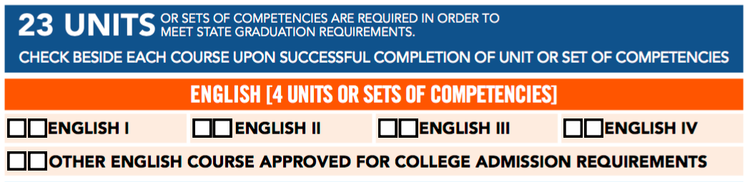

*English courses should include an integrated writing component, demonstrate critical thinking skills and fit into one of the categories of grammar, composition, or literature.
*English/Language Arts (I, II, III, IV) may include Introduction to Literature, American Lit., Classical Lit., English Lit., World Lit., Shakespeare, AP English Language & Composition, AP English Literature & Composition to fulfill this requirement.
*English/Language Arts (I, II, III, IV) may NOT include Journalism, Speech, Reading, and English-as-a-Second-Language courses to fulfill this requirement.

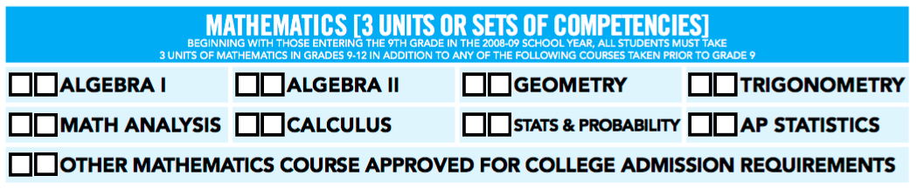

*All Mathematics courses must be taught at or above the rigor of Algebra I.
*Mathematics must include Algebra I, Algebra II, and Geometry to fulfill this requirement.
*Mathematics may include Math Analysis, Trigonometry; Pre-Calculus (must have completed Geometry & Algebra II), and Calculus courses to fulfill this requirement.
*Mathematics courses may NOT include Statistics/Probability, Computer Science, Intermediate Algebra, and Mathematics of Finance to fulfill this requirement.

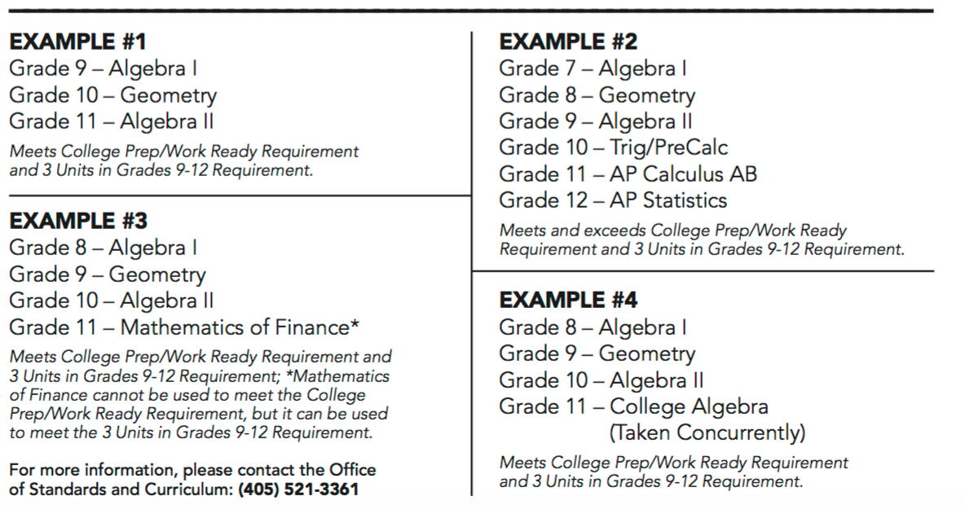
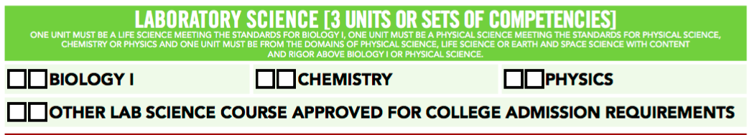

*Sciences may include Biology, Chemistry, Physics, or any Lab Science (physical, life, earth, or space science) to fulfill this requirement.
*Science courses may NOT include General Science courses with or without a lab to fulfill this requirement.
*All Science courses must include a lab component and be taught at or above the rigor of Biology I.

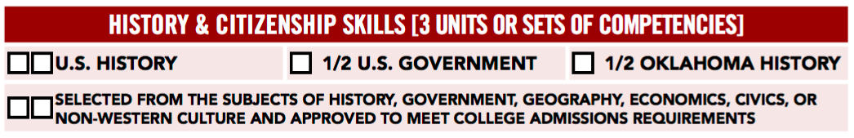

*History must include US History, US Government, and OK History to fulfill this requirement.
*History may include Geography, Economics, Civics, Non-Western Culture, and additional subjects of History or Government.
*History courses on non-Western culture should teach students cultures/traditions other than their own.
*History courses may NOT include Sociology, Psychology, Social Issues, Intro. To Law, Anthropology, Aerospace Science, American Documents, Military History, Legal Issues, etc…to fulfill this requirement.

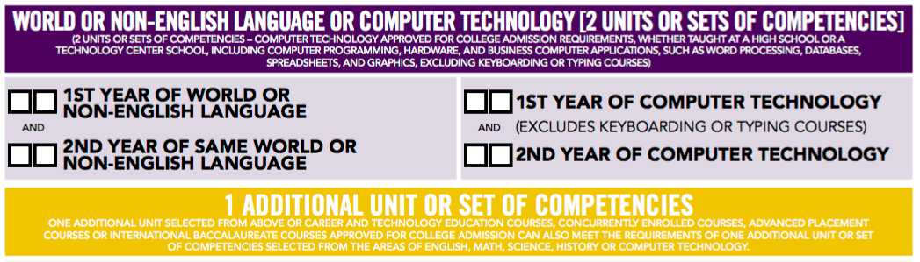

*Computer Technology may include Business Computer Applications (typically incorporating more than one application such as word processing, spreadsheets, databases, and graphics programs) or Computer Programming (understanding of computer hardware) to fulfill this requirement.
*Computer Technology courses may NOT include Keyboarding or other courses designed to teach typing skills to fulfill this requirement.

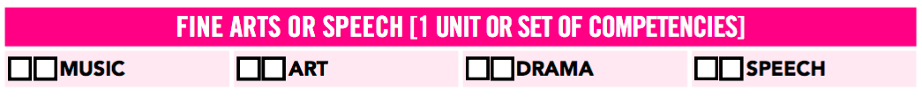

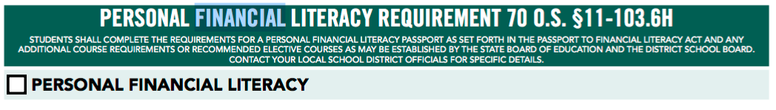

*Law requires all students take Personal Financial Literacy during grades 7-12 in order to graduate from an accredited high school.
*While there is no specific mandated curriculum, one option is an online course program available through
SDE. Instructors may download and use all or parts of this curriculum for their instructional purposes.
The school’s selected curriculum must meet the mandated standards, including all 14 Areas of Instruction.
Course work can be provided as a stand-alone course or integrated into other course(s), to be determined
by the school district.
*Students must demonstrate a satisfactory knowledge level (70%) for each of the 14 units of study. Earned credit must be represented by a letter grade and/or percent and NOT recorded as Pass/Fail.
*Completion of the course must be documented on a “Passport Transcript”. This Cumulative Record Form
template is available on the SDE web site and will serve as documentation for completion of Personal
Financial Literacy 1541, which can then be recorded on the student’s High School Transcript.

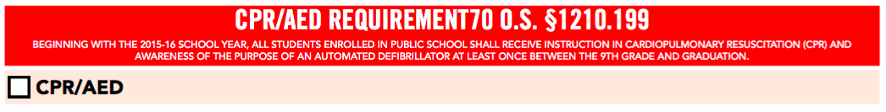

*Law requires all students receive instruction in CPR during grades 9-12 in order to graduate from an
accredited high school.

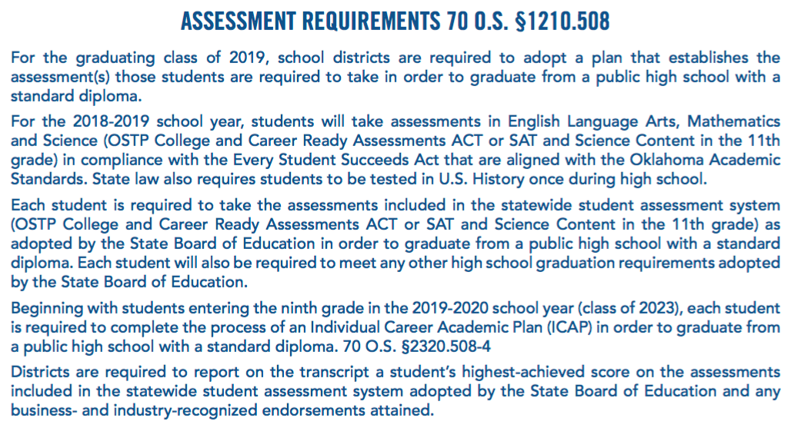

CHARTER SCHOOL CONTRACT

This Charter School Contract ("Contract") is executed as of the ___ day of __________, 20___, by and between ______________________ ("Sponsor"), and ________________ ("Charter School"). This Contract constitutes the Charter of the Charter School. When the terms "Contract" or "Charter" are used in this Contract, they are deemed to be synonymous.
The comprehensive instructional program and curriculum to be provided by the Charter School is described in the Charter Application (“Application”) submitted by the Charter School to Sponsor on ____________ ____, 20___, and approved by Sponsor on ___________ ___, 20___.
- GENERAL PROVISIONS
- Authority Granted by the Charter. The Sponsor authorizes the Charter School to operate a charter school subject to the terms of this Charter, the Oklahoma Charter Schools Act, Okla. Stat. tit. 70, §§ 3-130 et seq., as amended ("Act"), and all applicable rules and regulations (“Applicable Law”).
- Notices. The name and address of the representative authorized to act on behalf of the Charter School is as follows:
Name:
Address:
Phone:
Fax:
E-mail:

- Assignment. The obligations of the Charter School pursuant to this Charter may not be assigned, delegated, or subcontracted by the Charter School to any other individual or entity without the prior written permission of Sponsor. Provided, however, the Charter School may contract with individuals or entities for services necessary to fulfill its Charter obligations.
- Term of the Charter. This Charter will be effective on __________ ___, 20___ (the “Effective Date”), and shall terminate on ___________ ___, 20___, unless terminated sooner as herein provided.
- Renewal of the Charter School Contract. Pursuant to 70 O.S. §3-137, this Charter may be renewed upon expiration of the Term for successive five-year terms of duration, although the term of such renewal may vary based on the performance, demonstrated capacities and particular circumstances of each charter school. Prior to the beginning of the final year of the Term and any renewal term, Charter School may apply for renewal of this Contract. Further, Sponsor will issue Charter School a performance report and Charter renewal guidance prior to the beginning of the fourth year of the Term. Upon receipt of the performance report, Charter School shall have forty-five (45) days to respond to the performance report and submit any corrections or clarifications.

The Charter renewal guidance will include or explicitly refer to the criteria that will guide the renewal decision, to be based on the performance framework set forth in this Contract and consistent with the Act. In making its decision to renew or not renew the Charter, Sponsor shall: 1) ground its decision on evidence of the performance of the Charter School, including in its decision, consideration the percentage of at-risk students enrolled in Charter School; 2) grant renewal to Charter School that has achieved the standards, targets, and performance expectations set forth herein, and are organizationally and fiscally viable; 3) ensure that data used in making its decision are available to Charter School and the public; and 4) provide a public report summarizing the evidence used as the basis for its decision. Sponsor shall give written notice of its intent to deny the request for renewal at least eight (8) months prior to expiration of this Charter.
- Modification of the Charter. The terms of the Charter may be revised only through the written consent of the governing bodies of the Charter School and the Sponsor.
- Termination. Termination of this Contract shall be conducted in accordance with the provisions of 70 O.S. §3-137.
II. THE EDUCATIONAL PROGRAM
- Program of Instruction. The Charter School is authorized to implement the program of instruction, curriculum, and other services described herein and in the Application. The Charter School will provide a program of instruction for grades ____ through _____.
- Graduation Requirements (as applicable). The Charter School will comply with the graduation requirements set forth in 70 O.S. §11-103.6
- Enrollment. The Charter School shall verify residency consistent with the enrollment requirements below, shall not discriminate in enrollment, shall comply with immunization statutes, and shall select waiting list students by lottery as required by the Act.

Enrollment in the Charter School shall be open to any student who resides within the Sponsor’s geographical boundaries or who transfers to Charter School pursuant to 70 O.S. §§8-104 and 8-105, and is eligible by age or grade to enroll in the Charter School’s educational program. If there is insufficient enrollment from the Sponsor’s boundaries to fill capacity of the Charter School at any grade level, then the Charter School may elect to enroll students who reside outside the Sponsor’s geographical boundaries; provided however, in doing so the Charter School must give preference to students attending a Sponsor school site listed on the school improvement list as required by the Act.
If the number of students described above who apply for admission at any grade level exceeds the enrollment cap of the Charter School or any grade level then all such students shall be subject to a lottery for admission. The lottery shall use a mechanism for selecting students that will result in an equal probability that any student will be selected, and does not give the Charter School discretion to waive the selection of any student selected under the lottery mechanism. If the Sponsor desires to do so, it may have a representative present to observe the actual selection of students under the lottery process. Sibling policy will also be applied at the lottery; i.e., if more than one child from a family has applied for admission and one of the children is or has previously been selected by lottery, then other applicants from that family are also permitted to attend.
Prior to enrolling any student, the Charter School may advertise, at its expense, to the general public, through display on the Charter School’s website or through other mutually accepted methods, relevant information about the Charter School necessary for a student or parent to determine whether an application by the student/parent should be made to the Charter School. The Charter School may choose an appropriate method of advertisement. At a minimum, the advertisement must provide information as to the Charter School's purpose, mission, admission policies, and method by which any student or parent can apply for admission to the Charter School. The advertisement may explain that if capacity is insufficient to enroll all eligible students who apply to the Charter School, the Charter School shall select students through a lottery selection process that does not discriminate against any student.

Pursuant to Oklahoma law, at 70 O.S. §3-140, Sponsor may not restrict the number of students the Charter School shall enroll. Further, the capacity of the Charter School shall be determined annually by the governing board of Charter School based on the ability of the Charter School to facilitate academic success of its students, to achieve other objectives identified in this Contract, and to ensure that enrollment does not exceed the capacity of the facility or site. Total enrollment in the Charter School is anticipated to be _______ students in the 20___-20___ school year, and ____ students in the 20___-20___ school year; provided however, at any time between January 1 and March 15 of any calendar year in which this Charter is in effect, the Charter School may notify, in writing to the superintendent of schools of the Sponsor, that the total allowable number of enrolled students will be increased
The admission policies and practices of the Charter School shall prohibit discrimination on the basis of race, gender, national origin, income level, ethnicity, religion, disability, aptitude, academic or athletic ability, and proficiency in the English language.
The Charter School shall not admit any student until receipt of proof of residency and appropriate immunization records as required by state law.
- Non-discrimination. The educational program of the Charter School shall be nonsectarian in its programs, admission policies, employment practices, and all other operations. The Charter School shall be nonsectarian in its programs, admission policies, employment practices, and all other operations. Additionally, Charter School shall not discriminate in its operations against any student or employee on the basis of race, creed, gender, national origin, religion, disability or need for special education services.
- Services to Students with Disabilities. The Charter School will comply with the provisions of the Individuals with Disabilities Education Act (IDEA), and implementing state and federal regulations; Section 504 of the Rehabilitation Act of 1973 ("Section 504") and implementing state and federal regulations; Title II of the Americans with Disabilities Act and implementing regulations; the Policies and Procedures For Special Education In Oklahoma of the State Department of Education governing the education of children with disabilities. The Charter School agrees that it is the Local Educational Agency ("LEA") for federal funding purposes, as that term is defined in the above statutes and regulations, and that it accepts all responsibilities imposed by law under the above statutes and regulations.
Compliance includes, but is not limited to:
  - Child Find. The Charter School shall adopt and implement policies and practices that affirmatively seek out, identify, locate, and evaluate children with disabilities enrolled in the Charter School or contacting the Charter School regarding enrollment, and shall develop and implement a practical method to determine which children with disabilities are currently receiving needed special education and related services. For each eligible child, the Charter School shall develop and offer an individualized education program appropriate to the needs of that student.
  - Free Appropriate Public Education. The Charter School shall provide a free appropriate public education to all children with disabilities otherwise eligible to enroll in the Charter School.
  - Services to Students Subject to Disciplinary Removal. The Charter School shall comply with current IDEA regulations governing services to students subject to disciplinary removal, including regulations that require continuation of a free appropriate public education to a child with a disability even after disciplinary removal or change of placement of the child for valid disciplinary reasons.
  - Monitoring. The Charter School agrees that its implementation of programs required to be in compliance with laws governing the education of children with disabilities may be monitored for compliance by the United States Department of Education, Office of Special Education Programs; the United States Department of Education, Office For Civil Rights; the Special Education Division of the Oklahoma Department of Education. This monitoring activity may include responding to complaints and other investigations by the enforcing agencies, and may result in corrective actions imposed on the Charter School by these agencies for any discrepancies found. The Sponsor reserves the right to require periodic special education compliance reports from the Charter School in the same manner and format required of other of the Sponsor’s “school sites.”
  - Due Process Hearings. The Charter School's implementation of programs required to be in compliance with laws governing education of children with disabilities may be subject to court supervision via litigation against the Charter School brought by individuals affected by the actions of the Charter School. The Charter School is aware that the cost to the Charter School of this litigation can be substantial. The Charter School acknowledges and agrees that the Sponsor is in no way responsible for the costs of such litigation to which it is not a named party, including but not limited to attorneys’ fees.
  - Notice. The Charter School will comply with all requirements relating to notification to parents of their rights under IDEA and with notices required to be provided to parents of children with disabilities or children suspected of having disabilities.
- Assessments and Testing. The Charter School shall comply with the Oklahoma School Testing Program, shall be subject to the State Office of Accountability. Further, the Charter School shall participate in all testing as required by the Oklahoma School Testing Program Act and shall report test results as required of an Oklahoma public school district. The Charter School shall provide any requested data to the State Office of Accountability. In addition to such testing, the Charter School may assess whether students are meeting academic goals through the use of other norm-referenced or criterion-referenced achievement tests.
- Accountability. The Charter School shall comply with all federal and state statutes and regulations pertaining to accountability, including, but not limited to those set forth in 70 O.S. §3-137.
- Textbooks and Technological Aids. The Charter School shall provide all enrolled students with sufficient textbooks, workbooks, and other written curriculum materials to ensure delivery of the Charter School’s program of instruction during all years of operations as described in the Application. In addition, the Charter School shall provide students with the technological aids as may be deemed necessary to supplement the educational program. "Technological aids” includes, but are not limited to computers and software.
- Other Services to be Provided. The Charter School:
Will Will Not offer Advanced Placement classes.
Will Will Not offer counseling services.
Will Will Not offer a gifted and talented program.
Will Will Not offer extracurricular activities for students.
Will Will Not offer an International Baccalaureate Program.
The Charter School will annually, in January of each school year, provide written notice to the Sponsor of all extracurricular activities offered to its students. The Sponsor shall have no obligation to expend any funds, provide any facilities, or otherwise support any extracurricular activity offered by the Charter School.
- English Language Learners and Limited English Proficiency. The Charter School shall comply with federal statutory and constitutional requirements pertaining to students identified as Limited English Proficient and/or English Language Learners, including, but not limited to, ensuring equal access to the Charter School’s program of instruction and related educational services in accordance with the provisions of Title VI of the Civil Rights Act of 1964 and amendments of 42 USC §2000C-2 et seq. and accompanying federal and state regulations.
- Reporting of suspected child abuse, neglect, and/or exploitation. The Charter School shall comply with the Oklahoma Child Abuse Reporting and Prevention Act.
- Student Attendance. The Charter School shall have an attendance officer who shall enforce provisions of the compulsory attendance laws and submit lack of attendance reports to the appropriate authorities as required by Oklahoma law.
- Student Discipline. The Charter School shall comply with Oklahoma law regarding the out-of-school suspension of students and other disciplinary procedures, and shall afford students all due process rights to which they are entitled by state law and the federal Constitution in the out-of-school suspension process. The Charter School shall furnish an individualized out-of-school education plan to eligible students that are suspended out-of-school as required by Oklahoma law.
- Compliance with privacy laws. The Charter School shall comply with the Federal Family Educational Rights and Privacy Act and Oklahoma law safeguarding the confidentiality of student educational records. In addition, the Charter School shall comply with the student education record requirements contained in the IDEA.
- Safe School Committee. The Charter School shall comply with the statutory and other legal requirements to form and maintain a functioning Safe School Committee.
- Tuition or fees. The Charter School shall not charge students tuition or fees either directly or indirectly, regardless of what terminology may be used to describe any such attempted payments, for any activity required by the academic program of the Charter School
- Home-schooled students. The Charter School shall not be used in any manner to generate revenue for home-schooled students.
- Instructional Period. The Charter School shall provide instruction for at least the number of days, and hours during the day, as is required by Oklahoma law for the Sponsor. The Charter School shall provide a copy of the adopted school calendar for each year of operation at least 45 days in advance of the beginning of the school year and share any and all revisions of same upon adoption by the Charter School’s Board. In the event an emergency such as severe weather interferes with delivery of the program of instruction to student’s attendance, cancellation of school programs, activities, or instruction shall be conducted in accordance with the Charter School’s emergency policies and procedures.
III. FISCAL MANAGEMENT
  - The Charter School shall operate on a fiscal year basis. The Charter School shall utilize a fiscal year beginning July 1 and ending on the following June 30.
  - Funding, Fiscal Management, and Financial Reporting. In accordance with the provisions of 70 O.S. §3-136(A)(6), the Charter School shall, to the extent possible, comply with the same state and federal statutes and regulations relating to reporting requirements, financial audits, audit procedures, and audit requirements applicable to Oklahoma public school districts unless otherwise exempted by statute or regulation.
  - Oklahoma Cost Accounting System. The Charter School shall comply fully with the Oklahoma Cost Accounting System method of reporting school expenditures.
  - Student Records System. Charter School agrees to participate in the state student records system as required by the provisions of 70 O.S. §3-160 and accompany state regulations to ensure compliance with the tracking and reporting requirements of the Elementary and Secondary Education Act of 2001 (“ESEA”).
  - Annual Audit. The Charter School shall have the financial operations of the Charter School audited annually in accordance with the provisions of the Oklahoma Public School Audit Law. The Charter School shall bear any expense charged to the Charter School by the Auditor when conducting an investigative audit of the Charter School.
  - Accounting of Student Attendance. Because funds for a Charter School are based upon weights derived from statistics relating to student membership, student attendance, and student characteristics, the Charter School shall keep an accurate record of student attendance in compliance with reporting requirements of the State Department of Education and shall furnish such information to the Sponsor, upon reasonable advance request, at the times and in the format requested by the Sponsor.
  - Conflict of Interest. No transaction shall be executed between the Charter School and a member of the governing body of the Charter School or any member of the immediate family of a member of the governing body of the Charter School which violates, directly or indirectly, Oklahoma law governing conflict of interest transactions between a member of the Sponsor Board of Education and the Sponsor School District.
  - Commingling of Charter School Funds. The Charter School shall not commingle Charter School funds with the funds of any other person or entity. The Charter School shall keep separate and distinct accounting, auditing, budgeting, reporting, and recordkeeping systems for the management and operation of the Charter School. The Sponsor and Charter School mutually acknowledge that the Charter School may independently fundraise for private donations to support the Charter School.
  - Financial Records. The Charter School shall maintain all financial records needed to conduct an annual audit and to show compliance with this Charter, and shall not destroy such records for at least five (5) years.
  - Teachers Retirement. If the Charter School elects to participate in the Oklahoma Teachers' Retirement System (“OTRS”), the Charter School shall make timely contributions to the OTRS and to the Social Security System, and shall make timely withholdings of taxes required by state and federal statutes. Nothing in this section shall obligate the Charter School to assume the obligation to pay any portion of the obligation of any employee to OTRS.
  - Employment Contracts. The Charter School shall ensure that all contracts for services with teachers and school personnel shall comply with the requirements of 70 O.S. §3-135(B).
  - Unemployment Compensation Benefits. The Charter School will comply with requirements placed upon employers by the Oklahoma Employment Security Act. If electing to be a "taxable" employer, the Charter School will make timely payments to the Oklahoma Employment Security Commission. If electing to be a "reimbursing" employer, the Charter School will make timely reimbursements to the Commission for claims paid.
  - Fair Labor Standards Act. As a governmental entity, the Charter School understands that it is subject to the requirements of the Fair Labor Standards Act, including, but not limited to the payment of minimum wages, payment of overtime compensation to non-exempt employees and the maintenance of various records regarding pay and work times.
  - Pending Litigation. The Charter School hereby certifies that there is no pending litigation or threatened litigation at the present time that reasonably could have an adverse impact on operations of the Charter School. If at any time during the term of this Contract the Charter School is sued by or sues any person or entity in any jurisdiction the Charter School must immediately notify the Sponsor, in writing, of the suit and provide such information concerning the litigation as may be reasonably requested by the Sponsor.
  - Sponsor Funding. State aid funding shall be calculated and disbursed in accordance with the provisions of the Act, accompanying statutes and regulations of the State Board of Education and the Oklahoma State Department of Education, the terms of this Contract. The Charter School shall receive funding from the Sponsor as provided by Okla. Stat. tit. 70, § 3-142, and any subsequent amendments thereto in this or any other section of the statutes, less ____ percent (___%) of the total State Aid allocation, which shall be retained by the Sponsor as a fee for administrative services rendered. The State Board of Education shall determine the policy and procedure for the Sponsor making payments to the Charter School.
  - Sponsor Payments. The Sponsor shall make payment to the Charter School by the second Friday after the Sponsor’s receipt of any funds to which the Charter School is entitled.
  - Reporting. The Charter School will timely provide the Sponsor with all data that the Sponsor is required to include in the Sponsor’s report to the State Department of Education and other governmental agencies.
  - Fundraising. Subject to the limitations set forth by conflicts of interest statutes and regulations applicable to the Charter School, the Charter School may accept private donations, provided, however, that private donations shall in no way be used, directly or indirectly, to affect enrollment decisions or otherwise subvert the Charter School’s policies and procedures pertaining to admission and enrollment set forth in this Contract.
IV. FACILITIES, GOVERNANCE, AND OPERATIONS
  - Oklahoma Open Meeting Act. The Charter School shall comply with all requirements of the Oklahoma Open Meeting Act, including, but not limited to, timely notification to the County Clerk of all meetings of the governing body, the timely posting of agendas, the maintenance of minutes, and the restricted purposes of executive sessions.
  - Oklahoma Open Records Act. The Charter School shall comply with all requirements of the Oklahoma Open Records Act, including, but not limited to, having designated individuals to process requests for inspection or copying of records.
  - The Charter School shall promptly notify the Sponsor if operations cease or there is a change in the location of the facility. Failure to promptly notify the Sponsor that the Charter School has ceased to provide any of the grades or courses of instruction for which this Charter was granted will be good cause to terminate this Charter.
  - The Charter School shall comply with all state and local regulations concerning safety of buildings. The Charter School will obtain all needed permits and inspections required of buildings by state and local authorities, and, in particular, all building code and safety regulations for structures housing children.
  - The Charter School shall have the following administration. The administration of the Charter School is described in detail in the Application, which also describes the administrative structure, the duties of each administrator, and employment qualifications required to hold the various positions. The Charter School has determined that administrative positions will/will not be required to hold administrative certificates issued by the State Department of Education and that the Head of School shall have at least a Bachelor’s Degree.

The Charter School will have a governing body, which shall be responsible for the policies and operational decisions of the Charter School. The governing body shall meet at a minimum quarterly in the state, and a majority of the members of the governing body are residents within the geographic boundaries of Sponsor.
  - Facility Use. The Charter School shall have and maintain throughout the term of the Charter a lease agreement, title, or other legal instrument granting to the Charter School the right to occupy and use one or more facilities suitable for use as the Charter School facilities described by the Charter. The lease may not be made for more than one fiscal year, but may have options to lease in future fiscal years that are not beyond the length of the Charter.
The Charter School has secured the following facilities in which school operations are housed pursuant to a separate written Lease Agreement:
The street address of the facilities:
_________________________________________________________________
_________________________________________________________________
_________________________________________________________________
The owner of the above facilities and the owner's address:
_________________________________________________________________
_________________________________________________________________
_________________________________________________________________
All needed inspections, permits, and licenses required by state and local governments have been obtained.
The facilities will have all smoke detectors as required by state law.
The Charter School will conduct fire drills and any other emergency drills as required by state law.
  - The Charter School shall conduct safety training for personnel as required by statute. The Charter School shall conduct employee safety training, which may be required of the Charter School. The Charter School shall provide phone / data and utility services. The Charter School shall provide phone / data service at the school facility and utility services to properly maintain the school facility in comfort levels compatible with an appropriate learning environment.
  - Liability. The Charter School and Sponsor agree that neither party agrees to indemnify or hold harmless the other party with regard to any loss, damage, or claims arising out of this Contract or the operation of the Charter School unless expressly provided elsewhere in this Contract or as expressly stated by state or federal statutes or regulations.
  - The Charter School shall maintain insurance protection. The Charter School acknowledges and agrees that it has potential liability under the Oklahoma Governmental Tort Claims Act for negligent actions of its employees acting in the scope of their employment and under the federal and state Constitution, statutes, and regulations for actions that violate rights of students, parents, or employees. The Charter School also acknowledges that it may enter into contracts and sue and be sued for actions relating to contracts. The Charter School has secured and will maintain throughout the term of this Charter and any extension thereof: (1) liability insurance protection for ALL school operations in amounts equal to or greater than the minimum liability amounts set forth in the Oklahoma Governmental Tort Claims Act; (2) appropriate property and casualty insurance policies providing adequate protection of Charter School property; (3) fleet/liability insurance for any vehicle owned or operated by the Charter School in an amount equal to or greater than the amount required by law; (4) workers' compensation insurance as required by law; and (5) any other insurance which may now or hereafter be required by law. The Charter School will furnish the Sponsor with a copy of any policy of insurance it maintains within five (5) days of the Sponsor's written request for the policy.
  - Background Checks. The Charter School may not enter into an employment contract for the term of this Contract with any teacher or other personnel prior to the approval of this Contract by the Sponsor. The Charter School shall have employment contracts that reference Charter School’s Personnel Handbook, which Handbook is provided to each teacher or other personnel prior to or at the time of signing an employment contract. The Personnel Handbook sets forth the Charter School's personnel policies, including, but not limited to, policies related to certification, professional development, evaluation, suspension, dismissal and non-reemployment, sick leave, personal business leave, emergency leave, and family and medical leave. The employment contract or the Personnel Handbook shall also specifically set forth the salary, hours, fringe benefits, and work conditions of the employees. Upon contracting with an employee, the Charter School shall disclose, in writing, all employment rights of employees in the event the Charter School closes or its Charter is not renewed. The Charter School shall furnish Sponsor with copies of its form employment contracts.

For all Charter School employees, prospective employees, and substitutes, Charter School agrees to conduct any and all background checks and/or record searches, including, but not limited to, national criminal history record checks, sex offender registry checks, violent offender checks, and any other searches that are required of school districts under federal or state laws, rules, or regulations.
  - Immigration and Reform Control Act. The Charter School shall comply with the requirements of the Immigration and Reform Control Act that requires employers to enforce naturalization policies barring the employment of illegal aliens and requires employers to both verify the identity and the employment authorization of all employees through completion of Form I-9, Immigration and Naturalization Service.
  - Asbestos Hazardous Emergency Response Act. The Charter School shall comply with the requirements of federal law to make inspections to identify asbestos materials, take needed responses to control the release of asbestos fibers, compose a management plan on how the school will comply with the regulations, designate a person to carry out these duties, use specially-trained persons to make inspections and conduct periodic control; and notify, educate, and train school employees about the location and hazards of the chemical.
  - Oklahoma Hazard Communication Standard. The Charter School recognizes that the Oklahoma Department of Labor has issued regulations pursuant to the Oklahoma Occupational Health & Safety Standards Act designed to protect the health and safety of employees. These regulations require the identification of hazardous chemicals on the work site, and the training of employees about hazardous substances to which they may be exposed on the work site. The Charter School will abide by these regulations.
  - The Charter School and Sponsor shall comply with laws and regulations listed by the State Department Of Education. The Charter School and Sponsor will comply with all applicable federal statutes and regulations, state statutes and regulations, and local ordinances and rules; including without limitation those relating to health, safety, civil rights, and insurance listed annually by the State Department of Education for Charter School and public school compliance.
  - Disposition of Property. The Charter School shall adopt a rule specifying the method to be used for disposing of real and personal property acquired by the Charter School upon the expiration or termination of the Charter or upon failure of the Charter School to continue operations or when the real or personal property is no longer needed by the Charter School. Any real or personal property purchased by the Charter School at any time with state or local funds shall be retained by the Sponsor upon the occurrence of any of said events. However, if the Charter School continues operation in the geographical boundaries of the Sponsor under a new charter contract sponsored by another entity authorized under the Oklahoma Charter Schools Act to sponsor charter schools, then any personal property purchased with state or local funds by the Charter School may be retained by the Charter School for use in operation of the Charter School until termination of the new charter or failure of the charter school to continue operations, at which time all such personal property shall be retained by the Sponsor. So long as Sponsor remains in its role as Sponsor of the Charter School, on or before January 1 of each year, the Charter School shall provide to the Sponsor a full, detailed and complete inventory of all real and personal property that it has purchased with state or local funds.
  - The Sponsor and Charter School may enter into a separate agreement for the Charter School to purchase food services from the Sponsor.
  - Unless otherwise agreed to between Sponsor and Charter School, the Charter School shall provide at its sole cost transportation for students enrolled in the Charter School.

V. INSPECTIONS
Periodic Inspections. At Sponsor’s sole cost, reasonably routine scheduled, as agreed to between Sponsor and Charter School, inspections shall take place on a quarterly basis, or more frequently if the Sponsor reasonably deems that more frequent inspections are appropriate. The Charter School agrees to cooperate in good faith with the Sponsor's representatives making the Sponsor inspections. The purpose of the inspections will be to ascertain that the Charter School is properly fulfilling its obligations under:
The Oklahoma Charter Schools Act;
The Charter School's Mission Statement;
This Contract; and/or
The terms and conditions of the Charter School's Application to the Sponsor.
In the event that the Sponsor's representatives deem that the Charter School is not fulfilling its obligations with respect to any of the foregoing, the Sponsor will give written notice to the Charter School specifying the matters that have resulted in the Sponsor's findings. The Charter School shall have thirty (30) calendar days to correct the non-compliance, except that as to any deficiencies which would reasonably require more than thirty (30) calendar days to correct, the Charter School will not be in default as long as the Charter School is proceeding with due diligence and in good faith to correct the deficiencies. If the Charter School fails to correct the deficiencies within thirty (30) calendar days from the Charter School's receipt of the Sponsor's notice (or such longer time as may be permitted for deficiencies which reasonably cannot be corrected within thirty (30) calendar days under the above exception), the Sponsor may notify the Charter School that it is in default and that the Sponsor is exercising its right to terminate this Contract. However, the thirty (30) days’ notice will not be required in the event of a clear pattern of repeated material deficiencies or material breaches of this Contract or federal or Oklahoma law, in which case the Sponsor may notify the Charter School, in writing, that the Sponsor elects to terminate this Contract immediately.
VI. THIS AGREEMENT
- Entire Agreement. This Contract, including the terms incorporated by reference, contains the entire agreement of the parties. All prior representations, understandings, and discussions are merged into, superseded by and canceled by this Contract. The parties have jointly prepared this Contract; accordingly, this Contract shall not be construed more or less favorably with respect to either party. This Contract may not be modified or amended orally, but only by an instrument in writing, duly authorized and executed by the parties to this Contract.
- Severability. If any provision of this Contract is determined by a court or other tribunal to be unenforceable or invalid for any reason, the remainder of the Contract shall remain in full force and effect, so as to give effect to the intent of the parties to the extent valid and enforceable.
- No Waiver of Breach. No assent, express or implied, to any breach of any of the covenants or agreements herein shall waive any succeeding or other breach.
- Venue. Any lawsuit due to, arising under or in connection with this Contract shall only be brought in ________ County District Court or, where federal jurisdiction exists, the United States District for the __________ District of Oklahoma. The parties hereby consent to jurisdiction and venue in both the District Court of ___________ County, Oklahoma and the United States District Court for the ___________ District of Oklahoma for all purposes.
- Governing Law. This Agreement will be governed by and construed in accordance with the laws of the State of Oklahoma, without giving effect to any choice of law or conflict provision or rule (whether of the State of Oklahoma or any other jurisdiction) that would cause the laws of any jurisdiction other than the State of Oklahoma to be applied.
- Authority. The persons signing this instrument represent that they are duly authorized to execute this instrument on behalf of the respective parties and that this instrument has been duly and legally approved and adopted by the respective parties.
- Incorporation. The Charter School's Application, including any amendments, to Sponsor is incorporated herein by reference. In the event of any conflict between the terms and conditions of this Contract and the terms and conditions of the Application, the terms and conditions of this Contract will prevail.
IN WITNESS WHEREOF, the parties hereto have executed this Contract as of the date first above written.
Charter School Name: | Sponsor:
_______________________________ | _____________ SCHOOL DISTRICT NO. ______ OF ________ COUNTY, OKLAHOMA

BY: ____________________________ ATTEST: _____________________________
President, Board of Education Clerk of the Board of Education

