Books Available for 2022–2023 NEA Big Read Programming

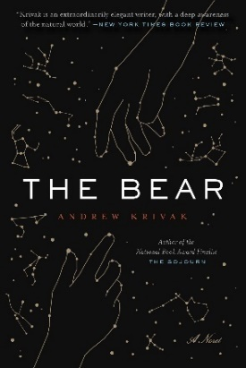 | The Bear is a post-apocalyptic fable by New England author Andrew Krivak about a father and daughter, the last two people on Earth, who live off the land at the foot of a mountain. When the daughter finds herself lost and alone, a bear appears to lead her back home.
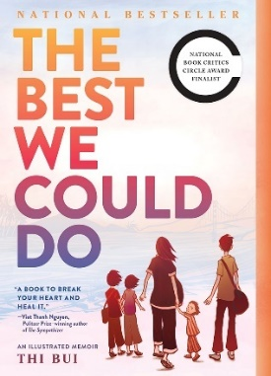 | The Best We Could Do is a graphic memoir by Thi Bui about the lasting effects of one family’s escape from war-torn Vietnam in the 1970s to a new life in America and the universal challenges of becoming a new parent. (Returning NEA Big Read book)
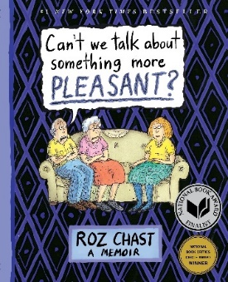 | Can’t We Talk About Something More Pleasant? is a graphic memoir by Roz Chast, a longtime cartoonist for the New Yorker, about her parents’ final years in their Brooklyn apartment and an assisted living facility. The story is told in part with cartoons, found documents, and family photos. (Returning NEA Big Read book)
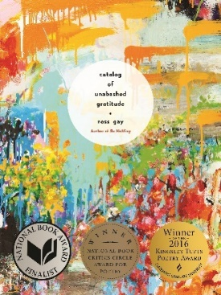 | Catalog of Unabashed Gratitude is a poetry collection by Indiana poet Ross Gay that celebrates life and goodness and that which nourishes us, fleetingly and forever, through love and loss, from everyday living and gardening and noticing what we often take for granted.
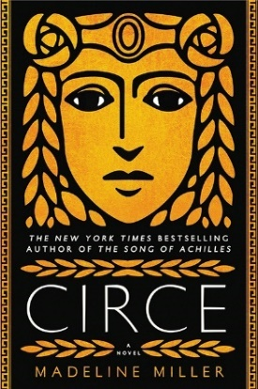 | Circe is a novel by Madeline Miller about the Greek goddess Circe that recasts this famous female figure from the Odyssey as a daughter, a mother, a lover, and a heroine among nymphs, gods, mortals, and monsters. (Returning NEA Big Read book)
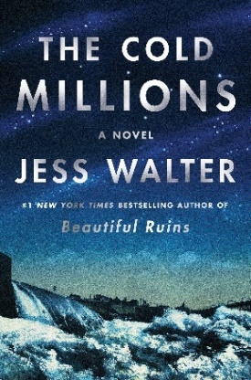 | The Cold Millions is a historical novel by Jess Walter set in the early part of the 20th century about two brothers from Montana who jump freight trains and arrive in Spokane, Washington. There they encounter poverty, violence, unions fighting for fair pay and better work conditions, a vaudeville singer, a powerful mining magnate, and the (real-life) activist Elizabeth Gurley Flynn.
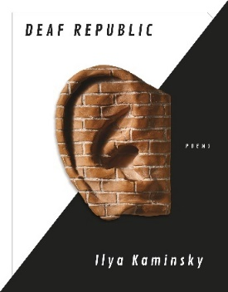 | Deaf Republic is a poetic narrative by Ukrainian-born poet and NEA Creative Writing Fellow Ilya Kaminsky about the fictional, private lives of townspeople in an occupied country who have all gone deaf and silent after seeing a soldier shoot and kill a deaf boy. They respond to this murder by turning to sign language to communicate and by committing small acts of heroism.
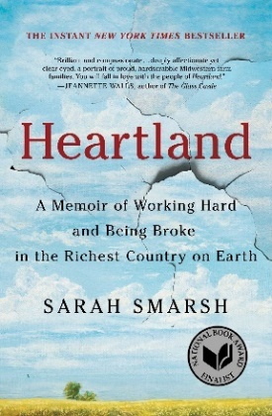 | Heartland: A Memoir of Working Hard and Being Broke in the Richest Country on Earth by Sara Smarsh chronicles her turbulent childhood in Kansas in the 1980s and 1990s. She shares stories of her family, as well as observations of poverty, untreated medical conditions, unsafe job conditions, abusive relationships, and other impediments to the American dream.
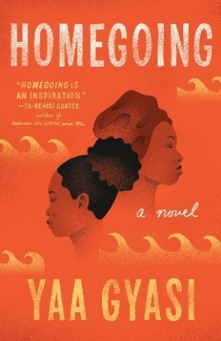 | Homegoing is an expansive novel about the legacy of chattel slavery by African-born writer Yaa Gyasi spanning eight generations. The novel begins with the parallel lives of two half-sisters from Ghana in the 18th century and follows their descendants through periods of history that include the American Civil War and Jazz Age Harlem.
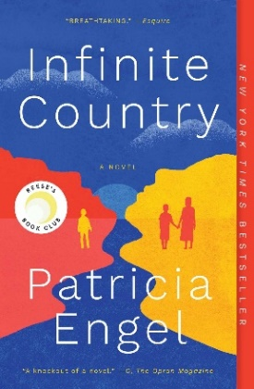 | Infinite Country is a novel by NEA Creative Writing Fellow Patricia Engel about a teenage daughter who tries to make her way from Bogotá, Colombia, to the U.S., and her mother and siblings who seek safety and opportunity in New Jersey amidst fears that they will be deported like her father. All members of the family hold on to hope, their culture, each other, and the dream of a better life.
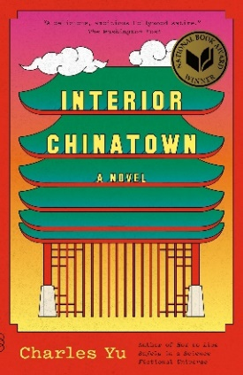 | Part novel, part screenplay, Interior Chinatown by Charles Yu follows a Taiwanese American Hollywood actor doomed to play bit parts and generic Asian characters until he gets entangled in a murder case in a procedural cop show. He begins to unravel buried legacies and pervasive stereotypes as he learns to become a new protagonist in his own story.
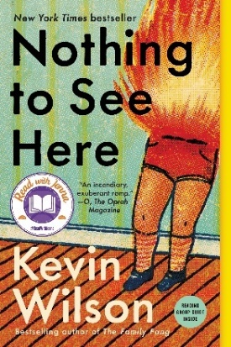 | Nothing to See Here is a novel by Tennessee author Kevin Wilson set in Nashville over one hot summer. It follows the emotional journey of a woman charged with looking after two children who, neglected by their wealthy father and stepmother, spontaneously burst into flames whenever they get upset.
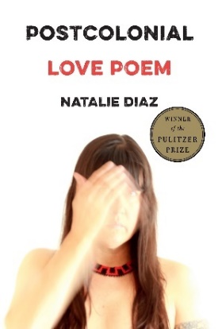 | Winner of the 2021 Pulitzer Prize in Poetry, Postcolonial Love Poem is a collection by Arizona poet Natalie Diaz—who is Mojave, an enrolled member of the Gila River Indian Tribe, Latinx, and queer. The poems push against the forces of racism, environmental destruction, addiction, and mental illness with the power of desire, love, and language.
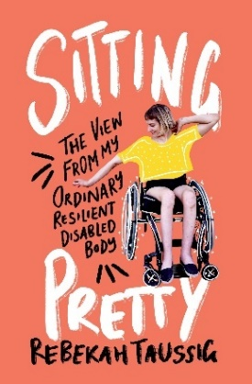 | Sitting Pretty: The View from my Ordinary Resilient Disabled Body is a memoir-in-essays by Rebekah Taussig that shares personal stories from her Missouri childhood to the present day. Taussig reflects on living both independently and dependently, the complex issues around charity and acts of kindness, the presentation of disability in the media, and how disability affects us all.
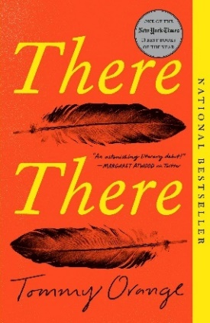 | There, There is a novel by Tommy Orange, an enrolled member of the Cheyenne and Arapaho Tribes of Oklahoma, that follows the unexpectedly connected lives of 12 characters from Native American communities who travel to a big, and ultimately volatile, powwow in the city of Oakland, California.

