OKLAHOMA STATE DEPARTMENT OF EDUCATION
STAR CBM
Technical Support: Screening for Characteristics of Dyslexia

This guidance is based off of information provided by the vendor, and is provided to assist districts in quickly finding essential information for using this screening instrument to meet the requirements of screening for characteristics of dyslexia. Specific questions about the assessment should be directed to the vendor.

September 2022

Contact Information
Name: | Susie Beauchamp, Account Executive for Oklahoma
Phone: | 866.559.6571 ext.4723 | 405.834.1047 (mobile)
Email: | Susie.beauchamp@renaissance.com
Website: | https://www.renaissance.com/products/star-assessments/

General Information
Administration Method: | Star CBM is administered individually by the teacher either in an online, paper, or blended online/paper setting.
Administration Time: | Star CBM measures take about 1 minute each to administer.  Star Early Literacy, as a computer adaptive test (CAT) takes about 10 minutes to complete.  Star Reading as a computer adaptive test (CAT), takes about 20 minutes to complete.  (Not every assessment is required during each administration.)

Direct Guidance and Grade-level Flowcharts from Renaissance, as well as Reading Data Reports
Using Star Assessments to Meet Reading Sufficiency Act (RSA) and Dyslexia Screening Guidelines in OK

Grade Level Assessment Pathway
To screen for characteristics of dyslexia, students must first take the Star Universal Screening Assessment. Students in kindergarten and 1st grade should begin with Star Early Literacy. By 2nd grade, students should use Star Reading. Students who score below the grade-level target will require additional testing through Star CBM. The subtests appropriate for the grade level are identified below.
There are four options for Rapid Naming. Teachers may select which skill is used. It should be a skill the student is already comfortable with as this assessment measures processing speed rather than knowledge of the skill. For example, if a student does not know the names of the colors used on the Rapid Color Naming, this is not a good option for the student. They would likely do better with the Rapid Picture Naming.
The other subtests in the Star CBM package are useful for gathering additional data around a student’s learning needs, as well as monitoring progress during intervention.

Determining Risk for Characteristics of Dyslexia
Use the Star Record Book to view both Star Early Literacy, Star Reading, and Star CBM data on one dashboard. Students scoring below 40 PR (red, yellow, or blue benchmark categories) on Star Early Literacy or Star Reading are considered at risk for reading difficulties and should receive additional instructional supports. Students further assessed and scoring below 40 PR (red or blue benchmark categories) are considered at risk for characteristics of dyslexia and other reading deficiencies and may need further assessment and/or intervention. Students falling in the red or blue benchmark categories are considered at risk for reading difficulties. See Star CBM Score and Benchmark Tables for more on how Percentile Ranks relate to CPM scores.

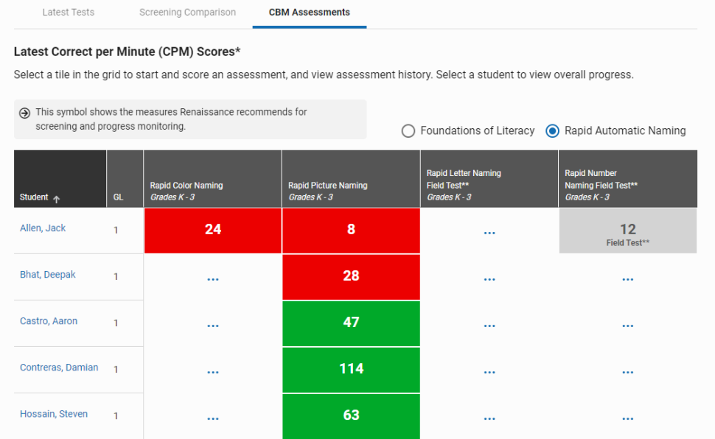
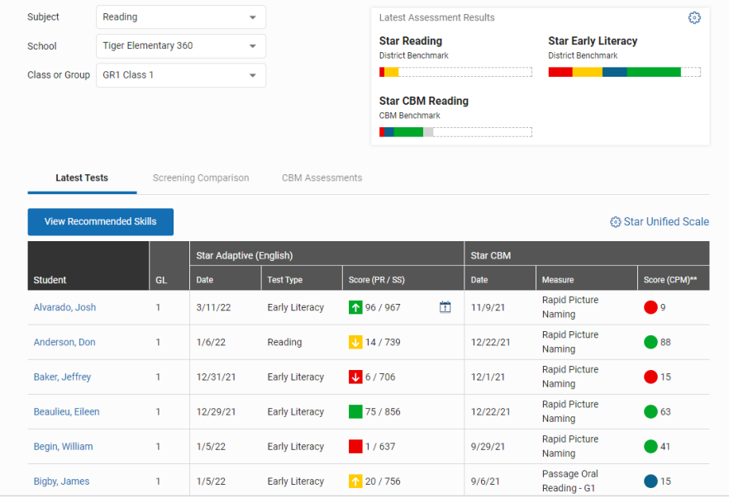
Star CBM scores are shown in Correct Per Minute (CPM) while the colors represent benchmark categories:
- Green – At/Above Benchmark
(40 PR and above)
- Blue – On Watch (20-39 PR)
- Red – Intervention (1-19 PR)

Rapid Color Naming or Rapid Picture Naming measures display to identify potential risk. to access Star CBM RAN data
.

Star Diagnostic Report for Star Early Literacy provides domain and skill-set information for individual students. This report can be used to view more detailed information on student performance for the Oklahoma required skills for dyslexia screening.

Choose Star Early Literacy Subdomains in the selection dropdown.
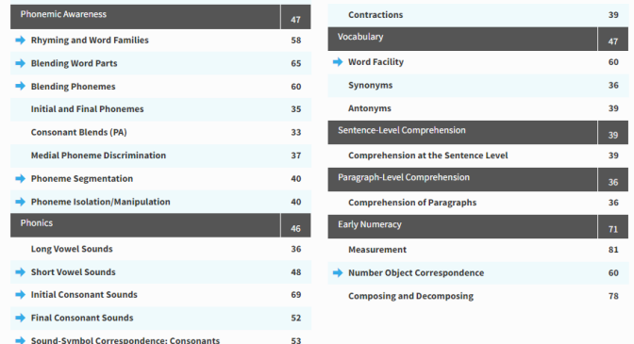
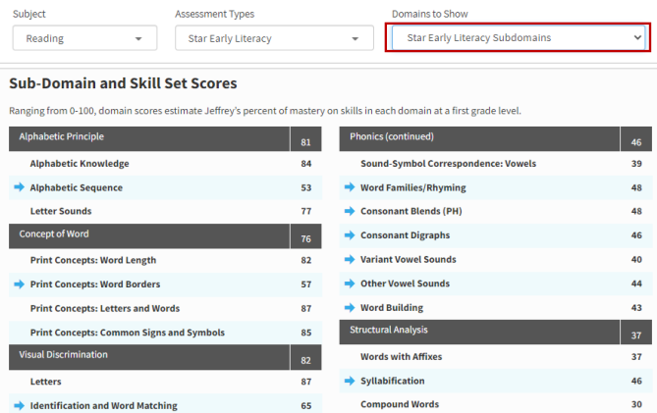

You can also use Star CBM and Star assessments for goal setting and progress monitoring. For additional support, please contact customer service at 1-800-338-4204.

Kindergarten Assessment Pathway
Begin with the Star Early Literacy Universal Screener.
If the student scores below the 40th percentile (see table below), administer Rapid Naming assessment.
Percentiles for Early Literacy (Universal Assessment)
 | Beginning of Year | Middle of Year | End of Year
10th percentile | 62 | 664 | 708
25th percentile | 661 | 701 | 741
40th percentile | 688 | 728 | 768

Choose one of the Rapid Naming assessments. The content should be familiar to the student to get valid results.
For all Rapid Naming assessments, the benchmark and at-risk cutoff scores are the same for all benchmark windows within a grade level.

Rapid Naming | At Risk | At/Above Benchmark
Rapid Color Naming | 0 to 32 | 33 and above
Rapid Picture Naming | 0 to 29 | 30 and above
Rapid Letter Naming | 0 to 24 | 25 and above
Rapid Number Naming | 0 to 32 | 33 and above

Students in kindergarten should be considered at-risk for characteristics of dyslexia if all of the following conditions apply:
- Star Early Literacy score below the 40th percentile, and
- Rapid Naming assessment (one) score in the at-risk range.

1st Grade Assessment Pathway
Begin with the Star Early Literacy Universal Screener.
If the student scores below the 40th percentile (see table below), administer Rapid Naming and Expressive Nonsense Word assessments.
Percentiles for Early Literacy (Universal Assessment)
 | Beginning of Year | Middle of Year | End of Year
10th percentile | 688 | 723 | 758
25th percentile | 728 | 764 | 799
40th percentile | 750 | 789 | 828

Choose one of the Rapid Naming assessments. The content should be familiar to the student to get valid results.
For all Rapid Naming assessments, the benchmark and at-risk cutoff scores are the same for all benchmark windows within a grade level.

Rapid Naming | At Risk | At/Above Benchmark
Rapid Color Naming | 0 to 39 | 40 and above
Rapid Picture Naming | 0 to 37 | 38 and above
Rapid Letter Naming | 0 to 39 | 40 and above
Rapid Number Naming | 0 to 47 | 48 and above

Expressive Nonsense Words
 | Beginning of Year | Middle of Year | End of Year
Intervention | 0 to 8 | 0 to 11 | 0 to 16
On Watch | 9 to 12 | 12 to 15 | 17 to 20
At/Above Benchmark | 13 and above | 16 and above | 21 and above

Students in 1st grade should be considered at-risk for characteristics of dyslexia if all of the following conditions apply:
- Star Early Literacy score below the 40th percentile, and
- Rapid Naming assessment (one) score in the at-risk range, and
- Expressive Nonsense Words score in either Intervention or On Watch range.

2nd Grade Assessment Pathway
Begin with the Star Reading Universal Screener.
If student scores below the 40th percentile (see table below), administer the Star Early Literacy.
If the student scores below the 40th percentile on Early Literacy (see table below), administer Rapid Naming and Expressive Nonsense Word assessments.
If the student scores above the 40th percentile on Early Literacy, the students is showing a reading difficulty, but characteristics of dyslexia may not be the cause. The student may be struggling with language comprehension (e.g., vocabulary, syntax, comprehension).
Percentiles for Star Reading and Star Early Literacy (Universal Assessment)
 | Beginning of Year | Middle of Year | End of Year
10th percentile | 792 | 820 | 847
25th percentile | 834 | 862 | 889
40th percentile | 868 | 893 | 919

Choose one of the Rapid Naming assessments. The content should be familiar to the student to get valid results.
For all Rapid Naming assessments, the benchmark and at-risk cutoff scores are the same for all benchmark windows within a grade level.

Rapid Naming | At Risk | At/Above Benchmark
Rapid Color Naming | 0 to 47 | 48 and above
Rapid Picture Naming | 0 to 45 | 46 and above
Rapid Letter Naming | 0 to 58 | 59 and above
Rapid Number Naming | 0 to 60 | 61 and above

Expressive Nonsense Words
 | Beginning of Year | Middle of Year | End of Year
Intervention | 0 to 15 | 0 to 17 | 0 to 22
On Watch | 16 to 23 | 18 to 27 | 23 to 32
At/Above Benchmark | 24 and above | 28 and above | 33 and above

Students in 2nd grade should be considered at-risk for characteristics of dyslexia if all of the following conditions apply:
- Star Reading score below the 40th percentile, and
- Star Early Literacy score below the 40th percentile, and
- Rapid Naming assessment (one) score in the at-risk range, and
- Expressive Nonsense Words score in either Intervention or On Watch range.

If the student shows difficulty in some but not all areas, then a reading difficulty exists, but the student may not be demonstrating risk for characteristics of dyslexia at this time.

3rd Grade Assessment Pathway
Begin with the Star Reading Universal Screener.
If the student scores below the 40th percentile (see table below), administer the Star Early Literacy.
If the student scores below the 40th percentile on Early Literacy (see table below), administer Rapid Naming and Expressive Nonsense Words assessments.
If the student scores above the 40th percentile on Early Literacy, the students is showing a reading difficulty, but characteristics of dyslexia may not be the cause. The student may be struggling with language comprehension (e.g., vocabulary, syntax, comprehension).
Percentiles for Star Reading and Star Early Literacy (Universal Assessment)
 | Beginning of Year | Middle of Year | End of Year
10th percentile | 865 | 884 | 902
25th percentile | 909 | 926 | 943
40th percentile | 940 | 955 | 970

Choose one of the Rapid Naming assessments. The content should be familiar to the student to get valid results.
For all Rapid Naming assessments, the benchmark and at-risk cutoff scores are the same for all benchmark windows within a grade level.

Rapid Naming | At Risk | At/Above Benchmark
Rapid Color Naming | 0 to 50 | 51 and above
Rapid Picture Naming | 0 to 48 | 49 and above
Rapid Letter Naming | 0 to 61 | 62 and above
Rapid Number Naming | 0 to 67 | 68 and above
Expressive Nonsense Words | At Risk | Not At Risk
Expressive Nonsense Words | 0-32 | 33 and above
Note: The Expressive Nonsense Word norms are for end-of-year 2nd grade. For purposes of identifying difficulties in word recognition skills, students should be able to reach these benchmarks.

Students in 3rd grade should be considered at-risk for characteristics of dyslexia if all of the following conditions apply:
- Star Reading score below the 40th percentile, and
- Star Early Literacy score below the 40th percentile, and
- Rapid Naming assessment (one) score in the at-risk range, and
- Expressive Nonsense Words score in the at-risk range.

If the student shows difficulty in some but not all areas, then a reading difficulty exists, but the student may not be demonstrating risk for characteristics of dyslexia at this time.

