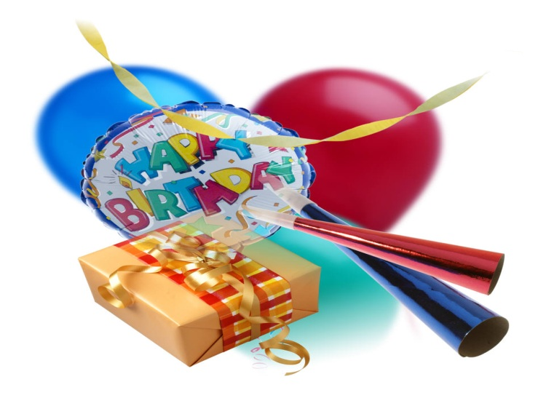

Name: Rikki Eichler
Birthday: 11/7/1988
Favorite Dessert: flowerless chocolate cake
Favorite Restaurant: Charlestons
Favorite Color: Purple
Favorite Drink: Dr. pepper
Favorite Store: Von Maur
Hobbies: Son
Favorite Junk Food: Sour Patch kids

