Oklahoma Academic Standards
Oklahoma is working to implement new academic state standards focused on preparing students for College, Careers and Citizenship - the Oklahoma Academic Standards. This includes the Common Core State Standards (CCSS), adopted in 2010, for English language arts and mathematics for grades K-12. Revisions of current state standards for remaining subject areas (social studies, science, visual arts/music, physical education, and world languages) began in 2012 and are ongoing.

Oklahoma’s Academic Standards serve as expectations for what students should know and be able to do by the end of the school year. The development, review and revision process involves stakeholders throughout the state of Oklahoma and is an ongoing and critical component to ensure Oklahoma students in every classroom receive current and relevant learning experiences
Oklahoma Academic Standards Does:  - Does focus Academic State Standards on deep thinking, conceptual understanding, and real-world problem solving skills  - Does set expectations for students to be College, Career, and Citizenship ready  - Does incorporate literacy in Science, Social Studies, and Technical Subjects  - Does emphasize the use of citations and examples from texts when creating opinions and arguments  - Does prioritize mathematical practices such as perseverance, reasoning, and modeling  - Does increase rigor and grade-level expectations | Oklahoma Academic Standards Does Not:  - Does Not dictate how teachers should teach  - Does Not mandate a specific curriculum  - Does Not limit advanced work beyond the standards  - Does Not require the purchase or development of entirely new instructional materials  - Does Not prescribe all that can or should be taught  - Does Not limit efforts to prepare students for College, Career, and Citizenship readiness  - Does Not prescribe interventions for students below grade-level  - Does Not determine the full range of support for English Language Learners and Students with Special needs.
Was Not written or funded by the Federal Government. Oklahoma educators and content specialists participated in the writing, review and feedback process of the Oklahoma Academic Standards.

Oklahoma Academic Standards for English, Mathematics, Social Studies, & Science:
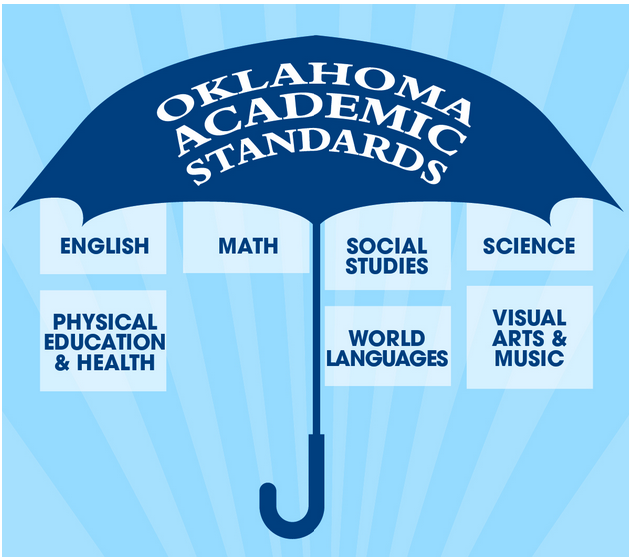
English and Mathematics: Oklahoma State Board of Education adopted Common Core State Standards (CCSS) for grades K-12 in June 2010. Pre-Kindergarten standards are currently undergoing revision. Transitions began in 2010 and will be completed by school districts prior to the 2014-2015 school year. Oklahoma educators participated in the drafting of the Common Core State Standards.

Social Studies: Oklahoma State Board of Education adopted revised Oklahoma content standards for Social Studies and History in 2012 for Pre-K-12 to include CCSS Reading and Writing Skills. Transition to be completed by school districts in the 2013-2014 school year. Committees of Oklahoma educators & content experts participated in writing the Oklahoma Academic Standards for Social Studies.

Science: Currently undergoing revision process (2012-2013) for grades PreK-12 to include CCSS Reading and Writing skills. Committees of Oklahoma educators & content experts are participating in writing the Oklahoma Academic Standards for Science.

