
Oklahoma State Department of Education
County 4-Mill Monthly Submission

September 3, 2014
VERSION 01.00

Oklahoma State Department of Education
2500 North Lincoln Boulevard
Oklahoma City, OK 73105-4599

Table of Contents
1 – Introduction 3
1.1 - Purpose 3
1.2 - How to use this document 3
2 – Completing the County 4-Mill Monthly Submission 4
2.1 Go to the County4Mill.Ok.Gov 4
2.2 Navigation of County 4-Mill Menus 5
2.3 General Navigation 5
3-- Submitting the Report 6
3.1 On Screen Data Entry 7
3.2 PIN Number Verification 8
3.3 Successful Submission 9

1 – Introduction
This website will collect the County 4-Mill Monthly Submission data from each of the 77 County Treasurers.

1.1 - Purpose
The purpose of this manual is to provide a step-by-step resource for accessing and submitting the State Aid County 4-Mill Monthly Submission.

1.2 - How to use this document
This document is intended to be a step-by-step guide for submitting County 4-Mill data. To access successfully, follow the steps outlined in this document. For assistance with a specific section, identify the exact area in the Table of Contents and navigate to that section with a click of the mouse to follow the instructional steps. If you have any questions regarding this report, please contact the State Aid Office at 405.521.3460 for assistance.

2 – Completing the County 4-Mill Monthly Submission
Access to the County 4-Mill Monthly Submission is provided to users by their County Treasurer. The County Treasurer will be given a single, unique PIN number which will grant them access to complete the submission.

2.1 Go to County4Mill.Ok.Gov
To begin, go to the County 4 Mill website (https://apps.sde.ok.gov/Co4Mill).
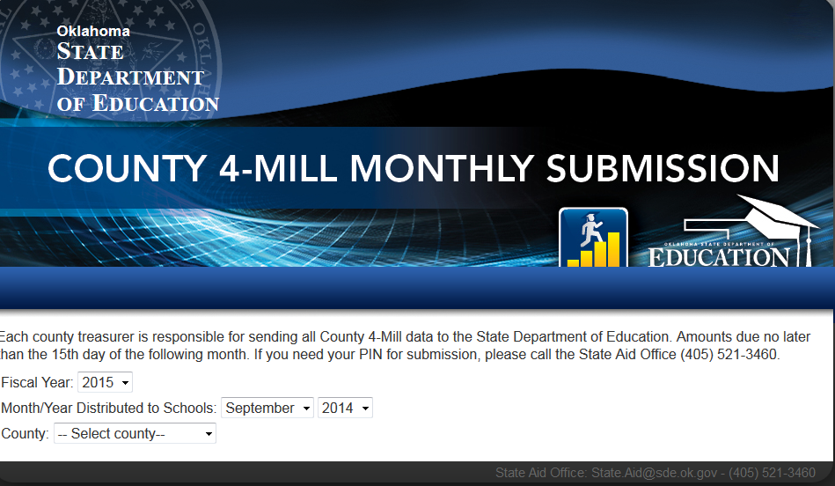
Figure 1 – County4Mill.Ok.Gov

2.2 Navigation of County 4-Mill Menus
Once on the website, select the appropriate month, year, and county options from the dropdown menus.
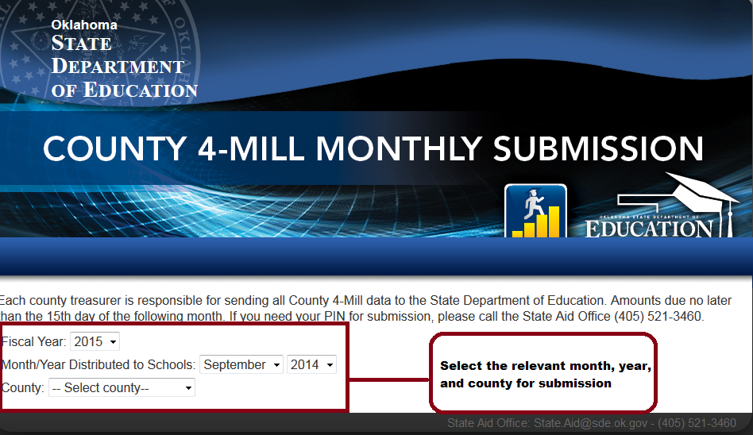
Figure 2 – Dropdown Selection

2.3 General Navigation
The following columns are visible—
Column Descriptions:
- Fiscal Year – The relevant fiscal year for the submission.
- Month/Year Distributed to Schools – The appropriate month and year for the current submission.
- County – The appropriate county attempting to submit data.
- County No. – The designated county number.
- District No.— The designated district number.
- District Name – The districts within the selected county.
- Amount –
- Name— Name of the person submitting the County 4-Mill data.
- Unlock— If submitted data needs to be revised, contact the State Aid Office in order for them to unlock the submission.
- Print— Prints submission.
- Clear—Clears all entered data.
- Save—Saves partial data in order for County 4-Mill to be submitted at a later date.
- Submit— Submits data to the State Aid Office.

3 – Submitting the Report
This section provides instructions for completing the report. The timeframe for the report’s submission is no later than the 15th day of the following month.

3.1 On Screen Data Entry
- After selecting the appropriate County, the County No., District No., and District Name will be prepopulated.
- Enter the Amount information for each district.
- Enter the name of the individual submitting the form.
- Click “Submit” to send the data.
- After submitting, a verification window will appear in order to collect the unique PIN number given to each County Treasurer.
- Enter the PIN number and press “OK”.
- Submission process complete.

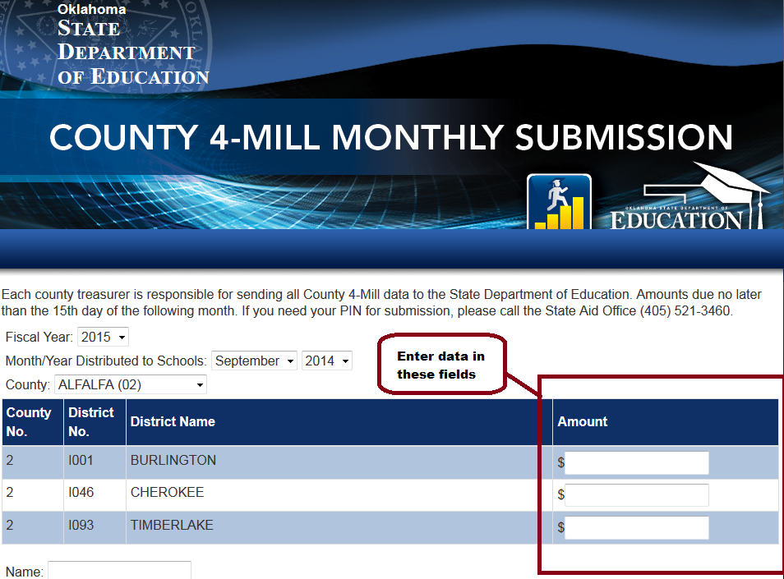
Figure 1 – Data Entry Fields
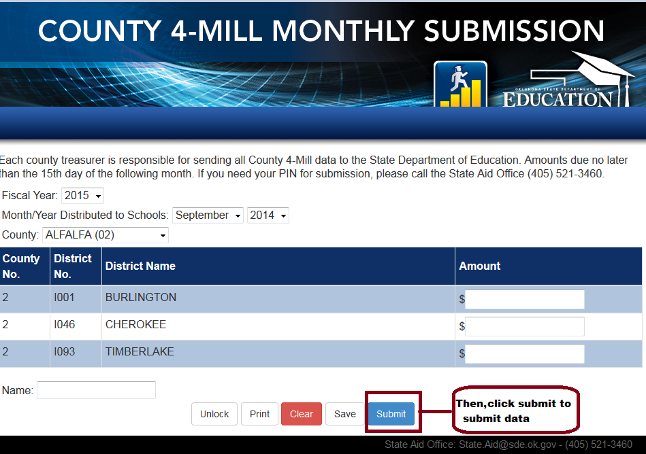
Figure 4 – Submit Data

3.2 PIN Number Verification

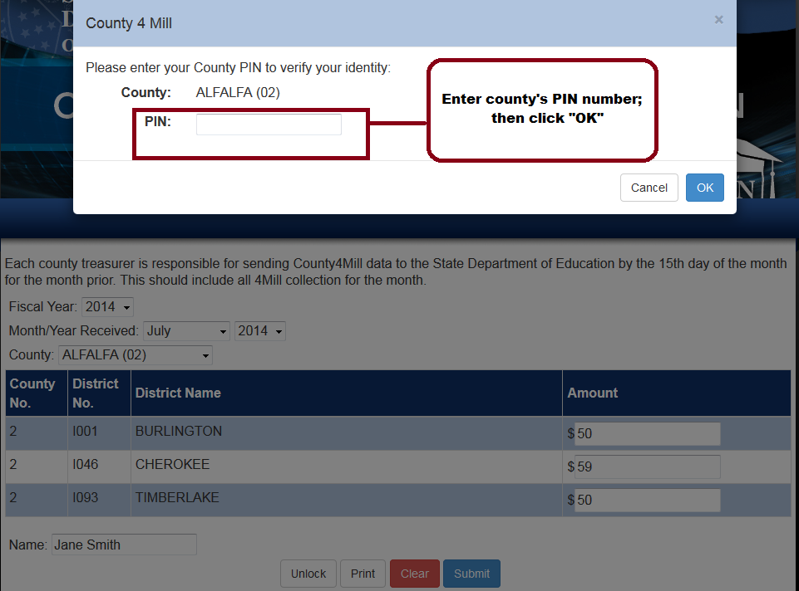
Figure 5 – PIN Number Verification

3.3 Successful Submission

Once the data is submitted, a message will show that the County 4-Mill Submission process is complete. It is recommended that you print a copy of your successful submission for your personal records.

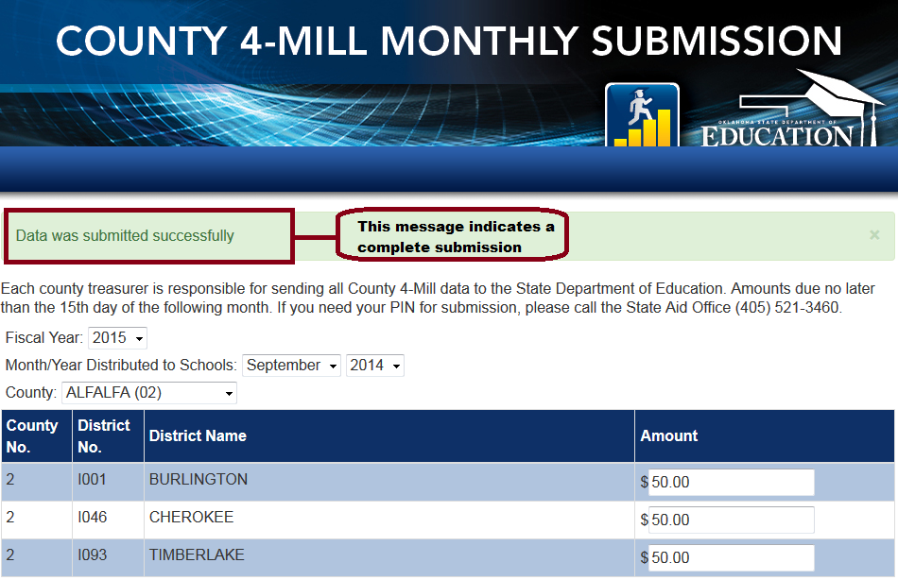
Figure 6 – Successful Submission

