Demographic Overlay Guide

The Office of Accountability | 3/30/17 | Version 1.0

Contents
Introduction 2
Purpose 2
Deadline 2
Access to the Demographic Overlay Report 3
Navigating to the Wave 3
Navigating to the Report 4
Site Selection and Reporting Status 5
Navigation Bar 6
Site Selector 6
Find Missing Students 6
On Screen Data Entry 6
Prepopulated Data 7
Final Report 7
Reporting Tools 7
Demographic Overlay Report 7
Report Column Definitions 8
Report Features 12
Contact Information 13

Introduction
The Demographic Overlay report displays the demographic information from your Student Information System (SIS) that will be used for all Assessment and Accountability Reporting including individual student reports from the Assessment vendor and the A-F Report Card. This data should be reviewed carefully and corrected within your SIS.

Purpose
The purpose of this manual is to provide a step-by-step resource for accessing and submitting the Demographic Overlay Report to the Oklahoma State Department of Education for review and approval.

Deadline
The deadline for certification of the Demographic Overlay Report is 10:00 AM, May 3, 2017. Upon certification, the data will be pulled into a snapshot table to be sent to the Assessment vendor and will be used for Accountability. The student demographic data will continue to update within the application so that you can view the demographics that your SIS is sending for your current students at any time throughout the year. Please note: All data must be finalized in your Student Information System on May 2, 2017 so that any changes will be reflected on May 3rd when the data is pulled and sent to the vendor.

Access to the Demographic Overlay Report
Access to the Demographic Overlay Report is provided to a user by the District Superintendent through the Single Sign-On System.
The Superintendent will need to grant each person access that they would like to review or submit the report. This will include the site level person who will complete each site level report and any other individuals determined by the Superintendent.

Navigating to the Wave
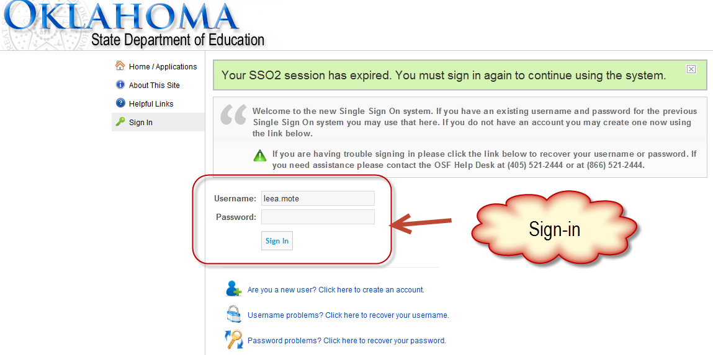
To begin, go to the Single Sign-On Web site (https://sdeweb01.sde.ok.gov/SSO2/Signin.aspx), log in, and choose the “The Wave’s Portal” option from the list of Systems. The list of systems will vary person-to-person depending on what other applications they have access to.

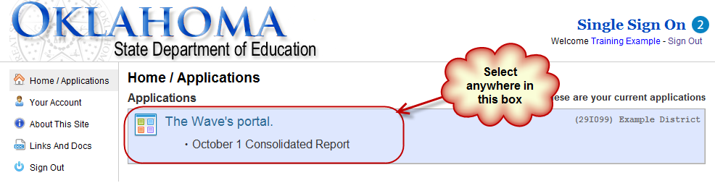

Navigating to the Report
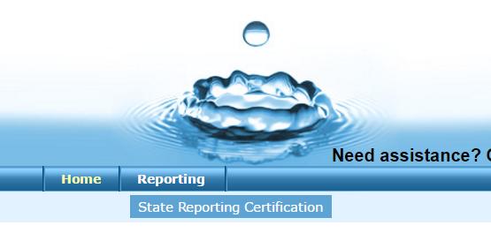
Once you are logged into the Wave, go to the Reporting tab and select State Reporting Certification. This is the application where reporting certification will take place. Once you’ve accessed the State Reporting Certification Application, you can scroll to the bottom of the screen and it will list all of the current reports.
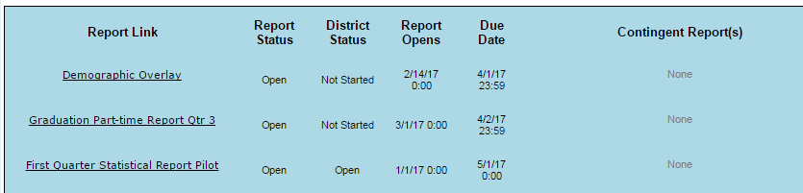
Select Demographic Overlay in the Report Link column.
Below is a list and description of the different columns in this table.
- Report Link - The link that will take you into the actual report
- Status - The "District" status. This will only change to the next level when all school sites associated with that report for your district reach the next level. There are four levels: "Not Started," "In Process," "Confirmed," and "Certified."
- Report Opens - The first day you can access the report.
- Due Date - The day the report is due certified (May 3rd, 2017).
- Contingent Report(s) - This indicates the report requires another report to be completed first. You will not be permitted to begin a report that is contingent upon another until the other report shows a status of "Certified." If "None" is listed, the report is NOT contingent and can be started on or after the "Report Opens" date. The Demographic Overlay Report is not contingent on any other report
- Report Note - This is a summary about the report. Clicking on this will provide you with information related to this report (e.g. Purpose, applicable state or federal laws, new additions or functions in the report).
- Program Area / Phone # - The State Department of Education program area responsible for the collection of this report and the phone number you should call with questions related to this report.

Site Selection and Reporting Status
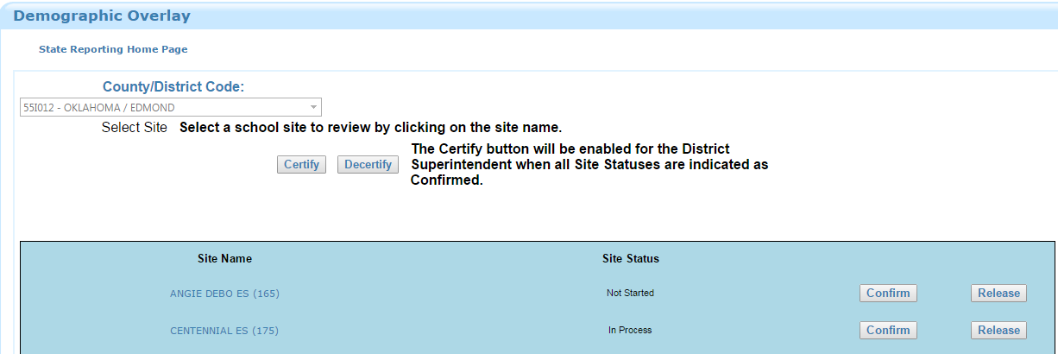
To begin the report, click on a school in the school list under the column heading “Site Name”.

For each site there is a site status to indicate what part in the process the school is in. All schools must reach a “Certified” status. Below is a graphical representation of the statuses that the report goes through. On this screen the following functions are available:
- Confirm - Only the District Superintendent and Site Principal will be able to click the "Confirm" button. This will lock the data so that it can no longer be edited. It will still be viewable.
- Release - Only the District Superintendent can click the "Release" button. This will undo the "Confirm" and allow the data to be edited again. Only the District Superintendent, not the State, can Release the report from Confirmation.
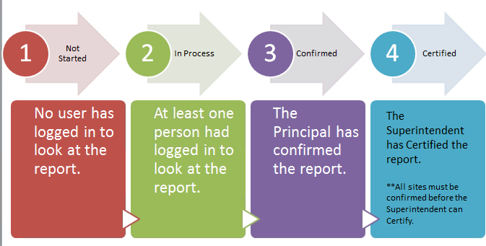
- Certify - Only the District Superintendent can click the "Certify" button and only after all of the schools are listed with a status of "Confirmed." This will lock the "Release" button so that the report can no longer be edited by the district. Only the state can unlock the Certified Report. Call the phone number on the State Reporting Certification Dashboard associated with this report to have the report unlocked.

Navigation Bar
Below the general instructions on the page is the Navigation Bar with six buttons. These buttons allow you to adjust the report to On Screen Data Entry from Prepopulated Data, Find Missing Students, Review the Final Report, Go back to the Site Selector screen, and view Reporting Tools.

Site Selector
The Site Selector button allows you to go back to the Site Selector screen to view the status of other sites within your district.

Find Missing Students
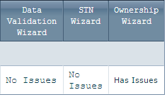
The Find Missing Students button should be the first thing that you do upon entering the report. This takes you to a list of students the SDE believes should be in your Demographic Overlay report, but have errors with some of the required fields. It is possible for this report to list no students if there are no errors currently present. There are three columns to the far right of the screen that display which wizard can be used to resolve the problem or problems for a student that is listed. To view these wizards, click on the District Tab at the top of the screen and navigate to the wizard that corresponds with the issue. If this report does not list any students, then you may continue reviewing the main report.
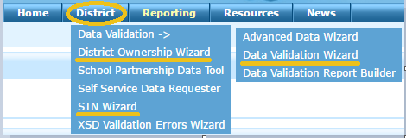

On Screen Data Entry
The Demographic Overlay Report begins with Prepopulated data from your Student Information System (SIS). Changes to student demographic must occur in your local SIS. If you encounter a problem with how the Teacher/Class Names are listed for a student that you cannot fix in your SIS, you have the opportunity to fix this issue by clicking on the On Screen Data Entry button. The student demographics will continue to update for all records, but from that point forward, the Teacher/Class Names will no longer update from your SIS.
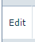
To edit a teacher name, click the Edit button that only appears after clicking the On Screen Data Entry button to the left side of the report.
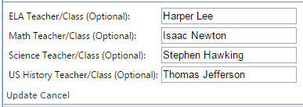
This will bring up the list of Teacher/Class Names. You can edit the Teacher/Class name by typing in the provided box. Please note: the Teacher/Class names will be used for all Assessment reporting. This information should match your Class Identification sheets exactly. Any differences could cause potential reporting discrepancies at the Teacher/Class level.

Prepopulated Data
If you have entered into On Screen Data Entry, but would like to revert to the data from your SIS, click on the Prepopulated Data button. This button is only available when you are in On Screen Data Entry.

Final Report
The Final Report button brings up the current student demographics.

Reporting Tools
Currently, there are no additional reports related to the Demographic Overlay. As needs arise, additional reports may be added into the Reporting Tools page.

Demographic Overlay Report
The Demographic Overlay report makes up the body of the screen. The information represented in this report reflects the information sent to the Wave from your Student Information System (SIS). If you find an error in the data displayed in this report, please update your SIS. Any changes made to your SIS should be reflected within 24 hours. If you discover that the information is correct in your SIS, but does not match the WAVE, please contact your SIS vendor. Your vendor will need to resolve the translation error. The description for each column in the Demographic Overlay can be found below.

Report Column Definitions
Column Header | Description | Wave Object
School ID | The two digit County code, four character District code, and three digit Site code. When combined, they comprise a unique identifier for a school. | School Info
STN | The Student Testing Number (STN) is a ten digit unique identifier for each student. A valid STN will begin with 100. | Student Personal
Local ID | The locally-assigned identifier for this student (if applicable). | Student Personal
Last Name | The student's last name. | Student Personal
First Name | The student's first name. | Student Personal
Birth Date | The student's birth date. | Student Personal
Gender | The student's gender. | Student Personal
Grade | The student's grade level. | Student Personal
ELL | An indicator of whether the student has been identified as an English Language Learner under Title III. Additional information about English Language Learners can be found at the following link: http://sde.ok.gov/sde/title-iii | Student Personal
ELL 1st Yr Prof | An indicator of whether the student exited the English Language Learner within the past 12 months. | Student Personal
ELL 2nd Yr Prof | An indicator of whether the student exited the English Language Learner within the past 13 to 24 months. | Student Personal
504 Prg | An indicator of whether the student is a qualified individual under Section 504 of the Rehabilitation Act? Please see the following link for more information about Section 504: http://sde.ok.gov/sde/sites/ok.gov.sde/files/documents/files/Parent-Guide-to-504.pdf | Student Personal
Large Print | An indicator of whether a student’s IEP requires state assessments to be administered in large print format. | EdPlan
Braille | An indicator of whether a student's IEP requires assessments to be administered in Braille format. | EdPlan
IEP | An indicator of whether a student is receiving special education services under IDEA. | Student Personal
Migrant | An indicator of whether the student is identified as a migrant student. Please see the following link for more information on migrant students: http://sde.ok.gov/sde/title-i-part-c | Student Personal
Title X | An indicator of whether the student has experienced homelessness at any point throughout the current school year. Please see the following link for more information: http://sde.ok.gov/sde/faqs/title-x-part-c-mckinney-vento-homeless-education-frequently-asked-questions#definitions | Student Personal
Economic Disadvantaged | An indicator of whether the student would be eligible for free-reduced lunch based on family income, even if they are not actually receiving a free or reduced lunch. | Student Personal
Hispanic | An indication that the individual traces his or her origin or descent to Mexico, Puerto Rico, Cuba, Central or South America, or other Spanish cultures, regardless of race. Any student that is listed as "Yes" for the Hispanic ethnicity column is considered Hispanic for Assessment and Accountability reports regardless of any of the racial identifiers. | Student Personal
American Indian | The student identifies as American Indian or Alaska Native. | Student Personal
Asian | The student identifies as Asian. | Student Personal
Black | The student identifies as Black or African American. | Student Personal
Pacific Islander | The student identifies as Pacific Islander. | Student Personal
White | The student identifies as White or Caucasian. | Student Personal
Military | An indicator of whether the student has a parent or legal guardian who is a member of the Armed Forces of the United States, a member of a reserve component of the Armed Forces of the United States, or a member of the National Guard. | Student Personal
Foster | An indicator of whether the student is currently in foster care. | Student Personal
Last Exit Date | The student's most recent exit date from your school site. This will allow you to distinguish between current students and students who were previously enrolled. | Student School Enrollment
ELA | This identifies the test type of the ELA assessment. (Not Applicable, OSTP/Online, OSTP/Paper, OAAP, ELL/Exempt.) | Student Section Enrollment
Math | This identifies the test type of the Math assessment. (Not Applicable, OSTP/Online, OSTP/Paper, OAAP.) | Student Section Enrollment
Science | This identifies the test type of the Science assessment. (Not Applicable, OSTP/Online, OSTP/Paper, OAAP, Biology EOI Exempt.) | Student Section Enrollment
US History | This identifies the test type of the US History assessment. (Not Applicable, OSTP/Online, OSTP/Paper) | Student Section Enrollment
ELA Teacher/Class (Optional) | This identifies the ELA teacher or class name for the student. | Section Info
Math Teacher/Class (Optional) | This identifies the Math teacher or class name for the student. | Section Info
Science Teacher/Class (Optional) | This identifies the Science teacher or class name for the student. | Section Info
US History Teacher/Class (Optional) | This identifies the US History teacher or class name for the student. | Section Info

Report Features
The Demographic Overlay Report has several useful features that allow you to select the number of records per page, sort and filter, rearrange the column order, and download the file as a Comma Separated Value file (.csv) or an Excel spreadsheet.
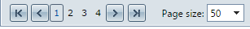
To select the number of records on each page, scroll to the bottom of the report and use the drop down menu to select either ten, twenty, or fifty records per page.
To sort a column, you click on the white column name in the blue report header. Click again to sort in the opposite order.
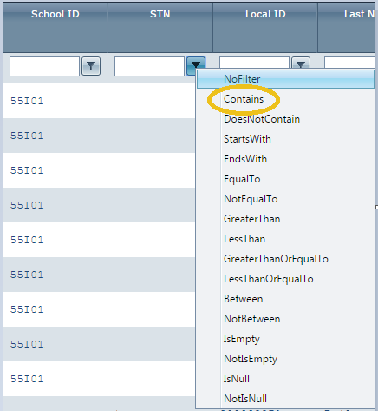
To filter a column, you begin by typing the filter criteria in the white box at the top of a column and clicking on the flag next to the column. This presents you with a list of filter types. The most commonly used filter is the “Contains” filter. This will display any record that contains the value entered into the white text box.
Another useful feature allows you to rearrange the order of the displayed columns by clicking on the column header and dragging it to your desired location.

If you find it easier to review the data in Excel or another spreadsheet/data processing software, you can download a copy of your data. To download an Excel spreadsheet (.xls format), navigate to the top right of the report, and click on the button with the green Excel logo. To download as a Comma Separated Values (.csv) file click on the csv button.

Contact Information
If you encounter any issues or need more information, please contact the Office of Assessment and Accountability.
Assessment – Main Line – 405-521-3341
Accountability – Main Line – 405-522-5169
To reach Angela Bilyeu, Assistant Executive Director of Assessment or Craig Walker, Executive Director of Assessment, please email Assessments@sde.ok.gov.
To reach Matt Morgan, Assistant Executive Director of Accountability or Dr. Michael Tamborski, Executive Director of Accountability, please email Accountability@sde.ok.gov.

