Dropout Report Calculations
State statute (70 O.S. § 35 E) requires each accredited Oklahoma school with students in any of the grades 7 - 12 to report dropouts to the Oklahoma State Department of Education (OSDE) on an annual basis for state and federal reporting requirements.
For the 2021 dropout report only, preliminary calculations are being sent to you as a .csv via t e-mail so that you may review while the calculation report web page is being built on Accountability Reporting. The purpose of this document is to assist you in reviewing the calculations in your .csv file.

Denominators (Columns G – J)
As part of the dropout rate, the denominator used for all calculations is the school’s certified enrollment count on the October 1 report.
To begin verifying student counts, first log in to the Wave Portal in Single Sign On.
Click the Reporting tab and then State Reporting Certification.
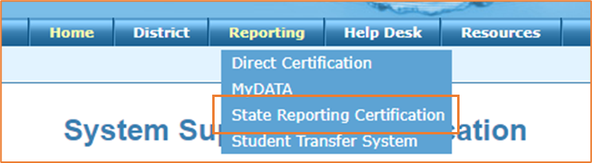

Scroll down and select the appropriate county/district, select October 1 Consolidated Report, and then select a site from what you see listed.
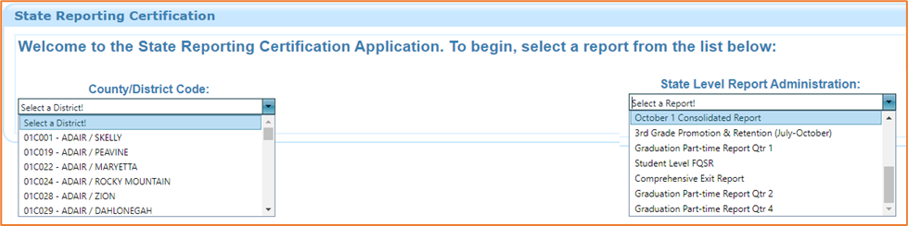
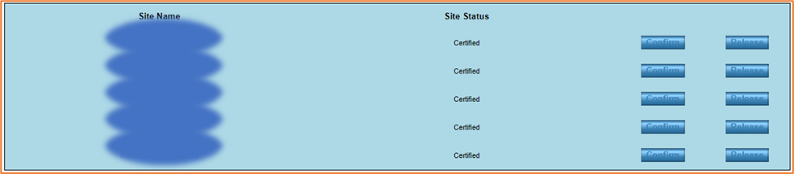
After selecting a school, click the reporting tools tab, select Oct 1 Student Demographic as the report and 2021 as the school year.
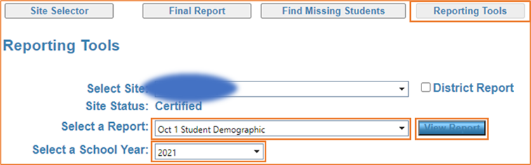
Now, click view report, and near the top of the report page you’ll be able to save your report as an Excel file.
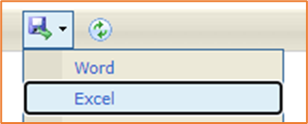
With this Excel file, you’ll be able to filter by grade level and age to confirm student counts. To meet state reporting requirements, we used the age (via Date of Birth) of the student as of Oct 1. 2020 to filter out students aged 19 or older in column I.

Numerators (Columns M, O, Q - AL
Because required state and federal reporting have different specifications for how the dropout numerator is calculated, there are several columns representing numerators based on both state and federal requirements.
Dropout counts can be verified through the dropout report in the Accountability Reporting application. After logging in to SSO and clicking into the app, click the Reports tab.
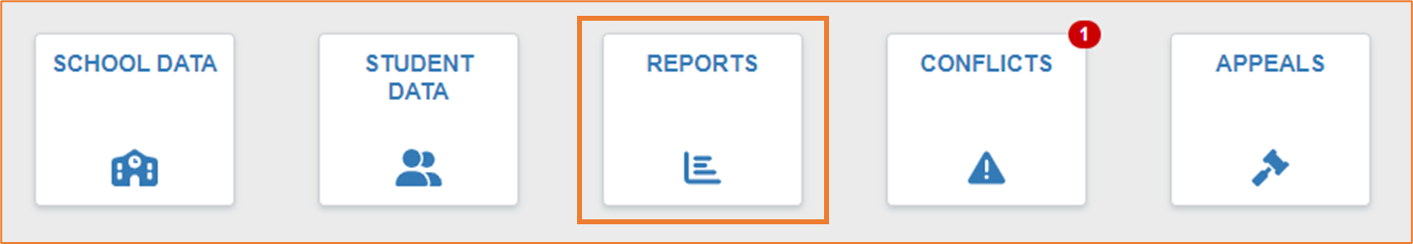
Next, select the dropout report from the Reports dropdown list.
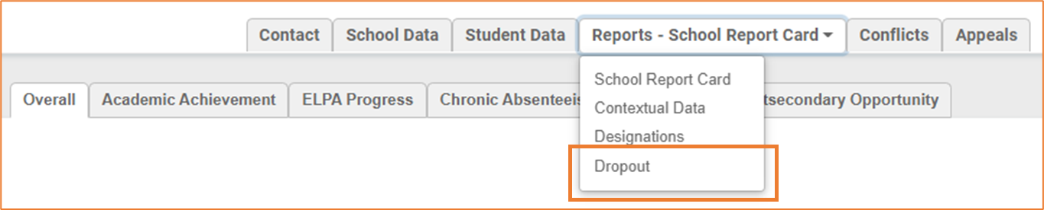
Click the blue numerator link. Every demographic need to filter for the appropriate numerator (grade, date of birth for age, gender, and race/ethnicity) are included in this pop-out.
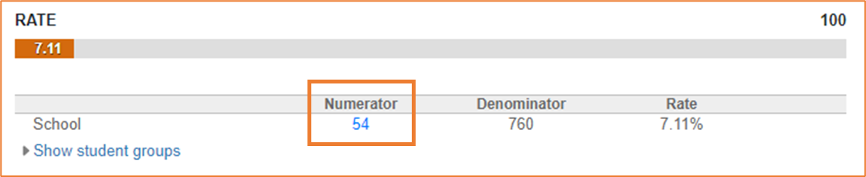
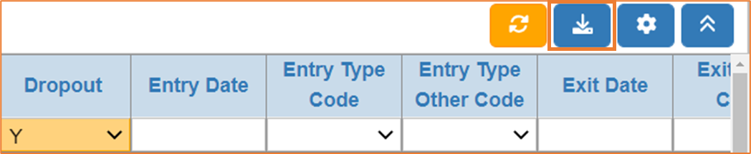

OHP and exceptions (Columns AM – AQ)
Students identified as Out-of-home placement are not included in your official dropout rate. For greater transparency, they are separated out in their own calculation. Because of the high mobility of these students, the denominator includes the total number of OHP students served by your school or district during the school year.
Exceptions are students for whom you provided documentation showing that records were requested or provided for purposes of enrolling in another Oklahoma school, but the student never actually enrolled. These students are not included in your official numerator, but they are shown here in an unadjusted dropout rate. Neither the unadjusted dropout rate nor the exception count will be included in the public report.

Verifying Rates
Dropout rates can be verified by dividing the appropriate numerator by the denominator. The formula for each rate is specified in the included data dictionary

How to ask us a question about the calculations
If you have evidence that any of the preliminary numbers are incorrect, if a documented rule is not being followed, or if you believe that an appeal was not applied appropriately, you may use the same application to submit a question or concern for us to review.
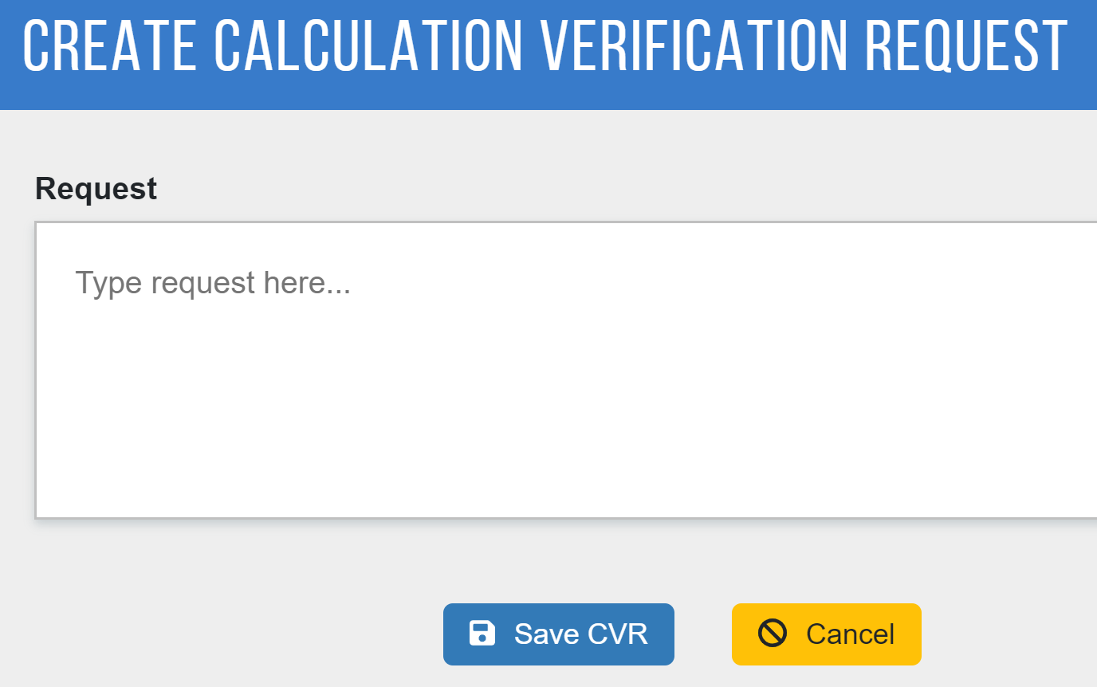
Please keep in mind that we are only able to review inquires relating to reviewing aggregations, and this should not be used as a forum to submit Data Verification Requests.
We ask that you please send us any concerns by 12:00 PM on Monday, April 25th, 2022. At the time, we will begin work and finalizing data for public reporting.
If you have any additional questions, please do not hesitate to email us at dqr@sde.ok.gov or call us at 405-521-2330.
The Data Quality and Research Team

