Certain students completing WIDA ACCESS and Alt ACCESS assessments may be eligible for exit by committee if meeting certain criteria. Instructions for each assessment type may be found below.

ACCESS for ELLs 2.0 ELP Band Instructions:

- STEP ONE: Step One has two parts. Check that the student is in 3rd grade or above and has met the two required criteria. In order for an EL student who takes ACCESS for ELLs 2.0 to advance to an ELP band committee and be considered for redesignation as English proficient and exit from EL services, the student must be found to have met the two required criteria on the ACCESS for ELLs 2.0 ELP Band Rubric, which are as follows:
  - The student must have scored within the ACCESS ELP band of 4.3-4.7 on Composite/Overall, AND
  - If student was in an OSTP-tested grade, the student must have scored Basic or above on their OSTP ELA test in the same year that they tested within the ACCESS ELP band, OR
  - If the student was not in an OSTP-tested grade, the student must have scored above the 35th percentile on a norm-referenced reading test that is from either the list of Approved Substitutions for OSTP ELA Score Requirement for Third Graders or the list of Approved Substitutions for OSTP ELA Score Requirement for Secondary Students in Non-OSTP Tested Grades.

IMPORTANT NOTE: Students who have not met the STEP ONE criteria are not eligible to advance to an ELP band committee, and are not eligible to be re-designated as English proficient and exited from EL services.

- STEP TWO: Step Two has two parts. Check that the student has met at least one of the optional criteria and secured the recommendation of the district EL representative. In order for a student who takes ACCESS for ELLs 2.0 and has advanced to an ELP band committee decision to be redesignated as English proficient and exited from EL services, the student must also be found to have:
  - Met at least one of the five additional optional criteria listed on #3-#7 on the ACCESS for ELLs 2.0 ELP Band Rubric, AND
  - Be recommended for redesignation as English proficient and exit from EL services by the district EL representative for that student.

Alternate ACCESS for ELLs ELP Band Instructions:

- STEP ONE: Step One has three parts. Check that the student in is 3rd grade or above and has met the three required criteria. In order for an EL student who takes Alternate ACCESS for ELLs to advance to an ELP band committee and be considered for redesignation as English proficient and exit from EL services, the student must be found to have met the three required criteria on the Alternate ACCESS for ELLs ELP Band Rubric, which are as follows:
  - The student must have scored within the Alternate ACCESS ELP band of A3-P1 on Composite/Overall for two consecutive test years, AND
  - The student must be found to have shown growth at the Essential Element level on the DLM Reading assessment, AND
  - The student must have demonstrated progress in acquiring ELA content area knowledge, as evidenced via IEP documentation.

IMPORTANT NOTE: Students who have not met the STEP ONE criteria are not eligible to advance to an ELP band committee, and are not eligible to be re-designated as English proficient and exited from EL services.

- STEP TWO: Step Two has two parts. Check that the student has secured the recommendation of the district EL and IEP representatives. In order for a student who takes Alternate ACCESS and has advanced to an ELP band committee decision to be redesignated as English proficient and exited from EL services, the student must also:
  - Be recommended for redesignation as English proficient and exit from EL services by the district EL representative for that student, AND
  - Be recommended for redesignation as English proficient and exit from EL services by the district IEP representative for that student.

In order to submit a request to exit a student based on ELP band committee:
1. Log onto Single Sign On. Select “Accountability Reporting”
2. Select District Data from the “Your District” drop down
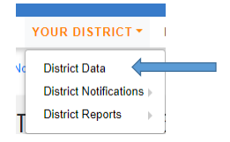
3. Select a School site and then select “Student Assessments ELP”
4. Select the student that meets the criteria for exit (e.g. composite of 4.3-4.7). Please note that you can only submit one request per student.
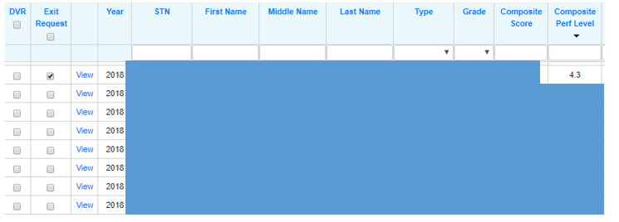

5. Once you’ve selected the student you wish to request an ELP Band exit, click ‘Create ELPA Band Committee Exit Request’ on the top of the screen.
6. In the Request box, explain how the student meets the criteria and attach the Access for ELLs 2.0: ELP Band Committee Rubric or Alt ACCESS Rubric.
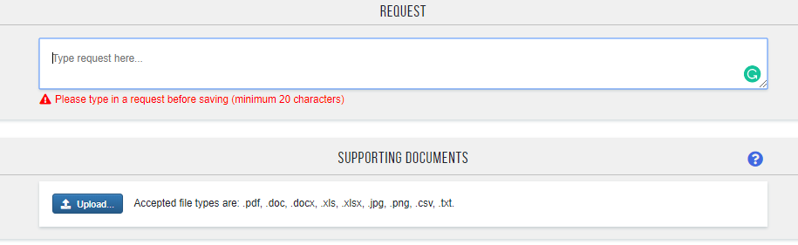
7. Hit “Save” or “Save and Return”
8. The exit requests are reviewed and granted by committee. Once a request has been reviewed, it will be “granted” or “denied”. Granted students will be “exited” and count as “on-track” for purposes of Accountability.

