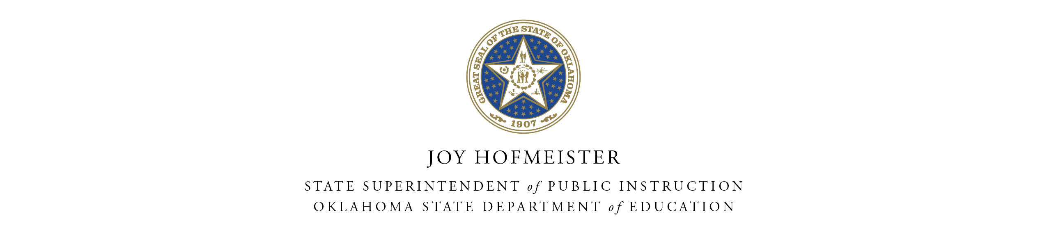

ANNUAL NEGLECTED AND DELINQUENT SURVEY

Subpart 2 Local Education Agencies
Annual Survey of Children Residing in Institutions for Neglected or Delinquent Children
______________________________________________________________________________

PURPOSE OF SURVEY

The purpose of the Annual Neglected and Delinquent Survey is to provide the U.S. Department of Education (ED) with accurate information to:

(1) Calculate school year 2017-2018 school district allocations for the Grants to Local Educational Agencies (LEAs) program authorized by Title I, Part A of the Elementary and Secondary Education Act (ESEA); and

(2) Determine the amount states have available for LEAs to operate local programs for at-risk children authorized by Title I, Part D, Subpart 2, ESEA.

SURVEY REQUIREMENTS

The Neglected and Delinquent Survey is required annually for all applicable Local Educational Agencies. No sampling or estimating is to be used in preparing this survey. Since this data will generate federal funds, it is subject to monitoring and must be supported by documented records that are kept on file at your agency. The completion of the Annual Neglected and Delinquent Survey is required to obtain funds.

IDENTIFYING YOUR INSTITUTION AS SERVING NEGLECTED OR DELINQUENT

Local institutions for neglected children- The definition in Section 1432(4)(A) of the Title I statute states: The term institution for neglected children and youth is a public or private residential facility, other than a foster home, that is operated for the care of children who have been committed to the institution or voluntarily placed in the institution under applicable state law, due to abandonment, neglect, or death of their parents or guardians.

OR

Local institutions for delinquent children- The definition in Section 1432(4)(B) of the Title I statute states: The term institution for delinquent children and youth is a public or private residential facility for the care of children who have been adjudicated to be delinquent.
Each eligible institution must identify itself as either an institution for neglected children or an institution for delinquent children, even if it serves both. The count of children in an institution for neglected children may include delinquent children. Likewise, the count of children in an institution for delinquent children may include neglected children.

The category of an institution should not change from year to year unless there has been an official change in the purpose for which the institution is operated, such as a new organizational owner serving a different population that still meets the eligibility requirements.

CHILDREN THAT ARE NOT ELIGIBLE TO BE COUNTED IN THIS SURVEY

Do not count children living in an individual foster home (a person’s home) or children attending a community day program where the child goes home at night. Though a Title I Part D delinquent community day program can receive funds, it cannot generate funds.

COUNTING ELIGIBLE CHILDREN

In order for a child to be eligible to be counted in this survey, a child must meet these three conditions:

1. The child must be age 5 through 17 when the survey was taken;

2. The child must live in a locally operated facility that meets the definition of an institution for neglected children or an institution for delinquent children, in Sections 1432(1), (4), of the Title I statute. See the definitions on page two.

3. The child must live in either a public or private institution for at least one day during the 30 day consecutive window count, which is from October 1, 2016 to October 30, 2016. The facility will submit a count to the local school district of children residing in the facility for each of the 30 days. At the end of the 30-day count, the district will enter the highest resident count for any single day during the count. This number represents the facility caseload and is to be entered on the form.

SURVEY ASSISTANCE

For assistance in completing the Annual Neglected and Delinquent Survey, please contact the Office of Federal Programs at 405-521-2846.

E-MAIL THE COMPLETED AND SIGNED SURVEY TO:

Anthony.Kibble@sde.ok.gov

SURVEY DEADLINE

Friday, November 18, 2016, is the deadline for the State Department of Education to receive the e-mailed Annual Neglected and Delinquent Survey.

OKLAHOMA STATE DEPARTMENT OF EDUCATION

County-District Code  &  Name of Local Educational Agency (LEA) / County | Facility Name | Neglected  Count  October 2016 | Delinquent  Count  October 2016 | Total
District Total

Please provide an explanation below, if the district has a significant difference in the number of neglected and delinquent children compared to the number reported in the previous year.

An example of this would be plus or minus 25 children and a 25% difference or an LEA for which a count was reported last year but not this year or vice-versa.

I certify that the local educational agency has determined that the data provided meet the requirements of Title I, ESEA. The information provided in this report is, to the best of my knowledge, complete and accurate.

___________________________________ __________________________
Superintendent’s Signature Certification Date

___________________________________
Superintendent’s Typed or Printed Name

If applicable, must be completed and returned by Friday, November 18, 2016, to: Anthony.Kibble@sde.ok.gov

