Families Data Tab Instructions
If you are serving families members at your site you will use a numeric 1 to indicate yes. Then you will enter in the total number of families that you serve in numeric form. See Figure 1.
Figure 1. Serving Families
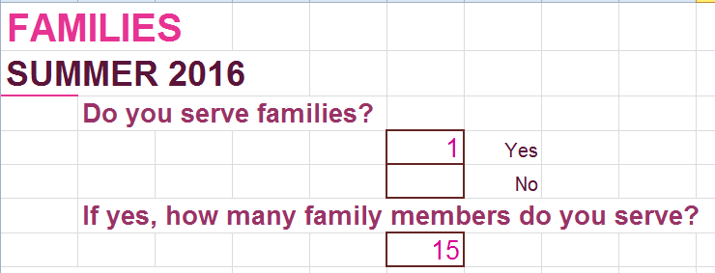
If you are not serving families at your site for the specific you will use a numeric 0 to indicate no. Then you will enter zero in the total number of families that you serve in numeric form. See Figure 2.
Figure 2.
