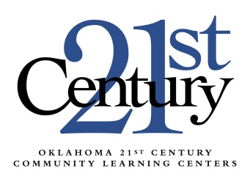
Approved Afterschool Specific
National Professional Development Opportunities
For Oklahoma 21st Century Community Learning Centers

To sustain a quality program, staff and volunteers who will be delivering academic support and enrichment services shall participate in a minimum of five “afterschool specific” learning opportunities. Staff training should focus on how afterschool is different from the normal school day as well as provide staff with ideas for enrichment and hands-on activities.
Below is a list of approved afterschool specific national and regional conferences and professional development opportunities for Oklahoma 21st Century Community Learning Centers. Please follow the links for more information on each event to assist with your PD planning for the year.

USDE 21st CCLC Summer Institute
United States Department of Education (USDE)
Usually around July
Dallas, TX
TBA

Beyond School Hours
Foundations, Inc.
Usually around February
Different locations each year
www.foundationsinc.org

NAA Annual Convention
National Afterschool Association
Usually around March
Different locations each year
naaweb.org/convention

BOOST (Best in Out of School Time) Conference
BOOST Collaborative
Usually around April
Palm Springs, CA
boostconference.org

Kansas Afterschool Educator Conference
Kansas Enrichment Network
Usually around April
Kansas City area
http://www.kansasenrichment.net/

The National Family and Community Engagement Conference
The National Family and Community Engagement Network (FCE Network)
Usually between April and June
Different locations each year
http://iel.org/fce

Summer Seminars
National Institute on Out-of-School Time (NIOST)
Usually around July
Brookline, MA
www.niost.org

Oklahoma Education and Industry Partnership Event
Usually around July
Midwest City, OK
*Call our office if you’re interested.

The Bridge from School to Afterschool and Back
School’s Out Washington
Usually around October
Seattle, WA
www.schoolsoutwashington.org/bridge

National Conference on Summer Learning
National Summer Learning Association
Usually around November
Location varies
www.summerlearning.org

Other Groups to Watch:
The Forum for Youth Investment
National Institute for Out-of-School Time
The Afterschool Corporation
Other State or Regional 21st CCLC Conferences

