

DRAFT

Oklahoma School Testing Program

2011 Technical Report

Achieving Classroom Excellence

End-of-Instruction

Assessments

Submitted to
The Oklahoma State Department of Education
September 2011

Executive Summary
Introduction
The Oklahoma School Testing Program (OSTP) is a state-wide assessment program that includes the End-of-Instruction (EOI) assessments, where students who complete an area of instruction must also take the corresponding state-wide, standardized assessment. The subjects included within this testing program are Algebra I, Algebra II, Geometry, Biology I, English II, English III, and U.S. History. Each test is a measure of a student’s knowledge relative to the Priority Academic Student Skills (PASS), Oklahoma’s content standards. These tests are part of the Achieving Classroom Excellence (ACE) legislation passed in 2005 as amended in 2006, which outlines the curriculum, the competencies, and the testing requirements for students to receive a high school diploma from the state of Oklahoma. Algebra I, English II, Biology I, and U.S. History were existing tests in the program with Algebra II, Geometry, and English III added as operational tests for the 2007-2008 testing cycle. These End-of-Instruction tests are administered in Winter, Trimester, Spring, and Summer. The OSTP was established to improve academic achievement for all Oklahoma students and it also meets the requirements of the No Child Left Behind Act (NCLB), which was introduced by the Federal Government in 2001. In 2006, Pearson was contracted by the Oklahoma State Department of Education (SDE) to develop, administer, and maintain the OSTP-ACE EOI tests. This report provides technical details of work accomplished through the end of 2011 on these tests.

Purpose
The purpose of this Technical Report is to provide objective information regarding technical aspects of the OSTP-ACE EOI assessments. This volume is intended to be one source of information to Oklahoma K-12 educational stakeholders (including testing coordinators, educators, parents, and other interested citizens) about the development, implementation, scoring, and technical attributes of the OSTP-ACE EOI assessments. Other sources of information regarding the OSTP-ACE EOI tests—administered mostly online, with some paper formatted tests available—include the administration manuals, interpretation manuals, student-, teacher-, and parent guides, implementation materials, and training materials.

The information provided here fulfills legal, professional, and scientific guidelines (AERA, APA, & NCME, 1999) for technical reports of large-scale educational assessments and is intended for use by qualified users within schools who use the OSTP-ACE EOI assessments and interpret the results. Specifically, information was selected for inclusion in this report based on NCLB requirements and the following Standards for Educational and Psychological Testing:
- Standards 6.1 – 6.15 Supporting Documentation for Tests
- Standards 10.1—10.12 Testing Individuals with Disabilities
- Standards13.1—13.19 Educational Testing and Assessment

This technical report provides accurate, complete, current, and clear documentation of the OSTP-ACE EOI development methods, data analysis, and results as is appropriate for use by qualified users and technical experts. Section 1 provides an overview of the test design, test content, and content standards. Section 2 provides summary information about the test administration. Section 3 details the classical item analyses and reliability results, and Section 4 details the calibration, equating, scaling analyses, and results. Section 5 provides the results of the classification accuracy and classifications studies. Finally, Section 6 provides higher-level summaries of all the tests included in the OSTP-ACE EOI testing program.

Information provided in this report presents valuable information about the OSTP-ACE EOI assessments regarding:
- Content standards,
- Content of the tests,
- Test form design,
- Administration of the tests,
- Identification of ineffective items,
- Detection of item bias,
- Reliability of the tests,
- Calibration of the tests,
- Equating of tests,
- Scaling and scoring of the tests, and
- Decision accuracy and classification.

Each of these facets in the OSTP-ACE EOI assessments development and use cycle is critical to validity of test scores and interpretation of results. This technical report covers all of these topics for the 2010-11 testing year.

Table of Contents
Section 1 1
1.1 Overview of the OSTP-ACE EOI Assessments 1
1.1.a Purpose 1
1.1.b PASS Content Standards 1
1.2 Summary of Test Development and Content Validity 3
1.2.a Aligning Test to PASS Content Standards 3
1.2.b Item Pool Development and Selection 4
1.2.c Configuration of the Seven Tests 5
1.2.d Operational and Field Test Items by Content Area 6
Section 2 14
2.1 Packaging and Shipping 14
2.2 Materials Return 14
2.3 Materials Discrepancies Process 15
2.4 Processing Assessment Materials Returned by Schools 15
Section 3 16
3.1 Sampling Plan and Field Test Design 16
3.1.a Sampling Plan 16
3.1.b Field Test Design 16
3.1.c Data Receipt Activities 16
3.2 Classical Item Analyses 18
3.2.a Test-Level Summaries of Classical Item Analyses 18
3.3 Procedures for Detecting Item Bias 19
3.3.a Differential Item Functioning Results 20
3.4 Data Review 21
3.4.a Results of Data Review 22
3.5 Test Reliability 23
3.6 Test Reliability by Subgroup 24
3.7 Inter-rater Reliability 26
Section 4 29
4.1 Item Response Theory (IRT) models 29
4.2 Pre-Equating 30
4.3 Assessment of IRT Fit to the model 30
4.3.a Calibration and IRT Fit Results for Post-Equated Tests 31
4.4 Calibration and Equating 32
4.4.a Common Linking Items for Spring 2011 32
4.5 Item Stability Evaluation Methods 33
4.5.a Results of the Item Parameter Item Stability Check 34
4.6 Scaling and Scoring Results 34
Section 5 55
5.1 Classification Consistency and Accuracy 55
Section 6 60
6.1 Descriptive Statistics 60
6.2 Performance Level Distribution 65
6.3 Conditional Standard Error of Measurement 66
6.4 Standard Error of Measurement 66
References 68
Appendix A 69
Appendix B 80
Appendix C 95

List of Tables
Table 1.1. Oklahoma Content Standards by Subject 2
Table 1.2. Criteria for Aligning the Test with PASS Standards and Objectives. 4
Table 1.3. Percentage of Items by Depth of Knowledge Levels 5
Table 1.4. Configuration of the OSTP-ACE EOI Tests for Winter/Trimester 2010-11 6
Table 1.5. Configuration of the OSTP-ACE/EOI Tests for Spring 2011 6
Table 1.6. Number of Common Linking Items per Subject for Spring 2011 6
Table 1.7. Number of Items and Points by Content Standard for Algebra I 7
Table 1.8. Number of Items and Points by Content Standard for Algebra II 8
Table 1.9. Number of Items and Points by Content Standard for Geometry 9
Table 1.10. Number of Items and Points by Content Standard for Biology I 10
Table 1.11. Number of Items and Points by Content Standard for English II 11
Table 1.12. Number of Items and Points by Content Standard for English III 12
Table 1.13. Number of Items and Points by Content Standard for U.S. History 13
Table 3.1. Demographic Characteristics of Calibration and Equating Sample for Winter/Trimester 2010-11 17
Table 3.2. Demographic Characteristics of Calibration and Equating Sample for Spring 2011 17
Table 3.3. Test-Level Summaries of Classical Item Analyses for Winter/Trimester 2010-11 and Spring 2011 19
Table 3.4. DIF Flag Incidence Across All OSTP-ACE EOI Field Test Items for Winter/Trimester 2010-11 and Spring 2011 21
Table 3.5. Number of Items Per Subject Flagged and Rejected During Winter/Trimester 2010–2011 and Spring 2011 Field Test Data Review 23
Table 3.6. Cronbach’s Alpha for Winter/Trimester 2010-11 and Spring 2011 Administrations by Subject 24
Table 3.7. Test Reliability by Subgroup for Spring 2011 25
Table 3.8.Inter-rater Reliability for English II Operational Writing Prompts for Winter/Trimester 2010-11 and Spring 2011 27
Table 3.9. Inter-rater Reliability for English III Operational Writing Prompts for Winter/Trimester 2010-11 and Spring 2011 28
Table 4.1. Number of Common Linking Items Per Subject for Spring 2011 32
Table 4.2. LOSS, HOSS, and Scaling Constants by Subject 34
Table 4.3. Performance-Level Cut Scores by Subject 35
Table 4.4. Raw Score to Scale Score Conversion Tables for Winter/Trimester 2010-11 36
Table 4.5.Raw Score to Scale Score Conversion Tables for Spring 2011 42
Table 5.1. Estimates of Accuracy and Consistency of Performance Classification for Winter/Trimester 2010-11 56
Table 5.2. Estimates of Accuracy and Consistency of Performance Classification for Spring 2011 56
Table 5.3. Accuracy and Consistency Estimates by Cut Score: False Positive- and False Negative Rates for Winter/Trimester 2010-11 58
Table 5.4. Accuracy and Consistency Estimates by Cut Score: False Positive- and False Negative Rates for Spring 2011 59
Table 6.1. Descriptive Statistics of the Scale Scores for Winter/Trimester 2010-11 - Overall 60
Table 6.2. Descriptive Statistics of the Scale Scores for Winter/Trimester 2010-11 by Gender 60
Table 6.3. Descriptive Statistics of the Scale Scores for Winter/Trimester 2010-11 by Race/Ethnicity 60
Table 6.4. Descriptive Statistics of the Scale Scores for Winter/Trimester 2010-11 by Free/Reduced Lunch Status 61
Table 6.5. Descriptive Statistics of the Scale Scores for Spring 2011 - Overall 62
Table 6.6. Descriptive Statistics of the Scale Scores for Spring 2011 by Gender 62
Table 6.7. Descriptive Statistics of the Scale Scores for Spring 2011 by Race/Ethnicity 63
Table 6.8. Descriptive Statistics of the Scale Scores for Spring 2011 by Free/Reduced Lunch Status 64
Table 6.9. Percentage of Students by Performance Level for Winter/Trimester 2010-11 and Spring 2011 65
Table 6.10. Overall Estimates of SEM by Subject 67

Overview of the Oklahoma School Testing Program (OSTP)
Achieving Classroom Excellence (ACE) End-of-Instruction (EOI) Assessments

Overview of the OSTP-ACE EOI Assessments
The Achieving Classroom Excellence End-of-Instruction assessment is a state-mandated, secondary-level, criterion-referenced testing program used to assess student proficiency at the End-of-Instruction in Algebra I, Algebra II, Geometry, Biology I, English II, English III, and U.S. History. The Oklahoma ACE EOI tests are used to assess student proficiency relative to a specific set of academic skills established by committees of Oklahoma educators. This special set of skills is referred to as the Priority Academic Student Skills (PASS), which represents skills that students are expected to master by the End-of-Instruction for each subject. All secondary-level students, who have completed instruction in Algebra I, Algebra II, Geometry, Biology I, English II, English III, and U.S. History must take the corresponding Oklahoma ACE EOI tests. The Spring 2009 administration was the first administration with graduation requirements attached to them for the incoming freshman students. For these students and future students, to graduate with a high school diploma from the State of Oklahoma, students must score proficient or above in Algebra I and English II, and two of the following five: Algebra II, Biology I, English III, Geometry, or U.S. History. Students who fail to earn a proficient score are permitted to retake these tests. All PASS standards and objectives are measured exclusively by multiple-choice items, except for English II and English III, each of which include one writing prompt. The Winter/Trimester 2010-11 and Spring 2011 OSTP-ACE EOI Algebra I, Algebra II, Geometry, Biology I, English II, English III, and U.S. History assessments were developed by Pearson in collaboration with the Oklahoma State Department of Education (SDE) and were administered by SDE.

Pearson scored, equated, and scaled the assessments. There was one form administered in Winter/Trimester 2010-11 for each subject. In the Spring 2011 administration, there were two core operational forms with 11 field test forms for Algebra I, Algebra II, Geometry, Biology I, and U.S. History and 16 field test forms for English II and English III. Each test form was embedded with field test items to add to the item pool. In addition, an equivalent form from one of the previous administrations was designated as a breach form and a Braille test was built for each subject using the Winter/Trimester 2010-11 test forms and then used again in the Spring 2011 administration. A student could receive an equivalent form for various reasons, including becoming ill during test administration or experiencing some kind of security breach. The State Department of Education Office of Accountability and Assessments determines eligibility for an equivalent form on a case-by-case basis. These students’ responses were scored and reported using the scoring tables from the form’s previous administration.

Purpose
Pearson developed the 2010-11 OSTP-ACE EOI assessments to measure the Oklahoma PASS content standards, as listed in the following section. The objectives associated with content and/or process standards tested are provided in Appendix A.

PASS Content Standards
The Oklahoma Content Standards are shown in Table 1.1.

Table 1.1. Oklahoma Content Standards by Subject
Algebra I
Standard 1. | Number Sense and Algebraic Operations
Standard 2. | Relations and Functions
Standard 3. | Data Analysis, Probability & Statistics
Algebra II
Standard 1. | Number Sense and Algebraic Operations
Standard 2. | Relations and Functions
Standard 3. | Data Analysis, Probability, & Statistics
Geometry
Standard 1. | Logical Reasoning
Standard 2. | Properties of 2-Dimensional Figures
Standard 3. | Triangles and Trigonometric Ratios
Standard 4. | Properties of 3-Dimensional Figures
Standard 5. | Coordinate Geometry
Biology I
PASS Process/Inquiry Standards and Objectives
Process 1. | Observe and Measure
Process 2. | Classify
Process 3. | Experiment
Process 4. | Interpret and Communicate
Process 5. | Model
PASS Content Standards and Objectives
Standard 1. | The Cell
Standard 2. | The Molecular Basis of Heredity
Standard 3. | Biological Diversity
Standard 4. | The Interdependence of Organisms
Standard 5. | Matter/Energy/Organization in Living Systems
Standard 6. | The Behavior of Organisms
English II
Reading/Literature:
Standard 1. | Vocabulary
Standard 2. | Comprehension
Standard 3. | Literature
Standard 4. | Research and Information
Writing/Grammar/Usage and Mechanics:
Standard 1/2. | Writing
Standard 3. | Grammar/Usage and Mechanics
English III
Reading/Literature:
Standard 1. | Vocabulary
Standard 2. | Comprehension
Standard 3. | Literature
Standard 4. | Research and Information
Writing/Grammar/Usage and Mechanics:
Standard 1/2. | Writing
Standard 3. | Grammar/Usage and Mechanics

Table 1.1. Oklahoma Content Standards by Subject (cont.)
U.S. History
Standard 1. | Civil War/Reconstruction Era
Standard 2. | Impact of Immigration and Industrialization
Standard 3. | Imperialism, World War I, and Isolationism
Standard 4. | United States During the 1920s and 1930s
Standard 5. | World War II
Standard 6. | United States Since World War II

Summary of Test Development and Content Validity
To ensure content validity of the Oklahoma ACE EOI tests, Pearson content experts closely study the Oklahoma Priority Academic Student Skills (PASS) and work with Oklahoma content area specialists, teachers, and assessment experts to develop a pool of items that measure Oklahoma’s Assessment Frameworks (i.e., PASS) for each subject. Once the need for field test items was determined, based on the availability of items for future test construction, a pool of items that measured Oklahoma's PASS in each subject was developed. These items were developed under universal design guidelines set by the SDE and carefully reviewed and discussed by Content and Bias/Sensitivity Review Committees to evaluate not only content validity, but also plain language and the quality and appropriateness of the items. These committees were comprised of Oklahoma teachers and SDE staff. The committees’ recommendations were used to select and/or revise items from the item pool used to construct the field test portions of the Winter/Trimester 2010-11 and the Spring 2011 assessments.

Aligning Test to PASS Content Standards
In addition to the test Blueprints provided by SDE, Table 1.2 describes four criteria for test alignment with the PASS Standards and Objectives.

Table 1.2. Criteria for Aligning the Test with PASS Standards and Objectives.
1. Categorical Concurrence | The test is constructed so that there are at least six items measuring each PASS standard with the content category consistent with the related standard. The number of items, six, is based on estimating the number of items that could produce a reasonably reliable estimate of a student’s mastery of the content measured.
2. Range-of-Knowledge | The test is constructed so that at least 50% of the objectives for a PASS standard have at least one corresponding assessment item.
3. Balance-of-Representation | The test is constructed according to the alignment blueprint, which reflects the degree of representation given on the test to each PASS standard and objective in terms of the percent of total test items measuring each standard and the number of test items measuring each objective.
4. Source-of-Challenge | Each test item is constructed in such a way that the major cognitive demand comes directly from the targeted PASS skill or concept being assessed, not from specialized knowledge or cultural background that the test-taker may bring to the testing situation.

Item Pool Development and Selection
The source of the operational items included a pool of previously field-tested or operationally-administered items ranging from the Spring 2005 through the Spring 2010 administrations for Algebra I, Biology I, English II, and U.S. History and from the census Spring 2007 field test through the Spring 2010 embedded field test for Algebra II, Geometry, and English III. Note that the items were calibrated live using data from the operational administrations to estimate parameters for these items.

The ACE EOI tests for the Winter/Trimester 2010-11 and Spring 2011 cycle were built by including previously field-tested and operational items. To equate the forms across years, the entire set of operational items served as anchors or links to the base scale. Equating is necessary to account for slight year-to-year differences in form difficulty and to maintain comparability across years. Details of the equating procedures applied are provided in a subsequent section in this document. Content experts also targeted the percentage of items measuring various Depth of Knowledge (DOK) levels for assembling the tests. Table 1.3 provides the DOK level percentages for the Winter/Trimester 2010-11 and Spring 2011 operational assessments. Notice that the actual percentage is close but not exactly within the target percentages in the operational test for some content areas.

Table 1.3. Percentage of Items by Depth of Knowledge Levels
Test Session | DOK Level | Target DOK | Actual
Test Session | DOK Level | Target DOK | Algebra I | Algebra II | Geometry | Biology I
Winter/ Trimester 2010-11 | 1 | 10-15 | 14.55 | 12.73 | 18.18 | 16.67
Winter/ Trimester 2010-11 | 2 | 60-70 | 65.45 | 65.45 | 63.64 | 63.33
Winter/ Trimester 2010-11 | 3/4 | 15-25 | 20.00 | 21.82 | 18.18 | 20.00
Spring 2011  Core A | 1 | 10-15 | 12.73 | 9.09 | 14.55 | 13.33
Spring 2011  Core A | 2 | 60-70 | 69.09 | 74.55 | 65.45 | 68.33
Spring 2011  Core A | 3/4 | 15-25 | 18.18 | 16.36 | 20.00 | 18.33
Spring 2011  Core B | 1 | 10-15 | 11.43 | 5.71 | 11.43 | 15.38
Spring 2011  Core B | 2 | 60-70 | 65.71 | 74.29 | 77.14 | 58.97
Spring 2011  Core B | 3/4 | 15-25 | 22.86 | 20.00 | 11.43 | 25.64
Note: All values are in percentages.

Table 1.3. Percentage of Items by Depth of Knowledge Levels (cont.)
Test Session | DOK Level | Target DOK | Actual
Test Session | DOK Level | Target DOK | English II | English III | U.S. History
Winter/ Trimester 2010-11 | 1 | 10-15 | 14.75 | 6.35 | 10.00
Winter/ Trimester 2010-11 | 2 | 60-70 | 60.66 | 68.25 | 66.67
Winter/ Trimester 2010-11 | 3/4 | 15-25 | 24.59 | 25.40 | 23.33
Spring 2011  Core A | 1 | 10-15 | 8.20 | 11.11 | 18.33
Spring 2011  Core A | 2 | 60-70 | 73.77 | 69.84 | 65.00
Spring 2011  Core A | 3/4 | 15-25 | 18.03 | 19.05 | 16.67
Spring 2011  Core B | 1 | 10-15 | 10.26 | 5.00 | 10.00
Spring 2011  Core B | 2 | 60-70 | 66.67 | 75.00 | 72.50
Spring 2011  Core B | 3/4 | 15-25 | 23.07 | 20.00 | 17.50
Note: All values are in percentages.

Configuration of the Seven Tests
Table 1.4 and Table 1.5 provide overviews of the number of operational and field test items for the Winter/Trimester 2010-11 and Spring 2011 OSTP-ACE EOI assessments. The Spring 2011 test was comprised of two dual core, operationally scored forms for each subject. While most items were unique to each form, there were at least 15 items in common across the core forms for use during calibration, scaling, and equating. The number of common linking items per subject is presented in Table 1.6. Field test items were embedded in the operational test forms for all content areas to build the item bank for future use. The forms in the Spring 2011 assessments were randomly assigned within classrooms to obtain randomly-equivalent samples of examinees for the field test items.

Table 1.4. Configuration of the OSTP-ACE EOI Tests for Winter/Trimester 2010-11
Subject | Forms | Item Counts (Per Form) |  |  | Maximum Possible Points on Test Items (Per Form)
Subject | Forms |  |  |  | OP |  | FT
Subject | Forms | OP | FT | Test | MC | CR | MC | CR
Algebra I | 1 | 55 | 20 | 75 | 55 | 0 | 20 | 0
Algebra II | 1 | 55 | 20 | 75 | 55 | 0 | 20 | 0
Biology I | 1 | 60 | 20 | 80 | 60 | 0 | 20 | 0
English II | 1 | 60/1* | 20 | 80/1* | 60 | 6 | 20 | 0
English III | 1 | 62/1* | 20 | 82/1* | 62 | 10 | 20 | 0
Geometry | 1 | 55 | 20 | 75 | 55 | 0 | 20 | 0
U.S. History | 1 | 60 | 20 | 80 | 60 | 0 | 20 | 0
Note: OP = Operational; FT = Field Test; MC = Multiple Choice; CR = Constructed Response; * = multiple choice/constructed response.

Table 1.5. Configuration of the OSTP-ACE/EOI Tests for Spring 2011
Subject | Forms | Item Counts (Per Form) |  |  | Maximum Possible Points on Test Items (Per Form)
Subject | Forms |  |  |  | OP |  | FT
Subject | Forms | OP** | FT | Test | MC | CR | MC | CR
Algebra I | 11 | 55 | 20 | 75 | 55 | 0 | 20 | 0
Algebra II | 11 | 55 | 20 | 75 | 55 | 0 | 20 | 0
Biology I | 11 | 60 | 20 | 80 | 60 | 0 | 20 | 0
English II | 16 | 60/1* | 20 | 80/1* | 60 | 6 | 20 | 0
English III | 16 | 62/1* | 20 | 82/1* | 62 | 10 | 20 | 0
Geometry | 11 | 55 | 20 | 75 | 55 | 0 | 20 | 0
U.S. History | 11 | 60 | 20 | 80 | 60 | 0 | 20 | 0
Note: OP = Operational; FT = Field Test; MC = Multiple Choice; CR = Constructed Response; * = multiple choice/constructed response; **=by Core Form (some items were common across forms).

Table 1.6. Number of Common Linking Items per Subject for Spring 2011
Subject | No. of CL Items | Total No. of Items*
Algebra I | 20 | 90
Algebra II | 20 | 90
Biology I | 21 | 99
English II | 22 | 100
English III | 23 | 103
Geometry | 20 | 90
U.S. History | 20 | 100
Note: No. = Number; CL = common linking items; *= Number of unique operational items.

Operational and Field Test Items by Content Area
Algebra I. The Winter/Trimester 2010-11 Algebra I administration was comprised of one form with 55 operational items and 20 field test items. There were two core forms and 11 field test sets in the Spring 2011 administration. Each of the forms contained 55 operational items and 20 field test items, totaling 75 items per form. The number of items and maximum points possible by content standard is shown in Table 1.7. Algebra I scores were reported by content standard and at the objective level. There were nine or more operational items in each reported category. Each item was mapped to one content standard and one objective per content standard.

Table 1.7. Number of Items and Points by Content Standard for Algebra I
Form | Content Standard |  |  |  |  |  | Total
Form | 1 |  | 2 |  | 3
Form | Items | Points | Items | Points | Items | Points | Items | Points
Winter 2010-11
Operational | 15 | 15 | 31 | 31 | 9 | 9 | 55 | 55
FT Form 1 | 5 | 5 | 11 | 11 | 4 | 4 | 20 | 20
Spring 2011
Core A | 15 | 15 | 31 | 31 | 9 | 9 | 55 | 55
Core B | 15 | 15 | 31 | 31 | 9 | 9 | 55 | 55
FT Form 1 | 6 | 6 | 11 | 11 | 3 | 3 | 20 | 20
FT Form 2 | 6 | 6 | 12 | 12 | 2 | 2 | 20 | 20
FT Form 3 | 6 | 6 | 11 | 11 | 3 | 3 | 20 | 20
FT Form 4 | 6 | 6 | 11 | 11 | 3 | 3 | 20 | 20
FT Form 5 | 6 | 6 | 11 | 11 | 3 | 3 | 20 | 20
FT Form 6 | 6 | 6 | 11 | 11 | 3 | 3 | 20 | 20
FT Form 7 | 6 | 6 | 10 | 10 | 4 | 4 | 20 | 20
FT Form 8 | 6 | 6 | 10 | 10 | 4 | 4 | 20 | 20
FT Form 9 | 6 | 6 | 11 | 11 | 3 | 3 | 20 | 20
FT Form 10 | 6 | 6 | 11 | 11 | 3 | 3 | 20 | 20
FT Form 11 | 6 | 6 | 11 | 11 | 3 | 3 | 20 | 20
Note: FT = Field Test.

Algebra II. The Winter/Trimester 2010-11 Algebra II administration was comprised of one form with 55 operational items and 20 field test items. There were two core forms and 11 field test sets in the Spring 2011 administration. Each of the forms contained 55 operational items and 20 field test items, totaling 75 items per form. The number of items and maximum points possible by content standard is shown in Table 1.8. Algebra II scores were reported by content standard and at the objective level. There were nine or more operational items in each reported category. Each item was mapped to one content standard and one objective per content standard.

Table 1.8. Number of Items and Points by Content Standard for Algebra II
Form | Content Standard |  |  |  |  |  | Total
Form | 1 |  | 2 |  | 3
Form | Items | Points | Items | Points | Items | Points | Items | Points
Winter 2010-11
Operational | 15 | 15 | 31 | 31 | 9 | 9 | 55 | 55
FT Form 1 | 4 | 4 | 13 | 13 | 3 | 3 | 20 | 20
Spring 2011
Core A | 15 | 15 | 31 | 31 | 9 | 9 | 55 | 55
Core B | 15 | 15 | 31 | 31 | 9 | 9 | 55 | 55
FT Form 1 | 6 | 6 | 11 | 11 | 3 | 3 | 20 | 20
FT Form 2 | 5 | 5 | 12 | 12 | 3 | 3 | 20 | 20
FT Form 3 | 5 | 5 | 12 | 12 | 3 | 3 | 20 | 20
FT Form 4 | 4 | 4 | 13 | 13 | 3 | 3 | 20 | 20
FT Form 5 | 5 | 5 | 12 | 12 | 3 | 3 | 20 | 20
FT Form 6 | 6 | 6 | 11 | 11 | 3 | 3 | 20 | 20
FT Form 7 | 5 | 5 | 12 | 12 | 3 | 3 | 20 | 20
FT Form 8 | 5 | 5 | 11 | 11 | 4 | 4 | 20 | 20
FT Form 9 | 5 | 5 | 12 | 12 | 3 | 3 | 20 | 20
FT Form 10 | 5 | 5 | 12 | 12 | 3 | 3 | 20 | 20
FT Form 11 | 5 | 5 | 11 | 11 | 4 | 4 | 20 | 20
Note: FT = Field Test.

Geometry. The Winter/Trimester 2010-11 Geometry administration was comprised of one form with 55 operational items and 20 field test items. There were two core forms and 11 field test sets in the Spring 2011 administration. Each of the forms contained 55 operational items and 20 field test items, totaling 75 items per form. The number of items and maximum points possible by content standard is shown in Table 1.9. Geometry scores were reported by content standard and at the objective level. There were six or more items in each reported category. Each item was mapped to one content standard and one objective per content standard.

Table 1.9. Number of Items and Points by Content Standard for Geometry
Form | Content Standard |  |  |  |  |  |  |  |  |  | Total
Form | 1 |  | 2 |  | 3 |  | 4 |  | 5
Form | Its | Pts | Its | Pts | Its | Pts | Its | Pts | Its | Pts | Its | Pts
Winter 2010-11
Operational | 6 | 6 | 20 | 20 | 12 | 12 | 10 | 10 | 7 | 7 | 55 | 55
FT Form 1 | 2 | 2 | 7 | 7 | 4 | 4 | 4 | 4 | 3 | 3 | 20 | 20
Spring 2011
Core A | 6 | 6 | 20 | 20 | 12 | 12 | 10 | 10 | 7 | 7 | 55 | 55
Core B | 6 | 6 | 20 | 20 | 12 | 12 | 10 | 10 | 7 | 7 | 55 | 55
FT Form 1 | 2 | 2 | 7 | 7 | 4 | 4 | 4 | 4 | 3 | 3 | 20 | 20
FT Form 2 | 2 | 2 | 7 | 7 | 4 | 4 | 4 | 4 | 3 | 3 | 20 | 20
FT Form 3 | 2 | 2 | 8 | 8 | 4 | 4 | 3 | 3 | 3 | 3 | 20 | 20
FT Form 4 | 2 | 2 | 7 | 7 | 4 | 4 | 4 | 4 | 3 | 3 | 20 | 20
FT Form 5 | 2 | 2 | 7 | 7 | 4 | 4 | 5 | 5 | 2 | 2 | 20 | 20
FT Form 6 | 2 | 2 | 7 | 7 | 4 | 4 | 5 | 5 | 2 | 2 | 20 | 20
FT Form 7 | 2 | 2 | 7 | 7 | 4 | 4 | 4 | 4 | 3 | 3 | 20 | 20
FT Form 8 | 2 | 2 | 7 | 7 | 4 | 4 | 5 | 5 | 2 | 2 | 20 | 20
FT Form 9 | 2 | 2 | 7 | 7 | 4 | 4 | 4 | 4 | 3 | 3 | 20 | 20
FT Form 10 | 2 | 2 | 7 | 7 | 4 | 4 | 5 | 5 | 2 | 2 | 20 | 20
FT Form 11 | 2 | 2 | 7 | 7 | 4 | 4 | 4 | 4 | 3 | 3 | 20 | 20
Note: Its = Number of Items; Pts = Number of Points; FT = Field Test.

Biology I. The Winter/Trimester 2010-11 Biology I administration was comprised of one form with 60 operational items and 20 field test items. There were two core forms and 11 field test sets in the Spring 2011 administration. Each of the forms contained 60 operational items and 20 field test items, totaling 80 items per form. The number of items and the maximum number points possible by content standard is shown in Table 1.10. Biology I scores were reported for content and process standards at the standard level. Each reported process standard has eight or more items and each content standard has eight or more items. Unlike other subjects, all items in Biology I were primarily mapped to process standards. All items (except safety items) were also mapped to content standards.

Table 1.10. Number of Items and Points by Content Standard for Biology I
Form | Content Standard |  |  |  |  |  |  |  |  |  |  |  | Total*
Form | 1 |  | 2 |  | 3 |  | 4 |  | 5 |  | 6
Form | Its | Pts | Its | Pts | Its | Pts | Its | Pts | Its | Pts | Its | Pts | Its | Pts
Winter 2010-11
Operational | 9 | 9 | 9 | 9 | 9 | 9 | 12 | 12 | 9 | 9 | 8 | 8 | 56 | 56
FT Form 1 | 6 | 6 | 2 | 2 | 2 | 2 | 1 | 1 | 3 | 3 | 5 | 5 | 19 | 19
Spring 2011
Core A | 8 | 8 | 10 | 10 | 9 | 9 | 12 | 12 | 9 | 9 | 8 | 8 | 56 | 56
Core B | 8 | 8 | 8 | 8 | 8 | 8 | 14 | 14 | 9 | 9 | 9 | 9 | 56 | 56
FT Form 1 | 2 | 2 | 3 | 3 | 2 | 2 | 5 | 5 | 2 | 2 | 4 | 4 | 18 | 18
FT Form 2 | 3 | 3 | 3 | 3 | 3 | 3 | 3 | 3 | 3 | 3 | 3 | 3 | 18 | 18
FT Form 3 | 3 | 3 | 4 | 4 | 4 | 4 | 3 | 3 | 2 | 2 | 3 | 3 | 19 | 19
FT Form 4 | 3 | 3 | 1 | 1 | 5 | 5 | 4 | 4 | 3 | 3 | 2 | 2 | 18 | 18
FT Form 5 | 4 | 4 | 3 | 3 | 2 | 2 | 3 | 3 | 4 | 4 | 2 | 2 | 18 | 18
FT Form 6 | 4 | 4 | 3 | 3 | 4 | 4 | 5 | 5 | 2 | 2 | - | - | 18 | 18
FT Form 7 | 5 | 5 | 3 | 3 | 4 | 4 | 3 | 3 | 3 | 3 | 1 | 1 | 19 | 19
FT Form 8 | 7 | 7 | 4 | 4 | 2 | 2 | 4 | 4 | - | - | - | - | 17 | 17
FT Form 9 | 4 | 4 | 4 | 4 | 4 | 4 | 5 | 5 | 1 | 1 | - | - | 18 | 18
FT Form 10 | 3 | 3 | 4 | 4 | 3 | 3 | 5 | 5 | 3 | 3 | - | - | 18 | 18
FT Form 11 | 5 | 5 | 4 | 4 | 2 | 2 | 5 | 5 | 1 | 1 | - | - | 17 | 17
Note: Its = Number of Items; Pts = Number of Points; FT = Field Test; Some totals for OP forms and FT forms are less than 60 (for OP) and 20 (for FT) due to dual item alignment – an item does not map to a content standard, but maps to a process.

English II. The Winter/Trimester 2010-11 English II administration was comprised of one form with 60 operational MC items, 1 open-ended writing prompt, and 20 field test MC items. All multiple-choice operational items were considered anchor items on this form, selected from available items in the item bank. There were two core forms and 16 field test sets in the Spring 2011 administration. Each of the forms contained 60 operational MC items, 1 operational open-ended writing prompt, and 20 field test MC items, totaling 81 items per form. Table 1.11 lists the number of items and the maximum possible number of points by content standard in the Winter/Trimester 2010-11 and Spring 2011 forms. English II scores were reported at the content standard level. Each item was mapped to one content standard and one objective. The writing prompts in English II were scored analytically on five traits with a maximum of four score points per trait. The scores in the analytic traits were reported in the Writing report. The trait scores were weighted differentially to derive a composite score that ranged from 1 to 6. The composite scores contributed to the English II total score.
Table 1.11. Number of Items and Points by Content Standard for English II
Form | Content Standard |  |  |  |  |  |  |  |  |  |  |  | Total
Form | R1 |  | R2 |  | R3 |  | R4 |  | W1/W2 |  | W3
Form | Its | Pts | Its | Pts | Its | Pts | Its | Pts | Its | Pts | Its | Pts | Its | Pts
Winter 2010-11
Operational | 6 | 6 | 18 | 18 | 18 | 18 | 6 | 6 | 1 | 6 | 12 | 12 | 61 | 66
FT Form 1 | 3 | 3 | 10 | 10 | 5 | 5 | 2 | 2 | - | - | - | - | 20 | 20
Spring 2011
Core A | 6 | 6 | 18 | 18 | 18 | 18 | 6 | 6 | 1 | 6 | 12 | 12 | 61 | 66
Core B | 6 | 6 | 18 | 18 | 18 | 18 | 6 | 6 | 1 | 6 | 12 | 12 | 61 | 66
FT Form 1 | 2 | 2 | 5 | 5 | 4 | 4 | 1 | 1 | - | - | 8 | 8 | 20 | 20
FT Form 2 | 2 | 2 | 7 | 7 | 6 | 6 | 5 | 5 | - | - | - | - | 20 | 20
FT Form 3 | 2 | 2 | 5 | 5 | 2 | 2 | 3 | 3 | - | - | 8 | 8 | 20 | 20
FT Form 4 | 2 | 2 | 7 | 7 | 8 | 8 | 3 | 3 | - | - | - | - | 20 | 20
FT Form 5 | 2 | 2 | 5 | 5 | 6 | 6 | 1 | 1 | - | - | 6 | 6 | 20 | 20
FT Form 6 | 2 | 2 | 7 | 7 | 8 | 8 | 3 | 3 | - | - | - | - | 20 | 20
FT Form 7 | 2 | 2 | 5 | 5 | 6 | 6 | 1 | 1 | - | - | 6 | 6 | 20 | 20
FT Form 8 | 2 | 2 | 10 | 10 | 6 | 6 | 2 | 2 | - | - | - | - | 20 | 20
FT Form 9 | 2 | 2 | 6 | 6 | 6 | 6 | 0 | 0 | - | - | 6 | 6 | 20 | 20
FT Form 10 | 3 | 3 | 6 | 6 | 6 | 6 | 5 | 5 | - | - | - | - | 20 | 20
FT Form 11 | 1 | 1 | 6 | 6 | 5 | 5 | 2 | 2 | - | - | 6 | 6 | 20 | 20
FT Form 12 | 3 | 3 | 6 | 6 | 8 | 8 | 3 | 3 | - | - | - | - | 20 | 20
FT Form 13 | 2 | 2 | 6 | 6 | 2 | 2 | 2 | 2 | - | - | 8 | 8 | 20 | 20
FT Form 14 | 2 | 2 | 8 | 8 | 8 | 8 | 2 | 2 | - | - | - | - | 20 | 20
FT Form 15 | 3 | 3 | 7 | 7 | 8 | 8 | 2 | 2 | - | - | - | - | 20 | 20
FT Form 16 | 1 | 1 | 6 | 6 | 10 | 10 | 3 | 3 | - | - | - | - | 20 | 20
Note: Its = Number of Items; Pts = Number of Points; FT = Field Test.

English III. The Winter/Trimester 2010-11 English III administration was comprised of one form with 62 operational MC items, 1 open-ended writing prompt, and 20 field test MC items. All multiple-choice operational items were considered anchor items on this form, selected from available items in the item bank. There were two core forms and 16 field test sets in the Spring 2011 administration. Each of the forms contained a set of 62 operational MC items, 1 operational open-ended writing prompt, and 20 field test MC items, totaling 83 items per form. Table 1.12 lists the number of items and the maximum possible number of points by content standard in the Winter/Trimester 2010-11 and Spring 2011 tests. English III scores were reported at the content standard level. Each item was mapped to one content standard and one objective. The writing prompts in English III were scored analytically on five traits with a maximum of four score points for each trait. The scores in the analytic traits were reported in the Writing report. The trait scores were weighted differentially to derive a composite score that ranged from 1 to 10. The composite scores contributed to the English III total score.

Table 1.12. Number of Items and Points by Content Standard for English III
Form | Content Standard |  |  |  |  |  |  |  |  |  |  |  |  |  |  |  |  | Total
Form | R1 |  |  |  | R2 |  |  |  | R3 |  |  | R4 |  | W1/W2 |  | W3
Form | Its | Pts |  | Its |  | Pts |  | Its |  | Pts |  | Its | Pts | Its | Pts | Its | Pts | Its | Pts
Winter 2010-11
Operational | 6 |  | 6 |  | 18 |  | 18 |  | 18 |  | 18 | 6 | 6 | 1 | 10 | 14 | 14 | 63 | 72
FT Form 1 | 3 |  | 3 |  | 6 |  | 6 |  | 8 |  | 8 | 3 | 3 | - | - | - | - | 20 | 20
Spring 2011
Core A | 6 |  | 6 |  | 17 |  | 17 |  | 19 |  | 19 | 6 | 6 | 1 | 10 | 14 | 14 | 63 | 72
Core B | 6 |  | 6 |  | 18 |  | 18 |  | 18 |  | 18 | 6 | 6 | 1 | 10 | 14 | 14 | 63 | 72
FT Form 1 | 1 |  | 1 |  | 5 |  | 5 |  | 5 |  | 5 | 1 | 1 | - | - | 8 | 8 | 20 | 20
FT Form 2 | 2 |  | 2 |  | 7 |  | 7 |  | 6 |  | 6 | 1 | 1 | - | - | 4 | 4 | 20 | 20
FT Form 3 | 2 |  | 2 |  | 7 |  | 7 |  | 8 |  | 8 | 3 | 3 | - | - | - | - | 20 | 20
FT Form 4 | 1 |  | 1 |  | 3 |  | 3 |  | 3 |  | 3 | 1 | 1 | - | - | 12 | 12 | 20 | 20
FT Form 5 | 2 |  | 2 |  | 4 |  | 4 |  | 4 |  | 4 | 2 | 2 | - | - | 8 | 8 | 20 | 20
FT Form 6 | 2 |  | 2 |  | 9 |  | 9 |  | 4 |  | 4 | 1 | 1 | - | - | 4 | 4 | 20 | 20
FT Form 7 | 3 |  | 3 |  | 7 |  | 7 |  | 5 |  | 5 | 5 | 5 | - | - | - | - | 20 | 20
FT Form 8 | 3 |  | 3 |  | 2 |  | 2 |  | 8 |  | 8 | 3 | 3 | - | - | 4 | 4 | 20 | 20
FT Form 9 | 3 |  | 3 |  | 10 |  | 10 |  | 6 |  | 6 | 1 | 1 | - | - | - | - | 20 | 20
FT Form 10 | 3 |  | 3 |  | 10 |  | 10 |  | 5 |  | 5 | 2 | 2 | - | - | - | - | 20 | 20
FT Form 11 | 3 |  | 3 |  | 6 |  | 6 |  | 9 |  | 9 | 2 | 2 | - | - | - | - | 20 | 20
FT Form 12 | 2 |  | 2 |  | 6 |  | 6 |  | 2 |  | 2 | 2 | 2 | - | - | 8 | 8 | 20 | 20
FT Form 13 | 1 |  | 1 |  | 9 |  | 9 |  | 7 |  | 7 | 3 | 3 | - | - | - | - | 20 | 20
FT Form 14 | 2 |  | 2 |  | 6 |  | 6 |  | 5 |  | 5 | 1 | 1 | - | - | 6 | 6 | 20 | 20
FT Form 15 | 3 |  | 3 |  | 7 |  | 7 |  | 7 |  | 7 | 3 | 3 | - | - | - | - | 20 | 20
FT Form 16 | 2 |  | 2 |  | 6 |  | 6 |  | 4 |  | 4 | 2 | 2 | - | - | 6 | 6 | 20 | 20
Note: Its = Number of Items; Pts = Number of Points; FT = Field Test.

U.S. History. The Winter/Trimester 2010-11 U.S. History administration was comprised of one form with 60 operational items and 20 field test items. There were two core forms and 11 field test sets in the Spring 2011 administration. Each of the forms contained a set of 60 operational items and 20 field test items, totaling 80 items per form. The number of items and maximum points possible by content standard in Winter/Trimester 2010-11 and Spring 2011 are shown in Table 1.13. U.S. History scores were reported only at the content standard level and each reported standard had six or more items.

Table 1.13. Number of Items and Points by Content Standard for U.S. History
Form | Content Standard |  |  |  |  |  |  |  |  |  |  |  | Total
Form | 1 |  | 2 |  | 3 |  | 4 |  | 5 |  | 6
Form | Its | Pts | Its | Pts | Its | Pts | Its | Pts | Its | Pts | Its | Pts | Its | Pts
Winter 2010-11
Operational | 6 | 6 | 9 | 9 | 9 | 9 | 12 | 12 | 9 | 9 | 15 | 15 | 60 | 60
FT Form 1 | 3 | 3 | 4 | 4 | 1 | 1 | 5 | 5 | 2 | 2 | 5 | 5 | 20 | 20
Spring 2011
Core A | 6 | 6 | 9 | 9 | 9 | 9 | 12 | 12 | 9 | 9 | 15 | 15 | 60 | 60
Core B | 6 | 6 | 9 | 9 | 9 | 9 | 12 | 12 | 9 | 9 | 15 | 15 | 60 | 60
FT Form 1 | 1 | 1 | 2 | 2 | 3 | 3 | 2 | 2 | 3 | 3 | 9 | 9 | 20 | 20
FT Form 2 | 3 | 3 | 2 | 2 | 4 | 4 | 4 | 4 | 1 | 1 | 6 | 6 | 20 | 20
FT Form 3 | 1 | 1 | 2 | 2 | 3 | 3 | 6 | 6 | 2 | 2 | 6 | 6 | 20 | 20
FT Form 4 | 1 | 1 | 2 | 2 | 2 | 2 | 7 | 7 | 3 | 3 | 5 | 5 | 20 | 20
FT Form 5 | 1 | 1 | 2 | 2 | 3 | 3 | 6 | 6 | 2 | 2 | 6 | 6 | 20 | 20
FT Form 6 | 3 | 3 | 4 | 4 | 2 | 2 | 4 | 4 | 3 | 3 | 4 | 4 | 20 | 20
FT Form 7 | 1 | 1 | 3 | 3 | 4 | 4 | 4 | 4 | 1 | 1 | 7 | 7 | 20 | 20
FT Form 8 | 1 | 1 | 3 | 3 | 3 | 3 | 5 | 5 | 5 | 5 | 3 | 3 | 20 | 20
FT Form 9 | 1 | 1 | 3 | 3 | 4 | 4 | 3 | 3 | 3 | 3 | 6 | 6 | 20 | 20
FT Form 10 | 2 | 2 | 5 | 5 | 3 | 3 | 4 | 4 | 3 | 3 | 3 | 3 | 20 | 20
FT Form 11 | - | - | 4 | 4 | 4 | 4 | 7 | 7 | 3 | 3 | 2 | 2 | 20 | 20
Note: Its = Number of Items; Pts = Number of Points; FT = Field Test.

Administration of the ACE EOI assessments
Valid and reliable assessment requires that assessments are first constructed in alignment with the Oklahoma content standards and then administered and scored according to sound measurement principles. Sound assessment practices require that schools administer all assessments in a consistent manner across the state so that all students have a fair and equitable opportunity for a score that accurately reflects their achievement in each subject.

The schools play a key role in administering the OSTP-ACE EOI assessments in a manner consistent with established procedures, monitoring the fair administration of the assessment, and working with the SDE office to address deviations from established assessment administration procedures. The role that district and school faculty members play is essential in the fair and equitable administration of successful ACE EOI assessments.

Packaging and Shipping
To provide OSTP-ACE EOI with secure and dependable services for the shipping of the Oklahoma assessment materials, Pearson’s Warehousing and Transportation Department maintains the quality and security of material distribution and return by using such methods as sealed trailers and hiring reputable carriers with the ability to immediately trace shipments. Pearson uses all available tracking capabilities to provide status information and early opportunities for corrective action.

Materials are packaged by school and delivered to the district coordinators. Each shipment to a district contains a shipping document set that includes a packing list for each school’s materials and a pallet map that shows the identity and pallet assignment of each carton.

Materials are packaged using information provided by the Assessment Coordinators through Pearson’s Access™ website, and optionally with data received directly from Oklahoma. Oklahoma educators also use the Access™ site to provide Pearson with the Pre-Identification information needed to print the student identification section on answer documents. Bar-coding of all secure materials during the pre-packaging effort allows for accurate tracking of these materials through the entire packing, delivery, and return process. It also permits Pearson to inventory all materials throughout the packaging and delivery process along with the ability to provide the customer with status updates at any time. Use of handheld radio-frequency scanners in the packaging process help to eliminate the possibility of packing the wrong materials. The proprietary “pick-and-pack” process prompts packaging personnel as to what materials are to go in which shipping box. If the packer tries to pack the wrong item (or number of items into a shipping carton), the system signals an alert.

Materials Return
Test administration handbooks provide clear instructions on how to assemble, box, label, and return testing materials after test administration. Because of the criticality of used test materials and quantities often involved, safety is also a major concern, not only for the materials but for the people moving them. Only single-column boxes are used to distribute and collect test materials, so the weight of each carton is kept to a reasonable and manageable limit.

Paper bands are provided to group and secure used student response booklets for scoring. Color-coded return mailing labels with detailed return information (district address and code number, receipt address, box x of y, shipper’s tracking number, etc.) are also provided. These labels facilitate accurate and efficient sorting of each carton and its contents upon receipt at Pearson.

Materials Discrepancies Process
The image scanning process enables Pearson to concurrently capture Optical Mark Read (OMR) responses, images, and security information electronically. All scorable material discrepancies are captured, investigated by our Oklahoma Call Center team, reported, and resolved prior to a batch passing through a clean post edit and images being released for scoring.

As scanning of materials progresses, any discrepancies in materials received versus shipped are reported immediately to the SDE and scoring will begin. This system allows Pearson to proceed in scoring clean batches while any discrepant material issues are being resolved. As discrepant materials are received, they will be processed. Data from discrepant material receipts are captured in the same database as all other material receipts resulting in a complete record of materials for each school. As batches clear the clean post edit, clipped images are prepared and distributed for scoring. The Oklahoma Call Center Team notifies the SDE regarding unresolved material discrepancies within 24 hours after Pearson’s initial attempt to contact the school principal. Within one week after materials are returned, Pearson’s Service Center Team also notifies the SDE of any missing or incomplete shipments from schools that received testing materials.

Resolution of missing secure test materials and used answer booklets. Pearson provides updates on a daily basis to the initial discrepancy reports, in response to SDE specifications and requests. The Oklahoma Call Center team makes every attempt to resolve all discrepancies involving secure test books and used answer booklets in a timely manner. Using daily, updated discrepancy reports, Pearson is in constant contact with the respective districts/schools. Pearson and the SDE work out details on specific approaches to resolution of material return discrepancies, and what steps will be taken if “lost” secure test books and/or used answer documents are not found and remain unreturned to Pearson.

Processing Assessment Materials Returned by Schools
Pearson’s receipt system provides for the logging of materials within 24 hours of receipt and the readiness of materials for scanning within 72 hours of receipt. District status is available from a web-based system accessible by SDE. In addition, the Oklahoma Call Center is able to provide receipt status information if required. The receipt notification website’s database is updated daily to allow for accurate information being presented to inquiring district/school personnel. As with initial shipping, the secure and accurate receipt of test materials is a priority with Pearson. Quality assurance procedures provide that all materials are checked in using pre-defined procedures. Materials are handled in a highly secure manner from the time of receipt until final storage and shredding. The receipt of all secure materials is verified through the scanning of barcodes and the comparison of this data to that in security files established during the initial shipment of Oklahoma test materials to the district assessment coordinators.

Classical Item Analysis and Results

Sampling Plan and Field Test Design

Sampling Plan
Population data were used for classical and item response theory (IRT) analyses for all Winter/Trimester 2010-11 and Spring 2011 tests. All students who complete a course with an End-of-Instruction test associated with it must also take the test.

Field Test Design
New items are field-tested to build up the item bank for future high stakes administrations. The overall field test design used by Pearson was an embedded field test design where newly-developed field test items were embedded throughout the test. The advantage of an embedded field test design is that test-takers do not know where the field test items are located and therefore will treat each item as a scored item. Twenty multiple choice field test items per form (Winter/Trimester 2010-11 and Spring 2011) were placed in common positions across forms and administrations. Field test items were prioritized for inclusion on forms based on current item bank analyses.

Data Receipt Activities
After all tests were scored, a data file was provided for item analyses and calibration. A data clean-up process that removed invalid cases, ineligible responses, absent students, and second time test takers was completed. A statistical key check was also performed at this time. This ‘cleaned’ sample was used for classical item analyses, calibration, and equating. Upon receipt of data, a research scientist inspected several data fields to determine if the data met expectations, including:
- Student ID
- Demographic fields
- Form identification fields
- Raw response fields
- Scored response fields
- Total score and subscore fields
- Fields used to implement exclusion from analysis rules

Exclusion Rules. Following data inspection and clean-up, exclusionary rules were applied to form the final sample that was used for classical item analyses, calibration, and equating. Any student who had attempted at least five responses was included in the data analyses. The demographic breakdown of the students in the Winter/Trimester 2010-11 and Spring 2011 item analysis and calibration sample appear in Table 3.14 and Table 3.15, respectively.

Table 3.14. Demographic Characteristics of Calibration and Equating Sample for Winter/Trimester 2010-11
Subject | Total | Male | Female | African American | Native American | Hispanic | Asian | Pacific Islander | White | Other
Algebra I | 1,348 | 698 | 636 | 126 | 249 | 149 | 28 | 3 | 746 | 41
Algebra II | 1,053 | 509 | 536 | 101 | 167 | 69 | 20 | 0 | 661 | 30
Biology I | 1,376 | 651 | 725 | 143 | 205 | 117 | 14 | 1 | 864 | 26
English II | 1,425 | 705 | 713 | 132 | 213 | 113 | 32 | 1 | 893 | 34
English III | 1,420 | 703 | 717 | 123 | 182 | 85 | 50 | 5 | 919 | 51
Geometry | 1,544 | 789 | 728 | 147 | 228 | 117 | 60 | 1 | 946 | 38
U.S. History | 1,394 | 696 | 695 | 141 | 226 | 116 | 19 | 2 | 848 | 40
Note: Gender and Ethnicity values may not add to the total due to missing responses.

Table 3.15. Demographic Characteristics of Calibration and Equating Sample for Spring 2011
Subject | Total | Male | Female | African American | Native American | Hispanic | Asian | Pacific Islander | White | Other
Algebra I | 27,063 | 12,597 | 12,850 | 2,272 | 4,421 | 4,286 | 515 | 56 | 14,641 | 872
Algebra II | 27,020 | 12,641 | 13,549 | 2,290 | 4,263 | 3,212 | 660 | 50 | 15,780 | 765
Biology I | 32,606 | 15,838 | 16,287 | 2,720 | 5,589 | 3,790 | 683 | 73 | 18,704 | 1,047
English II | 36,873 | 18,091 | 18,776 | 3,557 | 6,187 | 3,800 | 780 | 74 | 21,313 | 1,162
English III | 37,220 | 18,792 | 18,420 | 3,694 | 6,369 | 3,468 | 815 | 58 | 21,588 | 1,228
Geometry | 33,070 | 15,861 | 16,514 | 3,116 | 5,713 | 4,004 | 694 | 69 | 18,521 | 953
U.S. History | 29,765 | 14,531 | 14,878 | 2,720 | 4,773 | 3,155 | 672 | 61 | 17,566 | 818
Note: Gender and Ethnicity values may not add to the total due to missing responses.

Statistical Key Check. Administering items that have only one correct key and are correctly scored is critical for accurate assessment of student performance. To screen for potentially problematic items, a statistical key check was conducted and items were flagged that met any of the following criteria:
- Less than 200 students responded to the item
- Correct response p-value less than 0.20
- Correct response uncorrected point-biserial correlation less than 0.20
- Distractor p-value greater than or equal to 0.40
- Distractor point-biserial correlation greater than or equal to 0.05

Any flagged operational items are submitted for key review by the appropriate Pearson content specialist. Any flagged items that are identified by content experts as having key issues are submitted to SDE for review before dropping the item from the operational scoring. There were no items identified in the Winter/Trimester 2010-11 or Spring 2011 administrations as having a key issue. Once the keys were verified, classical item analyses were conducted.

Classical Item Analyses
Following completion of the data receipt activities and statistical key check, the following classical item analyses were conducted for operational and field test items:
- Total case count
- Summary demographic statistics (e.g., males, females, African American, White, Hispanic, Asian, Pacific Islander, Native American, and Other)
- Frequency distributions for all multiple choice items and frequency distributions of score ratings and condition codes for writing prompts
  - Percentage of students in different multiple choice categories and, for the writing prompt, in different score categories (overall and broken down by gender and ethnicity)
- Item p-value
  - Mean item p-value
- Item-test point-biserial correlation
  - Mean item-test point-biserial correlation
  - Point-biserial correlation by response option (overall and broken down by gender and ethnicity)
- Omit percentage per item
  - Not reached analysis results per item
- Mean score by response option (overall and broken down by gender and ethnicity)

Once the keys were verified and the item analysis results reviewed, the data were used for calibration and equating.

Test-Level Summaries of Classical Item Analyses
The test-level raw score descriptive statistics for the calibration samples are shown in Table 3.16. Note that students whose tests were invalidated and those students taking the test for a second time were excluded. The operational test results indicate that the omit rates were smaller than 1% for all subjects. The mean raw score and the mean percent of the maximum raw scores were relatively similar for both administrations. As indicated in the test configuration section, there were multiple forms with a duplicate set of operational items and a unique set of field test items in the Winter/Trimester 2010-11 and Spring 2011 tests. A separate item analysis by test form indicated that, in both administrations, the omit rates were below 1% for all content areas. The mean percent of the maximum possible raw score across forms indicates that the forms were relatively similar in difficulty for all content areas.

Table 3.16. Test-Level Summaries of Classical Item Analyses for Winter/Trimester 2010-11 and Spring 2011
Subject and Administration | Sample Size | Mean | Mean % of Max | Items / Points | Mean p | Mean r_{pb} | Omit Min | Omit Max
Algebra I-W10 | 1,348 | 29.92 | 0.54 | 55 | 0.54 | 0.38 | 0.00 | 0.37
Algebra I-S11 CA | 14,873 | 35.16 | 0.64 | 55 | 0.64 | 0.39 | 0.01 | 0.09
Algebra I-S11 CB | 12,190 | 35.44 | 0.64 | 55 | 0.64 | 0.39 | 0.01 | 0.08
Algebra II-W10 | 1,053 | 31.47 | 0.57 | 55 | 0.57 | 0.43 | 0.00 | 0.09
Algebra II-S11 CA | 14,685 | 31.95 | 0.58 | 55 | 0.58 | 0.43 | 0.01 | 0.16
Algebra II-S11 CB | 12,335 | 31.54 | 0.57 | 55 | 0.57 | 0.42 | 0.02 | 0.15
Biology I-W10 | 1,376 | 38.15 | 0.64 | 60 | 0.64 | 0.40 | 0.00 | 0.07
Biology I-S11 CA | 17,798 | 40.98 | 0.68 | 60 | 0.68 | 0.38 | 0.01 | 0.07
Biology I-S11 CB | 14,808 | 41.94 | 0.70 | 60 | 0.70 | 0.37 | 0.00 | 0.06
English II-W10 | 1,425 | 47.15 | 0.71 | 61/66 | 0.72 | 0.39 | 0.00 | 0.21
English II-S11 CAA | 8,134 | 50.21 | 0.76 | 61/66 | 0.77 | 0.35 | 0.00 | 5.16
English II-S11 CAB | 7,995 | 50.34 | 0.76 | 61/66 | 0.77 | 0.35 | 0.00 | 4.85
English II-S11 CBA | 7,770 | 49.91 | 0.76 | 61/66 | 0.76 | 0.34 | 0.01 | 5.16
English II-S11 CBB | 7,803 | 49.88 | 0.76 | 61/66 | 0.76 | 0.34 | 0.01 | 4.85
English III-W10 | 1,420 | 46.56 | 0.65 | 63/72 | 0.65 | 0.41 | 0.00 | 0.21
English III-S11 CAA | 8,167 | 48.07 | 0.67 | 63/72 | 0.67 | 0.40 | 0.01 | 5.93
English III-S11 CAB | 8,131 | 48.30 | 0.67 | 63/72 | 0.67 | 0.40 | 0.01 | 5.33
English III-S11 CBA | 7,707 | 49.02 | 0.68 | 63/72 | 0.68 | 0.39 | 0.00 | 5.93
English III-S11 CBB | 7,699 | 49.39 | 0.69 | 63/72 | 0.68 | 0.39 | 0.00 | 5.33
Geometry-W10 | 1,544 | 34.87 | 0.63 | 55 | 0.63 | 0.45 | 0.00 | 0.13
Geometry-S11 CA | 17,947 | 37.86 | 0.69 | 55 | 0.69 | 0.41 | 0.01 | 0.06
Geometry-S11 CA | 15,123 | 37.42 | 0.68 | 55 | 0.68 | 0.42 | 0.01 | 0.08
U.S. History-W10 | 1,394 | 37.83 | 0.63 | 60 | 0.63 | 0.40 | 0.00 | 0.14
U.S. History-S11 CA | 16,228 | 40.77 | 0.68 | 60 | 0.68 | 0.38 | 0.01 | 0.04
U.S. History-S11 CB | 13,537 | 41.02 | 0.68 | 60 | 0.68 | 0.38 | 0.00 | 0.06
Note: W10 = Winter/Trimester 2010-11; S11 CA = Spring 2011 Core A; S11 CB = Spring 2011 Core B; S11 CAA=Spring 11 MC form A +OE form A; S11 CAB=Spring 11 MC form A +OE form B; S11 CBA=Spring 11 MC form B +OE form A; S11 CBB=Spring 11 MC form B +OE form B; r_{pb} = point biserial correlation.

Procedures for Detecting Item Bias
One of the goals of the OSTP-ACE EOI assessments is to assemble a set of items that provides a measure of a student’s ability that is as fair and accurate as possible for all subgroups within the population. Differential item functioning (DIF) analysis refers to statistical procedures that assess whether items are differentially difficult for different groups of examinees. DIF procedures typically control for overall between-group differences on a criterion, usually total test scores. Between-group performance on each item is then compared within sets of examinees having the same total test scores. If the item is differentially more difficult for an identifiable subgroup when conditioned on ability, the item may be measuring something different from the intended construct. However, it is important to recognize that DIF-flagged items might be related to actual differences in relevant knowledge or skills or statistical Type I error. As a result, DIF statistics are used only to identify potential sources of item bias. Subsequent review by content experts and bias committees are required to determine the source and meaning of performance differences. For the OSTP-ACE EOI test DIF analyses, DIF statistics were estimated for all major subgroups of students with sufficient sample size: African American, Hispanic, Asian, Native American, and Female. Field test items with statistically-significant differences in performance were flagged so that items could be carefully examined for possible biased or unfair content that was undetected in earlier fairness and bias content review meetings held prior to form construction.

Pearson used the Mantel-Haenszel (MH) chi-square approach for detecting DIF in multiple choice and open-ended items. Pearson calculated the Mantel-Haenszel statistic (MH D-DIF; Holland & Thayer 1988) to measure the degree and magnitude of DIF. The student group of interest is the focal group, and the group to which performance on the item is being compared is the reference group. The reference groups for these DIF analyses were White for race and male for gender. The focal groups were females and minority race groups.

Items were separated into one of three categories on the basis of DIF statistics (Holland and Thayer 1988; Dorans and Holland 1993): negligible DIF (category A), intermediate DIF (category B), and large DIF (category C). The items in category C, which exhibit significant DIF, are of primary concern. The item classifications are based on the Mantel-Haenszel chi-square and the MH delta (Δ) value. Positive values of delta indicate that the item is easier for the focal group, and a negative value of delta indicates that the item is more difficult for the focal group. The item classifications are made as follows (Michaelides, 2008):
- The item is classified as C category if the MH D-DIF is significantly greater than 1.0 in absolute value, and its absolute value is at least 1.5.
- The item is classified as B category if the MH D-DIF is significantly different from zero, its absolute value is at least 1.0, and its absolute value is either less than 1.5 or not significantly greater than 1.0.
- The item is classified as A category if the MH D-DIF is not significantly different from zero (p≥0.05), or if its absolute value is less than 1.0.

Differential Item Functioning Results
The data in Table 3.17 summarizes the number of items in DIF categories for the seven subjects for the Winter/Trimester 2010-11 and Spring 2011 administrations. The results presented in this table are for field test items only. Items flagged for DIF were placed before expert content specialist committees during the Spring 2011 field test data review as described in the Section 3.4. Field test items that exhibit bias as a result of the content of the item were removed from the item bank excluding them from future use.

Table 3.17. DIF Flag Incidence Across All OSTP-ACE EOI Field Test Items for Winter/Trimester 2010-11 and Spring 2011
Subject | Total FT Items | Native American | Asian | African American | Hispanic | Female
Winter 2010-11
Algebra I | 20 | 1 | 0 | 2 | 0 | 1
Algebra II | 20 | 0 | 0 | 0 | 1 | 1
Geometry | 20 | 1 | 0 | 2 | 0 | 0
Biology I | 20 | 0 | 0 | 2 | 1 | 2
English II | 20 | 0 | 1 | 1 | 1 | 4
English III | 20 | 0 | 1 | 1 | 1 | 0
U.S. History | 20 | 0 | 0 | 1 | 2 | 2
Spring 2011
Algebra I | 220 | 4 | 6 | 28 | 4 | 14
Algebra II | 220 | 3 | 7 | 17 | 3 | 1
Geometry | 220 | 2 | 9 | 12 | 2 | 19
Biology I | 320 | 5 | 11 | 40 | 42 | 27
English II | 320 | 5 | 11 | 20 | 36 | 35
English III | 220 | 1 | 5 | 15 | 5 | 12
U.S. History | 220 | 0 | 7 | 21 | 8 | 19

Data Review
Data review represents a critical step in the test development cycle. At the data review meeting, SDE and Pearson staff had the opportunity to review actual student performance on the newly-developed and field-tested multiple choice items across the seven subjects based on the Winter/Trimester 2010-11 and Spring 2011 field test administrations. The data review focused on the content validity, curricular alignment, and statistical functioning of field-tested items prior to selection for operational test forms. The field test results used in the data review provided evidence that the items were designed to yield valid results and were accessible for use by the widest possible range of students. The review of student performance should provide evidence regarding the fulfillment of requirement 200.2(b)(2)of NCLB. The purpose of the review meeting was to ensure that psychometrically-sound, fair, and aligned items are used in the construction of the ACE EOI assessments and entered into the respective item banks. Pearson provided technical and psychometric expertise to provide a clear explanation about the content of the items, the field test process, the scoring process, and the resulting field test data to ensure the success of these meetings and the defensibility of the program.

Data review meetings were a collaborative effort between SDE and Pearson. SDE administrators and content specialists attended the meeting facilitated by Pearson content specialists and research scientists who trained the SDE staff on how to interpret and review the field test data. Meeting materials included a document explaining the flagging criteria, a document containing flagged items, and the item images. Pearson discussed with SDE the analyses performed and the criteria for flagging the items. Flagged items were then reviewed and decisions were made as to whether to accept the item, accept the item with revisions, or reject the item. Review of the data included presentation of p-value, point-biserial correlation, point-biserial correlation by response option, response distributions, mean overall score by response option, and indications of item DIF and IRT misfit. Items failing to meet the requirements of sound technical data were carefully considered for rejection by the review panel, thereby enhancing the reliability and improving the validity of the items left in the bank for future use. While the panel used the data as a tool to inform their judgments, the panel (and not the data alone) made the final determination as to the appropriateness or fairness of the assessment items. The flagging criteria for the ACE EOI assessments are as follows:
- p-value < .25 or > .90
- point-biserial correlation < .15
- distractor point-biserial correlation > .05
- differential item functioning (DIF): test item biases for subgroups
- IRT misfit as flagged by the Q1 index (see section 4.2)

Bias Review. One aspect of the data review meetings was to assess potential bias based on DIF results and item content. Although bias in the items had been avoided through writer training and review processes, there is always the potential for bias to be detected through statistical analysis. It is important to include this step in the development cycle because SDE and Pearson wish to avoid inclusion of an item that is biased in some way against a group, because the item may lead to inequitable test results. As described earlier, all field test items were analyzed statistically for DIF using the field test data. A Pearson research scientist explained the meaning, in terms of level, and the direction of the DIF flags. The data review panel reviewed the item content, the percentage of students selecting each response option, and the point-biserial correlation for each response option by gender and ethnicity for all items flagged for DIF. The data review panel was then asked if there was context (for example, cultural barriers) or language in an item that might result in bias (i.e., an explanation for the existence of the statistical DIF flag).

Results of Data Review
The number of items inspected during data review which met the statistical flagging criteria for the classical item analyses, DIF, and IRT procedures is presented in Table 3.18.

Table 3.18. Number of Items Per Subject Flagged and Rejected During Winter/Trimester 2010–2011 and Spring 2011 Field Test Data Review

Subject | No. of  FT Items | No. Flagged | Rejected | Accepted | Accepted with Edits
Winter 2010-11
Algebra I | 20 | 6 | 2 | 18 | 0
Algebra II | 20 | 15 | 1 | 17 | 2
Geometry | 20 | 14 | 6 | 13 | 1
Biology I | 20 | 10 | 2 | 18 | 0
English II | 20 | 9 | 6 | 14 | 0
English III | 20 | 8 | 2 | 16 | 2
U.S. History | 20 | 10 | 2 | 15 | 3
Spring 2011
Algebra I | 220 | 98 | 20 | 180 | 20
Algebra II | 220 | 89 | 22 | 181 | 17
Geometry | 220 | 82 | 23 | 177 | 20
Biology I | 320 | 170 | 85 | 235 | 0
English II | 320 | 152 | 53 | 267 | 0
English III | 220 | 82 | 13 | 195 | 12
U.S. History | 220 | 97 | 12 | 181 | 27

Test Reliability
The reliability of a test provides an estimate of the extent to which an assessment will yield the same results when administered in different times, locations, or samples, when the two administrations do not differ in relevant variables. The reliability coefficient is an index of consistency of test results. Reliability coefficients are usually forms of correlation coefficients and must be interpreted within the context and design of the assessment and of the reliability study. Cronbach’s alpha is a commonly-used internal consistency measure, which is derived from analysis of the consistency of the performance of individuals on items in a test administration. Cronbach’s alpha is calculated as shown in equation (1). In this formula, s_{i}² denotes the estimated variance for each item, with items indexed i = 1, 2, … k, and s²_{sum} denotes the variance for the sum of all k items:

 | 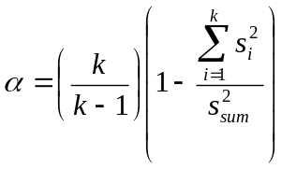. | (1)

Cronbach’s alpha was estimated for each of the content areas for the operational portion of the test.

Table 3.19 presents Cronbach’s alpha for the operational tests by subject area for the Winter/Trimester 2010-11 and Spring 2011 ACE EOI administrations. These reliability coefficients indicate that the OSTP-ACE EOI assessments had strong internal consistency and that the tests produce relatively stable scores.

Table 3.19. Cronbach’s Alpha for Winter/Trimester 2010-11 and Spring 2011 Administrations by Subject
Subject | Administration  and Form | Alpha
Algebra I | Winter 2010-11 | 0.89
 | Spring 2011 – Core A | 0.90
 | Spring 2011 – Core B | 0.89
Algebra II | Winter 2010-11 | 0.92
 | Spring 2011 – Core A | 0.92
 | Spring 2011 – Core B | 0.92
Biology I | Winter 2010-11 | 0.91
 | Spring 2011 – Core A | 0.90
 | Spring 2011 – Core B | 0.89
English II | Winter 2010-11 | 0.90
 | Spring 2011 – Core AA | 0.87
 | Spring 2011 – Core AB | 0.87
 | Spring 2011 – Core BA | 0.86
 | Spring 2011 – Core BB | 0.87
English III | Winter 2010-11 | 0.91
 | Spring 2011 – Core AA | 0.90
 | Spring 2011 – Core AB | 0.90
 | Spring 2011 – Core BA | 0.89
 | Spring 2011 – Core BB | 0.89
Geometry | Winter 2010-11 | 0.93
 | Spring 2011 – Core A | 0.91
 | Spring 2011 – Core B | 0.91
U.S. History | Winter 2010-11 | 0.91
 | Spring 2011 – Core A | 0.90
 | Spring 2011 – Core B | 0.90

Note: Core AA=Core MC form A+OE form A; Core AB=Core MC form A+OE form B; Core BA=Core MC form B+OE form A; Core BB=Core MC form B+OE form B.

Test Reliability by Subgroup
Table 3.20 addresses the reliability analysis results by the different reporting subgroups for the OSTP-ACE EOI assessments for Spring 2011 for each core form. Table 3.20 illustrates the subject, the subgroups, the number of students used in the analyses and the associated Cronbach’s Alpha for each subject and subgroup. In all instances, the reliability coefficients are well above the accepted lower limit of .70.

Table 3.20. Test Reliability by Subgroup for Spring 2011
Subject | Core | Male | Female | African-American | Native American | Hispanic | Asian | White
Algebra I | A | 0.90 | 0.89 | 0.88 | 0.89 | 0.90 | 0.92 | 0.89
 | B | 0.90 | 0.89 | 0.89 | 0.88 | 0.89 | 0.92 | 0.89
Algebra II | A | 0.92 | 0.91 | 0.90 | 0.91 | 0.91 | 0.93 | 0.92
 | B | 0.92 | 0.91 | 0.89 | 0.90 | 0.91 | 0.93 | 0.92
Biology I | A | 0.90 | 0.89 | 0.89 | 0.89 | 0.89 | 0.92 | 0.89
 | B | 0.90 | 0.88 | 0.88 | 0.88 | 0.90 | 0.91 | 0.88
English II | AA | 0.88 | 0.86 | 0.88 | 0.86 | 0.89 | 0.93 | 0.85
 | AB | 0.87 | 0.86 | 0.87 | 0.85 | 0.89 | 0.91 | 0.84
 | BA | 0.87 | 0.86 | 0.86 | 0.84 | 0.88 | 0.90 | 0.84
 | BB | 0.87 | 0.86 | 0.86 | 0.86 | 0.89 | 0.90 | 0.85
English III | AA | 0.90 | 0.89 | 0.89 | 0.90 | 0.89 | 0.91 | 0.89
 | AB | 0.90 | 0.89 | 0.89 | 0.88 | 0.90 | 0.91 | 0.89
 | BA | 0.90 | 0.88 | 0.89 | 0.88 | 0.89 | 0.89 | 0.89
 | BB | 0.90 | 0.88 | 0.88 | 0.88 | 0.89 | 0.89 | 0.89
Geometry | A | 0.91 | 0.91 | 0.90 | 0.90 | 0.91 | 0.91 | 0.90
 | B | 0.92 | 0.91 | 0.90 | 0.90 | 0.91 | 0.93 | 0.91
U.S. History | A | 0.90 | 0.89 | 0.89 | 0.89 | 0.90 | 0.92 | 0.89
 | B | 0.90 | 0.89 | 0.90 | 0.88 | 0.89 | 0.93 | 0.89
Note: Core AA=Core MC form A+OE form A; Core AB=Core MC form A+OE form B; Core BA=Core MC form B+OE form A; Core BB=Core MC form B+OE form B.

Table 3.20. Test Reliability by Subgroup for Spring 2011 (cont.)
Subject | Core | English Language Learner | Individual Education Plan | Economically Disadvantaged
Algebra I | A | 0.89 | 0.89 | 0.89
 | B | 0.89 | 0.89 | 0.88
Algebra II | A | 0.91 | 0.89 | 0.90
 | B | 0.89 | 0.89 | 0.90
Biology I | A | 0.85 | 0.90 | 0.89
 | B | 0.85 | 0.90 | 0.89
English II | AA | 0.86 | 0.90 | 0.88
 | AB | 0.86 | 0.88 | 0.87
 | BA | 0.88 | 0.89 | 0.87
 | BB | 0.87 | 0.89 | 0.87
English III | AA | 0.85 | 0.87 | 0.89
 | AB | 0.82 | 0.87 | 0.89
 | BA | 0.86 | 0.88 | 0.89
 | BB | 0.86 | 0.89 | 0.89
Geometry | A | 0.89 | 0.89 | 0.90
 | B | 0.90 | 0.89 | 0.91
U.S. History | A | 0.86 | 0.91 | 0.89
 | B | 0.86 | 0.92 | 0.89
Note: Core AA=Core MC form A+OE form A; Core AB=Core MC form A+OE form B; Core BA=Core MC form B+OE form A; Core BB=Core MC form B+OE form B.

Inter-rater Reliability
Inter-rater reliability is referred to as the degree of agreement among scorers that allows for the scores to be interpreted as reasonably intended by the test developer (AERA, APA and NCME, 1999). The Winter/Trimester 2010-11 English II and English III tests contained one operational writing prompt each and the Spring 2011 tests contained one writing prompt per core form. Raters were trained to implement the scoring rubrics, anchor papers, check sets, and resolution reading. The items were analytically scored by two raters on five strands in both administrations. The final writing score for a student in a given strand is the average of the two scores. The inter-rater reliability coefficients for the operational prompt are presented in Table 3.21 for English II and Table 3.22 for English III. The results show that exact and adjacent rater agreement on trait scores for both the Winter/Trimester 2010-11 and Spring 2011 operational writing prompts were reasonably high. The weighted Kappa statistic (Kraemer, 1982) is an indication of inter-rater reliability after correcting for chance. The Kappa values for the OSTP-ACE EOI Winter/Trimester 2010-11 and Spring 2011 operational writing prompts are close to or within the moderate range.

Table 3.21.Inter-rater Reliability for English II Operational Writing Prompts for Winter/Trimester 2010-11 and Spring 2011
Trait | Max Points | Valid N | Point Discrepancy Percentages |  |  |  |  |  |  | Agreement Percentages |  |  | Kappa
Trait | Max Points | Valid N | -3 | -2 | -1 | 0 | 1 | 2 | 3 | Exact | Adjacent | +/- 2 or more | Kappa
Winter/Trimester 2010-11
1 | 4 | 1,325 | 0.00 | 0.23 | 15.77 | 69.06 | 14.72 | 0.23 | 0.00 | 69.06 | 30.49 | 0.45 | 0.44
2 | 4 | 1,325 | 0.00 | 0.30 | 16.53 | 66.04 | 16.83 | 0.30 | 0.00 | 66.04 | 33.36 | 0.60 | 0.40
3 | 4 | 1,325 | 0.00 | 0.00 | 15.62 | 70.19 | 14.11 | 0.08 | 0.00 | 70.19 | 29.74 | 0.08 | 0.44
4 | 4 | 1,325 | 0.00 | 0.23 | 15.17 | 68.83 | 15.55 | 0.23 | 0.00 | 68.83 | 30.72 | 0.45 | 0.49
5 | 4 | 1,325 | 0.00 | 0.30 | 16.53 | 65.96 | 17.13 | 0.08 | 0.00 | 65.96 | 33.66 | 0.38 | 0.44
Spring 2011 Core Form A
1 | 4 | 15,081 | 0.00 | 0.45 | 17.68 | 64.05 | 17.37 | 0.45 | 0.00 | 64.05 | 35.04 | 0.90 | 0.30
2 | 4 | 15,081 | 0.00 | 0.53 | 17.46 | 63.83 | 17.77 | 0.41 | 0.00 | 63.83 | 35.23 | 0.94 | 0.29
3 | 4 | 15,081 | 0.00 | 0.44 | 17.46 | 63.85 | 17.82 | 0.44 | 0.00 | 63.85 | 35.28 | 0.88 | 0.30
4 | 4 | 15,081 | 0.00 | 0.56 | 17.01 | 65.06 | 16.91 | 0.46 | 0.00 | 65.06 | 33.92 | 1.02 | 0.32
5 | 4 | 15,081 | 0.00 | 0.68 | 17.86 | 62.68 | 18.12 | 0.65 | 0.00 | 62.68 | 35.99 | 1.33 | 0.30
Spring 2011 Core Form B
1 | 4 | 15,030 | 0.00 | 0.35 | 16.06 | 67.82 | 15.46 | 0.31 | 0.00 | 67.82 | 31.52 | 0.67 | 0.31
2 | 4 | 15,030 | 0.00 | 0.34 | 15.90 | 68.39 | 15.08 | 0.29 | 0.00 | 68.39 | 30.98 | 0.63 | 0.31
3 | 4 | 15,030 | 0.00 | 0.15 | 14.77 | 70.17 | 14.69 | 0.22 | 0.00 | 70.17 | 29.46 | 0.37 | 0.31
4 | 4 | 15,030 | 0.00 | 0.22 | 14.65 | 70.74 | 14.04 | 0.35 | 0.00 | 70.74 | 28.69 | 0.57 | 0.35
5 | 4 | 15,030 | 0.00 | 0.22 | 15.28 | 68.74 | 15.46 | 0.31 | 0.00 | 68.74 | 30.74 | 0.53 | 0.31

Table 3.22. Inter-rater Reliability for English III Operational Writing Prompts for Winter/Trimester 2010-11 and Spring 2011
Trait | Max Points | Valid N | Point Discrepancy Percentages |  |  |  |  |  |  | Agreement Percentages |  |  | Kappa
Trait | Max Points | Valid N | -3 | -2 | -1 | 0 | 1 | 2 | 3 | Exact | Adjacent | +/- 2 or more | Kappa
Winter/Trimester 2010-11
1 | 4 | 1,351 | 0.00 | 0.15 | 15.03 | 71.35 | 13.40 | 0.07 | 0.00 | 71.35 | 28.42 | 0.22 | 0.57
2 | 4 | 1,351 | 0.00 | 0.15 | 14.14 | 71.06 | 14.36 | 0.30 | 0.00 | 71.06 | 28.50 | 0.44 | 0.56
3 | 4 | 1,351 | 0.00 | 0.15 | 14.43 | 70.84 | 14.43 | 0.15 | 0.00 | 70.84 | 28.87 | 0.30 | 0.52
4 | 4 | 1,351 | 0.00 | 0.30 | 15.99 | 69.95 | 13.40 | 0.37 | 0.00 | 69.95 | 29.39 | 0.67 | 0.53
5 | 4 | 1,351 | 0.00 | 0.67 | 18.13 | 62.62 | 18.28 | 0.30 | 0.00 | 62.62 | 36.42 | 0.96 | 0.47
Spring 2011 Core Form A
1 | 4 | 14,932 | 0.01 | 0.56 | 17.89 | 63.84 | 17.04 | 0.64 | 0.02 | 63.84 | 34.92 | 1.23 | 0.36
2 | 4 | 14,932 | 0.00 | 0.60 | 17.44 | 64.58 | 16.82 | 0.55 | 0.01 | 64.58 | 34.26 | 1.16 | 0.37
3 | 4 | 14,932 | 0.01 | 0.48 | 17.26 | 65.09 | 16.70 | 0.46 | 0.00 | 65.09 | 33.97 | 0.94 | 0.37
4 | 4 | 14,932 | 0.01 | 0.70 | 17.31 | 64.38 | 17.06 | 0.55 | 0.00 | 64.38 | 34.36 | 1.26 | 0.37
5 | 4 | 14,932 | 0.01 | 0.78 | 18.42 | 61.71 | 18.38 | 0.70 | 0.00 | 61.71 | 36.80 | 1.49 | 0.34
Spring 2011 Core Form B
1 | 4 | 14,986 | 0.01 | 0.61 | 16.55 | 65.42 | 16.93 | 0.48 | 0.01 | 65.42 | 33.48 | 1.10 | 0.35
2 | 4 | 14,986 | 0.01 | 0.46 | 15.98 | 66.84 | 16.24 | 0.47 | 0.00 | 66.84 | 32.22 | 0.94 | 0.35
3 | 4 | 14,986 | 0.00 | 0.41 | 14.77 | 69.12 | 15.34 | 0.37 | 0.00 | 69.12 | 30.11 | 0.77 | 0.35
4 | 4 | 14,986 | 0.02 | 0.46 | 15.45 | 68.05 | 15.54 | 0.48 | 0.00 | 68.05 | 30.99 | 0.96 | 0.37
5 | 4 | 14,986 | 0.02 | 0.50 | 17.34 | 64.57 | 17.02 | 0.54 | 0.00 | 64.57 | 34.37 | 1.06 | 0.33

Calibration, Equating, and Scaling

This section introduces the IRT models, methods, and processes that were used to calibrate, equate, and scale the OCCT EOI tests. The three-parameter logistic (3-PL) item response theory (IRT) model (Lord & Novick, 1968) was used for dichotomously-scored test items and the Generalized Partial Credit (GPC; Muraki, 1997) model was used for polytomously-scored test items. For 2010-2011 academic season, preequating procedures were applied to the subjects of Algebra I, Algebra II, Biology I, Geometry, and U.S. History, and post-equating procedures for the subjects of ELA II and ELA III.

Item Response Theory (IRT) models
Dichotomous Item Response Theory Model. The three-parameter logistic (3-PL) item response theory (IRT) model (Lord & Novick, 1968) was used for calibrating the dichotomously-scored multiple choice items. In the 3-PL model (Lord, 1980), the probability that a student with an ability level of θ responds correctly to item i is

 | 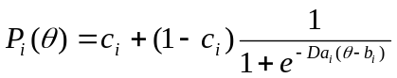, | (2)
where a_{i} is the item discrimination parameter, b_{i} is the item difficulty parameter, c_{i} is the lower asymptote parameter, and D is a scaling constant, which is traditional equal to 1.7. With multiple-choice items it is assumed that, due to guessing, examinees with very low ability levels have a probability greater than zero of responding correctly to an item. This probability is represented in the 3-PL model by the c_{i} parameter.

Polytomous Item Response Theory Model. For calibrating the polytomously-scored constructed response or open-ended (OE) writing prompt items, the Generalized Partial Credit (GPC; Muraki, 1997) model was used. In the GPC model, the probability that a student with ability level θ will have a score in the k^{th} category of the i^{th} item is

 | 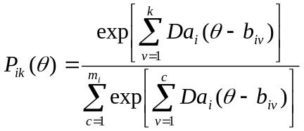, | (3)

where m_{i} is the total score levels for item i for k = v category responses, 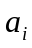 is the slope parameter (or Da_{i}), and 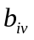 is the category intersection parameters (or (b_{i} – d_{iv}) where b_{i} is location/difficulty and d_{iv} is the threshold parameters representing category boundaries relative to the item location parameter).

The IRT models were implemented using MULTILOG 7.0 (Thissen, Chen, & Bock, 2003). MULTILOG estimates parameters simultaneously for dichotomous and polytomous items via marginal maximum likelihood procedures and implements the GPC model with the appropriate parameter coding. All item and student ability calibrations were independently conducted and verified by at least two Pearson research scientists.

Pre-Equating
Pre-equating procedures were applied to OCCT ACE EOI tests consisting entirely of dichotomously-scored multiple-choice items. These subjects included Algebra I, Algebra II, Biology I, Geometry, and U.S. History. ACE EOI tests English II and English III remained post-equated. All pre-equated forms were constructed using only previously-administered operational items and a set of unscored field-test items. Pearson Psychometric & Research Services staff created raw score to scale score (RSSS) tables using the freely-available program, POLYEQUATE (Kolen, 2004). Banked item parameter estimates for the forms’ operational items were imported into POLYEQUATE as both the “new” and “old” forms to create a table of raw score to true score equivalents.

Scaling constants provided in Table 4.24 (M1 and M2) were used to rescale true score equivalents to the reported scale score metric. The lowest obtainable scale score (LOSS) and highest obtainable scale score (HOSS) for each subject also appear in Table 4.24.

Performance level cut scores appear in Table 4.25. Because the scale cut score may not always be present in the RSSS table, the scale scores that were closest to, but below the scale scores (thetas) set in standard setting were used as the “effective” cut scores. In addition, a conditional standard error of measurement (CSEM; please see Section 6.3 for computation of CSEM) was computed for each of the raw score points. The resulting raw score to scale score conversions, CSEMs, as well as the performance levels for the pre-equated tests, are shown in Table 4.26 and Table 4.27, respectively, for the Winter 2010 and Spring 2011 administrations. This next section outlines post-equating work completed for the ACE EOI English II and English III tests.

Assessment of IRT Fit to the model
For post-equated tests, item fit was assessed using the Yen’s (1981, 1984) Q₁ item fit index, which approximately follows a χ² distribution:

 | 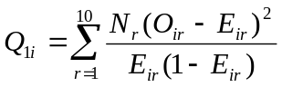, | (4)

where Q_{1i} is the fit of the ith item, N_{r} is the number of examinees per cell, O_{ir} is the observed proportion of examinees in cell r that correctly answered item i, and E_{ir} is the expected portion of examinees in cell r that correctly answered item i. The expected proportions are computed using ability- and item parameter estimates in Equations (2) and (3) and summing over examinees in cell r:

 | 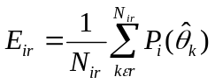. | (5)

Because chi-square statistics are affected by sample size and associated degrees of freedom, the following standardization of the Q₁ statistic was used:

 | 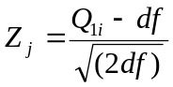. | (6)

The Z-statistic is an index of the degree to which observed proportions of item scores are similar to the proportions that would be expected, given the estimated ability- and item parameters. Large differences between expected and observed item performance may indicate poor item fit. To assess item fit, a critical Z-value is determined. Items with Z-values that are larger than this critical Z-value have poor item fit. The item characteristic curves, classical item statistics, and item content were reviewed for items flagged by Q₁. An internally-developed software program, Q1Static, was used to compute the Q₁ item fit index.

Operational items flagged by Q₁ that were not flagged by the classical item statistics and had reasonable IRT parameter estimates were not reviewed further. If any operational items were also flagged by classical item statistics and/or had poor IRT parameter estimates (e.g., low a parameter), the items were reviewed by Pearson content specialists. Any item that was potentially mis-keyed was presented to SDE to make a decision regarding whether to keep or remove the item. No such incidences occurred for operational items administered in Winter/Trimester 2010-11 or Spring 2011.

Calibration and IRT Fit Results for Post-Equated Tests

Winter/Trimester 2010-11
English II. For the Winter/Trimester 2010-11 English II assessment, based on the calibration sample, the Z-statistics for most operational items were smaller than the critical Z-statistic. One English II items were flagged for further review based on their fit statistics.

English III. For the Winter/Trimester 2010-11 English III assessment, based on the calibration sample, the Z-statistics for most operational items were smaller than the critical Z-statistic. Six English III items were flagged for further review based on their fit statistics.

For each item that was flagged based on its model fit indices, a careful review of both CTT and IRT item statistics was conducted to determine whether the item should be dropped from calibration, equating, or scoring. No items were dropped from any of the Winter/Trimester 2010-11 ACE EOI assessments for calibration, equating, or scoring as a result of the Q₁ results.

Spring 2011
English II. For the Spring 2011 English II assessment, based on the calibration sample, the Z-statistics for most operational items were smaller than the critical Z-statistic. One English II items were flagged for further review based on their fit statistics.

English III. For the Spring 2011 English III assessment, based on the calibration sample, the Z-statistics for most operational items were smaller than the critical Z-statistic. Two English III items were flagged for further review based on their fit statistics.

For each item that was flagged based on its model fit indices, a careful review of both CTT and IRT item statistics was conducted to determine whether the item should be dropped from calibration, equating, or scoring. No items were dropped from any of the Spring 2011 ACE EOI assessments for calibration, equating, or scoring as a result of the Q₁ results.

Field Test Items. The field test items across all subjects were evaluated using the Q₁ statistic to evaluate the extent to which the obtained proportions of item scores are close to the proportions that would be expected based on the estimated thetas and item parameters. Any field test items flagged by Q₁ were included in the data review for review by content specialists from Pearson and SDE (for more on data review, please see Section 3.4).

Calibration and Equating

The 3-PL model was used for calibration and equating of all items for the purposes of rescaling field test items to the bank metric for Algebra I, Algebra II, Geometry, Biology I, and U.S. History because these tests consist of only multiple choice items. Because English II and English III have multiple choice and constructed response items, a simultaneous calibration with the 3-PL and GPC models was implemented for the calibration and equating of the operational test form and for the field test items.

A common item, non-equivalent groups (CINEG) design was used for ACE EOI English II and English III tests to link the current test forms (i.e., Winter/Trimester 2010-11 and Spring 2011) to the base scale. Typically, for the CINEG design common, or anchor, items are selected to be representative of the test content in terms of difficulty and the test blueprint. For the ACE EOI English II and English III Winter/Trimester 2010-11 and Spring 2011 tests, all operational items were used as common or anchor items to link to the base scale. The Stocking and Lord (1983) procedure, which estimates the equating transformation constants by minimizing the distance between the test characteristic curves of the common items, was used to equate the tests to the base year.

Equating was conducted employing using freely-available software, STUIRT (Kim & Kolen, 2004). Prior to conducting the equating, anchor item stability checks were performed to eliminate the impact of item drift on equating.

Common Linking Items for Spring 2011
Table 4.23 presents the number and percentage of common linking items for all post-equated subject for the Spring 2011 administration. The common linking items were necessary as a result of two core operational forms for the Spring 2011 administration. The common linking items were used for simultaneous calibration during the IRT item parameter estimation to keep the items on the same scale. The common linking set was comprised of approximately 20 items or greater than 25% of all operational items, and counts vary by subject. In addition, the common linking set was proportionally representative of the total test in terms of content assessed and mimicked the difficulty of the overall test as well.

Table 4.23. Number of Common Linking Items Per Subject for Spring 2011
Subject | Number of Items on Test | Number of Linking Items | Percent of Test
English II | 61 | 22 | 36%
English III | 63 | 23 | 37%

Item Stability Evaluation Methods
Despite the careful selection and placement of the operational items, it is possible for these items to perform differentially across administrations. Dramatic changes in item parameter values can result in systematic errors in equating results (Kolen & Brennan, 2004). As a result, prior to finalizing the equating constants, Pearson evaluated changes in the item parameters from the item bank to the Winter 2010 and Spring 2011 administration. The process used in this evaluation is called an item parameter stability check.

The item parameter stability check that Pearson performed is an iterative approach, which uses a method that is similar to the one used to check for differential item functioning. This method is called the d² procedure. The steps taken were as follows:
- Use a theoretically-weighted posterior θ distribution, g(_{k}), with 40 quadrature points.
- Place the current linking item parameters on the baseline scale by computing Stocking & Lord (SL) constants using STUIRT and all (k) linking items.
- Apply the SL linking constants to the current item parameters and compute the current raw score to scale score table. The results based on all k linking items will comprise the original table.
- For each linking item, calculate the weighted sum of the squared deviation (d²) between the item characteristic curves.
  - Apply the SL constants to the estimated ability levels () associated with the standard normal θ distribution used to generate the SL constants.
  - For each anchor item, calculate a weighted sum of the squared deviations between the ICCs (d²) based on the old (x) and new (y) parameter estimates at each point in the θ distribution multiplied by the theoretically-weighted distribution.

 | 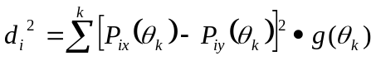 | (7)

  - Review and sort the items in descending (largest to smallest) order according to the d² estimate.
  - Step 4c) results in the item with the largest area at the top.
    - Drop the item with the largest d² from the linking set.
    - Repeat steps 2) through 4c) until 10 items are dropped computing 11 raw score to scale score tables for comparative purposes.
  - Review the raw score to scale score tables and keep the raw score to scale score table where the raw to scale tables across iterations do not differ at all of the cut score points. The raw score to scale score table before the last iteration becomes the final table.

Before removing any item from the item parameter stability check, the following additional characteristics were examined: 1) prior and current year p-values and point-biserial correlations, 2) prior and current year IRT parameter estimates, 3) prior and current year item sequence, 4) standard and objective/skill of the item, 5) impact on blueprint representation, 6) passage ID/title for items linked to a stimulus, and 7) content review of the actual item. Decisions about whether to keep or remove an item were evaluated on a per item basis. If an item (note, only one item can be removed at a time) was removed from the, the process (beginning at the equating step) was be repeated until there were no further items to be removed (the raw score to scale score table has stabilized or the item is judged that it should be included in the equating set; for example, a portion of the blueprint is not represented if the item is removed).

Results of the Item Parameter Item Stability Check
Once the anchor set was finalized, the equating constants obtained from the final Stocking and Lord (1983) run were applied to the non-anchor operational items for computation of raw score to scale score tables. For Winter/Trimester 2010-11, no items were removed from English II or from English III. For Spring 2011, ten anchor items were removed from English II and English III each. Any item removed from the item parameter stability check set still contributed to student scores.

Scaling and Scoring Results
The Lowest Obtainable Scale Score (LOSS), Highest Obtainable Scale Score (HOSS), and final scaling constants for each of the subjects are shown in Table 4.24. The scaling constants, M1 (multiplicative) and M2 (additive), place the true scores associated with each raw score point onto the reporting or operational scale using a straightforward linear transformation:

 | Scale Score = 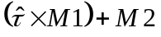 | (8)

where = true score.

The raw score to number-correct scales scores were generated from equated parameter estimates using a freely-available software program, POLYEQUATE (Kolen, 2004). Each scale score on the assessment is associated with a performance level that describes the types of behavior, knowledge, and skill a student in this score level is likely to be able to do. For the ACE EOI assessments, there are three cut scores that divide scores into four performance levels: Unsatisfactory, Limited Knowledge, Proficient, and Advanced. The cut scores for each of the tests appear in Table 4.25. In addition, a conditional standard error of measurement (CSEM; please see Section 6.3 for computation of CSEM) was computed for each of the raw score points. The resulting raw score to scale score conversions, CSEMs, as well as the performance levels for English II and English III are shown in Table 4.26 and Table 4.27 for Winter/Trimester 2010-11 and Spring 2011, respectively.

Table 4.24. LOSS, HOSS, and Scaling Constants by Subject
Subject | LOSS | HOSS | M1 | M2
Algebra I | 490 | 999 | 58.0000 | 723.8000
Algebra II | 440 | 999 | 77.1164 | 692.2381
Biology I | 440 | 999 | 76.49429 | 716.76173
English II | 440 | 999 | 84.80517 | 734.90335
English III | 440 | 999 | 74.32896 | 736.1256
Geometry | 440 | 999 | 75.51595 | 721.9844
US History | 440 | 999 | 77.92698 | 722.20515

Table 4.25. Performance-Level Cut Scores by Subject
Subject | Cut Scores
Subject | Limited Knowledge | Proficient | Advanced
Algebra I | 662 | 700 | 762
Algebra II | 654 | 700 | 783
Biology I | 627 | 691 | 775
English II | 588 | 693 | 797
English III | 670 | 700 | 802
Geometry | 635 | 700 | 777
U.S. History | 603 | 689 | 747

Table 4.26. Raw Score to Scale Score Conversion Tables for Winter/Trimester 2010-11
Raw Score | Algebra I |  |  | Biology I |  |  | U.S. History |  |  | English II
Raw Score | Scale Score | CSEM | Perf. Level | Scale Score | CSEM | Perf. Level | Scale Score | CSEM | Perf. Level | Scale Score | CSEM | Perf. Level
0 | 490 | 49 | 1 | 440 | 48 | 1 | 440 | 49 | 1 | 440 | 41 | 1
1 | 490 | 49 | 1 | 440 | 48 | 1 | 440 | 49 | 1 | 440 | 41 | 1
2 | 490 | 49 | 1 | 440 | 48 | 1 | 440 | 49 | 1 | 440 | 41 | 1
3 | 490 | 49 | 1 | 440 | 48 | 1 | 440 | 49 | 1 | 440 | 41 | 1
4 | 490 | 49 | 1 | 440 | 48 | 1 | 440 | 49 | 1 | 440 | 41 | 1
5 | 490 | 49 | 1 | 440 | 48 | 1 | 440 | 49 | 1 | 440 | 41 | 1
6 | 490 | 49 | 1 | 440 | 48 | 1 | 440 | 49 | 1 | 440 | 41 | 1
7 | 490 | 49 | 1 | 440 | 48 | 1 | 440 | 49 | 1 | 440 | 41 | 1
8 | 490 | 49 | 1 | 440 | 48 | 1 | 440 | 49 | 1 | 440 | 41 | 1
9 | 490 | 49 | 1 | 440 | 48 | 1 | 440 | 49 | 1 | 440 | 41 | 1
10 | 490 | 49 | 1 | 440 | 48 | 1 | 440 | 49 | 1 | 440 | 41 | 1
11 | 490 | 49 | 1 | 440 | 48 | 1 | 440 | 49 | 1 | 440 | 41 | 1
12 | 537 | 53 | 1 | 440 | 48 | 1 | 440 | 49 | 1 | 440 | 41 | 1
13 | 569 | 56 | 1 | 440 | 48 | 1 | 440 | 49 | 1 | 440 | 41 | 1
14 | 590 | 55 | 1 | 442 | 49 | 1 | 473 | 52 | 1 | 440 | 41 | 1
15 | 606 | 53 | 1 | 481 | 54 | 1 | 506 | 56 | 1 | 440 | 41 | 1
16 | 619 | 49 | 1 | 510 | 58 | 1 | 530 | 58 | 1 | 440 | 41 | 1
17 | 631 | 44 | 1 | 532 | 59 | 1 | 549 | 57 | 1 | 454 | 43 | 1
18 | 640 | 39 | 1 | 551 | 58 | 1 | 564 | 55 | 1 | 482 | 47 | 1
19 | 649 | 34 | 1 | 567 | 56 | 1 | 577 | 51 | 1 | 504 | 50 | 1
20 | 662 | 31 | 2 | 581 | 52 | 1 | 589 | 47 | 1 | 522 | 51 | 1
21 | 663 | 27 | 2 | 594 | 48 | 1 | 603 | 43 | 2 | 537 | 50 | 1
22 | 670 | 25 | 2 | 606 | 44 | 1 | 610 | 40 | 2 | 551 | 48 | 1
23 | 676 | 23 | 2 | 616 | 41 | 1 | 620 | 36 | 2 | 563 | 46 | 1
24 | 682 | 21 | 2 | 627 | 38 | 2 | 629 | 34 | 2 | 574 | 43 | 1
25 | 687 | 20 | 2 | 636 | 35 | 2 | 637 | 31 | 2 | 588 | 40 | 2
26 | 693 | 19 | 2 | 645 | 33 | 2 | 645 | 30 | 2 | 593 | 37 | 2
27 | 700 | 19 | 3 | 653 | 31 | 2 | 653 | 28 | 2 | 602 | 34 | 2
28 | 703 | 18 | 3 | 661 | 29 | 2 | 660 | 27 | 2 | 610 | 32 | 2
Note: CSEM = Conditional Standard Error of Measure; Perf. Level = Performance Level; 1 = Unsatisfactory, 2 = Limited Knowledge,
3 = Proficient, 4 = Advanced
Table 4.26. Raw Score to Scale Score Conversion Tables for Winter/Trimester 2010-11 (cont.)
Raw Score | Algebra I |  |  | Biology I |  |  | U.S. History |  |  | English II
Raw Score | Scale Score | CSEM | Perf. Level | Scale Score | CSEM | Perf. Level | Scale Score | CSEM | Perf. Level | Scale Score | CSEM | Perf. Level
29 | 708 | 17 | 3 | 669 | 28 | 2 | 667 | 25 | 2 | 618 | 30 | 2
30 | 713 | 17 | 3 | 676 | 26 | 2 | 674 | 24 | 2 | 625 | 29 | 2
31 | 717 | 16 | 3 | 683 | 25 | 2 | 680 | 24 | 2 | 632 | 27 | 2
32 | 722 | 16 | 3 | 691 | 24 | 3 | 689 | 23 | 3 | 639 | 26 | 2
33 | 727 | 16 | 3 | 697 | 24 | 3 | 693 | 22 | 3 | 645 | 25 | 2
34 | 731 | 16 | 3 | 704 | 23 | 3 | 699 | 22 | 3 | 652 | 24 | 2
35 | 736 | 15 | 3 | 710 | 22 | 3 | 704 | 21 | 3 | 658 | 23 | 2
36 | 740 | 15 | 3 | 716 | 22 | 3 | 710 | 21 | 3 | 664 | 23 | 2
37 | 745 | 15 | 3 | 722 | 21 | 3 | 716 | 20 | 3 | 670 | 22 | 2
38 | 749 | 15 | 3 | 728 | 21 | 3 | 721 | 20 | 3 | 676 | 22 | 2
39 | 754 | 15 | 3 | 734 | 20 | 3 | 727 | 20 | 3 | 681 | 21 | 2
40 | 762 | 15 | 4 | 740 | 20 | 3 | 733 | 20 | 3 | 687 | 21 | 2
41 | 764 | 15 | 4 | 746 | 20 | 3 | 738 | 20 | 3 | 693 | 21 | 3
42 | 769 | 15 | 4 | 752 | 20 | 3 | 747 | 20 | 4 | 699 | 21 | 3
43 | 774 | 16 | 4 | 758 | 20 | 3 | 750 | 20 | 4 | 704 | 21 | 3
44 | 779 | 16 | 4 | 764 | 20 | 3 | 756 | 20 | 4 | 710 | 21 | 3
45 | 785 | 17 | 4 | 775 | 20 | 4 | 762 | 20 | 4 | 716 | 21 | 3
46 | 791 | 17 | 4 | 776 | 20 | 4 | 768 | 21 | 4 | 722 | 21 | 3
47 | 797 | 19 | 4 | 782 | 20 | 4 | 775 | 21 | 4 | 728 | 21 | 3
48 | 804 | 20 | 4 | 789 | 21 | 4 | 782 | 22 | 4 | 734 | 21 | 3
49 | 812 | 23 | 4 | 796 | 21 | 4 | 789 | 23 | 4 | 740 | 21 | 3
50 | 822 | 26 | 4 | 803 | 22 | 4 | 797 | 24 | 4 | 746 | 21 | 3
51 | 833 | 32 | 4 | 811 | 23 | 4 | 806 | 25 | 4 | 753 | 22 | 3
52 | 847 | 40 | 4 | 819 | 25 | 4 | 815 | 27 | 4 | 760 | 22 | 3
53 | 868 | 50 | 4 | 829 | 28 | 4 | 826 | 30 | 4 | 767 | 23 | 3
54 | 904 | 57 | 4 | 839 | 31 | 4 | 838 | 33 | 4 | 775 | 24 | 3
55 | 999 | 39 | 4 | 852 | 35 | 4 | 852 | 38 | 4 | 783 | 25 | 3
56 | - | - | - | 868 | 40 | 4 | 870 | 43 | 4 | 797 | 27 | 4
Note: CSEM = Conditional Standard Error of Measure; Perf. Level = Performance Level; 1 = Unsatisfactory, 2 = Limited Knowledge,
3 = Proficient, 4 = Advanced
Table 4.26. Raw Score to Scale Score Conversion Tables for Winter/Trimester 2010-11 (cont.)
Raw Score | Algebra I |  |  | Biology I |  |  | U.S. History |  |  | English II
Raw Score | Scale Score | CSEM | Perf. Level | Scale Score | CSEM | Perf. Level | Scale Score | CSEM | Perf. Level | Scale Score | CSEM | Perf. Level
57 | - | - | - | 888 | 45 | 4 | 893 | 47 | 4 | 802 | 28 | 4
58 | - | - | - | 918 | 46 | 4 | 925 | 47 | 4 | 813 | 30 | 4
59 | - | - | - | 975 | 37 | 4 | 982 | 35 | 4 | 825 | 33 | 4
60 | - | - | - | 999 | 32 | 4 | 999 | 31 | 4 | 839 | 37 | 4
61 | - | - | - | - | - | - | - | - | - | 855 | 41 | 4
62 | - | - | - | - | - | - | - | - | - | 875 | 46 | 4
63 | - | - | - | - | - | - | - | - | - | 900 | 50 | 4
64 | - | - | - | - | - | - | - | - | - | 936 | 48 | 4
65 | - | - | - | - | - | - | - | - | - | 997 | 34 | 4
66 | - | - | - | - | - | - | - | - | - | 999 | 34 | 4
Note: CSEM = Conditional Standard Error of Measure; Perf. Level = Performance Level; 1 = Unsatisfactory, 2 = Limited Knowledge,
3 = Proficient, 4 = Advanced

Table 4.26. Raw Score to Scale Score Conversion Tables for Winter/Trimester 2010-11 (cont.)
Raw Score | Algebra II |  |  | Geometry |  |  | English III
Raw Score | Scale Score | CSEM | Perf. Level | Scale Score | CSEM | Perf. Level | Scale Score | CSEM | Perf. Level
0 | 440 | 66 | 1 | 440 | 64 | 1 | 440 | 46 | 1
1 | 440 | 66 | 1 | 440 | 64 | 1 | 440 | 46 | 1
2 | 440 | 66 | 1 | 440 | 64 | 1 | 440 | 46 | 1
3 | 440 | 66 | 1 | 440 | 64 | 1 | 440 | 46 | 1
4 | 440 | 66 | 1 | 440 | 64 | 1 | 440 | 46 | 1
5 | 440 | 66 | 1 | 440 | 64 | 1 | 440 | 46 | 1
6 | 440 | 66 | 1 | 440 | 64 | 1 | 440 | 46 | 1
7 | 440 | 66 | 1 | 440 | 64 | 1 | 440 | 46 | 1
8 | 440 | 66 | 1 | 440 | 64 | 1 | 440 | 46 | 1
9 | 440 | 66 | 1 | 440 | 64 | 1 | 440 | 46 | 1
10 | 440 | 66 | 1 | 440 | 64 | 1 | 440 | 46 | 1
11 | 440 | 66 | 1 | 440 | 64 | 1 | 440 | 46 | 1
12 | 440 | 66 | 1 | 503 | 69 | 1 | 440 | 46 | 1
13 | 504 | 72 | 1 | 544 | 71 | 1 | 440 | 46 | 1
14 | 545 | 75 | 1 | 571 | 70 | 1 | 477 | 51 | 1
15 | 574 | 75 | 1 | 591 | 66 | 1 | 506 | 55 | 1
16 | 596 | 71 | 1 | 606 | 60 | 1 | 527 | 57 | 1
17 | 614 | 65 | 1 | 619 | 54 | 1 | 543 | 56 | 1
18 | 629 | 59 | 1 | 635 | 47 | 2 | 558 | 54 | 1
19 | 642 | 52 | 1 | 640 | 41 | 2 | 571 | 51 | 1
20 | 654 | 45 | 2 | 649 | 36 | 2 | 583 | 48 | 1
21 | 663 | 40 | 2 | 657 | 32 | 2 | 595 | 44 | 1
22 | 672 | 35 | 2 | 665 | 28 | 2 | 605 | 41 | 1
23 | 680 | 31 | 2 | 672 | 26 | 2 | 614 | 38 | 1
24 | 688 | 29 | 2 | 679 | 24 | 2 | 623 | 35 | 1
25 | 700 | 26 | 3 | 685 | 23 | 2 | 631 | 33 | 1
26 | 702 | 24 | 3 | 691 | 22 | 2 | 639 | 31 | 1
27 | 708 | 23 | 3 | 700 | 21 | 3 | 646 | 29 | 1
28 | 714 | 22 | 3 | 703 | 20 | 3 | 653 | 28 | 1
Note: CSEM = Conditional Standard Error of Measure; Perf. Level = Performance Level; 1 = Unsatisfactory, 2 = Limited Knowledge,
3 = Proficient, 4 = Advanced
Table 4.26. Raw Score to Scale Score Conversion Tables for Winter/Trimester 2010-11 (cont.)
Raw Score | Algebra II |  |  | Geometry |  |  | English III
Raw Score | Scale Score | CSEM | Perf. Level | Scale Score | CSEM | Perf. Level | Scale Score | CSEM | Perf. Level
29 | 720 | 21 | 3 | 708 | 19 | 3 | 660 | 26 | 1
30 | 726 | 20 | 3 | 714 | 18 | 3 | 670 | 25 | 2
31 | 731 | 19 | 3 | 719 | 18 | 3 | 672 | 24 | 2
32 | 736 | 19 | 3 | 724 | 17 | 3 | 678 | 23 | 2
33 | 742 | 18 | 3 | 729 | 17 | 3 | 684 | 23 | 2
34 | 747 | 18 | 3 | 734 | 16 | 3 | 689 | 22 | 2
35 | 752 | 17 | 3 | 738 | 16 | 3 | 695 | 21 | 2
36 | 757 | 17 | 3 | 743 | 16 | 3 | 700 | 21 | 3
37 | 762 | 17 | 3 | 748 | 16 | 3 | 705 | 21 | 3
38 | 767 | 17 | 3 | 752 | 15 | 3 | 710 | 20 | 3
39 | 772 | 17 | 3 | 757 | 15 | 3 | 715 | 20 | 3
40 | 777 | 17 | 3 | 762 | 15 | 3 | 721 | 20 | 3
41 | 783 | 17 | 4 | 767 | 15 | 3 | 726 | 19 | 3
42 | 788 | 17 | 4 | 772 | 16 | 3 | 731 | 19 | 3
43 | 794 | 17 | 4 | 777 | 16 | 4 | 736 | 19 | 3
44 | 799 | 18 | 4 | 782 | 16 | 4 | 741 | 19 | 3
45 | 806 | 19 | 4 | 788 | 17 | 4 | 746 | 19 | 3
46 | 812 | 20 | 4 | 794 | 18 | 4 | 751 | 19 | 3
47 | 819 | 21 | 4 | 801 | 19 | 4 | 756 | 19 | 3
48 | 828 | 23 | 4 | 808 | 20 | 4 | 761 | 19 | 3
49 | 837 | 26 | 4 | 816 | 23 | 4 | 766 | 19 | 3
50 | 848 | 29 | 4 | 825 | 26 | 4 | 772 | 19 | 3
51 | 861 | 33 | 4 | 837 | 32 | 4 | 777 | 19 | 3
52 | 878 | 39 | 4 | 851 | 39 | 4 | 783 | 19 | 3
53 | 902 | 43 | 4 | 872 | 49 | 4 | 788 | 19 | 3
54 | 944 | 42 | 4 | 907 | 55 | 4 | 794 | 20 | 3
55 | 999 | 32 | 4 | 999 | 36 | 4 | 802 | 20 | 4
56 |  |  |  |  |  |  | 806 | 20 | 4
Note: CSEM = Conditional Standard Error of Measure; Perf. Level = Performance Level; 1 = Unsatisfactory, 2 = Limited Knowledge,
3 = Proficient, 4 = Advanced

Table 4.26. Raw Score to Scale Score Conversion Tables for Winter/Trimester 2010-11 (cont.)

Raw Score | Algebra II |  |  | Geometry |  |  | English III
Raw Score | Scale Score | CSEM | Perf. Level | Scale Score | CSEM | Perf. Level | Scale Score | CSEM | Perf. Level
57 | - | - | - | - | - | - | 813 | 21 | 4
58 | - | - | - | - | - | - | 819 | 21 | 4
59 | - | - | - | - | - | - | 826 | 22 | 4
60 | - | - | - | - | - | - | 833 | 22 | 4
61 | - | - | - | - | - | - | 841 | 23 | 4
62 | - | - | - | - | - | - | 849 | 24 | 4
63 | - | - | - | - | - | - | 858 | 25 | 4
64 | - | - | - | - | - | - | 867 | 27 | 4
65 | - | - | - | - | - | - | 877 | 29 | 4
66 | - | - | - | - | - | - | 888 | 32 | 4
67 | - | - | - | - | - | - | 901 | 35 | 4
68 | - | - | - | - | - | - | 917 | 37 | 4
69 | - | - | - | - | - | - | 938 | 37 | 4
70 | - | - | - | - | - | - | 968 | 32 | 4
71 | - | - | - | - | - | - | 999 | 25 | 4
72 | - | - | - | - | - | - | 999 | 25 | 4
Note: CSEM = Conditional Standard Error of Measure; Perf. Level = Performance Level; 1 = Unsatisfactory, 2 = Limited Knowledge,
3 = Proficient, 4 = Advanced
Table 4.27.Raw Score to Scale Score Conversion Tables for Spring 2011
Raw Score | Biology I Core A |  |  | Biology I Core B |  |  | U.S. History Core A |  |  | U.S. History Core B
Raw Score | Scale Score | CSEM | Perf. Level | Scale Score | CSEM | Perf. Level | Scale Score | CSEM | Perf. Level | Scale Score | CSEM | Perf. Level
0 | 440 | 48 | 1 | 440 | 47 | 1 | 440 | 47 | 1 | 440 | 51 | 1
1 | 440 | 48 | 1 | 440 | 47 | 1 | 440 | 47 | 1 | 440 | 51 | 1
2 | 440 | 48 | 1 | 440 | 47 | 1 | 440 | 47 | 1 | 440 | 51 | 1
3 | 440 | 48 | 1 | 440 | 47 | 1 | 440 | 47 | 1 | 440 | 51 | 1
4 | 440 | 48 | 1 | 440 | 47 | 1 | 440 | 47 | 1 | 440 | 51 | 1
5 | 440 | 48 | 1 | 440 | 47 | 1 | 440 | 47 | 1 | 440 | 51 | 1
6 | 440 | 48 | 1 | 440 | 47 | 1 | 440 | 47 | 1 | 440 | 51 | 1
7 | 440 | 48 | 1 | 440 | 47 | 1 | 440 | 47 | 1 | 440 | 51 | 1
8 | 440 | 48 | 1 | 440 | 47 | 1 | 440 | 47 | 1 | 440 | 51 | 1
9 | 440 | 48 | 1 | 440 | 47 | 1 | 440 | 47 | 1 | 440 | 51 | 1
10 | 440 | 48 | 1 | 440 | 47 | 1 | 440 | 47 | 1 | 440 | 51 | 1
11 | 440 | 48 | 1 | 440 | 47 | 1 | 440 | 47 | 1 | 440 | 51 | 1
12 | 440 | 48 | 1 | 440 | 47 | 1 | 440 | 47 | 1 | 440 | 51 | 1
13 | 440 | 48 | 1 | 452 | 49 | 1 | 440 | 47 | 1 | 440 | 51 | 1
14 | 458 | 51 | 1 | 492 | 53 | 1 | 440 | 47 | 1 | 440 | 51 | 1
15 | 496 | 55 | 1 | 519 | 56 | 1 | 472 | 51 | 1 | 449 | 52 | 1
16 | 522 | 58 | 1 | 539 | 56 | 1 | 501 | 55 | 1 | 490 | 57 | 1
17 | 543 | 58 | 1 | 555 | 54 | 1 | 524 | 57 | 1 | 519 | 59 | 1
18 | 560 | 56 | 1 | 569 | 51 | 1 | 543 | 57 | 1 | 541 | 60 | 1
19 | 574 | 53 | 1 | 581 | 48 | 1 | 559 | 55 | 1 | 559 | 58 | 1
20 | 587 | 49 | 1 | 592 | 44 | 1 | 574 | 52 | 1 | 574 | 55 | 1
21 | 598 | 45 | 1 | 602 | 40 | 1 | 586 | 48 | 1 | 587 | 51 | 1
22 | 608 | 41 | 1 | 611 | 37 | 1 | 603 | 45 | 2 | 603 | 47 | 2
23 | 617 | 37 | 1 | 619 | 34 | 1 | 608 | 41 | 2 | 609 | 43 | 2
24 | 627 | 34 | 2 | 627 | 31 | 2 | 618 | 38 | 2 | 618 | 39 | 2
25 | 634 | 32 | 2 | 635 | 29 | 2 | 627 | 35 | 2 | 627 | 35 | 2
26 | 642 | 30 | 2 | 642 | 28 | 2 | 636 | 32 | 2 | 635 | 33 | 2
27 | 649 | 28 | 2 | 649 | 26 | 2 | 644 | 30 | 2 | 643 | 30 | 2
28 | 656 | 27 | 2 | 655 | 25 | 2 | 651 | 29 | 2 | 651 | 29 | 2
Note: CSEM = Conditional Standard Error of Measure; Perf. Level = Performance Level; 1 = Unsatisfactory, 2 = Limited Knowledge,
3 = Proficient, 4 = Advanced
Table 4.27.Raw Score to Scale Score Conversion Tables for Spring 2011 (cont.)
Raw Score | Biology I Core A |  |  | Biology I Core B |  |  | U.S. History Core A |  |  | U.S. History Core B
Raw Score | Scale Score | CSEM | Perf. Level | Scale Score | CSEM | Perf. Level | Scale Score | CSEM | Perf. Level | Scale Score | CSEM | Perf. Level
29 | 663 | 25 | 2 | 662 | 25 | 2 | 659 | 27 | 2 | 658 | 27 | 2
30 | 669 | 24 | 2 | 668 | 24 | 2 | 666 | 26 | 2 | 665 | 26 | 2
31 | 675 | 24 | 2 | 674 | 23 | 2 | 672 | 25 | 2 | 671 | 25 | 2
32 | 682 | 23 | 2 | 680 | 23 | 2 | 679 | 24 | 2 | 678 | 24 | 2
33 | 691 | 22 | 3 | 691 | 22 | 3 | 689 | 23 | 3 | 689 | 23 | 3
34 | 694 | 22 | 3 | 692 | 22 | 3 | 691 | 22 | 3 | 690 | 22 | 3
35 | 699 | 22 | 3 | 698 | 22 | 3 | 697 | 22 | 3 | 696 | 22 | 3
36 | 705 | 21 | 3 | 704 | 21 | 3 | 703 | 21 | 3 | 702 | 21 | 3
37 | 711 | 21 | 3 | 709 | 21 | 3 | 709 | 21 | 3 | 708 | 21 | 3
38 | 717 | 21 | 3 | 715 | 21 | 3 | 715 | 20 | 3 | 714 | 21 | 3
39 | 723 | 21 | 3 | 721 | 21 | 3 | 721 | 20 | 3 | 720 | 20 | 3
40 | 729 | 21 | 3 | 727 | 21 | 3 | 726 | 20 | 3 | 725 | 20 | 3
41 | 735 | 21 | 3 | 733 | 21 | 3 | 732 | 20 | 3 | 731 | 20 | 3
42 | 741 | 21 | 3 | 739 | 21 | 3 | 738 | 20 | 3 | 737 | 20 | 3
43 | 747 | 21 | 3 | 746 | 21 | 3 | 747 | 20 | 4 | 747 | 20 | 4
44 | 753 | 21 | 3 | 752 | 21 | 3 | 749 | 20 | 4 | 748 | 20 | 4
45 | 760 | 22 | 3 | 758 | 22 | 3 | 756 | 20 | 4 | 754 | 20 | 4
46 | 767 | 22 | 3 | 765 | 22 | 3 | 762 | 20 | 4 | 760 | 20 | 4
47 | 775 | 23 | 4 | 775 | 22 | 4 | 768 | 21 | 4 | 767 | 21 | 4
48 | 781 | 23 | 4 | 780 | 23 | 4 | 775 | 21 | 4 | 773 | 21 | 4
49 | 789 | 24 | 4 | 787 | 24 | 4 | 782 | 22 | 4 | 780 | 22 | 4
50 | 797 | 25 | 4 | 796 | 25 | 4 | 790 | 23 | 4 | 788 | 23 | 4
51 | 806 | 27 | 4 | 804 | 26 | 4 | 798 | 24 | 4 | 796 | 24 | 4
52 | 816 | 29 | 4 | 814 | 28 | 4 | 807 | 26 | 4 | 804 | 26 | 4
53 | 827 | 31 | 4 | 824 | 30 | 4 | 817 | 28 | 4 | 814 | 28 | 4
54 | 839 | 34 | 4 | 836 | 34 | 4 | 828 | 32 | 4 | 825 | 32 | 4
55 | 854 | 39 | 4 | 850 | 39 | 4 | 841 | 36 | 4 | 838 | 36 | 4
56 | 871 | 43 | 4 | 867 | 44 | 4 | 857 | 41 | 4 | 854 | 41 | 4
57 | 894 | 48 | 4 | 889 | 49 | 4 | 879 | 46 | 4 | 875 | 46 | 4
Note: CSEM = Conditional Standard Error of Measure; Perf. Level = Performance Level; 1 = Unsatisfactory, 2 = Limited Knowledge,
3 = Proficient, 4 = Advanced
Table 4.27.Raw Score to Scale Score Conversion Tables for Spring 2011 (cont.)
Raw Score | Biology I Core A |  |  | Biology I Core B |  |  | U.S. History Core A |  |  | U.S. History Core B
Raw Score | Scale Score | CSEM | Perf. Level | Scale Score | CSEM | Perf. Level | Scale Score | CSEM | Perf. Level | Scale Score | CSEM | Perf. Level
58 | 927 | 47 | 4 | 922 | 49 | 4 | 909 | 48 | 4 | 904 | 48 | 4
59 | 986 | 35 | 4 | 985 | 37 | 4 | 966 | 40 | 4 | 957 | 42 | 4
60 | 999 | 32 | 4 | 999 | 34 | 4 | 999 | 33 | 4 | 999 | 34 | 4
Note: CSEM = Conditional Standard Error of Measure; Perf. Level = Performance Level; 1 = Unsatisfactory, 2 = Limited Knowledge,
3 = Proficient, 4 = Advanced
Table 4.27.Raw Score to Scale Score Conversion Tables for Spring 2011 (cont.)
Raw Score | Geometry Core A |  |  | Geometry Core B |  |  | Algebra II Core A |  |  | Algebra II Core B
Raw Score | Scale Score | CSEM | Perf. Level | Scale Score | CSEM | Perf. Level | Scale Score | CSEM | Perf. Level | Scale Score | CSEM | Perf. Level
0 | 440 | 58 | 1 | 440 | 56 | 1 | 440 | 69 | 1 | 440 | 71 | 1
1 | 440 | 58 | 1 | 440 | 56 | 1 | 440 | 69 | 1 | 440 | 71 | 1
2 | 440 | 58 | 1 | 440 | 56 | 1 | 440 | 69 | 1 | 440 | 71 | 1
3 | 440 | 58 | 1 | 440 | 56 | 1 | 440 | 69 | 1 | 440 | 71 | 1
4 | 440 | 58 | 1 | 440 | 56 | 1 | 440 | 69 | 1 | 440 | 71 | 1
5 | 440 | 58 | 1 | 440 | 56 | 1 | 440 | 69 | 1 | 440 | 71 | 1
6 | 440 | 58 | 1 | 440 | 56 | 1 | 440 | 69 | 1 | 440 | 71 | 1
7 | 440 | 58 | 1 | 440 | 56 | 1 | 440 | 69 | 1 | 440 | 71 | 1
8 | 440 | 58 | 1 | 440 | 56 | 1 | 440 | 69 | 1 | 440 | 71 | 1
9 | 440 | 58 | 1 | 440 | 56 | 1 | 440 | 69 | 1 | 440 | 71 | 1
10 | 440 | 58 | 1 | 440 | 56 | 1 | 440 | 69 | 1 | 440 | 71 | 1
11 | 440 | 58 | 1 | 440 | 56 | 1 | 440 | 69 | 1 | 440 | 71 | 1
12 | 446 | 58 | 1 | 494 | 61 | 1 | 521 | 74 | 1 | 440 | 71 | 1
13 | 502 | 64 | 1 | 530 | 64 | 1 | 559 | 76 | 1 | 522 | 77 | 1
14 | 536 | 67 | 1 | 555 | 64 | 1 | 584 | 73 | 1 | 561 | 78 | 1
15 | 560 | 66 | 1 | 574 | 61 | 1 | 602 | 68 | 1 | 588 | 76 | 1
16 | 580 | 63 | 1 | 590 | 57 | 1 | 617 | 61 | 1 | 607 | 71 | 1
17 | 596 | 58 | 1 | 603 | 51 | 1 | 629 | 54 | 1 | 623 | 64 | 1
18 | 610 | 53 | 1 | 615 | 46 | 1 | 640 | 47 | 1 | 636 | 56 | 1
19 | 622 | 47 | 1 | 626 | 41 | 1 | 654 | 40 | 2 | 654 | 49 | 2
20 | 635 | 42 | 2 | 635 | 36 | 2 | 659 | 35 | 2 | 657 | 42 | 2
21 | 642 | 37 | 2 | 644 | 33 | 2 | 667 | 31 | 2 | 666 | 36 | 2
22 | 651 | 34 | 2 | 652 | 30 | 2 | 674 | 28 | 2 | 674 | 32 | 2
23 | 660 | 31 | 2 | 660 | 28 | 2 | 681 | 26 | 2 | 681 | 28 | 2
24 | 668 | 28 | 2 | 668 | 26 | 2 | 688 | 24 | 2 | 688 | 26 | 2
25 | 675 | 26 | 2 | 675 | 25 | 2 | 694 | 23 | 2 | 694 | 24 | 2
26 | 682 | 25 | 2 | 682 | 23 | 2 | 700 | 22 | 3 | 700 | 22 | 3
27 | 689 | 23 | 2 | 688 | 22 | 2 | 706 | 21 | 3 | 706 | 21 | 3
28 | 700 | 22 | 3 | 694 | 21 | 2 | 711 | 20 | 3 | 712 | 20 | 3
Note: CSEM = Conditional Standard Error of Measure; Perf. Level = Performance Level; 1 = Unsatisfactory, 2 = Limited Knowledge,
3 = Proficient, 4 = Advanced
Table 4.27.Raw Score to Scale Score Conversion Tables for Spring 2011 (cont.)
Raw Score | Geometry Core A |  |  | Geometry Core B |  |  | Algebra II Core A |  |  | Algebra II Core B
Raw Score | Scale Score | CSEM | Perf. Level | Scale Score | CSEM | Perf. Level | Scale Score | CSEM | Perf. Level | Scale Score | CSEM | Perf. Level
29 | 701 | 21 | 3 | 700 | 20 | 3 | 717 | 19 | 3 | 717 | 20 | 3
30 | 707 | 20 | 3 | 706 | 20 | 3 | 722 | 19 | 3 | 723 | 19 | 3
31 | 712 | 19 | 3 | 712 | 19 | 3 | 727 | 18 | 3 | 728 | 19 | 3
32 | 718 | 19 | 3 | 717 | 18 | 3 | 732 | 18 | 3 | 733 | 18 | 3
33 | 723 | 18 | 3 | 723 | 18 | 3 | 738 | 18 | 3 | 738 | 18 | 3
34 | 728 | 18 | 3 | 728 | 17 | 3 | 743 | 17 | 3 | 743 | 17 | 3
35 | 733 | 17 | 3 | 733 | 17 | 3 | 748 | 17 | 3 | 748 | 17 | 3
36 | 738 | 17 | 3 | 738 | 17 | 3 | 753 | 17 | 3 | 753 | 17 | 3
37 | 743 | 17 | 3 | 743 | 16 | 3 | 758 | 17 | 3 | 758 | 17 | 3
38 | 748 | 17 | 3 | 748 | 16 | 3 | 763 | 17 | 3 | 763 | 17 | 3
39 | 753 | 17 | 3 | 753 | 16 | 3 | 768 | 17 | 3 | 769 | 17 | 3
40 | 758 | 17 | 3 | 758 | 16 | 3 | 774 | 17 | 3 | 774 | 17 | 3
41 | 764 | 17 | 3 | 764 | 17 | 3 | 783 | 17 | 4 | 783 | 18 | 4
42 | 769 | 18 | 3 | 769 | 17 | 3 | 785 | 18 | 4 | 785 | 18 | 4
43 | 777 | 18 | 4 | 777 | 17 | 4 | 791 | 18 | 4 | 791 | 18 | 4
44 | 782 | 19 | 4 | 781 | 18 | 4 | 797 | 18 | 4 | 797 | 19 | 4
45 | 788 | 20 | 4 | 787 | 18 | 4 | 804 | 19 | 4 | 804 | 19 | 4
46 | 796 | 21 | 4 | 794 | 19 | 4 | 811 | 20 | 4 | 811 | 20 | 4
47 | 804 | 23 | 4 | 801 | 21 | 4 | 818 | 21 | 4 | 818 | 22 | 4
48 | 813 | 25 | 4 | 809 | 23 | 4 | 826 | 23 | 4 | 827 | 23 | 4
49 | 823 | 28 | 4 | 818 | 26 | 4 | 836 | 25 | 4 | 836 | 25 | 4
50 | 835 | 32 | 4 | 828 | 30 | 4 | 846 | 28 | 4 | 847 | 29 | 4
51 | 850 | 37 | 4 | 841 | 36 | 4 | 859 | 33 | 4 | 860 | 33 | 4
52 | 869 | 43 | 4 | 858 | 43 | 4 | 874 | 38 | 4 | 876 | 38 | 4
53 | 896 | 47 | 4 | 883 | 50 | 4 | 897 | 44 | 4 | 899 | 43 | 4
54 | 945 | 44 | 4 | 933 | 49 | 4 | 937 | 44 | 4 | 938 | 43 | 4
55 | 999 | 35 | 4 | 999 | 40 | 4 | 999 | 33 | 4 | 999 | 32 | 4
Note: CSEM = Conditional Standard Error of Measure; Perf. Level = Performance Level; 1 = Unsatisfactory, 2 = Limited Knowledge,
3 = Proficient, 4 = Advanced

Table 4.27.Raw Score to Scale Score Conversion Tables for Spring 2011 (cont.)
Raw Score | English III Core A Prompt A |  |  | English III Core A Prompt B |  |  | English III Core B Prompt A |  |  | English III Core B Prompt B
Raw Score | Scale Score | CSEM | Perf. Level | Scale Score | CSEM | Perf. Level | Scale Score | CSEM | Perf. Level | Scale Score | CSEM | Perf. Level
0 | 440 | 47 | 1 | 440 | 47 | 1 | 440 | 46 | 1 | 440 | 45 | 1
1 | 440 | 47 | 1 | 440 | 47 | 1 | 440 | 46 | 1 | 440 | 45 | 1
2 | 440 | 47 | 1 | 440 | 47 | 1 | 440 | 46 | 1 | 440 | 45 | 1
3 | 440 | 47 | 1 | 440 | 47 | 1 | 440 | 46 | 1 | 440 | 45 | 1
4 | 440 | 47 | 1 | 440 | 47 | 1 | 440 | 46 | 1 | 440 | 45 | 1
5 | 440 | 47 | 1 | 440 | 47 | 1 | 440 | 46 | 1 | 440 | 45 | 1
6 | 440 | 47 | 1 | 440 | 47 | 1 | 440 | 46 | 1 | 440 | 45 | 1
7 | 440 | 47 | 1 | 440 | 47 | 1 | 440 | 46 | 1 | 440 | 45 | 1
8 | 440 | 47 | 1 | 440 | 47 | 1 | 440 | 46 | 1 | 440 | 45 | 1
9 | 440 | 47 | 1 | 440 | 47 | 1 | 440 | 46 | 1 | 440 | 45 | 1
10 | 440 | 47 | 1 | 440 | 47 | 1 | 440 | 46 | 1 | 440 | 45 | 1
11 | 440 | 47 | 1 | 440 | 47 | 1 | 440 | 46 | 1 | 440 | 45 | 1
12 | 447 | 48 | 1 | 447 | 48 | 1 | 451 | 47 | 1 | 452 | 46 | 1
13 | 490 | 53 | 1 | 490 | 53 | 1 | 492 | 52 | 1 | 492 | 51 | 1
14 | 518 | 56 | 1 | 518 | 56 | 1 | 518 | 55 | 1 | 518 | 54 | 1
15 | 538 | 57 | 1 | 538 | 57 | 1 | 538 | 55 | 1 | 536 | 54 | 1
16 | 554 | 55 | 1 | 554 | 55 | 1 | 554 | 54 | 1 | 551 | 53 | 1
17 | 568 | 53 | 1 | 568 | 53 | 1 | 567 | 51 | 1 | 564 | 50 | 1
18 | 580 | 49 | 1 | 580 | 49 | 1 | 579 | 47 | 1 | 576 | 47 | 1
19 | 590 | 45 | 1 | 590 | 45 | 1 | 589 | 44 | 1 | 586 | 43 | 1
20 | 600 | 41 | 1 | 600 | 41 | 1 | 598 | 40 | 1 | 595 | 39 | 1
21 | 609 | 38 | 1 | 609 | 38 | 1 | 607 | 36 | 1 | 604 | 36 | 1
22 | 617 | 35 | 1 | 617 | 35 | 1 | 615 | 33 | 1 | 612 | 33 | 1
23 | 625 | 32 | 1 | 625 | 32 | 1 | 622 | 31 | 1 | 620 | 31 | 1
24 | 632 | 30 | 1 | 632 | 30 | 1 | 629 | 29 | 1 | 627 | 29 | 1
25 | 638 | 28 | 1 | 638 | 28 | 1 | 636 | 27 | 1 | 633 | 27 | 1
Note: CSEM = Conditional Standard Error of Measure; Perf. Level = Performance Level; 1 = Unsatisfactory, 2 = Limited Knowledge,
3 = Proficient, 4 = Advanced
Table 4.27.Raw Score to Scale Score Conversion Tables for Spring 2011Table 4.27.Raw Score to Scale Score Conversion Tables for Spring 201(cont.)
Raw Score | English III Core A Prompt A |  |  | English III Core A Prompt B |  |  | English III Core B Prompt A |  |  | English III Core B Prompt B
Raw Score | Scale Score | CSEM | Perf. Level | Scale Score | CSEM | Perf. Level | Scale Score | CSEM | Perf. Level | Scale Score | CSEM | Perf. Level
26 | 645 | 26 | 1 | 642 | 26 | 1 | 642 | 25 | 1 | 640 | 26 | 1
27 | 651 | 25 | 1 | 648 | 25 | 1 | 648 | 24 | 1 | 646 | 24 | 1
28 | 656 | 24 | 1 | 654 | 24 | 1 | 654 | 23 | 1 | 652 | 23 | 1
29 | 662 | 23 | 1 | 660 | 23 | 1 | 660 | 22 | 1 | 658 | 23 | 1
30 | 670 | 22 | 2 | 670 | 22 | 2 | 665 | 22 | 1 | 663 | 22 | 1
31 | 673 | 21 | 2 | 671 | 21 | 2 | 670 | 21 | 2 | 670 | 21 | 2
32 | 678 | 20 | 2 | 676 | 21 | 2 | 675 | 20 | 2 | 674 | 21 | 2
33 | 682 | 20 | 2 | 681 | 20 | 2 | 680 | 20 | 2 | 679 | 20 | 2
34 | 687 | 19 | 2 | 686 | 20 | 2 | 685 | 20 | 2 | 684 | 20 | 2
35 | 692 | 19 | 2 | 691 | 19 | 2 | 690 | 19 | 2 | 689 | 19 | 2
36 | 700 | 19 | 3 | 695 | 19 | 2 | 695 | 19 | 2 | 694 | 19 | 2
37 | 701 | 18 | 3 | 700 | 18 | 3 | 700 | 19 | 3 | 700 | 19 | 3
38 | 706 | 18 | 3 | 705 | 18 | 3 | 705 | 18 | 3 | 703 | 18 | 3
39 | 710 | 18 | 3 | 709 | 18 | 3 | 709 | 18 | 3 | 708 | 18 | 3
40 | 715 | 18 | 3 | 714 | 18 | 3 | 714 | 18 | 3 | 713 | 18 | 3
41 | 719 | 17 | 3 | 718 | 17 | 3 | 719 | 18 | 3 | 718 | 18 | 3
42 | 724 | 17 | 3 | 723 | 17 | 3 | 723 | 17 | 3 | 722 | 17 | 3
43 | 728 | 17 | 3 | 727 | 17 | 3 | 728 | 17 | 3 | 727 | 17 | 3
44 | 733 | 17 | 3 | 732 | 17 | 3 | 733 | 17 | 3 | 732 | 17 | 3
45 | 737 | 17 | 3 | 736 | 17 | 3 | 737 | 17 | 3 | 736 | 17 | 3
46 | 742 | 17 | 3 | 741 | 17 | 3 | 742 | 17 | 3 | 741 | 17 | 3
47 | 746 | 17 | 3 | 746 | 17 | 3 | 747 | 17 | 3 | 746 | 17 | 3
48 | 751 | 17 | 3 | 750 | 17 | 3 | 751 | 17 | 3 | 751 | 17 | 3
49 | 756 | 17 | 3 | 755 | 17 | 3 | 756 | 17 | 3 | 755 | 17 | 3
50 | 760 | 17 | 3 | 760 | 17 | 3 | 761 | 17 | 3 | 760 | 17 | 3
51 | 765 | 17 | 3 | 765 | 17 | 3 | 766 | 17 | 3 | 765 | 17 | 3
52 | 770 | 18 | 3 | 770 | 18 | 3 | 771 | 17 | 3 | 770 | 17 | 3
53 | 776 | 18 | 3 | 775 | 18 | 3 | 776 | 17 | 3 | 775 | 17 | 3
Note: CSEM = Conditional Standard Error of Measure; Perf. Level = Performance Level; 1 = Unsatisfactory, 2 = Limited Knowledge,
3 = Proficient, 4 = Advanced
Table 4.27.Raw Score to Scale Score Conversion Tables for Spring 2011Table 4.27.Raw Score to Scale Score Conversion Tables for Spring 201(cont.)
Raw Score | English III Core A Prompt A |  |  | English III Core A Prompt B |  |  | English III Core B Prompt A |  |  | English III Core B Prompt B
Raw Score | Scale Score | CSEM | Perf. Level | Scale Score | CSEM | Perf. Level | Scale Score | CSEM | Perf. Level | Scale Score | CSEM | Perf. Level
54 | 781 | 18 | 3 | 780 | 18 | 3 | 781 | 17 | 3 | 781 | 17 | 3
55 | 786 | 19 | 3 | 786 | 19 | 3 | 787 | 18 | 3 | 786 | 18 | 3
56 | 792 | 19 | 3 | 792 | 19 | 3 | 792 | 18 | 3 | 792 | 18 | 3
57 | 802 | 20 | 4 | 802 | 20 | 4 | 802 | 18 | 4 | 802 | 18 | 4
58 | 805 | 21 | 4 | 804 | 20 | 4 | 804 | 19 | 4 | 803 | 19 | 4
59 | 811 | 21 | 4 | 811 | 21 | 4 | 810 | 20 | 4 | 809 | 19 | 4
60 | 819 | 22 | 4 | 818 | 22 | 4 | 817 | 20 | 4 | 816 | 20 | 4
61 | 826 | 24 | 4 | 825 | 23 | 4 | 824 | 21 | 4 | 823 | 21 | 4
62 | 835 | 25 | 4 | 834 | 25 | 4 | 832 | 23 | 4 | 831 | 22 | 4
63 | 844 | 27 | 4 | 843 | 26 | 4 | 840 | 24 | 4 | 839 | 24 | 4
64 | 855 | 29 | 4 | 853 | 28 | 4 | 849 | 27 | 4 | 848 | 26 | 4
65 | 866 | 32 | 4 | 865 | 31 | 4 | 860 | 30 | 4 | 858 | 29 | 4
66 | 880 | 35 | 4 | 877 | 34 | 4 | 872 | 33 | 4 | 870 | 32 | 4
67 | 895 | 38 | 4 | 892 | 37 | 4 | 886 | 37 | 4 | 884 | 37 | 4
68 | 914 | 40 | 4 | 910 | 40 | 4 | 904 | 41 | 4 | 900 | 41 | 4
69 | 937 | 40 | 4 | 932 | 41 | 4 | 926 | 42 | 4 | 921 | 43 | 4
70 | 968 | 35 | 4 | 962 | 36 | 4 | 957 | 39 | 4 | 950 | 41 | 4
71 | 999 | 27 | 4 | 999 | 27 | 4 | 999 | 30 | 4 | 999 | 29 | 4
72 | 999 | 27 | 4 | 999 | 27 | 4 | 999 | 30 | 4 | 999 | 29 | 4
Note: CSEM = Conditional Standard Error of Measure; Perf. Level = Performance Level; 1 = Unsatisfactory, 2 = Limited Knowledge,
3 = Proficient, 4 = Advanced

Table 4.27.Raw Score to Scale Score Conversion Tables for Spring 2011 (cont.)
Raw Score | English II Core A Prompt A |  |  | English II Core A Prompt B |  |  | English II Core B Prompt A |  |  | English II Core B Prompt B
Raw Score | Scale Score | CSEM | Perf. Level | Scale Score | CSEM | Perf. Level | Scale Score | CSEM | Perf. Level | Scale Score | CSEM | Perf. Level
0 | 440 | 35 | 1 | 440 | 35 | 1 | 440 | 35 | 1 | 440 | 34 | 1
1 | 440 | 35 | 1 | 440 | 35 | 1 | 440 | 35 | 1 | 440 | 34 | 1
2 | 440 | 35 | 1 | 440 | 35 | 1 | 440 | 35 | 1 | 440 | 34 | 1
3 | 440 | 35 | 1 | 440 | 35 | 1 | 440 | 35 | 1 | 440 | 34 | 1
4 | 440 | 35 | 1 | 440 | 35 | 1 | 440 | 35 | 1 | 440 | 34 | 1
5 | 440 | 35 | 1 | 440 | 35 | 1 | 440 | 35 | 1 | 440 | 34 | 1
6 | 440 | 35 | 1 | 440 | 35 | 1 | 440 | 35 | 1 | 440 | 34 | 1
7 | 440 | 35 | 1 | 440 | 35 | 1 | 440 | 35 | 1 | 440 | 34 | 1
8 | 440 | 35 | 1 | 440 | 35 | 1 | 440 | 35 | 1 | 440 | 34 | 1
9 | 440 | 35 | 1 | 440 | 35 | 1 | 440 | 35 | 1 | 440 | 34 | 1
10 | 440 | 35 | 1 | 440 | 35 | 1 | 440 | 35 | 1 | 440 | 34 | 1
11 | 440 | 35 | 1 | 440 | 35 | 1 | 440 | 35 | 1 | 440 | 34 | 1
12 | 440 | 35 | 1 | 440 | 35 | 1 | 440 | 35 | 1 | 440 | 34 | 1
13 | 440 | 35 | 1 | 440 | 35 | 1 | 440 | 35 | 1 | 440 | 34 | 1
14 | 440 | 35 | 1 | 440 | 35 | 1 | 440 | 35 | 1 | 440 | 34 | 1
15 | 457 | 38 | 1 | 456 | 37 | 1 | 445 | 35 | 1 | 444 | 35 | 1
16 | 480 | 41 | 1 | 479 | 41 | 1 | 469 | 40 | 1 | 468 | 40 | 1
17 | 499 | 44 | 1 | 498 | 43 | 1 | 489 | 43 | 1 | 488 | 43 | 1
18 | 515 | 44 | 1 | 514 | 44 | 1 | 507 | 45 | 1 | 506 | 45 | 1
19 | 528 | 44 | 1 | 527 | 44 | 1 | 521 | 45 | 1 | 520 | 45 | 1
20 | 541 | 42 | 1 | 540 | 42 | 1 | 535 | 44 | 1 | 534 | 44 | 1
21 | 551 | 40 | 1 | 550 | 40 | 1 | 547 | 42 | 1 | 546 | 42 | 1
22 | 561 | 38 | 1 | 560 | 38 | 1 | 557 | 40 | 1 | 556 | 40 | 1
23 | 570 | 35 | 1 | 569 | 36 | 1 | 567 | 38 | 1 | 566 | 38 | 1
24 | 579 | 33 | 1 | 578 | 33 | 1 | 577 | 36 | 1 | 576 | 36 | 1
25 | 588 | 31 | 2 | 588 | 31 | 2 | 588 | 34 | 2 | 588 | 34 | 2
Note: CSEM = Conditional Standard Error of Measure; Perf. Level = Performance Level; 1 = Unsatisfactory, 2 = Limited Knowledge,
3 = Proficient, 4 = Advanced
Table 4.27.Raw Score to Scale Score Conversion Tables for Spring 2011 (cont.)
Raw Score | English II Core A Prompt A |  |  | English II Core A Prompt B |  |  | English II Core B Prompt A |  |  | English II Core B Prompt B
Raw Score | Scale Score | CSEM | Perf. Level | Scale Score | CSEM | Perf. Level | Scale Score | CSEM | Perf. Level | Scale Score | CSEM | Perf. Level
26 | 594 | 29 | 2 | 593 | 30 | 2 | 594 | 32 | 2 | 593 | 32 | 2
27 | 601 | 28 | 2 | 600 | 28 | 2 | 601 | 30 | 2 | 600 | 30 | 2
28 | 608 | 27 | 2 | 607 | 27 | 2 | 609 | 29 | 2 | 608 | 29 | 2
29 | 614 | 26 | 2 | 613 | 26 | 2 | 616 | 28 | 2 | 615 | 28 | 2
30 | 621 | 25 | 2 | 620 | 25 | 2 | 623 | 27 | 2 | 622 | 27 | 2
31 | 627 | 24 | 2 | 626 | 24 | 2 | 630 | 26 | 2 | 629 | 26 | 2
32 | 633 | 23 | 2 | 632 | 24 | 2 | 636 | 25 | 2 | 635 | 25 | 2
33 | 639 | 23 | 2 | 638 | 23 | 2 | 642 | 24 | 2 | 642 | 24 | 2
34 | 644 | 22 | 2 | 644 | 23 | 2 | 649 | 24 | 2 | 648 | 24 | 2
35 | 650 | 22 | 2 | 650 | 22 | 2 | 655 | 23 | 2 | 654 | 23 | 2
36 | 656 | 22 | 2 | 655 | 22 | 2 | 661 | 23 | 2 | 660 | 23 | 2
37 | 662 | 22 | 2 | 661 | 22 | 2 | 667 | 23 | 2 | 666 | 23 | 2
38 | 667 | 22 | 2 | 667 | 22 | 2 | 673 | 22 | 2 | 672 | 22 | 2
39 | 673 | 22 | 2 | 673 | 22 | 2 | 679 | 22 | 2 | 678 | 22 | 2
40 | 679 | 22 | 2 | 679 | 22 | 2 | 685 | 22 | 2 | 684 | 22 | 2
41 | 685 | 22 | 2 | 684 | 22 | 2 | 693 | 22 | 3 | 693 | 22 | 3
42 | 693 | 22 | 3 | 693 | 22 | 3 | 697 | 22 | 3 | 696 | 22 | 3
43 | 697 | 22 | 3 | 696 | 22 | 3 | 703 | 22 | 3 | 703 | 22 | 3
44 | 703 | 22 | 3 | 703 | 22 | 3 | 709 | 22 | 3 | 709 | 22 | 3
45 | 709 | 22 | 3 | 709 | 23 | 3 | 716 | 22 | 3 | 715 | 23 | 3
46 | 716 | 23 | 3 | 716 | 23 | 3 | 722 | 23 | 3 | 722 | 23 | 3
47 | 723 | 23 | 3 | 722 | 23 | 3 | 729 | 23 | 3 | 729 | 23 | 3
48 | 730 | 24 | 3 | 729 | 24 | 3 | 736 | 23 | 3 | 736 | 23 | 3
49 | 737 | 24 | 3 | 737 | 24 | 3 | 743 | 24 | 3 | 743 | 24 | 3
50 | 744 | 25 | 3 | 744 | 25 | 3 | 751 | 24 | 3 | 750 | 24 | 3
51 | 752 | 26 | 3 | 752 | 26 | 3 | 758 | 25 | 3 | 758 | 25 | 3
52 | 761 | 26 | 3 | 760 | 27 | 3 | 767 | 26 | 3 | 767 | 26 | 3
53 | 769 | 28 | 3 | 769 | 28 | 3 | 775 | 27 | 3 | 775 | 27 | 3
Note: CSEM = Conditional Standard Error of Measure; Perf. Level = Performance Level; 1 = Unsatisfactory, 2 = Limited Knowledge,
3 = Proficient, 4 = Advanced
Table 4.27.Raw Score to Scale Score Conversion Tables for Spring 2011 (cont.)
Raw Score | English II Core A Prompt A |  |  | English II Core A Prompt B |  |  | English II Core B Prompt A |  |  | English II Core B Prompt B
Raw Score | Scale Score | CSEM | Perf. Level | Scale Score | CSEM | Perf. Level | Scale Score | CSEM | Perf. Level | Scale Score | CSEM | Perf. Level
54 | 779 | 29 | 3 | 779 | 29 | 3 | 785 | 28 | 3 | 785 | 28 | 3
55 | 797 | 31 | 4 | 797 | 31 | 4 | 797 | 29 | 4 | 797 | 29 | 4
56 | 800 | 32 | 4 | 801 | 33 | 4 | 805 | 31 | 4 | 805 | 31 | 4
57 | 813 | 35 | 4 | 813 | 35 | 4 | 817 | 33 | 4 | 817 | 33 | 4
58 | 827 | 37 | 4 | 827 | 38 | 4 | 830 | 35 | 4 | 830 | 36 | 4
59 | 842 | 41 | 4 | 844 | 42 | 4 | 844 | 38 | 4 | 845 | 39 | 4
60 | 860 | 44 | 4 | 862 | 45 | 4 | 861 | 42 | 4 | 863 | 43 | 4
61 | 882 | 48 | 4 | 885 | 49 | 4 | 881 | 45 | 4 | 883 | 46 | 4
62 | 908 | 50 | 4 | 912 | 50 | 4 | 905 | 47 | 4 | 909 | 48 | 4
63 | 942 | 47 | 4 | 947 | 47 | 4 | 937 | 46 | 4 | 942 | 45 | 4
64 | 990 | 36 | 4 | 996 | 35 | 4 | 983 | 37 | 4 | 988 | 36 | 4
65 | 999 | 34 | 4 | 999 | 35 | 4 | 999 | 33 | 4 | 999 | 33 | 4
66 | 999 | 34 | 4 | 999 | 35 | 4 | 999 | 33 | 4 | 999 | 33 | 4
Note: CSEM = Conditional Standard Error of Measure; Perf. Level = Performance Level; 1 = Unsatisfactory, 2 = Limited Knowledge,
3 = Proficient, 4 = Advanced

Table 4.27.Raw Score to Scale Score Conversion Tables for Spring 2011 (cont.)
Raw Score | Algebra I Core A |  |  | Algebra I Core B
Raw Score | Scale Score | CSEM | Perf. Level | Scale Score | CSEM | Perf. Level
0 | 490 | 54 | 1 | 490 | 54 | 1
1 | 490 | 54 | 1 | 490 | 54 | 1
2 | 490 | 54 | 1 | 490 | 54 | 1
3 | 490 | 54 | 1 | 490 | 54 | 1
4 | 490 | 54 | 1 | 490 | 54 | 1
5 | 490 | 54 | 1 | 490 | 54 | 1
6 | 490 | 54 | 1 | 490 | 54 | 1
7 | 490 | 54 | 1 | 490 | 54 | 1
8 | 490 | 54 | 1 | 490 | 54 | 1
9 | 490 | 54 | 1 | 490 | 54 | 1
10 | 490 | 54 | 1 | 490 | 54 | 1
11 | 490 | 54 | 1 | 490 | 54 | 1
12 | 490 | 54 | 1 | 504 | 54 | 1
13 | 537 | 57 | 1 | 560 | 59 | 1
14 | 575 | 60 | 1 | 587 | 59 | 1
15 | 598 | 59 | 1 | 606 | 58 | 1
16 | 615 | 56 | 1 | 620 | 54 | 1
17 | 628 | 52 | 1 | 632 | 48 | 1
18 | 640 | 46 | 1 | 642 | 43 | 1
19 | 649 | 41 | 1 | 651 | 37 | 1
20 | 662 | 35 | 2 | 662 | 32 | 2
21 | 665 | 31 | 2 | 666 | 28 | 2
22 | 672 | 27 | 2 | 672 | 25 | 2
23 | 679 | 24 | 2 | 678 | 23 | 2
24 | 685 | 22 | 2 | 684 | 21 | 2
25 | 690 | 20 | 2 | 689 | 19 | 2
26 | 695 | 19 | 2 | 694 | 18 | 2
27 | 700 | 17 | 3 | 700 | 17 | 3
28 | 705 | 16 | 3 | 704 | 17 | 3
Note: CSEM = Conditional Standard Error of Measure; Perf. Level = Performance Level; 1 = Unsatisfactory, 2 = Limited Knowledge,
3 = Proficient, 4 = Advanced
Table 4.27.Raw Score to Scale Score Conversion Tables for Spring 2011 (cont.)
Raw Score | Algebra I Core A |  |  | Algebra I Core B
Raw Score | Scale Score | CSEM | Perf. Level | Scale Score | CSEM | Perf. Level
29 | 709 | 16 | 3 | 708 | 16 | 3
30 | 713 | 15 | 3 | 712 | 15 | 3
31 | 717 | 15 | 3 | 717 | 15 | 3
32 | 721 | 14 | 3 | 721 | 14 | 3
33 | 725 | 14 | 3 | 725 | 14 | 3
34 | 729 | 14 | 3 | 729 | 14 | 3
35 | 733 | 13 | 3 | 733 | 14 | 3
36 | 737 | 13 | 3 | 737 | 13 | 3
37 | 741 | 13 | 3 | 741 | 13 | 3
38 | 745 | 13 | 3 | 745 | 13 | 3
39 | 749 | 13 | 3 | 749 | 13 | 3
40 | 753 | 13 | 3 | 753 | 13 | 3
41 | 757 | 13 | 3 | 757 | 13 | 3
42 | 762 | 13 | 4 | 762 | 14 | 4
43 | 765 | 13 | 4 | 766 | 14 | 4
44 | 770 | 14 | 4 | 771 | 14 | 4
45 | 775 | 14 | 4 | 776 | 15 | 4
46 | 780 | 15 | 4 | 781 | 15 | 4
47 | 786 | 16 | 4 | 787 | 16 | 4
48 | 792 | 18 | 4 | 793 | 18 | 4
49 | 799 | 20 | 4 | 800 | 20 | 4
50 | 807 | 24 | 4 | 809 | 23 | 4
51 | 817 | 30 | 4 | 818 | 29 | 4
52 | 829 | 40 | 4 | 831 | 39 | 4
53 | 846 | 55 | 4 | 848 | 54 | 4
54 | 875 | 68 | 4 | 877 | 67 | 4
55 | 999 | 34 | 4 | 999 | 32 | 4
Note: CSEM = Conditional Standard Error of Measure; Perf. Level = Performance Level; 1 = Unsatisfactory, 2 = Limited Knowledge,
3 = Proficient, 4 = Advanced

Classification Consistency and Accuracy Studies

Classification Consistency and Accuracy
Every test administration will result in some error in classifying examinees. The concept of the standard error of measurement (SEM) has implications for the interpretation of cut scores used to classify students into different performance levels. For example, a given student may have a true performance level greater than a cut score; however, due to random variations (measurement error), the student’s observed test score may be below the cut score. As a result, the student may be classified as having a lower performance level. As discussed in Section 6.4, a student’s observed score is most likely to fall within a standard error band around his or her true score. Thus, the classification of students into different performance levels can be imperfect; especially for the borderline students whose true scores lie close to the performance level cut scores.

According to Livingston and Lewis (1995, p. 180), the accuracy of a classification is “the extent to which the actual classifications of the test takers… agree with those that would be made on the basis of their true score” and are calculated from cross-tabulations between “classifications based on an observable variable and classifications based on an unobservable variable.” Since the unobservable variable—the true score—is not available, Livingston and Lewis provide a method to estimate the true score distribution of a test and create the cross-tabulation of the true score and observed variable (raw score) classifications. Consistency is “the agreement between classifications based on two non-overlapping, equally-difficult forms of the test” (p. 180). Consistency is estimated using actual response data from a test and the test’s reliability to statistically model two parallel forms of the test and compare the classifications on those alternate forms. There are three types of accuracy and consistency indices that can be generated using Livingston and Lewis’ approach: overall, conditional on level, and by cut score.

The overall accuracy of performance level classifications is computed as a sum of the proportions on the diagonal of the joint distribution of true score- and observed score levels. Essentially, overall accuracy is a proportion (or percentage) of correct classifications across all levels. The overall consistency index is computed as the sum of the diagonal cells in a consistency table. Another way to express overall consistency is to use the kappa coefficient, as used in the inter-rater reliability studies in Section 3.7. Like the inter-rater reliability studies, kappa provides an estimate of agreement or the proportion of consistent classifications between two different tests after taking into account chance.

Consistency conditional on performance level is computed as the ratio between the proportion of correct classifications at the selected performance level (for example, proficient students who were classified as proficient) and the proportion of all the students classified into that level (total proportion of students who were considered proficient). Accuracy conditional on performance level is computed in a similar manner except that in the consistency table where both row and column marginal sums are the same, the accuracy table uses the sum based on estimated status as the total for computing accuracy conditional on performance level.

To evaluate decisions at specific cut scores, the joint distribution of all the performance levels are collapsed into dichotomized distributions around that specific cut score (for example collapsing Unsatisfactory and Limited Knowledge and then Proficient and Advanced to assess decisions at the Proficient cut score). The accuracy index at cut score is computed as the sum of the proportions of correct classifications around this selected cut score. The consistency at a specific cut score is obtained in a similar way, but by dichotomizing the distributions at the cut score performance level and between all other performance levels combined. Table 5.28 for Winter/Trimester 2010-11 and Table 5.29 for Spring 2011 present the overall accuracy and consistency indices for all of the ACE EOI tests.

Table 5.28. Estimates of Accuracy and Consistency of Performance Classification for Winter/Trimester 2010-11
Subject | Accuracy | Consistency | Kappa | False Positives | False Negatives
Algebra I | 0.72 | 0.65 | 0.52 | 0.17 | 0.11
Algebra II | 0.78 | 0.73 | 0.60 | 0.16 | 0.07
Biology I | 0.77 | 0.71 | 0.59 | 0.11 | 0.11
English II | 0.78 | 0.73 | 0.57 | 0.06 | 0.15
English III | 0.76 | 0.73 | 0.58 | 0.20 | 0.04
Geometry | 0.79 | 0.75 | 0.63 | 0.11 | 0.10
U.S. History | 0.75 | 0.72 | 0.59 | 0.21 | 0.04

Table 5.29. Estimates of Accuracy and Consistency of Performance Classification for Spring 2011
Subject | Core | Accuracy | Consistency | Kappa | False Positives | False Negatives
Algebra I | A | 0.71 | 0.73 | 0.58 | 0.02 | 0.27
 | B | 0.71 | 0.72 | 0.56 | 0.02 | 0.27
Algebra II | A | 0.74 | 0.72 | 0.60 | 0.03 | 0.23
 | B | 0.73 | 0.71 | 0.59 | 0.03 | 0.23
Biology I | A | 0.77 | 0.73 | 0.59 | 0.09 | 0.15
 | B | 0.77 | 0.73 | 0.58 | 0.09 | 0.13
English II | AA | 0.75 | 0.70 | 0.52 | 0.04 | 0.21
 | AB | 0.77 | 0.70 | 0.52 | 0.06 | 0.17
 | BA | 0.78 | 0.70 | 0.50 | 0.10 | 0.12
 | BB | 0.79 | 0.71 | 0.53 | 0.08 | 0.14
English III | AA | 0.80 | 0.74 | 0.55 | 0.13 | 0.08
 | AB | 0.79 | 0.73 | 0.55 | 0.13 | 0.07
 | BA | 0.81 | 0.74 | 0.55 | 0.09 | 0.10
 | BB | 0.80 | 0.74 | 0.55 | 0.12 | 0.07
Geometry | A | 0.81 | 0.75 | 0.62 | 0.13 | 0.06
 | B | 0.79 | 0.74 | 0.61 | 0.09 | 0.11
U.S. History | A | 0.78 | 0.73 | 0.59 | 0.05 | 0.17
 | B | 0.78 | 0.73 | 0.59 | 0.05 | 0.17
Note: Core AA=Core MC form A+OE form A; Core AB=Core MC form A+OE form B; Core BA=Core MC form B+OE form A; Core BB=Core MC form B+OE form B.

As shown in Table 5.28 and Table 5.29, the overall accuracy indices range between 72 and 79 percent for Winter/Trimester 2010-11 and 71 and 81 percent for Spring 2011 and overall consistency ranging between 65 and 75 percent for Winter/Trimester 2010-11 and 70 and 75 percent for Spring 2011. Kappa coefficients range from 0.52 and 0.63 for Winter/Trimester 2010-11 and 0.50 and 0.62 for Spring 2011. The rate of false positives range from 6 to 21 percent for Winter/Trimester 2010-11 and 2 to 13 percent for Spring 2011. The false negative rates range from 4 to 15 percent for Winter/Trimester 2010-11 and 6 to 27 percent for Spring 2011.

Table 5.30 and Table 5.31 provide the accuracy-, consistency-, false positive-, and false negative rates by cut score for Winter/Trimester 2010-11 and Spring 2011, respectively. The data in these tables reveal that the level of agreement for both accuracy and consistency is above 85 percent in all cases, with most above 90 percent. In general, the high rates of accuracy and consistency support the cut decisions made using these assessments. Similar to Table 5.28 and Table 5.29, the false positive and false negative rates were comparable for the Winter/Trimester 2010-11 and Spring 2011 administrations and are quite low.

The importance of the dichotomous categorization is particularly notable when they map onto pass/fail decisions for the assessments. For the EOI tests, the U+L/P+A is the important dichotomization, because it directly translates to the pass/fail decision point. Similar to other dichotomization distinctions, there are three main scenarios at this cut point: 1) observed performance is accurately reflective of the true ability level (i.e., the examinee passed and should have passed); 2) the true ability level is below the standard, but the observed test score is above the standard (i.e., a false positive); and 3) the true ability level is above the standard, but the observed test score is below the standard (i.e., a false negative). In examining Table 5.30 and Table 5.31, in Winter/Trimester 2010-11 Algebra I, for example, 89 percent of students were correctly classified as pass or fail based on their performance (scenario 1), 9 percent passed but their true performance is below the standard (scenario 2), and 3 percent failed although their true performance is above the standard (scenario 3). Overall, the accuracy rates for accurate classification are above 85% for the Winter/Trimester and Spring administrations for all subjects – students are appropriately (more than 85% of the time) categorized into pass/fail classifications based on their true ability using their observed score (raw score) as their classification score.

Table 5.30. Accuracy and Consistency Estimates by Cut Score: False Positive- and False Negative Rates for Winter/Trimester 2010-11
Subject | Accuracy |  |  | Consistency |  |  | False Positives |  |  | False Negatives
Subject | U  /  L+P+A | U+L  /  P+A | U+L+P  /  A | U  /  L+P+A | U+L  /  P+A | U+L+P  /  A | U  /  L+P+A | U+L  /  P+A | U+L+P  /  A | U  /  L+P+A | U+L  /  P+A | U+L+P  /  A
Algebra I | 0.90 | 0.88 | 0.94 | 0.86 | 0.86 | 0.92 | 0.03 | 0.11 | 0.03 | 0.07 | 0.02 | 0.03
Algebra II | 0.92 | 0.91 | 0.93 | 0.91 | 0.89 | 0.91 | 0.06 | 0.07 | 0.04 | 0.02 | 0.02 | 0.03
Biology I | 0.94 | 0.91 | 0.92 | 0.92 | 0.89 | 0.89 | 0.05 | 0.02 | 0.05 | 0.02 | 0.06 | 0.03
English II | 0.98 | 0.92 | 0.89 | 0.97 | 0.90 | 0.85 | 0.02 | 0.01 | 0.04 | 0.01 | 0.07 | 0.07
English III | 0.94 | 0.92 | 0.88 | 0.94 | 0.91 | 0.86 | 0.05 | 0.06 | 0.10 | 0.01 | 0.01 | 0.02
Geometry | 0.95 | 0.93 | 0.91 | 0.93 | 0.91 | 0.91 | 0.01 | 0.02 | 0.08 | 0.05 | 0.05 | 0.01
U.S. History | 0.95 | 0.91 | 0.89 | 0.95 | 0.89 | 0.87 | 0.04 | 0.07 | 0.10 | 0.01 | 0.02 | 0.01
Note: U =Unsatisfactory; L = Limited Knowledge; P = Proficient; and A = Advanced.
Note: U / L+P+A = Unsatisfactory divided by Limited Knowledge plus Proficient plus Advanced; U+L / P+A = Unsatisfactory plus Limited Knowledge divided by Proficient plus Advanced; U+L+P / A = Unsatisfactory plus Limited Knowledge plus Proficient divided by Advanced.

Table 5.31. Accuracy and Consistency Estimates by Cut Score: False Positive- and False Negative Rates for Spring 2011
Subject | Core | Accuracy |  |  | Consistency |  |  | False Positives |  |  | False Negatives
Subject | Core | U  /  L+P+A | U+L  /  P+A | U+L+P  /  A | U  /  L+P+A | U+L  /  P+A | U+L+P  /  A | U  /  L+P+A | U+L  /  P+A | U+L+P  /  A | U  /  L+P+A | U+L  /  P+A | U+L+P  /  A
Algebra I | A | 0.95 | 0.88 | 0.88 | 0.94 | 0.89 | 0.89 | 0.00 | 0.00 | 0.01 | 0.05 | 0.12 | 0.11
 | B | 0.95 | 0.88 | 0.87 | 0.94 | 0.89 | 0.88 | 0.00 | 0.00 | 0.01 | 0.05 | 0.12 | 0.11
Algebra II | A | 0.93 | 0.89 | 0.92 | 0.91 | 0.89 | 0.91 | 0.01 | 0.01 | 0.01 | 0.06 | 0.11 | 0.06
 | B | 0.92 | 0.88 | 0.93 | 0.90 | 0.88 | 0.92 | 0.01 | 0.01 | 0.01 | 0.07 | 0.11 | 0.06
Biology I | A | 0.95 | 0.92 | 0.90 | 0.95 | 0.90 | 0.87 | 0.00 | 0.01 | 0.08 | 0.05 | 0.08 | 0.02
 | B | 0.96 | 0.92 | 0.89 | 0.96 | 0.91 | 0.86 | 0.00 | 0.01 | 0.09 | 0.04 | 0.07 | 0.03
English II | AA | 0.99 | 0.94 | 0.82 | 0.99 | 0.92 | 0.79 | 0.01 | 0.01 | 0.02 | 0.00 | 0.05 | 0.15
 | AB | 0.99 | 0.95 | 0.83 | 0.99 | 0.92 | 0.79 | 0.00 | 0.02 | 0.03 | 0.00 | 0.03 | 0.13
 | BA | 0.99 | 0.94 | 0.84 | 0.99 | 0.92 | 0.78 | 0.00 | 0.01 | 0.09 | 0.01 | 0.05 | 0.07
 | BB | 0.99 | 0.94 | 0.85 | 0.99 | 0.92 | 0.80 | 0.00 | 0.03 | 0.04 | 0.01 | 0.02 | 0.11
English III | AA | 0.96 | 0.94 | 0.90 | 0.95 | 0.92 | 0.85 | 0.02 | 0.04 | 0.06 | 0.01 | 0.02 | 0.04
 | AB | 0.96 | 0.94 | 0.89 | 0.95 | 0.92 | 0.85 | 0.03 | 0.04 | 0.07 | 0.01 | 0.02 | 0.04
 | BA | 0.96 | 0.94 | 0.90 | 0.95 | 0.92 | 0.86 | 0.01 | 0.02 | 0.05 | 0.03 | 0.03 | 0.05
 | BB | 0.96 | 0.94 | 0.90 | 0.95 | 0.92 | 0.86 | 0.02 | 0.04 | 0.07 | 0.02 | 0.02 | 0.04
Geometry | A | 0.96 | 0.94 | 0.91 | 0.96 | 0.91 | 0.88 | 0.03 | 0.03 | 0.07 | 0.01 | 0.04 | 0.02
 | B | 0.96 | 0.93 | 0.91 | 0.95 | 0.90 | 0.88 | 0.00 | 0.02 | 0.07 | 0.04 | 0.05 | 0.02
U.S. History | A | 0.97 | 0.91 | 0.90 | 0.96 | 0.90 | 0.87 | 0.00 | 0.01 | 0.04 | 0.03 | 0.08 | 0.06
 | B | 0.97 | 0.91 | 0.90 | 0.96 | 0.90 | 0.87 | 0.00 | 0.01 | 0.04 | 0.03 | 0.08 | 0.06
Note: U =Unsatisfactory; L = Limited Knowledge; P = Proficient; and A = Advanced.
Note: U / L+P+A = Unsatisfactory divided by Limited Knowledge plus Proficient plus Advanced; U+L / P+A = Unsatisfactory plus Limited Knowledge divided by Proficient plus Advanced; U+L+P / A = Unsatisfactory plus Limited Knowledge plus Proficient divided by Advanced.

Summary Statistics

Descriptive Statistics
The summary descriptive statistics of the scale scores for Winter/Trimester 2010-11 and Spring 2011 appears in Table 6.32 through Table 6.39. The scales scores presented exclude invalid student cases and second-time testers.

Table 6.32. Descriptive Statistics of the Scale Scores for Winter/Trimester 2010-11 - Overall
Subject | Total
Subject | N | Mean | SD | Med.
Algebra I | 1,348 | 708.3 | 60.9 | 703
Algebra II | 1,053 | 720.7 | 92.0 | 736
Biology I | 1,376 | 725.9 | 84.2 | 728
English II | 1,425 | 736.3 | 81.6 | 740
English III | 1,420 | 754.9 | 81.4 | 766
Geometry | 1,544 | 735.5 | 78.0 | 738
U.S. History | 1,394 | 718.7 | 80.9 | 727
Note: N = Sample size; SD = Standard Deviation; Med. = Median.

Table 6.33. Descriptive Statistics of the Scale Scores for Winter/Trimester 2010-11 by Gender
Subject | Female |  |  |  | Male
Subject | N | Mean | SD | Med. | N | Mean | SD | Med.
Algebra I | 636 | 708.2 | 55.3 | 708 | 698 | 709 | 65.8 | 703
Algebra II | 536 | 721.9 | 92.3 | 736 | 509 | 720.2 | 92.0 | 731
Biology I | 725 | 724.7 | 80.3 | 728 | 651 | 727.2 | 88.4 | 734
English II | 713 | 746.9 | 76.5 | 746 | 705 | 726.9 | 84.6 | 734
English III | 717 | 765.8 | 72.9 | 772 | 703 | 743.7 | 87.9 | 756
Geometry | 728 | 734.0 | 74.2 | 738 | 789 | 733.5 | 79.8 | 738
U.S. History | 695 | 708.3 | 76.9 | 716 | 696 | 729.2 | 83.6 | 738
Note: N = Sample size; SD = Standard Deviation; Med. = Median.

Table 6.34. Descriptive Statistics of the Scale Scores for Winter/Trimester 2010-11 by Race/Ethnicity
Subject | African-American |  |  |  | Native American
Subject | N | Mean | SD | Med. | N | Mean | SD | Med.
Algebra I | 126 | 671.8 | 49.7 | 676 | 249 | 704.7 | 57.9 | 703
Algebra II | 101 | 617.9 | 106.4 | 614 | 167 | 718.4 | 91.5 | 731
Biology I | 143 | 665.2 | 84.3 | 661 | 205 | 722.1 | 77.8 | 710
English II | 132 | 702.6 | 84.3 | 707 | 213 | 718.9 | 72.5 | 728
English III | 123 | 677.1 | 87.1 | 684 | 182 | 741.3 | 81.7 | 756
Geometry | 147 | 676.1 | 71.5 | 679 | 228 | 733.6 | 72.1 | 743
U.S. History | 141 | 682.8 | 97.7 | 699 | 226 | 709.1 | 84.0 | 716
Note: N = Sample size; SD = Standard Deviation; Med. = Median.

Table 6.34. Descriptive Statistics of the Scale Scores for Winter/Trimester 2010-11 by Race/Ethnicity (cont.)
Subject | Hispanic |  |  |  | Asian
Subject | N | Mean | SD | Med. | N | Mean | SD | Med.
Algebra I | 149 | 692.2 | 58.7 | 687 | 28 | 718.3 | 71.3 | 700
Algebra II | 69 | 689.5 | 78.7 | 688 | 20 | 751.6 | 98.4 | 752
Biology I | 117 | 685.3 | 91.5 | 697 | 14 | 728.5 | 107.2 | 734
English II | 113 | 687.3 | 87.6 | 699 | 32 | 728.2 | 109.9 | 747
English III | 85 | 706.5 | 95.4 | 715 | 50 | 819.4 | 48.9 | 819
Geometry | 117 | 712.0 | 83.1 | 714 | 60 | 809.0 | 69.8 | 825
U.S. History | 116 | 694.5 | 77.5 | 696 | 19 | 725.5 | 88.9 | 710
Note: N = Sample size; SD = Standard Deviation; Med. = Median.

Table 6.34. Descriptive Statistics of the Scale Scores for Winter/Trimester 2010-11 by Race/Ethnicity (cont.)
Subject | White
Subject | N | Mean | SD | Med.
Algebra I | 746 | 716.9 | 58.9 | 713
Algebra II | 661 | 739.7 | 79.0 | 747
Biology I | 864 | 741.9 | 78.2 | 749
English II | 893 | 752.2 | 76.4 | 753
English III | 919 | 768.3 | 72.2 | 772
Geometry | 946 | 743.7 | 73.2 | 750
U.S. History | 848 | 729.2 | 74.4 | 738
Note: N = Sample size; SD = Standard Deviation; Med. = Median.

Table 6.35. Descriptive Statistics of the Scale Scores for Winter/Trimester 2010-11 by Free/Reduced Lunch Status
Subject | Free/Reduced Lunch = Yes |  |  |  | Free/Reduced Lunch = No
Subject | N | Mean | SD | Med. | N | Mean | SD | Med.
Algebra I | 599 | 695.4 | 57.2 | 700 | 735 | 719.4 | 61.9 | 713
Algebra II | 355 | 677.6 | 100.9 | 700 | 690 | 743.4 | 78.5 | 752
Biology I | 508 | 695.5 | 86.4 | 697 | 868 | 743.6 | 77.6 | 752
English II | 599 | 715.7 | 79.5 | 722 | 819 | 752.5 | 79.0 | 760
English III | 526 | 723.0 | 86.7 | 739 | 894 | 773.6 | 71.9 | 777
Geometry | 606 | 706.4 | 78.6 | 708 | 911 | 751.9 | 70.6 | 757
U.S. History | 618 | 699.4 | 85.0 | 710 | 773 | 734.3 | 74.1 | 738
Note: N = Sample size; SD = Standard Deviation; Med. = Median.

Table 6.36. Descriptive Statistics of the Scale Scores for Spring 2011 - Overall
Subject | Total
Subject | N | Mean | SD | Med.
Core A
Algebra I | 14,873 | 732.2 | 54.6 | 737
Algebra II | 14,685 | 726.5 | 83.3 | 732
Biology I | 17,798 | 739.7 | 76.2 | 741
English II – OE A | 8,134 | 760.4 | 75.2 | 761
English II – OE B | 7,995 | 761.3 | 73.8 | 760
English III – OE A | 8,167 | 756.2 | 68.8 | 760
English III – OE B | 8,131 | 756.5 | 67.8 | 760
Geometry | 17,947 | 752.1 | 74.4 | 753
U.S. History | 16,228 | 733.1 | 73.8 | 738
Core B
Algebra I | 12,190 | 734.7 | 52.1 | 737
Algebra II | 12,335 | 722.7 | 85.7 | 728
Biology I | 14,808 | 744.9 | 72.9 | 746
English II – OE A | 7,770 | 762.0 | 72.6 | 758
English II – OE B | 7,803 | 761.7 | 73.4 | 767
English III – OE A | 7,707 | 760.9 | 65.5 | 761
English III – OE B | 7,699 | 762.0 | 65.2 | 765
Geometry | 15,123 | 747.9 | 72.6 | 753
U.S. History | 13,537 | 733.9 | 75.6 | 737

Note: N = Sample size; SD = Standard Deviation; Med. = Median.

Table 6.37. Descriptive Statistics of the Scale Scores for Spring 2011 by Gender
Subject | Female |  |  |  | Male
Subject | N | Mean | SD | Med. | N | Mean | SD | Med.
Core A
Algebra I | 7,099 | 733.1 | 52.8 | 737 | 6,892 | 730.5 | 56.4 | 733
Algebra II | 7,401 | 727.9 | 80.0 | 732 | 6,835 | 725.3 | 86.3 | 732
Biology I | 8,897 | 734.9 | 72.6 | 735 | 8,649 | 745.2 | 79.4 | 747
English II – OE A | 4,162 | 767.8 | 73.1 | 769 | 3,971 | 752.7 | 76.5 | 752
English II – OE B | 4,012 | 769.4 | 72.8 | 769 | 3,983 | 753.2 | 74.0 | 752
English III – OE A | 3,921 | 765.5 | 64.8 | 770 | 4,245 | 747.7 | 71.3 | 751
English III – OE B | 4,019 | 764.1 | 64.5 | 765 | 4,112 | 749.1 | 70.1 | 755
Geometry | 9,012 | 751.6 | 72.9 | 753 | 8,559 | 752.4 | 75.9 | 753
U.S. History | 8,179 | 719.9 | 69.7 | 721 | 7,855 | 747.1 | 75.3 | 749
Core B
Algebra I | 5,751 | 736.8 | 49.1 | 737 | 5,705 | 733.0 | 54.9 | 733
Algebra II | 6,148 | 724.1 | 81.6 | 728 | 5,806 | 721.3 | 89.3 | 728
Biology I | 7,390 | 741.0 | 69.8 | 746 | 7,189 | 749.4 | 75.7 | 758
English II – OE A | 3,976 | 768.2 | 71.5 | 767 | 3,794 | 755.5 | 73.1 | 758
English II – OE B | 4,015 | 768.3 | 72.8 | 767 | 3,788 | 754.8 | 73.5 | 758
English III – OE A | 3,955 | 766.0 | 62.8 | 766 | 3,752 | 755.4 | 67.9 | 761
English III – OE B | 3,860 | 768.0 | 62.0 | 765 | 3,839 | 755.9 | 67.8 | 760
Geometry | 7,502 | 747.9 | 70.1 | 748 | 7,302 | 747.8 | 75.2 | 753
U.S. History | 6,699 | 721.3 | 71.9 | 725 | 6,676 | 746.9 | 77.0 | 748
Note: N = Sample size; SD = Standard Deviation; Med. = Median.
Table 6.38. Descriptive Statistics of the Scale Scores for Spring 2011 by Race/Ethnicity
Subject | African-American |  |  |  | Native American
Subject | N | Mean | SD | Med. | N | Mean | SD | Med.
Core A
Algebra I | 1,262 | 711.3 | 55.8 | 717 | 2,384 | 722.1 | 53.5 | 725
Algebra II | 1,233 | 686.0 | 88.2 | 694 | 2,331 | 711.2 | 79.5 | 717
Biology I | 1,545 | 694.5 | 79.0 | 699 | 3,059 | 730.7 | 72.3 | 735
English II – OE A | 864 | 726.5 | 75.3 | 730 | 1,296 | 756.6 | 71.7 | 752
English II – OE B | 830 | 731.6 | 70.3 | 737 | 1,309 | 751.2 | 66.4 | 752
English III – OE A | 834 | 727.9 | 73.8 | 733 | 1,331 | 744.5 | 67.9 | 751
English III – OE B | 823 | 730.3 | 70.1 | 736 | 1,397 | 746.6 | 63.7 | 750
Geometry | 1,674 | 711.4 | 76.1 | 718 | 3,082 | 742.6 | 69.0 | 743
U.S. History | 1,488 | 694.2 | 75.7 | 697 | 2,621 | 723.8 | 72.4 | 726
Core B
Algebra I | 1,010 | 716.1 | 55.1 | 721 | 2,037 | 725.6 | 48.8 | 729
Algebra II | 1,057 | 689.1 | 86.1 | 700 | 1,932 | 707.3 | 82.4 | 717
Biology I | 1,175 | 703.6 | 72.1 | 709 | 2,530 | 736.3 | 68.3 | 739
English II – OE A | 829 | 728.4 | 68.4 | 729 | 1,268 | 754.5 | 66.4 | 751
English II – OE B | 819 | 730.2 | 69.9 | 736 | 1,288 | 751.8 | 69.7 | 758
English III – OE A | 750 | 730.3 | 67.0 | 737 | 1,237 | 752.7 | 62.5 | 756
English III – OE B | 744 | 732.6 | 64.8 | 741 | 1,196 | 752.6 | 62.6 | 755
Geometry | 1,442 | 705.4 | 72.5 | 712 | 2,631 | 739.3 | 67.9 | 743
U.S. History | 1,232 | 693.9 | 82.2 | 696 | 2,152 | 722.5 | 70.2 | 725
Note: N = Sample size; SD = Standard Deviation; Med. = Median.

Table 6.38. Descriptive Statistics of the Scale Scores for Spring 2011 by Race/EthnicityError: Reference source not found (cont.)
Subject | Hispanic |  |  |  | Asian
Subject | N | Mean | SD | Med. | N | Mean | SD | Med.
Core A
Algebra I | 2,361 | 724.2 | 57.5 | 729 | 269 | 772.5 | 62.1 | 775
Algebra II | 1,738 | 706.6 | 86.6 | 711 | 368 | 791.3 | 86.2 | 791
Biology I | 2,060 | 711.2 | 77.0 | 711 | 380 | 772.1 | 92.0 | 767
English II – OE A | 859 | 725.3 | 78.5 | 723 | 176 | 763.3 | 99.2 | 769
English II – OE B | 788 | 724.9 | 75.6 | 729 | 200 | 777.3 | 91.7 | 779
English III – OE A | 786 | 738.8 | 66.9 | 742 | 184 | 776.5 | 74.6 | 779
English III – OE B | 794 | 732.9 | 68.3 | 736 | 187 | 775.9 | 71.3 | 786
Geometry | 2,135 | 732.1 | 78.0 | 733 | 368 | 808.7 | 77.4 | 813
U.S. History | 1,707 | 708.1 | 78.7 | 715 | 354 | 740.2 | 83.0 | 749
Core B
Algebra I | 1,925 | 724.4 | 52.2 | 729 | 246 | 770.5 | 62.8 | 774
Algebra II | 1,474 | 702.6 | 89.8 | 712 | 292 | 788.2 | 89.9 | 785
Biology I | 1,730 | 714.5 | 76.6 | 721 | 303 | 777.2 | 75.9 | 787
English II – OE A | 824 | 726.7 | 75.7 | 729 | 184 | 789.3 | 85.5 | 797
English II – OE B | 821 | 726.5 | 79.1 | 729 | 178 | 780.3 | 87.2 | 785
English III – OE A | 728 | 740.2 | 66.1 | 742 | 191 | 785.5 | 66.5 | 792
English III – OE B | 715 | 743.2 | 64.3 | 746 | 170 | 786.4 | 68.1 | 792
Geometry | 1,869 | 726.5 | 71.8 | 728 | 326 | 801.6 | 79.1 | 809
U.S. History | 1,448 | 708.2 | 76.5 | 714 | 318 | 752.4 | 89.1 | 754
Note: N = Sample size; SD = Standard Deviation; Med. = Median.

Table 6.38. Descriptive Statistics of the Scale Scores for Spring 2011 by Race/Ethnicity (cont.)
Subject | White
Subject | N | Mean | SD | Med.
Core A
Algebra I | 8,098 | 739.3 | 51.8 | 741
Algebra II | 8,550 | 738.3 | 78.5 | 743
Biology I | 10,147 | 753.8 | 71.5 | 753
English II – OE A | 4,674 | 773.8 | 69.9 | 769
English II – OE B | 4,605 | 775.1 | 71.0 | 769
English III – OE A | 4,768 | 766.5 | 66.0 | 770
English III – OE B | 4,642 | 767.6 | 65.6 | 770
Geometry | 10,133 | 763.6 | 70.6 | 764
U.S. History | 9,576 | 745.3 | 69.2 | 747
Core B
Algebra I | 6,543 | 741.9 | 50.6 | 745
Algebra II | 7,230 | 733.2 | 82.3 | 738
Biology I | 8,557 | 757.9 | 69.1 | 758
English II – OE A | 4,431 | 775.9 | 69.1 | 775
English II – OE B | 4,468 | 775.8 | 69.2 | 775
English III – OE A | 4,566 | 770.2 | 63.7 | 771
English III – OE B | 4,631 | 771.2 | 63.7 | 775
Geometry | 8,388 | 760.2 | 69.4 | 764
U.S. History | 7,990 | 747.0 | 71.6 | 748
Note: N = Sample size; SD = Standard Deviation; Med. = Median.

Table 6.39. Descriptive Statistics of the Scale Scores for Spring 2011 by Free/Reduced Lunch Status
Subject | Free/Reduced Lunch = Yes |  |  |  | Free/Reduced Lunch = No
Subject | N | Mean | SD | Med. | N | Mean | SD | Med.
Core A
Algebra I | 6,458 | 717.5 | 55.1 | 721 | 7,533 | 744.1 | 51.0 | 745
Algebra II | 5,482 | 700.1 | 83.4 | 706 | 8,754 | 743.3 | 78.5 | 748
Biology I | 7,682 | 717.1 | 75.8 | 723 | 9,864 | 757.8 | 71.6 | 760
English II – OE A | 3,626 | 737.1 | 74.5 | 737 | 4,508 | 779.2 | 70.3 | 779
English II – OE B | 3,563 | 737.7 | 72.5 | 737 | 4,432 | 780.3 | 69.3 | 779
English III – OE A | 3,551 | 733.4 | 69.1 | 737 | 4,616 | 773.8 | 63.2 | 776
English III – OE B | 3,587 | 733.5 | 67.8 | 741 | 4,544 | 774.7 | 62.0 | 775
Geometry | 7,684 | 731.3 | 73.2 | 733 | 9,887 | 768.0 | 71.2 | 769
U.S. History | 6,352 | 710.7 | 74.6 | 715 | 9,682 | 748.0 | 69.4 | 749
Core B
Algebra I | 5,280 | 721.5 | 50.7 | 725 | 6,176 | 746.3 | 50.6 | 749
Algebra II | 4,602 | 697.5 | 84.2 | 706 | 7,352 | 738.5 | 82.3 | 743
Biology I | 6,301 | 724.0 | 72.2 | 727 | 8,278 | 761.2 | 69.3 | 765
English II – OE A | 3,502 | 739.1 | 70.7 | 743 | 4,268 | 780.8 | 68.7 | 775
English II – OE B | 3,501 | 739.1 | 73.1 | 743 | 4,302 | 780.2 | 68.4 | 785
English III – OE A | 3,200 | 740.3 | 66.6 | 747 | 4,507 | 775.5 | 60.7 | 776
English III – OE B | 3,206 | 742.2 | 64.6 | 746 | 4,493 | 776.1 | 61.9 | 775
Geometry | 6,492 | 726.2 | 70.7 | 728 | 8,312 | 764.7 | 69.6 | 764
U.S. History | 5,406 | 712.1 | 75.3 | 720 | 7,969 | 749.0 | 72.0 | 748
Note: N = Sample size; SD = Standard Deviation; Med. = Median.

Performance Level Distribution
The distributions of students in the four performance levels based on student performance in the Winter/Trimester 2010-11 and Spring 2011 administration are presented in Table 6.40 (please see Appendix B and Appendix C for distributions by scale score for Winter/Trimester 2010-11 and Spring 2011, respectively). As above, these percentages exclude invalid student data and second-time test-takers. The percentage distributions for each of the content areas are comparable to previous administrations (e.g., Winter/Trimester 2009-10 and Spring 2010).

Table 6.40. Percentage of Students by Performance Level for Winter/Trimester 2010-11 and Spring 2011
Subject | N | Unsatisfactory | Limited Knowledge | Proficient | Advanced
Winter 2010-11
Algebra I | 1,348 | 14.9% | 26.7% | 38.7% | 19.7%
Algebra II | 1,053 | 18.3% | 13.1% | 44.8% | 23.7%
Biology I | 1,376 | 11.4% | 20.2% | 34.2% | 34.2%
English II | 1,425 | 3.7% | 21.5% | 50.9% | 23.9%
English III | 1,420 | 12.9% | 7.2% | 50.4% | 29.5%
Geometry | 1,544 | 7.1% | 20.8% | 39.8% | 32.3%
U.S. History | 1,394 | 6.5% | 23.7% | 28.3% | 41.6%
Spring 2011 Core A
Algebra I | 14,873 | 6.8% | 14.6% | 48.8% | 29.8%
Algebra II | 14,685 | 13.8% | 18.2% | 42.0% | 26.0%
Biology I | 17,798 | 5.9% | 15.3% | 44.4% | 34.3%
English II – OE A | 8,134 | 1.6% | 12.9% | 49.3% | 36.1%
English II – OE B | 7,995 | 1.3% | 11.9% | 50.8% | 36.0%
English III – OE A | 8,167 | 9.4% | 6.7% | 56.3% | 27.6%
English III – OE B | 8,131 | 8.8% | 7.7% | 56.0% | 27.6%
Geometry | 17,947 | 4.7% | 12.8% | 44.5% | 38.0%
U.S. History | 16,228 | 3.3% | 18.9% | 30.4% | 47.4%
Spring 2011 Core B
Algebra I | 12,190 | 5.4% | 14.7% | 49.5% | 30.4%
Algebra II | 12,335 | 13.8% | 20.2% | 41.5% | 24.5%
Biology I | 14,808 | 5.4% | 12.4% | 43.9% | 38.3%
English II – OE A | 7,770 | 1.3% | 11.8% | 52.8% | 34.1%
English II – OE B | 7,803 | 1.5% | 11.9% | 52.4% | 34.3%
English III – OE A | 7,707 | 7.6% | 6.6% | 56.7% | 29.1%
English III – OE B | 7,699 | 7.0% | 6.9% | 56.4% | 29.7%
Geometry | 15,123 | 5.6% | 15.8% | 41.8% | 36.8%
U.S. History | 13,537 | 3.4% | 18.2% | 30.0% | 48.4%

Conditional Standard Error of Measurement
The conditional standard error of measurement (CSEM) was computed for each reported scale score. CSEM was computed using an IRT-based approach based on the following formula:

 | 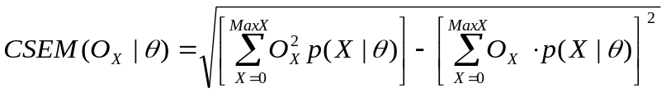 | (9)

where O_{X} is the observed scaled score for a particular number-correct score X, θ is the IRT ability scale value conditioned on, and 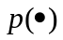 is the probability function. Pearson has implemented a computational approach for estimating CSEM(O_{x} | θ) in which p(X | θ ) is computed using a recursive algorithm given by Thissen, Pommerich, Billeaud, and Williams (1995). This algorithm is a polytomous generalization of the algorithm for dichotomous items given by Lord and Wingersky (1984). The values of θ used with the algorithm are obtained through the true score equating process (i.e., by solving for θ through the test characteristic curve for each number-correct score, X). There is one CSEM per number-correct score. The CSEMs by subject appear Table 4.26 and Table 4.27 for the Winter/Trimester 2010-11 and Spring 2011, respectively.

Standard Error of Measurement
Measurement error is associated with every test score. A student’s true score is the hypothetical average score that would result if the student took the test repeatedly under similar conditions. The standard error of measurement (SEM), as an overall test-level measure of error, can be used to construct a range around any given observed test score that likely includes the student’s true score. SEM is computed by taking the square root of the average value of the variances of the error of measurement associated with each of the raw score or scales scores:

 | 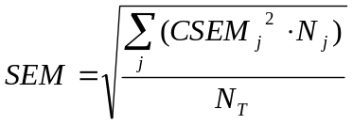 | (10)

where,
SEM = Standard Error of Measurement
CSEM = Conditional Standard of Measurement
N_{j} = number of examinees obtaining score j in the population
N_{T} = total number of students in test sample

SEM was computed for each of the content areas. Table 6.41 presents the overall estimates of SEM for each of the content areas for the Winter/Trimester 2010-2011 and Spring 2011 administrations.

Table 6.41. Overall Estimates of SEM by Subject
Subject | SEM*
Winter 2010-11
Algebra I | 25.67
Algebra II | 36.00
Biology I | 29.39
English II | 27.48
English III | 24.77
Geometry | 29.04
U.S. History | 28.32
Spring 2011
Algebra I – A | 22.96
Algebra I – B | 21.52
Algebra II – A | 32.00
Algebra II – B | 34.54
Biology I – A | 27.77
Biology I – B | 27.17
English II – AA | 30.77
English II – AB | 30.96
English II – BA | 29.22
English II – BB | 29.48
English III – AA | 22.46
English III – AB | 22.10
English III – BA | 21.35
English III – BB | 21.21
Geometry – A | 27.18
Geometry – B | 26.37
U.S. History - A | 27.04
U.S. History - B | 27.68
Note: *SEM = Standard Error of Measurement; SEM values are on the reportable scale metric; AA=Core MC form A+OE form A; AB=Core MC form A+OE form B; BA=Core MC form B+OE form A; BB=Core MC form B+OE form B.

References
American Educational Research Association (AERA), American Psychological Association (APA), & the National Council on Measurement in Education (NCME) (1999). Standards for educational and psychological testing. Washington, DC: AERA.
Dorans, N. J., & Holland, P. W. (1993). DIF detection and description: Mantel-Haenszel and standardization. In P. W. Holland & H. Wainer (Eds.), Differential item functioning (pp. 35-66). Hillsdale, NJ: Lawrence Erlbaum.
Holland, P. W., & Thayer, D.T. (1988). Differential Item Performance and the Mantel-Haenszel Procedure. (ETS RR-86-31). Princeton, NJ: Educational Testing Service.
Lord, F. M. (1980). Applications of item response theory to practical testing problems. Hillsdale, NJ: Lawrence Erlbaum.
Lord, F. M., & Novick, M. R. (1968). Statistical theories of mental test scores. Reading Massachusetts: Addison-Wesley Publishing Company.
Lord, F. M., & Wingersky, M. S. (1984). Comparison of IRT true-score and equipercentile observed-score “equatings.” Applied Psychological Measurement, 8, 453-461.
Kim, S. & Kolen, M. J. (2004). STUIRT: A computer program. Iowa City, IA: The University of Iowa. (Available from the web address: http://www.uiowa.edu/~casma).
Kolen, M.J. (2004). POLYEQUATE: A computer program. Iowa City, IA: The University of Iowa. (Available from the web address: http://www.uiowa.edu/~casma).
Kolen, M. J., & Brennan, R. L. (2004). Test equating, scaling, and linking: methods and practices (2nd ed.). New York: Springer.
Kraemer, H. C. (1982). Kappa coefficient. Encyclopedia of Statistical Sciences. Wiley.
Livingston, S. A., & Lewis, C. (1995). Estimating the consistency and accuracy of classifications based on test scores. Journal of Educational Measurement, 32, 179–197.
Michaelides, M. P. (2008). An Illustration of a Mantel-Haenszel Procedure to Flag Misbehaving Common Items in Test Equating. Practical Assessment Research & Evaluation, 13(7). Available online: http://pareonline.net/pdf/v13n7.pdf
Muraki, E. (1997). The generalized partial credit model. In W.J. van der Linden & R.K. Hambleton (Eds.), Handbook of Modern Item Response Theory (pp. 153-164). New York: Springer Verlag.
Stocking, M.L., & Lord, F.M. (1983). Developing a common metric in item response theory. Applied Psychological Measurement, 7, 201-210.
Thissen, D., Chen, W-H., & Bock, R. D. (2003). MUTILOG for Windows, Version 7 [Computer Software]. Lincolnwood, IL: Scientific Software International.
Thissen, D., Pommerich, M., Billeaud, K., & Williams, V.S.L. (1995). Item response theory for scores on tests including polytomous items with ordered responses. Applied Psychological Measurement, 19, 39-49.
Yen, W. M. (1981). Using simulation results to choose a latent trait model. Applied Psychological Measurement, 5, 245–262.
Yen, W. M. ( 1984). Effects of local item dependence on the fit and equating performance of the three-parameter logistic model. Applied Psychological Measurement, 8, 125-145.

Appendix A
Standards, Objectives/Skills, and Processes Assessed by Subject

Algebra I
Standard 1: Number Sense and Algebraic Operations
Standard 1.1 | Equations and Formulas
 | 1.1a Translate
 | 1.1b Literal Equations
 | 1.1c Problem Solving with Formulas
 | 1.1d Problem Solving
Standard 1.2 | Expressions
 | 1.2a Simplify expressions…
 | 1.2b Compute with polynomials…
 | 1.2c Factor polynomials
Standard 2: Relations and Functions
Standard 2.1 | Relations/Functions
 | 2.1a Distinguish linear and nonlinear
 | 2.1b Distinguish between relations…
 | 2.1c Dependent, Independ, Domain, Range
 | 2.1d Evaluate a function…
Standard 2.2 | Linear Equations and Graphs
 | 2.2a Solve linear equations
 | 2.2b Graph Transformations
 | 2.2c Slope
 | 2.2d Equation of a Line
 | 2.2e Match to a graph, table, etc.
Standard 2.3 | Linear Inequalities and Graphs
 | 2.3a Solve linear inequalities
 | 2.3b Match to a table, graph, etc.
Standard 2.4 | Systems of Equations
Standard 3: Data Analysis, Probability & Statistics
Standard 3.1 | Data Analysis
 | 3.1a Data Representations
 | 3.1b Data Predictions
 | 3.1c Problem Solving
Standard 3.2 | Line of Best Fit

Algebra II
Standard 1: Number Sense and Algebraic Operations
Standard 1.1 | Rational Exponents
 | 1.1a Convert expressions from radical notations to rational exponents and vice versa.
 | 1.1b Add, subtract, multiply, divide, and simplify radical expressions and expressions containing rational exponents.
Standard 1.2 | Polynomial and Rational Expressions
 | 1.2a Divide polynomial expressions by lower degree polynomials.
 | 1.2b Add, subtract, multiply, divide, and simplify rational expressions, including complex fractions.
Standard 1.3 | Complex Numbers
 | 1.3b Add, subtract, multiply, divide, and simplify expressions involving complex numbers.
Standard 2: Relations and Functions
Standard 2.1 | Functions and Function Notation
 | 2.1a Recognize the parent graphs of polynomial, exponential, and logarithmic functions and predict the effects of transformations on the parent graphs, using various methods and tools which may include graphing calculators.
 | 2.1b Use function notation to add, subtract, multiply, and divide functions.
 | 2.1c Combine functions by composition.
 | 2.1d Use algebraic, interval, and set notations to specify the domain and range of functions of various types.
 | 2.1e Find and graph the inverse of a function, if it exists.
Standard 2.2 | Systems of Equations
 | 2.2a Model a situation that can be described by a system of equations and inequalities and use the model to answer questions about the situation.
 | 2.2b Solve systems of linear equations and inequalities using various methods and tools which may include substitution, elimination, matrices, graphing, and graphing calculators.
 | 2.2c Use either one quadratic equation and one linear equation or two quadratic equations to solve problems.
Standard 2.3 | Quadratic Equations and Functions
 | 2.3a Solve quadratic equations by graphing, factoring, completing the square and quadratic formula.
 | 2.3b Graph a quadratic function and identify the x- and y-intercepts and maximum or minimum value, using various methods and tools which may include a graphing calculator.
 | 2.3c Model a situation that can be described by a quadratic function and use the model to answer questions about the situation.

Algebra II continued
Standard 2.4 | Identify, graph, and write the equations of the conic sections (circle, ellipse, parabola, and hyperbola).
Standard 2.5 | Exponential and Logarithmic Functions
 | 2.5a Graph exponential and logarithmic functions.
 | 2.5b Apply the inverse relationship between exponential and logarithmic functions to convert from one form to another.
 | 2.5c Model a situation that can be described by an exponential or logarithmic function and use the model to answer questions about the situation.
Standard 2.6 | Polynomial Equations and Functions
 | 2.6a Solve polynomial equations using various methods and tools which may include factoring and synthetic division.
 | 2.6b Sketch the graph of a polynomial function.
 | 2.6c Given the graph of a polynomial function, identify the x- and y-intercepts, relative maximums and relative minimums, using various methods and tools which may include a graphing calculator.
 | 2.6d Model a situation that can be described by a polynomial function and use the model to answer questions about the situation.
Standard 2.7 | Rational Equations and Functions
 | 2.7a Solve rational equations.
 | 2.7b Sketch the graph of a rational function.
 | 2.7c Given the graph of a rational function, identify the x- and y-intercepts, asymptotes, using various methods and tools which may include a graphing calculator.
 | 2.7d Model a situation that can be described by a rational function and use the model to answer questions about the situation.
Standard 3: Data Analysis, Probability, & Statistics
Standard 3.1 | Analysis of Collected Data …
 | 3.1a Display data on a scatter plot.
 | 3.1b Interpret results using a linear, exponential or quadratic model/equation.
 | 3.1c Identify whether the model/equation is a curve of best fit for the data, using various methods and tools which may include a graphing calculator.
Standard 3.3 | Identify and use arithmetic and geometric sequences

Geometry
Standard 1: Logical Reasoning
Standard 1.1 | Identify and use logical reasoning skills (inductive and deductive) to make and test conjectures, formulate counter examples, and follow logical arguments.
Standard 1.2 | State, use, and examine the validity of the converse, inverse, and contrapositive of “if-then” statements.
Standard 2: Properties of 2-Dimensional Figures
Standard 2.2 | Line and Angle Relationships
 | 2.2a Use the angle relationships formed by parallel lines cut by a transversal to solve problems.
 | 2.2b Use the angle relationships formed by two lines cut by a transversal to determine if the two lines are parallel and verify, using algebraic and deductive proofs.
 | 2.2c Use relationships between pairs of angles (for example, adjacent, complementary, vertical) to solve problems.
Standard 2.3 | Polygons and Other Plane Figures
 | 2.3a Identify, describe, and analyze polygons (for example, convex, concave, regular, pentagonal, hexagonal, n-gonal).
 | 2.3b Apply the interior and exterior angle sum of convex polygons to solve problems, and verify using algebraic and deductive proofs.
 | 2.3c Develop and apply the properties of quadrilaterals to solve problems (for example, rectangles, parallelograms, rhombi, trapezoids, kites).
 | 2.3d Use properties of 2-dimensional figures and side length, perimeter or circumference, and area to determine unknown values and correctly identify the appropriate unit of measure of each.
Standard 2.4 | Similarity
 | 2.4a Determine and verify the relationships of similarity of triangles, using algebraic and deductive proofs.
 | 2.4b Use ratios of similar 2-dimensional figures to determine unknown values, such as angles, side lengths, perimeter or circumference, and area.
Standard 2.5 | Congruence
 | 2.5a Determine and verify the relationships of congruency of triangles, using algebraic and deductive proofs.
 | 2.5b Use the relationships of congruency of 2-dimensional figures to determine unknown values, such as angles, side lengths, perimeter or circumference, and area.
Standard 2.6 | Circles
 | 2.6a Find angle measures and arc measures related to circles.
 | 2.6b Find angle measures and segment lengths using the relationships among radii, chords, secants, and tangents of a circle.

Geometry continued
Standard 3: Triangles and Trigonometric Ratios
Standard 3.1 | Use the Pythagorean Theorem and its converse to find missing side lengths and to determine acute, right, and obtuse triangles, and verify using algebraic and deductive proofs.
Standard 3.2 | Apply the 45-45-90 and 30-60-90 right triangle relationships to solve problems, and verify using algebraic and deductive proofs.
Standard 3.3 | Express the trigonometric functions as ratios and use sine, cosine, and tangent ratios to solve real-world problems.
Standard 4: Properties of 3-Dimensional Figures
Standard 4.1 | Polyhedra and Other Solids
 | 4.1a Identify, describe, and analyze polyhedra (for example, regular, decahedral).
 | 4.1b Use properties of 3-dimensional figures; side lengths, perimeter or circumference, and area of a face; and volume, lateral area, and surface area to determine unknown values and correctly identify the appropriate unit of measure of each.
Standard 4.2 | Similarity and Congruence
 | 4.2a Use ratios of similar 3-dimensional figures to determine unknown values, such as angles, side lengths, perimeter or circumference of a face, area of a face, and volume.
 | 4.2b Use the relationships of congruency of 3-dimensional figures to determine unknown values, such as angles, side lengths, perimeter or circumference of a face, area of a face, and volume.
4.3 | Create a model of a 3-dimensional figure from a 2-dimensional drawing and make a 2-dimensional representation of a 3-dimensional object (for example, nets, blueprints, perspective drawings).
Standard 5: Coordinate Geometry
Standard 5.1 | Use coordinate geometry to find the distance between two points; the midpoint of a segment; and to calculate the slopes of a parallel, perpendicular, horizontal, and vertical lines.
Standard 5.2 | Properties of Figures
 | 5.2a Given a set of points determine the type of figure formed based on its properties.
 | 5.2b Use transformations (reflection, rotation, translation)on geometric figures to solve problems within coordinate geometry.

Biology I
PASS Process/Inquiry Standards and Objectives
Process 1 Observe and Measure
P1.1 | Qualitative/quantitative observations and changes
P1.2  P1.3 | Use appropriate System International (SI) units and tools
Process 2 Classify
P2.1 | Use observable properties to classify
P2.2 | Identify properties of a classification system
Process 3 Experiment
P3.1 | Evaluate the design of investigations
P3.2  P3.4 | Identify a testable hypothesis, variables, and control in an experiment
P3.3 | Use mathematics to show relationships
P3.5 | Identify potential hazards and practice safety procedures in all science activities
Process 4 Interpret and Communicate
P4.1 | Select predictions based on observed patterns of evidence
P4.3 | Interpret line, bar, trend, and circle graphs
P4.4 | Accept or reject a hypothesis
P4.5 | Make logical conclusions based on experimental data
P4.8 | Identify an appropriate graph or chart
Process 5 Model
P5.1 | Interpret a model which explains a given set of observations
P5.2 | Select predictions based on models
PASS Content Standards
Standard 1 The Cell
1.1 | Cell structures and functions
1.2 | Differentiation of cells
Standard 2 The Molecular Basis of Heredity
2.1 | DNA structure and function in heredity
2.2 | Sorting and recombination of genes
Standard 3 Biological Diversity
3.1 | Variation among organisms
3.2 | Natural selection and biological adaptations
Standard 4 The Interdependence of Organisms
4.1 | Earth cycles including abiotic and biotic factors
4.2 | Organisms both cooperate and compete
4.3 | Population dynamics
Standard 5 Matter/Energy/Organization in Living Systems
5.1 | Complexity and organization used for survival
5.2 | Matter and energy flow in living and nonliving systems

Biology I continued
Standard 6 The Behavior of Organisms
6.1 | Specialized cells
6.2 | Behavior patterns can be used to ensure reproductive success

English II
Reading/Literature
Standard 1 Vocabulary
Standard 2 Comprehension
2.1 | Literal Understanding
2.2 | Inferences and Interpretation
2.3 | Summary and Generalization
2.4 | Analysis and Evaluation
Standard 3 Literature
3.1 | Literary Genres
3.2 | Literary Elements
3.3 | Figurative Language
3.4 | Literary Works
Standard 4 Research and Information
Writing/Grammar/Usage and Mechanics
Standard 1/2 Writing
 | Writing Prompt
Standard 3 Grammar/Usage and Mechanics
3.1 | Standard Usage
3.2 | Mechanics and Spelling
3.3 | Sentence Structure

English III
Reading/Literature
Standard 1 Vocabulary
Standard 2 Comprehension
2.1 | Literal Understanding
2.2 | Inference and Interpretation
2.3 | Summary and Generalization
2.4 | Analysis and Evaluation
Standard 3 Literature
3.1 | Literary Genres
3.2 | Literary Elements
3.3 | Figurative Language
3.4 | Literary Works
Standard 4 Research and Information
Writing/Grammar/Usage and Mechanics
Standard 1/2 Writing
 | Writing Prompt
Standard 3 Grammar/Usage and Mechanics
3.1 | Standard English Usage
3.2 | Mechanics and Spelling
3.3 | Sentence Structure
3.4 | Manuscript Conventions

U.S. History
Standard 1 Civil War/Reconstruction Era
Standard 2 Impact of Immigration and Industrialization
2.1 | Immigration and Impact on Native Americans
2.2 | Industrialization
Standard 3 Imperialism, World War I, and Isolationism
3.1 | American Imperialism
3.2 | World War I and Isolationism
Standard 4 United States During the 1920s and 1930s
4.1 | Cultural Life Between the Wars
4.2 | Economic Destabilization
4.3 | The Great Depression, the Dust Bowl, and the New Deal
Standard 5 World War II
5.1 | Preparing for War
5.2 | World War II
Standard 6 United States Since World War II
6.1 | Post War Foreign Policies and Events
6.2 | Events Changing Domestic and Foreign Policies and Events
6.3 | Post War Domestic Policies and Events

Appendix B
Scale Score Distributions for Winter/Trimester 2010-11

Algebra I Scale Score Distribution for Winter/Trimester 2010-11
Scale Score | Frequency | Percent | Cumulative Frequency | Cumulative Percent
490 | 8 | 0.6 | 8 | 0.6
537 | 8 | 0.6 | 16 | 1.2
569 | 16 | 1.2 | 32 | 2.4
590 | 16 | 1.2 | 48 | 3.6
606 | 16 | 1.2 | 64 | 4.7
619 | 20 | 1.5 | 84 | 6.2
631 | 39 | 2.9 | 123 | 9.1
640 | 35 | 2.6 | 158 | 11.7
649 | 43 | 3.2 | 201 | 14.9
662 | 46 | 3.4 | 247 | 18.3
663 | 49 | 3.6 | 296 | 22.0
670 | 58 | 4.3 | 354 | 26.3
676 | 50 | 3.7 | 404 | 30.0
682 | 49 | 3.6 | 453 | 33.6
687 | 61 | 4.5 | 514 | 38.1
693 | 47 | 3.5 | 561 | 41.6
700 | 61 | 4.5 | 622 | 46.1
703 | 55 | 4.1 | 677 | 50.2
708 | 50 | 3.7 | 727 | 53.9
713 | 48 | 3.6 | 775 | 57.5
717 | 40 | 3.0 | 815 | 60.5
722 | 36 | 2.7 | 851 | 63.1
727 | 31 | 2.3 | 882 | 65.4
731 | 38 | 2.8 | 920 | 68.2
736 | 32 | 2.4 | 952 | 70.6
740 | 32 | 2.4 | 984 | 73.0
745 | 33 | 2.4 | 1,017 | 75.4
749 | 34 | 2.5 | 1,051 | 78.0
754 | 32 | 2.4 | 1,083 | 80.3
762 | 36 | 2.7 | 1,119 | 83.0
764 | 29 | 2.2 | 1,148 | 85.2
769 | 28 | 2.1 | 1,176 | 87.2
774 | 22 | 1.6 | 1,198 | 88.9
779 | 16 | 1.2 | 1,214 | 90.1
785 | 21 | 1.6 | 1,235 | 91.6
791 | 27 | 2.0 | 1,262 | 93.6
797 | 11 | 0.8 | 1,273 | 94.4
804 | 16 | 1.2 | 1,289 | 95.6
812 | 12 | 0.9 | 1,301 | 96.5
822 | 16 | 1.2 | 1,317 | 97.7
833 | 9 | 0.7 | 1,326 | 98.4
847 | 7 | 0.5 | 1,333 | 98.9
868 | 7 | 0.5 | 1,340 | 99.4
Algebra I Scale Score Distribution for Winter/Trimester 2010-11 (cont.)
Scale Score | Frequency | Percent | Cumulative Frequency | Cumulative Percent
904 | 4 | 0.3 | 1,344 | 99.7
999 | 4 | 0.3 | 1,348 | 100.0

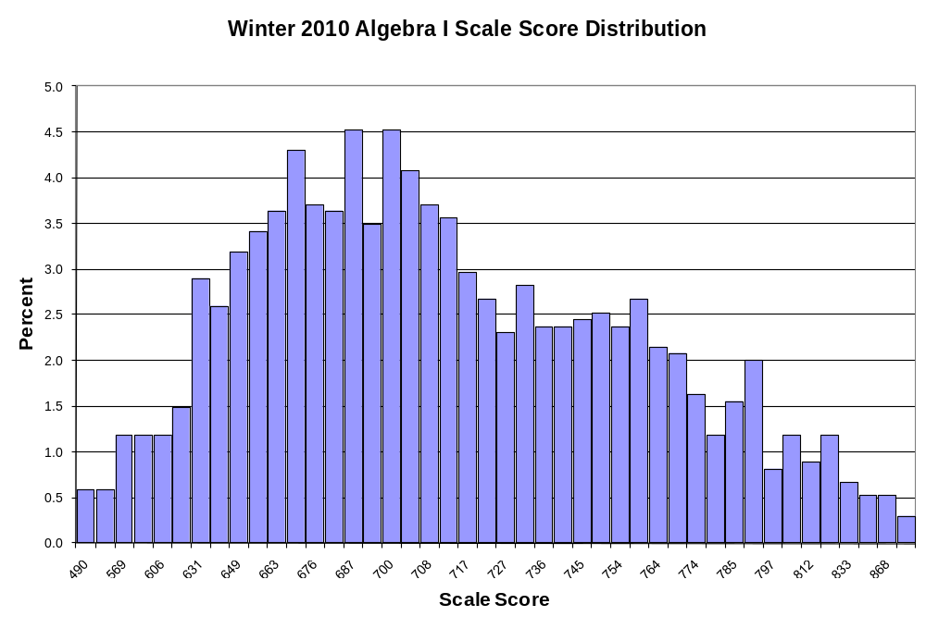

Algebra II Scale Score Distribution for Winter/Trimester 2010-11
Scale Score | Frequency | Percent | Cumulative Frequency | Cumulative Percent
440 | 27 | 2.6 | 27 | 2.6
504 | 15 | 1.4 | 42 | 4.0
545 | 13 | 1.2 | 55 | 5.2
574 | 26 | 2.5 | 81 | 7.7
596 | 27 | 2.6 | 108 | 10.3
614 | 30 | 2.8 | 138 | 13.1
629 | 25 | 2.4 | 163 | 15.5
642 | 30 | 2.8 | 193 | 18.3
654 | 35 | 3.3 | 228 | 21.7
663 | 30 | 2.8 | 258 | 24.5
672 | 17 | 1.6 | 275 | 26.1
680 | 29 | 2.8 | 304 | 28.9
688 | 27 | 2.6 | 331 | 31.4
700 | 26 | 2.5 | 357 | 33.9
702 | 21 | 2.0 | 378 | 35.9
708 | 22 | 2.1 | 400 | 38.0
714 | 30 | 2.8 | 430 | 40.8
720 | 27 | 2.6 | 457 | 43.4
726 | 35 | 3.3 | 492 | 46.7
731 | 26 | 2.5 | 518 | 49.2
736 | 32 | 3.0 | 550 | 52.2
742 | 30 | 2.8 | 580 | 55.1
747 | 30 | 2.8 | 610 | 57.9
752 | 41 | 3.9 | 651 | 61.8
757 | 30 | 2.8 | 681 | 64.7
762 | 30 | 2.8 | 711 | 67.5
767 | 28 | 2.7 | 739 | 70.2
772 | 30 | 2.8 | 769 | 73.0
777 | 34 | 3.2 | 803 | 76.3
783 | 31 | 2.9 | 834 | 79.2
788 | 24 | 2.3 | 858 | 81.5
794 | 24 | 2.3 | 882 | 83.8
799 | 22 | 2.1 | 904 | 85.8
806 | 18 | 1.7 | 922 | 87.6
812 | 18 | 1.7 | 940 | 89.3
819 | 14 | 1.3 | 954 | 90.6
828 | 24 | 2.3 | 978 | 92.9
837 | 15 | 1.4 | 993 | 94.3
848 | 13 | 1.2 | 1,006 | 95.5
861 | 17 | 1.6 | 1,023 | 97.2
878 | 10 | 0.9 | 1,033 | 98.1
902 | 9 | 0.9 | 1,042 | 99.0
Algebra II Scale Score Distribution for Winter/Trimester 2010-11 (cont.)
Scale Score | Frequency | Percent | Cumulative Frequency | Cumulative Percent
944 | 7 | 0.7 | 1,049 | 99.6
999 | 4 | 0.4 | 1,053 | 100.0

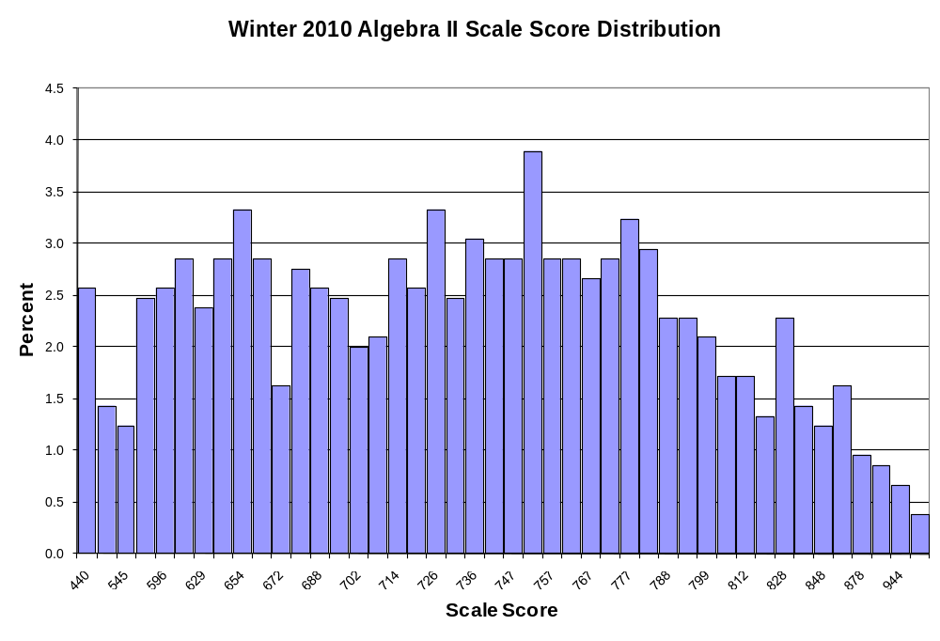

Biology I Scale Score Distribution for Winter/Trimester 2010-11
Scale Score | Frequency | Percent | Cumulative Frequency | Cumulative Percent
440 | 7 | 0.5 | 7 | 0.5
442 | 2 | 0.1 | 9 | 0.7
481 | 3 | 0.2 | 12 | 0.9
510 | 9 | 0.7 | 21 | 1.5
532 | 6 | 0.4 | 27 | 2.0
551 | 11 | 0.8 | 38 | 2.8
567 | 22 | 1.6 | 60 | 4.4
581 | 12 | 0.9 | 72 | 5.2
594 | 17 | 1.2 | 89 | 6.5
606 | 35 | 2.5 | 124 | 9.0
616 | 33 | 2.4 | 157 | 11.4
627 | 26 | 1.9 | 183 | 13.3
636 | 22 | 1.6 | 205 | 14.9
645 | 33 | 2.4 | 238 | 17.3
653 | 34 | 2.5 | 272 | 19.8
661 | 38 | 2.8 | 310 | 22.5
669 | 39 | 2.8 | 349 | 25.4
676 | 41 | 3.0 | 390 | 28.3
683 | 45 | 3.3 | 435 | 31.6
691 | 27 | 2.0 | 462 | 33.6
697 | 42 | 3.1 | 504 | 36.6
704 | 42 | 3.1 | 546 | 39.7
710 | 46 | 3.3 | 592 | 43.0
716 | 40 | 2.9 | 632 | 45.9
722 | 29 | 2.1 | 661 | 48.0
728 | 33 | 2.4 | 694 | 50.4
734 | 39 | 2.8 | 733 | 53.3
740 | 33 | 2.4 | 766 | 55.7
746 | 32 | 2.3 | 798 | 58.0
752 | 46 | 3.3 | 844 | 61.3
758 | 31 | 2.3 | 875 | 63.6
764 | 30 | 2.2 | 905 | 65.8
775 | 38 | 2.8 | 943 | 68.5
776 | 56 | 4.1 | 999 | 72.6
782 | 38 | 2.8 | 1,037 | 75.4
789 | 43 | 3.1 | 1,080 | 78.5
796 | 29 | 2.1 | 1,109 | 80.6
803 | 37 | 2.7 | 1,146 | 83.3
811 | 47 | 3.4 | 1,193 | 86.7
819 | 32 | 2.3 | 1,225 | 89.0
829 | 28 | 2.0 | 1,253 | 91.1
839 | 39 | 2.8 | 1,292 | 93.9
852 | 30 | 2.2 | 1,322 | 96.1
Biology I Scale Score Distribution for Winter/Trimester 2010-11 (cont.)
Scale Score | Frequency | Percent | Cumulative Frequency | Cumulative Percent
868 | 25 | 1.8 | 1,347 | 97.9
888 | 14 | 1.0 | 1,361 | 98.9
918 | 11 | 0.8 | 1,372 | 99.7
975 | 3 | 0.2 | 1,375 | 99.9
999 | 1 | 0.1 | 1,376 | 100.0

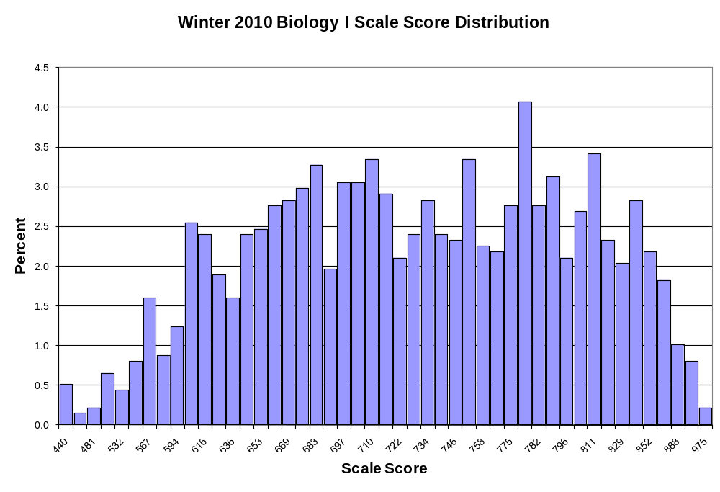

English II Scale Score Distribution for Winter/Trimester 2010-11
Scale Score | Frequency | Percent | Cumulative Frequency | Cumulative Percent
440 | 9 | 0.6 | 9 | 0.6
454 | 2 | 0.1 | 11 | 0.8
482 | 4 | 0.3 | 15 | 1.1
504 | 4 | 0.3 | 19 | 1.3
522 | 5 | 0.4 | 24 | 1.7
537 | 7 | 0.5 | 31 | 2.2
551 | 7 | 0.5 | 38 | 2.7
563 | 4 | 0.3 | 42 | 2.9
574 | 11 | 0.8 | 53 | 3.7
588 | 6 | 0.4 | 59 | 4.1
593 | 9 | 0.6 | 68 | 4.8
602 | 8 | 0.6 | 76 | 5.3
610 | 12 | 0.8 | 88 | 6.2
618 | 21 | 1.5 | 109 | 7.6
625 | 12 | 0.8 | 121 | 8.5
632 | 16 | 1.1 | 137 | 9.6
639 | 11 | 0.8 | 148 | 10.4
645 | 21 | 1.5 | 169 | 11.9
652 | 17 | 1.2 | 186 | 13.1
658 | 26 | 1.8 | 212 | 14.9
664 | 17 | 1.2 | 229 | 16.1
670 | 33 | 2.3 | 262 | 18.4
676 | 30 | 2.1 | 292 | 20.5
681 | 32 | 2.2 | 324 | 22.7
687 | 36 | 2.5 | 360 | 25.3
693 | 36 | 2.5 | 396 | 27.8
699 | 36 | 2.5 | 432 | 30.3
704 | 35 | 2.5 | 467 | 32.8
710 | 43 | 3.0 | 510 | 35.8
716 | 34 | 2.4 | 544 | 38.2
722 | 49 | 3.4 | 593 | 41.6
728 | 41 | 2.9 | 634 | 44.5
734 | 40 | 2.8 | 674 | 47.3
740 | 53 | 3.7 | 727 | 51.0
746 | 54 | 3.8 | 781 | 54.8
753 | 61 | 4.3 | 842 | 59.1
760 | 56 | 3.9 | 898 | 63.0
767 | 59 | 4.1 | 957 | 67.2
775 | 59 | 4.1 | 1,016 | 71.3
783 | 69 | 4.8 | 1,085 | 76.1
797 | 61 | 4.3 | 1,146 | 80.4
802 | 51 | 3.6 | 1,197 | 84.0
813 | 51 | 3.6 | 1,248 | 87.6
English II Scale Score Distribution for Winter/Trimester 2010-11 (cont.)
Scale Score | Frequency | Percent | Cumulative Frequency | Cumulative Percent
825 | 41 | 2.9 | 1,289 | 90.5
839 | 38 | 2.7 | 1,327 | 93.1
855 | 36 | 2.5 | 1,363 | 95.6
875 | 29 | 2.0 | 1,392 | 97.7
900 | 14 | 1.0 | 1,406 | 98.7
936 | 8 | 0.6 | 1,414 | 99.2
997 | 8 | 0.6 | 1,422 | 99.8
999 | 3 | 0.2 | 1,425 | 100.0

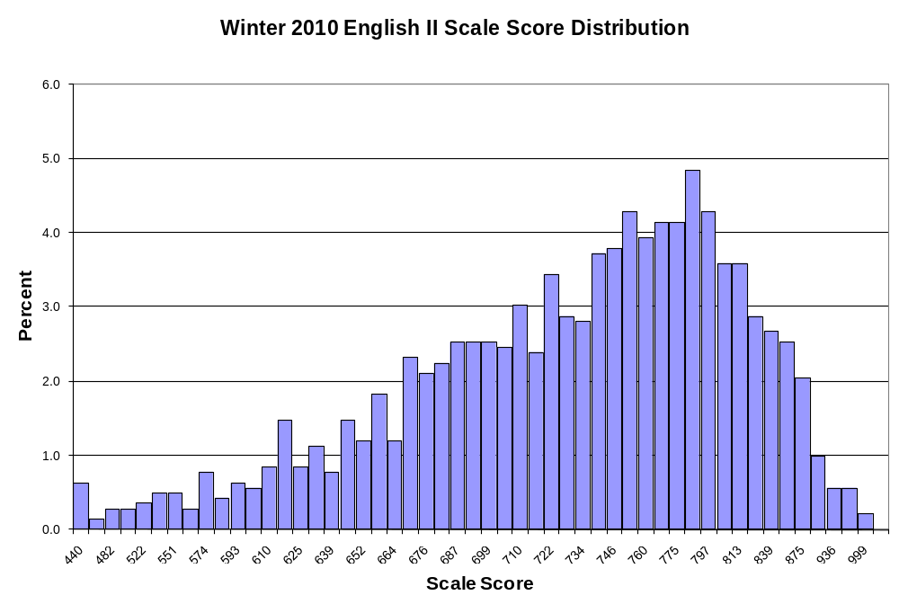

English III Scale Score Distribution for Winter/Trimester 2010-11
Scale Score | Frequency | Percent | Cumulative Frequency | Cumulative Percent
440 | 6 | 0.4 | 6 | 0.4
477 | 3 | 0.2 | 9 | 0.6
506 | 5 | 0.4 | 14 | 1.0
527 | 5 | 0.4 | 19 | 1.3
543 | 13 | 0.9 | 32 | 2.3
558 | 9 | 0.6 | 41 | 2.9
571 | 8 | 0.6 | 49 | 3.5
583 | 7 | 0.5 | 56 | 3.9
595 | 15 | 1.1 | 71 | 5.0
605 | 10 | 0.7 | 81 | 5.7
614 | 9 | 0.6 | 90 | 6.3
623 | 19 | 1.3 | 109 | 7.7
631 | 12 | 0.8 | 121 | 8.5
639 | 17 | 1.2 | 138 | 9.7
646 | 13 | 0.9 | 151 | 10.6
653 | 13 | 0.9 | 164 | 11.5
660 | 19 | 1.3 | 183 | 12.9
670 | 14 | 1.0 | 197 | 13.9
672 | 13 | 0.9 | 210 | 14.8
678 | 18 | 1.3 | 228 | 16.1
684 | 19 | 1.3 | 247 | 17.4
689 | 24 | 1.7 | 271 | 19.1
695 | 14 | 1.0 | 285 | 20.1
700 | 21 | 1.5 | 306 | 21.5
705 | 24 | 1.7 | 330 | 23.2
710 | 29 | 2.0 | 359 | 25.3
715 | 32 | 2.3 | 391 | 27.5
721 | 22 | 1.5 | 413 | 29.1
726 | 28 | 2.0 | 441 | 31.1
731 | 25 | 1.8 | 466 | 32.8
736 | 28 | 2.0 | 494 | 34.8
741 | 32 | 2.3 | 526 | 37.0
746 | 35 | 2.5 | 561 | 39.5
751 | 38 | 2.7 | 599 | 42.2
756 | 48 | 3.4 | 647 | 45.6
761 | 47 | 3.3 | 694 | 48.9
766 | 63 | 4.4 | 757 | 53.3
772 | 44 | 3.1 | 801 | 56.4
777 | 54 | 3.8 | 855 | 60.2
783 | 39 | 2.7 | 894 | 63.0
788 | 58 | 4.1 | 952 | 67.0
794 | 49 | 3.5 | 1,001 | 70.5
802 | 38 | 2.7 | 1,039 | 73.2
English III Scale Score Distribution for Winter/Trimester 2010-11 (cont.)
Scale Score | Frequency | Percent | Cumulative Frequency | Cumulative Percent
806 | 36 | 2.5 | 1,075 | 75.7
813 | 41 | 2.9 | 1,116 | 78.6
819 | 42 | 3.0 | 1,158 | 81.5
826 | 36 | 2.5 | 1,194 | 84.1
833 | 26 | 1.8 | 1,220 | 85.9
841 | 38 | 2.7 | 1,258 | 88.6
849 | 30 | 2.1 | 1,288 | 90.7
858 | 35 | 2.5 | 1,323 | 93.2
867 | 25 | 1.8 | 1,348 | 94.9
877 | 27 | 1.9 | 1,375 | 96.8
888 | 19 | 1.3 | 1,394 | 98.2
901 | 8 | 0.6 | 1,402 | 98.7
917 | 11 | 0.8 | 1,413 | 99.5
938 | 4 | 0.3 | 1,417 | 99.8
968 | 3 | 0.2 | 1,420 | 100.0

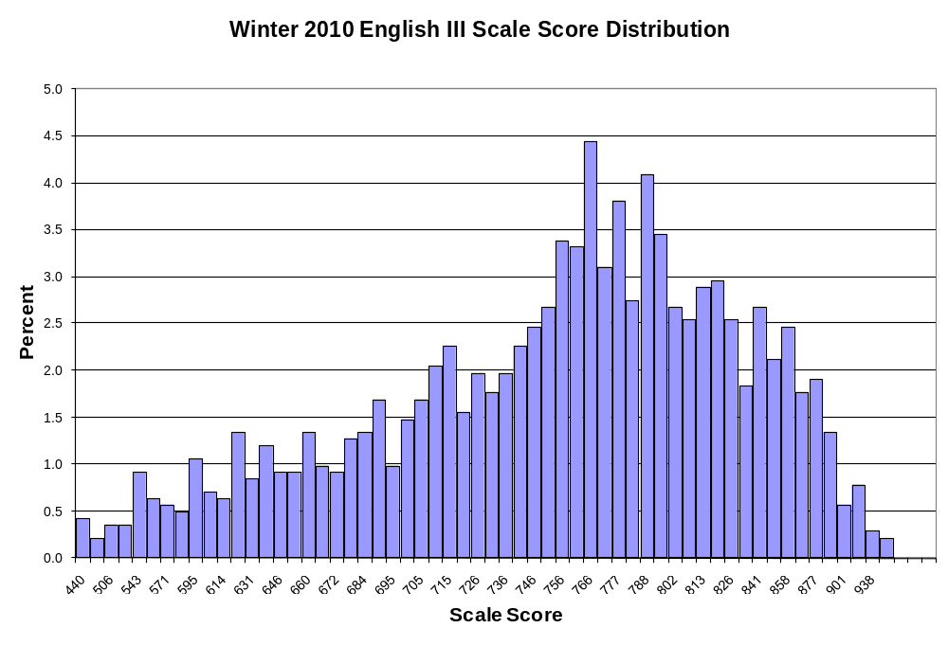

Geometry Scale Score Distribution for Winter/Trimester 2010-11
Scale Score | Frequency | Percent | Cumulative Frequency | Cumulative Percent
440 | 10 | 0.6 | 10 | 0.6
503 | 11 | 0.7 | 21 | 1.4
544 | 11 | 0.7 | 32 | 2.1
571 | 13 | 0.8 | 45 | 2.9
591 | 24 | 1.6 | 69 | 4.5
606 | 19 | 1.2 | 88 | 5.7
619 | 22 | 1.4 | 110 | 7.1
635 | 24 | 1.6 | 134 | 8.7
640 | 28 | 1.8 | 162 | 10.5
649 | 31 | 2.0 | 193 | 12.5
657 | 48 | 3.1 | 241 | 15.6
665 | 28 | 1.8 | 269 | 17.4
672 | 36 | 2.3 | 305 | 19.8
679 | 47 | 3.0 | 352 | 22.8
685 | 43 | 2.8 | 395 | 25.6
691 | 36 | 2.3 | 431 | 27.9
700 | 48 | 3.1 | 479 | 31.0
703 | 35 | 2.3 | 514 | 33.3
708 | 34 | 2.2 | 548 | 35.5
714 | 40 | 2.6 | 588 | 38.1
719 | 49 | 3.2 | 637 | 41.3
724 | 35 | 2.3 | 672 | 43.5
729 | 32 | 2.1 | 704 | 45.6
734 | 34 | 2.2 | 738 | 47.8
738 | 38 | 2.5 | 776 | 50.3
743 | 39 | 2.5 | 815 | 52.8
748 | 40 | 2.6 | 855 | 55.4
752 | 44 | 2.8 | 899 | 58.2
757 | 40 | 2.6 | 939 | 60.8
762 | 31 | 2.0 | 970 | 62.8
767 | 43 | 2.8 | 1,013 | 65.6
772 | 33 | 2.1 | 1,046 | 67.7
777 | 43 | 2.8 | 1,089 | 70.5
782 | 51 | 3.3 | 1,140 | 73.8
788 | 50 | 3.2 | 1,190 | 77.1
794 | 47 | 3.0 | 1,237 | 80.1
801 | 35 | 2.3 | 1,272 | 82.4
808 | 49 | 3.2 | 1,321 | 85.6
816 | 45 | 2.9 | 1,366 | 88.5
825 | 46 | 3.0 | 1,412 | 91.5
837 | 46 | 3.0 | 1,458 | 94.4
851 | 33 | 2.1 | 1,491 | 96.6
Geometry Scale Score Distribution for Winter/Trimester 2010-11 (cont.)
Scale Score | Frequency | Percent | Cumulative Frequency | Cumulative Percent
872 | 22 | 1.4 | 1,513 | 98.0
907 | 23 | 1.5 | 1,536 | 99.5
999 | 8 | 0.5 | 1,544 | 100.0

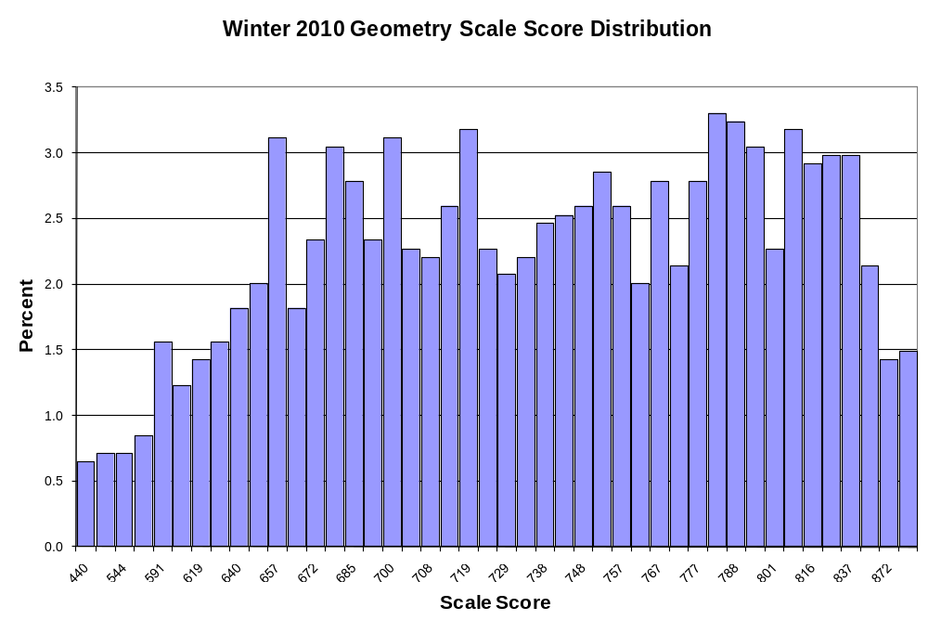

U.S. History Scale Score Distribution for Winter/Trimester 2010-11
Scale Score | Frequency | Percent | Cumulative Frequency | Cumulative Percent
440 | 12 | 0.9 | 12 | 0.9
473 | 4 | 0.3 | 16 | 1.1
506 | 11 | 0.8 | 27 | 1.9
530 | 10 | 0.7 | 37 | 2.7
549 | 8 | 0.6 | 45 | 3.2
564 | 18 | 1.3 | 63 | 4.5
577 | 11 | 0.8 | 74 | 5.3
589 | 16 | 1.1 | 90 | 6.5
603 | 21 | 1.5 | 111 | 8.0
610 | 29 | 2.1 | 140 | 10.0
620 | 31 | 2.2 | 171 | 12.3
629 | 26 | 1.9 | 197 | 14.1
637 | 30 | 2.2 | 227 | 16.3
645 | 26 | 1.9 | 253 | 18.1
653 | 19 | 1.4 | 272 | 19.5
660 | 28 | 2.0 | 300 | 21.5
667 | 32 | 2.3 | 332 | 23.8
674 | 43 | 3.1 | 375 | 26.9
680 | 45 | 3.2 | 420 | 30.1
689 | 23 | 1.6 | 443 | 31.8
693 | 39 | 2.8 | 482 | 34.6
699 | 39 | 2.8 | 521 | 37.4
704 | 43 | 3.1 | 564 | 40.5
710 | 48 | 3.4 | 612 | 43.9
716 | 46 | 3.3 | 658 | 47.2
721 | 33 | 2.4 | 691 | 49.6
727 | 41 | 2.9 | 732 | 52.5
733 | 36 | 2.6 | 768 | 55.1
738 | 46 | 3.3 | 814 | 58.4
747 | 43 | 3.1 | 857 | 61.5
750 | 44 | 3.2 | 901 | 64.6
756 | 37 | 2.7 | 938 | 67.3
762 | 56 | 4.0 | 994 | 71.3
768 | 46 | 3.3 | 1,040 | 74.6
775 | 51 | 3.7 | 1,091 | 78.3
782 | 51 | 3.7 | 1,142 | 81.9
789 | 42 | 3.0 | 1,184 | 84.9
797 | 35 | 2.5 | 1,219 | 87.4
806 | 29 | 2.1 | 1,248 | 89.5
815 | 31 | 2.2 | 1,279 | 91.8
826 | 27 | 1.9 | 1,306 | 93.7
838 | 25 | 1.8 | 1,331 | 95.5
852 | 32 | 2.3 | 1,363 | 97.8
U.S. History Scale Score Distribution for Winter/Trimester 2010-11 (cont.)
Scale Score | Frequency | Percent | Cumulative Frequency | Cumulative Percent
870 | 11 | 0.8 | 1,374 | 98.6
893 | 11 | 0.8 | 1,385 | 99.4
925 | 6 | 0.4 | 1,391 | 99.8
982 | 2 | 0.1 | 1,393 | 99.9
999 | 1 | 0.1 | 1,394 | 100.0

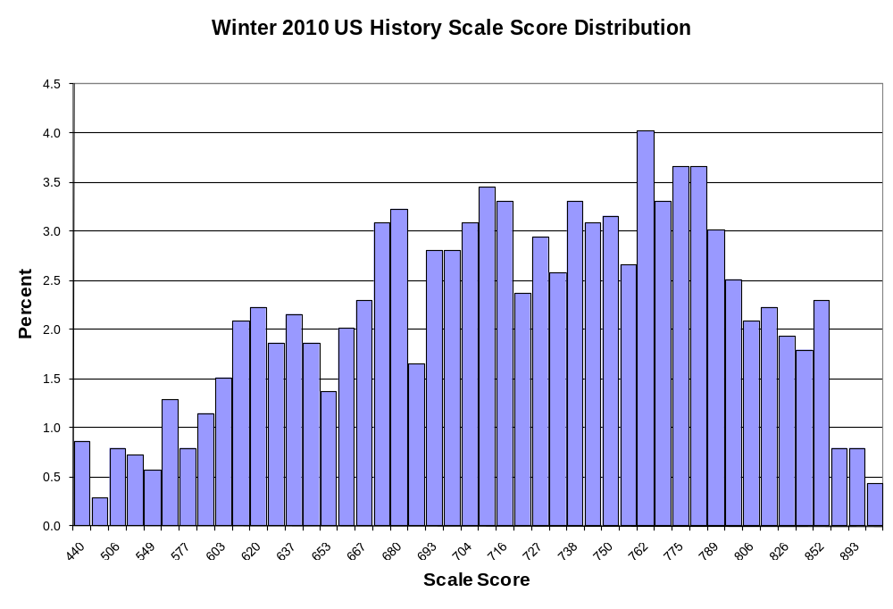

Appendix C
Scale Score Distributions for Spring 2011

Algebra I Core A Score Distribution for Spring 2011
Scale Score | Frequency | Percent | Cumulative Frequency | Cumulative Percent
490 | 95 | 0.6 | 95 | 0.6
537 | 58 | 0.4 | 153 | 1.0
575 | 74 | 0.5 | 227 | 1.5
598 | 98 | 0.7 | 325 | 2.2
615 | 140 | 0.9 | 465 | 3.1
628 | 145 | 1.0 | 610 | 4.1
640 | 182 | 1.2 | 792 | 5.3
649 | 221 | 1.5 | 1,013 | 6.8
662 | 237 | 1.6 | 1,250 | 8.4
665 | 240 | 1.6 | 1,490 | 10.0
672 | 263 | 1.8 | 1,753 | 11.8
679 | 330 | 2.2 | 2,083 | 14.0
685 | 333 | 2.2 | 2,416 | 16.2
690 | 376 | 2.5 | 2,792 | 18.8
695 | 387 | 2.6 | 3,179 | 21.4
700 | 434 | 2.9 | 3,613 | 24.3
705 | 407 | 2.7 | 4,020 | 27.0
709 | 476 | 3.2 | 4,496 | 30.2
713 | 464 | 3.1 | 4,960 | 33.3
717 | 454 | 3.1 | 5,414 | 36.4
721 | 471 | 3.2 | 5,885 | 39.6
725 | 497 | 3.3 | 6,382 | 42.9
729 | 480 | 3.2 | 6,862 | 46.1
733 | 499 | 3.4 | 7,361 | 49.5
737 | 505 | 3.4 | 7,866 | 52.9
741 | 526 | 3.5 | 8,392 | 56.4
745 | 494 | 3.3 | 8,886 | 59.7
749 | 493 | 3.3 | 9,379 | 63.1
753 | 516 | 3.5 | 9,895 | 66.5
757 | 539 | 3.6 | 10,434 | 70.2
762 | 466 | 3.1 | 10,900 | 73.3
765 | 459 | 3.1 | 11,359 | 76.4
770 | 499 | 3.4 | 11,858 | 79.7
775 | 452 | 3.0 | 12,310 | 82.8
780 | 423 | 2.8 | 12,733 | 85.6
786 | 389 | 2.6 | 13,122 | 88.2
792 | 397 | 2.7 | 13,519 | 90.9
799 | 363 | 2.4 | 13,882 | 93.3
807 | 278 | 1.9 | 14,160 | 95.2
817 | 244 | 1.6 | 14,404 | 96.8
829 | 221 | 1.5 | 14,625 | 98.3
846 | 143 | 1.0 | 14,768 | 99.3
Algebra I Core A Score Distribution for Spring 2011 (cont.)
Scale Score | Frequency | Percent | Cumulative Frequency | Cumulative Percent
875 | 81 | 0.5 | 14,849 | 99.8
999 | 24 | 0.2 | 14,873 | 100.0
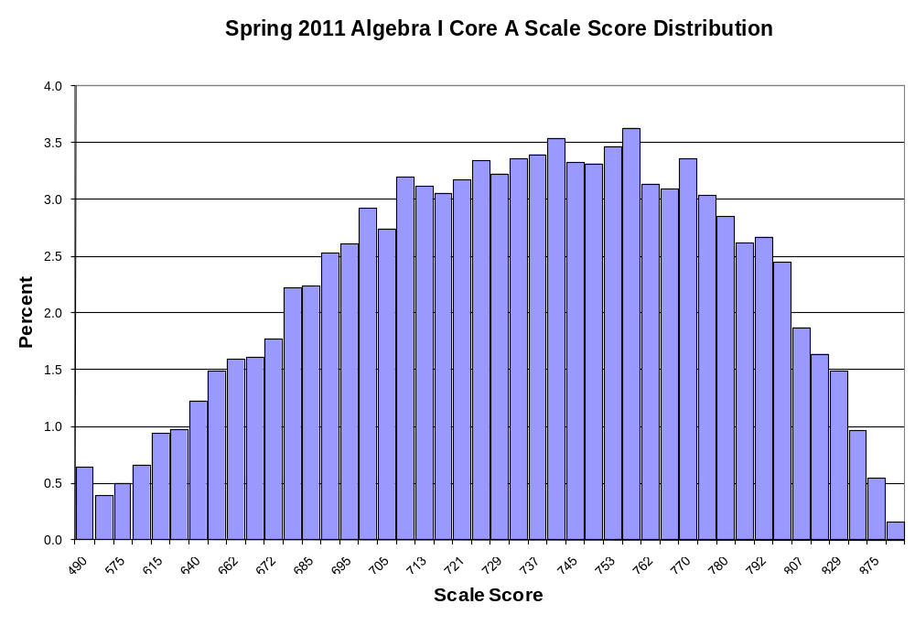

Algebra I Core B Score Distribution for Spring 2011
Scale Score | Frequency | Percent | Cumulative Frequency | Cumulative Percent
490 | 31 | 0.3 | 31 | 0.3
504 | 18 | 0.1 | 49 | 0.4
560 | 33 | 0.3 | 82 | 0.7
587 | 40 | 0.3 | 122 | 1.0
606 | 63 | 0.5 | 185 | 1.5
620 | 101 | 0.8 | 286 | 2.3
632 | 101 | 0.8 | 387 | 3.2
642 | 131 | 1.1 | 518 | 4.2
651 | 142 | 1.2 | 660 | 5.4
662 | 186 | 1.5 | 846 | 6.9
666 | 227 | 1.9 | 1,073 | 8.8
672 | 229 | 1.9 | 1,302 | 10.7
678 | 262 | 2.1 | 1,564 | 12.8
684 | 284 | 2.3 | 1,848 | 15.2
689 | 316 | 2.6 | 2,164 | 17.8
694 | 288 | 2.4 | 2,452 | 20.1
700 | 390 | 3.2 | 2,842 | 23.3
704 | 358 | 2.9 | 3,200 | 26.3
708 | 373 | 3.1 | 3,573 | 29.3
712 | 337 | 2.8 | 3,910 | 32.1
717 | 354 | 2.9 | 4,264 | 35.0
721 | 404 | 3.3 | 4,668 | 38.3
725 | 447 | 3.7 | 5,115 | 42.0
729 | 404 | 3.3 | 5,519 | 45.3
733 | 377 | 3.1 | 5,896 | 48.4
737 | 444 | 3.6 | 6,340 | 52.0
741 | 390 | 3.2 | 6,730 | 55.2
745 | 427 | 3.5 | 7,157 | 58.7
749 | 423 | 3.5 | 7,580 | 62.2
753 | 427 | 3.5 | 8,007 | 65.7
757 | 479 | 3.9 | 8,486 | 69.6
762 | 439 | 3.6 | 8,925 | 73.2
766 | 422 | 3.5 | 9,347 | 76.7
771 | 375 | 3.1 | 9,722 | 79.8
776 | 379 | 3.1 | 10,101 | 82.9
781 | 364 | 3.0 | 10,465 | 85.8
787 | 352 | 2.9 | 10,817 | 88.7
793 | 302 | 2.5 | 11,119 | 91.2
800 | 256 | 2.1 | 11,375 | 93.3
809 | 254 | 2.1 | 11,629 | 95.4
818 | 205 | 1.7 | 11,834 | 97.1
831 | 143 | 1.2 | 11,977 | 98.3
Algebra I Core B Score Distribution for Spring 2011 (cont.)
Scale Score | Frequency | Percent | Cumulative Frequency | Cumulative Percent
848 | 118 | 1.0 | 12,095 | 99.2
877 | 58 | 0.5 | 12,153 | 99.7
999 | 37 | 0.3 | 12,190 | 100.0

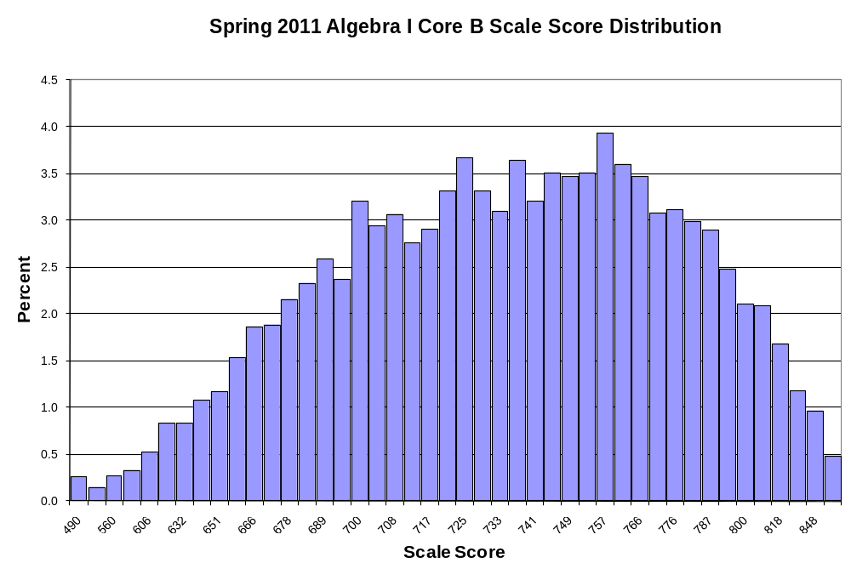

Algebra II Core A Score Distribution for Spring 2011
Scale Score | Frequency | Percent | Cumulative Frequency | Cumulative Percent
440 | 241 | 1.6 | 241 | 1.6
521 | 145 | 1.0 | 386 | 2.6
559 | 171 | 1.2 | 557 | 3.8
584 | 232 | 1.6 | 789 | 5.4
602 | 284 | 1.9 | 1,073 | 7.3
617 | 310 | 2.1 | 1,383 | 9.4
629 | 291 | 2.0 | 1,674 | 11.4
640 | 348 | 2.4 | 2,022 | 13.8
654 | 366 | 2.5 | 2,388 | 16.3
659 | 395 | 2.7 | 2,783 | 19.0
667 | 362 | 2.5 | 3,145 | 21.4
674 | 363 | 2.5 | 3,508 | 23.9
681 | 403 | 2.7 | 3,911 | 26.6
688 | 383 | 2.6 | 4,294 | 29.2
694 | 404 | 2.8 | 4,698 | 32.0
700 | 433 | 2.9 | 5,131 | 34.9
706 | 390 | 2.7 | 5,521 | 37.6
711 | 435 | 3.0 | 5,956 | 40.6
717 | 402 | 2.7 | 6,358 | 43.3
722 | 413 | 2.8 | 6,771 | 46.1
727 | 425 | 2.9 | 7,196 | 49.0
732 | 399 | 2.7 | 7,595 | 51.7
738 | 393 | 2.7 | 7,988 | 54.4
743 | 406 | 2.8 | 8,394 | 57.2
748 | 481 | 3.3 | 8,875 | 60.4
753 | 373 | 2.5 | 9,248 | 63.0
758 | 410 | 2.8 | 9,658 | 65.8
763 | 413 | 2.8 | 10,071 | 68.6
768 | 409 | 2.8 | 10,480 | 71.4
774 | 381 | 2.6 | 10,861 | 74.0
783 | 382 | 2.6 | 11,243 | 76.6
785 | 372 | 2.5 | 11,615 | 79.1
791 | 375 | 2.6 | 11,990 | 81.6
797 | 380 | 2.6 | 12,370 | 84.2
804 | 334 | 2.3 | 12,704 | 86.5
811 | 306 | 2.1 | 13,010 | 88.6
818 | 262 | 1.8 | 13,272 | 90.4
826 | 274 | 1.9 | 13,546 | 92.2
836 | 257 | 1.8 | 13,803 | 94.0
846 | 212 | 1.4 | 14,015 | 95.4
859 | 198 | 1.3 | 14,213 | 96.8
874 | 165 | 1.1 | 14,378 | 97.9
Algebra II Core A Score Distribution for Spring 2011 (cont.)
Scale Score | Frequency | Percent | Cumulative Frequency | Cumulative Percent
897 | 145 | 1.0 | 14,523 | 98.9
937 | 107 | 0.7 | 14,630 | 99.6
999 | 55 | 0.4 | 14,685 | 100.0

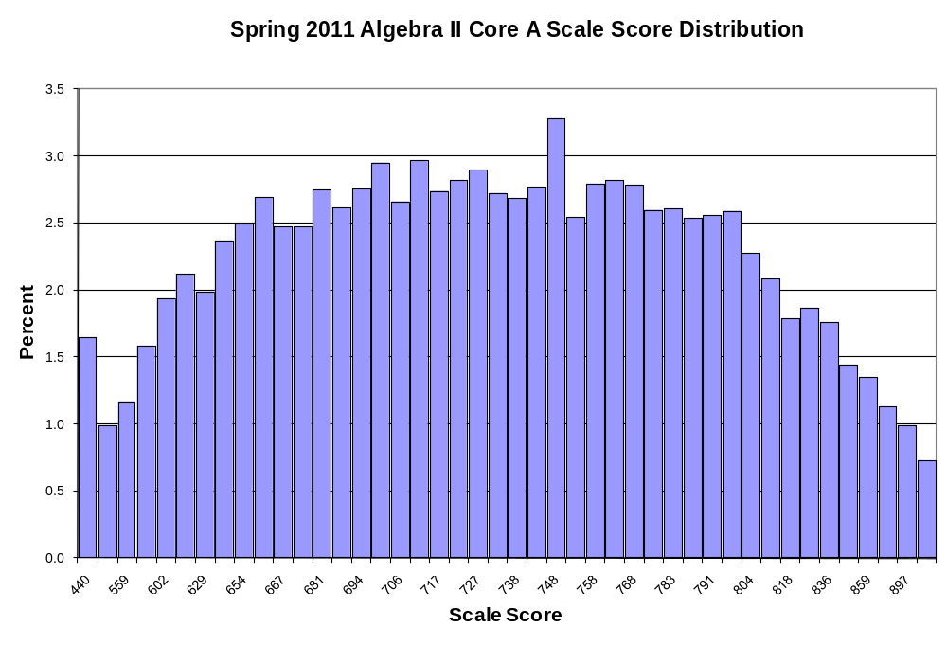

Algebra II Core B Score Distribution for Spring 2011
Scale Score | Frequency | Percent | Cumulative Frequency | Cumulative Percent
440 | 283 | 2.3 | 283 | 2.3
522 | 125 | 1.0 | 408 | 3.3
561 | 189 | 1.5 | 597 | 4.8
588 | 186 | 1.5 | 783 | 6.3
607 | 270 | 2.2 | 1,053 | 8.5
623 | 326 | 2.6 | 1,379 | 11.2
636 | 318 | 2.6 | 1,697 | 13.8
654 | 347 | 2.8 | 2,044 | 16.6
657 | 329 | 2.7 | 2,373 | 19.2
666 | 370 | 3.0 | 2,743 | 22.2
674 | 351 | 2.8 | 3,094 | 25.1
681 | 350 | 2.8 | 3,444 | 27.9
688 | 385 | 3.1 | 3,829 | 31.0
694 | 358 | 2.9 | 4,187 | 33.9
700 | 342 | 2.8 | 4,529 | 36.7
706 | 357 | 2.9 | 4,886 | 39.6
712 | 353 | 2.9 | 5,239 | 42.5
717 | 359 | 2.9 | 5,598 | 45.4
723 | 367 | 3.0 | 5,965 | 48.4
728 | 354 | 2.9 | 6,319 | 51.2
733 | 357 | 2.9 | 6,676 | 54.1
738 | 357 | 2.9 | 7,033 | 57.0
743 | 339 | 2.7 | 7,372 | 59.8
748 | 342 | 2.8 | 7,714 | 62.5
753 | 296 | 2.4 | 8,010 | 64.9
758 | 354 | 2.9 | 8,364 | 67.8
763 | 320 | 2.6 | 8,684 | 70.4
769 | 337 | 2.7 | 9,021 | 73.1
774 | 288 | 2.3 | 9,309 | 75.5
783 | 329 | 2.7 | 9,638 | 78.1
785 | 284 | 2.3 | 9,922 | 80.4
791 | 267 | 2.2 | 10,189 | 82.6
797 | 249 | 2.0 | 10,438 | 84.6
804 | 242 | 2.0 | 10,680 | 86.6
811 | 233 | 1.9 | 10,913 | 88.5
818 | 257 | 2.1 | 11,170 | 90.6
827 | 224 | 1.8 | 11,394 | 92.4
836 | 222 | 1.8 | 11,616 | 94.2
847 | 179 | 1.5 | 11,795 | 95.6
860 | 151 | 1.2 | 11,946 | 96.8
876 | 153 | 1.2 | 12,099 | 98.1
899 | 124 | 1.0 | 12,223 | 99.1
Algebra II Core B Score Distribution for Spring 2011 (cont.)
Scale Score | Frequency | Percent | Cumulative Frequency | Cumulative Percent
938 | 73 | 0.6 | 12,296 | 99.7
999 | 39 | 0.3 | 12,335 | 100.0

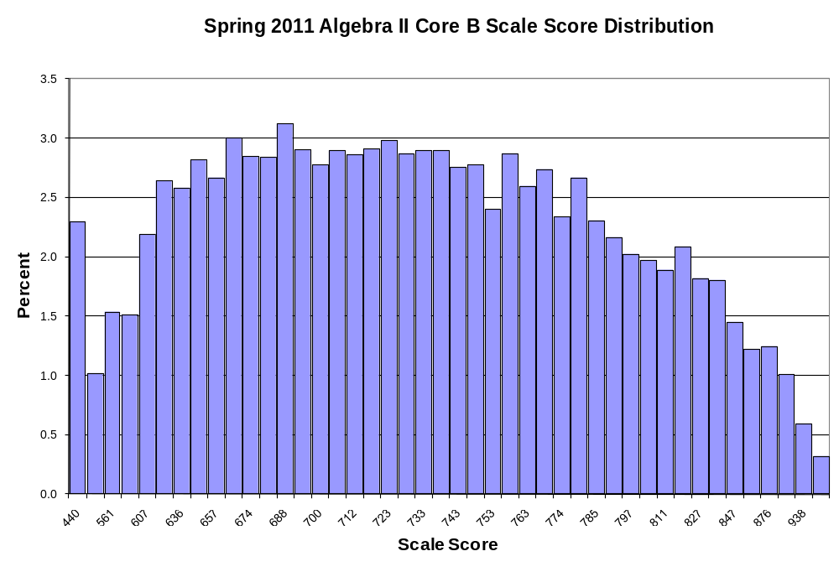

Biology I Core A Score Distribution for Spring 2011
Scale Score | Frequency | Percent | Cumulative Frequency | Cumulative Percent
440 | 55 | 0.3 | 55 | 0.3
458 | 31 | 0.2 | 86 | 0.5
496 | 51 | 0.3 | 137 | 0.8
522 | 53 | 0.3 | 190 | 1.1
543 | 77 | 0.4 | 267 | 1.5
560 | 87 | 0.5 | 354 | 2.0
574 | 94 | 0.5 | 448 | 2.5
587 | 137 | 0.8 | 585 | 3.3
598 | 125 | 0.7 | 710 | 4.0
608 | 176 | 1.0 | 886 | 5.0
617 | 172 | 1.0 | 1,058 | 5.9
627 | 203 | 1.1 | 1,261 | 7.1
634 | 221 | 1.2 | 1,482 | 8.3
642 | 241 | 1.4 | 1,723 | 9.7
649 | 289 | 1.6 | 2,012 | 11.3
656 | 293 | 1.6 | 2,305 | 13.0
663 | 360 | 2.0 | 2,665 | 15.0
669 | 356 | 2.0 | 3,021 | 17.0
675 | 379 | 2.1 | 3,400 | 19.1
682 | 387 | 2.2 | 3,787 | 21.3
691 | 418 | 2.3 | 4,205 | 23.6
694 | 440 | 2.5 | 4,645 | 26.1
699 | 434 | 2.4 | 5,079 | 28.5
705 | 512 | 2.9 | 5,591 | 31.4
711 | 556 | 3.1 | 6,147 | 34.5
717 | 510 | 2.9 | 6,657 | 37.4
723 | 561 | 3.2 | 7,218 | 40.6
729 | 638 | 3.6 | 7,856 | 44.1
735 | 609 | 3.4 | 8,465 | 47.6
741 | 635 | 3.6 | 9,100 | 51.1
747 | 595 | 3.3 | 9,695 | 54.5
753 | 679 | 3.8 | 10,374 | 58.3
760 | 651 | 3.7 | 11,025 | 61.9
767 | 673 | 3.8 | 11,698 | 65.7
775 | 670 | 3.8 | 12,368 | 69.5
781 | 690 | 3.9 | 13,058 | 73.4
789 | 619 | 3.5 | 13,677 | 76.8
797 | 672 | 3.8 | 14,349 | 80.6
806 | 651 | 3.7 | 15,000 | 84.3
816 | 572 | 3.2 | 15,572 | 87.5
827 | 596 | 3.3 | 16,168 | 90.8
839 | 448 | 2.5 | 16,616 | 93.4
Biology I Core A Score Distribution for Spring 2011 (cont.)
Scale Score | Frequency | Percent | Cumulative Frequency | Cumulative Percent
854 | 388 | 2.2 | 17,004 | 95.5
871 | 343 | 1.9 | 17,347 | 97.5
894 | 243 | 1.4 | 17,590 | 98.8
927 | 132 | 0.7 | 17,722 | 99.6
986 | 63 | 0.4 | 17,785 | 99.9
999 | 13 | 0.1 | 17,798 | 100.0

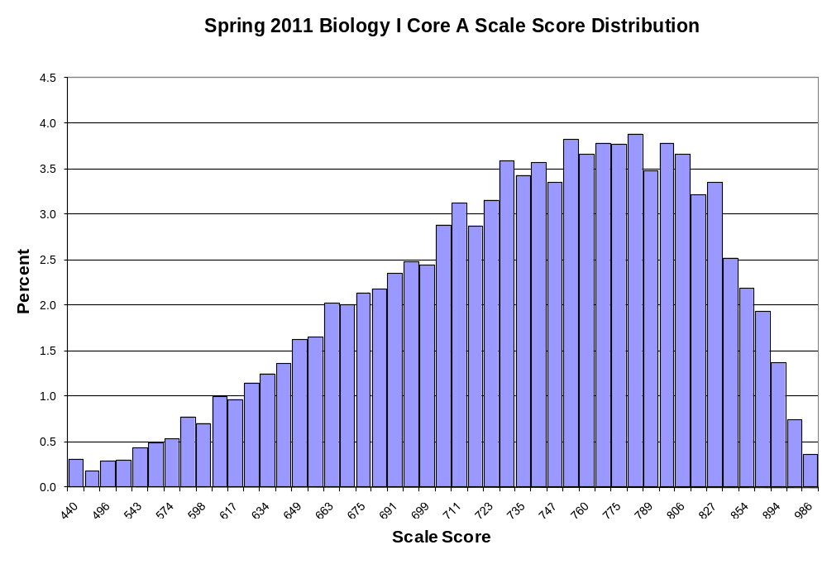

Biology I Core B Score Distribution for Spring 2011
Scale Score | Frequency | Percent | Cumulative Frequency | Cumulative Percent
440 | 26 | 0.2 | 26 | 0.2
452 | 19 | 0.1 | 45 | 0.3
492 | 22 | 0.1 | 67 | 0.5
519 | 38 | 0.3 | 105 | 0.7
539 | 46 | 0.3 | 151 | 1.0
555 | 58 | 0.4 | 209 | 1.4
569 | 76 | 0.5 | 285 | 1.9
581 | 68 | 0.5 | 353 | 2.4
592 | 98 | 0.7 | 451 | 3.0
602 | 111 | 0.7 | 562 | 3.8
611 | 107 | 0.7 | 669 | 4.5
619 | 124 | 0.8 | 793 | 5.4
627 | 143 | 1.0 | 936 | 6.3
635 | 125 | 0.8 | 1,061 | 7.2
642 | 184 | 1.2 | 1,245 | 8.4
649 | 182 | 1.2 | 1,427 | 9.6
655 | 212 | 1.4 | 1,639 | 11.1
662 | 207 | 1.4 | 1,846 | 12.5
668 | 218 | 1.5 | 2,064 | 13.9
674 | 269 | 1.8 | 2,333 | 15.8
680 | 301 | 2.0 | 2,634 | 17.8
691 | 320 | 2.2 | 2,954 | 19.9
692 | 367 | 2.5 | 3,321 | 22.4
698 | 315 | 2.1 | 3,636 | 24.6
704 | 388 | 2.6 | 4,024 | 27.2
709 | 415 | 2.8 | 4,439 | 30.0
715 | 450 | 3.0 | 4,889 | 33.0
721 | 431 | 2.9 | 5,320 | 35.9
727 | 505 | 3.4 | 5,825 | 39.3
733 | 514 | 3.5 | 6,339 | 42.8
739 | 544 | 3.7 | 6,883 | 46.5
746 | 530 | 3.6 | 7,413 | 50.1
752 | 584 | 3.9 | 7,997 | 54.0
758 | 567 | 3.8 | 8,564 | 57.8
765 | 573 | 3.9 | 9,137 | 61.7
775 | 618 | 4.2 | 9,755 | 65.9
780 | 633 | 4.3 | 10,388 | 70.2
787 | 653 | 4.4 | 11,041 | 74.6
796 | 597 | 4.0 | 11,638 | 78.6
804 | 612 | 4.1 | 12,250 | 82.7
814 | 535 | 3.6 | 12,785 | 86.3
824 | 558 | 3.8 | 13,343 | 90.1
Biology I Core B Score Distribution for Spring 2011 (cont.)
Scale Score | Frequency | Percent | Cumulative Frequency | Cumulative Percent
836 | 443 | 3.0 | 13,786 | 93.1
850 | 380 | 2.6 | 14,166 | 95.7
867 | 263 | 1.8 | 14,429 | 97.4
889 | 203 | 1.4 | 14,632 | 98.8
922 | 114 | 0.8 | 14,746 | 99.6
985 | 51 | 0.3 | 14,797 | 99.9
999 | 11 | 0.1 | 14,808 | 100.0

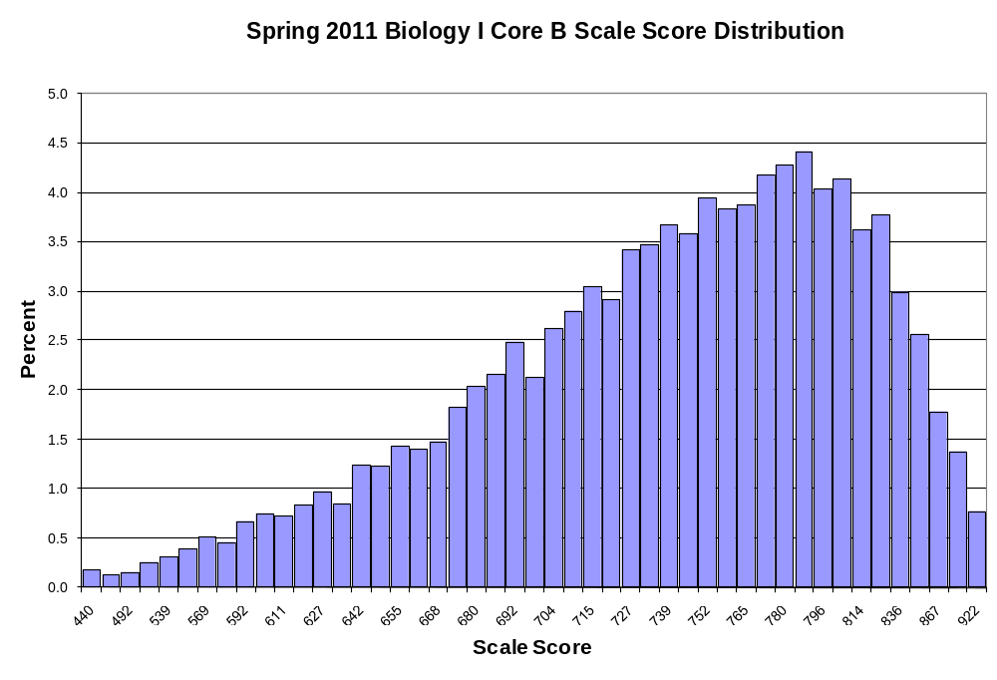

English II Core AA Score Distribution for Spring 2011
Scale Score | Frequency | Percent | Cumulative Frequency | Cumulative Percent
440 | 9 | 0.1 | 9 | 0.1
457 | 8 | 0.1 | 17 | 0.2
480 | 9 | 0.1 | 26 | 0.3
499 | 10 | 0.1 | 36 | 0.4
515 | 8 | 0.1 | 44 | 0.5
528 | 10 | 0.1 | 54 | 0.7
541 | 13 | 0.2 | 67 | 0.8
551 | 12 | 0.1 | 79 | 1.0
561 | 13 | 0.2 | 92 | 1.1
570 | 19 | 0.2 | 111 | 1.4
579 | 23 | 0.3 | 134 | 1.6
588 | 24 | 0.3 | 158 | 1.9
594 | 23 | 0.3 | 181 | 2.2
601 | 29 | 0.4 | 210 | 2.6
608 | 37 | 0.5 | 247 | 3.0
614 | 32 | 0.4 | 279 | 3.4
621 | 45 | 0.6 | 324 | 4.0
627 | 39 | 0.5 | 363 | 4.5
633 | 35 | 0.4 | 398 | 4.9
639 | 55 | 0.7 | 453 | 5.6
644 | 60 | 0.7 | 513 | 6.3
650 | 47 | 0.6 | 560 | 6.9
656 | 80 | 1.0 | 640 | 7.9
662 | 76 | 0.9 | 716 | 8.8
667 | 91 | 1.1 | 807 | 9.9
673 | 104 | 1.3 | 911 | 11.2
679 | 128 | 1.6 | 1,039 | 12.8
685 | 142 | 1.7 | 1,181 | 14.5
693 | 145 | 1.8 | 1,326 | 16.3
697 | 174 | 2.1 | 1,500 | 18.4
703 | 192 | 2.4 | 1,692 | 20.8
709 | 229 | 2.8 | 1,921 | 23.6
716 | 260 | 3.2 | 2,181 | 26.8
723 | 287 | 3.5 | 2,468 | 30.3
730 | 283 | 3.5 | 2,751 | 33.8
737 | 354 | 4.4 | 3,105 | 38.2
744 | 375 | 4.6 | 3,480 | 42.8
752 | 372 | 4.6 | 3,852 | 47.4
761 | 414 | 5.1 | 4,266 | 52.4
769 | 466 | 5.7 | 4,732 | 58.2
779 | 463 | 5.7 | 5,195 | 63.9
797 | 434 | 5.3 | 5,629 | 69.2
English II Core AA Score Distribution for Spring 2011 (cont.)
Scale Score | Frequency | Percent | Cumulative Frequency | Cumulative Percent
800 | 462 | 5.7 | 6,091 | 74.9
813 | 442 | 5.4 | 6,533 | 80.3
827 | 386 | 4.7 | 6,919 | 85.1
842 | 379 | 4.7 | 7,298 | 89.7
860 | 302 | 3.7 | 7,600 | 93.4
882 | 254 | 3.1 | 7,854 | 96.6
908 | 160 | 2.0 | 8,014 | 98.5
942 | 86 | 1.1 | 8,100 | 99.6
990 | 31 | 0.4 | 8,131 | 100.0
999 | 3 | 0.0 | 8,134 | 100.0

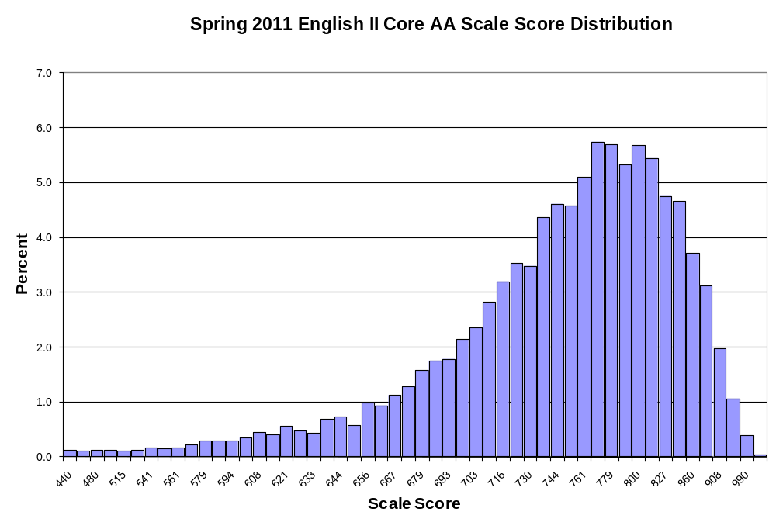

English II Core AB Score Distribution for Spring 2011
Scale Score | Frequency | Percent | Cumulative Frequency | Cumulative Percent
440 | 9 | 0.1 | 9 | 0.1
456 | 2 | 0.0 | 11 | 0.1
479 | 6 | 0.1 | 17 | 0.2
498 | 5 | 0.1 | 22 | 0.3
514 | 6 | 0.1 | 28 | 0.4
527 | 11 | 0.1 | 39 | 0.5
540 | 10 | 0.1 | 49 | 0.6
550 | 12 | 0.2 | 61 | 0.8
560 | 12 | 0.2 | 73 | 0.9
569 | 16 | 0.2 | 89 | 1.1
578 | 17 | 0.2 | 106 | 1.3
588 | 34 | 0.4 | 140 | 1.8
593 | 20 | 0.3 | 160 | 2.0
600 | 24 | 0.3 | 184 | 2.3
607 | 27 | 0.3 | 211 | 2.6
613 | 30 | 0.4 | 241 | 3.0
620 | 37 | 0.5 | 278 | 3.5
626 | 48 | 0.6 | 326 | 4.1
632 | 41 | 0.5 | 367 | 4.6
638 | 40 | 0.5 | 407 | 5.1
644 | 61 | 0.8 | 468 | 5.9
650 | 56 | 0.7 | 524 | 6.6
655 | 53 | 0.7 | 577 | 7.2
661 | 63 | 0.8 | 640 | 8.0
667 | 74 | 0.9 | 714 | 8.9
673 | 110 | 1.4 | 824 | 10.3
679 | 118 | 1.5 | 942 | 11.8
684 | 116 | 1.5 | 1,058 | 13.2
693 | 147 | 1.8 | 1,205 | 15.1
696 | 158 | 2.0 | 1,363 | 17.0
703 | 227 | 2.8 | 1,590 | 19.9
709 | 222 | 2.8 | 1,812 | 22.7
716 | 289 | 3.6 | 2,101 | 26.3
722 | 289 | 3.6 | 2,390 | 29.9
729 | 318 | 4.0 | 2,708 | 33.9
737 | 334 | 4.2 | 3,042 | 38.0
744 | 346 | 4.3 | 3,388 | 42.4
752 | 423 | 5.3 | 3,811 | 47.7
760 | 411 | 5.1 | 4,222 | 52.8
769 | 435 | 5.4 | 4,657 | 58.2
779 | 461 | 5.8 | 5,118 | 64.0
797 | 472 | 5.9 | 5,590 | 69.9
English II Core AB Score Distribution for Spring 2011 (cont.)
Scale Score | Frequency | Percent | Cumulative Frequency | Cumulative Percent
801 | 427 | 5.3 | 6,017 | 75.3
813 | 425 | 5.3 | 6,442 | 80.6
827 | 405 | 5.1 | 6,847 | 85.6
844 | 370 | 4.6 | 7,217 | 90.3
862 | 288 | 3.6 | 7,505 | 93.9
885 | 226 | 2.8 | 7,731 | 96.7
912 | 154 | 1.9 | 7,885 | 98.6
947 | 71 | 0.9 | 7,956 | 99.5
996 | 31 | 0.4 | 7,987 | 99.9
999 | 8 | 0.1 | 7,995 | 100.0

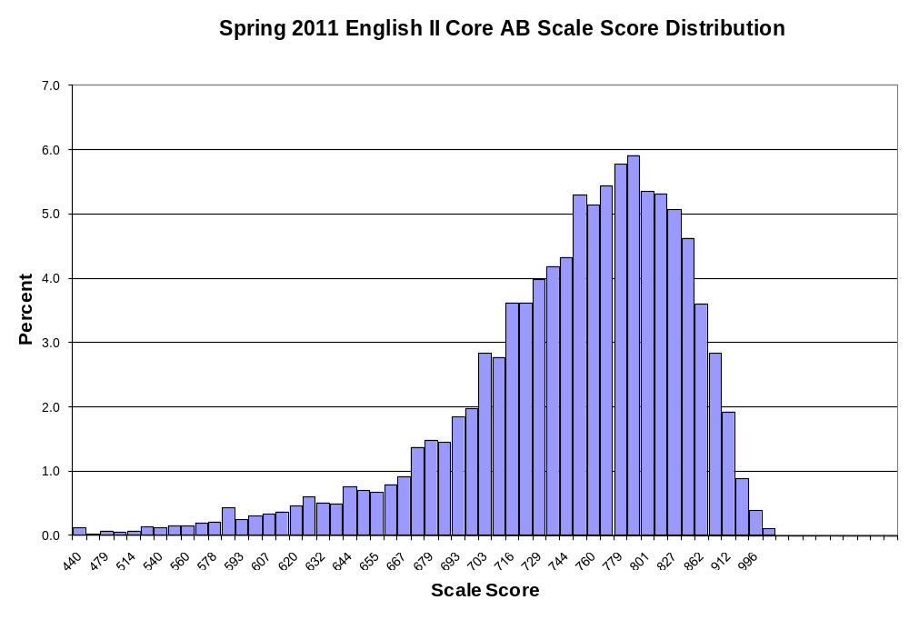

English II Core BA Score Distribution for Spring 2011
Scale Score | Frequency | Percent | Cumulative Frequency | Cumulative Percent
440 | 5 | 0.1 | 5 | 0.1
445 | 5 | 0.1 | 10 | 0.1
469 | 6 | 0.1 | 16 | 0.2
489 | 5 | 0.1 | 21 | 0.3
507 | 10 | 0.1 | 31 | 0.4
521 | 9 | 0.1 | 40 | 0.5
535 | 9 | 0.1 | 49 | 0.6
547 | 11 | 0.1 | 60 | 0.8
557 | 13 | 0.2 | 73 | 0.9
567 | 17 | 0.2 | 90 | 1.2
577 | 13 | 0.2 | 103 | 1.3
588 | 16 | 0.2 | 119 | 1.5
594 | 20 | 0.3 | 139 | 1.8
601 | 27 | 0.3 | 166 | 2.1
609 | 25 | 0.3 | 191 | 2.5
616 | 33 | 0.4 | 224 | 2.9
623 | 23 | 0.3 | 247 | 3.2
630 | 44 | 0.6 | 291 | 3.7
636 | 43 | 0.6 | 334 | 4.3
642 | 48 | 0.6 | 382 | 4.9
649 | 63 | 0.8 | 445 | 5.7
655 | 75 | 1.0 | 520 | 6.7
661 | 68 | 0.9 | 588 | 7.6
667 | 88 | 1.1 | 676 | 8.7
673 | 113 | 1.5 | 789 | 10.2
679 | 118 | 1.5 | 907 | 11.7
685 | 110 | 1.4 | 1,017 | 13.1
693 | 156 | 2.0 | 1,173 | 15.1
697 | 168 | 2.2 | 1,341 | 17.3
703 | 195 | 2.5 | 1,536 | 19.8
709 | 214 | 2.8 | 1,750 | 22.5
716 | 236 | 3.0 | 1,986 | 25.6
722 | 255 | 3.3 | 2,241 | 28.8
729 | 270 | 3.5 | 2,511 | 32.3
736 | 301 | 3.9 | 2,812 | 36.2
743 | 326 | 4.2 | 3,138 | 40.4
751 | 404 | 5.2 | 3,542 | 45.6
758 | 376 | 4.8 | 3,918 | 50.4
767 | 406 | 5.2 | 4,324 | 55.6
775 | 383 | 4.9 | 4,707 | 60.6
785 | 411 | 5.3 | 5,118 | 65.9
797 | 424 | 5.5 | 5,542 | 71.3
English II Core BA Score Distribution for Spring 2011 (cont.)
Scale Score | Frequency | Percent | Cumulative Frequency | Cumulative Percent
805 | 435 | 5.6 | 5,977 | 76.9
817 | 412 | 5.3 | 6,389 | 82.2
830 | 359 | 4.6 | 6,748 | 86.8
844 | 285 | 3.7 | 7,033 | 90.5
861 | 272 | 3.5 | 7,305 | 94.0
881 | 187 | 2.4 | 7,492 | 96.4
905 | 140 | 1.8 | 7,632 | 98.2
937 | 90 | 1.2 | 7,722 | 99.4
983 | 36 | 0.5 | 7,758 | 99.8
999 | 12 | 0.2 | 7,770 | 100.0

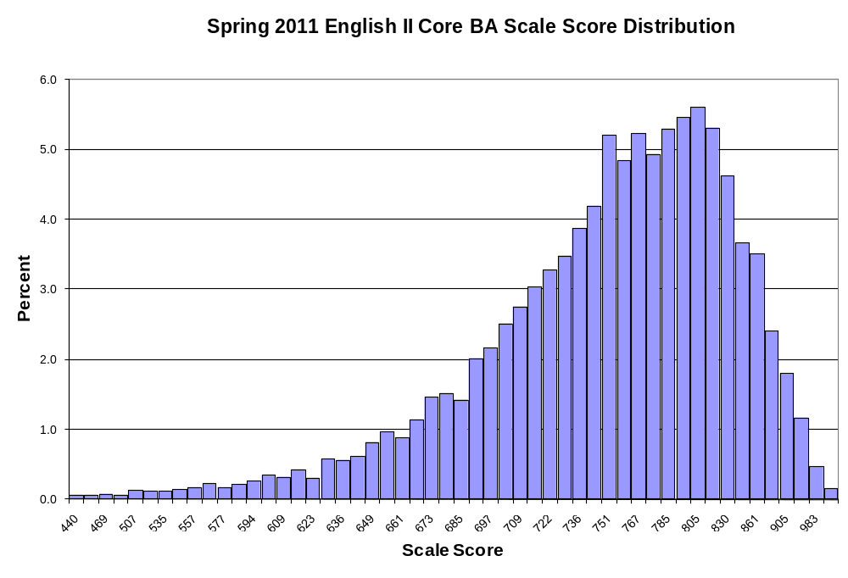
English II Core BB Score Distribution for Spring 2011
Scale Score | Frequency | Percent | Cumulative Frequency | Cumulative Percent
440 | 8 | 0.1 | 8 | 0.1
444 | 4 | 0.1 | 12 | 0.2
468 | 1 | 0.0 | 13 | 0.2
488 | 10 | 0.1 | 23 | 0.3
506 | 4 | 0.1 | 27 | 0.3
520 | 10 | 0.1 | 37 | 0.5
534 | 15 | 0.2 | 52 | 0.7
546 | 16 | 0.2 | 68 | 0.9
556 | 16 | 0.2 | 84 | 1.1
566 | 18 | 0.2 | 102 | 1.3
576 | 17 | 0.2 | 119 | 1.5
588 | 14 | 0.2 | 133 | 1.7
593 | 16 | 0.2 | 149 | 1.9
600 | 32 | 0.4 | 181 | 2.3
608 | 30 | 0.4 | 211 | 2.7
615 | 26 | 0.3 | 237 | 3.0
622 | 35 | 0.4 | 272 | 3.5
629 | 39 | 0.5 | 311 | 4.0
635 | 52 | 0.7 | 363 | 4.7
642 | 55 | 0.7 | 418 | 5.4
648 | 63 | 0.8 | 481 | 6.2
654 | 48 | 0.6 | 529 | 6.8
660 | 80 | 1.0 | 609 | 7.8
666 | 103 | 1.3 | 712 | 9.1
672 | 113 | 1.4 | 825 | 10.6
678 | 93 | 1.2 | 918 | 11.8
684 | 126 | 1.6 | 1,044 | 13.4
693 | 148 | 1.9 | 1,192 | 15.3
696 | 159 | 2.0 | 1,351 | 17.3
703 | 180 | 2.3 | 1,531 | 19.6
709 | 213 | 2.7 | 1,744 | 22.4
715 | 234 | 3.0 | 1,978 | 25.3
722 | 258 | 3.3 | 2,236 | 28.7
729 | 268 | 3.4 | 2,504 | 32.1
736 | 304 | 3.9 | 2,808 | 36.0
743 | 319 | 4.1 | 3,127 | 40.1
750 | 359 | 4.6 | 3,486 | 44.7
758 | 383 | 4.9 | 3,869 | 49.6
767 | 452 | 5.8 | 4,321 | 55.4
775 | 376 | 4.8 | 4,697 | 60.2
785 | 433 | 5.5 | 5,130 | 65.7
797 | 449 | 5.8 | 5,579 | 71.5
English II Core BB Score Distribution for Spring 2011 (cont.)
Scale Score | Frequency | Percent | Cumulative Frequency | Cumulative Percent
805 | 437 | 5.6 | 6,016 | 77.1
817 | 411 | 5.3 | 6,427 | 82.4
830 | 363 | 4.7 | 6,790 | 87.0
845 | 312 | 4.0 | 7,102 | 91.0
863 | 234 | 3.0 | 7,336 | 94.0
883 | 199 | 2.6 | 7,535 | 96.6
909 | 151 | 1.9 | 7,686 | 98.5
942 | 74 | 0.9 | 7,760 | 99.4
988 | 32 | 0.4 | 7,792 | 99.9
999 | 11 | 0.1 | 7,803 | 100.0

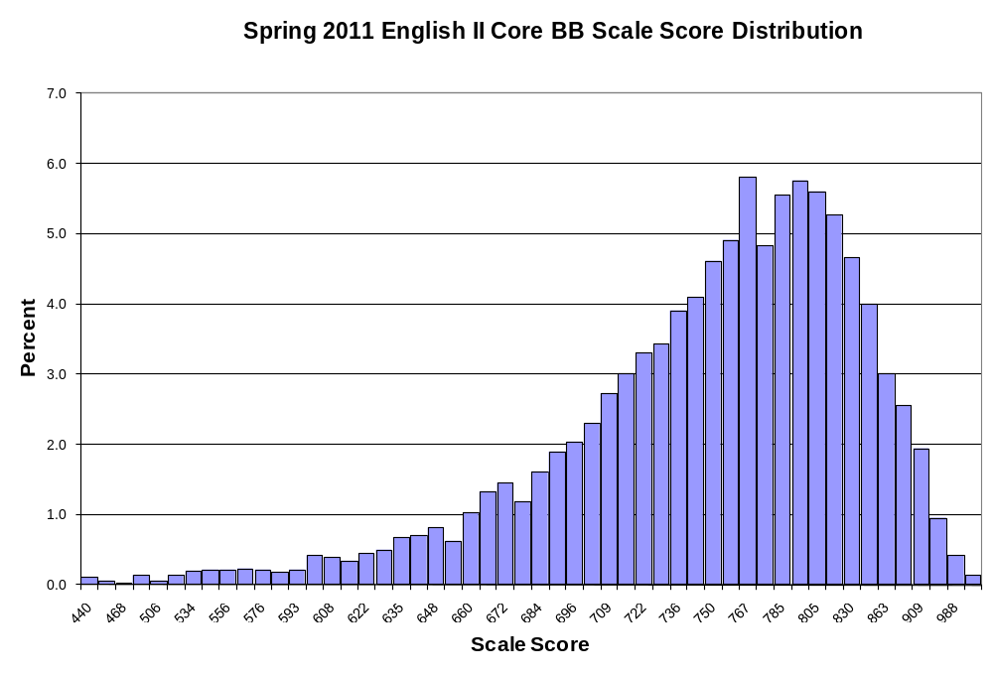

English III Core AA Score Distribution for Spring 2011
Scale Score | Frequency | Percent | Cumulative Frequency | Cumulative Percent
440 | 10 | 0.1 | 10 | 0.1
447 | 5 | 0.1 | 15 | 0.2
490 | 9 | 0.1 | 24 | 0.3
518 | 11 | 0.1 | 35 | 0.4
538 | 16 | 0.2 | 51 | 0.6
554 | 26 | 0.3 | 77 | 0.9
568 | 23 | 0.3 | 100 | 1.2
580 | 31 | 0.4 | 131 | 1.6
590 | 35 | 0.4 | 166 | 2.0
600 | 39 | 0.5 | 205 | 2.5
609 | 46 | 0.6 | 251 | 3.1
617 | 52 | 0.6 | 303 | 3.7
625 | 55 | 0.7 | 358 | 4.4
632 | 63 | 0.8 | 421 | 5.2
638 | 64 | 0.8 | 485 | 5.9
645 | 66 | 0.8 | 551 | 6.7
651 | 67 | 0.8 | 618 | 7.6
656 | 75 | 0.9 | 693 | 8.5
662 | 74 | 0.9 | 767 | 9.4
670 | 73 | 0.9 | 840 | 10.3
673 | 72 | 0.9 | 912 | 11.2
678 | 68 | 0.8 | 980 | 12.0
682 | 107 | 1.3 | 1,087 | 13.3
687 | 111 | 1.4 | 1,198 | 14.7
692 | 117 | 1.4 | 1,315 | 16.1
700 | 119 | 1.5 | 1,434 | 17.6
701 | 126 | 1.5 | 1,560 | 19.1
706 | 115 | 1.4 | 1,675 | 20.5
710 | 161 | 2.0 | 1,836 | 22.5
715 | 159 | 1.9 | 1,995 | 24.4
719 | 185 | 2.3 | 2,180 | 26.7
724 | 196 | 2.4 | 2,376 | 29.1
728 | 197 | 2.4 | 2,573 | 31.5
733 | 193 | 2.4 | 2,766 | 33.9
737 | 212 | 2.6 | 2,978 | 36.5
742 | 210 | 2.6 | 3,188 | 39.0
746 | 251 | 3.1 | 3,439 | 42.1
751 | 242 | 3.0 | 3,681 | 45.1
756 | 249 | 3.0 | 3,930 | 48.1
760 | 258 | 3.2 | 4,188 | 51.3
765 | 293 | 3.6 | 4,481 | 54.9
English III Core AA Score Distribution for Spring 2011 (cont.)
Scale Score | Frequency | Percent | Cumulative Frequency | Cumulative Percent
770 | 287 | 3.5 | 4,768 | 58.4
776 | 286 | 3.5 | 5,054 | 61.9
781 | 284 | 3.5 | 5,338 | 65.4
786 | 250 | 3.1 | 5,588 | 68.4
792 | 322 | 3.9 | 5,910 | 72.4
802 | 278 | 3.4 | 6,188 | 75.8
805 | 292 | 3.6 | 6,480 | 79.3
811 | 265 | 3.2 | 6,745 | 82.6
819 | 223 | 2.7 | 6,968 | 85.3
826 | 229 | 2.8 | 7,197 | 88.1
835 | 216 | 2.6 | 7,413 | 90.8
844 | 181 | 2.2 | 7,594 | 93.0
855 | 173 | 2.1 | 7,767 | 95.1
866 | 135 | 1.7 | 7,902 | 96.8
880 | 102 | 1.2 | 8,004 | 98.0
895 | 72 | 0.9 | 8,076 | 98.9
914 | 51 | 0.6 | 8,127 | 99.5
937 | 18 | 0.2 | 8,145 | 99.7
968 | 16 | 0.2 | 8,161 | 99.9
999 | 6 | 0.1 | 8,167 | 100.0

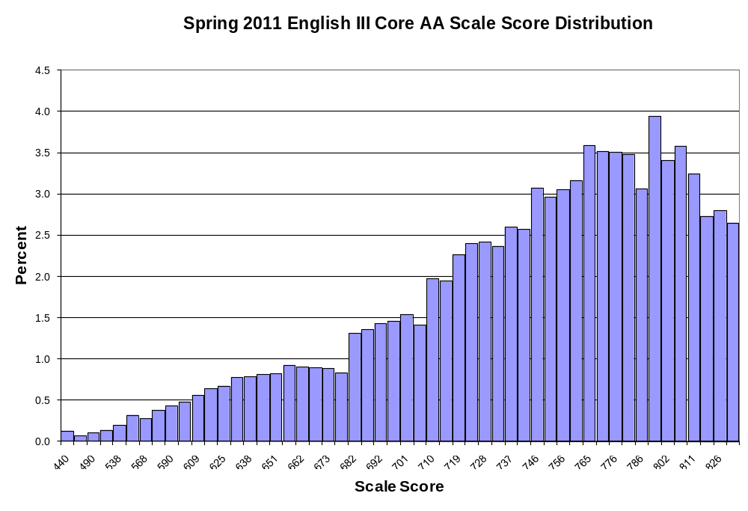
English III Core AB Score Distribution for Spring 2011
Scale Score | Frequency | Percent | Cumulative Frequency | Cumulative Percent
440 | 6 | 0.1 | 6 | 0.1
449 | 5 | 0.1 | 11 | 0.1
491 | 8 | 0.1 | 19 | 0.2
517 | 9 | 0.1 | 28 | 0.3
536 | 18 | 0.2 | 46 | 0.6
552 | 14 | 0.2 | 60 | 0.7
565 | 19 | 0.2 | 79 | 1.0
577 | 34 | 0.4 | 113 | 1.4
587 | 28 | 0.3 | 141 | 1.7
597 | 40 | 0.5 | 181 | 2.2
606 | 43 | 0.5 | 224 | 2.8
614 | 51 | 0.6 | 275 | 3.4
622 | 64 | 0.8 | 339 | 4.2
629 | 59 | 0.7 | 398 | 4.9
636 | 70 | 0.9 | 468 | 5.8
642 | 63 | 0.8 | 531 | 6.5
648 | 52 | 0.6 | 583 | 7.2
654 | 66 | 0.8 | 649 | 8.0
660 | 63 | 0.8 | 712 | 8.8
670 | 84 | 1.0 | 796 | 9.8
671 | 83 | 1.0 | 879 | 10.8
676 | 78 | 1.0 | 957 | 11.8
681 | 65 | 0.8 | 1,022 | 12.6
686 | 97 | 1.2 | 1,119 | 13.8
691 | 108 | 1.3 | 1,227 | 15.1
695 | 111 | 1.4 | 1,338 | 16.5
700 | 124 | 1.5 | 1,462 | 18.0
705 | 147 | 1.8 | 1,609 | 19.8
709 | 138 | 1.7 | 1,747 | 21.5
714 | 166 | 2.0 | 1,913 | 23.5
718 | 179 | 2.2 | 2,092 | 25.7
723 | 194 | 2.4 | 2,286 | 28.1
727 | 194 | 2.4 | 2,480 | 30.5
732 | 200 | 2.5 | 2,680 | 33.0
736 | 218 | 2.7 | 2,898 | 35.6
741 | 195 | 2.4 | 3,093 | 38.0
746 | 235 | 2.9 | 3,328 | 40.9
750 | 271 | 3.3 | 3,599 | 44.3
755 | 285 | 3.5 | 3,884 | 47.8
760 | 270 | 3.3 | 4,154 | 51.1
765 | 284 | 3.5 | 4,438 | 54.6
English III Core AB Score Distribution for Spring 2011 (cont.)
Scale Score | Frequency | Percent | Cumulative Frequency | Cumulative Percent
770 | 273 | 3.4 | 4,711 | 57.9
775 | 298 | 3.7 | 5,009 | 61.6
780 | 287 | 3.5 | 5,296 | 65.1
786 | 309 | 3.8 | 5,605 | 68.9
792 | 284 | 3.5 | 5,889 | 72.4
802 | 276 | 3.4 | 6,165 | 75.8
804 | 279 | 3.4 | 6,444 | 79.3
811 | 256 | 3.1 | 6,700 | 82.4
818 | 242 | 3.0 | 6,942 | 85.4
825 | 223 | 2.7 | 7,165 | 88.1
834 | 205 | 2.5 | 7,370 | 90.6
843 | 199 | 2.4 | 7,569 | 93.1
853 | 146 | 1.8 | 7,715 | 94.9
865 | 124 | 1.5 | 7,839 | 96.4
877 | 118 | 1.5 | 7,957 | 97.9
892 | 87 | 1.1 | 8,044 | 98.9
910 | 43 | 0.5 | 8,087 | 99.5
932 | 24 | 0.3 | 8,111 | 99.8
962 | 13 | 0.2 | 8,124 | 99.9
999 | 7 | 0.1 | 8,131 | 100.0

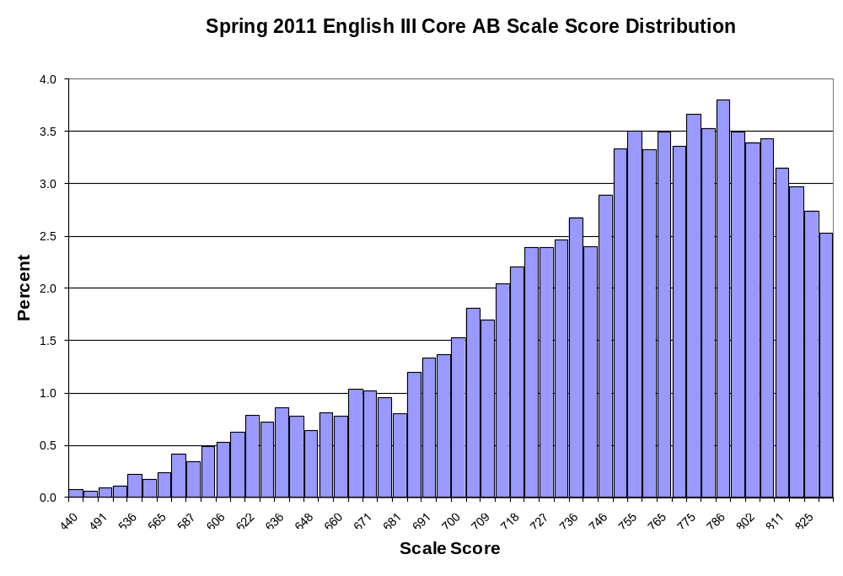
English III Core BA Score Distribution for Spring 2011
Scale Score | Frequency | Percent | Cumulative Frequency | Cumulative Percent
440 | 7 | 0.1 | 7 | 0.1
451 | 1 | 0.0 | 8 | 0.1
492 | 7 | 0.1 | 15 | 0.2
518 | 10 | 0.1 | 25 | 0.3
538 | 13 | 0.2 | 38 | 0.5
554 | 17 | 0.2 | 55 | 0.7
567 | 5 | 0.1 | 60 | 0.8
579 | 16 | 0.2 | 76 | 1.0
589 | 23 | 0.3 | 99 | 1.3
598 | 30 | 0.4 | 129 | 1.7
607 | 22 | 0.3 | 151 | 2.0
615 | 38 | 0.5 | 189 | 2.5
622 | 33 | 0.4 | 222 | 2.9
629 | 45 | 0.6 | 267 | 3.5
636 | 53 | 0.7 | 320 | 4.2
642 | 48 | 0.6 | 368 | 4.8
648 | 49 | 0.6 | 417 | 5.4
654 | 57 | 0.7 | 474 | 6.2
660 | 55 | 0.7 | 529 | 6.9
665 | 59 | 0.8 | 588 | 7.6
670 | 64 | 0.8 | 652 | 8.5
675 | 74 | 1.0 | 726 | 9.4
680 | 75 | 1.0 | 801 | 10.4
685 | 85 | 1.1 | 886 | 11.5
690 | 86 | 1.1 | 972 | 12.6
695 | 121 | 1.6 | 1,093 | 14.2
700 | 132 | 1.7 | 1,225 | 15.9
705 | 145 | 1.9 | 1,370 | 17.8
709 | 146 | 1.9 | 1,516 | 19.7
714 | 150 | 1.9 | 1,666 | 21.6
719 | 177 | 2.3 | 1,843 | 23.9
723 | 180 | 2.3 | 2,023 | 26.2
728 | 197 | 2.6 | 2,220 | 28.8
733 | 227 | 2.9 | 2,447 | 31.8
737 | 190 | 2.5 | 2,637 | 34.2
742 | 220 | 2.9 | 2,857 | 37.1
747 | 239 | 3.1 | 3,096 | 40.2
751 | 237 | 3.1 | 3,333 | 43.2
756 | 274 | 3.6 | 3,607 | 46.8
761 | 259 | 3.4 | 3,866 | 50.2
766 | 271 | 3.5 | 4,137 | 53.7
English III Core BA Score Distribution for Spring 2011 (cont.)
Scale Score | Frequency | Percent | Cumulative Frequency | Cumulative Percent
771 | 276 | 3.6 | 4,413 | 57.3
776 | 258 | 3.3 | 4,671 | 60.6
781 | 277 | 3.6 | 4,948 | 64.2
787 | 247 | 3.2 | 5,195 | 67.4
792 | 266 | 3.5 | 5,461 | 70.9
802 | 258 | 3.3 | 5,719 | 74.2
804 | 255 | 3.3 | 5,974 | 77.5
810 | 261 | 3.4 | 6,235 | 80.9
817 | 220 | 2.9 | 6,455 | 83.8
824 | 227 | 2.9 | 6,682 | 86.7
832 | 177 | 2.3 | 6,859 | 89.0
840 | 187 | 2.4 | 7,046 | 91.4
849 | 176 | 2.3 | 7,222 | 93.7
860 | 147 | 1.9 | 7,369 | 95.6
872 | 123 | 1.6 | 7,492 | 97.2
886 | 95 | 1.2 | 7,587 | 98.4
904 | 50 | 0.6 | 7,637 | 99.1
926 | 36 | 0.5 | 7,673 | 99.6
957 | 27 | 0.4 | 7,700 | 99.9
999 | 7 | 0.1 | 7,707 | 100.0

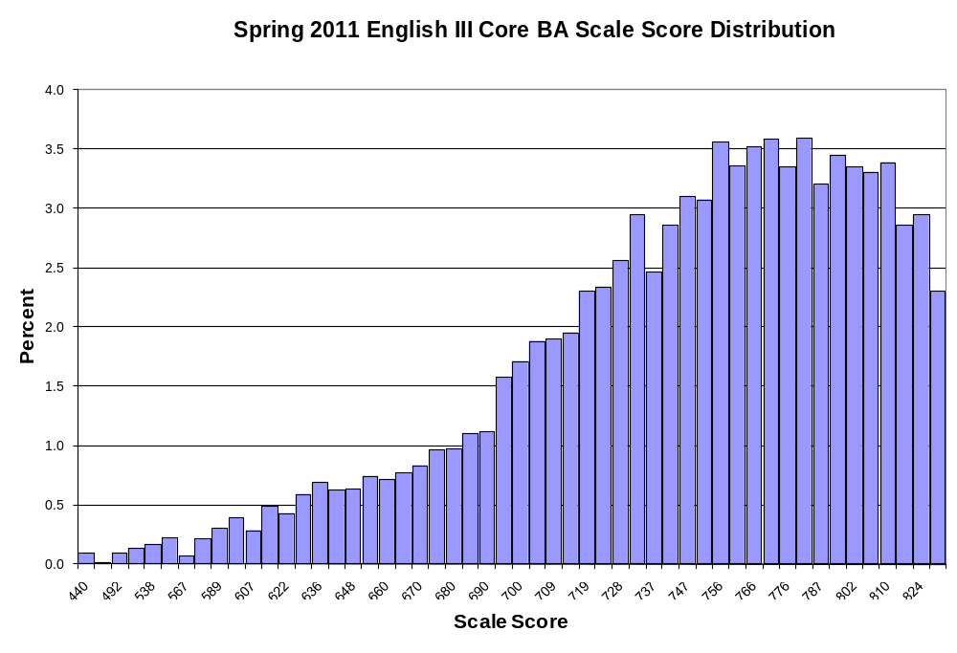
English III Core BB Score Distribution for Spring 2011
Scale Score | Frequency | Percent | Cumulative Frequency | Cumulative Percent
440 | 5 | 0.1 | 5 | 0.1
452 | 5 | 0.1 | 10 | 0.1
492 | 2 | 0.0 | 12 | 0.2
518 | 6 | 0.1 | 18 | 0.2
536 | 12 | 0.2 | 30 | 0.4
551 | 14 | 0.2 | 44 | 0.6
564 | 13 | 0.2 | 57 | 0.7
576 | 7 | 0.1 | 64 | 0.8
586 | 15 | 0.2 | 79 | 1.0
595 | 23 | 0.3 | 102 | 1.3
604 | 31 | 0.4 | 133 | 1.7
612 | 38 | 0.5 | 171 | 2.2
620 | 34 | 0.4 | 205 | 2.7
627 | 36 | 0.5 | 241 | 3.1
633 | 35 | 0.5 | 276 | 3.6
640 | 39 | 0.5 | 315 | 4.1
646 | 41 | 0.5 | 356 | 4.6
652 | 60 | 0.8 | 416 | 5.4
658 | 63 | 0.8 | 479 | 6.2
663 | 63 | 0.8 | 542 | 7.0
670 | 69 | 0.9 | 611 | 7.9
674 | 80 | 1.0 | 691 | 9.0
679 | 83 | 1.1 | 774 | 10.1
684 | 96 | 1.2 | 870 | 11.3
689 | 97 | 1.3 | 967 | 12.6
694 | 104 | 1.4 | 1,071 | 13.9
700 | 107 | 1.4 | 1,178 | 15.3
703 | 110 | 1.4 | 1,288 | 16.7
708 | 129 | 1.7 | 1,417 | 18.4
713 | 171 | 2.2 | 1,588 | 20.6
718 | 169 | 2.2 | 1,757 | 22.8
722 | 198 | 2.6 | 1,955 | 25.4
727 | 223 | 2.9 | 2,178 | 28.3
732 | 198 | 2.6 | 2,376 | 30.9
736 | 196 | 2.5 | 2,572 | 33.4
741 | 215 | 2.8 | 2,787 | 36.2
746 | 241 | 3.1 | 3,028 | 39.3
751 | 227 | 2.9 | 3,255 | 42.3
755 | 231 | 3.0 | 3,486 | 45.3
760 | 255 | 3.3 | 3,741 | 48.6
765 | 265 | 3.4 | 4,006 | 52.0
English III Core BB Score Distribution for Spring 2011 (cont.)
Scale Score | Frequency | Percent | Cumulative Frequency | Cumulative Percent
770 | 281 | 3.6 | 4,287 | 55.7
775 | 289 | 3.8 | 4,576 | 59.4
781 | 254 | 3.3 | 4,830 | 62.7
786 | 289 | 3.8 | 5,119 | 66.5
792 | 291 | 3.8 | 5,410 | 70.3
802 | 246 | 3.2 | 5,656 | 73.5
803 | 263 | 3.4 | 5,919 | 76.9
809 | 223 | 2.9 | 6,142 | 79.8
816 | 232 | 3.0 | 6,374 | 82.8
823 | 241 | 3.1 | 6,615 | 85.9
831 | 197 | 2.6 | 6,812 | 88.5
839 | 189 | 2.5 | 7,001 | 90.9
848 | 191 | 2.5 | 7,192 | 93.4
858 | 150 | 1.9 | 7,342 | 95.4
870 | 111 | 1.4 | 7,453 | 96.8
884 | 88 | 1.1 | 7,541 | 97.9
900 | 85 | 1.1 | 7,626 | 99.1
921 | 41 | 0.5 | 7,667 | 99.6
950 | 16 | 0.2 | 7,683 | 99.8
999 | 16 | 0.2 | 7,699 | 100.0

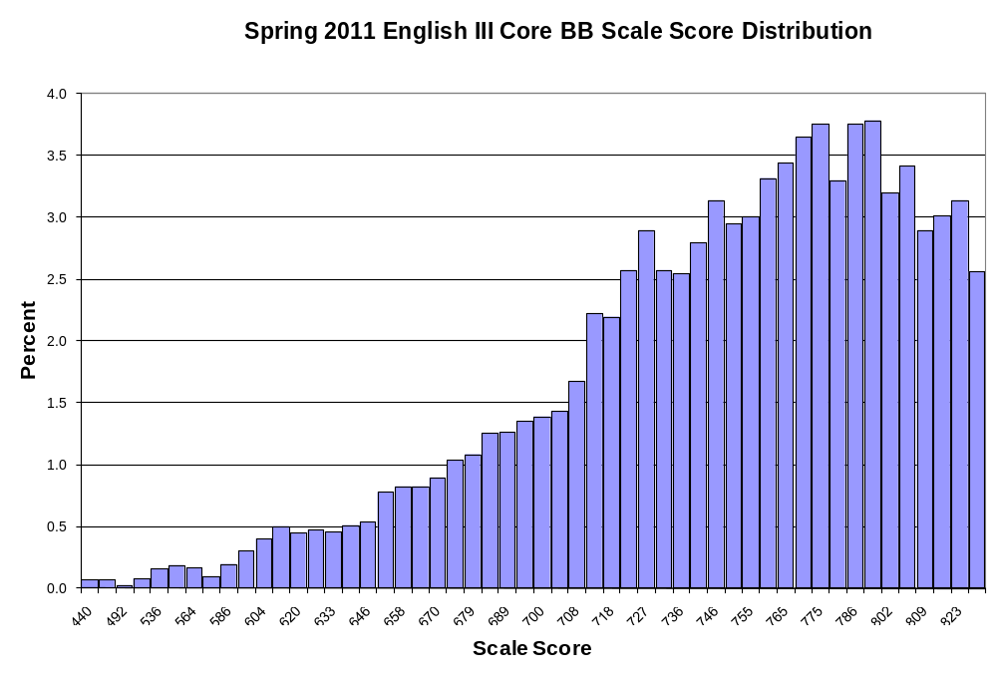
Geometry Core A Score Distribution for Spring 2011
Scale Score | Frequency | Percent | Cumulative Frequency | Cumulative Percent
440 | 46 | 0.3 | 46 | 0.3
446 | 42 | 0.2 | 88 | 0.5
502 | 43 | 0.2 | 131 | 0.7
536 | 56 | 0.3 | 187 | 1.0
560 | 102 | 0.6 | 289 | 1.6
580 | 115 | 0.6 | 404 | 2.3
596 | 156 | 0.9 | 560 | 3.1
610 | 127 | 0.7 | 687 | 3.8
622 | 148 | 0.8 | 835 | 4.7
635 | 199 | 1.1 | 1,034 | 5.8
642 | 205 | 1.1 | 1,239 | 6.9
651 | 245 | 1.4 | 1,484 | 8.3
660 | 281 | 1.6 | 1,765 | 9.8
668 | 312 | 1.7 | 2,077 | 11.6
675 | 333 | 1.9 | 2,410 | 13.4
682 | 368 | 2.1 | 2,778 | 15.5
689 | 360 | 2.0 | 3,138 | 17.5
700 | 413 | 2.3 | 3,551 | 19.8
701 | 446 | 2.5 | 3,997 | 22.3
707 | 399 | 2.2 | 4,396 | 24.5
712 | 465 | 2.6 | 4,861 | 27.1
718 | 487 | 2.7 | 5,348 | 29.8
723 | 544 | 3.0 | 5,892 | 32.8
728 | 501 | 2.8 | 6,393 | 35.6
733 | 550 | 3.1 | 6,943 | 38.7
738 | 570 | 3.2 | 7,513 | 41.9
743 | 517 | 2.9 | 8,030 | 44.7
748 | 601 | 3.3 | 8,631 | 48.1
753 | 574 | 3.2 | 9,205 | 51.3
758 | 644 | 3.6 | 9,849 | 54.9
764 | 618 | 3.4 | 10,467 | 58.3
769 | 653 | 3.6 | 11,120 | 62.0
777 | 659 | 3.7 | 11,779 | 65.6
782 | 625 | 3.5 | 12,404 | 69.1
788 | 640 | 3.6 | 13,044 | 72.7
796 | 693 | 3.9 | 13,737 | 76.5
804 | 656 | 3.7 | 14,393 | 80.2
813 | 641 | 3.6 | 15,034 | 83.8
823 | 679 | 3.8 | 15,713 | 87.6
835 | 612 | 3.4 | 16,325 | 91.0
850 | 547 | 3.0 | 16,872 | 94.0
869 | 453 | 2.5 | 17,325 | 96.5
Geometry Core A Score Distribution for Spring 2011 (cont.)
Scale Score | Frequency | Percent | Cumulative Frequency | Cumulative Percent
896 | 321 | 1.8 | 17,646 | 98.3
945 | 218 | 1.2 | 17,864 | 99.5
999 | 83 | 0.5 | 17,947 | 100.0

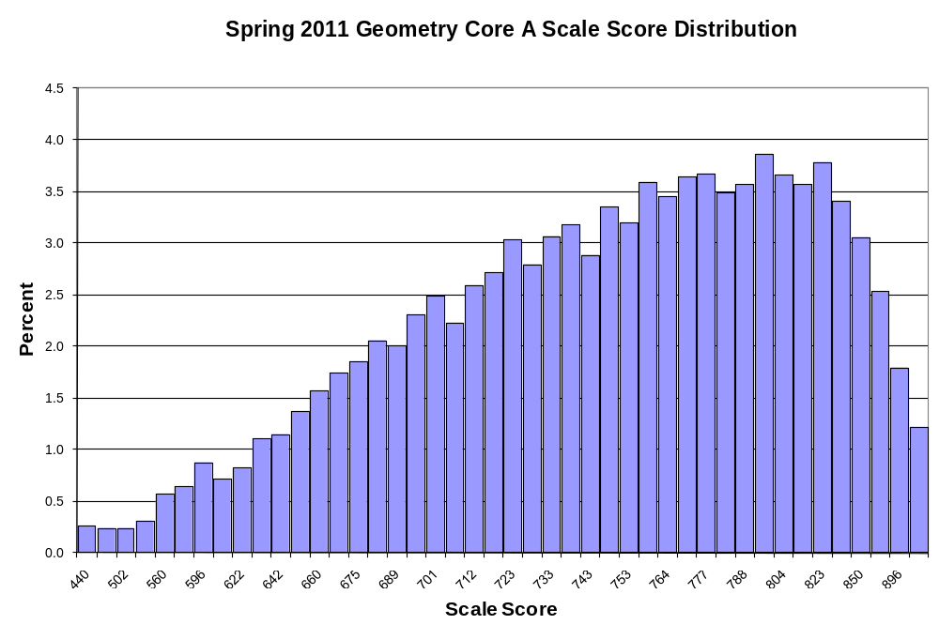

Geometry Core B Score Distribution for Spring 2011
Scale Score | Frequency | Percent | Cumulative Frequency | Cumulative Percent
440 | 36 | 0.2 | 36 | 0.2
494 | 31 | 0.2 | 67 | 0.4
530 | 44 | 0.3 | 111 | 0.7
555 | 74 | 0.5 | 185 | 1.2
574 | 93 | 0.6 | 278 | 1.8
590 | 104 | 0.7 | 382 | 2.5
603 | 138 | 0.9 | 520 | 3.4
615 | 144 | 1.0 | 664 | 4.4
626 | 179 | 1.2 | 843 | 5.6
635 | 199 | 1.3 | 1,042 | 6.9
644 | 190 | 1.3 | 1,232 | 8.1
652 | 217 | 1.4 | 1,449 | 9.6
660 | 275 | 1.8 | 1,724 | 11.4
668 | 272 | 1.8 | 1,996 | 13.2
675 | 281 | 1.9 | 2,277 | 15.1
682 | 309 | 2.0 | 2,586 | 17.1
688 | 320 | 2.1 | 2,906 | 19.2
694 | 333 | 2.2 | 3,239 | 21.4
700 | 374 | 2.5 | 3,613 | 23.9
706 | 402 | 2.7 | 4,015 | 26.5
712 | 379 | 2.5 | 4,394 | 29.1
717 | 417 | 2.8 | 4,811 | 31.8
723 | 409 | 2.7 | 5,220 | 34.5
728 | 460 | 3.0 | 5,680 | 37.6
733 | 427 | 2.8 | 6,107 | 40.4
738 | 456 | 3.0 | 6,563 | 43.4
743 | 504 | 3.3 | 7,067 | 46.7
748 | 482 | 3.2 | 7,549 | 49.9
753 | 483 | 3.2 | 8,032 | 53.1
758 | 474 | 3.1 | 8,506 | 56.2
764 | 523 | 3.5 | 9,029 | 59.7
769 | 533 | 3.5 | 9,562 | 63.2
777 | 534 | 3.5 | 10,096 | 66.8
781 | 530 | 3.5 | 10,626 | 70.3
787 | 516 | 3.4 | 11,142 | 73.7
794 | 532 | 3.5 | 11,674 | 77.2
801 | 522 | 3.5 | 12,196 | 80.6
809 | 544 | 3.6 | 12,740 | 84.2
818 | 563 | 3.7 | 13,303 | 88.0
828 | 445 | 2.9 | 13,748 | 90.9
841 | 427 | 2.8 | 14,175 | 93.7
858 | 413 | 2.7 | 14,588 | 96.5
Geometry Core B Score Distribution for Spring 2011 (cont.)
Scale Score | Frequency | Percent | Cumulative Frequency | Cumulative Percent
883 | 268 | 1.8 | 14,856 | 98.2
933 | 185 | 1.2 | 15,041 | 99.5
999 | 82 | 0.5 | 15,123 | 100.0

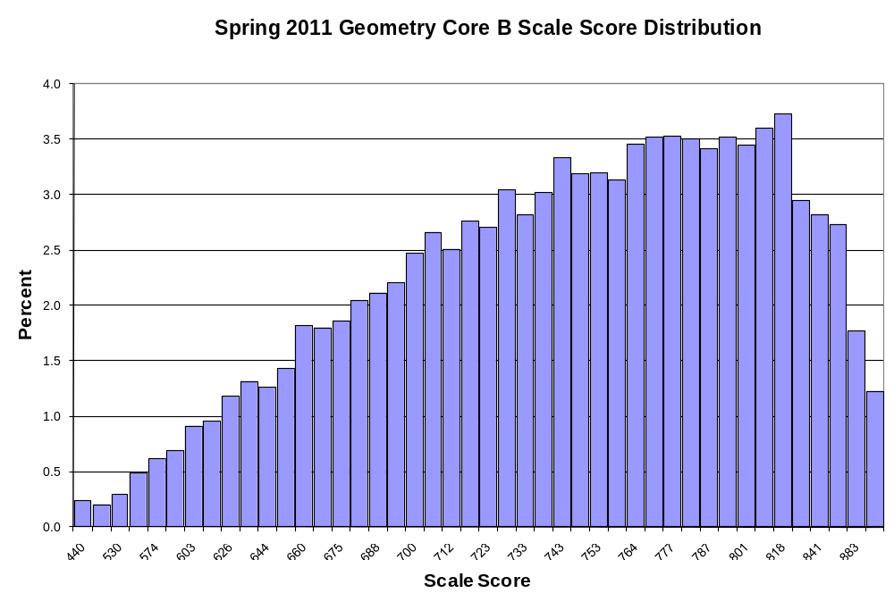

U.S. History Core A Score Distribution for Spring 2011
Scale Score | Frequency | Percent | Cumulative Frequency | Cumulative Percent
440 | 55 | 0.3 | 55 | 0.3
472 | 45 | 0.3 | 100 | 0.6
501 | 36 | 0.2 | 136 | 0.8
524 | 47 | 0.3 | 183 | 1.1
543 | 66 | 0.4 | 249 | 1.5
559 | 79 | 0.5 | 328 | 2.0
574 | 99 | 0.6 | 427 | 2.6
586 | 106 | 0.7 | 533 | 3.3
603 | 159 | 1.0 | 692 | 4.3
608 | 191 | 1.2 | 883 | 5.4
618 | 206 | 1.3 | 1,089 | 6.7
627 | 221 | 1.4 | 1,310 | 8.1
636 | 249 | 1.5 | 1,559 | 9.6
644 | 271 | 1.7 | 1,830 | 11.3
651 | 309 | 1.9 | 2,139 | 13.2
659 | 332 | 2.0 | 2,471 | 15.2
666 | 329 | 2.0 | 2,800 | 17.3
672 | 365 | 2.2 | 3,165 | 19.5
679 | 430 | 2.6 | 3,595 | 22.2
689 | 421 | 2.6 | 4,016 | 24.7
691 | 431 | 2.7 | 4,447 | 27.4
697 | 441 | 2.7 | 4,888 | 30.1
703 | 461 | 2.8 | 5,349 | 33.0
709 | 509 | 3.1 | 5,858 | 36.1
715 | 516 | 3.2 | 6,374 | 39.3
721 | 522 | 3.2 | 6,896 | 42.5
726 | 503 | 3.1 | 7,399 | 45.6
732 | 569 | 3.5 | 7,968 | 49.1
738 | 564 | 3.5 | 8,532 | 52.6
747 | 622 | 3.8 | 9,154 | 56.4
749 | 553 | 3.4 | 9,707 | 59.8
756 | 587 | 3.6 | 10,294 | 63.4
762 | 561 | 3.5 | 10,855 | 66.9
768 | 571 | 3.5 | 11,426 | 70.4
775 | 588 | 3.6 | 12,014 | 74.0
782 | 589 | 3.6 | 12,603 | 77.7
790 | 539 | 3.3 | 13,142 | 81.0
798 | 576 | 3.5 | 13,718 | 84.5
807 | 553 | 3.4 | 14,271 | 87.9
817 | 475 | 2.9 | 14,746 | 90.9
828 | 392 | 2.4 | 15,138 | 93.3
841 | 377 | 2.3 | 15,515 | 95.6
U.S. History Core A Score Distribution for Spring 2011 (cont.)
Scale Score | Frequency | Percent | Cumulative Frequency | Cumulative Percent
857 | 265 | 1.6 | 15,780 | 97.2
879 | 227 | 1.4 | 16,007 | 98.6
909 | 140 | 0.9 | 16,147 | 99.5
966 | 67 | 0.4 | 16,214 | 99.9
999 | 14 | 0.1 | 16,228 | 100.0

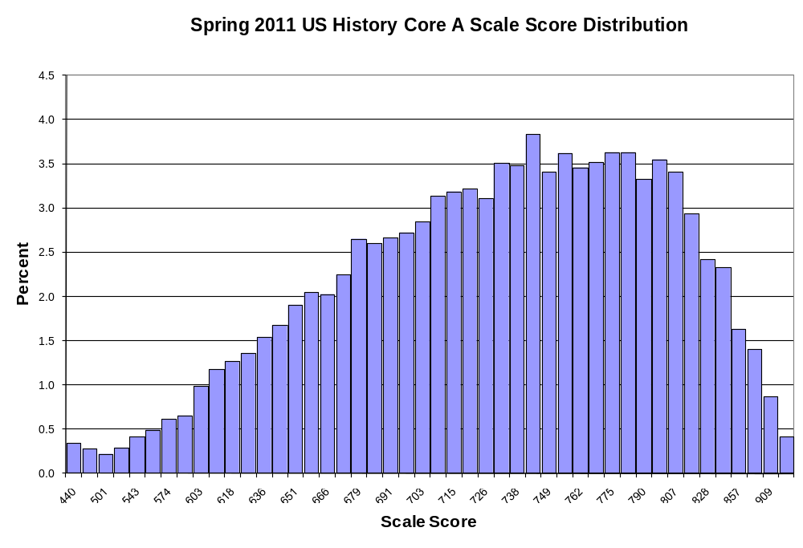

U.S. History Core B Score Distribution for Spring 2011
Scale Score | Frequency | Percent | Cumulative Frequency | Cumulative Percent
440 | 52 | 0.4 | 52 | 0.4
449 | 24 | 0.2 | 76 | 0.6
490 | 40 | 0.3 | 116 | 0.9
519 | 51 | 0.4 | 167 | 1.2
541 | 45 | 0.3 | 212 | 1.6
559 | 71 | 0.5 | 283 | 2.1
574 | 89 | 0.7 | 372 | 2.7
587 | 91 | 0.7 | 463 | 3.4
603 | 157 | 1.2 | 620 | 4.6
609 | 128 | 0.9 | 748 | 5.5
618 | 150 | 1.1 | 898 | 6.6
627 | 186 | 1.4 | 1,084 | 8.0
635 | 202 | 1.5 | 1,286 | 9.5
643 | 209 | 1.5 | 1,495 | 11.0
651 | 245 | 1.8 | 1,740 | 12.9
658 | 246 | 1.8 | 1,986 | 14.7
665 | 302 | 2.2 | 2,288 | 16.9
671 | 329 | 2.4 | 2,617 | 19.3
678 | 304 | 2.2 | 2,921 | 21.6
689 | 329 | 2.4 | 3,250 | 24.0
690 | 367 | 2.7 | 3,617 | 26.7
696 | 386 | 2.9 | 4,003 | 29.6
702 | 382 | 2.8 | 4,385 | 32.4
708 | 373 | 2.8 | 4,758 | 35.1
714 | 413 | 3.1 | 5,171 | 38.2
720 | 421 | 3.1 | 5,592 | 41.3
725 | 466 | 3.4 | 6,058 | 44.8
731 | 460 | 3.4 | 6,518 | 48.1
737 | 462 | 3.4 | 6,980 | 51.6
747 | 500 | 3.7 | 7,480 | 55.3
748 | 492 | 3.6 | 7,972 | 58.9
754 | 549 | 4.1 | 8,521 | 62.9
760 | 454 | 3.4 | 8,975 | 66.3
767 | 474 | 3.5 | 9,449 | 69.8
773 | 444 | 3.3 | 9,893 | 73.1
780 | 459 | 3.4 | 10,352 | 76.5
788 | 462 | 3.4 | 10,814 | 79.9
796 | 462 | 3.4 | 11,276 | 83.3
804 | 457 | 3.4 | 11,733 | 86.7
814 | 374 | 2.8 | 12,107 | 89.4
825 | 349 | 2.6 | 12,456 | 92.0
838 | 329 | 2.4 | 12,785 | 94.4
U.S. History Core B Score Distribution for Spring 2011 (cont.)
Scale Score | Frequency | Percent | Cumulative Frequency | Cumulative Percent
854 | 271 | 2.0 | 13,056 | 96.4
875 | 224 | 1.7 | 13,280 | 98.1
904 | 143 | 1.1 | 13,423 | 99.2
957 | 85 | 0.6 | 13,508 | 99.8
999 | 29 | 0.2 | 13,537 | 100.0

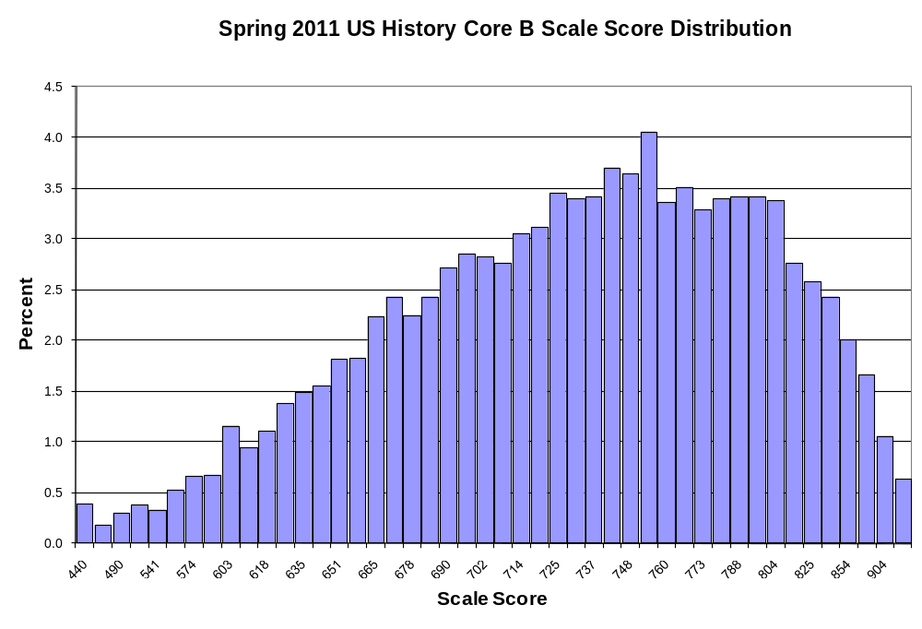

Note that the item stability check was applied only to post-equated tests.

