Professional Development Opportunities
To sustain a quality program, staff and volunteers who will be delivering academic support and enrichment services shall participate in a minimum of five, afterschool-specific, learning opportunities. These opportunities may include a host of different types of learning, including but not limited to conferences, workshops, professional learning communities (PLC), on-line learning, webinars, book discussions and program visits.
Where can I find professional development opportunities?
http://www.ok.gov/sde/21st-cclc-grantee-resources-trainings - A list of conferences approved for afterschool-specific professional development is on the 21st CCLC website.
https://y4y.ed.gov – You for Youth (Y4Y) was created by the United States Department of Education (USDE) to provide resources specifically for afterschool programs. On this website you will find a plethora of training resources, tools, and sharing of ideas on specific topics.
http://naaweb.org – National Afterschool Association website provides many resources for PLC discussions, webinars, and weekly tips.
http://click2sciencepd.org – Click2Science is an interactive, professional development site for trainers, coaches, site directors and frontline staff/volunteers working in out-of-school time STEM programs.
www.cypq.org – Online training courses are available for the Youth Work Methods Series. Also available from the David P. Weikart Center for Youth Program Quality is a monthly newsletter, Program Quality News.
http://www.air.org/ - Beyond the Bell at American Institutes for Research supports the afterschool and expanded learning field in building quality programs and activities for young people by delivering knowledge, strategies, and results so practitioners can make research-based decisions that produce sustained improvements. One of their recent resources is Beyond the Bell – 4th Edition: A Toolkit for Creating Effective Afterschool and Expanded Learning Programs.
http://www.afterschoolalliance.org – A nonprofit public awareness and advocacy group dedicated to ensuring that all children have access to afterschool programs. The website includes policy information and research as well as ideas on how to advocate for afterschool programs. Lights on Afterschool is a project of the Afterschool Alliance.
http://niost.org – The National Institute on Out-of-School Time at Wellesley College produces a wide array of research and technical papers, assessment and training tools, and publications. Their journal Afterschool Matters is the only peer-reviewed journal in the out-of-school time field.
http://www.hfrp.org/ - The Harvard Family Research Project provides publications and resources related to out-of-school time and family involvement.
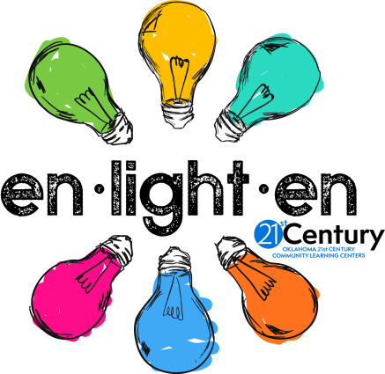
http://youthtoday.org – Youth Today is an independent, nationally distributed newspaper that publishes up-to-date information related to issues facing today’s youth and provides contact information for foundations interested in youth development issues and listings of recent grant awards to youth-serving organizations. Also available at this site are reviews of books and videos for use with staff and kids, analysis of groundbreaking research in the youth services field, and coverage of federal and state legislative issues concerning youth.

The 21st CCLC office has a lending library to allow grantees check out and preview resources before ordering. Resources vary from activity materials to training guides to concept books (inventory list available at http://www.ok.gov/sde/21st-cclc-grantee-resources-trainings).

