Dropout Report
Quarters 1-3 and the Fourth Quarter
Version 1 - 04/01/2021

Introduction
This guide is meant to help assist district staff to navigate through the Dropout Report. This guide can be used for both the Quarters 1-3 Report opening late April/early May 2021, as well as the Fourth Quarter Dropout Report currently open as of April 2021.
This guide WILL update when the Quarter 1-3 Report opens. The first version of this guide will focus primarily on the Fourth Quarter Dropout Report.

How to get to the Dropout Report
To begin, go to the Single Sign On Website, log in and choose “The Wave’s Portal” option from the list of application(s)
Screenshot from Single Sign On above
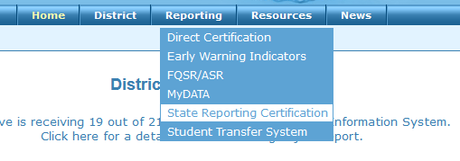
Once in the Wave, look for the “Reporting” tab and select “State Reporting Certification” from the drop-down list. If you are not able to see the “Reporting” tab or in the drop down, “State Reporting Certification” as options, contact your district superintendent or single sign-on administrator for access.

Screenshots from The Wave’s Portal above
Once in “State Reporting Certification” look for one of the following, the “Quarter 1-3 Dropout Report” Report “Fourth Quarter Report” in the list of reports. Review the “Report Opens” and “Due Date”. If the report is currently open, the “Report Status” will show as “Open” otherwise, it will say Closed.
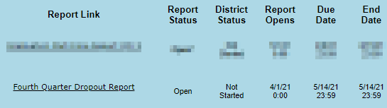
Screenshot from The Wave’s Portal Report Selector above

Dropout Reporting Windows
The Quarters 1-3 Dropout Report is scheduled to open annually in April and will stay open through June 30. This report will include dropouts that occurred between October 1 and June 30.
The Fourth Quarter Dropout will open in August and will stay open through October of the following school year. This report will include any dropout found that are still applicable from the Quarter 1-3 Dropout Report as well as any dropouts that occurred between July 1 and September 30.
Back to Top of Dropout Report Guide

Dropout Report Statuses
After clicking on either instance of the Dropout Report you will see a list of the site(s) in your district. Each site has a site status to indicate the progress status of the site(s). Select a site to continue to the Dropout Report.
While OSDE does not expect districts to certify Quarters 1-3 dropout reports, the option is available. Only data from the Fourth Quarter Dropout report will be used for reporting purposes.

The progress statuses are as followed:
- Inactive: Any site that is not expected to complete the report
- Not Started: No user has logged in to look at the report
- In Process: At least one person has logged in to look at the report
- Confirmed: The Principal has confirmed the report
- Certified: The Superintendent has certified the report
To certify all sites required to complete the report must be confirmed.
Back to Top of Dropout Report Guide

Dropout Report Layout
After selecting a site, you will be taken to the “Final Report”. There will be buttons along the top of the reporting window that will take you to various sections of the Dropout Report application.
- Site Selection: Returns you to the site selector.
- Final Report: The data that will be reviewed. This data is prepopulated from your student information system (SIS) and is updated nightly if it relates to current year data.
- Reporting Tools: Contains reports that may help assist in the completion of the Dropout Report.
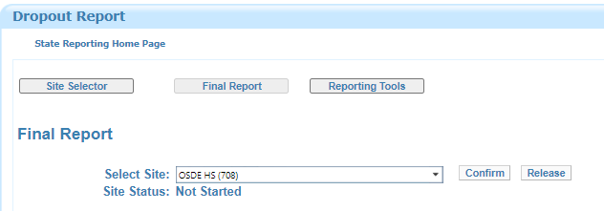
Screenshot from The Wave’s Portal Dropout Report above
Back to Top of Dropout Report Guide

Dropout Report Navigation

How to complete the Dropout Report
As of April 1, 2021
Both instances of the Dropout Report will default to the “Final Report” which will include all students found to be a dropout at the site or district. The “Final Report” is prepopulated entirely from information sent to the Wave from a local SIS. To complete the report follow the following steps:
- Review the list of students appearing on your dropout report. This will show any student enrolled in grades seven through twelve that were identified as a dropout. There are 25 data points currently shown.
  - The layout for the report as well as the list of exit codes used and whether a subsequent enrollment is expected is below.
  - If you find that a student is inappropriately showing on the Dropout Report please contact StudentDataInfo@sde.ok.gov.
    - NOTE: The Office of Data & Information Systems is working with the Office of Accountability department to account for any enrollment adjustments made through the EZ Grad Entry Window open through April 19, 2021.
- After verifying that all information is correct for a site, the site principal will confirm the report. Once all site(s) within a district is confirmed, the Superintendent can certify. By certifying the Dropout Report the Superintendent is verifying that all information for their district is accurate. This information will be used for state and federal reporting.
Back to Top of Dropout Report Guide

Confirming, Releasing, and Certifying the Report
After verifying that all information is correct for a site, the site principal will confirm the report. Once all site(s) within a district is confirmed, the Superintendent can certify. By certifying the Dropout Report the Superintendent is verifying that all information for their district is accurate. This information will be used for state and federal reporting.
Once a site is marked as confirmed by the principal, the data will no longer update daily. It will remain exactly as it appeared at the time of confirmation. If data corrections are necessary after a site was confirmed the district superintendent can press the “release” button.
If released, the report will return to the current state of data contained inside of the Wave as of the time of the last refresh. The Wave and your student information system should mirror each other in information during this reporting window.
Contact the office of Data & Information Systems if the district superintendent has certified the report but changes are necessary. Once an OSDE Data & Information Systems staff member decertifies the report, each site(s) status will return to “Confirmed” status.
Back to Top of Dropout Report Guide

Reporting Reminders
- Check and correct the Waze Wizards. Currently, there are three main to review-- the STN System, Data Validation Wizard, and District Ownership Wizard. While reviewing the Data Validation Wizard, be sure to clear the “Student Demographics” and “Student School Enrollment” sections as these may cause issues with reporting.
- Students with the following Exit Codes will be considered a dropout unless a subsequent enrollment is found, review the list of codes in Table 1
    - NOTE: If you expected one of your students to transfer to another district but the student never ended up enrolling at that district or any other Oklahoma Public school district, even if records were sent in preparation for the transfer if the subsequent school never enrolled the student, or the student enrolled after the cutoff window for reporting, the student will remain the responsibility of your district. If you have investigated the student's whereabouts and can confirm that the student has enrolled at another district or you believe the student did enroll elsewhere but need assistance, contact StudentDataInfo@sde.ok.gov for further investigation.

TABLE 1
Code | Base (SIF) Description | OSDE Definition | Is Considered a Dropout | Action in Dropout Report
1907 | Student enters a different public school in the same local education agency | Student is changing sites in the same district.  Note: If the student is changing sites from a regular site to a charter school site in the same district, utilize code 3508. | No* | Will not be considered a dropout if a subsequent enrollment is found by September 30.
1908 | Transferred to a public school in a different local education agency in the same state | Student is exiting the district, going to another public school district in Oklahoma. | No* | Will not be considered a dropout if a subsequent enrollment is found by September 30.
1909 | Transferred to a public school in a different state | Student is exiting the district, going to another public school district in a different state. | No | Will not be considered a dropout.
1910 | Transferred to a private, non-religiously-affiliated school in the same local education agency | Student is exiting the district, going to a non-religious private school located inside the public school district boundaries. | No | Will not be considered a dropout.
1911 | Transferred to a private, non-religiously-affiliated school in a different local education agency in the same state | Student is exiting the district, going to a non-religious private school located outside of the public school district's boundaries in the state of Oklahoma. | No | Will not be considered a dropout.
1912 | Transferred to a private, non-religiously-affiliated school in a different state | Student is exiting the district, going to a non-religious private school located in a different state. | No | Will not be considered a dropout.
1913 | Transferred to a private, religiously-affiliated school in the same local education agency | Student is exiting the district, going to a religiously-affiliated private school located inside the public school district boundaries. | No | Will not be considered a dropout.
1914 | Transferred to a private, religiously-affiliated school in a different local education agency in the same state | Student is exiting the district, going to a religiously-affiliated private school located outside of the public school district's boundaries in the state of Oklahoma. | No | Will not be considered a dropout.
1915 | Transferred to a private, religiously-affiliated school in a different state | Student is exiting the district, going to a religiously-affiliated private school located in a different state. | No | Will not be considered a dropout.
1916 | Transferred to a school outside of the country | Student is exiting the district, going to a school in a different country. This exit code is used for Foreign Exchange students who are returning to their home country. | No | Will not be considered a dropout.
1917 | Transferred to an institution | Student is exiting the district, going to an institution.  Note: This code is used if the student is going to an institution and will no longer be counted on the membership of any public school district.  If the student will still be counted on the membership of a public school district, a different code is used. This code should only be utilized if the institution the student is transferring to CANNOT offer a state certified diploma. If a diploma can be achieved by the student while attending this institution, a different exit code should be used. | Yes | Will be considered a dropout unless a subsequent enrollment is found by September 30.
1918 | Transferred to home schooling | Student is exiting the district, going to be home schooled. | No | Will not be considered a dropout.
1919 | Transferred to a charter school | Student is exiting the district, going to be attending a charter school in a different district.  Note: If the student will be attending a charter school in the same district, utilize code 3508. | No* | Will not be considered a dropout if a subsequent enrollment is found by September 30.
1921 | Graduated with regular, advanced, International Baccalaureate, or other type of diploma (Oklahoma currently offers a regular diploma only) | Student is exiting the district. The student has graduated or received a diploma and is no longer going to be counted on membership or attendance.  Note: An Exit Type Other Code is expected with this code to indicate the number of years it took the student to graduate. | No | Will not be considered a dropout.
1922 | Completed school with other credentials | The student has completed high school, but NOT by obtaining a diploma. | Yes | Will be considered a dropout unless a subsequent enrollment is found by September 30.
1923 | Died or is permanently incapacitated | The student has died or is permanently incapacitated.  Note: There should be an additional Exit Type Other Code associated with this determining whether the reason is “Died” or is “Permanently Incapacitated." | No | Will not be considered a dropout.
1924 | Withdrawn due to illness | Student is exiting the district. The student has withdrawn due to illness and is no longer being counted on membership or attendance. | Yes | Will be considered a dropout unless a subsequent enrollment is found by September 30.
1926 | Reached maximum age for services | Student is exiting the district. The student has reached the maximum age for services. | No | Will not be considered a dropout.
1927 | Discontinued schooling | Student is exiting the district. The student is a drop out as defined by Oklahoma State Law. | Yes | Will be considered a dropout unless a subsequent enrollment is found by September 30.
1928 | Completed grade 12, but did not meet all graduation requirements | Student is exiting the district. The student has left school having completed grade 12 but does not meet all of the requirements necessary to receive a diploma and graduate. | Yes | Will be considered a dropout unless a subsequent enrollment is found by September 30.
1930 | Enrolled in a postsecondary early admission program, eligible to return | Student is exiting the district. The student is enrolled in a postsecondary early admission program, but is not receiving services from the district. Student has not graduated. | Yes | Will be considered a dropout unless a subsequent enrollment is found by September 30.
1931 | Not enrolled, unknown status | Student is exiting the district. The student is not presently enrolled and the reason for the exit is not yet known. This code will commonly be used only for a short period of time. A student may have exited and the district is not yet aware of the reason. A request for records may not have been received.  After the district is made aware of the reason for the exit, the exit code must be changed to reflect an accurate description of the reason for exit.  Note: This is not a valid code for the end of the school year. | Yes | Will be considered a dropout unless a subsequent enrollment is found by September 30.
3500 | Enrolled in an adult education or training program | Student is exiting the district. The student has left the district and is now enrolled in an adult education or training program Student is working toward a state approved GED program. | Yes | Will be considered a dropout unless a subsequent enrollment is found by September 30.
3501 | Completed a state-recognized vocational education program | The student is exiting the district by completing a state-recognized vocational education program. | Yes | Will be considered a dropout unless a subsequent enrollment is found by September 30.
3502 | Not enrolled, eligible to return | The student is exiting the district, but is eligible to return. This code may be used temporarily but does not reflect accurately the movement of the student. A student with this code will be flagged with a warning at the end of school requiring this exit code to be modified to reflect an accurate description of the reason for the exit. | Yes | Will be considered a dropout unless a subsequent enrollment is found by September 30.
3503 | Enrolled in a foreign exchange program, eligible to return | The student is exiting the district to participate in a foreign exchange program.  Note: These are American students exiting the country for a foreign exchange program. | No | Will not be considered a dropout.
3504 | Withdrawn from school, under the age for compulsory attendance; eligible to return | The student is exiting the district and is under the age for compulsory attendance (the student is age 5 or younger). | Yes* | Will be considered a dropout if this code is used and the student is older than 6 years old upon exit unless a subsequent enrollment is found by September 30.
3505 | Exited | This code is a general code to be used when modifying a student's record in the district.  Examples:  1. The student is changing grade levels in the same site. This requires an exit and a new entry at the new grade level.  2. The student was a full-time Kindergarten student and is now a part-time Kindergarten student in the same site. This requires an exit and a new entry. | Yes | Will be considered a dropout unless a subsequent enrollment is found by September 30.
3508 | Student is in a charter school managed by the same local education agency | The student is exiting one site and is going to attend a charter school in the same district. | No* | Will not be considered a dropout if a subsequent enrollment is found by September 30.
3509 | Completed with a state-recognized equivalency certificate | The student is exiting the district having received a state-recognized equivalency certificate (Example. G.E.D.). | Yes | Will be considered a dropout unless a subsequent enrollment is found by September 30.
9999 | Other | OSDE does not ever expect to receive code 9999 – Other. This code is reserved for emergency legislative updates or mid-year policy changes and is not valid for another reason. If you cannot find a code that fits a scenario, please call OSDE. | Yes | Will be considered a dropout unless a subsequent enrollment is found by September 30.

Back to Top of Dropout Report Guide

Find Missing Students
Find Missing Students will not be added to the School Year 2020-2021 version of the Fourth Quarter Dropout Report. It will be visible during School Year 2021-2022.
Coming Soon in School Year 2020-2021 for the Quarters 1-3 Dropout Report.
This section will show any student that would be considered to be a dropout but may appear as a dropout as a result of an improper exit code OR due to a lack of exit information for current year records.
Back to Top of Dropout Report Guide

Dropout Reporting Tools
The “Reporting Tools” section contains reports that may help assist in the completion of this report. All reports can be viewed for multiple school years; by default, the “Select a School Year” year will be the current school year. Reports are viewable by default by site but can be viewed by the district if the “District Report” button is checked. This option may not work depending on your SSO account access.
All reporting tool reports can be downloaded via XML, CSV, PDF, MHTML, Excel, TIFF, or Word. If you are having trouble downloading a report, make sure that pop-ups are allowed. Depending on the web browser used, the placement of the screenshot below may differ.
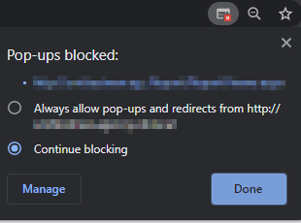
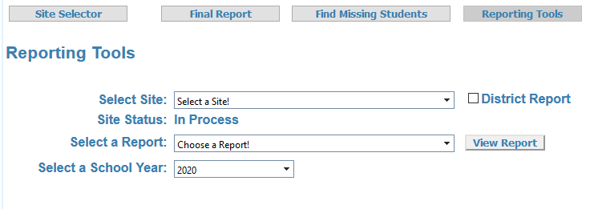
Screenshot of Reporting Tools above
The following are the reports currently available:
- Dropout Race/Ethnicity Report - Counts of dropouts by grade level and one of the 7 race/ethnicity options. (Hispanic Latino, American Indian, Asian, Black, Pacific Islander, White, or two or more races)
- Dropout Re-Entries Report - List of students that have re-entered and are not considered a dropout. This will list where the student has re-entered.
- Dropout Report - The "Final Report" of students found to be a dropout.
- Dropouts by Demographic - Counts of students in specific program areas.
- Reentry Code Counts - Counts of reentries aggregated by the reentry code.
Back to Top of Dropout Report Guide

Tips on Navigating the Dropout Report

Sort students by…
The data grid can be filtered based on criteria you will enter into the text box below the column header. Next to the text box, a cone-like icon will bring up a list of filter options. Once the filter criteria has been entered, you will then pick the filter option.
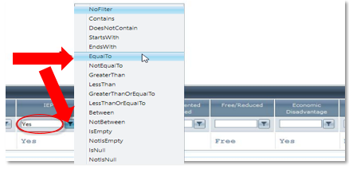
The filter features available above
You are also able to sort the report by selecting the column title. This will sort the report alphabetically based on the column header you selected.
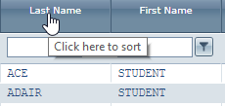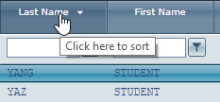
The sort features available above
Back to Top of Dropout Report Guide

Change Report View
The data grid can be re-organized by clicking and dragging the column to the space you would like it to appear. To move the column, hover over the column header until the crosshairs appear.
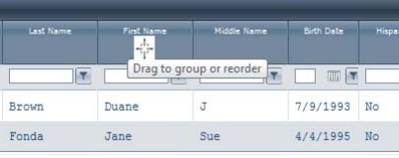
The export buttons available on this report above
Back to Top of Dropout Report Guide

Export the Final Report
To the far right of the data grid, there will be two icons that will allow you to export the “Final Report”. The data will download to either XLS (Excel) or CSV (Excel) format depending on which button is clicked. After clicking either button, the information will begin to download.
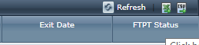
The export buttons available on this report above
Back to Top of Dropout Report Guide

Collected Data
Review the table to view the definition of the 25 data points currently collected for this report. If there are issues with a certain data point, a point of contact has also been provided.
Data Point | Definition
School ID | The county-district-site code for the student enrollment record
School Year | The school year the enrollment record pertains to. For purposes of reporting student dropouts, a dropout reporting year is defined as October 1 of one school year through September 30 of the subsequent school year.
STN | The State Testing Number for the student. If issues appear related to the STN, contact StudentDataInfo@sde.ok.gov
Local Id | The local identifier is set by the local student information system (SIS). If issues appear related to the local Id, contact your SIS vendor support.
First Name, Middle Name, Last Name (appears as 3 separate fields) | The legal first, middle, name last name of the student. It should appear in the local student information system (SIS). If issues appear related to the name of a student, contact your SIS vendor support.
Birth Date | The day of birth for the student.
Gender | The student’s gender. This value is set by the SIS, if issues appear related to the local Id, contact your SIS vendor support.
Grade | The grade level of the student. It is expected that only grade levels 7-12 appear on the Dropout Report. This value is set by the SIS, if issues appear related to the local Id, contact your SIS vendor support.
Hispanic Latino | An indication that the individual traces his or her origin or descent to Mexico, Puerto Rico, Cuba, Central or South America, or other Spanish cultures, regardless of race. This value is set by the SIS, if issues appear related to the local Id, contact your SIS vendor support.
American Indian, Asian, Black, Pacific Islander, White  (appears as 5 separate fields) | The race the student identifies with. This value is set by the SIS, if issues appear related to the local Id, contact your SIS vendor support.
ELL | Yes or No, if the student is an English Language Learner under Title 3. This value is set by the SIS, if issues appear related to the local Id, contact your SIS vendor support.
IEP | Yes or No, if the student is IDEA-eligible ("special education"). This value is set by the SIS, if issues appear related to the local Id, contact your SIS vendor support.
Economic Disadvantage | Yes or No, if the student meets the State criteria for classification as having an economic disadvantage. This value is set by the SIS, if issues appear related to the local Id, contact your SIS vendor support.
Migrant | Yes or no, if this is a migrant student. This value is set by the SIS, if issues appear related to the local Id, contact your SIS vendor support.
Homeless | Yes or no, if this is a homeless student. This value is set by the SIS, if issues appear related to the local Id, contact your SIS vendor support.
Homeless McKinney Vento | Yes or no, if this student was served by McKinney Vento sub grants during this current school year. This value is set by the SIS, if issues appear related to the local Id, contact your SIS vendor support.
Entry Date | The entry date the enrollment record pertains to. This value is set by the SIS, if issues appear related to the entry, contact your SIS vendor support if it relates to a current year record. If it does not pertain to a current year record, contact StudentDataInfo@sde.ok.gov
Exit Date | The exit date the enrollment record pertains to. This value is set by the SIS, if issues appear related to the exit date, contact your SIS vendor support if it relates to a current year record. If it does not pertain to a current year record, contact StudentDataInfo@sde.ok.gov
Exit Reason | The exit reason for the enrollment. This value is set by the SIS, if issues appear related to the exit reason, contact your SIS vendor support if it relates to a current year record. If it does not pertain to a current year record, contact StudentDataInfo@sde.ok.gov

