Oklahoma State Department of Education
Joy Hofmeister
State Superintendent of Public Instruction

December 4, 2015

Dear Superintendent:

Under the No Child Left Behind Act of 2001 (NCLB), districts are required to annually contact officials from all private schools within the district. In addition, if there are students who are residents within the district but attend a private school outside of the district attendance area, the district is required to contact those private school officials. If either of these scenarios apply, the district must submit a District Affirmation of Consultation with Private School Officials form (page 5), for each private school consulted, to the Office of Federal Programs. If, after consultation, the private school wishes for their students, teachers, and other educational staff to participate, the Declaration of Intent to Participate in Federal Programs for Private Schools form (pages 6, 7, 8, and 10) must be completed for each private school participating and returned to the Office of Federal Programs.

The district is responsible for implementing equitable services for private school students, teachers, and other educational staff eligible to participate in federal programs. After consultation with each private school, please return the completed documents electronically to the Office of Federal Programs to Rose.Carlson@sde.ok.gov with the following subject line: Private School Packet, typed exactly as shown, no later than Friday, February 5, 2016.

If no private schools exist in the district or the district has no resident students attending private schools in another district, complete the form below and send electronically to Rose.Carlson@sde.ok.gov with the following subject line: Private School Packet, typed exactly as shown, no later than Friday, February 5, 2016. Keep this private school packet for future reference. No further action is required.

For more information concerning the provision of equitable services to private school students, teachers, and other educational personnel, please refer to the State Department of Education website at <http://www.sde.ok.gov>. If you have any questions, please contact the Office of Federal Programs at (405) 521-2846. Thank you for your assistance.

Sincerely,

Gloria Bayouth
Executive Director
Office of Federal Programs

Submit to Oklahoma State Department of Education (OSDE) by Friday, February 5, 2016.

Certification that no private schools exist in this district and none of our resident students attend a private school in another district:
District Name & Code | County Code County Name
Superintendent Signature | Date

State and Federal Requirements for the Participation of Private Schools
District use only

in Federal Programs under the No Child Left Behind Act of 2001
FY2016

- Each year the State Department of Education Office of Federal Programs distributes the Declaration of Intent to Participate in Federal Programs for Private Schools form to district superintendents for consultation and completion with eligible private school administrators within each district. The administrator of each eligible private school with 501(c)(3) nonprofit certification who desires for their students, teachers, and other educational staff to participate in any of the eligible federal programs (see page 6), must complete and return the form to the districts by the indicated deadline to participate in federal programs in the 2016-2017 school year.

- Federal guidelines require districts to annually conduct timely, meaningful, and ongoing consultation with private school officials of participating private school students, teachers, and other educational staff. The district must inform private school administrators of the benefits and limitations of the No Child Left Behind Act of 2001 (NCLB) and provide the opportunity for private school students, teachers, and other educational staff to participate in the district programs.

- Each district will receive a federal program allocation which includes counts of both public and private school students to implement programs under NCLB.

- Each local district must consult with the private school officials about proposed uses of federal funds. All equitable services information must be submitted to the district and included as part of the district application. Participation by private school students, teachers, and other educational staff is limited to the extent allowable under specific NCLB programs.

- Allocations for participating private school students, teachers, and other educational staff are included in the district's Preliminary Allocation Notification for each federal program. After the district calculates an amount for use in serving the private school students, teachers, and other educational staff, projected expenditures for these equitable services must be entered in the summary budget of the district application under function code 5500. Control of the federal funds legally remains with the district. The district shall make final decisions with respect to the services to be implemented for private school students, teachers, and other educational staff. Neither the State Department of Education nor a district may make direct payments to a private school or expend funds for any purpose that would benefit a private school or the general needs of the private school students.

- Oklahoma’s approved ESEA Flexibility Waiver allows all districts to transfer up to 100 percent of Title II, Part A funds into Title I Part A. However, “Each program covered by the transferability authority is subject to equitable participation requirements, which may not be waived (ESEA section 9401(c)(5)). Before a local education agency may transfer funds, it must engage in timely and meaningful consultation with appropriate private school officials ESEA sections 6123(e)(2) and 9501. With respect to the transferred funds, the local education agency must provide private school students and teachers equitable services under the program from which the funds are transferred based on the total amount of funds available to each program after the transfer.” Sufficient funds must remain in Title II, Part A to provide for equitable services for participating private schools.

- Flexibility provisions (Title VI) in ESEA Flexibility Waiver allow eligible districts to transfer up to 100 percent of the portions generated by both public and private school students for certain program funds after consultation with private schools and others. Equitable services still apply when transferring funds. Prior to the transfer of any funds and as a part of program planning, private schools and other public school staff must be informed that the district intends to transfer funds.

- A discreet audit trail for the expenditure of allocations for equitable services to private school students, their teachers, and other educational personnel must be established by the district business office to avoid commingling these federal funds with public school federal funds. Invoices for expenditures for equitable services must be coded under function code 5500 by district program staff to alert business office staff that such expenditures are to be charged to the equitable services account. Purchases made on behalf of equitable services may not be paid from the public school portion of the district allocation, nor may purchases for the public school program be paid from funds generated by private school students. Payment by the district for purchases of equitable services must be deducted from individual accounts established for equitable services for each private school with participants under function code 5500 in the appropriate program's budget page.

- The district is responsible for ordering materials or equipment needed to implement the program for equitable services in the approved district application. The district is also responsible for arranging for all training programs and services to be implemented for private school students, teachers, and other educational staff. Services and materials purchased or provided by the district for private school students and teachers must be secular, neutral, and nonideological. The district must maintain an inventory of materials and equipment purchased with federal funds on behalf of each participating private school.

- The district is legally required to retain title to all purchases made with federal funds for equitable services. All purchases must be appropriately labeled or otherwise identified by the district to indicate the year and source of federal funds with which they were purchased. When materials and equipment purchased with federal funds for temporary use in the program located at the private school are no longer needed to meet program purposes, the district must ensure their return and equitable distribution among other private schools with participants.

- Federal funds allocated for private school students, teachers, and other educational staff are to be used for expenditures approved in the current year's district application.

- If a private school closes or withdraws from participation in a federal program, the district must immediately notify the State Department of Education Office of Federal Programs.

- When calculating reasonable and necessary administrative costs, the district should include the costs of administering the programs for both public and private school participants.

- An LEA must consult with appropriate officials from private schools during the design and development of the LEA’s Title I program for eligible private school students. After consultation with appropriate private school officials, the LEA must design a Title I program that meets the needs of eligible private school students. The LEA is responsible for planning, designing, and implementing the Title I program and may not delegate that responsibility to the private schools or their officials.

- Title I regulations prohibit LEAs from using Title I funds for the needs of the private school or the general needs of children in the private school.

- Title I regulations require that any Title I funded equipment or supplies placed in the private school are used for Title I purposes only.

- Title I expenditures for other benefits to eligible private school students should be equal to the proportion of funds allocated to participating public school attendance areas (based on the number of private school students from low-income families). Funds generated by private school students must only be used for instructional costs associated with providing Title I services to eligible private school students.

- Title I regulations require that, to be eligible for Title I services, a private school student must reside in a participating public school attendance area and meet the requirements in section 1115(b) of the ESEA which requires the LEA to use multiple, educationally related, objective criteria in selecting children to participate in the Title I program.

- Title I services are to be provided to participating private school students by an LEA or third party contractor employee who is independent of the private school in the provision of Title I services. A private school teacher can only be employed for Title I purposes outside of the time he or she is employed by the private school and the private school teacher must be under the direct supervision of the LEA with respect to all Title I activities.

- Private school principals may not sign time and effort records.

- Title I regulations require an LEA to consult with appropriate officials from private schools during the design and development of the LEA’s program for eligible private school students. The consultation should include how the LEA will assess academically the services to eligible private school students and how the LEA will use the results of that assessment to improve Title I services.
District Affirmation of Consultation
With Private School Officials
For services to be provided School Year 2016-2017 (FY2017)
(Duplicate form as needed and electronically submit to OSDE by Friday, February 5, 2016.)

Federal regulations require that timely and meaningful consultation occur between the local educational agency and private school officials prior to any decision that affects the opportunities of eligible private school children, teachers, and other educational personnel to participate in federal programs. Consultation shall continue throughout the implementation and assessment of activities.

The following topics must be discussed during the ongoing consultation process:

- How the district will identify the needs of eligible private school children and teachers;
- What services the district will offer;
- How the decision of services delivered will be made;
- How, where, and by whom services will be provided;
- How the district will assess services to eligible private school students;
- Size and scope of equitable services;
- Method or sources of data that will be used to determine the number of private school children from low-income families residing in participating public school attendance area;
- Equitable services the district will provide to teachers and families of participating private school children; and
- If the district disagrees with the views of the private school officials on the provisions of services, the district must provide the private school the reason in writing as to why they disagree.

The following multiple, educationally related, objective criteria will be used to determine private school student eligibility for the Title I Part A program:

We agree that timely and meaningful consultation occurred before the district made any decision that affected the participation of eligible private school children under NCLB.

We agree that we have participated in meaningful and timely discussion on each federal program and have chosen to participate in the programs marked on the Declaration of Intent to Participate in Federal Programs form.

WE AGREE that timely and meaningful consultation shall continue throughout implementation and assessment of services provided under NCLB on the following dates: ___________________.

Public School Official Signature | Date |  | Public School District County # District #
Public School Address |  |  | Public School Phone Number
Private School Representative Signature | Date |  | Name of Private School Private School #
Private School Address |  |  | Private School Phone Number
Private School wishes to participate in Federal Programs: |  |  | Yes ____ No ____

Declaration of Intent to Participate in Federal Programs
For Private Schools
For services to be provided School Year 2016-2017 (FY2017)
(Duplicate form as needed and electronically submit to OSDE by Friday, February 5, 2016.)

For private school students, teachers, and other educational staff to be eligible to participate in federal programs administered by the local school district, pages 5 and 6 of this form must be completed, signed by the private school representative, and submitted to the OSDE by Friday, February 5, 2016. This form must be completed annually by the local district and each participating private school.

County: Public School District:
Public School Contact Person:
Public School Contact Person Phone: Fax:
Private school officials who desire their teachers and students to benefit from federal educational programs through collaboration with the local school district must be accredited either by the State Board of Education or by the Oklahoma Private School Accreditation Commission (OPSAC) which is an accreditation entity approved by the State Board of Education. Registration with the State Department of Education is an alternative to accreditation. Private schools that have students, teachers, and other educational staff who participate, must also have 501(c)(3) certification issued by the Internal Revenue Service.

Indicate (√) the status of the private school. Check only one:
___ (1) Accredited by the State Board of Education (SBE).
___ (2) Accredited by the SBE through the Oklahoma Private School Accreditation Commission.
___ (3) Our school is not accredited, but we wish to register with the State Department of Education.

Provide all information requested below for use by the OSDE in calculating federal program allocations for the district and each participating private school in the 2016-2017 school year. Tax exempt number must be provided.

I. Private School Name: ___________________________________ Phone:
Mailing address:
Private School Administrator: ________________________________ Fax:
Private School Administrator email address: ___________________________________________________
- Federal Tax Exempt Number (IRS Code Section 501(c)(3):

- Total enrollment in K-12 on October 1, 2015. Do not include preschool or homebound enrollment.
Total enrollment: _______________
Total number of ELL students identified through English language proficiency testing: ____________
Total number of Migrant students identified through a Certificate of Eligibility: ____________

IV. Indicate (√) each federal program in which the private school teachers, other educational staff, or students will participate in during 2016-2017. Federal funds will not be reserved for any private school students, teachers, and other educational staff if the school fails to indicate a choice.
____ Title I Part A: Helping Disadvantaged Children*
____ Title I Part C: Education of Migratory Children
____ Title II Part A: Teacher and Principal Training**
____ Title II Part B: Mathematics and Science Partnerships
____ Title III Part A: Language Instruction for Limited English Proficient and Immigrant Students

*If Title I Part A is checked for participation, the private school needs to complete the Family Income Eligibility Form From Private School Officials and return to the local public school. The local public school needs to complete the Private School Low-Income Student Count for Title I Part A Services form and return to OSDE.

** If Title II Part A is checked for participation, please verify that the private school is physically located within your LEA. If the private school is located within another LEA, please forward this information to the LEA in which the private school is located and remove the check mark.

STATEMENT OF ASSURANCES for PRIVATE SCHOOLS

For teachers, other educational staff, and students of private schools to be eligible to participate in federal programs, private schools must be organized according to the recognized patterns shown below.

MINIMUM CRITERIA FOR REGISTRATION

- School will be in session for 180 days or 1080 hours. Five (5) days may be professional days. Student seat time is 1030
hours. If a private school is in session for less than 180 days, the school will be required to submit official documentation verifying the number of days in session to the LEA providing equitable services.
- School will be in session six (6) hours per day exclusive of lunch time.
- Adequate and appropriate facilities, supplies, and equipment will be provided to carry out the educational program.
- A governing board will develop objectives and oversee program implementation.
- Safe and sanitary conditions will be maintained in buildings where children receive instruction.
- Compliance with Title VI of the Civil Rights Act, Title IX of Public Law 92-318, Family Education Rights and Privacy Act, Public Law 105-17 (IDEA), Section 504 of the Vocational Rehabilitation Act of 1973, and with the rules and regulations there under governing the programs and funds is assured.
- School officials will meet with local school district administration to provide suggestions, ideas, program options, etc. that meet the needs of their participants to help the local school district in planning, implementing, and evaluating programs, services, and activities supported by federal program allocations.
- Services, materials, and equipment provided for the benefit of participating private school students must be secular, neutral, and nonideological. Control of federal funds and the title to any equipment and materials must remain with the public agency, i.e., the local educational agency (LEA). No federal funds may be paid to any private school and the title to equipment and materials may not be transferred to any private school.
- If a student is attending a private school in one district and residing in the attendance area of another district, the school officials of the district where the private school is located is responsible for notifying the district in which the student resides.

The Organizational Patterns of Schools as specified by the State of Oklahoma are listed below. Please check (√) all that apply and enter enrollment figures. Do not include preschool or homebound enrollment.

Elementary School Middle School / Jr. High High School
( ) K-5 ________ ( ) 5-9 ________ ( ) 9-12 _________
( ) K-6 ________ ( ) 6-9 ________ ( ) 10-12 ________
( ) K-8 ________ ( ) 7-9 ________
( ) 8-9 ________

The state minimum school term length is 180 days. Indicate the length of your school term:

The state minimum school day length is six (6) hours. Indicate the length of your school day:

Private School Representative (signature) Date

Private School Name

Family Income Eligibility Form
From Private School Officials

Families Who Meet the Poverty Criterion
For Use in Determining Title I Services

Name of Private School

Public School District

Please complete one form for each resident public school district with low-income students attending the private school in October 2015. Duplicate form as necessary.

Please provide below the grade levels and addresses (including zip codes) of your students whose families meet the poverty criteria of _______________________________ and were in attendance October 2015.
(Identify the poverty criterion used, e.g., enrollment in the U.S. Department of Agriculture’s free and reduced-price lunch program.) Do not provide the names of the families or students. More than one grade level can be listed on the form as long as there is a separate form for each school district. Submit form(s) to OSDE by Friday, February 5, 2016.

Grade Level | Address Including City and Zip Code

Private School Students Who Reside in Another School District
(Duplicate as needed)

Private School Student is Attending
Public School Where Private School is Located
Public School Where Private School Student Resides

If a student is attending a private school in one district and residing in the attendance area of another district, the school officials of the district where the private school is located is responsible for notifying the district in which the student resides.

The intended use of this form is for the district where the private school is located to notify the district where the private student resides. Documentation should be maintained for future monitoring purposes.

Student Name | Grade Level | Address Including City and Zip Code

NOTE: The district where the private school student resides is responsible for completing the Private School Low-Income Student Count for Title I Part A Services form, page 10 of this packet, for any low-income private school student and reporting that information to the Office of Federal Programs.

Electronically Submit to OSDE
Private School Low-Income Student Count for Title I Part A Services

Section 1120 of Title I requires that local education agencies (LEA) provide eligible private school children, their teachers, and their families with Title I educational services or other benefits that are equitable to those provided to eligible public school children and families. Title I services for eligible private school children, their teachers, and their families must be developed in consultation with private school officials.

Under Section 1113(c) of Title I, an LEA must allocate funds to a participating public school attendance area or school on the basis of the total number of children aged 5-17 from low-income families, including low-income children aged 5-17 attending private schools. Thus, the LEA, in consultation with private school officials, must obtain the best available poverty data on private school children who reside in participating attendance areas. Because private school officials may have access to some sources of poverty information not easily accessible to public school officials, it is very important that public and private school officials cooperate in this effort.

An LEA may use the following methods to obtain poverty data on private school children:

- Using the same measure of poverty. If available, an LEA should use the same measure of poverty used to count public school children, e.g., free and reduced price lunch data, etc.
- Using comparable poverty data from a survey and allowing such survey results to be extrapolated if complete actual data are unavailable.
- Using comparable poverty data from a different source. If data from the same source used for public school children are not available, an LEA may use poverty data for private school children that are from a different source than the data it uses for public school children so long as the income threshold in both sources is generally the same.
- Using proportionality. An LEA may apply the low-income percentage of each participating public school attendance area to the number of private school children who reside in that school attendance area. To do this, an LEA will need the addresses and grade levels of those students attending private schools.

Complete the form below using the data the private school provides on the Family Income Eligibility Form to report the October 2015 count of low-income private school students residing in the attendance area of public school sites receiving Title I services. This completed form must be returned with the complete packet by Friday, February 5, 2016. Submit one form for each private school located within the district.
Name of private school:

List Public School Title I Sites | Grade Span | Number of Low-Income students from attendance area who attended private school in  October 2015 (Aged 5-17) | Site will be served (Indicate SW, T, or P*)
NOT the Private Schools - Private students served must live in the attendance area of a Title I school. | Grade Span |  | Site will be served (Indicate SW, T, or P*)
TOTAL
*SW=Schoolwide, T = Targeted Assistance, P = Schoolwide Planning
District use only

Reading and/or Math Achievement Chart for Title I Students

Title I regulations require an LEA to consult with appropriate officials from private schools during the design and development of the LEA’s program for eligible private school students on issues such as how the LEA will assess academically the services to eligible private school students and how the LEA will use the results of that assessment to improve Title I services.

LEA chart of the Assessment Instruments, Annual Progress Reading and/or Math Goals, and Percentage of Title I Students Achieving Goals by Grade Level

Reading and/or Math Achievement
Grade Level(s) | Assessment Instruments* | Annual Progress Reading and/or Math Goals | Percentage of Title I Students Achieving Reading Goals
Kindergarten
Grades 1-2
Grades 3-6
Grades 7-9
Grades 10-12

* Note that the assessment instruments used and annual progress goals for student achievement are to be determined in consultation between public and private school officials. This form may be used during that consultation process. Do not submit this form to the OSDE.

District use only

FY2016 Title I Application Information

Determining District Set Asides for Equitable Share

In the Grants Management System on Low Income Step 4, under the Set Asides heading, the Non-Public Equitable Service Reservation and the Required Non-Public Equitable Share Service Reservation Total are pre-calculated for the LEA. This calculation will reflect information that will be prepopulated based on district reporting of 2015 Low Income data and Private School Low Income student count obtained from this FY2016 Private School Packet.

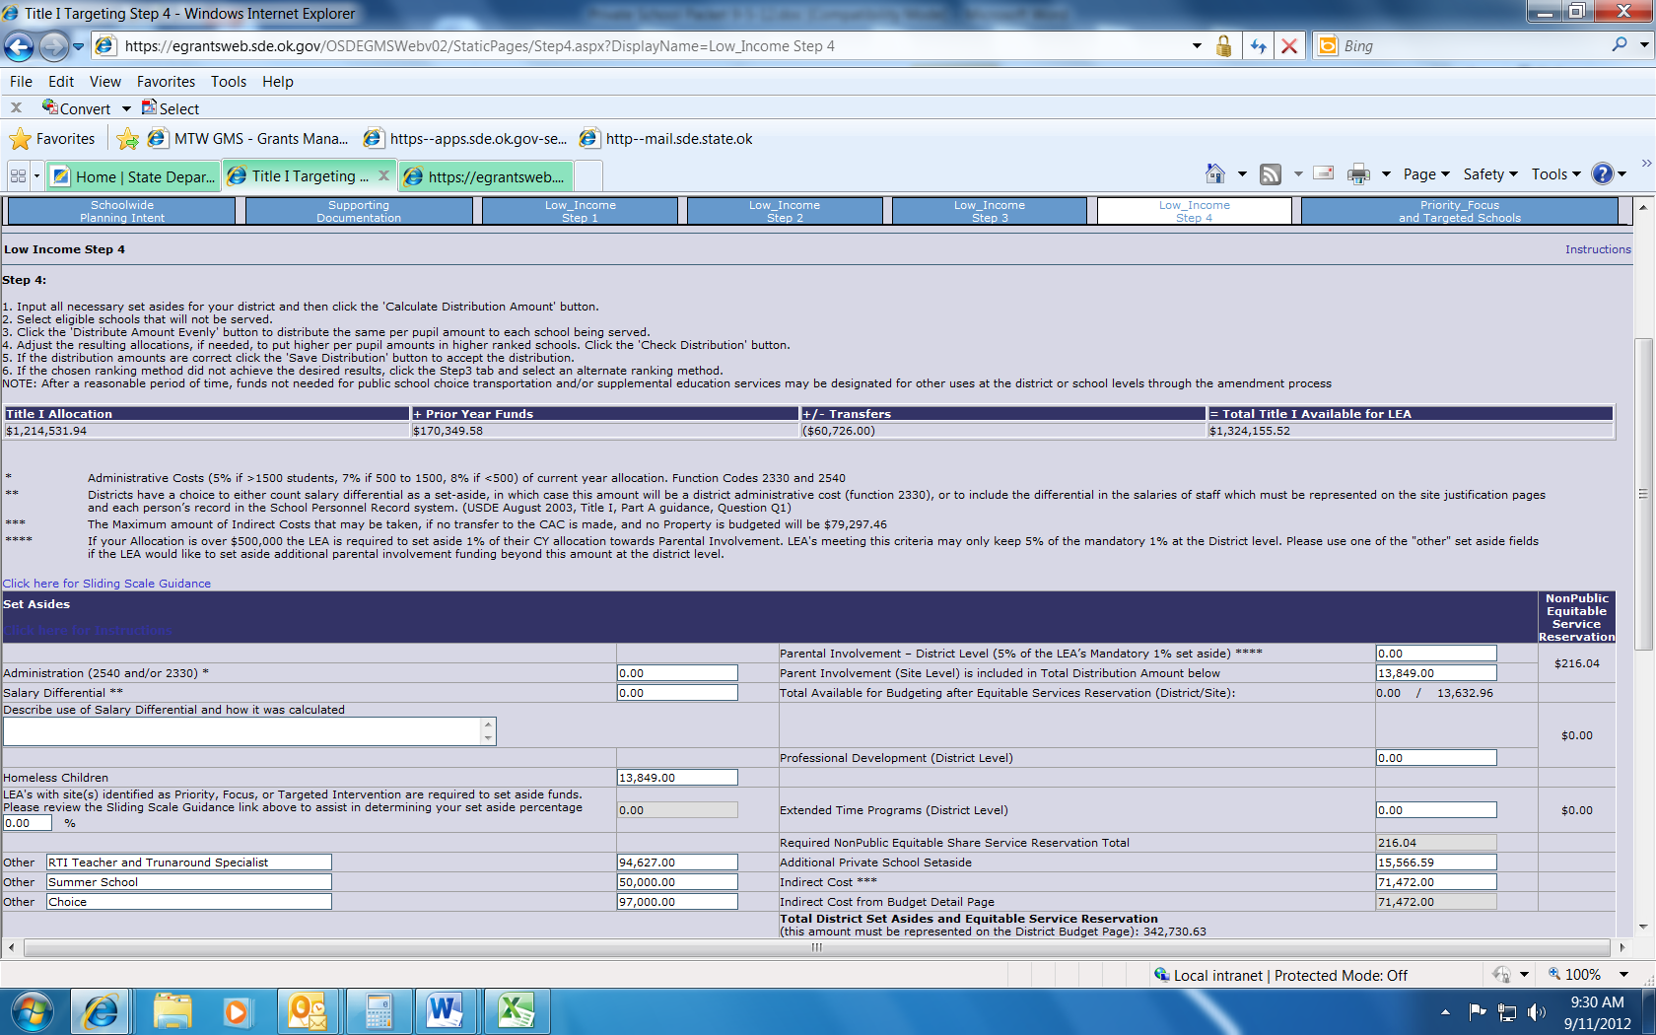

The Required Non-Public Equitable Share Service Reservation Total amount represents the District Set Aside for Private School Reservations in Parental Involvement, Professional Development, and Extended Time Programs. This total amount, along with the total Non-Public Allocation below, equals the TOTAL Private School Set Aside to be budgeted on the District Budget Detail Page.
District use only

Determining Funds Generated for Equitable Share

The Grants Management System on Low Income Step 4 will calculate the non-public set aside funds generated at the site level as well as the district total in the Non-Public Allocation column. This calculation reflects information that will be prepopulated based on district reporting of 2015 Low Income data and the Non-Public Low Income student count obtained from this FY2016 Private School Packet.

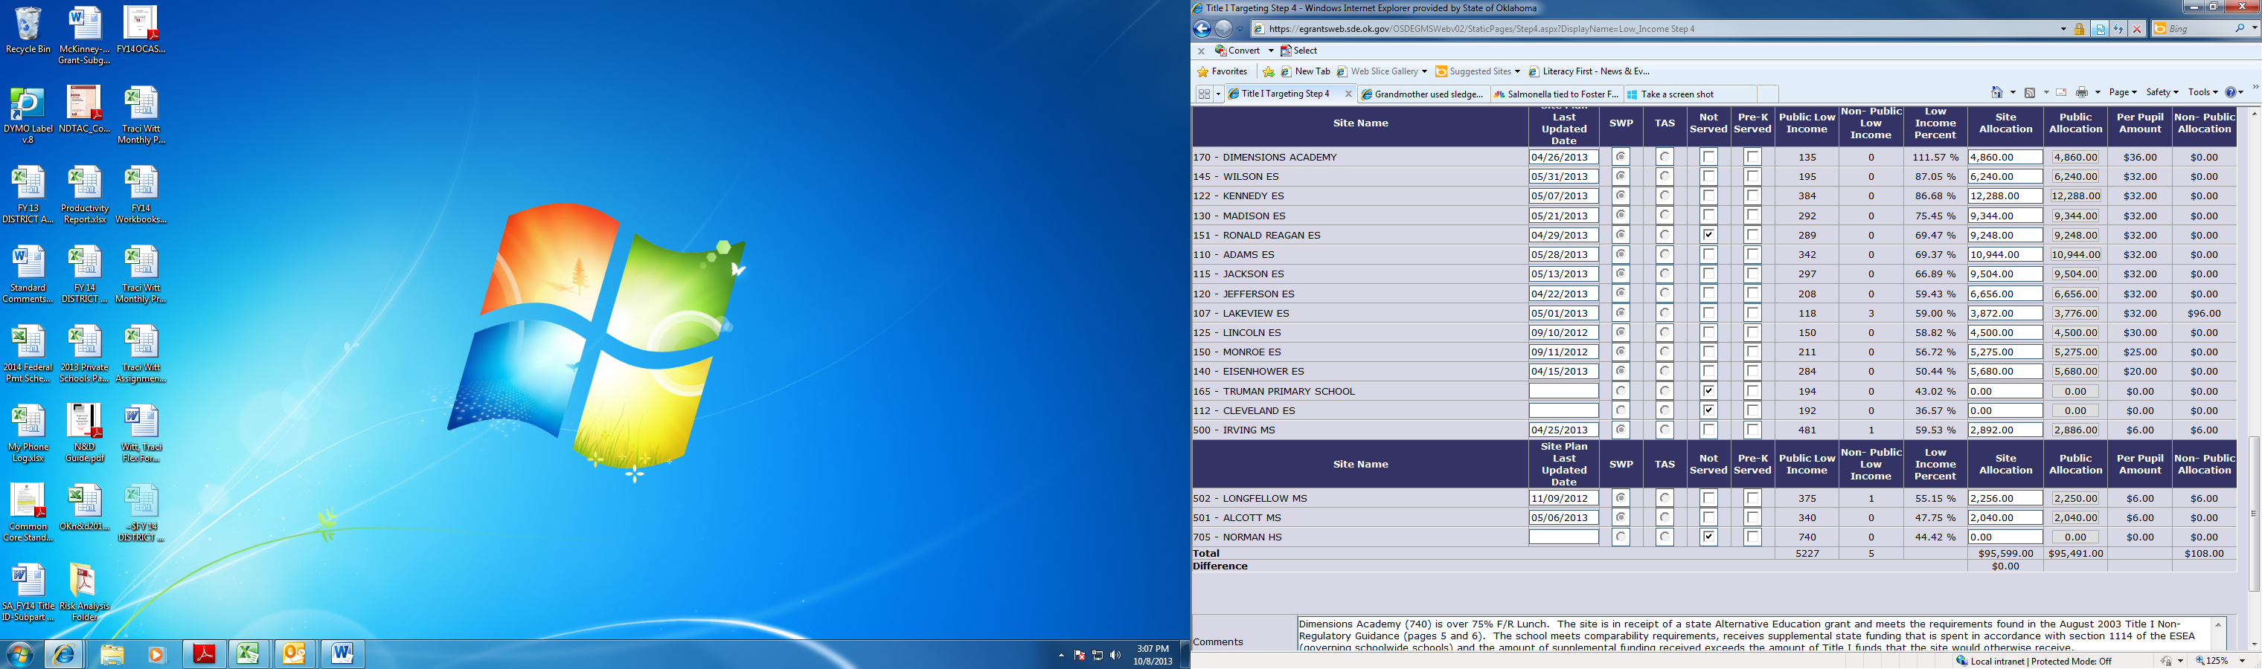
The Non-Public Allocation Total from Low Income Step 4, along with the district Required Non-Public Equitable Share Service Reservation Total from the District Set Asides, example on page 12, would equal the TOTAL Private School Set Aside, to be budgeted on the District Budget Detail Page.

After consultation with private school officials, the LEA determines which option it will use to fund the Title I programs for eligible private school children.

Option 1, School-by-School: Use funds generated by private school children from low-income families to provide Title I instructional services on a school-by-school basis to eligible private school children residing in participating public school attendance areas.

Option 2, Pooling; Combine (pool) funds generated by all private school children from low-income families to be used to provide Title I instructional services to eligible children who reside in participating public school attendance areas and attend any private school.

Consultation Process Flow Chart


