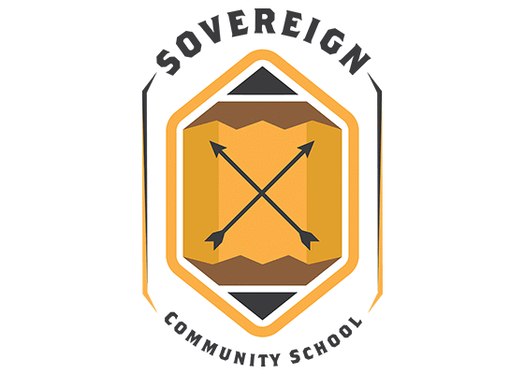

Corrective Action Planning:
Re-Engaging The Mission

Activate the next generation of indigenous leaders by engaging our youth with rigorous, culturally-relevant curriculum that challenges them to understand and affirm their roles as citizens of our many Native nations.

SCHOOLWIDE CORRECTIVE ACTION:

At our school, we have identified a need for improved academic outcomes among our students. In order to address this issue, we have developed a corrective action plan that focuses on providing additional support and resources for students who are struggling academically.

The first step in our plan is to identify the specific areas where students are having difficulty. This will be done through reestablished assessments and evaluations, as well as through feedback from teachers and parents. Once we have a clear understanding of where students are struggling, we will be able to tailor our interventions to meet their specific needs.

Next, we will provide additional support and resources for students who are struggling academically. This may include additional tutoring and homework help through our academic intervention hour(s), as well as providing access to educational materials and technology. We will also work to create a positive learning environment that is conducive to success, by promoting a culture of respect and collaboration, and by providing opportunities for students to engage in extracurricular activities.

In addition to providing support and resources for students who are struggling academically, we will also focus on engaging and motivating students to take an active role in their own learning. This may include providing opportunities for students to take leadership roles in the classroom and encouraging them to set and work toward academic goals.

Finally, we will regularly evaluate and assess the effectiveness of our corrective action plan and make adjustments as needed. We will involve teachers, parents, and students in this process, and will use feedback and data to make informed decisions about how to improve our approach.

Overall, our goal is to provide the support and resources that students need to succeed academically, and to create a positive learning environment that is conducive to success. We are committed to working together with our students, parents, and teachers to achieve this goal, and we are confident that with everyone's help, we will be able to improve academic outcomes at our school.

ADMINISTRATIVE COMPLIANCE:

School leadership will work closely with the state Regional Accreditation Officer (RAO) and the State Department of Education to ensure that the school is meeting all administrative and accreditation standards for state and federal compliance. This involves regular communication and collaboration between the school and these external organizations.

First, school leadership will maintain open lines of communication with the Regional Accreditation Officer, providing updates on the school's progress and addressing any concerns that may arise. This may include regular meetings, phone calls, and email correspondence.

Second, school leadership will work closely with the Regional Accreditation Officer to ensure that the school is meeting all administrative and accreditation standards. This may include providing regular reports on the school's progress and compliance with state regulations and working with the Regional Accreditation Officer to develop and implement plans for addressing any areas of non-compliance.

Third, school leadership will collaborate with the State Department of Education to ensure that the school is meeting all state standards. This may include participating in regular meetings and trainings, providing updates on the school's progress, and working with the State Department of Education to identify and address any areas of concern.

Fourth, school leadership will ensure that all necessary documentation and reporting is filed and submitted in a timely manner. This may include annual reports, progress updates, and compliance documentation.

Overall, the school leadership will work closely with the state Regional Accreditation Officer and the State Department of Education to ensure that the school is meeting all administrative and accreditation standards. By maintaining open lines of communication, collaborating on compliance efforts, and providing regular updates and reports, school leadership will work to ensure that the school is in compliance with all regulations and that the students are receiving a high-quality education.

SCHOOL CULTURE: Re-Engaging the Mission

Sovereign at its heart is a community of teachers, parents, and students whose mission must be focused on creating a positive and inclusive culture of high expectations where all students feel safe, respected, and valued. In order to achieve this goal, we are developing a plan that focuses on rebuilding relationships, promoting positive behavior, and fostering a sense of community.

Building relationships: We will work to build positive relationships between students, teachers, and staff. This may include activities such as mentoring, buddy programs, and regular opportunities for students and staff to interact and get to know each other. We will also work to build positive relationships with parents and community partners.

Promoting positive behavior: We will promote positive behavior by creating clear expectations and consequences for behavior, providing positive reinforcement for good behavior, and addressing negative behavior in a constructive manner. We will also provide students with opportunities to take leadership roles and make positive contributions to the school community.

Fostering a sense of community: We will create a sense of community by encouraging participation in school events, clubs, and extracurricular activities, and by providing opportunities for students to work together on projects and service-learning initiatives. We will also work to create a welcoming and inclusive environment for all students, regardless of their backgrounds or abilities.

The plan will be regularly reviewed and evaluated to ensure that it is meeting its goals. We will involve teachers, parents, and students in the evaluation process and use feedback to make improvements. Our goal is to create a positive and inclusive school culture where all students feel safe, respected, and valued. We are confident that by focusing on building relationships, promoting positive behavior, and fostering a sense of community, we will be able to create a positive and inclusive culture at our school.

SCHOOL ACADEMIC GROWTH PLAN:

Our school has developed an academic growth plan to ensure that all students are making progress and reaching their full potential. The plan focuses on three main areas: assessment, instruction, and support.

Assessment: We will regularly assess student progress using a variety of measures, including benchmarking through NWEA assessments, standardized tests, formative assessments, and teacher observations. This data will be used to identify areas of strength and weakness and to inform instruction.

Instruction: We will provide high-quality instruction that is tailored to meet the individual needs of each student. This may include differentiated instruction, small group instruction, and the use of technology to support learning. We will also provide professional development for teachers to ensure that they are equipped to deliver effective instruction.

Support: We will provide a variety of support services for students who need extra assistance. This may include tutoring, mentoring, and counseling. We will also work closely with parents and community partners to provide additional resources and support for students and families.
The academic growth plan will be regularly reviewed and evaluated to ensure that it is meeting its goals. We will also involve teachers, parents, and students in the evaluation process and use feedback to make improvements.

Our goal is to ensure that all students are making measured progress and reaching their full potential. With a focus on assessment, instruction, and support, we are confident that we can create a culture of academic excellence at our school.

