Subject: ACCESS for ELLs 2.0 Test Window Closing and Student Completion Check for Oklahoma State Department of Education

To: Oklahoma Test Coordinators
From: DRC Customer Support
Date: April 21, 2017

RE: ACCESS for ELLs 2.0 Test Window Closing and Student Completion Check

The testing window for ACCESS for ELLs 2.0 for your state will end on Friday, April 28, 2017. Districts and schools should ensure that all students scheduled to test online have done so by this date.
To help with this, the following report in WIDA AMS can be generated:

- Log in to WIDA AMS
- Click on Report Delivery>Status Reports
- Select the Administration and District (Select the School, if applicable)
- Click on the Daily Cumulative Student Status Report

This report is an Excel document that allows a district or school to sort by Testing Status and isolate the students who are Completed, In Progress, or Not Started by each domain. This report is in real time.

SORTING:

When you open the report with Excel, the best way to organize the data is the following:

- Highlight rows 1-5, right click, and select Delete.
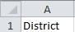
- Highlight the entire document by pressing the between 1 and A.

- Select Data from the top menu, select Sort and select Column N or Test Status.

- Select OK.

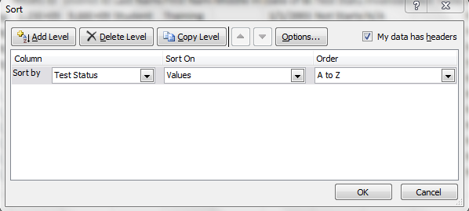
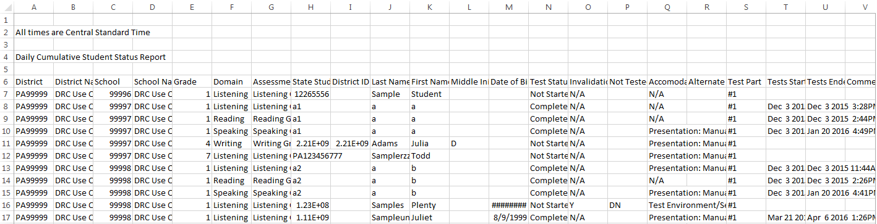

FILTERING:

You can also use the filtering options available in Excel to easily narrow in on specific schools, domains, or test status. To filter:

- Highlight rows 1-5, right click, and select Delete.
- Highlight the entire document by pressing the between 1 and A.

- Select Data from the top menu, select Filter.

- A dropdown will appear at each header column. Select the dropdown you would like to filter and check the appropriate boxes (This example shows filtering by Test Status.)

- Click OK.

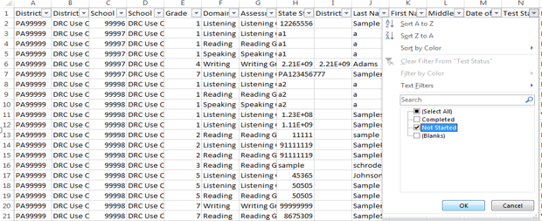

This report can be used to compare to your school roster of students to ensure that all students have completed their online tests. Tests that have a status of In Progress or Completed at the close of your testing window will be included in final scoring and reporting. Tests that have a status of Not Started will not be included; however, these could represent students that were initially setup in test sessions and are no longer enrolled or completed the paper version of ACCESS for ELLs 2.0.

Please contact DRC Customer Support with any questions at WIDA@DataRecognitionCorp.com or 1-855-787-9615.

