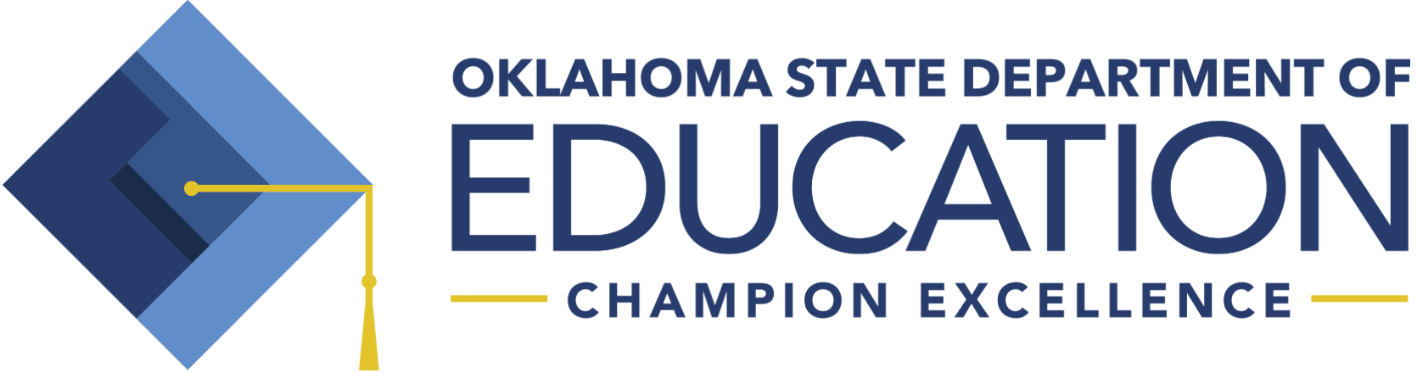
RSA APPROVED K-3 SCREENING INSTRUMENTS (Beginning 2019-2020)

Reading Sufficiency Act (RSA) K-3 State Approved Screening Instruments

The Oklahoma State Board of Education approved an updated list of screening instruments for RSA on June 28, 2018. On May 23, 2019, this list was updated as a result of a settled lawsuit involving one of the screening instruments.

These screening instruments will go into effect for the 2019-2020 school year. All students will be screened for reading at the beginning, middle, and end of the school year. The screening instruments are:

- Acadience | Dynamic Measurement Group, Inc.
- AIMSweb Plus | NCS Pearson, Inc.
- Formative Assessment System for Teachers (FAST) | Fastbridge Learning, Inc.
- Istation | Imagination State
- MAP Growth | NWEA
- mCLASS: DIBELS 8th edition | Amplify Learning, Inc.
- STAR Early Learning Assessment System (includes STAR Early Literacy and STAR Reading) | Renaissance Learning

In order to be included on the approved list, each screening instrument had to meet all five criteria Oklahoma approved screeners. The criteria are:

- Meets the criteria of a screening instrument as defined by the Oklahoma State Department of Education and the evidence standards from the National Center for Intensive Intervention,
- Demonstrates convincing evidence for reliability and validity,
- Assesses all five reading skill areas defined in RSA Oklahoma statute (phonemic awareness, phonics, reading fluency, vocabulary, and comprehension),
- Reports scores as required by RSA Oklahoma statute; and
- Provides accommodations for subgroups of students as required by RSA Oklahoma statute.

RSA APPROVED K-3 SCREENING INSTRUMENTS (Beginning 2019-2020)

Statute 70 O.S. § 1210.508C (B)(1)

B. 1. Each student enrolled in kindergarten, first, second and third grade of the public schools of this state shall be assessed at the beginning and end of each school year using a screening instrument approved by the State Board of Education for the acquisition of reading skills including, but not limited to, phonemic awareness, phonics, reading fluency, vocabulary, and comprehension.

Statute 70 O.S. § 1210.508C (C)

C. The State Board of Education shall approve screening instruments for use at the beginning and end of the school year, for monitoring of progress, and for measurement of reading skills at the end of the school year as required in subsections A and B of this section; provided, at least one of the screening instruments shall meet the following criteria:

- Assess for phonemic awareness, phonics, reading fluency, and comprehension;
- Document the validity and reliability of each assessment;
- Can be used for diagnosis and progress monitoring;
- Can be used to assess special education and limited-English-proficient students; and
- Accompanied by a data management system that provides profiles for students, class, grade level and school building. The profiles shall identify each student’s instructional point of need and reading achievement level. The State Board shall also determine other comparable reading assessments for diagnostic purposes and for periodic and post assessments to be used for students at risk of reading failure. The State Board shall ensure that any assessments approved are in alignment with the subject matter standards adopted by the State Board of Education.

Statute 70 O.S. § 1210.508C (H)(1)

H. 1. Any first-grade, second-grade or third-grade student who demonstrates proficiency in reading at the third-grade level through a screening instrument which meets the acquisition of reading skills criteria pursuant to subsection B of this section shall not be subject to retention pursuant to this section. After a student has demonstrated proficiency through a screening instrument, the district shall provide notification to the parent or guardian of the student that they have satisfied the requirements of the Reading Sufficiency Act and will not be subject to retention pursuant to this section.

