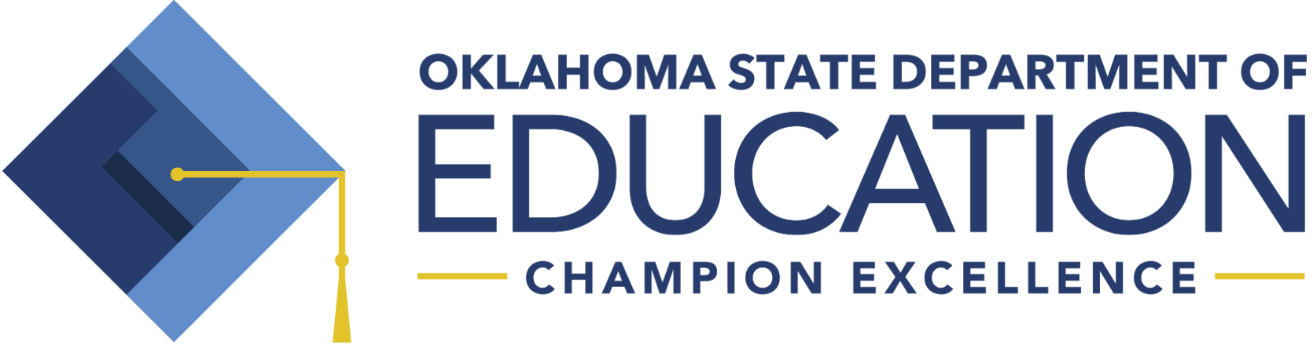
RSA APPROVED K-3 SCREENING INSTRUMENTS (Beginning 2019-2020)

Reading Sufficiency Act (RSA) K-3 State Approved Screening Instruments

The Oklahoma State Board of Education approved an updated list of screening instruments for RSA on June 28, 2018. On May 23, 2019, this list was updated as a result of a settled lawsuit involving one of the screening instruments.

These screening instruments will go into effect for the 2019-2020 school year. All students will be screened for reading at the beginning, middle, and end of the school year. The screening instruments are:

- Acadience | Dynamic Measurement Group, Inc.
- AIMSweb Plus | NCS Pearson, Inc.
- Formative Assessment System for Teachers (FAST) | Fastbridge Learning, Inc.
- Istation | Imagination State
- MAP Growth | NWEA
- mCLASS: DIBELS 8th edition | Amplify Learning, Inc.
- STAR Early Learning Assessment System (includes STAR Early Literacy and STAR Reading) | Renaissance Learning

In order to be included on the approved list, each screening instrument had to meet all five criteria Oklahoma approved screeners. The criteria are:

- Meets the criteria of a screening instrument as defined by the Oklahoma State Department of Education and the evidence standards from the National Center for Intensive Intervention,
- Demonstrates convincing evidence for reliability and validity,
- Assesses all five reading skill areas defined in RSA Oklahoma statute (phonemic awareness, phonics, reading fluency, vocabulary, and comprehension),
- Reports scores as required by RSA Oklahoma statute; and
- Provides accommodations for subgroups of students as required by RSA Oklahoma statute.

RSA APPROVED K-3 SCREENING INSTRUMENTS (Beginning 2019-2020)

Statute 70 O.S. § 1210.508C (A)(1)

A. 1. Each student enrolled in kindergarten in a public school in this state shall be screened at the beginning, middle and end of each school year for reading skills including, but not limited to, phonemic awareness, letter recognition, and oral language skills as identified in the subject matter standards adopted by the State Board of Education. A screening instrument approved by the State Board shall be utilized for the purposes of this section.

Statute 70 O.S. § 1210.508C (B)

B. Each student enrolled in first, second and third grade of the public schools of this state shall be assessed at the beginning, middle and end of each school year using a screening instrument approved by the State Board of Education for the acquisition of reading skills including, but not limited to, phonemic awareness, phonics, reading fluency, vocabulary, and comprehension.

Statute 70 O.S. § 1210.508C (D)

D. The State Board of Education shall approve screening instruments for use at the beginning and end of the school year, for monitoring of progress, and for measurement of reading skills at the end of the school year as required in subsections A and B of this section; provided, at least one of the screening instruments shall meet the following criteria:

- Assess for phonemic awareness, phonics, reading fluency, vocabulary and comprehension;
- Document the validity and reliability of each assessment;
- Can be used for identifying students who are at risk for reading deficiency and progress monitoring throughout the school year;
- Can be used to assess students with disabilities and English language learners; and
- Accompanied by a data management system that provides profiles for students, class, grade level and school building. The profiles shall identify each student’s instructional point of need and reading achievement level. The State Board shall also determine other comparable reading assessments for diagnostic purposes to be used for students at risk of reading failure. The State Board shall ensure that any assessments approved are in alignment with the subject matter standards adopted by the State Board of Education.

